About parental leave reimbursement
Service providers that make a parental leave entitlement payment to staff employed to deliver the funded kindergarten program can apply to the Department of Education and Training (the Department) for reimbursement of the parental leave payment.
The eligibility criteria and further information about parental leave reimbursement is available in The Kindergarten Guide. http://www.education.vic.gov.au/childhood/providers/funding/Pages/kinderfundingcriteria.aspx
Applications for parental leave reimbursement are subject to approval by the Department.
Before applying please ensure you have updated the staff member’s information in KIM for whom you are applying for parental leave reimbursement. Click the Edit button next to the staff member to check and/or update information.
- From the service provider home page, click on the service name.
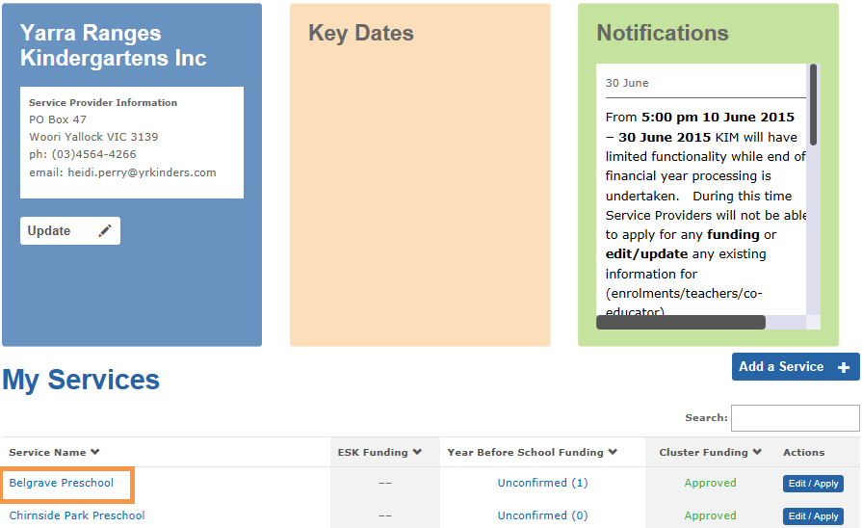
- In the Teachers or Other Educators tab, click Application next to the relevant teacher or other educator and then select Parental Leave from the drop-down list.
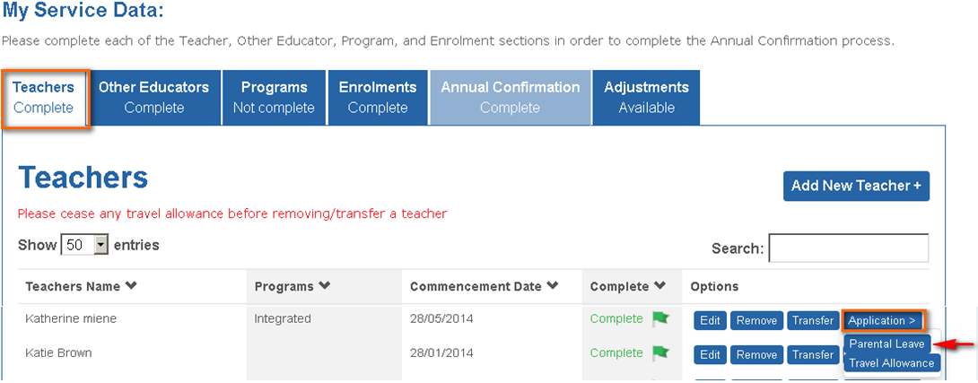
Result: the Parental Leave Details screen displays.
- Select the type of parental leave taken by the staff member (Maternity, Adoption or Partner).

Maternity or Adoption leave
- Enter the date the leave commenced and the date the leave finished in dd/mm/yyyy format.
- Enter the gross hourly rate of pay at the time of commencement of leave
- Enter the total weekly hours of employment for this employee
- Enter the total weekly hours, including non-contact time, in the funded kindergarten program
Result: KIM will automatically calculate the total amount to be reimbursed.
- Click Next to navigate to the Certification screen. Complete the Name, Position and Date fields.
- Click Submit.
Result: the application is submitted for Department approval. The submitted form will display in the Submitted tab under the Application Status menu.

Partner leave
- Enter the date the leave commenced and the date the leave finished in dd/mm/yyyy format.
- Enter the gross hourly rate of pay at the time of commencement of leave
- Enter the total daily hours of employment for this employee
- Enter the total daily hours, including non-contact time, in the funded kindergarten program
Result: KIM will automatically calculate the total amount to be reimbursed.
- Click Next to navigate to the Certification screen. Complete the Name, Position and Date fields.
- Click Submit.
Result: the application is submitted for Department approval. The submitted form will display in the Submitted tab under the Application Status menu.

You can save the application at any time by clicking the Save button. To re-open the saved application, go to Application Status in the main service menu and click on the Saved tab. Open the saved application by clicking on the application name.

