If you are an approved Kindergarten Cluster Manager (KCM), you can apply for cluster management funding through the Kindergarten Information Management system (KIM). The Department of Education and Training (the Department) provides kindergarten cluster management funding as a contribution toward the cost of managing and coordinating a cluster of services.
New and existing KCMs adding new services to the cluster receive a one-off start-up grant and an annual grant for each service managed by the KCM. For more information about how the funding amount is calculated, refer to Part A of The Kindergarten Guide.
An application for Cluster management funding can be made for:
- a service that is currently managed by the KCM
- a new service for which the KCM has never received kindergarten funding
- a service for which the KCM has previously received kindergarten funding (a recommencing service), or
- a service that is transferring to the KCM’s cluster.
If adding a new service to the cluster for which this KCM has never received kindergarten funding, the KCM must also submit a SA01 Application for service approval through the Australian Children’s Education & Care Quality Authority (ACECQA).
If transferring a service from another funded service provider to the KCM’s cluster, the KCM must also submit a SA04 Notification of Transfer of Service Approval through ACECQA at least 42 days before the proposed transfer date.
For more information go to: http://www.acecqa.gov.au
Please contact your local Department Regional office prior to adding or transferring a service to your cluster.
Applying for cluster funding for a service managed by the KCM
The service may or may not be in receipt of year before school funding.
- On your KIM home page, click Edit/Apply next to the corresponding service.
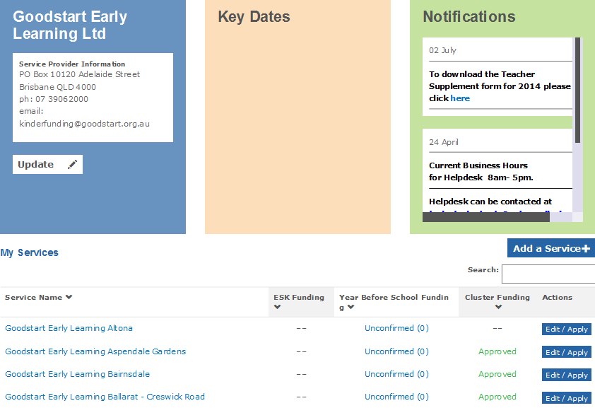
- Select Cluster Funding and click Apply.
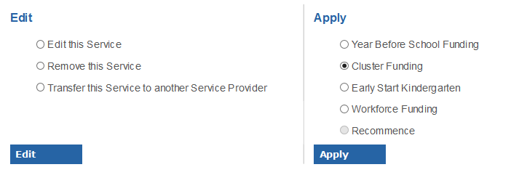
Result: the Cluster Application screen displays.

- Click Apply For Cluster.
- Click on the text Add a Service to a Cluster to download the application template.
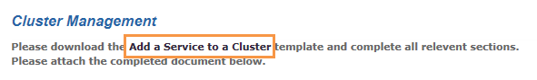
Result: The message “Do you want to open add a service to a cluster.doc” displays.
- Click Open.
Result: The template opens as a separate Word document.
- If you want to save the KIM application while you complete the template document, go back to KIM and click Save.
Result: The service’s Cluster Funding status displays on the Home page as More Information
- To re-open and edit the application, click on More Information.
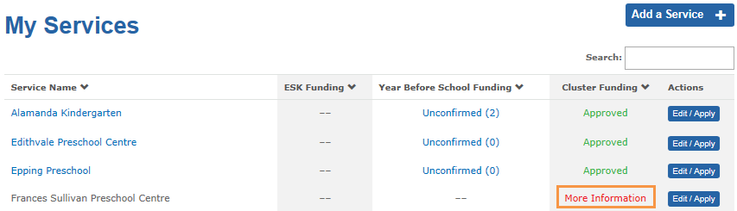
- Click View Application
- To upload the completed Add a service to a cluster template, click Upload+
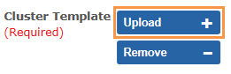
Result: the File Upload window displays.
- Click Browse to locate the document on your computer.
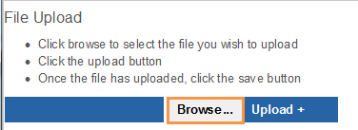
Result: a Choose File to Upload screen displays
- When you have located the document that you wish to upload, double click on the document name or select the document and click Open.
Result: The file name will display.
- Click Upload+ to upload the selected file to KIM.
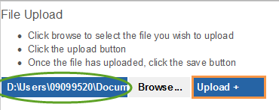
- If you have attached the wrong file, click Exit and repeat from step 10. Otherwise, click Save.
Result: the uploaded document name will display
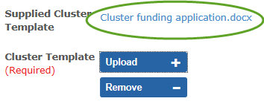
- Indicate whether the local council has endorsed this application to add this service to the kindergarten cluster.
If you answer Yes, continue to Step 15.
If you answer No, go to Step 16.
- Attach the Council’s letter of endorsement by clicking Upload + and then Browse to locate the document on your computer.
- If you would like to attach additional documentation to support the application, click the Upload + button in the Further / Additional Documentation section and then Browse to locate the document on your computer.
Repeat step 16 to add further documents.
- When the application is complete, click Submit.
Result: the application is submitted for Department approval. The service’s Cluster Funding status displays on the Home page as More Information

Applying for cluster funding for a new service for which this KCM has never received funding
- On your KIM home page, click Add a Service+
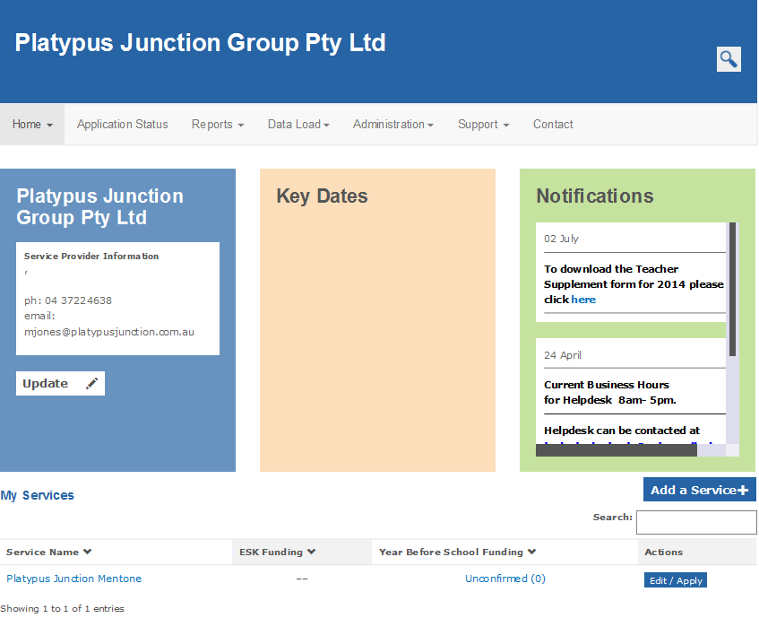

Result: A screen with Service Details, Street Address and Emergency Contact Details displays.

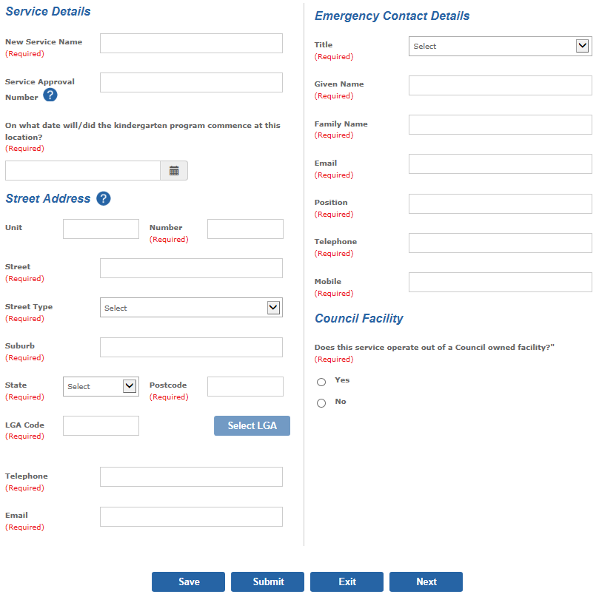
- In the Service Details section, enter the service’s name and Service Approval Number for which you are applying for funding.
- Select the date the kindergarten program commenced or is commencing.
- In the Street Address section, enter the address, telephone number and email of the service for which you are seeking funding and select the Local Government Area (LGA).
- In the Emergency Contact Details section, enter the name, address, email and telephone number of a person who can be contacted in case of an emergency.
- Indicate whether the service operates out of a Council owned facility.
- Click Next to navigate to the next page.
- Indicate that you wish to apply for cluster funding for the service
- Select whether the core nature of education and care provided at this location is Preschool/kindergarten or Long Day Care
- Select the service’s current National Quality Framework rating. If ‘Other’ is selected, you are required to enter further details.
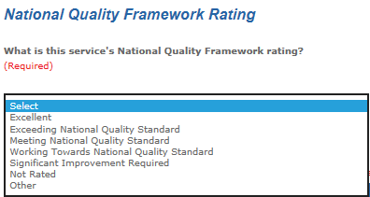

- Indicate whether the funded kindergarten program is the only program offered at this service.
If you answer ‘No’, select the services, programs or activities that are also available at the service.
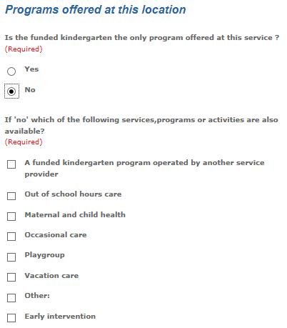
- Click Submit.
- Follow steps 4 to 16 on pages 2 to 3 of this guide.

Applying for cluster funding for a recommencing service
- On your KIM Home page, find the service that you wish to recommence from the list under My Services. If the service is not in the list, follow the previous instructions for a new service for which this KCM has never received funding.
- Click Edit/Apply
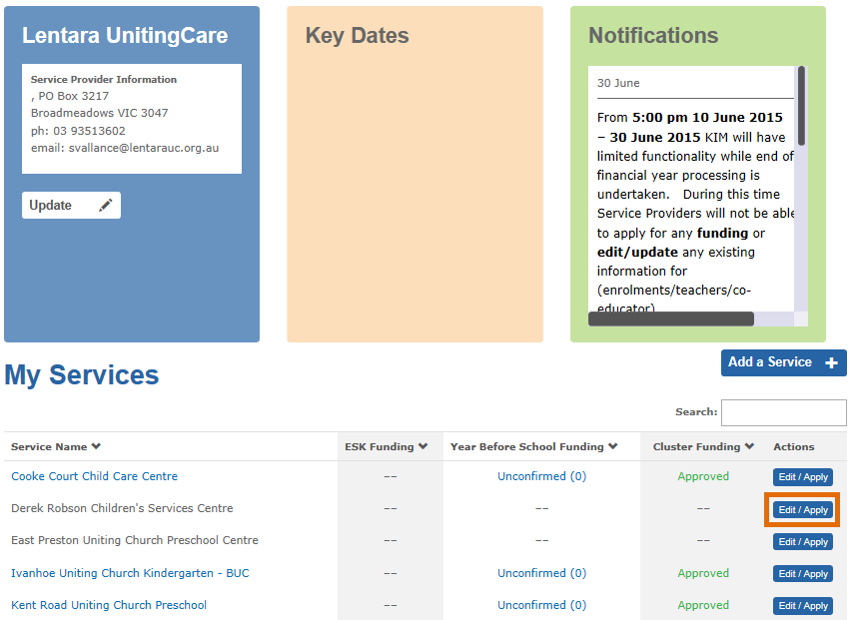
Result: The Edit/Apply options window displays.
- Select Recommence and click Apply
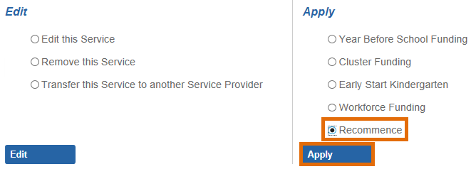
Result: Service Details, Street Address and Emergency Contact Details for the service display.
- If the name of the service has changed, enter the new name.
- Select the date the kindergarten program recommenced or is recommencing at this location.
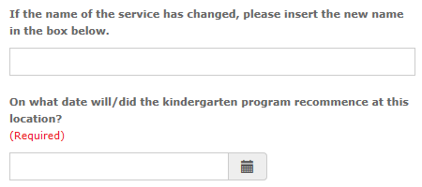

- Ensure that the street address, telephone, email and emergency contact details are correct and update if required.
- Indicate whether the service operates out of a Council owned facility.
- Click Next to navigate to the next page.
- Indicate that you wish to apply for cluster funding for the service
- Select whether the core nature of education and care provided at this location is Preschool/kindergarten or Long Day Care
- Select the service’s current National Quality Framework rating. If ‘Other’ is selected, you are required to enter further details.
- Indicate whether the funded kindergarten program is the only program offered at this service.
If you answer ‘No’, select the services, programs or activities that are also available at the service.
- Click Submit.
- Follow steps 4 to 16 on pages 2 to 3 of this guide.

Applying for cluster funding for a transferred service
The following steps are completed by the KCM who is adding the service to its cluster and is dependent on the transferring service provider completing an application to transfer a service in KIM. Refer to the Quick Reference Guide: How to transfer a service for more information.
- Open Application Status from the main menu and click on the Transferred tab.
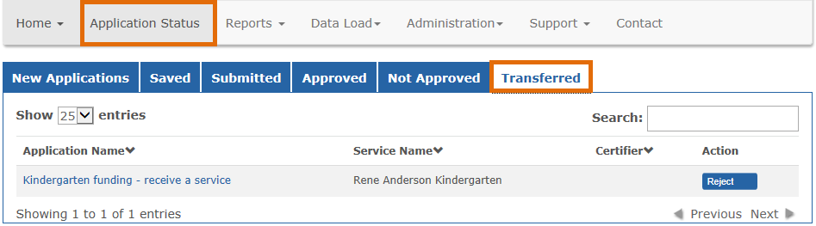
- Click on the application name Kindergarten funding – receive a service.
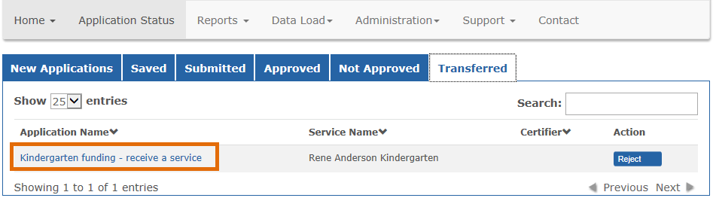
Result: the service provider, service, address and emergency contact details display with pre-populated information.
- If the name of the service has changed, you can enter the new service name.
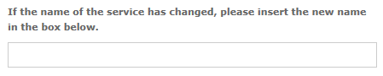
- You can also update the address and emergency contact details if they are incorrect.
- Click Next to navigate to the next page.
- Indicate that you wish to apply for cluster funding for the service
- Select whether the core nature of education and care provided at this location is Preschool/kindergarten or Long Day Care
- Select the service’s current National Quality Framework rating. If ‘Other’ is selected, you are required to enter further details.
- If the transferring service provider has agreed to share information about the educators, program and children relating to the kindergarten program at the service, a message will display reminding you to ensure all the information is complete and correct before submitting Annual Confirmation.
- Indicate whether the funded kindergarten program is the only program offered at this service.
If you answer ‘No’, select the services, programs or activities that are also available at the service.
- Click Submit.
- Follow steps 4 to 16 on pages 2 to 3 of this guide

