Accessing KIM
To access the Kindergarten Information Management system (KIM) you will need a registered eduPass account. Each service provider has one person designated as an Organisation Administrator (OA) who is responsible for inviting other users from their organisation to register for and activate eduPass accounts.
This quick reference guide describes how you can register for, and activate your eduPass account and then access KIM.

For more information about how the OA invites users to create an eduPass account, see the Quick Reference Guide: How Organisation Administrators Add a User.
If you do not know who has been designated as the OA for your organisation, call the Help Desk on 1800 614 810.

Register for an eduPass account
You will be sent an invitation email which contains instructions on how to accept the invitation to register for an eduPass account. The email will include an invitation code that looks like this: 12345678-1234-1234-1234-123456789012
- Open the email and copy the following web address into your browser:
https://edupass.education.vic.gov.au/community/invitation
Result: the first Invitation screen displays.
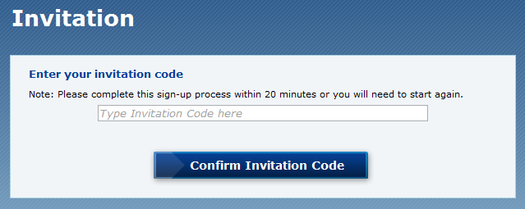
- Copy the invitation code from your email invitation and click the Confirm Invitation Code button. Result: the second Invitation screen displays.
- Click I don’t have an account
Result: the Register your details section displays.
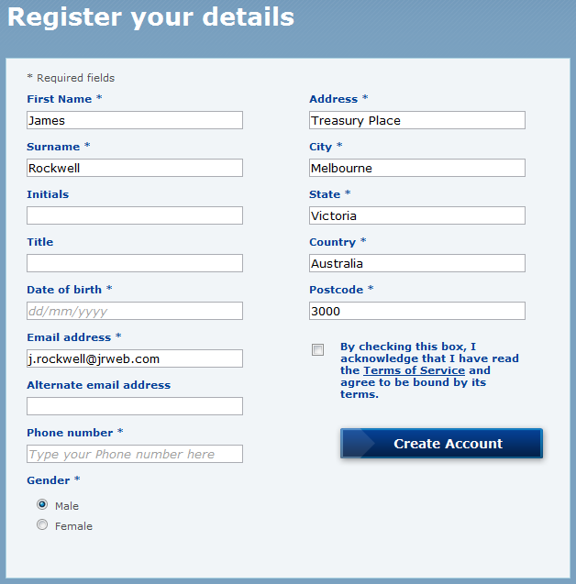
- Complete the required fields marked with a “*”, click on the link to read the Terms of Service and check the box to accept them, then click Create Account.
Result: an invitation confirmation message displays. eduPass will send a second email asking you to activate your account with your UserID and a temporary password.

Activate your eduPass account
- Open the Your eduPass account has been created email and copy the following web address from the email into your browser:
https://edupass.education.vic.gov.au/community/portal
Result: the eduPass Log in screen displays in your web browser.
- When prompted, select the option This is a private computer.
- Copy the UserID and Temporary Password from the Your eduPass account has been created email into User ID and Password, and then click Log in.
- Result: the First Use screen displays. You will need to enter information that will be used to keep your account secure.
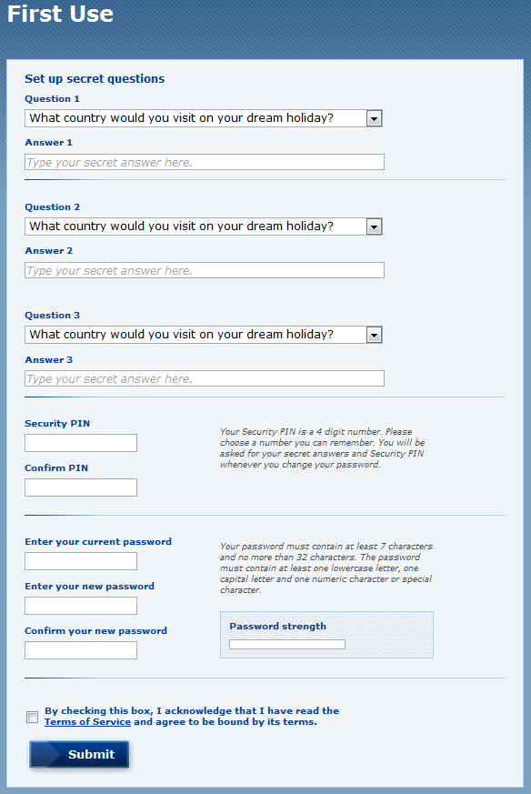
- Select questions and type answers for each of the three secret questions.
- In the Security PIN field, type a four-digit number you can easily remember, and then repeat in the Confirm PIN field.
- In the Enter your current password field, type the Temporary Password from the Your eduPass account has been created email.
- In the Enter your new password field, type a new password of your choice, and then repeat in the Confirm your new password field.
- Tick the check box: By checking this box, I acknowledge that I have read the Terms of Service and agree to be bound by its terms.
- Click Submit.
Result: a confirmation screen displays. Your account is now activated and ready to use.

Access KIM
- Click on the following link or type this address into your internet web browser: https://kim.eduweb.vic.gov.au
Add the link to your web browser favourites to access KIM quickly in the future.
Result: the KIM Login screen displays.
- When prompted, select This is a private computer
- Type your UserID starting with ‘EC’ and your eduPass password into the UserID and Password fields, and then press Log in.
Result: the KIM – Acceptable Use Policy screen displays.
- Click Acceptable Use Policy to read the policy and click Continue.
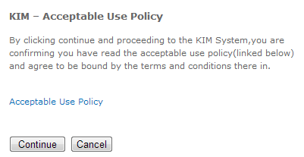

Result: the KIM Home screen displays.
- Under Support on the KIM home page main menu, select the sub-menu Support where you will find Quick Reference Guides to assist you in navigating and using KIM.

