This Quick Reference Guide is to assist approved service providers in applying to transfer a service that is currently in receipt of kindergarten per capita funding through the Kindergarten Information Management (KIM) system.
The benefit of using the transfer option in KIM is that all service, educator, program and enrolment information can be transferred to the new service provider.
Please contact your local Department Regional office prior to using the transfer option in KIM.
A SA04 Notification of Transfer of Service Approval must be submitted through the Australian Children’s Education & Care Quality Authority (ACECQA) at least 45 days before the proposed transfer date (see http://www.acecqa.gov.au for more information). The SA04 must be submitted before or at the same time as the application to transfer a service in KIM.
The application to transfer a service in KIM has two parts:
- Part 1: to be completed by the transferring service provider
- Part 2: to be completed by the receiving service provider
Part 2 cannot commence until Part 1 is submitted and approved by the Department.

Part 1 – to be completed by the transferring service provider
- On your KIM home page, click on Edit/Apply for the corresponding service.
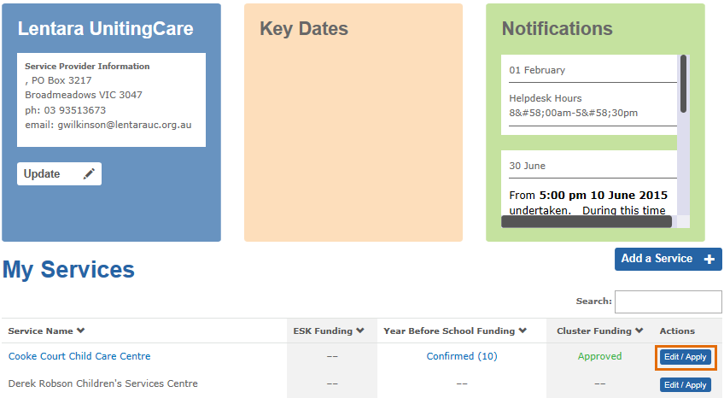
Result: The Edit/Apply options window displays.
- Select Transfer this service to another Service Provider and click Edit
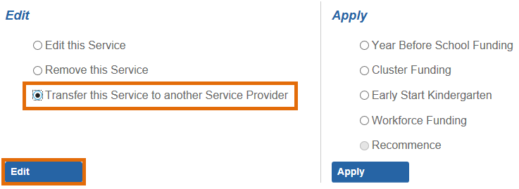
Result: the Transfer Service Details screen with display
- Enter the proposed Service Transfer Date which should match the date provided to ACECQA.
- Enter the legal entity name of the receiving service provider. As
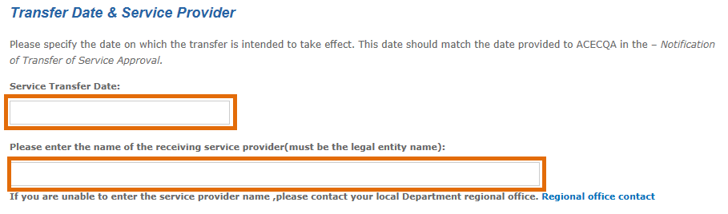
- Indicate whether the service operates out of a Council owned facility.
- In the section Information Transfer, indicate whether you would like to share information about the educators, program and enrolments associated with the funded kindergarten program with the receiving service provider.
- If you select “Yes”, this information will automatically transfer in the KIM system to the receiving service provider.
- If you select “No”, the information will not transfer.
- Click Submit.
Result: the form will be submitted for Department approval.
- To view the submitted form, open Application Status from the main menu. Click on the Submitted tab. The submitted form will display under this tab until it is approved.
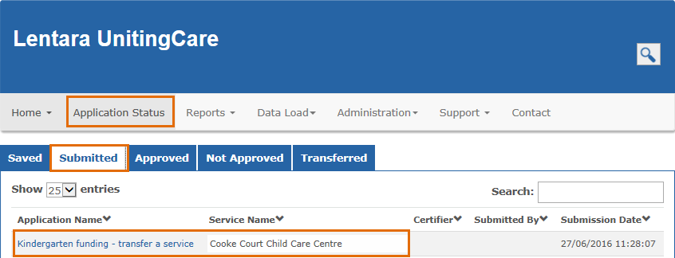

Part 2 – to be completed by the receiving service provider

Part 2 can only commence once Part 1 is approved by the Department.
Once Part 1 is approved, the form will be available to the receiving service provider to complete.
- Open Application Status from the main menu and click on the Transferred tab.
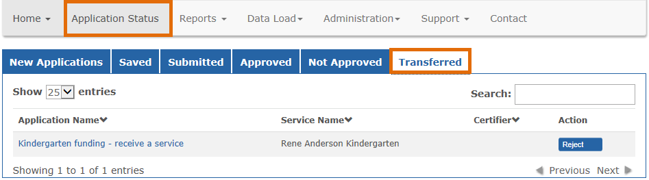
- Click on the application name Kindergarten funding – receive a service.
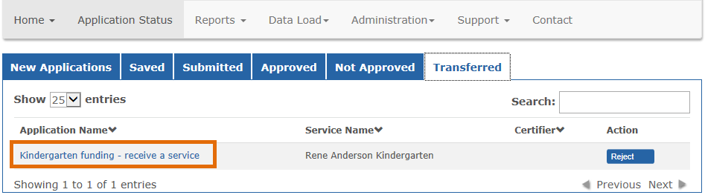
Result: the service provider, service, address and emergency contact details display with pre-populated information.
- If the name of the service has changed, you can enter the new service name.
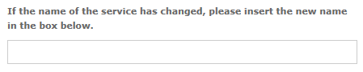
- You can also update the address and emergency contact details if they are incorrect.
- Click Next to navigate to the next page.
- If you are a local government managed organisation, a church organisation or a tertiary education institution, you are required to indicate whether your organisation uses an incorporated association (for example, a parent committee of management) to manage the day to day operation of the service. If ‘yes’, enter the legal entity name.
- If the service provider is a Kindergarten Cluster Manager, indicate whether you wish to apply for cluster funding for the service
- Select whether the core nature of education and care provided at this location is Preschool/kindergarten or Long Day Care
- Select the service’s current National Quality Framework rating. If ‘Other’ is selected, you are required to enter further details.
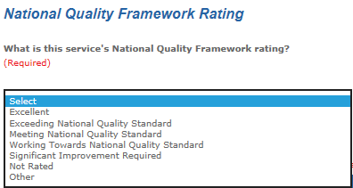
- If the transferring service provider has agreed to share information about the educators, program and children relating to the kindergarten program at the service, a message will display reminding you to ensure all the information is complete and correct before submitting Annual Confirmation.
- Indicate whether the funded kindergarten program is the only program offered at this service.
If you answer ‘No’, select the services, programs or activities that are also available at the service.
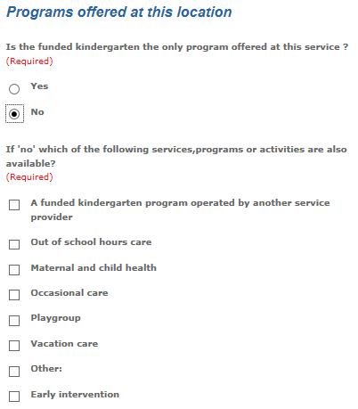
- Click Submit.
If you indicated in step 7 that you wish to apply for cluster funding for this service, the cluster funding application screen will display. Refer to the Quick Reference Guide: How to apply for cluster management funding for instructions on completing the cluster funding application.
Once submitted, the application will display under the Submitted tab in the Application Status menu until it is approved.

