This Quick Reference Guide is to assist service providers in ceasing funding to a service that is currently in receipt of kindergarten per capita funding through the Kindergarten Information Management (KIM) system.
The reasons for ceasing kindergarten funding to a service include:
- The service is closing
- A funded kindergarten program will no longer be offered at the service
- The service provider is unable to employ a suitably qualified early childhood teacher
- The service ceases to be an approved education and care service, licensed Victorian Children’s service, or service regulated under the Education and Training Reform Act 2006.
If the service is transferring from one approved service provider to another, do not cease funding to the service. Please refer to the Quick Reference Guide: How to transfer a service for more information.

- On your KIM home page, click Edit/Apply next to the corresponding service.
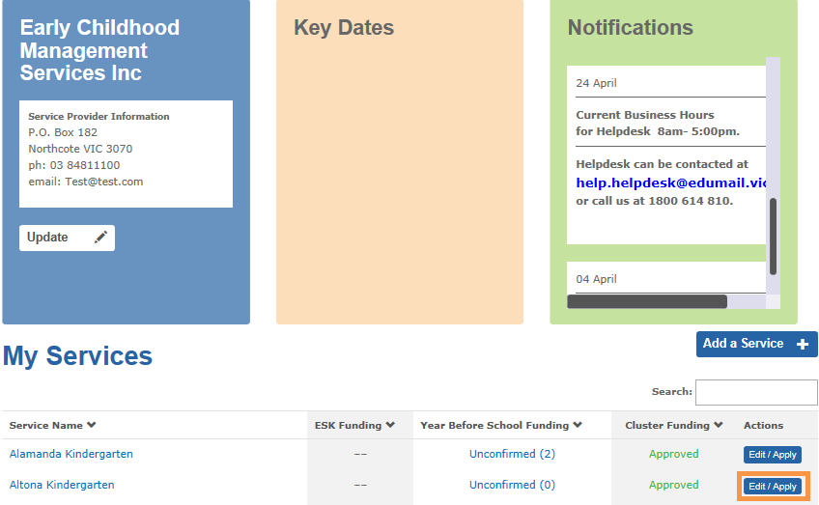

- Select Remove this Service and click Edit
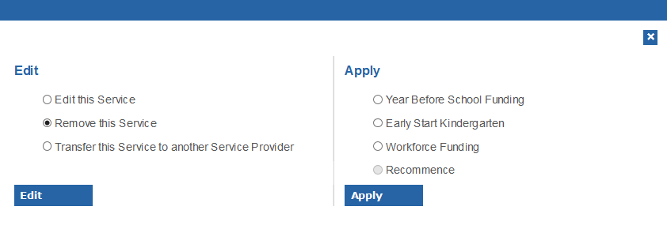
Result: The Remove Service Details screen is displayed.
- Select the reason the service is being removed (the service is closing or the service is no longer eligible for kindergarten funding).
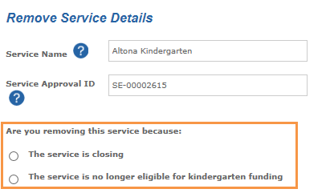

- In the section Cease Funding Details enter the date the service will or has ceased operating a funded kindergarten program.
- Type further information about why the funded kindergarten program has ceased or the service has ceased to operate.
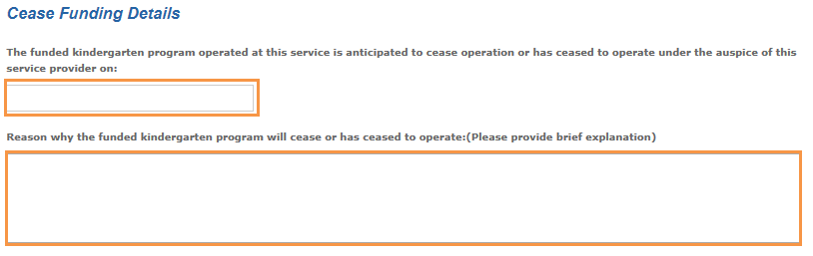
- Click Submit.
Result: the form is submitted for Department approval.

