About the Kindergarten Census
The Kindergarten Census collects information required to fulfil Victoria’s reporting requirements under the National Partnership for Early Childhood Education. The Department also uses the Kindergarten Census to ensure services continue to comply with policies outlined in the Kindergarten Funding Guide.
From Monday 6 August 2018, the census data collection is open in the Kindergarten Information Management (KIM) system to collect attendance and fee information for the Kindergarten Census Week (30 July to 4 August 2018).

Before starting the Kindergarten Census data collection
All the information in KIM about your organisation and the service(s) it operates must be up-to-date and complete prior to starting the Annual Census. This includes changes to enrolments, programs, teachers or other educators.
The Annual Confirmation tab must have the status Complete to activate the Annual Census tab.
If your service delivers a sessional kindergarten program, you will be required to specify the days the child was absent during the census week.
If your service delivers a kindergarten program integrated into long day care, you will be required to enter the hours the child attended during the census week.
**The Census can only be submitted ONCE. Changes cannot be made after submission**

This Quick Reference Guide provides step-by-step instructions on completing the census for:
- services delivering the kindergarten program using a sessional program
(page 2)
- services delivering the kindergarten program integrated into long day care (page 6)
Services that deliver the kindergarten program using both a sessional program and integrated into long day care, should refer to both sets of instructions when completing the census.

Handy Hints
Click the Save button at the bottom of the screen every 10-15 minutes after entering enrolments in case of a page time-out. The census can be reopened and continued by clicking the Edit button again.
The green flag indicates the information provided is complete.
The red flag indicates the information provided is incomplete.

Completing the census for a sessional model
- On the service provider home page, click on the name of the service.
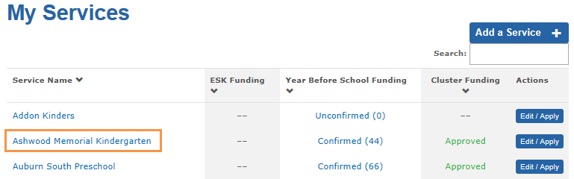
Result: The service home page displays.
- Click on the Annual Census tab.
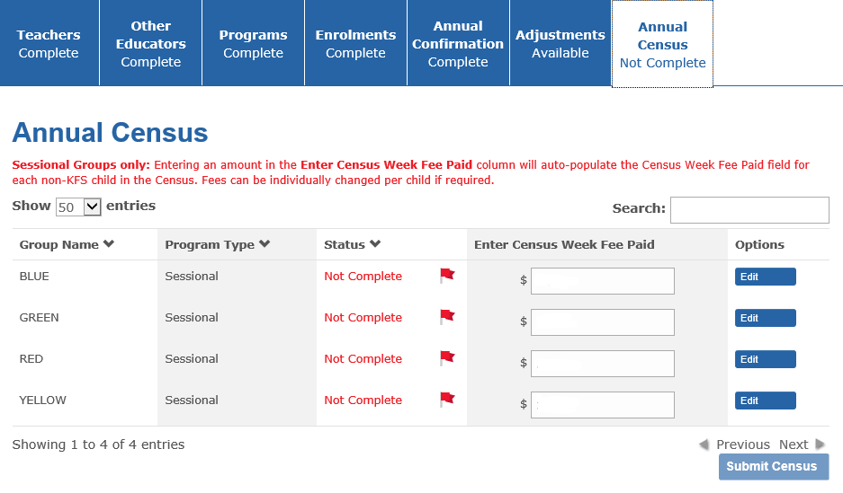
- For each sessional group, enter the normal weekly fee paid by families for children to attend the kindergarten program in the Enter Census Week Paid box. In the following example, $50 has been entered in each of the boxes. This amount will pre-populate the Census Week Fee Paid for every child in these groups except those receiving Kindergarten Fee Subsidy, which will pre-populate with $0. The fee paid amount can be changed manually for each individual child in the census screens.
Note: This is optional. You can proceed to the next step (click the Edit button), without entering a fee amount.
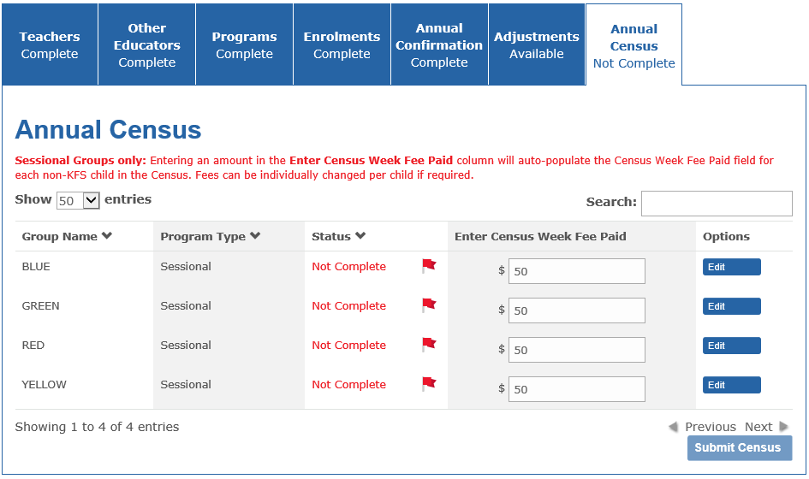

- After entering an amount in the Enter Census Week Fee Paid box, click the Edit button to enter the attendance data for the first group.
Result: the census week attendance screen displays.
Each child’s attendance days are pre-ticked according to the child’s enrolled session times (from the Programs tab). In the following example, the child attended on Tuesday, Wednesday and Thursday of census week. Untick the boxes if the child was absent on any of the days.
(Note: the child names have been de-identified for this guide)
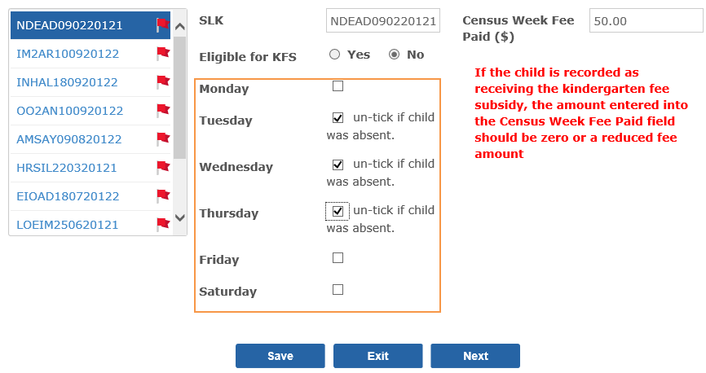
- If the child was absent for the whole of census week, un-tick all of the days.
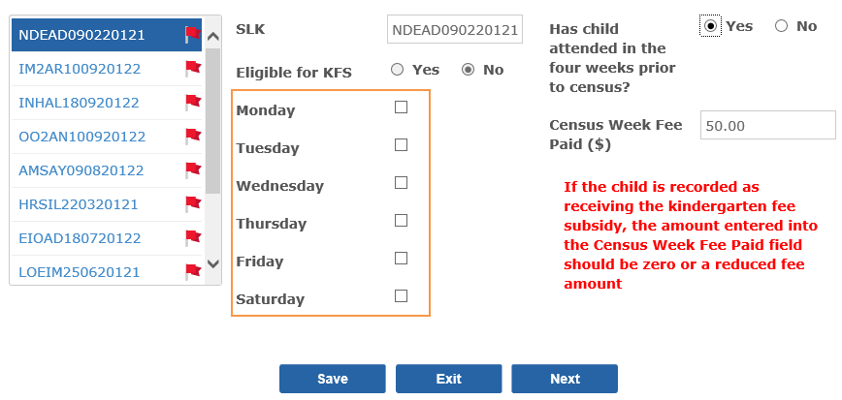
If the child was absent for the whole of census week, you will be required to answer further question(s) about the child’s absence:
- Has the child attended in the four weeks prior to census?
If you answer “Yes” to this question, you are not required to provide any further information.
If you answer “No” to this question, the following question will display:
- Is the child expected to return to the service?
If you answer “No” to this question, you are not required to provide any further information.
If you answer “Yes” to this question, you must select a reason for the child’s absence from the drop down box (illness, holidays, family reasons, planned closure or other).
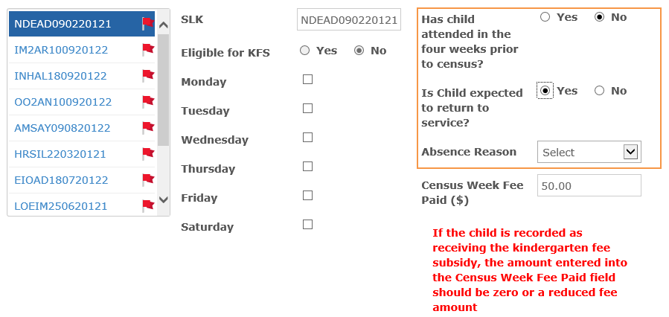
- Check the Census Week Fee Paid by the family for the child to attend the kindergarten program (after any subsidies or discounts) during the census week. If the pre-populated amount displayed is incorrect, please update with the correct amount.
If the child is eligible for the Kindergarten Fee Subsidy (KFS) but the family pays a small fee, please enter this fee.
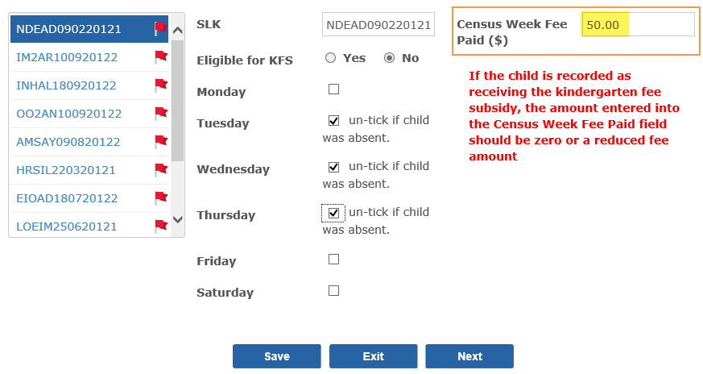
Click Next to navigate to the next child.
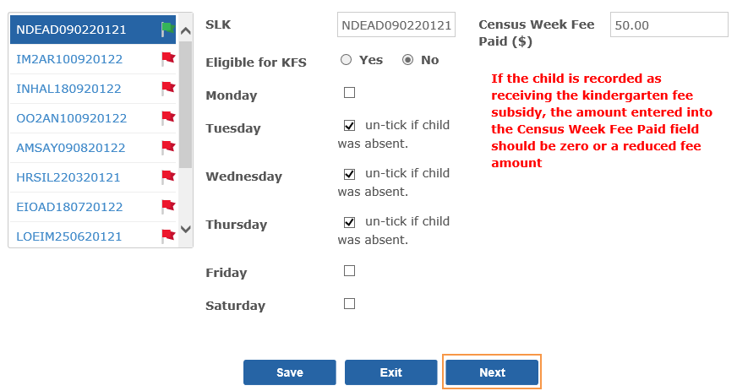
Result: the child is marked as complete (green flag ) and the next child’s records will display. You can go back and edit the previous child’s census data at any time by clicking the Previous button or by selecting the child’s name from the left hand panel using the up and down arrow on your keyboard.
- Repeat steps 4 to 7 for all children.
- Once you have completed census week attendance for all of the children listed (i.e. each child has a green flag ), click the Save button.
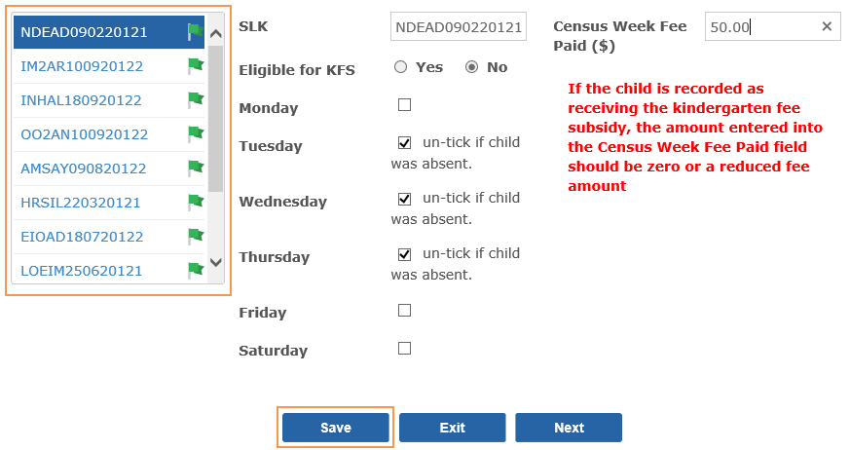
- The Annual Census Status of the group should change to Complete.
If the service runs multiple groups, repeat steps 3 to 10 for each group until all groups display with a Status of Complete.
- When all groups display with a Status of Complete and all tabs (Teachers, Other Educators, Programs, Enrolments and Annual Confirmation) are Complete, click the Submit Census button. If you are unable to submit the census, check that all tabs and groups are marked as Complete.
Result: The Certification screen displays
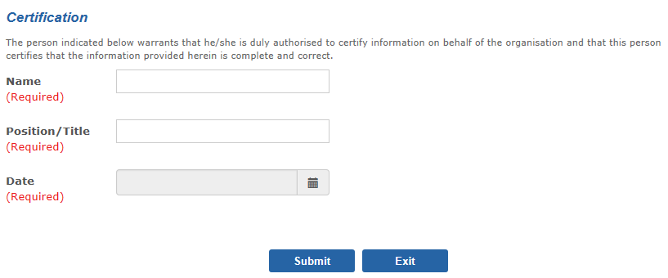
- Enter the name and position/title of the authorised person who is certifying that the information provided is true and correct.
- Enter the date of submission.
- Click the Submit button once only.
Result: The Annual Census tab displays as Complete.

Completing the census for an integrated long day care model
- On the service provider home page, click on the name of the service.
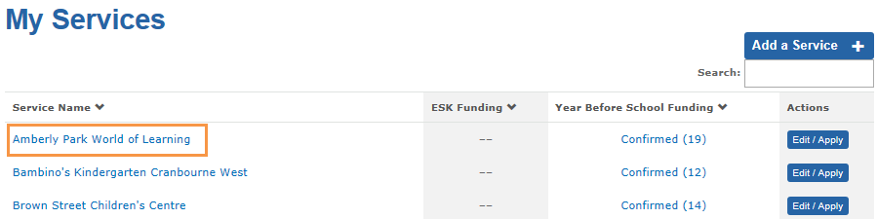
- Click on the Annual Census tab.
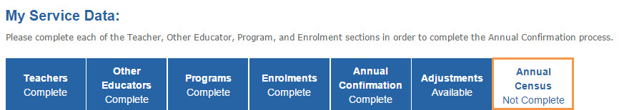
- Click the Edit button.
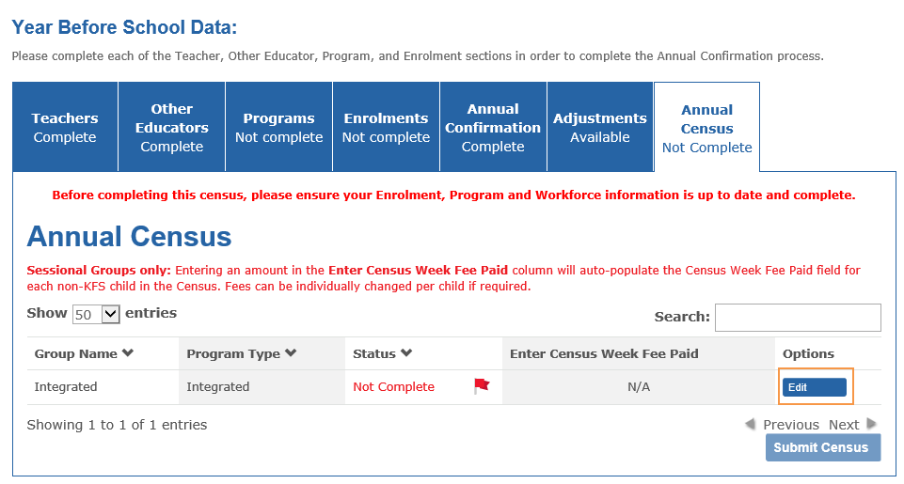
Result: the census week attendance screen displays.
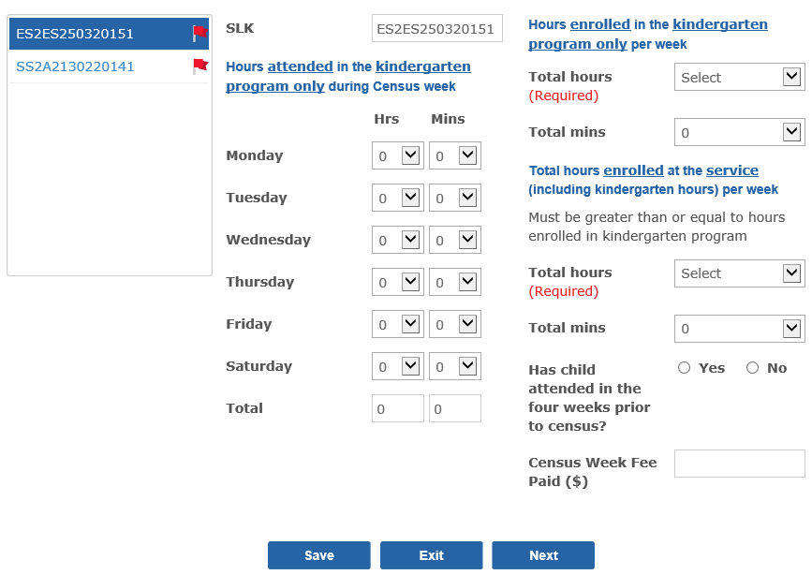
- Select the hours and minutes (to the nearest quarter hour) that the child attended in the kindergarten program only during the census week. Note that the kindergarten program total Hrs and total Mins will automatically calculate as you select the times.
In the following example, the child attended the funded kindergarten program for 4 hours and 30 minutes on Monday and Wednesday during the Census week for a total of 9 hours for the week. The child was absent from the funded kindergarten program for 6 hours during the Census week.
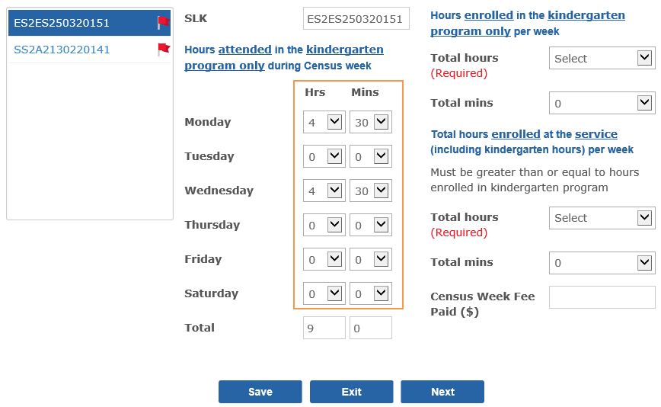
- Enter the hours the child is enrolled in the kindergarten program only per week. Note: All children enrolled in a funded kindergarten program must be enrolled for at least 15 hours per week.
In the following example, the child is enrolled to attend the funded kindergarten program for 15 hours per week.
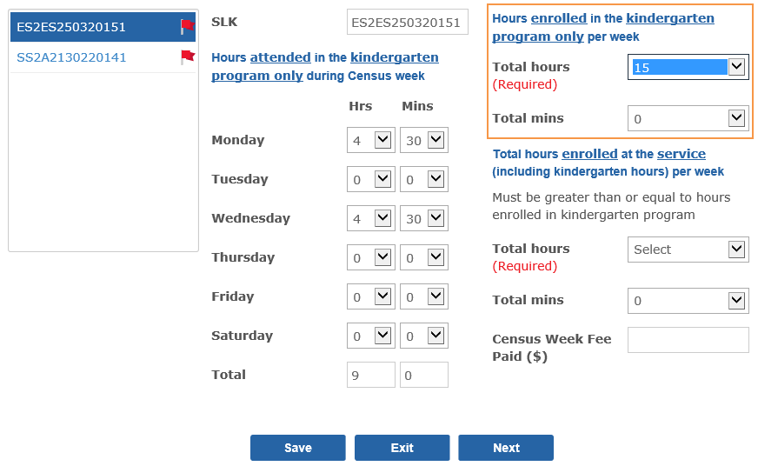
- Enter the total hours the child is enrolled at the service (including the kindergarten hours) per week.
In the following example, the child is enrolled for 15 hours of kindergarten plus 5 hours and 30 minutes of additional care for a total of 20 hours and 30 minutes.
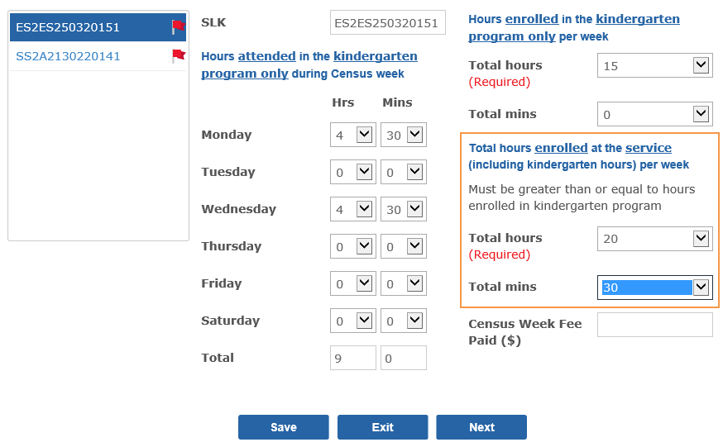
- If the child was absent for the full census week (total Hrs and total Mins is zero), you will be required to answer further question(s) about the child’s absence:
- Has the child attended in the four weeks prior to census?
If you answer “Yes” to this question, you are not required to provide any further information.
If you answer “No” to this question, the following question will display:
- Is the child expected to return to the service?
If you answer “No” to this question, you are not required to provide any further information.
If you answer “Yes” to this question, you must select a reason for the child’s absence (illness, holidays, family reasons, planned closure or other).
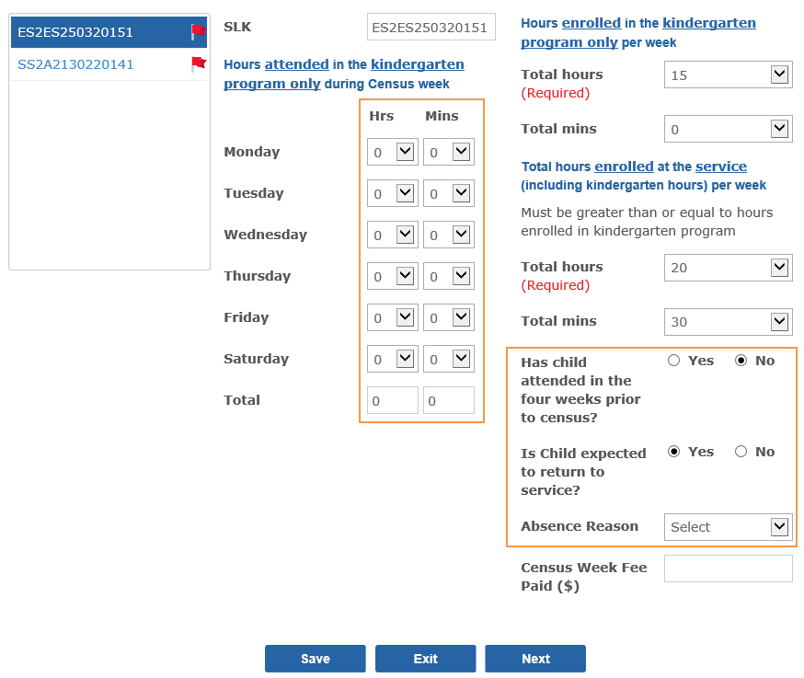
- In the Census Week Fee Paid ($) box, enter the fee paid by the family for the child to attend the overall long day care program in the period covering the census week after any subsidies or discounts have been deducted (the family’s out of pocket expense).
In the following example, $350 has been entered in the Census Week Fee Paid box.
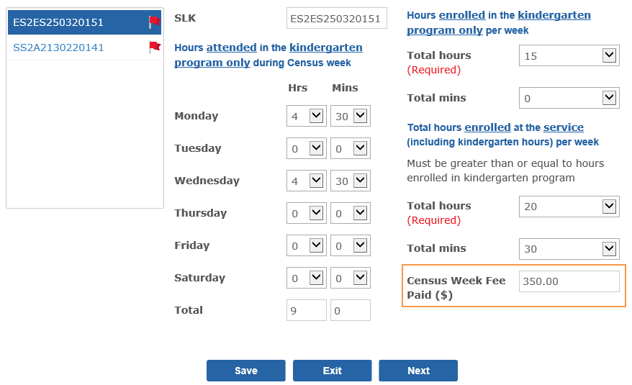
- Navigate to the next child by clicking Next.
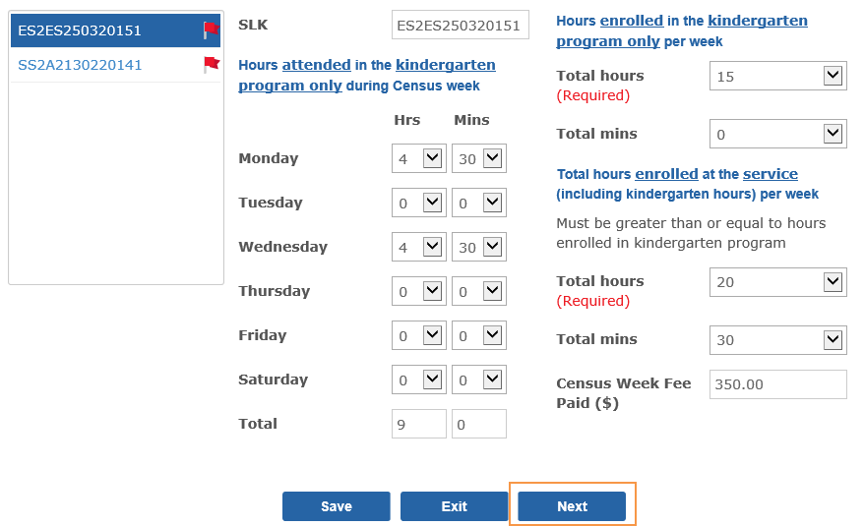
Result: the child is marked as complete (green flag) and the next child’s records will display. You can go back and edit the previous child’s census data at any time by clicking the Previous button.
- Repeat steps 4 to 9 for all children.
- Once attendance is completed for all of the enrolments listed, (i.e. each child has a green flag), click Save.
Result: The Annual Census Status of the group should change to Complete.
- When all groups display with a Status of Complete and all tabs (Teachers, Other Educators, Programs, Enrolments and Annual Confirmation) are Complete, click the Submit Census button. If you are unable to submit the census, check that all tabs and groups are marked as Complete.
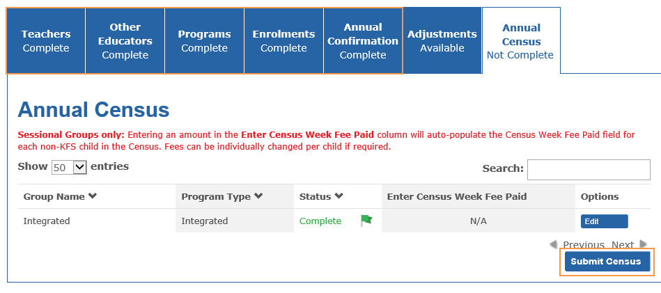
Result: The Certification screen displays
- Enter the name and position/title of the authorised person who is certifying that the information provided is true and correct.
- Enter the date of submission.
- Click the Submit button once only.
Result: The Annual Census tab displays as Complete.

