About other educators
Funded service providers may employ another educator to assist the qualified early childhood teacher in the delivery of a funded kindergarten program.
You are required to provide the details of other educators who assist in the delivery of the funded kindergarten program at the service(s) you operate via the Kindergarten Information Management (KIM) system.

Add an educator
- Go to your service’s Home page by clicking the service name under My Services on your service provider Home page.
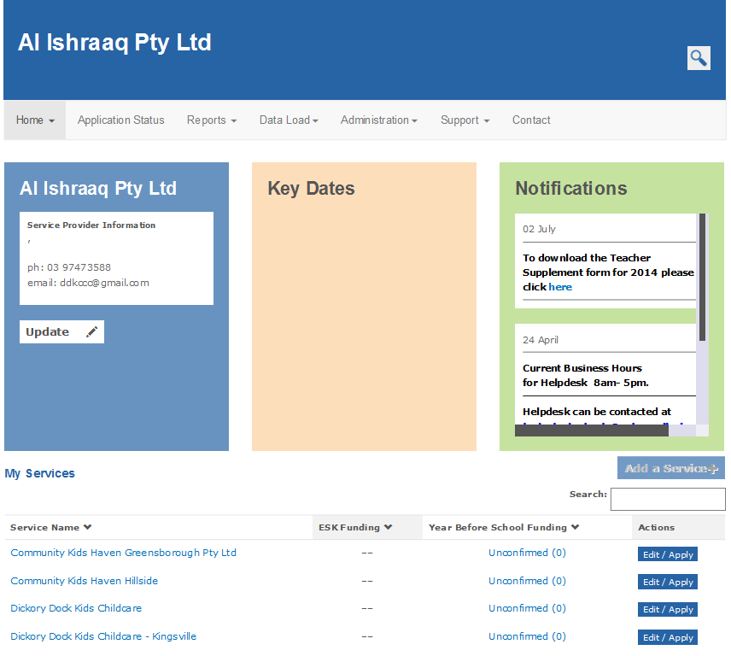

- Click on the Other Educators tab.
Result: any educators previously added will display in a list. If no educators have been added, the tab will be empty.
- Click the Add New Other Educator+ button.
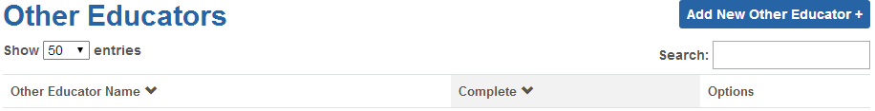
Result: the Other Educator Details section displays.
- Enter the Given Name, Family Name, Gender and Date of Birth (DD/MM/YYYY) of the educator.
- Select the highest qualification or teaching qualification that the educator holds from the drop-down list.
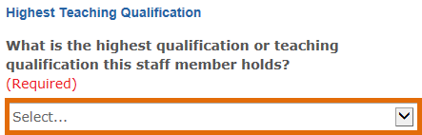
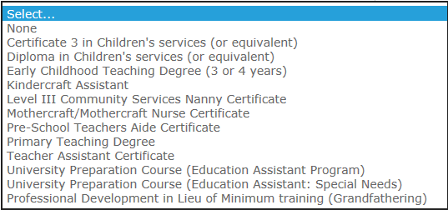

- Select the award or industrial agreement used in the employment of the educator.
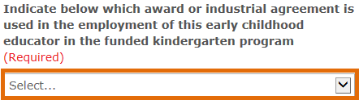
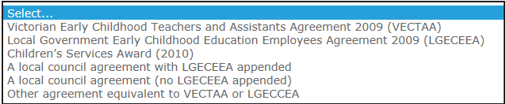
- If VECTAA or LGECEEA (or equivalent) is selected, indicate the level at which the educator is classified and paid.
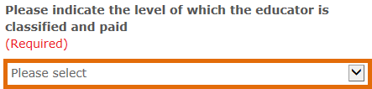
- Enter the total number of professional development hours undertaken by this assistant in the previous year. Do not include hours associated with progression towards formal academic qualifications.
- Enter the number of hours and minutes (to the nearest quarter hour) worked in the kindergarten program for children in the year before school.
- Enter the number of hours and minutes (to the nearest quarter hour) worked in any program other than the kindergarten program.
- Click Save.
Result: The added educator will display under the Other Educator tab. If all required information is complete for that educator, their status will display as Complete. If information is still required to be entered, the status will display as No Complete.
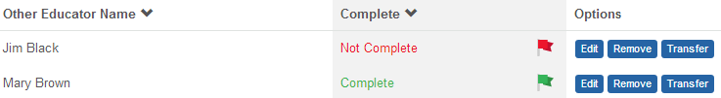

Edit an educator
- Click the Edit button next to the teacher you wish to edit.
Result: The Other Educator Details section displays..
- Edit details as required and click Save.

Remove an educator
- Click the Remove button next to the teacher you wish to remove.
- Enter the final date of work for the assistant leaving the service and select a reason for the assistant leaving the service from the drop-down list.
- Click Remove.
Result: The educator will no longer display in the list of other educators for the service.

