Kindergarten Parent Opinion Survey
The Kindergarten Parent Opinion Survey is an annual online survey that seeks feedback from parents of children who are enrolled in a Victorian funded kindergarten program. The survey includes questions regarding parent satisfaction, together with questions that reflect the Victorian Early Years Learning and Development Framework and the National Quality Framework.

WHEN does the survey take place?
The 2019 survey will take place from Monday 7 October to Friday 25 October 2019.

why is the survey important?
The survey results can be used to identify areas of strength and areas for improvement at your service(s). The results provide a good starting point for conversations between service providers and teachers/educators about possible actions to build on service strengths and address areas of concern.
The Department is also required to report on state-wide levels of parent satisfaction in the year before school in the Victorian Budget papers. Results are also used to inform early childhood policy and planning and service improvement initiatives across the state.

WHO participates in the survey?
All funded kindergarten providers, including long day care centres and independent schools in Victoria, are asked to email or SMS a link to the survey to parents of children enrolled in the Four- year-old Kindergarten program and encourage them to participate. In 2018 over 11,000 parents participated in the survey.

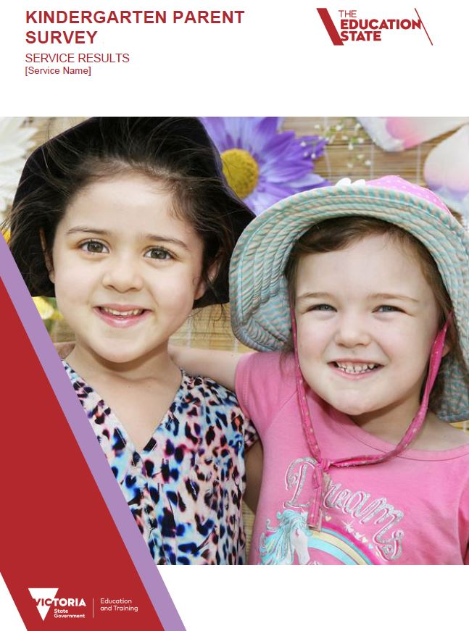
who conducts the survey?
The Social Research Centre has been contracted by the Department to conduct the survey on their behalf until 2019. You will receive communications from the Social Research Centre on behalf of the Department regarding the 2019 Kindergarten Parent Opinion Survey.
The Social Research Centre can be contacted on 1800 255 668 or email: parentsurvey@srcentre.com.au

how are parents approached to participate?
Service providers or individual services are asked to email or SMS a link to the survey to the parents of children enrolled in the Four-year-old Kindergarten program. Information postcards will also be sent to services with a link to the survey for distribution to parents.

Survey timeline and phases
Phase | Steps | Timeline
- Invite | During this week you will receive an email containing the unique survey link for your service(s).  Services are asked to send parents an invitation to the survey via SMS and/or email using the templates provided. | Survey opens 7 October
- Monitor progress and remind parents | You will receive regular updates on the number of surveys completed for your service(s).  Send reminders to parents, if you choose to do so, using the email and/or SMS templates provided. | Survey closes 25 October
- Receive your report | The Social Research Centre will send you information on how you can access your individual survey report. | December 2019

do all services receive SURVEY results?
Individual service level reports are available where a service has five or more respondents to the survey (in order to ensure the privacy and confidentiality of the respondents). These reports provide a summary of responses received as well as comparisons against the local government area and state-wide results.
Service providers who operate multiple services, are also provided with a service provider report where two or more of their services qualify for a service level report (five or more respondents to the survey).
A high level summary of the results from the annual surveys is also publicly available on the Department’s website: Kindergarten Parent Opinion Survey results

HOW to access your report(s)
An email will be sent by the Social Research Centre in December with information about how to download your report(s). You can also contact your local Department regional office for a copy of your report.

privacy statement
No identifying information of participants is collected in the survey. Participants remain completely anonymous.
The Department is committed to protecting the privacy, confidentiality and security of personal information. The Department and the Social Research Centre are required to comply with the Privacy and Data Protection Act 2014. The Social Research Centre also adheres to the Privacy (Market and Social Research) Code 2014.
For questions about the survey call 1800 255 668 or email: parentsurvey@srcentre.com.au or contact your local Department Regional Office

