Kindergarten Parent Opinion Survey
The Kindergarten Parent Opinion Survey is an annual online survey that invites parents to provide feedback about what’s going well in their child’s kindergarten program, as well as any areas for improvement. The survey includes questions about parent satisfaction as well as questions that reflect the Victorian Early Years Learning and Development Framework and the National Quality Framework.

WHEN does the survey take place?
The 2019 survey will take place from Monday 7 October to Friday 25 October 2019.

why is the survey important?

The results will help your service to provide the best possible kindergarten experience for children and families. They will also give the Department of Education and Training a better idea of how kindergarten programs are faring across the state.

How long does the survey take?
The survey only takes a few minutes to complete.

WHO can participate in the survey?
Parents or guardians of children enrolled in a Four-year-old funded Kindergarten program may complete the survey.
In 2018 over 11,000 parents participated in the survey. The survey is not compulsory, however your participation contributes to improvement in the quality of kindergarten programs.

how is the survey accessed?
Your kindergarten service may have contacted you via email or SMS with a link to complete the survey online. You can also use the following link to access the survey:
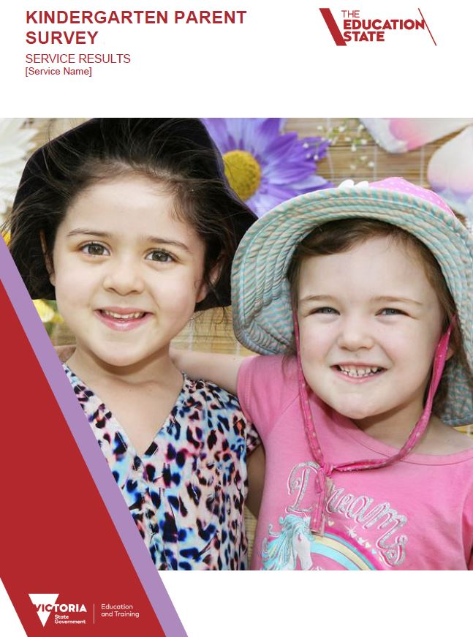
www.srcentre.com.au/parentsurvey
The survey is carried out online and can be completed by parents on a smartphone, tablet or desktop computer.

privacy statement
No identifying information of participants is collected in the survey. Participants remain completely anonymous.
The Department is committed to protecting the privacy, confidentiality and security of personal information. The Department and the Social Research Centre are required to comply with the Privacy and Data Protection Act 2014. The Social Research Centre also adheres to the Privacy (Market and Social Research) Code 2014.
For questions about the survey call 1800 255 668 or email: parentsurvey@srcentre.com.au or contact your local Department Regional Office

