- The Department owns all IP Rights arising in connection with or relating to the Kinder Brand.
- The Department will, while You remain an Approved Service Provider, and subject to You agreeing to the below Terms of Use, grant You a licence to use the Kinder Brand
By proceeding to use the Kinder Brand signage and resources, you acknowledge you have read, understand and accept you are bound by the Kinder Brand Terms of Use
Terms of Use
- You acknowledge that Your right to use the Kinder Brand is subject to the Department’s prior approval.
- You will only use the Kinder Brand for the Approved Use and in accordance with the Kinder Brand Guidelines.
- You will only use the Kinder Brand in Marketing Materials in accordance with the Kinder Brand Guidelines.
- You will ensure in relation to any material produced by You or on Your behalf that uses the Kinder Brand that:
  - You only use the Kinder Brand while You holds an Approved Service Provider status;
  - [Use the Kinder Brand and apply its use as per the Kinder Brand Guidelines]
- You must not knowingly do any act or thing, and must ensure that no other person involved in the reproduction of the Kinder Brand, does any act or thing, which might reasonably be expected to adversely affect the name or reputation of the Department.
Grant of licence
- The Department grants You a non-exclusive licence to use, reproduce and otherwise exploit the Department’s IP in the Kinder Brand only for the purposes of the Approved Use and in accordance with the Kinder Brand Guidelines.
- You acknowledge that the Department IP is, as between the parties, the exclusive property of the Department and the State of Victoria. Except for these specific terms of use, the Department does not grant You a licence to use, adapt, copy or reproduce Department IP.
Trademarks
- Nothing in these Terms of Use grants You any ownership of or rights to use the trademarks of the Department.
- You will not adopt, register or attempt to register or use any trademarks which are identical or deceptively similar to the Department’s trademarks or Kinder Brand.
Termination
- The Department may terminate these Terms of Use immediately by giving You 14 days’ notice by email.
- On termination of the Terms of Use, You must cease using the Kinder Brand, Department IP in all materials and must remove or delete the Department IP from existing tangible materials including signage and marketing materials.
General
- The Terms of Use are governed exclusively by the laws of Victoria, Australia.
- You must not transfer or assign any rights or obligations under these Terms of Use without the prior written consent of the Department.
Defined Terms
In these Terms of Use, the following meanings apply:
Approved Service Provider means: | An approved provider of a government funded kindergarten program.  A person who holds a provider approval under National Law. A provider approval authorises a person to apply for one or more service approvals and is valid in all jurisdictions.
Approved Use means: | 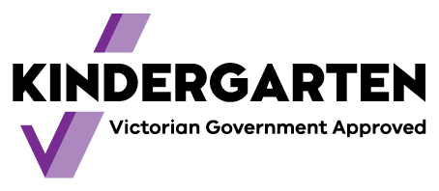  Use of the “Kinder” Brand Logo in signage of the Approved Service Provider’s premises and on marketing materials, in accordance with the Kinder Brand Guidelines.
Department means: | The State of Victoria as represented through the Department of Education and Training,  2 Treasury Place, East Melbourne Victoria 3002
Department IP means: | Intellectual Property, including the trade marks, trade dress, logos and the copyright subsisting in the “Kinder Brand”.
“Kinder” Brand means: | “Kinder Tick” word mark.  The Kinder Brand (known publicly as the Kinder Tick) is used by early childhood education services across Victoria to show they meet the Victorian  Government criteria to receive funding to deliver their  kindergarten program.  Families can look for the Kinder Tick as a symbol to  identify a Victorian Government funded kindergarten  program in both a long day care and in a standalone  (sessional) kindergarten setting.  Participating kindergarten programs and early childhood  services will display the Kinder Tick on their building  via outdoor and indoor signage, and on their website  and marketing materials. Staff, including teachers and  educators, will be familiar with the brand and be able to  assist with any questions parents or carers have about the  brand and what it means for their service.  “Kinder” logo mark:  “Kinder” colours:  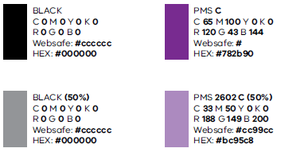
Kinder Brand Guidelines means: | [Kinder Brand guidelines]
Marketing Materials means: | Include any hardcopy and/or electronic communication medium that is used to market the Approved Service Provider’s services (for example, signage, websites, social media profiles or platforms, newsletters and brochures or booklets)

