Kinder Tick communication toolkit for services
  - Resources to help your service talk about the Victorian Kinder Tick
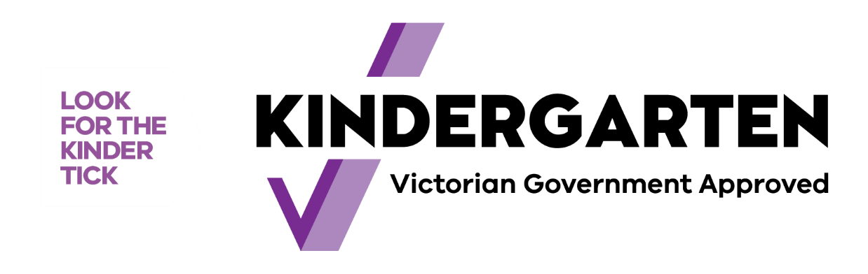

CONTENTS

Introducing the Kinder Tick 3
RESOURCES DESIGNED TO HELP YOU 3
DIGITAL MATERIALS 3
ACTION CHECKLIST 4
BACKGROUND 4
FAST FACTS 6
SAMPLE CONTENT: FOR YOUR COMMUNITY 7
Kinder Tick newsletter and website copy 7
Twitter 8
Facebook 8

The Victorian Government is introducing a new logo to help families find funded kindergarten programs that they can count on. The Kinder Tick makes it easier for services to show families they offer kinder programs approved to receive Victorian Government funding.
When families see the Kinder Tick, they can be confident:
- the program will be led by a qualified early childhood teacher
- children will benefit from play-based learning
- the kindergarten program is funded and approved by the Victorian Government
- the program meets government guidelines and complies with the National Quality Framework.

Introducing the Kinder Tick
Your service can display the Kinder Tick to show you provide a Victorian Government funded and approved kindergarten program.
By looking for the Kinder Tick, parents and carers can feel confident their child will be taking part in a contemporary evidence-based learning program led by a qualified early childhood teacher. The Kinder Tick will also tell parents and carers their choice of kindergarten program meets a set of Victorian Government funding guidelines that are in place to make sure children are able to benefit from a kindergarten program wherever it’s delivered.

The Department of Education and Training (DET) is committed to working with services and providers to ensure you are well supported during the roll-out of the Kinder Tick. If you have any questions, please send your enquiries to DET by contacting Kinder.Tick@education.vic.gov.au or your local Area Early Childhood Improvement Branch team.

RESOURCES DESIGNED TO HELP YOU
This resource kit is designed to provide you with suggested content to share across your communication channels. This includes content for social media, newsletters, family communication platforms, on your website and within your service. This will help to spread the word about what the Kinder Tick means, as well as to encourage families to enrol at your service.

DIGITAL MATERIALS
- This resource kit — including suggested content for your social media channels, newsletter, online family communication platform and your website
- Letters — to share with families, select the correct letter for your area depending on whether funded Three-Year-Old Kindergarten is offered
- Fact sheet (digital version) — to provide families with general information about the introduction of the Kinder Tick, and what it means for them
- Poster (digital version) — to encourage families to talk to your service about enrolling their child. There is also a PDF version that can be edited to personalise it to your service
- Flyer (digital version) — to inform your community about the Kinder Tick. There is also a PDF version that can be edited to personalise it to your service
- Email signature block — with the Kinder Tick symbol
- Social media tiles — for use on your service’s Twitter, Instagram or Facebook pages.

To access the materials above, visit: education.vic.gov.au/kinder-tick-info

The Kinder Tick webpage is: vic.gov.au/kindertick

ACTION CHECKLIST
Listed below are some activities that you are welcome to consider:
 | ACTION | COMPLETE
1 | Include information in your newsletter or on your family communication platform, including:  - What is the Kinder Tick?  - Look for the Kinder Tick at our service.
2 | If you have social media accounts, post about the Kinder Tick, explain the purpose and provide practical information for parents and carers. You could use the social media tiles for this.
3 | Add the Kinder Tick image and symbol to the signature of your emails.
4 | Share information with families. This might include:  - printing or emailing letters to families  - printing and displaying posters, flyers and fact sheets at your service  - emailing flyer  - distributing these products using your preferred communication channel.
5 | You can also consider promoting this information to your community as well; for example, through your local Maternal and Child Health service, playgroups, school newsletters, on community noticeboards or at community facilities, such as a library.

BACKGROUND

Building the Education State starts with the early years
The Victorian Government is making record investments in early childhood education. This means quality early education for our youngest.
As part of this, the Victorian Government is investing almost $5 billion over ten years to deliver funded Three-Year-Old Kindergarten. Children across the state will have access to two years of play-based learning programs to help them learn, develop and thrive.
Research shows the many ways children benefit from two years of quality kindergarten programs led by early childhood teachers. The government is introducing the Kinder Tick to ensure these benefits are available to all Victorian children, and to support families to understand and engage in their children’s learning.
The Kinder Tick is being introduced to help families recognise funded kindergarten programs that have been approved by the Victorian Government and meet the set requirements needed to receive government funding.
The Kinder Tick will be communicated in a way that helps families better understand what kindergarten involves, what is being offered at different services and how to find a program for their child that best suits their needs.
As services in Victoria move towards delivering funded Three-Year-Old Kindergarten to children, the Kinder Tick is a simple, engaging way that families can think about kindergarten. This will create more certainty about what their child will experience at kindergarten and help them feel confident in their choice of provider.

FAST FACTS
These are the main points and facts about the Kinder Tick and these statements can be adapted for use across a range of communications.
The Kinder Tick:
- acknowledges a kindergarten service’s status as an approved provider of a funded kindergarten program
- helps families recognise funded and approved kindergarten programs
- helps services promote their funded kindergarten program and encourage enrolments
- is used only by approved kindergarten program providers that meet the requirements of the Victorian funding guidelines
- helps families find a kinder program they can count on.
The Kinder Tick will have a range of benefits to families, including:
- supporting families to find the kindergarten program that best suits their needs
- showing that kindergarten programs deliver evidence-informed, play-based learning programs led by a qualified early childhood teacher. As part of a kindergarten program, children learn through play, meet new friends and develop important life skills
- highlighting research that shows two years of a quality kindergarten program has significant and long-lasting benefits for young children’s learning and development
- showing the options available to families. Kindergarten programs are available through long day care and standalone kindergarten services. Any service with a tick is delivering an approved, funded play-based kindergarten program
- helping families feel confident their child is taking part in a kindergarten program that meets important Victorian Government funding guidelines.
About kindergarten service delivery in Victoria:
- The Kinder Tick provides a clear identifier of Victorian Government approved kindergarten programs in both long day care and in standalone facilities
- All Victorian Government funded and approved kindergarten programs are eligible to display the Kinder Tick, no matter the service delivery model, operational or management structure
- Kindergarten programs with the Kinder Tick are led by qualified early childhood teachers.

SAMPLE CONTENT: FOR YOUR COMMUNITY
You know families in your community best, so we suggest you take the sample content below and adapt and personalise it as you require.

Kinder Tick newsletter and website copy

Sample copy – Introducing the Kinder Tick
We’re displaying the Kinder Tick to show we’re an approved provider of a Victorian Government funded and approved kindergarten program. That means our service delivers a play-based learning program, led by a qualified early childhood teacher.
The Kinder Tick shows we meet criteria in the funding guidelines set out by the Victorian Government — which means you can have confidence your child’s learning and development will be supported by qualified early childhood teachers and educators through a responsive, evidence-based learning program.
<insert service name> is proud to display the Kinder Tick.

Sample copy – for services with funded Three-Year-Old Kindergarten

Have you seen this symbol?
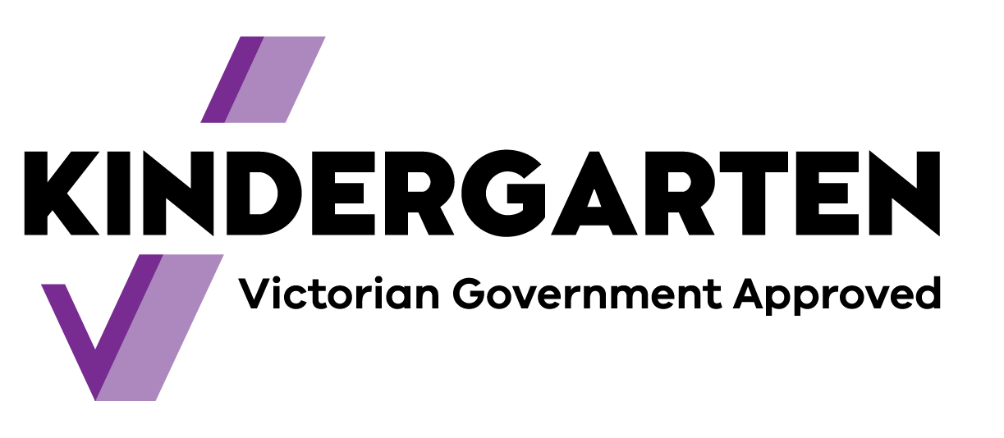
We use the Kinder Tick because we’re an approved provider of a Victorian Government funded kindergarten program. That means our service delivers a play-based learning program, led by a qualified early childhood teacher.
The Kinder Tick shows we meet criteria in the funding guidelines set out by the Victorian Government — which means you can have confidence that your child’s learning and development will be supported by qualified early childhood teachers and educators through a responsive, evidence-based learning program.
At our service, we offer Three-Year-Old Kindergarten as well as kindergarten programs in the year before school.
Research from across the globe shows that two years of quality kindergarten programs improves a child’s learning outcomes.
Children who attend two years of kindergarten also show higher levels of emotional intelligence and wellbeing into their school years and beyond.
By looking for the Kinder Tick, you can be certain your child will be taking part in a kinder program that will give them their best start in life.
To find out more, visit: vic.gov.au/kinder

Kinder Tick social media copy
The following sample posts have been provided for you to share on your social media channels (e.g. Facebook, Instagram or Twitter). This content can be adapted to suit your audience, provided the key information does not change.
If you would like to include a link to a website for your audience to find out more information, we suggest linking to vic.gov.au/kindertick
You can consider posting one of the Kinder Tick social tiles as images to accompany the text below.

Twitter

Sample post
Look for the #KinderTick at <insert service name>. We’re proud to offer a kinder program funded and approved by the Victorian Government.

Sample post
We’re proud to display #KinderTick because we’re a kinder you can count on. Talk to us about enrolling today or visit: <LINK>

Facebook

Sample post
Thinking about enrolling your child in a kindergarten program? Look for the #KinderTick. The Kinder Tick is used by early childhood education and care services across Victoria to show their kinder program is approved to receive Victorian Government funding.
When you see the Kinder Tick, you can be confident:
- the program will be led by a qualified early childhood teacher
- children will benefit from play-based learning
- the kindergarten program is funded and approved by the Victorian Government
- the program meets government guidelines and complies with the National Quality Framework.
By looking for the Kinder Tick, you can be sure your child is taking part in an evidence-informed, play-based learning program that meets government guidelines.
<service name> is proud to display the Kinder Tick.

Sample post
In a kindergarten program, children use play to build their language skills and learn about numbers and patterns. They also learn how to get along with others, share, listen, and manage their emotions. Early childhood teachers and educators help children become curious, creative and confident about learning.

Research shows the pre-school years are critical when it comes to supporting learning and development — and that the right support at these ages can help benefit children into their school years and beyond.
By looking for the Kinder Tick, you can be sure your child is taking part in an evidence-informed, play-based learning program that meets government guidelines.
<service name> is proud to display the Kinder Tick.

Sample post
Research shows two years of quality kindergarten gives children the best start in life. We offer Victorian Government funded and approved kindergarten programs, delivered by a qualified early childhood teacher.
Look for the #KinderTick at our service at <insert name>. Talk to us about enrolling today.

