Kindergarten Infrastructure and

Services Plan

City of Wyndham

**CONTENTS**

1. Introduction 3

1.1. Reform context 3

1.2. Purpose of KISPs 3

1.3. How to use the KISP 3

1.4. Structure of the KISP 3

1.5. Disclaimer 4

2. Map of Early Childhood Education services in City of Wyndham 5

3. Local context 8

3.1 Purpose 8

3.2 Key considerations 8

4. Funded kindergarten enrolment estimates between 2021-29 for City of Wyndham 24

4.1 Purpose 24

4.2 Methodology 24

4.3 Summary of current kindergarten provision 25

4.4 Approach to optimising the use of existing services and infrastructure 26

4.5 Agreed estimates of demand for funded kindergarten places that cannot be met through existing services and infrastructure 27

5. Authorisation 32

# Introduction

## Reform context

In an Australian first, the Victorian Government has committed to implement Three-Year-Old Kindergarten for all children over a 10-year roll-out with a total investment of almost $5 billion, including $1.68 billion to support the infrastructure expansion required for the reform. This reform will add another year of universal funded kindergarten so that, by 2029, all children in Victoria will have access to two years of play-based learning through a funded kindergarten program.

## Purpose of KISPs

Three-Year-Old Kindergarten will require a large expansion of kindergarten across the State. The Government has invited all 79 Victorian Local Governments to discuss and agree upon a Kindergarten Infrastructure and Services Plan (KISP) for their Local Government Area (LGA).

Each KISP has been jointly developed with Local Government and published to estimate the growth in demand for kindergarten within the LGA. The KISPs will help all kindergarten providers meet demand and provide a clear picture of infrastructure need across the State.

While a KISP is not a funding document and does not define required infrastructure projects or commit any party to funding specific projects, it is expected that future investment requests through Building Blocks and funding decisions about Local Government and not-for-profit projects would align with the relevant KISP.

## How to use the KISP

Each KISP contains estimates of future kindergarten supply of, and demand for, Three and Four-Year-Old Kindergarten places against existing enrolment capacity. Not-for-profit and for-profit providers can use these estimates to inform their plans to expand kindergarten programs, establish new services or invest in new or extended facilities.

For example, KISPs provide demand estimates in terms of where, when and how much demand for kindergarten places will grow in an LGA. KISPs also estimate where and how many kindergarten places providers can accommodate in existing facilities before an area needs new infrastructure to meet demand. The estimates can be used to inform decisions about where and when expansions of kindergarten program capacity and the construction of new or extended facilities are needed to meet demand growth.

Where there is an agreed KISP for the LGA, the Local Government and not-for-profit kindergarten providers seeking co-investments through the Building Blocks Capacity Building stream must refer to, and align their proposed project with, the infrastructure need identified in the KISP.

## Structure of the KISP

Each KISP consists of the following sections:

* **Section 1**: A short introduction to the Three-Year-Old Kindergarten reform and the KISP.
* **Section 2**: A map of existing and planned Early Childhood Education and Care service locations.
* **Section 3**: Local knowledge and context relevant to the expansion of kindergarten services.
* **Section 4**: Funded kindergarten demand estimates.

## Disclaimer

All data presented in this document are estimates only and are based on the best information available to the Department and Local Government at the time. They are published on an as-is basis and are for informational purposes only. They are subject to adjustment in response to market forces and as new data and other relevant information becomes available. The data may under- or over-estimate both total demand in a given location or year and the capacity for new demand to be met by providers. As a result, operational and business decisions should not be made solely based on this document. Any use of this data is solely at the risk of the user. The Department and Local Government accept no responsibility for any loss or damage, either direct or incidental, that may result from the use of the data.

# Map of Early Childhood Education services in City of Wyndham

The map below shows the distribution of currently operating and new services that are planned to open in the future in the LGA and across its communities.

This map has been prepared using Departmental data, from both the National Quality Agenda IT System (NQAITS) and the Victorian School Building Authority (VSBA). Where applicable, this map has been refined by the Wyndham City Council and the Department to capture other services that are planned to open in the future.

**Services that are planned to open in the next 12 months**

|  |  |  |  |
| --- | --- | --- | --- |
| **Service name** | **Project type** | **Suburb** | **Total licensed capacity** |
| Leading Leaps | New Early Learning Facility | Tarneit | 100 |
| Truganina South East Integrated Family Centre (interim name) | Integrated Children’s Centre | Truganina | 99 |
| Riverdale L2 Multi-Purpose Community Centre (interim name) | Integrated Children’s Centre | Tarneit | 99 |
| Tarneit North Integrated Family Centre (interim name) – operational as a kindergarten in 2023 | Integrated Children’s Centre | Tarneit | 99 |
| **Total licensed capacity** |  |  | 397 |

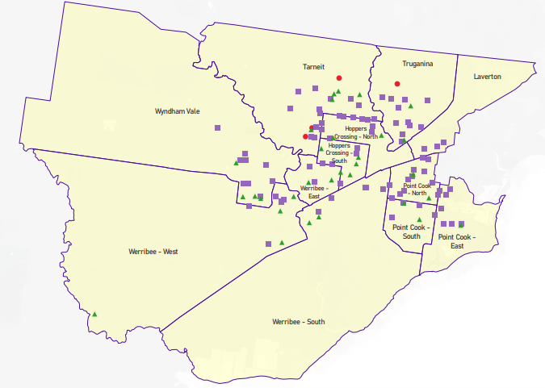



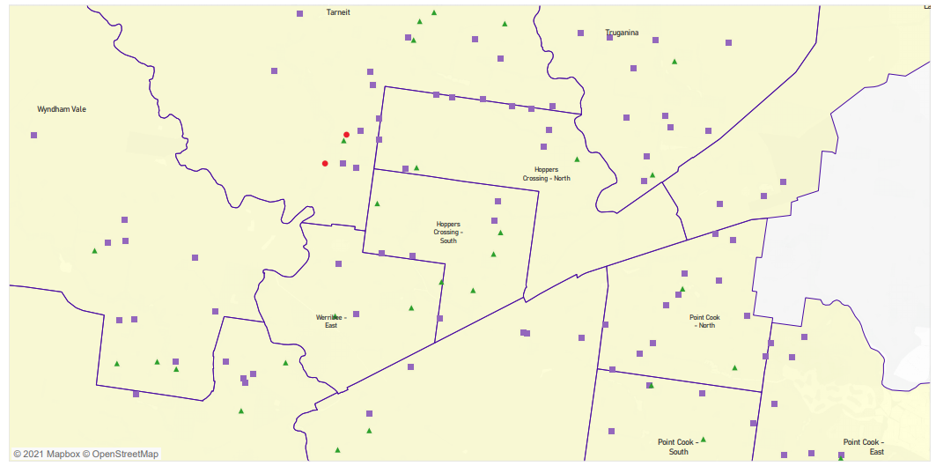



# Local context

d

## 3.1 Purpose

Local, place-based knowledge and context play an important role in supporting the implementation of Three-Year-Old Kindergarten across Victoria. This section of the KISP documents this knowledge and context as supplementary information to funded kindergarten enrolment estimates in Section 4.

## 3.2 Key considerations

Wyndham City Council (Council) identifies that there is a strong preference in the community to participate in sessional kindergarten programs. With the analysis of historical enrolment trends and the findings of market research conducted at the start of 2020, Council is predicting municipal-wide demand of four-year old sessional kindergarten to be between 60% to 65% of the four-year-old population. This demand rate varies by year and by local area.

The market research indicated demand for three-year-old sessional kindergarten is likely to be 10% lower than that for four-year-old kindergarten. Propensity to use kindergarten in long day care is predicted to be higher for this group. Demand for sessional three-year-old kindergarten is expected to be between 50% and 55% of Wyndham's three-year-old population, varying by year and local area.

The Department’s modelling of kindergarten demand is sector agnostic and treats kindergarten as a program not a place. This therefore includes the provision of kindergarten in long day care (LDC) settings as a contributor to the supply of kindergarten places. In some SA2s, such as those in Point Cook East, West and South the inclusion of LDC licenced places has the effect of minimising the demand that Council sees for sessional kindergarten places through its central enrolment program.

The commentary provided in the following sections of the Local Context highlight particular risk areas for sessional kindergarten shortages, as well as other factors Council feels may impact demand or supply of kindergarten across Wyndham.

*Covid19 – Note that the impacts of Covid19 on supply and demand for kindergarten services are not yet well understood and actual activity will be closely monitored and considered in future modelling by Council.*

**Key demographic trends that influence demand for kindergarten**

This section provides a high-level summary of localised factors and trends that influence kindergarten demand in Wyndham. In some cases, these factors and their impacts are further detailed by local area in the section ‘Council’s commentary by local area’.

**Population growth**

Wyndham is one of the largest and fastest growing municipalities in Australia, therefore population growth is the key driver of increasing demand for kindergarten in Wyndham. The population of Wyndham is forecast to grow by around 70% from approximately 302,000 today to 500,000 by 2041[1]. The population of three and four-year-old children across Wyndham is expected to grow from 12,200 in the year of roll-out to around 14,700, an increase of about 2,500 children or a 20% increase.

High birth and migration rates are the key drivers of population growth in Wyndham. In 2020, around 14 babies are born to Wyndham parents each day, equating to approximately 4.2 primary school classes each week[2]. Intrastate, interstate and overseas migration all contribute significantly to Wyndham’s growth, particularly in growth areas. While the extent of the impact on population growth caused by COVID19 is not yet well understood, short term increases in intrastate migration and reductions in overseas migration are indicated for growth areas[3].

**High proportion of young families and large households**

Wyndham, together with Casey and Hume, is home to the largest family household size in Greater Melbourne[4], and more than half of all households are families with children. Wyndham has a relatively young population makeup, with 58% of residents aged 35 years or below. Forecast .id takes Wyndham’s localised household composition into account when forecasting population growth, giving a strong base from which to estimate kindergarten service demand.

**Cultural diversity and newly arrived residents**

Almost half of all Wyndham residents were born overseas (47%) and over half speak a language other than English (53%).

Council’s central registration team has found that families who experience language barriers or are new to communities generally have a lower understanding of services available and are therefore less able to navigate access to the service system. This generally results in later enrolments.

Culturally appropriate and adapted communications and marketing, including communications via local networks and community leaders, will be essential to ensuring the full participation of families from across Wyndham’s diverse cultural and language groups.

**Relative disadvantage**

Levels of relative disadvantage vary dramatically by suburb across Wyndham, ranging from the 12th percentile in Werribee to 90th percentile in Williams Landing. A loose correlation is evident between relative disadvantage and propensity to access a sessional or LDC kindergarten service type. The higher the disadvantage, the higher rate of sessional service access, in general.

Table 2. SEIFA Index of Relative Socio-economic Disadvantage by suburb, 2016 (released 2018)

|  |  |  |
| --- | --- | --- |
| Suburb | Index of Relative Socio-economic Disadvantage | Percentile within Victoria |
| Hoppers Crossing | 977 | 23 |
| Point Cook | 1071 | 87 |
| Tarneit | 1021 | 50 |
| Truganina | 1022 | 51 |
| Williams Landing | 1075 | 90 |
| Werribee | 949 | 12 |
| Wyndham Vale (incl. Manor Lakes) | 988 | 28 |

**Council’s Commentary by Local Area**

This section provides a snapshot of the key trends in each local area that Council believes will impact demand and supply of kindergarten services. This is intended to provide additional context to the data included in Section 4, particularly where Council has identified a risk of waiting lists for sessional kindergarten due to family preferences.

Historical enrolment patterns and market research indicate that demand rates for sessional kindergarten versus kindergarten in LDC vary by local area and are likely to vary over time. There is also natural movement between some local areas, partly driven by supply, while residents of other areas demonstrate an unwillingness to venture outside their own suburb.

**Hoppers Crossing Area - Equivalent to combined SA2s Hoppers Crossing North and Hoppers Crossing South**

Council believes existing capacity in Hoppers Crossing should be adequate to maintain four-year-old supply and support the introduction of five hours of funded three-year-old kindergarten in sessional services, however expects waiting lists by 2029 when 15 hours is introduced.

It must be noted that the established suburb of Hoppers Crossing also primarily contains ageing brownfield sites. A fitness for purpose audit revealed that facilities may require enhancements or renovations in future years to ensure they are in a condition to continue to provide kindergarten services to the community. Mossfiel Kindergarten has been flagged as an initial site for potential upcoming redevelopment.

Hoppers Crossing has a stable local population and is located in the centre of Wyndham. These factors have enabled Hoppers Crossing kindergartens to play an important role in accommodating overflow demand from neighbouring growth areas until new services come online in those areas.

In 2019, the number of children enrolled in a Council-run sessional kindergarten was greater than the four-year-old population of that area (104%). Of the 540 children placed in one of Council’s Hoppers Crossing kindergartens, 38% originated from other suburbs, with the most common being Tarneit (108 children), Truganina (45 children) and Werribee (28 children).

A phone survey of LDC providers conducted by Council in 2019 indicated the number of children enrolled in a funded kindergarten place in a Hoppers Crossing LDC service in 2019 was equivalent to approximately 34% of the four-year-old population. It is likely that some of these children were from other suburbs.

With the introduction of three-year-old kindergarten, Hoppers Crossing services will continue to play a role in accommodating excess demand from surrounding growth areas until new facilities come online in those areas. Excess capacity in Hoppers Crossing may also enable services to offer more than 5 hours of service for three-year-old kindergarten ahead of 2029.

Higher rates of demand from neighbouring areas has been accounted for in Council’s prediction that demand for sessional kindergarten will exceed supply in Hoppers Crossing once 15 hours is introduced.

**Point Cook – Equivalent to combined SA2s Point Cook East, Point Cook North and Point Cook South**

Combined KISP estimates for Point Cook SA2s do not acknowledge any unmet demand for Point Cook until year 2027, which shows modest levels of unmet demand in Point Cook South. This is predominantly due to a large LDC sector within the Point Cook area which provides a significant number of potential kindergarten places within the supply forecasts.

From the Council’s perspective, Point Cook is a priority area for new sessional infrastructure as shortfalls are expected from the year of roll-out, and no new sessional infrastructure is planned for the area. The likely shortfall in sessional capacity increases annually to 2029 as existing services are no longer able to serve as many children as before – a pattern common across Wyndham areas.

In addition to new sessional infrastructure requirements, Council has flagged its existing Jamieson Way Kindergarten as a potential site for redevelopment. This site could accommodate an additional room/s to increase sessional capacity in Point Cook.

Shortfalls in sessional supply are caused by the extremely limited capacity available in existing high-demand sessional facilities. In 2022, it is expected that only 25% of the three-year-old Point Cook population can be served within sessional programs, compared with anticipated demand from 55% of the population.

An increase in room requirements from 2029 is caused by the increase in service hours from 5 to 15 hours per week for three-year-old groups. By 2029, there may only be capacity in sessional facilities to serve 13% of the three-year-old population.

Surplus capacity within the LDC sector combined with limited sessional service supply may influence a proportion of families to use LDC kindergarten services even if they would prefer a sessional format. Significant sessional waitlists are predicted in any case.

The Point Cook area is unique in that local families are reluctant to travel outside of Point Cook for kindergarten services. An assessment of travel barriers supports the argument that travel in and out of Point Cook by public transport and car can be difficult, particularly during peak times. Of the Point Cook residents enrolled in one of Council’s sessional kindergartens in 2019, 97% attended a kindergarten located in their home suburb. Around 80 children living in another suburb accessed a Point Cook sessional kindergarten, with the highest number coming from Williams Landing. The number of children enrolled in a funded kindergarten place in a Point Cook LDC was equivalent to approximately 33% of the four-year-old population.

Historical sessional enrolment patterns show that families at some Point Cook kindergartens will not accept unfavourable timetable options, and groups have been closed despite waiting lists at other times. Achieving maximum facility utilisation will rely on successful uptake of three-year-old groups at these times.

**Tarneit - Equivalent to Tarneit SA2**

Strong population growth in greenfield areas of Tarneit is expected to drive increasing demand in the area. The 2029 increase to 15-hour programs for three-year-olds sharply increases unmet demand from that year onward. Given the significant shortfalls expected across the whole market from year 2029, staggering the delivery of infrastructure in earlier years is optimal from Council’s perspective to maintain realistic construction and capital investment schedules.

New sessional infrastructure coming online around the time of roll-out combined with crisis timetabling are expected to generate a small amount of surplus sessional capacity in the first few years of roll-out. Surplus sessional capacity in 2023 and 2024 may absorb unmet demand expected in neighbouring Truganina and Williams Landing areas as historical travel behaviour indicates some permeability between these areas, as well as enable increased service hours for three-year-old groups.

Of the children placed in a Tarneit sessional kindergarten in 2019, 18% originated from another suburb, with the majority coming from nearby Truganina, followed by Hoppers Crossing. Of the Tarneit residents attending sessional kindergarten, 26% accessed a kindergarten in another suburb, primarily Hoppers Crossing and Werribee respectively.

At 33% of the four-year-old population, Tarneit’s LDC usage rate appeared like that of Point Cook. However, this may have been due to a shortage of sessional places and/or the effects of Truganina and Williams Landing families also accessing these services.

**Truganina and Williams Landing - Equivalent to combined SA2s Truganina and Laverton residual**

Truganina and Williams Landing are adjacent suburbs which are planned for in combination due to a high propensity for families to access services across the border. Williams Landing is a relatively small, built-out suburb with no sessional kindergarten infrastructure of its own. Truganina is a rapidly expanding growth area and includes one sessional kindergarten facility on the border of Williams Landing.

Sessional shortfalls are expected in this area relatively soon following reform roll-out, largely due to limited existing supply and fast-growing population. The forecast demand rate in this area is the lowest of all areas of Wyndham, as a large proportion of local families travel to neighbouring areas for kindergarten. This is believed to be, at least in part, due to limited local service supply. This area also has a higher propensity for LDC services compared with other Wyndham areas.

Truganina kindergartens had a high proportion of local families attending in 2019, with only 6% coming from other suburbs. However, this area also sees the highest number of children accessing kindergarten elsewhere (32%) due to a lack of availability – there are currently only two Council-owned kindergartens in Truganina, with a third to open in 2022. Tarneit, Hoppers Crossing and Point Cook kindergartens are the most common for those attending outside of the Truganina and Williams Landing local area.

Planning by Council generally looks at Tarneit and Truganina’s requirements together due to the propensity for Truganina and Williams Landing families to attend kindergartens in Tarneit.

The number of children enrolled in a Truganina/Williams Landing kindergarten in 2019 equalled around 16% of the four-year-old population. This figure is expected to increase over time as new services open, as is the proportion of children accessing sessional kindergarten in this area.

**Werribee - Equivalent to combined SA2s Werribee East, Werribee South and most of Werribee West**

The suburb of Werribee and some Werribee SA2 geographies are unique in that they include a mix of growth and established areas across broad geographic areas.

Whilst the KISP predicts shortfalls in all SA2s – Werribee East, Werribee South and Werribee West – Council predicts that unmet sessional demand will be most heavily felt in Werribee West. Council’s data analysis suggests adequate capacity for sessional kindergarten in Werribee East. It also shows enough capacity to service Werribee South in the short-term, but there are potential shortfalls in future years. Some of this may be absorbed by proposed infrastructure in the Riverwalk – Werribee Junction small geographic area. Council’s knowledge of the LDC sector across the three SA2s is limited. It is possible that the LDC sector may face capacity shortages in Werribee East and Werribee South.

Werribee East aligns to the Glen Devon, Riverdene and Heathdale small geographic areas Council uses for planning. The four-year-old and three-year-old id.Forecast population projections for these established areas are relatively stable, and if anything, may decline very slightly each year from now on. Enrolments at the two Council-run kindergartens in this SA2 have been decreasing over time, whilst externally operated Quantin Binnah Kindergarten has maintained a high level of demand, some of which originates from neighbouring Tarneit.

The introduction of some mixed three and four-year-old groups from 2022 at each of the three kindergartens should maximise utilisation and provide an adequate split of three and four-year old sessional places in Werribee East. However, the success of this model will rely on families accepting available timetable options and potentially moving from one service to another between the first and second year of funded kindergarten.

The Werribee South SA2 includes the Werribee Central, Werribee South and Werribee Employment Area small geographic areas.

Werribee Central includes two Council-run sessional kindergartens with adequate sessional capacity – Dr Charles Prouse Kindergarten (single unit) and College Road Kindergarten (triple unit). The three and four-year-old populations of the Werribee Central area are expected to grow by around 30 and 40 children respectively between 2022 and 2030, which should be accommodated within existing capacity, particularly at the currently under-utilised College Road.

The Werribee South small geographic area does not contain a sessional kindergarten. This area is only expected to experience marginal growth over the next 10 years (less than one kindergarten group). In 2019, the home address of families versus the enrolled kindergarten were analysed. It was found that 11 children out of a predicted four-year-old population of 28 in that year (39% of the population) attended one of Council’s sessional kindergartens. Of those, almost half attended a Point Cook kindergarten, which further strengthens Council’s position that additional sessional capacity is required in that area. The others were primarily scattered amongst various Werribee kindergartens. Council does not have access to data regarding long day care usage for these residents.

Forecast.id data suggests there will be only 20 three and four-year-old children (combined) in the Werribee Employment Area in 2022. Planning for this precinct is currently on hold, but if development goes ahead the population will increase dramatically to around 775 three and four-year olds (combined) by 2040. Short-term demand for sessional kindergarten can be accommodated by neighbouring Werribee and Hoppers Crossing kindergartens. In 2019, 9 children attended Woodville Park Kindergarten, 2 attended Wyndham Park Kindergarten and 1 attended College Road. However, additional facilities will be required in the future. Population figures and demand trends for this area should be monitored closely to ensure facilities are delivered at an appropriate time.

Council considers Werribee West to be the highest priority in regard to predicted supply shortages in the suburb of Werribee. It feels early delivery of sessional kindergarten services should be considered consistent with localised residential development and population growth on the western side of Werribee in greenfield PSP areas.

It is the council’s view that there will likely be a scenario of localised unmet demand in growth areas which are relatively isolated from established area services with travel times exacerbated by barriers such as rail and waterways, and where new services are not provided in sync with growth. Research shows that families prefer not to travel more than 10 to 15 minutes to access kindergarten, although in reality they may be willing to travel a bit further.

Council predicts that without new infrastructure to support demand for sessional kindergarten in Werribee’s growth areas, waiting lists for limited existing services may result while established area services within the same geography may experience vacancies. It is also likely that families in western Werribee will find accessing neighbouring area services in Wyndham Vale more convenient which may exacerbate pressure on services in those areas already experiencing high demand.

Services in established areas of Werribee accommodate many children from other areas, similarly to Hoppers Crossing. In 2019, 27% of children enrolled in a sessional kindergarten were from other suburbs, and 20% of the Werribee families accessing a sessional program attended elsewhere.

The number of children enrolled in a funded kindergarten place in a Werribee LDC was equivalent to approximately 22% of Werribee’s four-year-old population.

**Wyndham Vale and Manor Lakes – Equivalent to Wyndham Vale SA2**

Significant shortfalls in supply are expected for the Wyndham Vale and Manor Lakes area from year of roll-out across both three and four-year-old programs. This large geographic area includes growth and established areas similarly to Werribee, however established area services are already relatively near capacity with four-year-old enrolments. As at 6 May 2021, there were 28 four-year-olds on the waiting list for a place at a sessional kindergarten in Wyndham Vale or Manor Lakes.

Predicted shortfalls are due to a combination of limited sessional supply available after serving four-year-old demand, and population growth. Council believes significant new infrastructure is required to meet sessional demand in growth areas.

In 2019, Wyndham Vale and Manor Lakes sessional kindergartens did not have adequate capacity to accommodate demand from local families. 26% of the Wyndham Vale/Manor Lakes children accessing sessional kindergarten in 2019 accessed a service outside of their home suburb, most commonly in Werribee.

Equivalent to 30% of the four-year-old population attended kindergarten in LDC in this area.

**Little River and Rural West - Equivalent SA2 part of Werribee West**

The Little River and Rural West combined area includes the small rural township of Little River, the large rural area bordering the Eynesbury area in Melton and the western side of Wyndham Vale, Manor Lakes and Werribee. The population is likely to increase modestly across this area over time and increased kindergarten demand will likely be absorbed by a range of service areas.

Little River has one sessional kindergarten and no LDC services. The kindergarten primarily accommodates residents. A handful of children from other suburbs may attend this kindergarten each year.

**Community Preferences Likely to Influence Behaviour**

Council conducted market research with young families at the beginning of 2020 to help predict future usage patterns of three-year-old and four-year-old funded kindergarten. The research findings, demonstrating statistically significant results[5], were used in conjunction with past enrolment trends to form assumptions about likely behaviour of Wyndham families, and how that may vary by local area.

**Families’ preferences for low travel time and location convenience**

Convenience of location is indicated by families as an essential factor in selecting where to enrol. Seeking care outside of the local area is only an option if it is still convenient to other activities, such as school and work[6], and it doesn’t require too much time in the car.

Focus group participants indicated a maximum threshold of 10 to 15 minutes for travel to kindergarten. However, Council acknowledges this threshold may be slightly higher for some families, particularly if faced with limited supply options.

Figure 9. Travel time threshold[7]

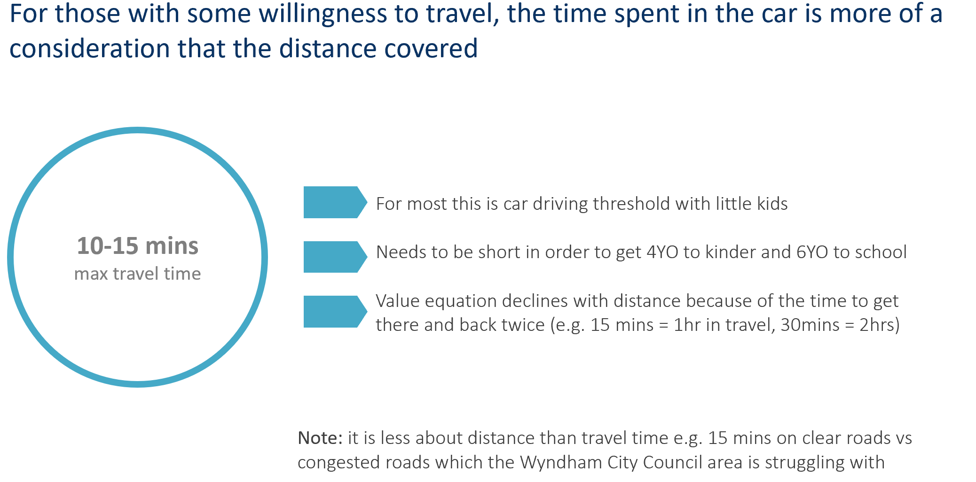

**High participation rate from roll-out year indicated by strong interest from families**

A high level of reported and demonstrated interest in three-year-old kindergarten has been received from Wyndham families by Council. Market research conducted in early 2020 with statistically significant results[8] showed that 93% of respondents who will have a child aged 3 beyond year 2020 reported wanting a three-year-old kindergarten service (58% sessional + 35% integrated LDC = 93%), see Figure 1. *Demand for Three-Year-Old Kindergarten by Sector* below.

Figure 1. Demand for Three-Year-Old Kindergarten by Sector[9]

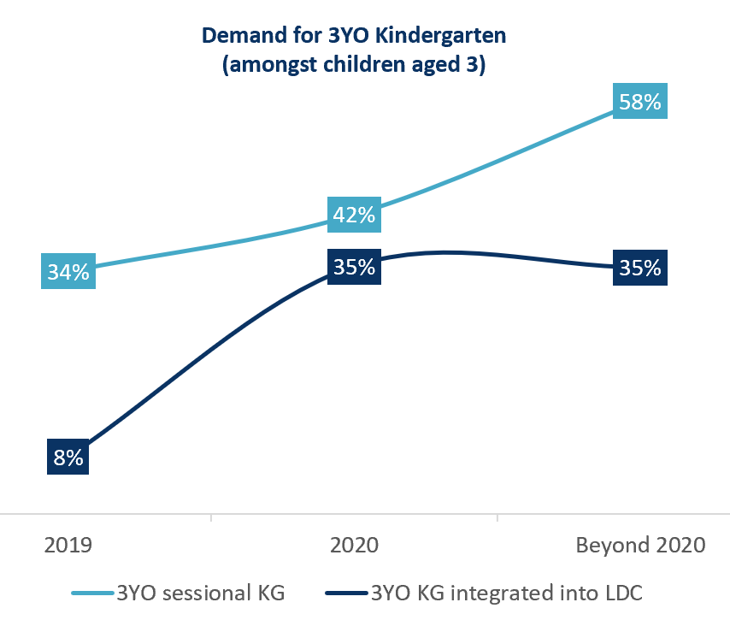

In 2021 Council increased the three-year-old kindergarten service offering which lead to significantly high uptake and increases to waiting lists. This response further supports the predication of a strong overall participation rate in three-year-old kindergarten from the year of roll-out. At 8th April 2021, 776 three-year-old kindergarten places across Wyndham had been filled with 0 vacancies and 462 children on waiting lists.

**Families’ awareness and perceptions of program types**

In Wyndham, sessional kindergarten is the preferred model for three-year-old kindergarten. With 5 hours of funding provided, 58% of Wyndham families indicate a preference for a sessional three-year-old kindergarten program, increasing to 63% when 15 hours are introduced (see Figure 1. *Demand for Three-Year-Old Kindergarten by Sector* above and Figure 2. Preferred type of kindergarten given access to 5-hours and 15 hours). An integrated LDC model is also a popular choice for three-year-old kindergarten, with a higher propensity for three-year-olds to attend this program format compared with four-year-olds (compare with Figure 2. Demand for Four-Year-Old Kindergarten by Sector below).

Figure 2. Preferred type of kindergarten given access to 5-hours and 15 hours[10]

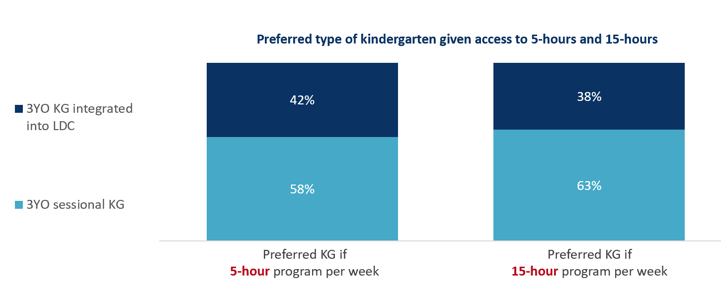

Figure 3. Demand for Four-Year-Old Kindergarten by Sector[11]

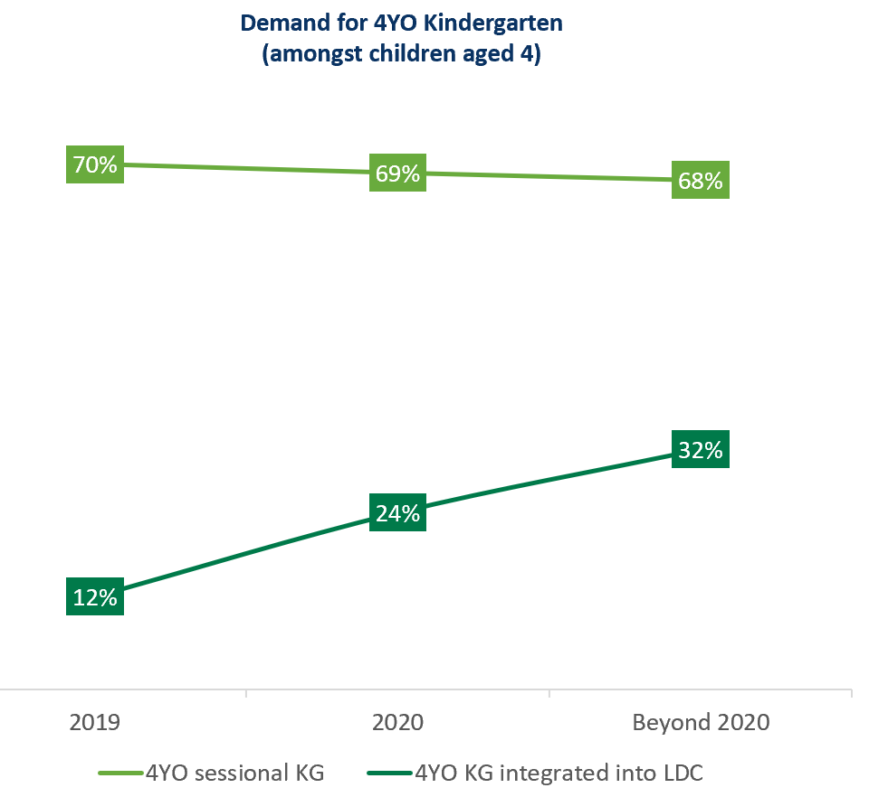

The research showed that sessional kindergarten is better understood than kindergarten integrated into LDC, and that families with a better understanding are more likely to select this service type. This highlights an opportunity to promote the benefits of kindergarten in LDC to increase usage of this sector and better utilise existing capacity. It may take time to influence a demonstrable shift in perceptions and behaviour.

**Families’ who prefer kindergarten integrated into LDC appear to need the hours to cover work commitments.**

Families that favour kindergarten integrated into LDC have higher requirements for hours per day of kindergarten. This indicates that a preference for the LDC model is linked with a need for the longer service hours offered by that model, likely due to other commitments of the family, such as work.

There is also a correlation between the rate of preference for LDC as a service type, and rates of existing LDC usage for the three-year-old age group. This indicates that the rate of families who are likely to choose a LDC model for three-year-old kindergarten, is likely similar to that of existing three-year-old day care enrolments.

Figure 7. Number of hours per day of service wanted by model of service and funding level[12]

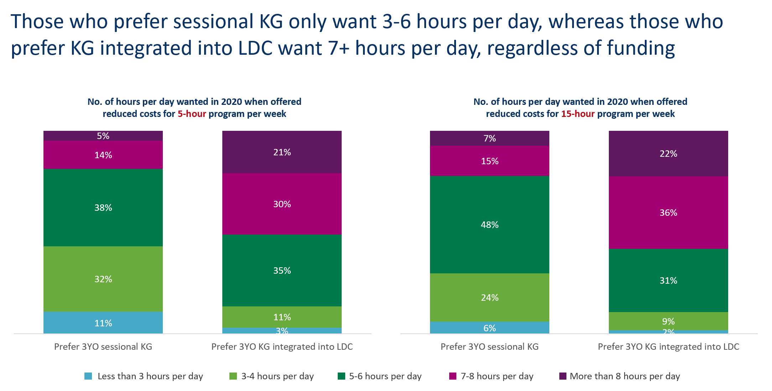

Figure 8. Number of days per week preferred by model of service and funding level[13]

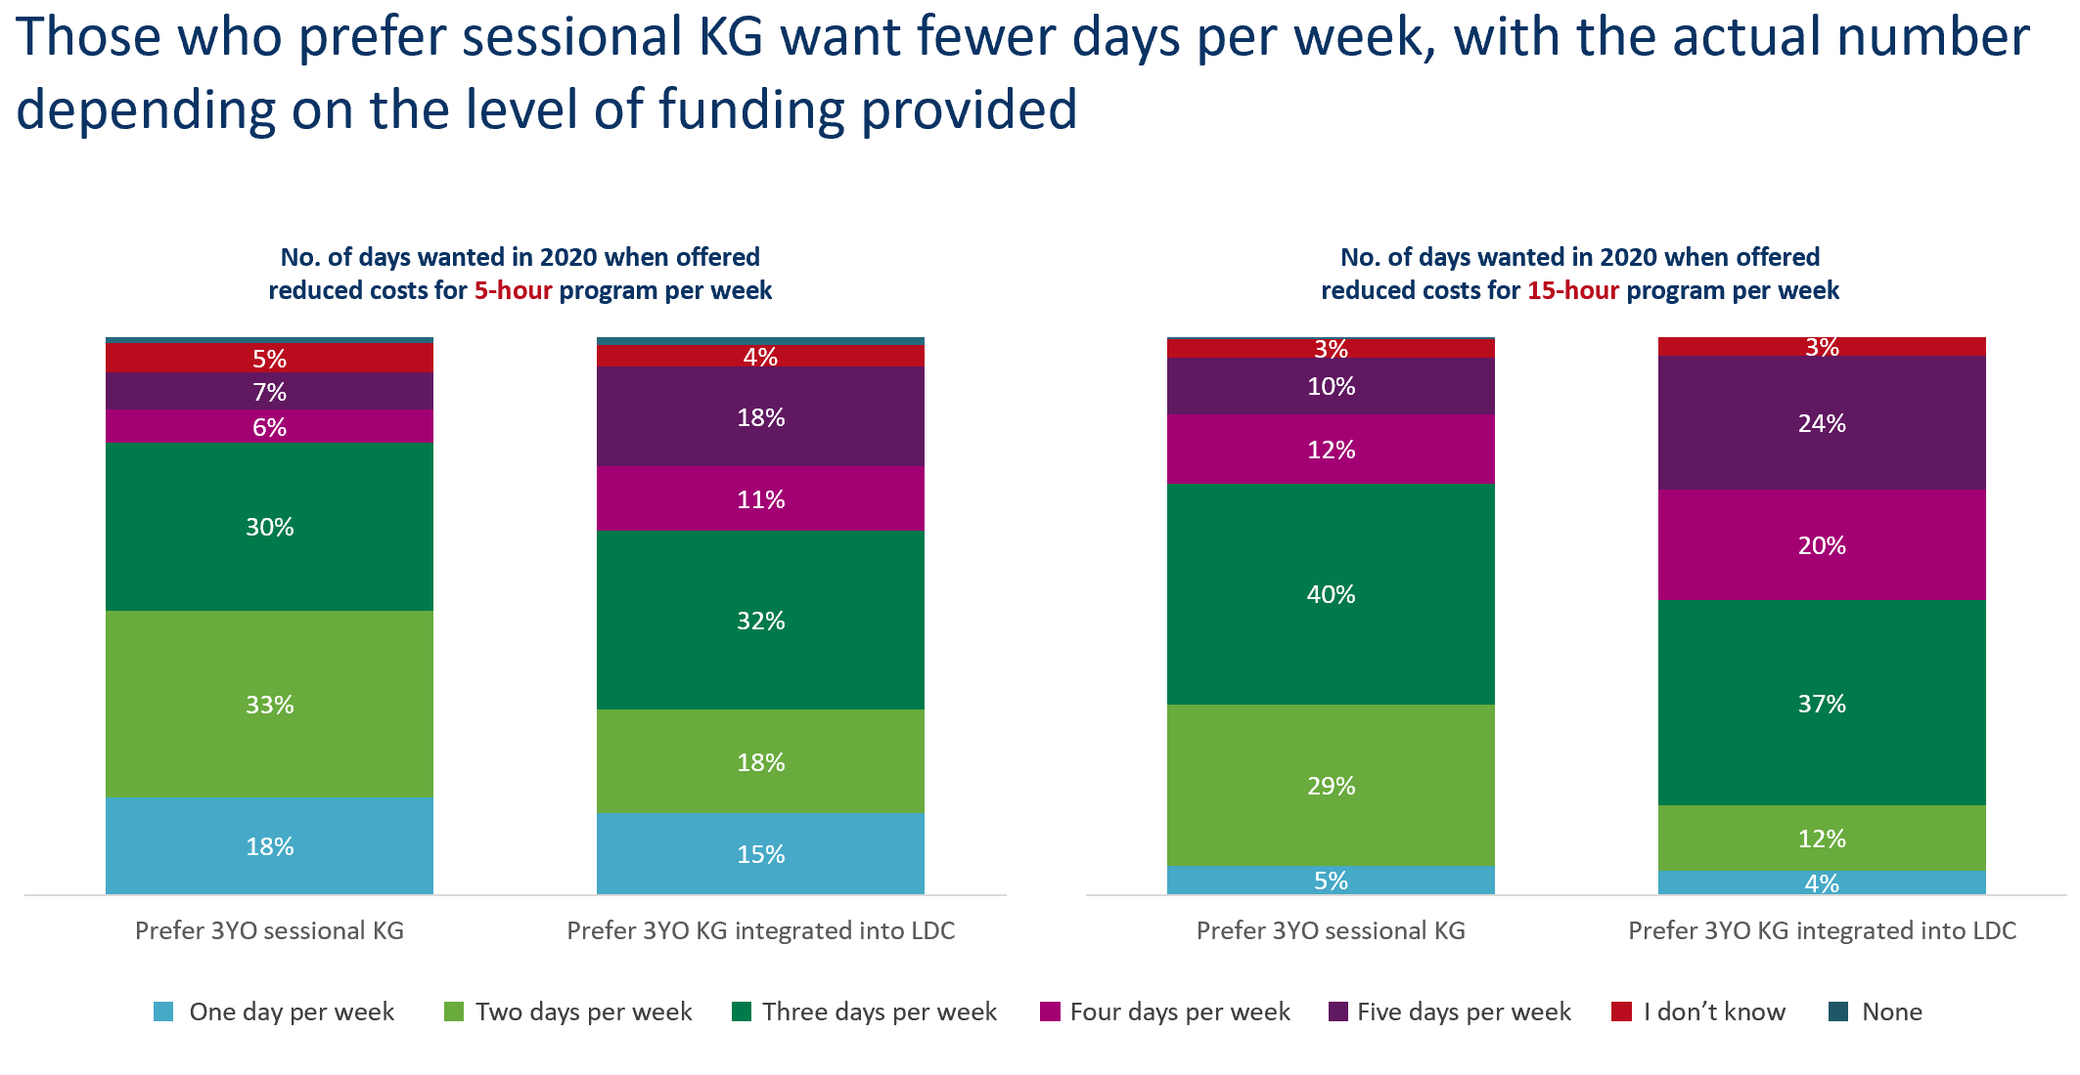

**Families’ preference for avoiding out-of-pocket costs**

Families’ preference is to avoid out-of-pocket costs and many report that cost is a barrier to accessing early education and care services (see Figure 10. Attitudes about the cost of early education and care services). Financial stress caused by the cost of early education and care services is reportedly higher for those using day care only or kindergarten integrated into LDC, than those using sessional kindergarten (see Figure 11. Relationship between out-of-pocket costs for day care and/or kindergarten, and attitudes towards stress).

Figure 10. Attitudes about the cost of early education and care services[14]

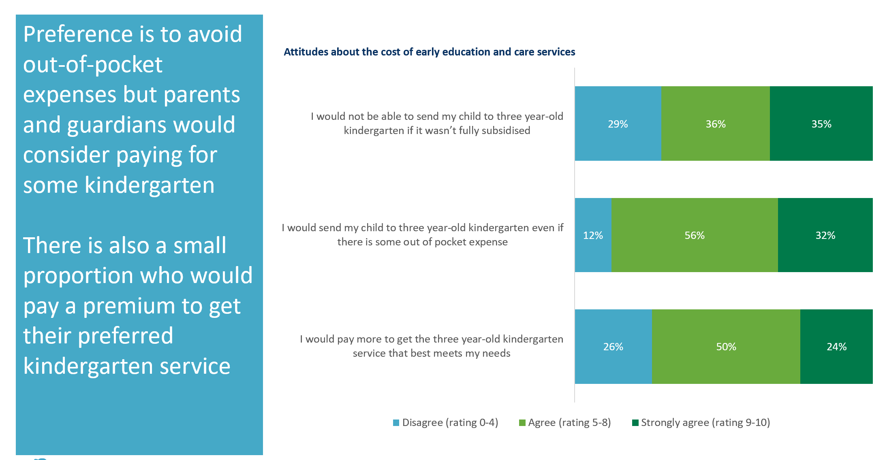

Figure 11. Relationship between out-of-pocket costs for day care and/or kindergarten, and attitudes towards stress[15]

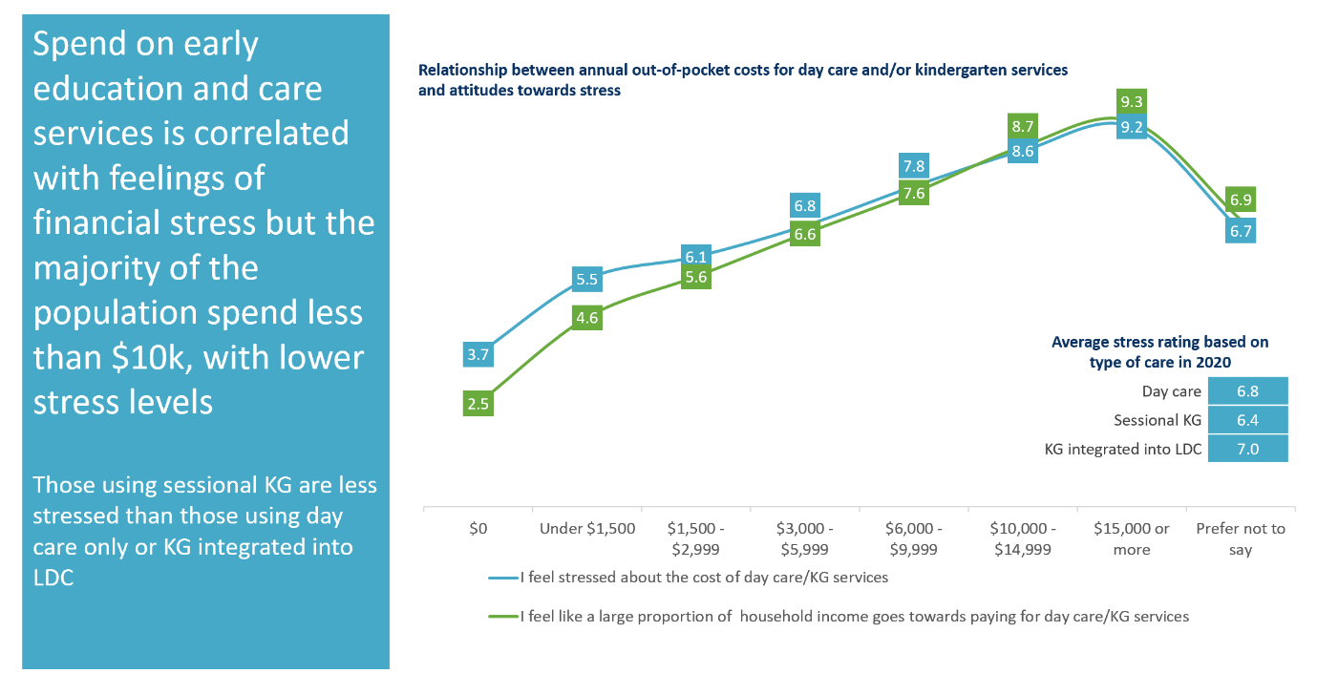

**Factors That May Influence Supply of Early Childhood Education and Care**

This section provides a high-level summary of localised factors and trends that may influence kindergarten supply in Wyndham. In some cases, these factors and their impacts were further detailed by local area in the section *‘Council’s commentary by local area’ (above).*

**Families’ preference for sessional or LDC service formats are moderately inflexible**

Whilst there is excess capacity within the LDC sector that could in theory cover the demand for three-year-old and four-year-old kindergarten, market research findings and historical usage patterns (outlined in previous sections) strongly indicate that a significant proportion of families will likely continue to demand a sessional format. This indicates that excess LDC capacity may be inaccessible without significant sector and community change management activities.

Findings also indicate that there is potential to increase market share within the LDC sector through marketing approaches over time. Fundamental differences between the different models of service, such as hours of service and affordability, will impact family choices.

**Private service providers highly willing to provide integrated, but not sessional, three-year-old kindergarten**

Roughly 91% of Wyndham LDC providers indicated that they intend to offer at least 5 hours of funded three-year-old kindergarten by 2022[16].

It is assumed that many private LDC providers have spare infrastructure capacity to offer additional kindergarten places for children. This is in addition to the equivalent three-year-old day care and four-year-old integrated kindergarten enrolments they already provide. However, it is likely that spare kindergarten capacity would be diminished if an integrated model, requiring additional day care hours, be provided for each kindergarten enrolment. Also, family preferences for a sessional model may limit the market opportunities for an expanded kindergarten service to a sessional model offering.

Council and DET have begun engagement with private providers to support their transition to the reformed service environment. In April 2021, private providers did not indicate an intention or interest in delivering sessional services. There is opportunity for Council and DET to support the private sector to offer increased sessional service options to cater to families’ preferences. Ongoing support for LDC providers during the reform implementation, including encouraging providers to understand and meet the service needs of the local market, is planned to be delivered in collaboration between Wyndham and DET.

**Facility capital works pipeline now insufficient to meet increased kindergarten requirements generated by reforms**

Council is required to deliver eighteen new early years facilities in growth areas, as per Precinct Structure Plan (PSP) guidelines, and developer contributions are tied to the delivery of these sites. As new residential communities develop, on-time delivery of early years services is considered essential and are key to activating and establishing new communities.

This pipeline of works was planned as a requirement to meet the demand for four-year-old kindergarten services alone. Demand forecasts show that unless significant market shifts occur, additional infrastructure (on top of the eighteen facilities) will be required to meet sessional service demand for both three and four-year-olds in the long term.

While some established areas of Wyndham, mainly Point Cook, are forecast to experience increased sessional kindergarten service demand, there are limited opportunities for Council to deliver new infrastructure to meet this demand.

Additionally, double-unit kindergartens are anticipated to be integrated into all new school sites where another kindergarten is not already planned adjacent, as per the Victorian Government’s policy to reduce “Ditch the double drop off [to school and kindergarten]”.

Historically, the private LDC sector has responded to population growth by establishing new sites and services in growth areas as they develop. This trend is expected to continue.

**Other Information About the Expansion of Early Childhood Services**

The increase to 15 hours of three-year-old kindergarten in 2029 marks a significant increase in infrastructure requirements across Wyndham at that point in time. Council would like to reiterate the importance of evenly distributing kindergarten infrastructure spending over time, with consideration of a range of influencing factors such as residential development patterns and land availability. This approach would also allow services to increase the number of hours offered, where possible, prior to the 2029 deadline.

As already mentioned, established areas of Wyndham contain ageing brownfield sites. A fitness for purpose audit revealed that some Council facilities may require enhancements or renovations in future years to ensure they are in a condition to continue to provide kindergarten services to the community. Capital investment may be required not only for new infrastructure projects, but also at existing sites to maintain adequate sessional kindergarten capacity.

# Funded kindergarten enrolment estimates between 2021-29 for City of Wyndham

## 4.1 Purpose

As Three-Year-Old Kindergarten is rolled-out and Victoria’s population grows, demand for both Three and Four-Year-Old Kindergarten places will increase significantly. While additional capacity will be needed to meet this demand, this will vary across the State and over time, due to differences in the capacity of existing services, growth trends and sector composition.

To identify where, when and how many additional kindergarten places are expected over the roll-out in the City of Wyndham, the Wyndham City Council and the Department have developed:

1. A summary of the current provision of kindergarten within the LGA (**Section 4.3**).
2. An approach to optimising the utilisation of existing services and infrastructure through ‘change management’ strategies that the Wyndham City Council and the Department will support to help meet additional demand in the LGA (**Section 4.4**).
3. An estimate of the Three and Four-Year-Old kindergarten places that cannot be met through existing services for the 2021-29 period, taking into account the additional demand that can be accommodated by optimising utilisation of existing services and infrastructure through point 2, above (**Section 4.5**).

Local Government and providers can use these published estimates to inform reform implementation activities such as service planning, kindergarten program expansion, infrastructure investments and Building Blocks funding applications in alignment with future demand over the 10-year roll-out.

## 4.2 Methodology

The estimated Three and Four-Year-Old Kindergarten places used in the following sections have been agreed between the Wyndham City Council and the Department, and were informed by:

* Estimates developed by the Department which draw on a range of inputs, including population forecasts, current enrolments and results from the Kindergarten Capacity Assessment Program (KCAP), conducted in 2019.
* The estimated capacity of new services that are planned to open in the LGA (Section 2)
* Local knowledge and context provided by the Local Government (Section 3) that explains particular issues and trends in their area.
* The approach to optimising utilisation of existing services in the LGA (Section 4.4), and
* Other sources, such as modelling undertaken by Local Governments and local data.

The KISP measures a service’s capacity to deliver funded kindergarten in terms of the number of children it could enrol in Three and Four-Year-Old Kindergarten. The number of funded kindergarten places is different from a service’s licensed or approved places, which count the number of children permitted to attend the service at any one time under the license. Many services can enrol more children in their funded kindergarten program(s) than they have licensed places for because they can run more than one kindergarten program per week. Kindergarten places are therefore a more accurate measure of service kindergarten capacity than licensed places.

Three-Year-Old Kindergarten places have been presented as 15-hour places so they can be easily compared to Four-Year-Old Kindergarten places. Moreover, when Three-Year-Old Kindergarten is fully rolled-out in 2029, every three-year-old child will have access to 15-hours of kindergarten.

From 2023 all providers will have flexibility to determine how many hours of funded Three-Year-Old Kindergarten they deliver per week, with a minimum of five hours and a maximum of 15-hours funded pro-rata. It is expected that hours offered will vary. Given this variation, **it is important to be aware that during the transition to all three-year-old children receiving 15-hours of funded kindergarten per week in 2029,** **the 15‑hour places presented in this report may represent multiple three-year-old places that individually receive less than 15-hours of kindergarten per week.**

These estimates have been developed at an LGA and community level to show the overall forecast and variation within an area. The KISP defines community at the Statistical Area Level 2, which is medium-sized areas which represent a community that interacts socially and economically, with a population range of 3,000 to 25,000 people, and an average population of about 10,000 people.

## 4.3 Summary of current kindergarten provision

The figures below provide a summary of current kindergarten provision within the LGA and provide relevant context for the estimates of demand for funded kindergarten places included in Section 4.5. The data included in this section are largely drawn from:

* The Kindergarten Capacity Assessment Program (KCAP), collected between June and October 2019.
* The Department’s Kindergarten Information Management System (KIMS), as at 2019.
* The Department’s Quality and Regulatory Division (QARD) monitoring data, as at 2019.
* The National Quality Agenda IT System (NQAITS), as at Mar 2021.
* The Victorian Child and Adolescent Monitoring System (VCAMS), as at 2018.

Please note that, because these sources were collected at different points, this may result in slightly different totals appearing in the below data.

|  |  |
| --- | --- |
| Number of services by service type (NQAITs, 2021) | |
| Stand-alone kindergartens | 31 |
| Long day care centres | 86 |

|  |  |
| --- | --- |
| Percentage of services by management type, LGA level (NQAITs, 2021) | |
| ***Type*** | ***Percentage*** |
| Local Government | 21% |
| Private not for profit | 23% |
| Private for profit | 56% |
| Other | 1% |

|  |  |
| --- | --- |
| Current kindergarten offering | |
| Four-Year-Old Kindergarten participation rate (VCAMS, 2018): | 91% |
| Number of services that offer a funded kindergarten program (DET, 2019): | 91 |
| Number of services that offer an unfunded Three-Year-Old Kindergarten program (DET, 2019): | 11 |

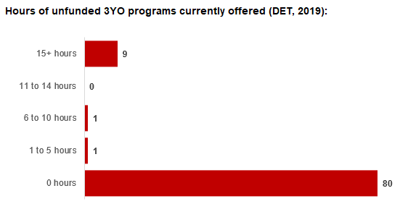

## 4.4 Approach to optimising the use of existing services and infrastructure

**Change management strategies to optimise existing** **services and infrastructure**

Children can often be accommodated through existing spare places and by services ‘unlocking’ unused capacity. As the experience of providers in the 2020 Three-Year-Old Kindergarten roll-out LGAs shows, while the optimisation of existing services can be challenging, it is highly time- and cost-effective compared to building new capacity through infrastructure projects. It also helps target infrastructure investment to the places that need it most and avoids over-supplying the local market.

The Wyndham City Council and the Department will support providers and services to maximise their kindergarten places through the following change management activities and practices:

* Increasing the capacity of any Local Government operated services by:
  + Running additional programs.
  + Using different timetables, including running 7.5-hour days.
  + Changing the delivery model, such as introducing rotational models or mixed-age groups.
  + Having degree-qualified kindergarten teachers leading integrated kindergarten programs in long day care settings.
* Encouraging and supporting other providers and services in the LGA to undertake change management.

The Wyndham City Council and the Department have estimated how many Three and Four-Year-Old Kindergarten places can be accommodated through existing services in the LGA (**Table 1**). Both parties are committed to helping providers and services offer these kindergarten places before progressing to funded infrastructure solutions to meet demand. This commitment is reflected in the LGA and community level estimates below (**Table 2** onwards), which assume that demand will be met first through existing services and second through additional infrastructure. Note that in some cases the number of kindergarten places that can be offered through existing services may exceed demand for kindergarten places.

**Table 1: Total estimated funded kindergarten places that can be offered by optimising existing services and infrastructure across the LGA, between 2021-29 (presented in 15-hour equivalent places)**

|  |  |  |  |  |  |  |  |  |  |
| --- | --- | --- | --- | --- | --- | --- | --- | --- | --- |
|  | **2021** | **2022** | **2023** | **2024** | **2025** | **2026** | **2027** | **2028** | **2029** |
| Estimated existing supply of kindergarten places* | 9,317 | 9,565 | 9,565 | 9,565 | 9,565 | 9,565 | 9,565 | 9,565 | 9,565 |

*\**This may be higher than current three and four-year-old enrolments as it includes any spare places that are currently available or could be generated by making some minor adjustments to programming approaches.

## 4.5 Agreed estimates of demand for funded kindergarten places that cannot be met through existing services and infrastructure

The below estimates (**Table 2** onwards) have been developed by the Wyndham City Council and the Department to illustrate the estimated:

1. Total number of Three and Four-Year-Old Kindergarten places expected over the roll-out period.
2. Three and Four-Year-Old Kindergarten places that cannot be accommodated by optimising existing services and infrastructure over the roll-out period.

These estimates have been developed to reflect that the increase in demand for Three-Year-Old Kindergarten places will be gradual.

In estimating how many Three and Four-Year-Old Kindergarten places cannot be accommodated by existing services and infrastructure, the Wyndham City Council and the Department have taken into account any new places that will be made available through planned expansions of existing services or new services, into estimates of existing supply, where this information is available. This may include Local Government owned services being developed and planned Kindergartens on School Sites.

These estimates do not, however, estimate how and when the broader sector will expand to meet the additional demand for kindergarten places that are estimated over the roll-out period.

Infrastructure need in the LGA and its local communities is indicated by the bottom rows of the tables in this section (**Table 2** onwards): ‘Total kindergarten places that cannot be accommodated by existing services’. For example, if the number of kindergarten places for the LGA or a community is above zero in this row, it means that the area is estimated to need additional infrastructure (noting that further optimisation which avoids the need for additional infrastructure may be possible). Any type of provider – Local Government, not-for-profit or for-profit – can build this additional infrastructure. If this row shows all zeros, it means that there is no estimated need for additional infrastructure in the area.

Local Government and not-for-profit kindergarten providers must refer to the estimates in this section and consider Section 3: Local Context when applying through the Building Blocks Capacity Building Grants stream for Government funding. Under this stream, projects must be in a community where there is infrastructure need either shown in the community’s table of estimated demand for kindergarten places (i.e. there are numbers in the bottom row above zero) or demonstrated through a consideration of the local context. Projects in LGAs or communities where demand can be met through existing services (i.e. the bottom row shows all zeros) are not eligible for funding under this stream.

**LGA estimates**

**Table 2: Total estimated three and four-year-old kindergarten places between 2021-29 (presented in 15-hour equivalent places)**

|  |  |  |  |  |  |  |  |  |  |
| --- | --- | --- | --- | --- | --- | --- | --- | --- | --- |
| **LGA level estimates** | **2021** | **2022** | **2023** | **2024** | **2025** | **2026** | **2027** | **2028** | **2029** |
| Total estimated demand for kindergarten places (three and four-year-old children) | 5,151 | 6,712 | 7,777 | 8,620 | 9,378 | 10,585 | 11,320 | 12,077 | 13,030 |
| Total kindergarten places that cannot be accommodated by existing services | 0 | 3 | 40 | 149 | 630 | 1,740 | 2,364 | 3,015 | 3,826 |

**Community estimates**

**Table 3-14: Total estimated three and four-year-old kindergarten places between 2021-29 (presented in 15-hour equivalent places)**

|  |  |  |  |  |  |  |  |  |  |
| --- | --- | --- | --- | --- | --- | --- | --- | --- | --- |
| **Hoppers Crossing - North estimates** | **2021** | **2022** | **2023** | **2024** | **2025** | **2026** | **2027** | **2028** | **2029** |
| Estimated three and four-year-old kindergarten places demanded | 384 | 445 | 491 | 541 | 580 | 567 | 587 | 607 | 634 |
| Total kindergarten places that cannot be accommodated by existing services | 0 | 0 | 0 | 0 | 0 | 0 | 0 | 0 | 0 |

|  |  |  |  |  |  |  |  |  |  |
| --- | --- | --- | --- | --- | --- | --- | --- | --- | --- |
| **Hoppers Crossing - South estimates** | **2021** | **2022** | **2023** | **2024** | **2025** | **2026** | **2027** | **2028** | **2029** |
| Estimated three and four-year-old kindergarten places demanded | 378 | 446 | 491 | 535 | 566 | 579 | 599 | 620 | 649 |
| Total kindergarten places that cannot be accommodated by existing services | 0 | 0 | 0 | 0 | 0 | 0 | 0 | 0 | 0 |

|  |  |  |  |  |  |  |  |  |  |
| --- | --- | --- | --- | --- | --- | --- | --- | --- | --- |
| **Laverton *Residual estimates** | **2021** | **2022** | **2023** | **2024** | **2025** | **2026** | **2027** | **2028** | **2029** |
| Estimated three and four-year-old kindergarten places demanded | 29 | 69 | 95 | 124 | 143 | 149 | 159 | 170 | 184 |
| Total kindergarten places that cannot be accommodated by existing services | 0 | 0 | 0 | 0 | 0 | 0 | 0 | 0 | 0 |

|  |  |  |  |  |  |  |  |  |  |
| --- | --- | --- | --- | --- | --- | --- | --- | --- | --- |
| **Point Cook - East estimates** | **2021** | **2022** | **2023** | **2024** | **2025** | **2026** | **2027** | **2028** | **2029** |
| Estimated three and four-year-old kindergarten places demanded | 245 | 335 | 396 | 450 | 487 | 510 | 531 | 550 | 578 |
| Total kindergarten places that cannot be accommodated by existing services | 0 | 0 | 0 | 0 | 0 | 0 | 0 | 0 | 0 |

|  |  |  |  |  |  |  |  |  |  |
| --- | --- | --- | --- | --- | --- | --- | --- | --- | --- |
| **Point Cook North estimates** | **2021** | **2022** | **2023** | **2024** | **2025** | **2026** | **2027** | **2028** | **2029** |
| Estimated three and four-year-old kindergarten places demanded | 573 | 688 | 763 | 837 | 890 | 899 | 933 | 967 | 1013 |
| Total kindergarten places that cannot be accommodated by existing services | 0 | 0 | 0 | 0 | 0 | 0 | 0 | 0 | 0 |

|  |  |  |  |  |  |  |  |  |  |
| --- | --- | --- | --- | --- | --- | --- | --- | --- | --- |
| **Point Cook South estimates** | **2021** | **2022** | **2023** | **2024** | **2025** | **2026** | **2027** | **2028** | **2029** |
| Estimated three and four-year-old kindergarten places demanded | 516 | 613 | 673 | 726 | 765 | 826 | 864 | 903 | 958 |
| Total kindergarten places that cannot be accommodated by existing services | 0 | 0 | 0 | 0 | 0 | 0 | 33 | 72 | 127 |

|  |  |  |  |  |  |  |  |  |  |
| --- | --- | --- | --- | --- | --- | --- | --- | --- | --- |
| **Tarneit estimates** | **2021** | **2022** | **2023** | **2024** | **2025** | **2026** | **2027** | **2028** | **2029** |
| Estimated three and four-year-old kindergarten places demanded | 1,008 | 1,376 | 1,638 | 1,846 | 2,001 | 2,352 | 2,561 | 2,781 | 3,053 |
| Total kindergarten places that cannot be accommodated by existing services | 0 | 0 | 0 | 0 | 141 | 491 | 700 | 921 | 1,193 |

|  |  |  |  |  |  |  |  |  |  |
| --- | --- | --- | --- | --- | --- | --- | --- | --- | --- |
| **Truganina estimates** | **2021** | **2022** | **2023** | **2024** | **2025** | **2026** | **2027** | **2028** | **2029** |
| Estimated three and four-year-old kindergarten places demanded | 682 | 938 | 1,086 | 1,162 | 1,215 | 1,388 | 1,443 | 1,496 | 1,569 |
| Total kindergarten places that cannot be accommodated by existing services | 0 | 0 | 0 | 0 | 53 | 227 | 281 | 335 | 407 |

|  |  |  |  |  |  |  |  |  |  |
| --- | --- | --- | --- | --- | --- | --- | --- | --- | --- |
| **Werribee - East estimates** | **2021** | **2022** | **2023** | **2024** | **2025** | **2026** | **2027** | **2028** | **2029** |
| Estimated three and four-year-old kindergarten places demanded | 339 | 399 | 419 | 432 | 478 | 568 | 593 | 618 | 653 |
| Total kindergarten places that cannot be accommodated by existing services | 0 | 3 | 23 | 36 | 82 | 173 | 198 | 223 | 257 |

|  |  |  |  |  |  |  |  |  |  |
| --- | --- | --- | --- | --- | --- | --- | --- | --- | --- |
| **Werribee - South estimates** | **2021** | **2022** | **2023** | **2024** | **2025** | **2026** | **2027** | **2028** | **2029** |
| Estimated three and four-year-old kindergarten places demanded | 209 | 279 | 339 | 387 | 423 | 488 | 532 | 586 | 651 |
| Total kindergarten places that cannot be accommodated by existing services | 0 | 0 | 0 | 0 | 0 | 65 | 110 | 163 | 229 |

|  |  |  |  |  |  |  |  |  |  |
| --- | --- | --- | --- | --- | --- | --- | --- | --- | --- |
| **Werribee - West estimates** | **2021** | **2022** | **2023** | **2024** | **2025** | **2026** | **2027** | **2028** | **2029** |
| Estimated three and four-year-old kindergarten places demanded | 264 | 392 | 505 | 605 | 681 | 836 | 928 | 1,023 | 1,140 |
| Total kindergarten places that cannot be accommodated by existing services | 0 | 0 | 0 | 0 | 71 | 225 | 318 | 413 | 529 |

|  |  |  |  |  |  |  |  |  |  |
| --- | --- | --- | --- | --- | --- | --- | --- | --- | --- |
| **Wyndham Vale estimates** | **2021** | **2022** | **2023** | **2024** | **2025** | **2026** | **2027** | **2028** | **2029** |
| Estimated three and four-year-old kindergarten places demanded | 525 | 732 | 881 | 977 | 1,148 | 1,423 | 1,589 | 1,754 | 1,949 |
| Total kindergarten places that cannot be accommodated by existing services | 0 | 0 | 17 | 112 | 283 | 559 | 724 | 889 | 1,084 |

# Authorisation

The Area Executive Director (Western Melbourne) of the Department of Education and Training and the Chief Executive of Wyndham City Council endorse this Kindergarten Services and Infrastructure Plan for City of Wyndham by signing on 08/06/2021.

This KISP is not intended to create legal relations or constitute a legally binding contractual agreement between the parties. The parties may review this KISP in 2023 to publish a new version that will replace the previous version.

An out-of-cycle review may be triggered if both parties agree that there has been a change in relevant data, information or the local early childhood sector that significantly affects the reliability of a KISP’s estimates for planning purposes.

**Signed for and on behalf and with the authority of Wyndham City Council**

Signature Witness Signature

Name: Natalie Walker

Title: Acting Chief Executive Officer  
  
Address: 45 Princes Highway, Werribee, Victoria 3030

**Signed by Area Executive Director (Western Melbourne), Department of Education and Training**

Signature Witness Signature

Name: John Dainutis

Title: Area Executive Director (Western Melbourne)

Address: 900/1 McNab Avenue, Footscray, Victoria 3011

1. .id Forecast
2. The ABS indicates that 4,986 babies were born to Wyndham mothers in 2020 https://www.abs.gov.au/statistics/people/population/regional-population/2019-20. The average Victorian primary class size is 22.4 students according to DET’s Summary Statistics of Victorian Schools available via http://www.education.vic.gov.au/about/ department/Pages/factsandfigures.aspx
3. https://forecast.id.com.au/wyndham/forecast-covid19-impact
4. Based on the ABS Census 2016: Casey: 3.1; Cardinia: 2.8; Hume: 3.1; Melton: 3; Whittlesea: 3; Wyndham:3.1; Greater Melbourne: 2.6
5. Quantitative research: A combination of intercept and online surveys generated a total of 513 responses, a very robust sample size providing statistical precision of +/-4.38%. Good representation across local areas and type of early education and care exposure was achieved, and data weighting was applied correct population represented in results. Qualitative research: 4 4 x 60-minute focus groups including participants from across local areas and early education and care experience levels.
6. Base. Have child aged 0 to 3 and would consider day care or kindergarten in 2020 n=371

   Source. D1 To what extent do you agree or disagree with the following statements about the location of 3 year-old kindergarten services? I would use kindergarten outside my local area if …
7. Source. Qualitative research
8. Quantitative research: A combination of intercept and online surveys generated a total of 513 responses, a very robust sample size providing statistical precision of +/-4.38%. Good representation across local areas and type of early education and care exposure was achieved, and data weighting was applied correct population represented in results. Qualitative research: 4 X 60 minute focus groups including participants from across local areas and early education and care experience levels.
9. Source: Market research survey findings 2020. Base. Had a child aged 3 in 2019 (n=181); Have a child aged 3 in 2020 (n=138); Will have a child aged 3 in 2021 (n=114)

   Source. S5 In 2019, did any of your children attend day care or kindergarten? S6 This year (2020), are your child/ren enrolled or do you plan to enter any of your children into day care or kindergarten? S7 Do you plan to send your child/ren to day care or kindergarten in future years (beyond 2020)?

   Note. ‘No care” indicates anyone who isn’t using, doesn’t want or doesn’t know if they want any early education and/or care services. Percentages across each type of care do not sum to 100% as more than one type of care can be used.
10. Base. Have child aged 0 to 3 and would consider day care or kindergarten in 2020 n=371

    Source. C5 If you had access to a 5-hour program per week, how would you prefer to access 3 year-old kindergarten? C5a If 5 hours of sessional 3 year-old kindergarten was available at a dedicated kindergarten facility, which of the following best describes how you would like to see that 5 hours delivered? C6 If you had access to a 15-hour program per week, how would you prefer to access 3 year-old kindergarten? C6a If 15 hours of sessional 3 year-old kindergarten was available at a dedicated kindergarten facility, which of the following best describes how you would like to see that 15 hours delivered?
11. Source: Market research survey findings 2020. Base. Had a child aged 4 in 2019 (n=99); Have a child aged 4 in 2020 (n=181); Will have a child aged 4 in 2021 (n=138) Source. S5 In 2019, did any of your children attend day care or kindergarten? S6 This year (2020), are your child/ren enrolled or do you plan to enter any of your children into day care or kindergarten? S7 Do you plan to send your child/ren to day care or kindergarten in future years (beyond 2020)? Percentages across each type of care do not sum to 100% as more than one type of care can be used.
12. Base. Have child aged 0 to 3 and would consider day care or kindergarten in 2020 n=371

    Source. C2a In 2020, how many hours per day of day care and/or 3 year-old kindergarten do you want for your children? C2b If the out-of-pocket cost was reduced for 5 hours of 3 year-old kindergarten per week through government funding, how many hours per day of day care and/or 3 year-old kindergarten would you want for your children? C2c If the out-of-pocket cost was reduced for 15 hours of 3 year-old kindergarten per week through government funding, how many hours per day of day care and/or 3 year-old kindergarten would you want for your children?
13. Base. Have child aged 0 to 3 n=397

    Source. C1a In 2020, how many days of day care and/or 3 year-old kindergarten do you want for your children? C1b If the out-of-pocket cost was reduced for 5 hours of 3 year-old kindergarten per week through government funding, how many days per week of day care and/or 3 year-old kindergarten would you want for your children? C1c If the out-of-pocket cost was reduced for 15 hours of 3 year-old kindergarten per week through government funding, how many days per week of day care and/or 3 year-old kindergarten would you want for your children?
14. Base. Have child aged 0 to 3 and would consider day care or kindergarten in 2020 n=371

    Source. D3 To what extent do you agree with the following statements about the cost of early education and care services?
15. Base. Source. Z4 Do you know how much you spend each year on day care and/or kindergarten services out of pocket? Z5 To what extent do you agree with the following statements?
16. KCAP survey by DET