Kindergarten Infrastructure and
Services Plan
City of Whitehorse
CONTENTS

1. Introduction 3
1.1. Reform context 3
1.2. Purpose of KISPs 3
1.3. How to use the KISP 3
1.4. Structure of the KISP 4
1.5. Disclaimer 4
2. Map of Early Childhood Education services in City of Whitehorse 5
3. WHITEHORSE Local context 6
3.1 Purpose 6
3.2 Council acknowledgements 6
3.3 Key considerations 7
3.3.1 Assumptions used in modelling future unmet demand…………………………………7 3.3.2 ASR Research Report……………………………………………………………………..9
3.3.3 Whitehorse Population……………………………………………………………………..9
3.3.4 Whitehorse Population Forecast………………………………………………………...10
3.3.5 Whitehorse Early Years Forecast……………………………………………………….11
3.3.6 Whitehorse Family Type and Housing………………………………………………….11
3.3.7 Migration into and out of Whitehorse……………………………………………………12
3.3.8 Vulnerability in one or more domains…………………………………………………...13
3.3.9 Education…………………………………………………………………………………..13
3.4 KISP & ASR Research Estimates for Unmet Demand for Kindergarten Places………….13
3.4.1 Additional of the ASR Research Report………………………………………………..14
3.5 References……………………………………………………………………………………….14
4. Funded kindergarten enrolment estimates between 2021-29 for City of Whitehorse 15
4.1 Purpose 15
4.2 Methodology 15
4.3 Summary of current kindergarten provision 16
4.4 Approach to optimising the use of existing services and infrastructure 17
4.5 Agreed estimates of demand for funded kindergarten places that cannot be met through existing services and infrastructure 18
5. Authorisation 23

Introduction

Reform context
In an Australian first, the Victorian Government has committed to implement Three-Year-Old Kindergarten for all children over a 10-year roll-out with a total investment of almost $5 billion, including $1.68 billion to support the infrastructure expansion required for the reform. This reform will add another year of universal funded kindergarten so that, by 2029, all children in Victoria will have access to two years of play-based learning through a funded kindergarten program.

Purpose of KISPs
Three-Year-Old Kindergarten will require a large expansion of kindergarten across the State. The Government has invited all 79 Victorian Local Governments to have input into the Kindergarten Infrastructure and Services Plan (KISP) for their Local Government Area (LGA).
Each KISP has to estimate the growth in demand for kindergarten within the LGA. The KISPs will help all kindergarten providers meet demand and provide a clear picture of infrastructure need across the State.
While a KISP is not a funding document and does not define required infrastructure projects or commit any party to funding specific projects, it is expected that future investment requests through Building Blocks and funding decisions about Local Government and not-for-profit projects should reference or align where possible with the relevant KISP.

How to use the KISP
Each KISP contains estimates of future kindergarten supply of, and demand for, Three and Four-Year-Old Kindergarten places against existing enrolment capacity. Not-for-profit and for-profit providers can use these estimates to inform their plans to expand kindergarten programs, establish new services or invest in new or extended facilities.
For example, KISPs provide demand estimates in terms of where, when and how much demand for kindergarten places will grow in an LGA. KISPs also estimate where and how many kindergarten places providers can accommodate in existing facilities before an area needs new infrastructure to meet demand. The estimates can be used to inform decisions about where and when expansions of kindergarten program capacity and the construction of new or extended facilities are needed to meet demand growth.
Note As actual demographics and other demand factors as well as those factors driving supply may deviate from current projections, it will be necessary for the KISP to be reviewed and if necessary amended on an annual basis. In this way, the KISP will always be based on the most current and reliable data. In June 2021 Whitehorse Council commissioned a project to develop a comprehensive kindergarten infrastructure strategy for the municipality which updates a similar strategy developed in 2011. The 2021 strategy will be incorporated into the Whitehorse KISP on the first 12 month review.
Where there is an agreed KISP for the LGA, the Local Government and not-for-profit kindergarten providers seeking investments or when agreed to co-investments through the Building Blocks Capacity Building stream must refer to, and align their proposed project with, the infrastructure need identified in the KISP.

Structure of the KISP
Each KISP consists of the following sections:
- Section 1: A short introduction to the Three-Year-Old Kindergarten reform and the KISP.
- Section 2: A map of existing and planned Early Childhood Education and Care service locations.
- Section 3: Local knowledge and context relevant to the expansion of kindergarten services.
- Section 4: Funded kindergarten demand estimates.

Disclaimer
All data presented in this document are estimates only and are based on the best information available to the Department and Local Government at the time. They are published on an as-is basis and are for informational purposes only. They are subject to adjustment in response to market forces and as new data and other relevant information becomes available. The data may under- or over-estimate both total demand in a given location or year and the capacity for new demand to be met by providers. As a result, operational and business decisions should not be made solely based on this document. Any use of this data is solely at the risk of the user. The Department and Local Government accept no responsibility for any loss or damage, either direct or incidental, that may result from the use of the data.

Map of Early Childhood Education services in City of Whitehorse
The map below shows the distribution of currently operating and new services that are planned to open in the future in the LGA and across its communities.
This map has been prepared using Departmental data, from both the National Quality Agenda IT System (NQAITS) and the Victorian School Building Authority (VSBA). Where applicable, this map has been refined by the Whitehorse City Council and the Department to capture other services that are planned to open in the future.
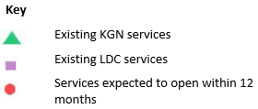
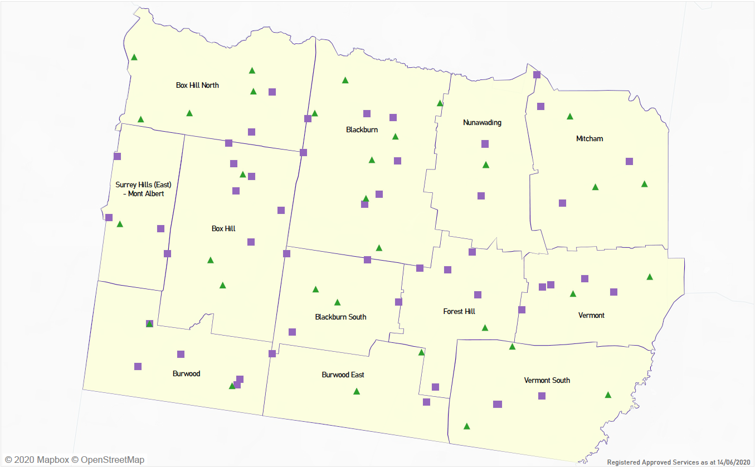

WHITEHORSE Local context
d

3.1 Purpose
Local, place-based knowledge and context play an important role in supporting the implementation of Three-Year-Old Kindergarten across Victoria. This section of the KISP documents this knowledge and context and has informed the funded kindergarten enrolment estimates in Section 4.

3.3 Key considerations
3.3.1 Assumptions used in modelling future unmet demand for kindergarten places

The assessment of the sufficiency of the current supply of kindergarten places in Whitehorse to meet future demand for funded 3 year old and 4 year old places (over the next 10 years) is a relatively complex project. Such an assessment relies on an analysis of current and historic data and the overlay of a set of assumptions to develop a model of what the future supply and demand of kindergarten places will look like. The following points outlines some of these complex issues:

- Population Projections and the impact of COVID. The population projections used in this report are from the Victorian Government’s Victoria in Future population projections (VIF 2019).
The projections for the change in the number of the 0-5 year old cohort for the past 5 years has generally not reflected the local experience. The projections assumed a relatively stable number of children in that cohort which will slowly rise by approximately 18% over a 15 year period to 2031. However local birth notification data is showing an actual decline of a 17% decline in the total number of births recorded since 2016 and with no clear future change in the trend yet evident.
Secondly, it is too early to assess whether the current pandemic will further suppress annual births recorded as well as the number of children migrating into and out of the municipality each year. Overseas students contribute to the number of children born into the municipality each year and it is not clear if the pandemic will have an impact on the number of overseas students settling in the municipality each year. If this turns out to be the case then the demand factor in the projections provided may be overstated.
- Family preference (agency) in selecting their preferred type of funded kindergarten service for their child/ren. The two key types of funded kindergarten services are sessional or traditional kindergarten services and secondly integrated kindergarten in long day care centres.

At present, the majority of enrolments in four-year-old kindergarten are at sessional based kindergarten services rather than long day care services, at a ratio of 62:38. While no studies have been undertaken to ascertain the basis for the higher levels of enrolment through sessional kindergarten places, anecdotal evidence suggests this may be due to parental preferences, with a number of factors likely to be at play:
- Higher cost of attending integrated child care centre places.
- Perception of quality differences in education provided.
- Local convenience.
- Governance structure of services (parent managed sessional kindergartens as opposed to corporate based management structures)
- Stronger associations between sessional kindergarten centres and preferred primary schools.
- Stronger community feel of sessional kindergartens

While the ratio is very slowly moving to a more equitable distribution of enrolments between the two service types, the growth in the provision of kindergarten places lies almost entirely with integrated kindergarten services. The KISP estimates have been developed using a ‘sector agnostic’ approach, with an assumption that existing capacity in both sessional and long-day-care settings can be utilised to address new kindergarten demand. This does not factor in existing preferences within the municipality for sessional kindergarten services. Should existing preferences remain, and long-day-care capacity is not utilised to the extent that has been modelled, it is possible that unmet demand may be higher than estimated. It is hoped that over time as KISP’s are reviewed that more sophisticated modelling considering preference in model assumptions can be applied in the future.
- Operational Service Models. At this stage it remains difficult to precisely determine how kindergarten services will stage their progression from an initial 5 hours of 3 year old kindergarten service in 2022 to 15 hours in 2029. The KISP estimates are based on a relatively smooth transition over the period. However, financial sustainability factors may influence the transition (i.e. bring forward or push back depending on the circumstances).

- Maximising licensed place availability into operational service models. The KISP estimates are based on broad assumptions about service efficiency (i.e. how many children can be accommodated within each service). There are two key impediments that may impact a kindergarten service offering their theoretical maximum number of kindergarten places to the community. The first impediment relates to financial sustainability. A kindergarten service will generally structure its service modelling on its confidence that it will be able to attract sufficient children to fill x number of groups and secondly, that it can attract the appropriate number of qualified staff to educate and manage each group.

- Kindergarten services often have an ideological view on what it defines as quality pedagogy. Those views may limit the number of children that the kindergarten service will support (i.e. qualitative factors overriding quantitative factors). If the number of kindergarten places actually offered by services is less than those estimated in the KISP, this would have the result of reducing estimated supply, and potentially increasing unmet demand.

- Kindergartens on School Sites: There are currently 5 kindergartens that have been co-located on school sites within Whitehorse that are managed by the respective school councils. The state government has advised Council that there is currently no strategic plan available to assess whether any of the remaining 43 primary schools are capable to accommodate a kindergarten service in the future if the opportunity arose.

- Council infrastructure: There are now 21 sessional kindergartens located on council controlled land. (A further six are located on church owned and controlled land and the remaining 5 operate on DET owned land). The majority of the stock of sessional kindergarten facilities are located on small house blocks and were built in the 1960s through to the mid 1970s. The majority of these facilities were constructed using cheap building materials and following simple single room design. These buildings are now approaching an average 50 years of age and will reach a point where they require rebuilding to modern standards and conveniences.

- Private Infrastructure: As mentioned above, there has been significant investment in the construction of new larger long day care centres in the municipality in the past 4 years. During that time total long day care places have increased from approximately 2,550 to 4,350 (approx 70% increase). The total 3yo and 4yo places funded (integrated) kindergarten places in the 49 child care centres is 2,200 based on effective full time use. However about 75% of all places are part time use and that expands the number of funded kinder places that can provided in the future. A further 8 integrated kindergarten facilities are expected to commence operations in 2022. While planning applications exist for additional long day care centres in the future, it is too early to ascertain what impact the current impact will have on service demand. Hence it is too early to predict whether supply for this sector will continue to grow, stabilise or contract.

3.3.2 ASR Research Report

In 2021, Whitehorse Council commissioned ASR Research to undertake an independent review of the impact of the government’s kindergarten reforms on the capacity of the existing kindergarten facilities across the municipality.

The report was completed in early 2022. The findings which generally align with this KISP are detailed later in this section.

3.3.3 Whitehorse Population

As of June 2019, Whitehorse had an estimated resident population of 178,739. The City of Whitehorse has a lower proportion of pre-schoolers and higher proportion of people at post retirement age than Greater Melbourne.

The City of Whitehorse is located 12 to 22km East of Melbourne CBD. The major features of the city include the large technology precinct in the Tally Ho area, the Melbourne campus of Deakin University, Box Hill Institute and Box Hill Hospital. The three major activity centres are Box Hill, Forest Hill Chase and the Nunawading mega mile. Whitehorse also has several smaller neighbourhood shopping centres scattered around the municipality.

The areas attract a range of ages to the municipality, and although local government boundaries are often irrelevant to young people, they are hubs for recreational and educational activity for the city.

Key findings:
- Whitehorse has a lower proportion of pre-schoolers and a higher proportion of people at post retirement age than greater Melbourne.
- Box Hill TAFE and Deakin University invite a high proportion of 18–24 year olds into the municipality, in particular for Box Hill and Burwood.
- There is a large proportion of international students in the municipality, and it is likely they are from predominantly Asian backgrounds.
- Most children aged 0–4 (making up 5.4% of the population, at 8,822 people) are found in Mitcham, followed by Nunawading and Blackburn North.
- Most children aged 5–11 (which make up 8.0% of the population, at 12,958) are found in Vermont, closely followed by Blackburn North and Mont Albert North.
- Those aged 12–17 (which make up 7.0% of the population, at 11,285) are mostly found in Blackburn North, Vermont and Mont Albert.
- Whitehorse’s indigenous population is 358 (0.2% of the population). 0–4 year olds make up 8.7%, 5–14 years make up 18.2% and 15–24 make up 19.8% of that indigenous population group.

3.3.4 Whitehorse Population Forecasts

By 2036 it is expected that the population as a whole will increase, particularly in the older age groups. Source: Population and household forecasts, 2016 to 2041, prepared by .id (informed decisions)

As described above, different areas within the City of Whitehorse have different functions based on both area of development and proximity to education and employment opportunities. Box Hill, Box Hill North, Box Hill South, Burwood, and to a lesser extent, Nunawading and Mitcham attract large numbers of young adults based on the location of tertiary education institutions and access to employment. Mont Albert, Mont Albert North and Surrey Hills are attractive areas for mature families, while Vermont, Vermont South and Burwood East are expected to experience a net migration loss in the early part of the forecast period as children leave home to establish new households elsewhere.

The variety of function and role of the small areas in the City of Whitehorse means that population outcomes differ significantly across the LGA. Couple families with dependents are forecast to increase by 5,410 households, to comprise 32.7% of all households in 2036, compared to 34.8% in 2016.

Figure 1: Key Demographics for the City of Whitehorse
 | 2016 | 2021 | 2026 | 2031 | 2036 | 2041
Population | 169,641 | 185,300 | 198,791 | 210,027 | 220,039 | 229,324
Avg annual growth rate (5yrs) | 1.5% | 1.8% | 1.4% | 1.1% | 0.9% | 0.8%
Households | 63,026 | 69,034 | 74,582 | 79,274 | 83,563 | 87,523
Change in households (5yrs) | 3,224 | 6,008 | 5,548 | 4,692 | 4,289 | 3,960
Avg household size | 2.64 | 2.62 | 2.61 | 2.59 | 2.58 | 2.57

As mentioned earlier, one key statistic that is relevant to this assessment of the supply and demand of kindergarten places in Whitehorse is the falling trend in births recorded across the municipality. In 2007/08, the municipality recorded 2,035 births. In 2020/21 the municipality recorded 1,528 births despite the higher base population. The decreasing trend has been noted for the past 5 years and is viewed to be related to economic factors including housing affordability and the number of young overseas students living in the municipality. That said, it is difficult to assess how the current COVID19 pandemic will affect the future numbers recorded in the municipality.

At this stage, the number of funded kindergarten places remains strong and consistent with figures recorded over the past decade (ie About 1,850 places +/- 50 places). That situation may change in the coming years unless children migrating into the municipality offset the decreased new birth numbers.
3.3.5 Whitehorse Early Years 0 – 4 year olds

Mitcham has the highest number of children under the age of four (1,137), while Mont Albert has the lowest number of children under the age of four (235). As can be seen in figure 2 below, under four year olds as a percentage of the population, make up from 3.6% of the population in Burwood and 3.9% in Vermont South, to Mitcham (7.0%), Nunawading (6.7%), Box Hill North (5.9%) and Vermont (5.9%) which all have the highest parentage of 0–4 year olds.

Figure 2: Number of 0–4 year olds in the municipality by suburb
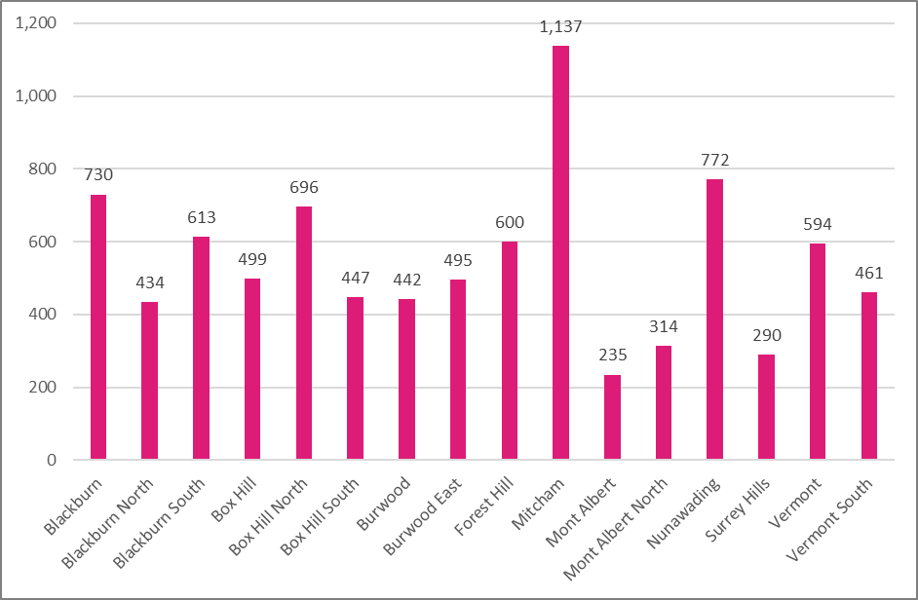

Figure 3: Total number of young people in Whitehorse (2016) and forecast (2031)
 | 2016 | 2031 | Chg | 2041 | Chg
0-4 | 9,640 | 11,406 | 18.3% | 12,136 | 6.4%
5-9 | 9,865 | 10,875 | 10.2% | 11,617 | 6.8%
10-14 | 9,455 | 10,820 | 14.4% | 11,665 | 7.8%
15-19 | 10,853 | 14,684 | 35.3% | 15,590 | 6.2%
3.3.6 Whitehose Family type and housing

Between 2011 and 2016, the number of households with children increased by 1,792 households or 3.0%. The total number of couples with children increased by 1,574 households, whilst the total number of single parents with children increased by 218 households. The breakdown can be seen in the figure 8, below.

As stated earlier, birth notifications have been trending downwards since 2016, from 1,844 down to 1,528 in 2021.
3.3.7 Migration in and out of the Whitehorse

Migration, or residential mobility, together with births and deaths are significant components of population change. The movement of people into, and out of an area directly influences the characteristics of the population and the demand for services and facilities. Migration is the most volatile component of population change and can be affected by changing housing and economic opportunities such as housing affordability issues or the job market.

There are three main types of migration in Australia, overseas migration, between-state migration, and within-state migration. By far the most common form of migration is within-state, and largely involves moves between neighbouring and existing urban areas where moves are often short. Overseas migration has been significantly impacted by COVID-19 due to border closures, the impacts of which are yet to be properly understood.

Prior to 2020, the City of Whitehorse experienced a strong growth in population born from China. Its population increased by more than 65% between 2011 and 2016. While most young people in Whitehorse were born in Australia; China and India are the most common places of birth for those born outside of Australia and in those aged under 25, there are greater numbers in the ages between 15 and 24. This trend generally reflects the high numbers of international students attending tertiary institutions in the municipality.

Figure 4: Place of birth for under 25 year olds
 | 0-14 | 15-24
Australia | 22,961 | 13,972
China (excludes SARs and Taiwan) | 909 | 4,015
India | 375 | 706
Malaysia | 263 | 626
England | 227 | 224
New Zealand | 210 | 227
Sri Lanka | 77 | 360
Hong Kong (SAR of China) | 93 | 330
Singapore | 154 | 139
Korea, Republic of (South) | 101 | 192

Most people who moved into the municipality by far, came from overseas at 17,803 persons. Next they came from out of Victoria, then Boroondara, Monash, Manningham and Knox. Most people who moved out of the municipality moved interstate, followed by Maroondah, Boroondara, Knox and Manningham.
3.3.8 Vulnerable in one or more domains

According to the Australian Early Development Census 2018, the percentage of children developmentally vulnerable in one or more domains is 13.3%, less than the Victorian average of 19.9%.
3.3.9 Education

More than one quarter (27.8%) of residents currently attend an educational institution. Whitehorse has a higher proportion of residents that attended University, compared to Greater Melbourne – at 8.8% compared to 6.4% for the metropolitan region. 84.1% of persons lived in households that had Internet access of any form at their dwelling, compared to the Metropolitan Melbourne and Victorian State averages of 81.7% and 79.6% respectively.

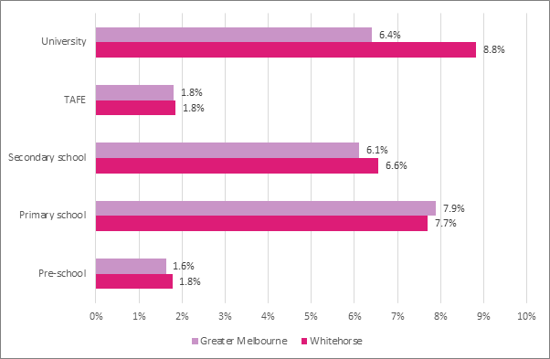
3.4 KISP & ASR Research Estimates for Unmet Demand for Kindergarten Places in Whitehorse

Over the period of Government's kindergarten reform (2022-2029), there are five sectors of the municipality where there is potential projected unmet demand for sessional kindergarten. This indicates where the number of children forecast cannot be accommodated in existing sessional facilities when two years of 15 hours is implemented. Using DET assumptions around incremental service roll-out from five hours in 2022 to 15 hours by 2029, this unmet demand is identified to become an issue in:

- North East Sector (Nunawading & Mitcham): in 2025/26 unmet demand is projected at 23 places rising to 165 places in 2029 (3 small or 2 large kindergarten rooms).
- North West Sector (Box Hill, Box Hill North and Mont Albert and Mont Albert North) : in 2025/26 unmet demand is projected at 30 places rising to 146 places in 2029 (3 small or 2 large kindergarten rooms).
- South West Sector (Surrey Hills, Box Hill South and Burwood): in 2025/26 unmet demand is projected at 33 places rising to 111 places in 2029 (2 small or 2 large kindergarten rooms).
- South East Sector (Vermont & Vermont South): in 2026 unmet demand is projected at 40 places rising to 62 places in 2029. (1 large kindergarten room)
- South Sector (Blackburn South, Forest Hills and East Burwood): in 2026/7 unmet demand is projected at 15 places rising to 46 places in 2029. (1 small kindergarten room)

As pointed out above, the key driver for unmet demand is the timing of when the full 15 hours of funded kindergarten is offered for 3-year-old children during the roll-out period.

Note, it is difficult to align specific geographical areas between the two documents as the data source for geographical areas is not identical and provides for discrepancies. While the KISP uses a numerical range to project unmet demand, the overall implications regarding unmet demand in the respective sectors of the municipality are similar between the two reports.

3.4.1 Additional Findings of the ASR Research Report (Jan 2022)

- The majority of Council owned sessional kindergarten sites contain only 1 main activity room (82% of all facilities - 18 facilities).
- Only 21% of Council’s sessional kindergarten facilities are rated either very good or good in terms of being fit for purpose (i.e. meets current program/service delivery needs in either a fully efficient and effective manner or an acceptable manner). Approximately 37% are rated fair (i.e. meets most current program/service delivery needs and some inefficiencies and ineffectiveness present). Approximately 42% of Council’s sessional kindergarten facilities are rated poor in terms of being fit for purpose (i.e. limited ability to meet current program / service delivery needs).
- Of even greater concern is that over two thirds (70%) of Council’s sessional kindergarten facilities are rated as either poor or very poor in terms of being fit for future use (i.e. either has limited ability to meet current program/service delivery needs or is critically deficient and does not meet current program/service delivery and is neither efficient nor effective).

3.5 References

- City of Whitehorse Community Profile http://profile.id.com.au/whitehorse
- City of Whitehorse Community Atlas http://atlas.id.com.au/whitehorse
- City of Whitehorse Population Forecast http://forecast.id.com.au/whitehorse
- Australian Bureau of Statistics: http://www.abs.gov.au/
- Australian Early Development Census: https://www.aedc.gov.au/data/data-explorer
- Victorian Child and Adolescent Monitoring System (VCAMS) Indicators http://www.education.vic.gov.au/about/research/Pages/vcamsindicator.aspx

Funded kindergarten enrolment estimates between 2021-29 for City of Whitehorse

4.1 Purpose
As Three-Year-Old Kindergarten is rolled-out and Victoria’s population grows, demand for both Three and Four-Year-Old Kindergarten places will increase significantly. While additional capacity will be needed to meet this demand, this will vary across the State and over time, due to differences in the capacity of existing services, growth trends and sector composition.
To identify where, when and how many additional kindergarten places are expected over the roll-out in the City of Whitehorse, Whitehorse City Council and the Department have developed:
- A summary of the current provision of kindergarten within the LGA (Section 4.3).
- An approach to optimising the utilisation of existing services and infrastructure through ‘change management’ strategies that Whitehorse City Council and the Department will support to help meet additional demand in the LGA (Section 4.4).
- An estimate of the Three and Four-Year-Old kindergarten places that cannot be met through existing services for the 2021-29 period, taking into account the additional demand that can be accommodated by optimising utilisation of existing services and infrastructure through point 2, above (Section 4.5).
Local Government and providers can use these published estimates to inform reform implementation activities such as service planning, kindergarten program expansion, infrastructure investments and Building Blocks funding applications in alignment with future demand over the 10-year roll-out.

4.2 Methodology
The estimated Three and Four-Year-Old Kindergarten places used in the following sections were informed by:
- Estimates developed by the Department which draw on a range of inputs, including population forecasts, current enrolments and results from the Kindergarten Capacity Assessment Program (KCAP), conducted in 2019.
- The estimated capacity of new services that are planned to open in the LGA (Section 2)
- Local knowledge and context provided by the Local Government (Section 3) that explains particular issues and trends in their area.
- The approach to optimising utilisation of existing services in the LGA (Section 4.4), and
- Other sources, such as modelling undertaken by Local Governments and local data.
The KISP measures a service’s capacity to deliver funded kindergarten in terms of the number of children it could enrol in Three and Four-Year-Old Kindergarten. The number of funded kindergarten places is different from a service’s licensed or approved places, which count the number of children permitted to attend the service at any one time under the license. Many services can enrol more children in their funded kindergarten program(s) than they have licensed places for because they can run more than one kindergarten program per week. Kindergarten places are therefore a more accurate measure of service kindergarten capacity than licensed places.
Three-Year-Old Kindergarten places have been presented as 15-hour places so they can be easily compared to Four-Year-Old Kindergarten places. Moreover, when Three-Year-Old Kindergarten is fully rolled-out in 2029, every three-year-old child will have access to 15-hours of kindergarten.
From 2023 all providers will have flexibility to determine how many hours of funded Three-Year-Old Kindergarten they deliver per week, with a minimum of five hours and a maximum of 15-hours funded pro-rata. It is expected that hours offered will vary. Given this variation, it is important to be aware that during the transition to all three-year-old children receiving 15-hours of funded kindergarten per week in 2029, the 15-hour places presented in this report may represent multiple three-year-old places that individually receive less than 15-hours of kindergarten per week.
These estimates have been developed at an LGA and community level to show the overall forecast and variation within an area. The KISP defines community at the Statistical Area Level 2, which is medium-sized areas which represent a community that interacts socially and economically, with a population range of 3,000 to 25,000 people, and an average population of about 10,000 people.

4.3 Summary of current kindergarten provision
The figures below provide a summary of current kindergarten provision within the LGA and provide relevant context for the estimates of demand for funded kindergarten places included in Section 4.5. The data included in this section are largely drawn from:
- The Kindergarten Capacity Assessment Program (KCAP), collected between June and October 2019.
- The Department’s Kindergarten Information Management System (KIMS), as at 2019.
- The Department’s Quality and Regulatory Division (QARD) monitoring data, as at 2019.
- The National Quality Agenda IT System (NQAITS), as at April 2020.
- The Victorian Child and Adolescent Monitoring System (VCAMS), as at 2018.
Please note that, because these sources were collected at different points, this may result in slightly different totals appearing in the below data.

Number of services by service type (NQAITs, 2020)

Stand-alone kindergartens | 35
Long day care centres | 46

Percentage of services by management type, LGA level (NQAITs, 2020)
Type | Percentage
Local Government | 5%
Private not for profit | 47%
Private for profit | 37%
Other | 11%

Current kindergarten offering
Four-Year-Old Kindergarten participation rate (VCAMS, 2018): | 89%
Number of services that offer a funded kindergarten program (DET, 2019): | 76
Number of services that offer an unfunded Three-Year-Old Kindergarten program (DET, 2019): | 50
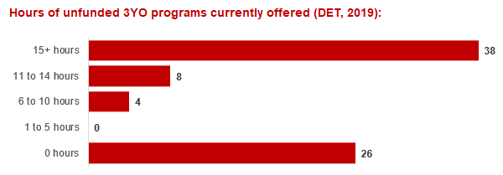

4.4 Approach to optimising the use of existing services and infrastructure
Change management strategies to optimise existing services and infrastructure
Children can often be accommodated through existing spare places and by services ‘unlocking’ unused capacity. As the experience of providers in the 2020 Three-Year-Old Kindergarten roll-out LGAs shows, while the optimisation of existing services can be challenging, it is highly time- and cost-effective compared to building new capacity through infrastructure projects. It also helps target infrastructure investment to the places that need it most and avoids over-supplying the local market.
The Department will support providers and services to maximise their kindergarten places through the following change management activities and practices:
- Increasing the capacity of any Local Government operated services by:
  - Running additional programs.
  - Using different timetables, including running 7.5-hour days.
  - Changing the delivery model, such as introducing rotational models or mixed-age groups.
  - Having degree-qualified kindergarten teachers leading integrated kindergarten programs in long day care settings.
- Encouraging and supporting other providers and services in the LGA to undertake change management.
The Department has estimated how many Three and Four-Year-Old Kindergarten places can be accommodated through existing services in the LGA (Table 1). Both parties are committed to helping providers and services offer these kindergarten places before progressing to funded infrastructure solutions to meet demand. This commitment is reflected in the LGA and community level estimates below (Table 2 onwards), which assume that demand will be met first through existing services and second through additional infrastructure. Note that in some cases the number of kindergarten places that can be offered through existing services may exceed demand for kindergarten places.
Table 1: [Range of] total estimated funded kindergarten places that can be offered by optimising existing services and infrastructure across the LGA, between 2021-29 (presented in 15-hour equivalent places)
 | 2021 | 2022 | 2023 | 2024 | 2025 | 2026 | 2027 | 2028 | 2029
Estimated existing supply of kindergarten places* | 4,300 | 4,300 | 4,300 | 4,300 | 4,300 | 4,300 | 4,300 | 4,300 | 4,300
Total three and four-year-old places that can be accommodated by optimising existing services** | 4,300 – 5,717 | 4,300 – 5,717 | 4,300 – 5,717 | 4,300 – 5,717 | 4,300 – 5,717 | 4,300 – 5,717 | 4,300 – 5,717 | 4,300 – 5,717 | 4,300 – 5,717
*This may be higher than current three and four-year-old enrolments as it includes any spare places that are currently available or could be generated by making some minor adjustments to programming approaches.
**The likely expansion of services and kindergarten places in response to population growth (i.e. growth in demand not generated by the Three-Year-Old Kindergarten Reform that would likely occur) is not accounted for in these estimates.

4.5 Agreed estimates of demand for funded kindergarten places that cannot be met through existing services and infrastructure
The below estimates (Table 2 onwards) have been developed by Whitehorse City Council and the Department to illustrate the estimated:
- Total number of Three and Four-Year-Old Kindergarten places expected over the roll-out period.
- Three and Four-Year-Old Kindergarten places that cannot be accommodated by optimising existing services and infrastructure over the roll-out period.
These estimates have been developed to reflect that the increase in demand for Three-Year-Old Kindergarten places will be gradual.
In estimating how many Three and Four-Year-Old Kindergarten places cannot be accommodated by existing services and infrastructure, Whitehorse City Council and the Department have taken into account any new places that will be made available through planned expansions of existing services or new services, into estimates of existing supply, where this information is available. This may include Local Government owned services being developed and planned Kindergartens on School Sites.
These estimates do not, however, estimate how and when the broader sector will expand to meet the additional demand for kindergarten places that are estimated over the roll-out period.
Infrastructure need in the LGA and its local communities is indicated by the bottom rows of the tables in this section (Table 2 onwards): ‘Total kindergarten places that cannot be accommodated by existing services’. For example, if the number of kindergarten places for the LGA or a community is above zero in this row, it means that the area is estimated to need additional infrastructure (noting that further optimisation which avoids the need for additional infrastructure may be possible). Any type of provider – Local Government, not-for-profit or for-profit – can build this additional infrastructure. If this row shows all zeros, it means that there is no estimated need for additional infrastructure in the area.
Local Government and not-for-profit kindergarten providers must refer to the estimates in this section or if alternative data is provided in the local government context section with that data when applying through the Building Blocks Capacity Building Grants stream for Government funding. Under this stream, projects must be in a community where there is infrastructure need as shown in the community’s table of estimated demand for kindergarten places (i.e. there are numbers in the bottom row above zero). Projects in LGAs or communities where demand can be met through existing services (i.e. the bottom row shows all zeros) are not eligible for funding under this stream.

LGA estimates
Table 2: [Range of] estimated three and four-year-old kindergarten places between 2021-29 (presented in 15-hour equivalent places)
LGA level estimates | 2021 | 2022 | 2023 | 2024 | 2025 | 2026 | 2027 | 2028 | 2029
Total estimated demand for kindergarten places (three and four-year-old children) | 2,002 | 3,113 | 3,295 | 3,444 | 3,576 | 3,760 | 3,922 | 4,276 | 4,744
Total kindergarten places that cannot be accommodated by existing services | 0 | 0 | 0 | 0 - 25 | 0 - 90 | 3 - 182 | 30 - 256 | 124 - 486 | 333 - 802

Community estimates
Table 3-14: [Range of] estimated three and four-year-old kindergarten places between 2021-29 (presented in 15-hour equivalent places)
Blackburn estimates | 2021 | 2022 | 2023 | 2024 | 2025 | 2026 | 2027 | 2028 | 2029
Total estimated demand for kindergarten places (three and four-year-old children) | 353 | 537 | 560 | 577 | 592 | 612 | 632 | 652 | 674
Total kindergarten places that cannot be accommodated by existing services | 0 | 0 | 0 | 0 | 0 | 0 | 0 | 0 | 0

Blackburn South estimates | 2021 | 2022 | 2023 | 2024 | 2025 | 2026 | 2027 | 2028 | 2029
Total estimated demand for kindergarten places (three and four-year-old children) | 127 | 183 | 190 | 196 | 201 | 208 | 215 | 228 | 264
Total kindergarten places that cannot be accommodated by existing services | 0 | 0 | 0 | 0 | 0 | 0 | 0 | 0 | 0 - 7

Box Hill estimates | 2021 | 2022 | 2023 | 2024 | 2025 | 2026 | 2027 | 2028 | 2029
Total estimated demand for kindergarten places (three and four-year-old children) | 183 | 313 | 342 | 369 | 395 | 429 | 455 | 523 | 598
Total kindergarten places that cannot be accommodated by existing services | 0 | 0 | 0 | 0 - 6 | 0 - 31 | 0 - 65 | 0 - 91 | 62 - 159 | 136 - 234

Box Hill North estimates | 2021 | 2022 | 2023 | 2024 | 2025 | 2026 | 2027 | 2028 | 2029
Total estimated demand for kindergarten places (three and four-year-old children) | 196 | 272 | 286 | 297 | 307 | 321 | 341 | 395 | 444
Total kindergarten places that cannot be accommodated by existing services | 0 | 0 | 0 | 0 | 0 | 0 | 0 | 0 - 48 | 0 - 97

Burwood estimates | 2021 | 2022 | 2023 | 2024 | 2025 | 2026 | 2027 | 2028 | 2029
Total estimated demand for kindergarten places (three and four-year-old children) | 199 | 302 | 332 | 359 | 385 | 415 | 442 | 469 | 522
Total kindergarten places that cannot be accommodated by existing services | 0 | 0 | 0 | 0 - 7 | 0 - 33 | 3 - 63 | 30 - 90 | 57 - 117 | 111 - 171

Burwood East estimates | 2021 | 2022 | 2023 | 2024 | 2025 | 2026 | 2027 | 2028 | 2029
Total estimated demand for kindergarten places (three and four-year-old children) | 70 | 96 | 106 | 115 | 124 | 136 | 146 | 193 | 234
Total kindergarten places that cannot be accommodated by existing services | 0 | 0 | 0 | 0 | 0 | 0 | 0 | 0 | 0

Forest Hill estimates | 2021 | 2022 | 2023 | 2024 | 2025 | 2026 | 2027 | 2028 | 2029
Total estimated demand for kindergarten places (three and four-year-old children) | 148 | 217 | 228 | 238 | 246 | 258 | 267 | 281 | 322
Total kindergarten places that cannot be accommodated by existing services | 0 | 0 | 0 | 0 | 0 - 3 | 0 - 15 | 0 - 24 | 5 - 38 | 46 - 79

Mitcham estimates | 2021 | 2022 | 2023 | 2024 | 2025 | 2026 | 2027 | 2028 | 2029
Total estimated demand for kindergarten places (three and four-year-old children) | 188 | 270 | 286 | 299 | 310 | 326 | 338 | 391 | 440
Total kindergarten places that cannot be accommodated by existing services | 0 | 0 | 0 | 0 - 12 | 0 - 23 | 0 - 40 | 0 - 51 | 0 - 104 | 40 - 153

Nunawading estimates | 2021 | 2022 | 2023 | 2024 | 2025 | 2026 | 2027 | 2028 | 2029
Total estimated demand for kindergarten places (three and four-year-old children) | 155 | 236 | 251 | 263 | 274 | 290 | 300 | 321 | 366
Total kindergarten places that cannot be accommodated by existing services | 0 | 0 | 0 | 0 | 0 | 0 | 0 | 0 | 0 - 5

Surrey Hills (East) – Mont Albert estimates | 2021 | 2022 | 2023 | 2024 | 2025 | 2026 | 2027 | 2028 | 2029
Total estimated demand for kindergarten places (three and four-year-old children) | 96 | 161 | 168 | 172 | 176 | 182 | 187 | 191 | 201
Total kindergarten places that cannot be accommodated by existing services | 0 | 0 | 0 | 0 | 0 | 0 | 0 | 0 | 0

Vermont estimates | 2021 | 2022 | 2023 | 2024 | 2025 | 2026 | 2027 | 2028 | 2029
Total estimated demand for kindergarten places (three and four-year-old children) | 171 | 369 | 376 | 380 | 383 | 389 | 398 | 408 | 418
Total kindergarten places that cannot be accommodated by existing services | 0 | 0 | 0 | 0 | 0 | 0 | 0 | 0 | 0

Vermont South estimates | 2021 | 2022 | 2023 | 2024 | 2025 | 2026 | 2027 | 2028 | 2029
Total estimated demand for kindergarten places (three and four-year-old children) | 116 | 159 | 169 | 177 | 184 | 194 | 201 | 224 | 261
Total kindergarten places that cannot be accommodated by existing services | 0 | 0 | 0 | 0 | 0 | 0 | 0 | 0 - 20 | 0 - 57

Authorisation
The Area Executive Director, Inner East Area of the Department of Education and Training and the Chief Executive of Whitehorse City Council endorse this Kindergarten Services and Infrastructure Plan (KISP) for City of Whitehorse by signing on ………. / ………. / ……….
This KISP is not intended to create legal relations or constitute a legally binding contractual agreement between the parties. The parties may review this KISP in 2024 to publish a new version that will replace the previous version.
