Kindergarten Infrastructure and

Services Plan

Wellington Shire

**CONTENTS**

1. Introduction 3

1.1. Reform context 3

1.2. Purpose of KISPs 3

1.3. How to use the KISP 3

1.4. Structure of the KISP 3

1.5. Disclaimer 4

2. Map of Early Childhood Education services in Wellington Shire 5

3. Local context 7

3.1 Purpose 7

3.2 Key considerations 7

4. Funded kindergarten enrolment estimates between 2021-29 for Wellington Shire 11

4.1 Purpose 11

4.2 Methodology 11

4.3 Summary of current kindergarten provision 12

4.4 Approach to optimising the use of existing services and infrastructure 13

4.5 Agreed estimates of demand for funded kindergarten places that cannot be met through existing services and infrastructure 14

5. Authorisation 18

# Introduction

## Reform context

In an Australian first, the Victorian Government has committed to implement Three-Year-Old Kindergarten for all children over a 10-year roll-out with a total investment of almost $5 billion, including $1.68 billion to support the infrastructure expansion required for the reform. This reform will add another year of universal funded kindergarten so that, by 2029, all children in Victoria will have access to two years of play-based learning through a funded kindergarten program.

## Purpose of KISPs

Three-Year-Old Kindergarten will require a large expansion of kindergarten across the State. The Government has invited all 79 Victorian Local Governments to discuss and agree upon a Kindergarten Infrastructure and Services Plan (KISP) for their Local Government Area (LGA).

Each KISP has been jointly developed with Local Government and published to estimate the growth in demand for kindergarten within the LGA. The KISPs will help all kindergarten providers meet demand and provide a clear picture of infrastructure need across the State.

While a KISP is not a funding document and does not define required infrastructure projects or commit any party to funding specific projects, it is expected that future investment requests through Building Blocks and funding decisions about Local Government and not-for-profit projects would align with the relevant KISP.

## How to use the KISP

Each KISP contains estimates of future kindergarten supply of, and demand for, Three and Four-Year-Old Kindergarten places against existing enrolment capacity. Not-for-profit and for-profit providers can use these estimates to inform their plans to expand kindergarten programs, establish new services or invest in new or extended facilities.

For example, KISPs provide demand estimates in terms of where, when and how much demand for kindergarten places will grow in an LGA. KISPs also estimate where and how many kindergarten places providers can accommodate in existing facilities before an area needs new infrastructure to meet demand. The estimates can be used to inform decisions about where and when expansions of kindergarten program capacity and the construction of new or extended facilities are needed to meet demand growth.

Where there is an agreed KISP for the LGA, the Local Government and not-for-profit kindergarten providers seeking co-investments through the Building Blocks Capacity Building stream must refer to, and align their proposed project with, the infrastructure need identified in the KISP.

## Structure of the KISP

Each KISP consists of the following sections:

* **Section 1**: A short introduction to the Three-Year-Old Kindergarten reform and the KISP.
* **Section 2**: A map of existing and planned Early Childhood Education and Care service locations.
* **Section 3**: Local knowledge and context relevant to the expansion of kindergarten services.
* **Section 4**: Funded kindergarten demand estimates.

## Disclaimer

All data presented in this document are estimates only and are based on the best information available to the Department and Local Government at the time. They are published on an as-is basis and are for informational purposes only. They are subject to adjustment in response to market forces and as new data and other relevant information becomes available. The data may under- or over-estimate both total demand in a given location or year and the capacity for new demand to be met by providers. As a result, operational and business decisions should not be made solely based on this document. Any use of this data is solely at the risk of the user. The Department and Local Government accept no responsibility for any loss or damage, either direct or incidental, that may result from the use of the data.

# Map of Early Childhood Education services in Wellington Shire

The map below shows the distribution of currently operating and new services that are planned to open in the future in the LGA and across its communities.

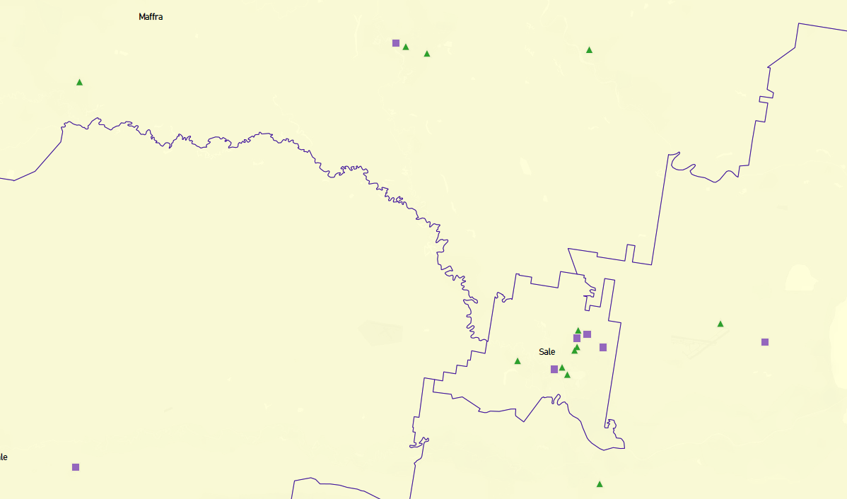This map has been prepared using Departmental data, from both the National Quality Agenda IT System (NQAITS) and the Victorian School Building Authority (VSBA). Where applicable, this map has been refined by Wellington Shire Council and the Department to capture other services that are planned to open in the future.

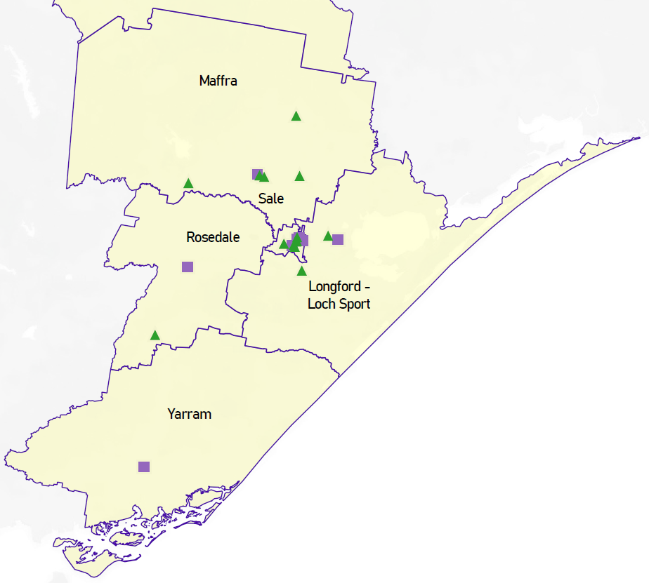

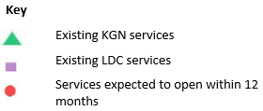

# Local context

d

## 3.1 Purpose

Local, place-based knowledge and context play an important role in supporting the implementation of Three-Year-Old Kindergarten across Victoria. This section of the KISP documents this knowledge and context and has informed the funded kindergarten enrolment estimates in Section 4.

## 3.2 Key considerations

**Projects and trends that will impact supply and demand for early childhood education and care**

Forecasting data projects that between 2021-2041 the Wellington Shire will see an increase of approximately 275 new dwellings per annum. New residential developments are underway or planned in Sale, Wurruk, Longford, Stratford and Rosedale areas.

Changes to existing industry and new industry growth is projected to impact population growth and migration in the Wellington Shire impacting how and where kindergarten and childcare programs are accessed. A notable mention is the closure of Ash Timber mill in Heyfield by 2030 and subsequent loss of employment opportunities in the region.  It is projected that migration out of the Heyfield area will increase as people seek new employment opportunities.

However, there are also significant growth in existing and new sustainable energy industry which will have impacts on supply and demand. They include:

* New sustainable energy including Maffra Solar Farms and Star of the South Offshore Wind Turbines near Yarram, and plans for on shore gas, carbon capture and storage off of the Wellington Shire coast
* Expansion to existing agriculture, horticulture, dairy and broiler industries are continuing to grow
* Public and community services growth
* Increase in military base services due to the growth of the East Sale RAAF Base
* Development of new TAFE in Sale.

With the growth of these industries and creation of new jobs, especially in smaller and more isolated pockets of Wellington Shire demand for access to kindergarten programs in these areas is anticipated to increase.

**Key local geographic considerations or information relevant to Three-Year-Old Kindergarten**

*Yarram*

Yarram and feeder towns such as Alberton, Woodside and Port Albert, have begun to experience some growth that is expected to continue over the next ten years. The overall SEIFA index of disadvantage for Yarram is 1017.  However, within the Yarram community there are areas of Yarram that score between 784 to 932.  This suggests there are neighborhoods within Yarram that are more vulnerable than other part of the local community.  Currently, there is only one early learning center that provides kindergarten and childcare programming for residents to access. The local community also has access to other early years programs such as Family Day Care and Maternal Child Health.  Both Department of Education and Training (DET) and Wellington Shire Council data projects that the supply of kindergarten places will not meet demand throughout this period. The existing kindergarten is already operating at capacity and cannot accommodate the increased demand which will occur from the roll out of funded Three-Year-Old Kindergarten.

*Loch Sport*

Currently there are no kindergarten programs operating in the Loch Sport and surrounding area including feeder towns such as Golden Beach and Seaspray. Families that require access kindergarten would need to travel between 1 - 2-hour return trip twice a day to Longford or Sale. The local community has access to a Maternal and Child Health program at the local health service.  The forecasted population growth and migration in the Loch Sport area is projected to decrease, and not until 2026 will there be a small increase in population.  With 30-40 children aged 3- and 4-years-old living in the district over the next decade, access to kindergarten is a priority.

The Loch Sport and surrounding area experiences significant disadvantage and vulnerability as per the SEIFA index. Despite forecasting data not showing growth in Loch Sport and surrounds between 2021-2031, we understand the importance of providing accessible kindergarten programs for children and families experiencing disadvantage and vulnerability. A kindergarten program in Loch Sport will support eliminating barriers currently experienced in accessing kindergarten programs and provide greater opportunity for access to and participation in kindergarten programs within close proximity to where children ~~l~~ive. Wellington Shire Council recognizes the likelihood of a kindergarten in Loch Sport running under capacity, however, believe it is important in supporting equitable access and participation for children and families experiencing disadvantage and vulnerability.

*Longford*

Longford is on the fringe of Sale and is zoned as a residential area. As a result, Longford will be experiencing significant growth due to migration of residents and planned residential development over the next 10 years.  Currently there is only one kindergarten program within the town.  Residents choose between using this service or accessing kindergarten programs within Sale.  The overall SEIFA index of disadvantage for Longford is 1049.

*Wurruk*

Wurruk is on the fringe of Sale and is zoned as a residential area.  Wurruk has a major highway and railway line that divides the town. Major residential development is planned for the south side of the highway, whereas existing residential homes are located on the north side.  The current SEIFA index of residents on the north side is 780, whereas the SEIFA index for the south side is between 1021 - 1078.  Currently there is only one kindergarten program within the town. The existing kindergarten is located on north side of the highway on the primary school site.

*Rosedale*

Population and migration growth in Rosedale is anticipated to continue between 2021-2031 particularly amongst children aged 0-8 years, with planned residential developments in the town, and is projected to increase the demand for kindergarten places during this time. Increased availability of services in Rosedale will also capture some children who currently attend kindergarten in Sale or Traralgon due to limited availability in Rosedale, or because their families/carers work in a larger town. The overall SEIFA index of disadvantage for Rosedale is 1025 however there are areas of Rosedale that score 893 – 1005. This suggests that there are areas within Rosedale community that are more vulnerable than others. Currently there is one kindergarten program in the town, supported playgroup and Maternal and Child Health as part of the Rosedale Community Hub, and family day care.

*Gormandale*

Gormandale is a small rural town located within the hills in the south-east pocket of Wellington Shire. Gormandale has a SEIFA index of disadvantage of 1023. Currently there is one kindergarten program on the Gormandale Primary School site. Whilst there is a service in town, some residents choose to access early years services where they work such as in Traralgon.

*Sale*

Sale is the main regional town of Wellington Shire with the majority of employment, health and education services and major hospital located here. Overall, Sale has a SEIFA index of disadvantage of 970. However, within Sale there are areas that score between 702 – 1091. This suggests that there are areas of Sale that are more vulnerable than other communities. Sale will be experiencing significant population growth, particularly amongst children aged 0-8 years, due to migration of residents and planned residential developments over the next 10 years. This combined with the roll out of funded Three-Year-Old Kindergarten, will notably increase the demand for early years services. Currently Sale has access to early years services such as 9 kindergarten programs of which 3 are offered in a long day care setting, 5 childcare facilities, Maternal and Child Health, supported playgroups and family daycare.  There is a prevalence of single-room facilities in Sale, many aged and in poor condition.

*Briagolong*

Briagolong is a small town located approximately 10 minutes from Stratford and is zoned as residential. The overall SEIFA index of disadvantage for Briagolong is 1049 however, within Briagolong there are areas that score between 968 – 1005. This suggest that there are areas of Briagolong that are more vulnerable than other communities. Currently there is one kindergarten program in Briagolong operating out of a multiuse building which also has occasional care and Maternal and Child Health. The building is ageing and in need of upgrade. Some residents choose to access early years services where they work including in Sale and Maffra.

*Stratford*

Stratford is experiencing significant residential development and will be the highest growing town in Wellington Shire over the next 10 years, with a large increase in the 0-8-year-old population. Overall, the SEIFA index of disadvantage for Stratford is 1007 however there are areas in the community that score between 934 – 1019 suggesting that there are areas of Stratford that are more vulnerable than other communities. Currently Stratford has one kindergarten program and Maternal and Child Health. There will be a significant increase in demand for kindergarten services and the town lacks infrastructure to accommodate it. Families are currently accessing kindergarten and childcare services in neighbouring towns of Maffra and Sale.

*Heyfield*

Currently Heyfield has one kindergarten program, occasional care and Maternal and Child Health. The overall SEIFA index of disadvantage for Heyfield is 1017. However, there are areas in the community that score between 859 – 927 suggesting that there are areas of Heyfield more vulnerable than other communities. As previously mentioned, the Ash Timber Mill is the major industry and employer of the Heyfield community with a planned closure by 2030. If this is to close it will have a major impact on local employment and population. The district is expected to experience a small increase in the 0-8-year-old population between 2021 and 2031, with the demand for kindergarten services expected to increase significantly due to the roll out of funded 3-year-old kindergarten. The existing infrastructure will not be able to support this increased demand.

*Maffra*

Maffra is the second largest town in Wellington Shire and currently has access to three kindergarten programs of which one is offered in a long day care setting and one in a long day care centre. Occasional care and Maternal and Child Health service the town. The overall SEIFA index of disadvantage for Maffra is 975. However, there are areas of Maffra that score between 860 – 983 suggesting that there are areas of Maffra more vulnerable than other communities.

**Other information about the expansion of early childhood services**

Data through surveys of families and early years services, including Wellington Shire Early Years’ service audits, demonstrated more demand for childcare rather than kindergarten in the Wellington Shire.

Wellington Shire Council do not manage any early years services, however many services do operate out of Council-owned buildings via leasing agreements.

Uniting (VIC/TAS) and Sale Combined Kindergartens Incorporated (SCKI) are the only two Early Years Managers in Wellington Shire*. Between them they manage 12 of the 20 funded kindergarten services. Of the remaining services four are run by Committees of Management and three of these are in long day care services. Two services are managed by a for-profit provider. One service is managed by a government school and one by an independent school.

Maternal and Child Health in Wellington Shire is managed by the two hospitals: Central Gippsland Health and Yarram and District Health Services.

When reviewing this section, please also refer to Wellington Shire Council ‘Early Years Infrastructure Plan’.  This document will provide further context to overall early years’ service and infrastructure needs (in addition to kindergarten infrastructure) that will need to be considered as part of future early years infrastructure needs.  For a copy of this document, please contact Wellington Shire Council on 1300 366 244 and speak with Coordinator Social Planning and Policy.

*\*at the time of finalizing this document, 2 Early Years Managers (EYM) operate in Wellington Shire, and 1 Committee of Management Kindergarten is considering transitioning to a new EYM not currently delivering a service in Wellington Shire LGA.*

# Funded kindergarten enrolment estimates between 2021-29 for Wellington Shire

## 4.1 Purpose

As Three-Year-Old Kindergarten is rolled-out and Victoria’s population grows, demand for both Three and Four-Year-Old Kindergarten places will increase significantly. While additional capacity will be needed to meet this demand, this will vary across the State and over time, due to differences in the capacity of existing services, growth trends and sector composition.

To identify where, when and how many additional kindergarten places are expected over the roll-out in Wellington Shire, Wellington Shire Council and the Department have developed:

1. A summary of the current provision of kindergarten within the LGA (**Section 4.3**).
2. An approach to optimising the utilisation of existing services and infrastructure through ‘change management’ strategies that Wellington Shire Council and the Department will support to help meet additional demand in the LGA (**Section 4.4**).
3. An estimate of the Three and Four-Year-Old kindergarten places that cannot be met through existing services for the 2021-29 period, taking into account the additional demand that can be accommodated by optimising utilisation of existing services and infrastructure through point 2, above (**Section 4.5**).

Local Government and providers can use these published estimates to inform reform implementation activities such as service planning, kindergarten program expansion, infrastructure investments and Building Blocks funding applications in alignment with future demand over the 10-year roll-out.

## 4.2 Methodology

The estimated Three and Four-Year-Old Kindergarten places used in the following sections have been agreed between Wellington Shire Council and the Department, and were informed by:

* Estimates developed by the Department which draw on a range of inputs, including population forecasts, current enrolments and results from the Kindergarten Capacity Assessment Program (KCAP), conducted in 2019.
* The estimated capacity of new services that are planned to open in the LGA (Section 2)
* Local knowledge and context provided by the Local Government (Section 3) that explains particular issues and trends in their area.
* The approach to optimising utilisation of existing services in the LGA (Section 4.4), and
* Other sources, such as modelling undertaken by Local Governments and local data.

The KISP measures a service’s capacity to deliver funded kindergarten in terms of the number of children it could enrol in Three and Four-Year-Old Kindergarten. The number of funded kindergarten places is different from a service’s licensed or approved places, which count the number of children permitted to attend the service at any one time under the license. Many services can enrol more children in their funded kindergarten program(s) than they have licensed places for because they can run more than one kindergarten program per week. Kindergarten places are therefore a more accurate measure of service kindergarten capacity than licensed places.

Three-Year-Old Kindergarten places have been presented as 15-hour places so they can be easily compared to Four-Year-Old Kindergarten places. Moreover, when Three-Year-Old Kindergarten is fully rolled-out in 2029, every three-year-old child will have access to 15-hours of kindergarten.

From 2023 all providers will have flexibility to determine how many hours of funded Three-Year-Old Kindergarten they deliver per week, with a minimum of five hours and a maximum of 15-hours funded pro-rata. It is expected that hours offered will vary. Given this variation, **it is important to be aware that during the transition to all three-year-old children receiving 15-hours of funded kindergarten per week in 2029,** **the 15‑hour places presented in this report may represent multiple three-year-old places that individually receive less than 15-hours of kindergarten per week.**

These estimates have been developed at an LGA and community level to show the overall forecast and variation within an area. The KISP defines community at the Statistical Area Level 2, which is medium-sized areas which represent a community that interacts socially and economically, with a population range of 3,000 to 25,000 people, and an average population of about 10,000 people.

## 4.3 Summary of current kindergarten provision

The figures below provide a summary of current kindergarten provision within the LGA and provide relevant context for the estimates of demand for funded kindergarten places included in Section 4.5. The data included in this section are largely drawn from:

* The Kindergarten Capacity Assessment Program (KCAP), collected between June and October 2019.
* The Department’s Kindergarten Information Management System (KIMS), as at 2019.
* The Department’s Quality and Regulatory Division (QARD) monitoring data, as at 2019.
* The National Quality Agenda IT System (NQAITS), as at April 2020.
* The Victorian Child and Adolescent Monitoring System (VCAMS), as at 2018.

Please note that, because these sources were collected at different points, this may result in slightly different totals appearing in the below data.

|  |  |
| --- | --- |
| Number of services by service type (NQAITs, 2021) | |
| Stand-alone kindergartens | 14 |
| Long day care centres | 8 |

|  |  |
| --- | --- |
| Percentage of services by management type, LGA level (NQAITs, 2021) | |
| ***Type*** | ***Percentage*** |
| Local Government | 0% |
| Private not for profit | 77% |
| Private for profit | 14% |
| Other | 9% |

|  |  |
| --- | --- |
| Current kindergarten offering | |
| Four-Year-Old Kindergarten participation rate (VCAMS, 2018): | 95% |
| Number of services that offer a funded kindergarten program (DET, 2019): | 19 |
| Number of services that offer an unfunded Three-Year-Old Kindergarten program (DET, 2019): | 10 |

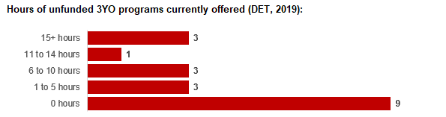

## 4.4 Approach to optimising the use of existing services and infrastructure

**Change management strategies to optimise existing** **services and infrastructure**

Children can often be accommodated through existing spare places and by services ‘unlocking’ unused capacity. As the experience of providers in the 2020 Three-Year-Old Kindergarten roll-out LGAs shows, while the optimisation of existing services can be challenging, it is highly time- and cost-effective compared to building new capacity through infrastructure projects. It also helps target infrastructure investment to the places that need it most and avoids over-supplying the local market.

Wellington Shire Council and the Department will support providers and services to maximise their kindergarten places through the following change management activities and practices:

* Increasing the capacity of any Local Government operated services by:
  + Running additional programs.
  + Using different timetables, including running 7.5-hour days.
  + Changing the delivery model, such as introducing rotational models or mixed-age groups.
  + Having degree-qualified kindergarten teachers leading integrated kindergarten programs in long day care settings.
* Encouraging and supporting other providers and services in the LGA to undertake change management.

Wellington Shire Council and the Department have estimated how many Three and Four-Year-Old Kindergarten places can be accommodated through existing services in the LGA (**Table 1**). Both parties are committed to helping providers and services offer these kindergarten places before progressing to funded infrastructure solutions to meet demand. This commitment is reflected in the LGA and community level estimates below (**Table 2** onwards), which assume that demand will be met first through existing services and second through additional infrastructure. Note that in some cases the number of kindergarten places that can be offered through existing services may exceed demand for kindergarten places.

**Table 1: Total estimated funded kindergarten places that can be offered by optimising existing services and infrastructure across the LGA, between 2021-29 (presented in 15-hour equivalent places)**

|  |  |  |  |  |  |  |  |  |  |
| --- | --- | --- | --- | --- | --- | --- | --- | --- | --- |
|  | **2021** | **2022** | **2023** | **2024** | **2025** | **2026** | **2027** | **2028** | **2029** |
| Estimated existing supply of kindergarten places* | 1004 | 1004 | 1004 | 1004 | 1004 | 1004 | 1004 | 1004 | 1004 |

*\**This may be higher than current three and four-year-old enrolments as it includes any spare places that are currently available or could be generated by making some minor adjustments to programming approaches.

## 4.5 Agreed estimates of demand for funded kindergarten places that cannot be met through existing services and infrastructure

The below estimates (**Table 2** onwards) have been developed by Wellington Shire Council and the Department to illustrate the estimated:

1. Total number of Three and Four-Year-Old Kindergarten places expected over the roll-out period.
2. Three and Four-Year-Old Kindergarten places that cannot be accommodated by optimising existing services and infrastructure over the roll-out period.

These estimates have been developed to reflect that the increase in demand for Three-Year-Old Kindergarten places will be gradual.

In estimating how many Three and Four-Year-Old Kindergarten places cannot be accommodated by existing services and infrastructure, Wellington Shire Council and the Department have taken into account any new places that will be made available through planned expansions of existing services or new services, into estimates of existing supply, where this information is available. This may include Local Government owned services being developed and planned Kindergartens on School Sites.

These estimates do not, however, estimate how and when the broader sector will expand to meet the additional demand for kindergarten places that are estimated over the roll-out period.

Infrastructure need in the LGA and its local communities is indicated by the bottom rows of the tables in this section (**Table 2** onwards): ‘Total kindergarten places that cannot be accommodated by existing services’. For example, if the number of kindergarten places for the LGA or a community is above zero in this row, it means that the area is estimated to need additional infrastructure (noting that further optimisation which avoids the need for additional infrastructure may be possible). Any type of provider – Local Government, not-for-profit or for-profit – can build this additional infrastructure. If this row shows all zeros, it means that there is no estimated need for additional infrastructure in the area.

Local Government and not-for-profit kindergarten providers must refer to the estimates in this section when applying through the Building Blocks Capacity Building Grants stream for Government funding. Under this stream, projects must be in a community where there is infrastructure need as shown in the community’s table of estimated demand for kindergarten places (i.e. there are numbers in the bottom row above zero). Projects in LGAs or communities where demand can be met through existing services (i.e. the bottom row shows all zeros) are not eligible for funding under this stream.

**LGA estimates**

**Table 2: Estimated three and four-year-old kindergarten places between 2021-29 (presented in 15-hour equivalent places)**

|  |  |  |  |  |  |  |  |  |  |
| --- | --- | --- | --- | --- | --- | --- | --- | --- | --- |
| **LGA level estimates** | **2021** | **2022** | **2023** | **2024** | **2025** | **2026** | **2027** | **2028** | **2029** |
| Total estimated demand for kindergarten places (three and four-year-old children) | 485 | 635 | 689 | 752 | 804 | 893 | 942 | 993 | 1060 |
| Total kindergarten places that cannot be accommodated by existing services | 0 | 0 | 0 | 12 | 23 | 43 | 54 | 65 | 79 |

**Community estimates**

**Table 3-8: Estimated three and four-year-old kindergarten places between 2021-29 (presented in 15-hour equivalent places)**

|  |  |  |  |  |  |  |  |  |  |
| --- | --- | --- | --- | --- | --- | --- | --- | --- | --- |
| **Alps – West estimates** | **2021** | **2022** | **2023** | **2024** | **2025** | **2026** | **2027** | **2028** | **2029** |
| Total estimated demand for kindergarten places (three and four-year-old children) | 0 | 0 | 0 | 0 | 0 | 0 | 0 | 0 | 0 |
| Total kindergarten places that cannot be accommodated by existing services | 0 | 0 | 0 | 0 | 0 | 0 | 0 | 0 | 0 |

|  |  |  |  |  |  |  |  |  |  |
| --- | --- | --- | --- | --- | --- | --- | --- | --- | --- |
| **Longford - Loch Sport estimates** | **2021** | **2022** | **2023** | **2024** | **2025** | **2026** | **2027** | **2028** | **2029** |
| Total estimated demand for kindergarten places (three and four-year-old children) | 53 | 66 | 71 | 77 | 81 | 90 | 95 | 101 | 108 |
| Total kindergarten places that cannot be accommodated by existing services | 0 | 0 | 0 | 0 | 0 | 0 | 0 | 0 | 0 |

|  |  |  |  |  |  |  |  |  |  |
| --- | --- | --- | --- | --- | --- | --- | --- | --- | --- |
| **Maffra estimates** | **2021** | **2022** | **2023** | **2024** | **2025** | **2026** | **2027** | **2028** | **2029** |
| Total estimated demand for kindergarten places (three and four-year-old children) | 144 | 191 | 208 | 228 | 245 | 274 | 289 | 306 | 327 |
| Total kindergarten places that cannot be accommodated by existing services | 0 | 0 | 0 | 0 | 0 | 0 | 0 | 0 | 0 |

|  |  |  |  |  |  |  |  |  |  |
| --- | --- | --- | --- | --- | --- | --- | --- | --- | --- |
| **Rosedale estimates** | **2021** | **2022** | **2023** | **2024** | **2025** | **2026** | **2027** | **2028** | **2029** |
| Total estimated demand for kindergarten places (three and four-year-old children) | 32 | 46 | 52 | 59 | 65 | 75 | 81 | 87 | 95 |
| Total kindergarten places that cannot be accommodated by existing services | 0 | 0 | 0 | 6 | 12 | 22 | 27 | 33 | 41 |

|  |  |  |  |  |  |  |  |  |  |
| --- | --- | --- | --- | --- | --- | --- | --- | --- | --- |
| **Sale estimates** | **2021** | **2022** | **2023** | **2024** | **2025** | **2026** | **2027** | **2028** | **2029** |
| Total estimated demand for kindergarten places (three and four-year-old children) | 221 | 279 | 299 | 323 | 341 | 374 | 392 | 410 | 433 |
| Total kindergarten places that cannot be accommodated by existing services | 0 | 0 | 0 | 0 | 0 | 0 | 0 | 0 | 0 |

|  |  |  |  |  |  |  |  |  |  |
| --- | --- | --- | --- | --- | --- | --- | --- | --- | --- |
| **Yarram estimates** | **2021** | **2022** | **2023** | **2024** | **2025** | **2026** | **2027** | **2028** | **2029** |
| Total estimated demand for kindergarten places (three and four-year-old children) | 36 | 53 | 58 | 65 | 71 | 80 | 85 | 90 | 97 |
| Total kindergarten places that cannot be accommodated by existing services | 0 | 0 | 0 | 6 | 12 | 21 | 26 | 31 | 38 |

# Authorisation

The Area Executive Director (Outer Gippsland) of the Department of Education and Training and the Chief Executive of Wellington Shire Council endorse this Kindergarten Services and Infrastructure Plan (KISP) for Wellington Shire by signing on 27 / 01 / 2022.

This KISP is not intended to create legal relations or constitute a legally binding contractual agreement between the parties. The parties may review this KISP in 2024 to publish a new version that will replace the previous version.

An out-of-cycle review may be triggered if both parties agree that there has been a change in relevant data, information or the local early childhood sector that significantly affects the reliability of a KISP’s estimates for planning purposes.

**Signed for and on behalf and with the authority of Wellington Shire Council**

…………………………………… …………………………………

Signature Witness Signature

Name: David Morcom  
Title: Chief Executive Officer

Address: 18 Desailly Street, Sale VIC 3850

**Signed by Area Executive Director (Outer Gippsland), Department of Education and Training**

…………………………………… …………………………………

Signature Witness Signature

Name: Alison Clark  
Title: Area Executive Director (Outer Gippsland)

Address: 64-66 Foster Street, Sale VIC 3850