Kindergarten Infrastructure and
Services Plan
City of Warrnambool
CONTENTS
1. Introduction 3
1.1. Reform context 3
1.2. Purpose of KISPs 3
1.3. How to use the KISP 3
1.4. Structure of the KISP 3
1.5. Disclaimer 4
2. Map of Early Childhood Education services in the City of Warrnambool 5
3. Local context 6
3.1 Purpose 6
3.2 Key considerations 6
4. Funded kindergarten enrolment estimates between 2021-29 for the City of Warrnambool 9
4.1 Purpose 9
4.2 Methodology 9
4.3 Summary of current kindergarten provision 10
4.4 Approach to optimising the use of existing services and infrastructure 11
4.5 Agreed estimates of demand for funded kindergarten places that cannot be met through existing services and infrastructure 12
5. Authorisation 15

Introduction

Reform context
In an Australian first, the Victorian Government has committed to implement Three-Year-Old Kindergarten for all children over a 10-year roll-out with a total investment of almost $5 billion, including $1.68 billion to support the infrastructure expansion required for the reform. This reform will add another year of universal funded kindergarten so that, by 2029, all children in Victoria will have access to two years of play-based learning through a funded kindergarten program.

Purpose of KISPs
Three-Year-Old Kindergarten will require a large expansion of kindergarten across the State. The Government has invited all 79 Victorian Local Governments to discuss and agree upon a Kindergarten Infrastructure and Services Plan (KISP) for their Local Government Area (LGA).
Each KISP has been jointly developed with Local Government and published to estimate the growth in demand for kindergarten within the LGA. The KISPs will help all kindergarten providers meet demand and provide a clear picture of infrastructure need across the State.
While a KISP is not a funding document and does not define required infrastructure projects or commit any party to funding specific projects, it is expected that future investment requests through Building Blocks and funding decisions about Local Government and not-for-profit projects would align with the relevant KISP.

How to use the KISP
Each KISP contains estimates of future kindergarten supply of, and demand for, Three and Four-Year-Old Kindergarten places against existing enrolment capacity. Not-for-profit and for-profit providers can use these estimates to inform their plans to expand kindergarten programs, establish new services or invest in new or extended facilities.
For example, KISPs provide demand estimates in terms of where, when and how much demand for kindergarten places will grow in an LGA. KISPs also estimate where and how many kindergarten places providers can accommodate in existing facilities before an area needs new infrastructure to meet demand. The estimates can be used to inform decisions about where and when expansions of kindergarten program capacity and the construction of new or extended facilities are needed to meet demand growth.
Where there is an agreed KISP for the LGA, the Local Government and not-for-profit kindergarten providers seeking co-investments through the Building Blocks Capacity Building stream must refer to, and align their proposed project with, the infrastructure need identified in the KISP.

Structure of the KISP
Each KISP consists of the following sections:
- Section 1: A short introduction to the Three-Year-Old Kindergarten reform and the KISP.
- Section 2: A map of existing and planned Early Childhood Education and Care service locations.
- Section 3: Local knowledge and context relevant to the expansion of kindergarten services.
- Section 4: Funded kindergarten demand estimates.

Disclaimer
All data presented in this document are estimates only and are based on the best information available to the Department and Local Government at the time. They are published on an as-is basis and are for informational purposes only. They are subject to adjustment in response to market forces and as new data and other relevant information becomes available. The data may under- or over-estimate both total demand in a given location or year and the capacity for new demand to be met by providers. As a result, operational and business decisions should not be made solely based on this document. Any use of this data is solely at the risk of the user. The Department and Local Government accept no responsibility for any loss or damage, either direct or incidental, that may result from the use of the data.

Map of Early Childhood Education services in the City of Warrnambool
The map below shows the distribution of currently operating and new services that are planned to open in the future in the LGA and across its communities.
This map has been prepared using Departmental data, from both the National Quality Agenda IT System (NQAITS) and the Victorian School Building Authority (VSBA). Where applicable, this map has been refined by the Warrnambool City Council and the Department to capture other services that are planned to open in the future.
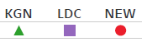
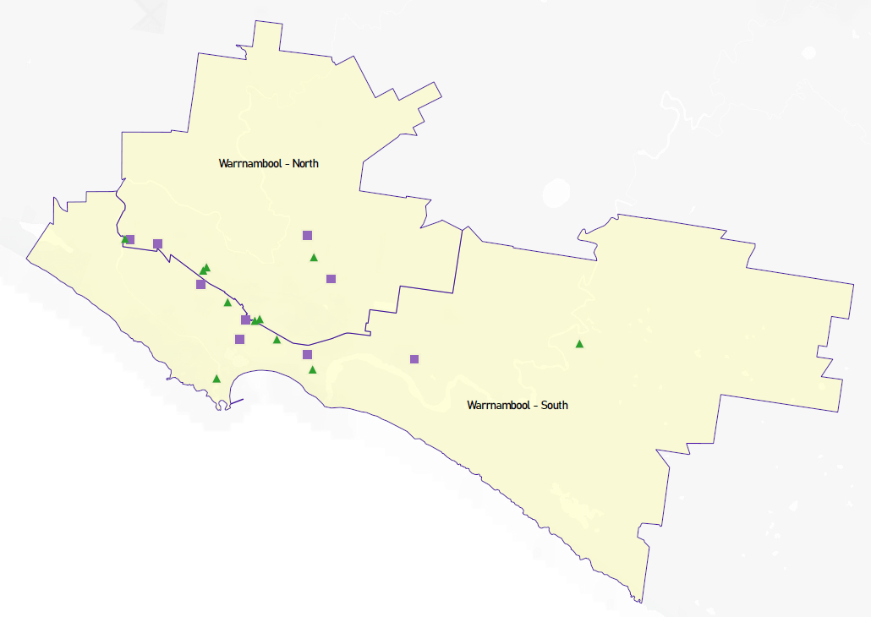

Local context
d

3.1 Purpose
Local, place-based knowledge and context play an important role in supporting the implementation of Three-Year-Old Kindergarten across Victoria. This section of the KISP documents this knowledge and context and has informed the funded kindergarten enrolment estimates in Section 4.

3.2 Key considerations
Key demographic trends that influence demand for kindergarten
Warrnambool City is located in south-western Victoria, about 260 kilometres from the Melbourne CBD. Warrnambool is the largest city in south-west Victoria. 84% of its population was born in Australia and 8 percent, overseas. Aboriginal and Torres Strait Islander population is 1.7%. As a single post-code municipality, Warrnambool covers 120 square kilometres, and contains the localities of Allansford, Dennington, Merrivale, South-East Hopkins, Warrnambool Central, Warrnambool North, Woodford and Bushfield. 5.5% of the city’s population require support and assistance with core activities.

Warrnambool has many outstanding and unique features, and a population that is growing at a steady rate of around 1.2%. As a vibrant regional centre, the city provides retail, professional, educational, social and health services to a regional catchment of approximately 100,000 people.

With a median age of 40, a labour force participation rate of over 60% and unemployment rate of 5.3%, Warrnambool boasts of a $4.5 billion economy which is over 25% of the Great South Coast economy. Health Care and Social Assistance is the largest employer and the Construction Industry makes the highest contribution to economic output at nearly $ 600 million per annum. Of the over 15,500 employees working in Warrnambool, 12,738 live in the municipality and the rest live in neighbouring municipalities with the largest cohort belonging to Moyne Shire at 1,480. Approximately 25% of people aged 15 and over are engaged in volunteer work. Overall, 3,503 residents aged between 15-64 report to be wholly disengaged, i.e., neither engaged in employment or education, and of them, 1,784 are in the age group of 25-54 years.

Total dwellings stand at 15,188 occupied by 13,554 households, with 28% of households as lone person households and 29% renting households. Most builds at just under 12,000 are separate houses and 2,875 are medium density properties. A significant 1,588 private homes remain unoccupied. Median weekly personal income stands at $619 and median weekly household income is $1,180 this well below the state average of $1,419. (ABS data 2016 census, updated 2019)

As part of the Victorian Government’s regional growth strategy, Council is preparing for significant industry diversification, economic growth and an associated population increase in the Local Government Area (LGA) from almost 37,225, in 2021 to more than 46,210 by 2036 (id.com, Forecast for Warrnambool 2016).
The number of babies and young children (0-4 years) in the City is expected to increase by almost 1000 children by 2036. This represents a 39% increase in the population of 0- 4 year olds living in Warrnambool and needing education and care services into the future.
Given the proximity of Moyne Shire to Warrnambool, many families that live in Moyne and work in Warrnambool choose to utilise services in Warrnambool.
As a regional centre, services located in Warrnambool already meet the needs of a proportion of families living outside the municipal boundary. This is especially the case for residents of Moyne Shire, with 15% of Warrnambool’s workforce residing in this neighbouring area. Another 4.1% come from other regional towns and cities. It is expected these figures will increase as a result of COVID (2016 Census)
This commuting workforce results in demand for Early Childhood Services from families living in Moyne. In 2021, approximately 8% of the families with children enrolled in kindergarten services liv W2040 community plan demonstrates the aspirations of the community to ensure children thrive and are given the best opportunities to education.
The Health and Wellbeing Plan 2017-2021 shows the needs of support for the community, Warrnambool has higher than the state average numbers of violence against women and children, high consumption of alcohol and other drugs and children who are falling behind with 18.3% of children at school entry developmentally vulnerable on one or more domains (AEDC). These have been identified as priorities within the plan to seek better outcomes for the community.
The figures in the SEIFA index of disadvantage in Warrnambool indicate consistent and relative levels of disadvantage compared to the state’s average 1010.1. Warrnambool is sitting at 986 which is lower than the state average and demonstrates that there is a higher level of vulnerability and disadvantage within the community. (i.d.community data, 2016 census)
Families experiencing disadvantage and vulnerability place limitations to transport options, this cost and time requirement could be a potential barrier for 3 year. old preschool engagement, this impact is already being seen through 4 year old engagement.
Enrolments and feedback from families and statistics of attendance over the last few years show families in Warrnambool predominately use stand-alone kindergarten for their child’s funded kindergarten year. Reasons for this use vary but include:
- Many families believe sessional kindergartens provide a better educational outcome than kindergarten in a Long Day Care setting, and favour them for that reason
- Costs differences between Long Day Care and standalone kindergarten show that generally standalone kindergarten is more affordable
- Sessional kindergartens are very popular amongst families and have always been well attended - many already offer long days of kindergarten (2 x 7.5 hours), to meet working parent’s needs.
Warrnambool City is experiencing significant population growth. By 2031 it is anticipated that the City’s population will be around 44,000 people, with the growth occurring across all age groups. This growth, along with accompanying population growth across the wider region, impacts on the demand for community services and infrastructure across the city.
Integrated multi-purpose community facilities, that provide places for the delivery and administration of efficient and effective community services and appropriate and flexible spaces for community activities, will be critical in maintaining liveability and a sense of community as well as supporting optimal community health and wellbeing, these kindergartens and childcare.
Other information about the expansion of early childhood services
The Community Service Infrastructure Plan and Policy 2013 revised in 2021 indicates the need for more infrastructure across the community. Most of the kindergarten standalone facilities are based around the city fringes and have been around in some instances for 70 years or more. There is a need for services to be in the new development areas across the city to meet the demand for services but also to ensure the lifestyle, health and wellbeing of families can be met and for families to be able to be within walking distance to facilities. The first hub identified as a need is to be located at the Brierly Reserve site North East of the City, close to the area of lowest SEFIA index within the community.
All kindergartens across the City are experiencing work force shortages and services are indicating they may struggle to deliver 3 year old kindergarten on top of the 4 year old programs that already exist even though they are keen to and understand the importance of the place 3 year old kinder plays in children’s development.
Workforce availability is likely going to be a challenge within the municipality to deliver 3 year. old kindergarten program with a shortage of teachers and diploma qualified work force. Whilst service’s infrastructure capacity can at times limit service delivery, it is more likely that room capacity will be limited by ratio and staffing requirements as this will limit the operational models and what can be provided across the municipality. If workforce issues are not adequately addressed this may impact on the service’s ability to offer 3 year old kindergarten to all eligible children.
COVID impact
In the first quarter of the pandemic 12,000 people moved from Melbourne to regional Victoria, The Great Australian Population Shift Report states that those regions two to three hours from the key metropolitan markets are the towns who are benefiting most from the population shift, Warrnambool was identified as being one of them. (id.com data)
The report states there are three underpinning reasons why the pandemic could influence people’s preferred lifestyle and living location into the future:
- We are now far more willing to work from home
- We favour larger properties, with room to form a home base, grow veggies and spend time with the kids; and
- We may be happy to live further from key CBD locations, because we are not commuting every day (Ripehouse Advisory 2020)
We still don’t know the full effects of COVID inward migration that population growth is occurring and is expected to rise even further. This will put pressure on services existing and see a need for further capacity within services. Warrnambool Planning Department have already seen unprecedented growth with building permits doubling in the 6 months leading up to December 2020. This coupled with new land sales growing with new estates having sold out in a week. Buyers and permit applications are a mix of existing residents and out of town buyers.
Increased levels of domestic violence have been reported during COVID and this will potentially impact on future kindergarten access and participation.

Funded kindergarten enrolment estimates between 2021-29 for the City of Warrnambool

4.1 Purpose
As Three-Year-Old Kindergarten is rolled-out and Victoria’s population grows, demand for both Three and Four-Year-Old Kindergarten places will increase significantly. While additional capacity will be needed to meet this demand, this will vary across the State and over time, due to differences in the capacity of existing services, growth trends and sector composition.
To identify where, when and how many additional kindergarten places are expected over the roll-out in the City of Warrnambool, Warrnambool City Council and the Department have developed:
- A summary of the current provision of kindergarten within the LGA (Section 4.3).
- An approach to optimising the utilisation of existing services and infrastructure through ‘change management’ strategies that Warrnambool City Council and the Department will support to help meet additional demand in the LGA (Section 4.4).
- An estimate of the Three and Four-Year-Old kindergarten places that cannot be met through existing services for the 2021-29 period, taking into account the additional demand that can be accommodated by optimising utilisation of existing services and infrastructure through point 2, above (Section 4.5).
Local Government and providers can use these published estimates to inform reform implementation activities such as service planning, kindergarten program expansion, infrastructure investments and Building Blocks funding applications in alignment with future demand over the 10-year roll-out.

4.2 Methodology
The estimated Three and Four-Year-Old Kindergarten places used in the following sections have been agreed between Warrnambool City Council and the Department, and were informed by:
- Estimates developed by the Department which draw on a range of inputs, including population forecasts, current enrolments and results from the Kindergarten Capacity Assessment Program (KCAP), conducted in 2019.
- The estimated capacity of new services that are planned to open in the LGA (Section 2)
- Local knowledge and context provided by the Local Government (Section 3) that explains particular issues and trends in their area.
- The approach to optimising utilisation of existing services in the LGA (Section 4.4), and
- Other sources, such as modelling undertaken by Local Governments and local data.
The KISP measures a service’s capacity to deliver funded kindergarten in terms of the number of children it could enrol in Three and Four-Year-Old Kindergarten. The number of funded kindergarten places is different from a service’s licensed or approved places, which count the number of children permitted to attend the service at any one time under the license. Many services can enrol more children in their funded kindergarten program(s) than they have licensed places for because they can run more than one kindergarten program per week. Kindergarten places are therefore a more accurate measure of service kindergarten capacity than licensed places.
Three-Year-Old Kindergarten places have been presented as 15-hour places so they can be easily compared to Four-Year-Old Kindergarten places. Moreover, when Three-Year-Old Kindergarten is fully rolled-out in 2029, every three-year-old child will have access to 15-hours of kindergarten.
From 2023 all providers will have flexibility to determine how many hours of funded Three-Year-Old Kindergarten they deliver per week, with a minimum of five hours and a maximum of 15-hours funded pro-rata. It is expected that hours offered will vary. Given this variation, it is important to be aware that during the transition to all three-year-old children receiving 15-hours of funded kindergarten per week in 2029, the 15-hour places presented in this report may represent multiple three-year-old places that individually receive less than 15-hours of kindergarten per week.
These estimates have been developed at an LGA and community level to show the overall forecast and variation within an area. The KISP defines community at the Statistical Area Level 2, which is medium-sized areas which represent a community that interacts socially and economically, with a population range of 3,000 to 25,000 people, and an average population of about 10,000 people.

4.3 Summary of current kindergarten provision
The figures below provide a summary of current kindergarten provision within the LGA and provide relevant context for the estimates of demand for funded kindergarten places included in Section 4.5. The data included in this section are largely drawn from:
- The Kindergarten Capacity Assessment Program (KCAP), collected between June and October 2019.
- The Department’s Kindergarten Information Management System (KIMS), as at 2019.
- The Department’s Quality and Regulatory Division (QARD) monitoring data, as at 2019.
- The National Quality Agenda IT System (NQAITS), as at March 2021.
- The Victorian Child and Adolescent Monitoring System (VCAMS), as at 2018.
Please note that, because these sources were collected at different points, this may result in slightly different totals appearing in the below data.
Number of services by service type (NQAITs, 2021)

Stand-alone kindergartens | 11
Long day care centres | 9

Percentage of services by management type, LGA level (NQAITs, 2021)
Type | Percentage
Local Government | 60%
Private not for profit | 20%
Private for profit | 15%
Other | 5%

Current kindergarten offering
Four-Year-Old Kindergarten participation rate (VCAMS, 2018): | 93%
Number of services that offer a funded kindergarten program (DET, 2019): | 18
Number of services that offer an unfunded Three-Year-Old Kindergarten program (DET, 2019): | 5
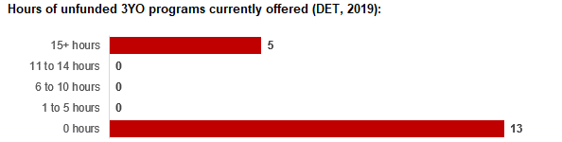

4.4 Approach to optimising the use of existing services and infrastructure
Change management strategies to optimise existing services and infrastructure
Children can often be accommodated through existing spare places and by services ‘unlocking’ unused capacity. As the experience of providers in the 2020 Three-Year-Old Kindergarten roll-out LGAs shows, while the optimisation of existing services can be challenging, it is highly time- and cost-effective compared to building new capacity through infrastructure projects. It also helps target infrastructure investment to the places that need it most and avoids over-supplying the local market.
Warrnambool City Council and the Department will support providers and services to maximise their kindergarten places through the following change management activities and practices:
- Increasing the capacity of any Local Government operated services by:
  - Running additional programs.
  - Using different timetables, including running 7.5-hour days.
  - Changing the delivery model, such as introducing rotational models or mixed-age groups.
  - Having degree-qualified kindergarten teachers leading integrated kindergarten programs in long day care settings.
- Encouraging and supporting other providers and services in the LGA to undertake change management.
Warrnambool City Council and the Department have estimated how many Three and Four-Year-Old Kindergarten places can be accommodated through existing services in the LGA (Table 1). Both parties are committed to helping providers and services offer these kindergarten places before progressing to funded infrastructure solutions to meet demand. This commitment is reflected in the LGA and community level estimates below (Table 2 onwards), which assume that demand will be met first through existing services and second through additional infrastructure. Note that in some cases the number of kindergarten places that can be offered through existing services may exceed demand for kindergarten places.
Table 1: Total estimated funded kindergarten places that can be offered by optimising existing services and infrastructure across the LGA, between 2021-29 (presented in 15-hour equivalent places)
 | 2021 | 2022 | 2023 | 2024 | 2025 | 2026 | 2027 | 2028 | 2029
Estimated existing supply of kindergarten places* | 1,013 | 1,013 | 1,013 | 1,013 | 1,013 | 1,013 | 1,013 | 1,013 | 1,013
*This may be higher than current three and four-year-old enrolments as it includes any spare places that are currently available or could be generated by making some minor adjustments to programming approaches.
**The likely expansion of services and kindergarten places in response to population growth (i.e. growth in demand not generated by the Three-Year-Old Kindergarten Reform that would likely occur) is not accounted for in these estimates.

4.5 Agreed estimates of demand for funded kindergarten places that cannot be met through existing services and infrastructure
The below estimates (Table 2 onwards) have been developed by Warrnambool City Council and the Department to illustrate the estimated:
- Total number of Three and Four-Year-Old Kindergarten places expected over the roll-out period.
- Three and Four-Year-Old Kindergarten places that cannot be accommodated by optimising existing services and infrastructure over the roll-out period.
These estimates have been developed to reflect that the increase in demand for Three-Year-Old Kindergarten places will be gradual.
In estimating how many Three and Four-Year-Old Kindergarten places cannot be accommodated by existing services and infrastructure, Warrnambool City Council and the Department have taken into account any new places that will be made available through planned expansions of existing services or new services, into estimates of existing supply, where this information is available. This may include Local Government owned services being developed and planned Kindergartens on School Sites.
These estimates do not, however, estimate how and when the broader sector will expand to meet the additional demand for kindergarten places that are estimated over the roll-out period.
Infrastructure need in the LGA and its local communities is indicated by the bottom rows of the tables in this section (Table 2 onwards): ‘Total kindergarten places that cannot be accommodated by existing services’. For example, if the number of kindergarten places for the LGA or a community is above zero in this row, it means that the area is estimated to need additional infrastructure (noting that further optimisation which avoids the need for additional infrastructure may be possible). Any type of provider – Local Government, not-for-profit or for-profit – can build this additional infrastructure. If this row shows all zeros, it means that there is no estimated need for additional infrastructure in the area.
Local Government and not-for-profit kindergarten providers must refer to the estimates in this section when applying through the Building Blocks Capacity Building Grants stream for Government funding. Under this stream, projects must be in a community where there is infrastructure need as shown in the community’s table of estimated demand for kindergarten places (i.e. there are numbers in the bottom row above zero). Projects in LGAs or communities where demand can be met through existing services (i.e. the bottom row shows all zeros) are not eligible for funding under this stream.
LGA estimates
Table 2: Total estimated three and four-year-old kindergarten places between 2021-29 (presented in 15-hour equivalent places)
LGA level estimates | 2021 | 2022 | 2023 | 2024 | 2025 | 2026 | 2027 | 2028 | 2029
Total estimated demand for kindergarten places (three and four-year-old children) | 494 | 612 | 686 | 734 | 773 | 839 | 874 | 909 | 956
Total kindergarten places that cannot be accommodated by existing services | 0 | 0 | 0 | 0 | 0 | 0 | 19 | 44 | 77

Community estimates
Table 3-4: Total estimated three and four-year-old kindergarten places between 2021-29 (presented in 15-hour equivalent places)
Warrnambool – North estimates | 2021 | 2022 | 2023 | 2024 | 2025 | 2026 | 2027 | 2028 | 2029
Total estimated demand for kindergarten places (three and four-year-old children) | 282 | 359 | 407 | 441 | 468 | 514 | 538 | 563 | 596
Total kindergarten places that cannot be accommodated by existing services | 0 | 0 | 0 | 0 | 0 | 0 | 19 | 44 | 77

Warrnambool – South estimates | 2021 | 2022 | 2023 | 2024 | 2025 | 2026 | 2027 | 2028 | 2029
Total estimated demand for kindergarten places (three and four-year-old children) | 213 | 253 | 279 | 293 | 305 | 326 | 336 | 346 | 360
Total kindergarten places that cannot be accommodated by existing services | 0 | 0 | 0 | 0 | 0 | 0 | 0 | 0 | 0

Authorisation
The Area Executive Director (Wimmera South West) of the Department of Education and Training and the Chief Executive of Warrnambool City Council endorse this Kindergarten Services and Infrastructure Plan (KISP) for the City of Warrnambool by signing on 05 / 08 / 2021.
This KISP is not intended to create legal relations or constitute a legally binding contractual agreement between the parties. The parties may review this KISP in 2024 to publish a new version that will replace the previous version.
An out-of-cycle review may be triggered if both parties agree that there has been a change in relevant data, information or the local early childhood sector that significantly affects the reliability of a KISP’s estimates for planning purposes.

Signed for and on behalf and with the authority of Warrnambool City Council

…………………………………… …………………………………
Signature Witness Signature

Name: Peter Schneider
Title: Chief Executive Officer
Address: PO Box 198, Warrnambool 3280

Signed by Area Executive Director (Wimmera South West) Department of Education and Training

…………………………………… …………………………………
Signature Witness Signature

Name: Suzanne Camm

Title: Area Executive Director (Wimmera South West)

Address: PO Box 1127, Warrnambool 3280

