Kindergarten Infrastructure and
Services Plan
Swan Hill Rural City Council
CONTENTS
1. Introduction 3
1.1. Reform context 3
1.2. Purpose of KISPs 3
1.3. How to use the KISP 3
1.4. Structure of the KISP 3
1.5. Disclaimer 4
2. Map of Early Childhood Education services in the Rural City of Swan Hill 5
3. Local context 6
3.1 Purpose 6
3.2 Key considerations 6
4. Funded kindergarten enrolment estimates between 2021-29 for the Rural City of Swan Hill 11
4.1 Purpose 11
4.2 Methodology 11
4.3 Summary of current kindergarten provision 12
4.4 Approach to optimising the use of existing services and infrastructure 13
4.5 Agreed estimates of demand for funded kindergarten places that cannot be met through existing services and infrastructure 14
5. Authorisation 17

Introduction

Reform context
In an Australian first, the Victorian Government has committed to implement Three-Year-Old Kindergarten for all children over a 10-year roll-out with a total investment of almost $5 billion, including $1.68 billion to support the infrastructure expansion required for the reform. This reform will add another year of universal funded kindergarten so that, by 2029, all children in Victoria will have access to two years of play-based learning through a funded kindergarten program.

Purpose of KISPs
Three-Year-Old Kindergarten will require a large expansion of kindergarten across the State. The Government has invited all 79 Victorian Local Governments to discuss and agree upon a Kindergarten Infrastructure and Services Plan (KISP) for their Local Government Area (LGA).
Each KISP has been jointly developed with Local Government and published to estimate the growth in demand for kindergarten within the LGA. The KISPs will help all kindergarten providers meet demand and provide a clear picture of infrastructure need across the State.
While a KISP is not a funding document and does not define required infrastructure projects or commit any party to funding specific projects, it is expected that future investment requests through Building Blocks and funding decisions about Local Government and not-for-profit projects would align with the relevant KISP.

How to use the KISP
Each KISP contains estimates of future kindergarten supply of, and demand for, Three and Four-Year-Old Kindergarten places against existing enrolment capacity. Not-for-profit and for-profit providers can use these estimates to inform their plans to expand kindergarten programs, establish new services or invest in new or extended facilities.
For example, KISPs provide demand estimates in terms of where, when and how much demand for kindergarten places will grow in an LGA. KISPs also estimate where and how many kindergarten places providers can accommodate in existing facilities before an area needs new infrastructure to meet demand. The estimates can be used to inform decisions about where and when expansions of kindergarten program capacity and the construction of new or extended facilities are needed to meet demand growth.
Where there is an agreed KISP for the LGA, the Local Government and not-for-profit kindergarten providers seeking co-investments through the Building Blocks Capacity Building stream must refer to, and align their proposed project with, the infrastructure need identified in the KISP.

Structure of the KISP
Each KISP consists of the following sections:
- Section 1: A short introduction to the Three-Year-Old Kindergarten reform and the KISP.
- Section 2: A map of existing and planned Early Childhood Education and Care service locations.
- Section 3: Local knowledge and context relevant to the expansion of kindergarten services.
- Section 4: Funded kindergarten demand estimates.

Disclaimer
All data presented in this document are estimates only and are based on the best information available to the Department and Local Government at the time. They are published on an as-is basis and are for informational purposes only. They are subject to adjustment in response to market forces and as new data and other relevant information becomes available. The data may under- or over-estimate both total demand in a given location or year and the capacity for new demand to be met by providers. As a result, operational and business decisions should not be made solely based on this document. Any use of this data is solely at the risk of the user. The Department and Local Government accept no responsibility for any loss or damage, either direct or incidental, that may result from the use of the data.

Map of Early Childhood Education services in the Rural City of Swan Hill
The map below shows the distribution of currently operating and new services that are planned to open in the future in the LGA and across its communities.
This map has been prepared using Departmental data, from both the National Quality Agenda IT System (NQAITS) and the Victorian School Building Authority (VSBA). Where applicable, this map has been refined by the Swan Hill Rural City Council and the Department to capture other services that are planned to open in the future.
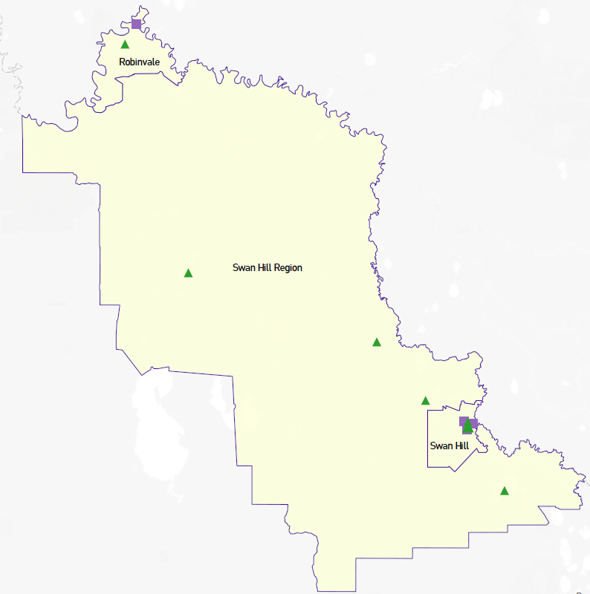
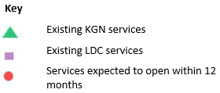

Local context
d

3.1 Purpose
Local, place-based knowledge and context play an important role in supporting the implementation of Three-Year-Old Kindergarten across Victoria. This section of the KISP documents this knowledge and context and has informed the funded kindergarten enrolment estimates in Section 4.

3.2 Key considerations
Key demographic trends that influence demand for kindergarten
Based on the 2016 ABS Census of Population and Housing the Swan Hill LGA has a population of 20,584 people and 4,942 families. In total 832 people (4% of the LGA population) identify as Aboriginal and/or Torres Strait Islander.
Of our population 74.7% were born in Australia - more than 15,000 of our 20,000 community members. This contrasts with 81.9% of our population identifying as Australian born in the 2011 Census confirming an increasing cultural diversity across our municipality. At the time of the 2016 Census there were 3,408 children aged 0-12 years. Consistent annual birth rates would suggest this number remains relatively constant.
The Swan Hill city itself has a population of almost 11,000 and is a regional service centre for some 40,000 people across the catchment. This catchment stretches along the Murray Valley into the state’s Mallee and the Western Riverina and Far West in New South Wales. The next largest centre within the Swan Hill Rural City municipality is Robinvale. Robinvale has a registered population of 3,313 (at the SA2 level) which is disputed to be more accurately between a minimum of 7,205 and a maximum of 12,131.

AGE BY SEX Count of persons - 2016 Census of Population and Housing SHRCC
Age (years): | Males | Females | Persons
0 | 141 | 110 | 257
1 | 154 | 117 | 265
2 | 119 | 127 | 240
3 | 151 | 117 | 270
4 | 159 | 134 | 295
0-4 years | 718 | 607 | 1,326
https://quickstats.censusdata.abs.gov.au/census_services/getproduct/census/2016/communityprofile/LGA26610?opendocument

Projects or trends that may influence supply of early childhood education and care
Birth Notifications
The number of birth notifications received by the Swan Hill Rural City Council Maternal and Child Health Service per year may fluctuate from time to time but is relatively consistent averaging receipt of 315.5 birth notifications per year over the past eight years.
Birth Notifications Received 1/7/2016 –30/10/2020
 | SHRCC TOTAL  Birth Notifications | Robinvale and Manangatang Birth Notifications | Swan Hill, Ultima, Lake Boga, Nyah West, Piangil  Birth Notifications
2020/2021 | 110 | 18 | 92
2019/2020 | 340 | 80 | 260
2018/2019 | 296 | 77 | 219
2017/2018 | 313 | 62 | 251
2016/2017 | 338 | 82 | 256
SHRCC MCH Annual Reports Data

Mapping Kindergarten Service Supply and Demand
Swan Hill
As reported in the Swan Hill Rural City Council Early – Middle Years Plan (2020 -2029 Background Document – Mapping Service and Staffing Supply Demand) it is only within the city of Swan Hill itself that there is any anticipated risk of kindergarten supply being outstripped by demand with the implementation of funded kindergarten to three-year olds. The current and projected population of three and four year olds within the city of Swan Hill, based on 2016 Census of Population and Housing data and Swan Hill Rural City Council Birth Notifications, suggests there will be an annual average of approximately 330 three and four- year- olds. As such the mapping of demand presented below applies specifically to Swan Hill.
Since the adoption of the MEMYP there has been some changes in services delivering kindergarten programs in Swan Hill and some proposed new services which suggests adequate infrastructure will exist to meet the growing demand arising from the three-year- old kindergarten rollout. These include:
- The closure of the Goodstart Beveridge St Swan Hill (Long Day Care Centre)
- A new kindergarten service known as Shamrock Park to be opened at St Mary’s School Primary Swan Hill
- A new Long Day Care Centre is proposed next to the FLO Campus in Swan Hill
- Potential for a new kindergarten to open at a primary school site.

Robinvale
The next largest community within the Swan Hill municipality, Robinvale, has benefitted from recent early childhood education and care service refurbishments at Murray Valley Aboriginal Co-operative and new build (Robinvale Preschool). Murray Valley Aboriginal Cooperative is an Integrated Long Day Care (LDC) service operating 5 days a week, which is also co-located with the three and four-year-old kindergarten service. Licensed to accommodate 95 children the service currently provides 22 kindergarten places weekly (limited to this number due to availability of qualified staff) within this setting. Built in 2019 the new Robinvale Preschool (previously located on Leonora St) is now onsite at Robinvale College. Whilst Robinvale Preschool currently only operates one room there is a second room which can be activated as needed (assuming there are sufficient and qualified staff). The two-room service has the potential to a total of 66 approved kindergarten places (with capacity for up to 100 enrolments).
The current and projected population of three and four-year-olds within the SA2 of Robinvale, based on 2016 Census of Population and Housing data (approximate annual age cohort of 50 children / young people) and Birth Notifications (an average of 70 in 2017-2018 68 births and 2018-2019 71 births), suggests there will be an annual average of approximately 120 three and four-year-olds combined. Based on this kindergarten demand would be met by the two current providers. However, recent research by Geographia suggests a significant ‘undercount’ of the Robinvale population through the traditional Census mechanisms.
Council Owned Kindergarten Infrastructure
Council owns 6 kindergarten centres which were included in the SHRCC Audit of Early Years Infrastructure Report, 2013.
Swan Hill Kindergarten Infrastructure
As identified in the report Swan Hill North Preschool and Swan Hill South Preschool will both need major refurbishment or replacement. The realisation of the physical/infrastructure capacity by new entrants into the kindergarten sector should be closely monitored before investing in the ageing infrastructure of Swan Hill North and South Preschool.
In the MEMYP it has been clearly identified that there is a need for MCH Services to be co-located within a Regional Children’s Hub in Swan Hill that can accommodate other early years services, early intervention services and/or allied health services with programs and activities that support children, parents and families .
Feedback gained from families through the MEMYP consultation indicates increasing community receptiveness to accessing preschool on-site at schools and through the integrated Long Day Care setting – with key reasons cited as continuity of educational journey, convenience and longer hours provided.
Woorinen South Kindergarten Infrastructure
New entrants into kindergarten program delivery may impact on the Woorinen South Preschool enrolments into the future and may have flow-on effects to enrolments at Woorinen District Primary School. Co-location of Woorinen Preschool onto Woorinen District Primary School grounds attracted some early positive parent and broader community interest through the consultation process and the conversation needs to be continued.
The future location of MCH services and playgroups in Woorinen South will be considered as part of the planned community consultation in relation to the future of the Woorinen South preschool.

Manangatang and District Kindergarten Infrastructure
The Manangatang and District Preschool is the oldest kindergarten infrastructure within the Swan Hill municipality and is a single standalone sessional kindergarten service. Manangatang and District Preschool currently operates well under its possible capacity with no expectation that demand above capacity will be a concern. The kindergarten is located within the Manangatang Community Centre and the cost of upgrades to the building will likely be prohibitive. Future consideration will need to be taken and one option may include relocation of the service on the local school site. This option needs further scoping and consultation.
The future location of MCH services and playgroups in Manangatang will be considered as part of the planned community consultation in relation to the future of the Manangatang preschool.
Community Consultations
A comprehensive community consultation will be planned in Swan Hill, Manangatang and Woorinen South during 2021/2022 to hear from community and co-design future infrastructure needs (subject to any future pandemic restrictions).
Nyah West, Lake Boga and Robinvale Kindergarten Infrastructure
The remaining Council owned preschools have undergone refurbishment or a new build in recent years and they all include a consultation room to MCH service (or other visiting service).
- The Nyah West Preschool was refurbished in 2013/2014.
- The Lake Boga Preschool was refurbished in 2019
- The Robinvale College Early Learning Centre was newly constructed in 2019.

Key local geographic considerations or information relevant to Three-Year-Old Kindergarten
The Swan Hill Rural City municipality covers a geographical area f 6115.3km2 and stretches from Lake Boga and Tresco communities in the south to Robinvale in the north and bordered by the Murray River for its Eastern and Northern boundary.
Generally, families across the municipality want their children to attend kindergarten close to where they live unless for instance a parent resides in one community but works in another and may subsequently seek care and education closer to where they work. Travel to kindergarten in another location is not an option for most families due to the distance. In terms of looking at where families might travel so that their children can attend kindergarten it is anticipated that:
- Families residing in Swan Hill city will choose a kindergarten in Swan Hill with some opting to travel a short distance (12kms) to Woorinen South.
- Families residing in Robinvale will choose a kindergarten in Robinvale as the closest other option in Manangatang is 56 kms away.
- Families residing in Manangatang will choose kindergarten in Manangatang as they are 56 kms from their closest alternative options in Robinvale or Nyah West.
- Families in Nyah West and surrounds will choose kindergarten in Nyah West, but some may opt to travel to 20 km to Woorinen South or 30 km to Swan Hill.
- Families residing in Woorinen South and surrounds will choose kindergarten in Woorinen South but may opt to travel 12kms to Swan Hill or 20kms to Nyah West.
- Families residing in Lake Boga will choose kindergarten in Lake Boga but may opt to travel to 17kms to Swan Hill.
Public transport is not available in any of our smaller communities and is limited in Swan Hill.
Other information about the expansion of early childhood services
Childcare – gaps in equitable service delivery
Broadly speaking the childcare needs of Swan Hill city-based families are being much better met than that their rural and Robinvale based peers. Amongst all communities there is the need for childcare hours which better met the needs of working families in terms of earlier drop off times and for a small, but incredibly important, portion of our community – those families with children with additional needs.
Workforce challenges
The dynamic nature of staffing makes this difficult to track and predict. Data obtained from the Capacity Assessment interviews conducted in 2019 is provided at the municipal level so information cannot be differentiated to community level. Recruitment and retention of suitably qualified educators is currently a challenge and will be into the future.

Funded kindergarten enrolment estimates between 2021-29 for the Rural City of Swan Hill

4.1 Purpose
As Three-Year-Old Kindergarten is rolled-out and Victoria’s population grows, demand for both Three and Four-Year-Old Kindergarten places will increase significantly. While additional capacity will be needed to meet this demand, this will vary across the State and over time, due to differences in the capacity of existing services, growth trends and sector composition.
To identify where, when and how many additional kindergarten places are expected over the roll-out in the Rural City of Swan Hill, Swan Hill Rural City Council and the Department have developed:
- A summary of the current provision of kindergarten within the LGA (Section 4.3).
- An approach to optimising the utilisation of existing services and infrastructure through ‘change management’ strategies that Swan Hill Rural City Council and the Department will support to help meet additional demand in the LGA (Section 4.4).
- An estimate of the Three and Four-Year-Old kindergarten places that cannot be met through existing services for the 2021-29 period, taking into account the additional demand that can be accommodated by optimising utilisation of existing services and infrastructure through point 2, above (Section 4.5).
Local Government and providers can use these published estimates to inform reform implementation activities such as service planning, kindergarten program expansion, infrastructure investments and Building Blocks funding applications in alignment with future demand over the 10-year roll-out.

4.2 Methodology
The estimated Three and Four-Year-Old Kindergarten places used in the following sections have been agreed between Swan Hill Rural City Council and the Department, and were informed by:
- Estimates developed by the Department which draw on a range of inputs, including population forecasts, current enrolments and results from the Kindergarten Capacity Assessment Program (KCAP), conducted in 2019.
- The estimated capacity of new services that are planned to open in the LGA (Section 2)
- Local knowledge and context provided by the Local Government (Section 3) that explains particular issues and trends in their area.
- The approach to optimising utilisation of existing services in the LGA (Section 4.4), and
- Other sources, such as modelling undertaken by Local Governments and local data.
The KISP measures a service’s capacity to deliver funded kindergarten in terms of the number of children it could enrol in Three and Four-Year-Old Kindergarten. The number of funded kindergarten places is different from a service’s licensed or approved places, which count the number of children permitted to attend the service at any one time under the license. Many services can enrol more children in their funded kindergarten program(s) than they have licensed places for because they can run more than one kindergarten program per week. Kindergarten places are therefore a more accurate measure of service kindergarten capacity than licensed places.
Three-Year-Old Kindergarten places have been presented as 15-hour places so they can be easily compared to Four-Year-Old Kindergarten places. Moreover, when Three-Year-Old Kindergarten is fully rolled-out in 2029, every three-year-old child will have access to 15-hours of kindergarten.
From 2023 all providers will have flexibility to determine how many hours of funded Three-Year-Old Kindergarten they deliver per week, with a minimum of five hours and a maximum of 15-hours funded pro-rata. It is expected that hours offered will vary. Given this variation, it is important to be aware that during the transition to all three-year-old children receiving 15-hours of funded kindergarten per week in 2029, the 15-hour places presented in this report may represent multiple three-year-old places that individually receive less than 15-hours of kindergarten per week.
These estimates have been developed at an LGA and community level to show the overall forecast and variation within an area. The KISP defines community at the Statistical Area Level 2, which is medium-sized areas which represent a community that interacts socially and economically, with a population range of 3,000 to 25,000 people, and an average population of about 10,000 people.

4.3 Summary of current kindergarten provision
The figures below provide a summary of current kindergarten provision within the LGA and provide relevant context for the estimates of demand for funded kindergarten places included in Section 4.5. The data included in this section are largely drawn from:
- The Kindergarten Capacity Assessment Program (KCAP), collected between June and October 2019.
- The Department’s Kindergarten Information Management System (KIMS), as at 2019.
- The Department’s Quality and Regulatory Division (QARD) monitoring data, as at 2019.
- The National Quality Agenda IT System (NQAITS), as at April 2020.
- The Victorian Child and Adolescent Monitoring System (VCAMS), as at 2018.
Please note that, because these sources were collected at different points, this may result in slightly different totals appearing in the below data.
Number of services by service type (NQAITs, 2020)

Stand-alone kindergartens | 8
Long day care centres | 6

Percentage of services by management type, LGA level (NQAITs, 2020)
Type | Percentage
Local Government | 0%
Private not for profit | 71%
Private for profit | 21%
Other | 7%

Current kindergarten offering
Four-Year-Old Kindergarten participation rate (VCAMS, 2018): | 97%
Number of services that offer a funded kindergarten program (DET, 2019): | 11
Number of services that offer an unfunded Three-Year-Old Kindergarten program (DET, 2019): | 6
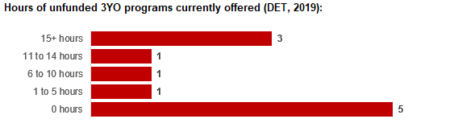

4.4 Approach to optimising the use of existing services and infrastructure
Change management strategies to optimise existing services and infrastructure
Children can often be accommodated through existing spare places and by services ‘unlocking’ unused capacity. As the experience of providers in the 2020 Three-Year-Old Kindergarten roll-out LGAs shows, while the optimisation of existing services can be challenging, it is highly time- and cost-effective compared to building new capacity through infrastructure projects. It also helps target infrastructure investment to the places that need it most and avoids over-supplying the local market.
Swan Hill Rural City Council and the Department will support providers and services to maximise their kindergarten places through the following change management activities and practices:
- Increasing the capacity of any Local Government operated services by:
  - Running additional programs.
  - Using different timetables, including running 7.5-hour days.
  - Changing the delivery model, such as introducing rotational models or mixed-age groups.
  - Having degree-qualified kindergarten teachers leading integrated kindergarten programs in long day care settings.
- Encouraging and supporting other providers and services in the LGA to undertake change management.
Swan Hill Rural City Council and the Department have estimated how many Three and Four-Year-Old Kindergarten places can be accommodated through existing services in the LGA (Table 1). Both parties are committed to helping providers and services offer these kindergarten places before progressing to funded infrastructure solutions to meet demand. This commitment is reflected in the LGA and community level estimates below (Table 2 onwards), which assume that demand will be met first through existing services and second through additional infrastructure. Note that in some cases the number of kindergarten places that can be offered through existing services may exceed demand for kindergarten places.
Table 1: Total estimated funded kindergarten places that can be offered by optimising existing services and infrastructure across the LGA, between 2021-29 (presented in 15-hour equivalent places)
 | 2021 | 2022 | 2023 | 2024 | 2025 | 2026 | 2027 | 2028 | 2029
Estimated existing supply of kindergarten places* | 563 | 563 | 563 | 563 | 563 | 563 | 563 | 563 | 563
*This may be higher than current three and four-year-old enrolments as it includes any spare places that are currently available or could be generated by making some minor adjustments to programming approaches.

4.5 Agreed estimates of demand for funded kindergarten places that cannot be met through existing services and infrastructure
The below estimates (Table 2 onwards) have been developed by Swan Hill Rural City Council and the Department to illustrate the estimated:
- Total number of Three and Four-Year-Old Kindergarten places expected over the roll-out period.
- Three and Four-Year-Old Kindergarten places that cannot be accommodated by optimising existing services and infrastructure over the roll-out period.
These estimates have been developed to reflect that the increase in demand for Three-Year-Old Kindergarten places will be gradual.
In estimating how many Three and Four-Year-Old Kindergarten places cannot be accommodated by existing services and infrastructure, Swan Hill Rural City Council and the Department have taken into account any new places that will be made available through planned expansions of existing services or new services, into estimates of existing supply, where this information is available. This may include Local Government owned services being developed and planned Kindergartens on School Sites.
These estimates do not, however, estimate how and when the broader sector will expand to meet the additional demand for kindergarten places that are estimated over the roll-out period.
Infrastructure need in the LGA and its local communities is indicated by the bottom rows of the tables in this section (Table 2 onwards): ‘Total kindergarten places that cannot be accommodated by existing services’. For example, if the number of kindergarten places for the LGA or a community is above zero in this row, it means that the area is estimated to need additional infrastructure (noting that further optimisation which avoids the need for additional infrastructure may be possible). Any type of provider – Local Government, not-for-profit or for-profit – can build this additional infrastructure. If this row shows all zeros, it means that there is no estimated need for additional infrastructure in the area.
Local Government and not-for-profit kindergarten providers must refer to the estimates in this section when applying through the Building Blocks Capacity Building Grants stream for Government funding. Under this stream, projects must be in a community where there is infrastructure need as shown in the community’s table of estimated demand for kindergarten places (i.e. there are numbers in the bottom row above zero). Projects in LGAs or communities where demand can be met through existing services (i.e. the bottom row shows all zeros) are not eligible for funding under this stream.
LGA estimates
Table 2: Total estimated three and four-year-old kindergarten places between 2021-29 (presented in 15-hour equivalent places)
LGA level estimates | 2021 | 2022 | 2023 | 2024 | 2025 | 2026 | 2027 | 2028 | 2029
Total estimated demand for kindergarten places (three and four-year-old children) | 253 | 322 | 346 | 372 | 392 | 426 | 443 | 460 | 483
Total kindergarten places that cannot be accommodated by existing services | 0 | 0 | 0 | 0 | 0 | 0 | 0 | 0 | 5

Community estimates
Table 3-5: Total estimated three and four-year-old kindergarten places between 2021-29 (presented in 15-hour equivalent places)
Robinvale estimates |  | 2021 |  | 2022 |  | 2023 |  | 2024 |  | 2025 |  | 2026 |  | 2027 |  | 2028 |  | 2029
Total estimated demand for kindergarten places (three and four-year-old children) |  | 54 |  | 77 |  | 79 |  | 80 |  | 81 |  | 83 |  | 84 |  | 85 |  | 87
Total kindergarten places that cannot be accommodated by existing services |  | 0 |  | 0 |  | 0 |  | 0 |  | 0 |  | 0 |  | 0 |  | 0 |  | 0
Swan Hill estimates | 2021 |  | 2022 |  | 2023 |  | 2024 |  | 2025 |  | 2026 |  | 2027 |  | 2028 |  | 2029
Total estimated demand for kindergarten places (three and four-year-old children) | 151 |  | 192 |  | 206 |  | 221 |  | 233 |  | 254 |  | 264 |  | 274 |  | 288
Total kindergarten places that cannot be accommodated by existing services | 0 |  | 0 |  | 0 |  | 0 |  | 0 |  | 0 |  | 0 |  | 0 |  | 5

Swan Hill Region estimates | 2021 | 2022 | 2023 | 2024 | 2025 | 2026 | 2027 | 2028 | 2029
Total estimated demand for kindergarten places (three and four-year-old children) | 48 | 67 | 74 | 80 | 85 | 94 | 98 | 103 | 108
Total kindergarten places that cannot be accommodated by existing services | 0 | 0 | 0 | 0 | 0 | 0 | 0 | 0 | 0

Authorisation
The Area Executive Director (Mallee) of the Department of Education and Training and the Chief Executive of Swan Hill Rural City Council endorse this Kindergarten Services and Infrastructure Plan (KISP) for the Rural City of Swan Hill by signing on 14/12/2021.
This KISP is not intended to create legal relations or constitute a legally binding contractual agreement between the parties. The parties may review this KISP in 2024 to publish a new version that will replace the previous version.
An out-of-cycle review may be triggered if both parties agree that there has been a change in relevant data, information or the local early childhood sector that significantly affects the reliability of a KISP’s estimates for planning purposes.
Signed for and on behalf and with the authority of Swan Hill Rural City Council

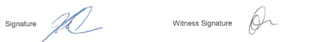

Name: John McLinden

Title: Chief Executive Officer

Address: 45 Splatt Street, Swan Hill, Victoria, 3585

Signed by Area Executive Director (Mallee), Department of Education and Training
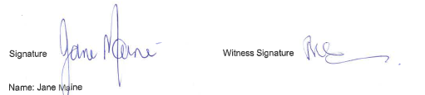

Title: Area Executive Director (Mallee)
Address: 91 Pine Avenue, Mildura, Victoria 3500

Research by GeoGraphia (Robinvale Population Determination Briefing Paper, prepared for Swan Hill Rural City Council July 2019) outlines a population estimation exercise to provide a more accurate measure of the actual, daily resident population in the Robinvale SA2

