QUICK REFERENCE GUIDE

HOW TO MANAGE USERS IN THE KINDERGARTEN INFORMATION MANAGEMENT SYSTEM (KIMS)
This guide provides step-by-step instructions for managing users in the Kindergarten Information Management System (KIMS).

There are two types of Administrators.
- The EduPass Org Admin
- The KIMS Service Provider Admin (there can be more than one of these)
When the Service Provider is fist created, the Early Childhood Improvement Branch will complete a form to have the EduPass Org Admin created. This FIRST user will be given the dual role of being the EduPass Org Admin and the Service Provider Admin in KIMS with access to all Services.
To add more users to the KIMS platform:
- The EduPass Org Admin will need to send out EduPass invitations to the new users.
- The new users will then need to accept the invite and create an EduPass ID.
- They will be given access to KIMS, but the KIMS Service Provider Admin will need to allocate Roles / Permissions and Services to them (as below).
To change which data and Services that Users can see:
- The KIMS Service Provider Admin will change the Roles / Permissions and Services under that Service Provider.
The KIMS Service Provider Admin
There can be more one KIMS Service Provider Admin, you just need to allocate the role to another User.
The KIMS Service Provider Admin will be responsible for:
- Assigning User Roles - There are three types of roles available
- Assign data Permissions – to Kindergarten Data or School Readiness Funding
- Assigning Services to the user to enable them to access a Service profile
User Roles:
- Service Provider Admin – this role is given to the Service Providers’ Organisation Administrator. They can access all kindergarten and School Readiness Funding Information (including financial information). They are able to complete the User Management tasks listed above.
- Service Provider – this role can access kindergarten and/or School Readiness Funding information (including financial information) and add/update services depending on the permissions it has been allocated.
- Service – this role can an access kindergarten and/or School Readiness Funding Information for their assigned service/s. They cannot access financial information.
Permissions:
- Both – this permission allows the user to access both the Kindergarten and the School Readiness Funding data
- SRF Only – This permission allows the user to access only School Readiness Funding plans, this could be given to an Educator working on the School Readiness Funding plan
- Kindergarten Data only – This permission allows the user to access only the Kindergarten data and could be given to an administrator of a service.
Status:
- This will show if the User is Active or Inactive in EduPass.
- To remove a staff member, contact the Helpdesk to make that person Inactive in KIMS and EduPass.
- Every year the EduPass system will suspend all accounts, and all users will need to request an extension.
Services
- Each user can be allocated one or more Services from that Service Provider

Overview of the process for managing users in KIMS
Editing Roles and Permissions  - Click Service Provider/Services tab  - Click User Management tab  - Locate the user to update from the list of Users  Click Edit  - Select a User Role from the drop-down options  - Select a Permission from the drop-down options.  Note: A User’s Role or Permissions can be changed for more access or to limit access  - Click Save | Assigning Services to a User  - Click Service Provider/Services tab  - Click User Management tab  - Locate the user to update from the list of users  Click Assign Services  - Click on the service to assign to the user from the Available Services list, click the arrow to move the service into the Selected Services list.  Note: To select multiple services to assign to a user, hold down the Ctrl button while clicking on the desired services.  - Click Save

System Steps for managing users in the Kindergarten Information Management System
EDITING ROLES AND PERMISSIONS
- Click Service Provider/Services tab

- Click User Management tab

- Locate the user to update from the list of Users
Click Edit
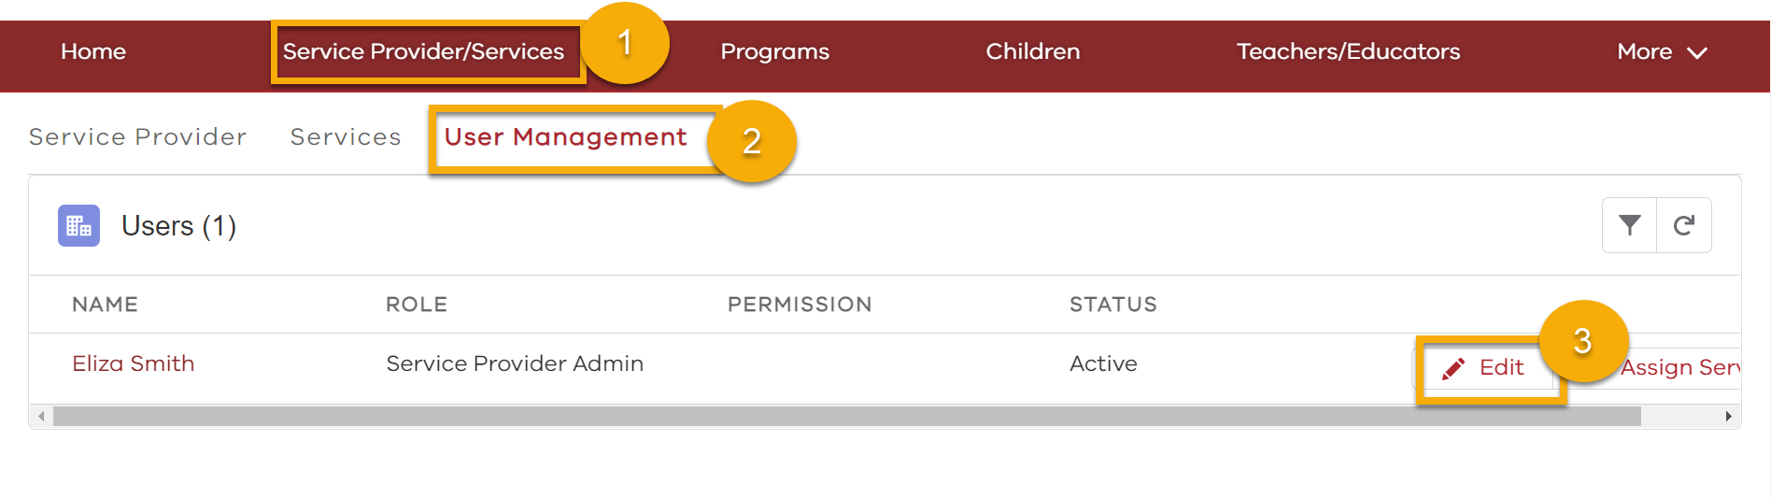

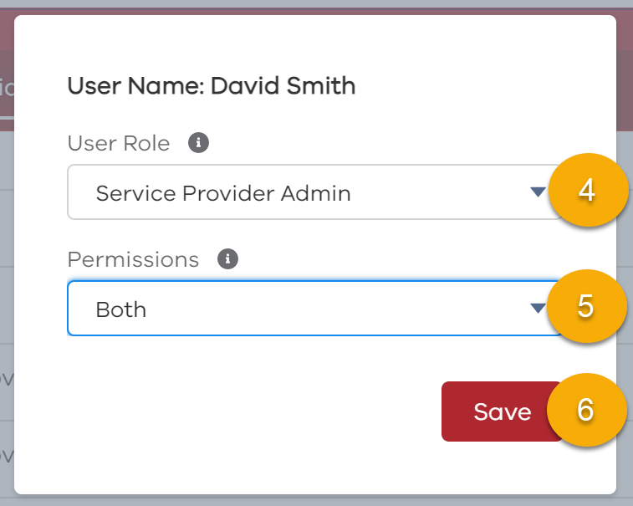
- Select a User Role from the drop-down options
- Select a Permission from the drop-down options.
Note: A User’s Role or Permissions can be changed for more access or to limit access
- Click Save
Note: Any changes made will appear update immediately.

ASSIGNING SERVICES TO A USER
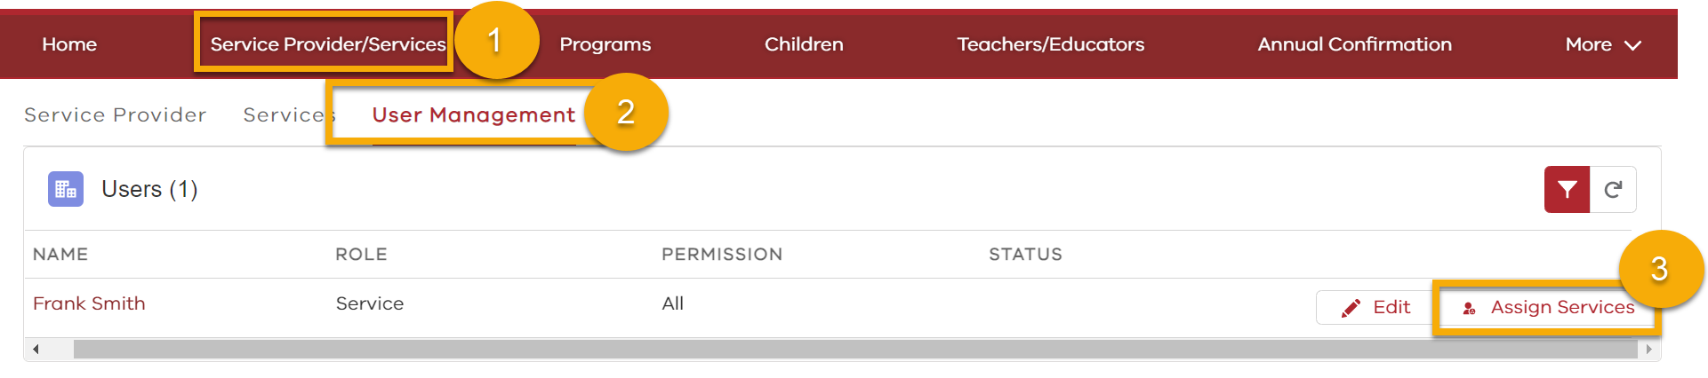
- Click Service Provider/Services tab

- Click User Management tab

- Locate the user to update
Click Assign Services

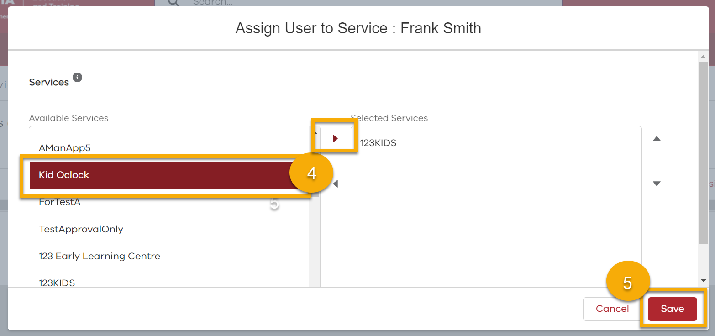
- Click on the service to assign to the user from the Available Services list, click the arrow to move the service into the Selected Services list.
Note: To select multiple services to assign to a user, hold down the Ctrl button while clicking on the desired services.

- Click Save

