QUICK REFERENCE GUIDE

How to complete the annual census in the Kindergarten Information Management System (KIMS)

This guide provides step-by-step instructions for completing the Annual Census in KIMS.
Every August all VIC Government-funded community kindergartens (services) must complete the early childhood education Annual Preschool Census. The census is completed and submitted in KIMS.
The census is open each year in August (dates subject to change depending on federal government advice) and services must submit the Annual Census by the requested date - late submissions cannot be processed.
The Annual Census is completed for all services regardless of program model.
- Sessional
- Integrated Long Day Care
- Both Sessional and Integrated Long Day Care

However, this guide will cover the steps for all these three program models.
Separate guides are available within KIMS for services that only offer Sessional OR Integrated Long Day Care programs
The census includes: 3YO and 4YO per capita funded children

Children accessing Early Start Kindergarten or Access to Early Learning funding are not required to be included and will NOT appear in the Annual Census.
Overview of process for completing the Annual Census in KIMS
- Click the More tab
- Select Annual Census from the drop down options
- Click the Annual Census name to open it. You may only have one displayed, or more than one, depending on your KIMS access.
- Enter the normal weekly fee paid by families for children to attend the kindergarten program. Note: If the children are accessing Free Kinder Funding enter $0.
- Confirm all the children listed have a green Child Completion Indicator flag.

- Complete Census information for each child
- If the Group field has a populated entry (e.g. Wombat Group) this indicates the child is a sessional child. These children require days and fees.
- If the Group field is blank this indicates this is an integrated long day care child. These children require days, hours and minutes at the kindergarten and at the long day care.
- Confirm all the children listed have a green Annual Census Completion Indicator flag.
- Enter your information as the submitter of the Annual Census and Submit.
System Steps for how to complete Annual Census
- Click the More tab
- Select Annual Census from the dropdown
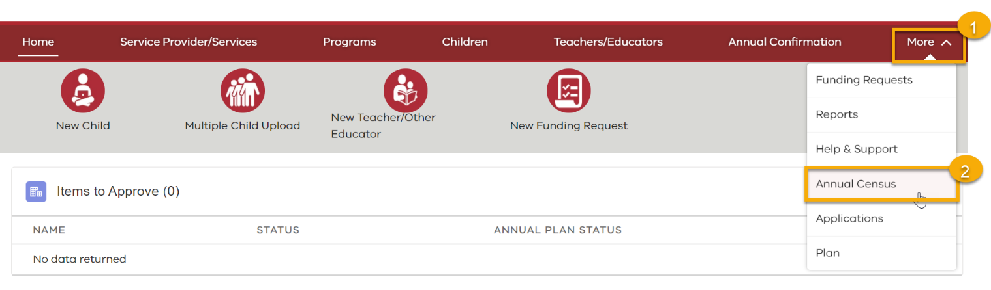
- Click the Annual Census name to open it
Note: There are 3 statuses for Annual Censuses:
(Not Started, In Progress or Complete)
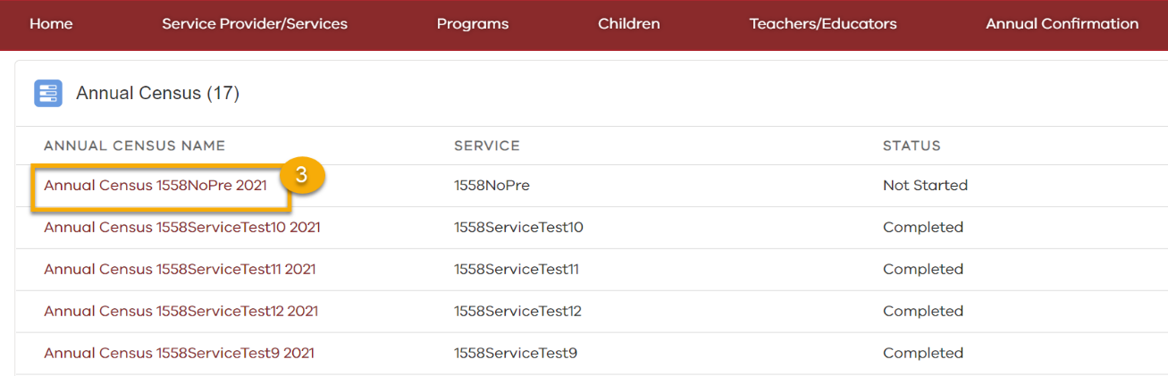
- GROUPS TAB – ONLY APPLICABLE TO SESSIONAL SERVICES OR THOSE WITH SESSIONS
4a: Click the Edit pencil
4b: Enter the normal weekly fee paid by families for children to attend the kindergarten program.
Note: Only numerical values can be entered e.g. 200
Note: If the children are accessing Free Kinder Funding enter $0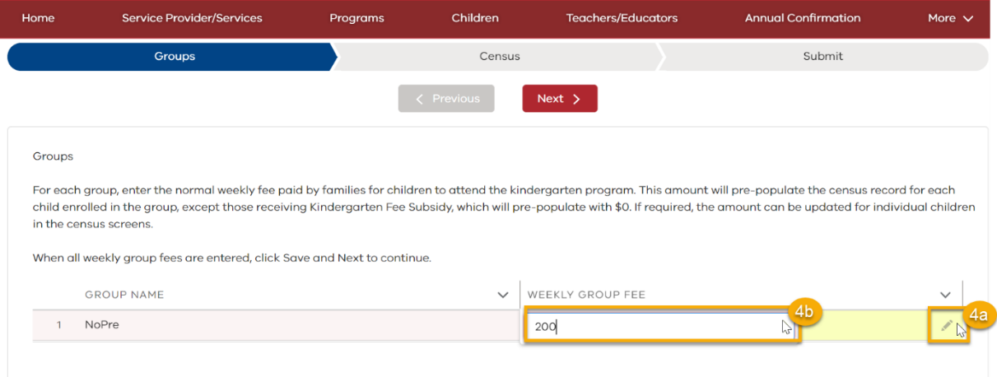
4c: Click Save
4d: Click Next
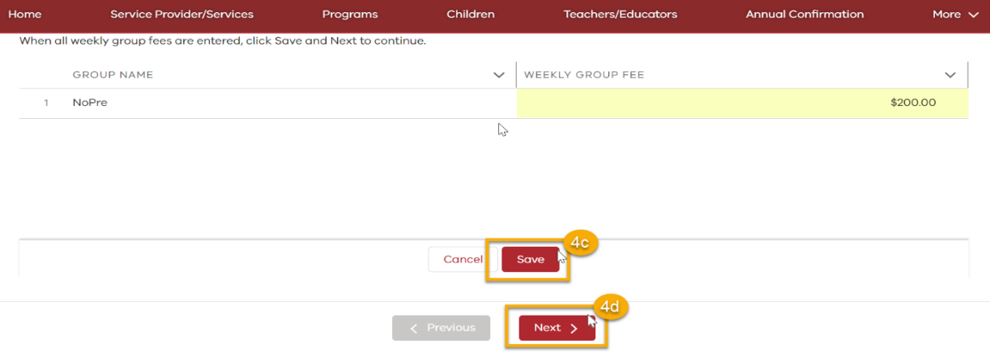
- Confirm all the children listed have a green Child Completion Indicator flag.

Note: Early Start Kindergarten (ESK) and Access to Early Learning (AEL) children will NOT be present in this list of children as YBS, ESK and AEL census is completed in October

If any of the children have a red Child Completion Indicator flag or you wish to update their details continue to Step 5a

If all the children have a green Child Completion Indicator flag continue to Step 6

5a: Click Edit
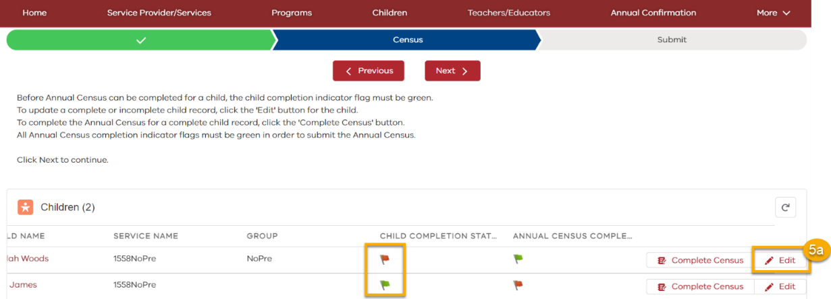
5a: Click Edit
5b: Complete/Update the child’s details and click Next 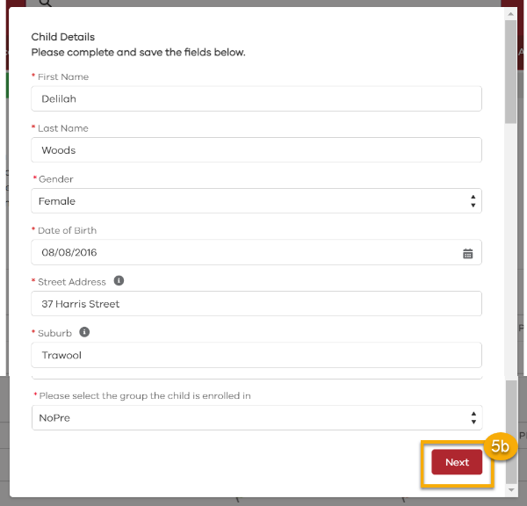and Save 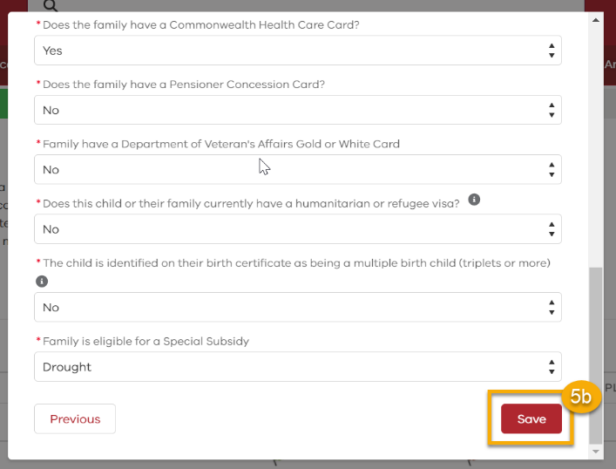
Once Save has been clicked the child’s details will be complete and the Child Completion Indicator flag will change from red to green.
- Confirm all the children listed have a green Annual Census Completion Indicator flag.
If any of the children have a red Annual Census Completion Indicator flag continue to Step 6a
If all the children have a green Annual Census Completion Indicator flag continue to Step 7
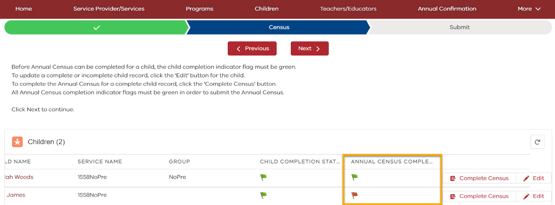
6a: If the Group field has a populated entry (e.g. Wombat Group) this indicates the child is a sessional child
If the Group field is blank this indicates this is an integrated long day care child
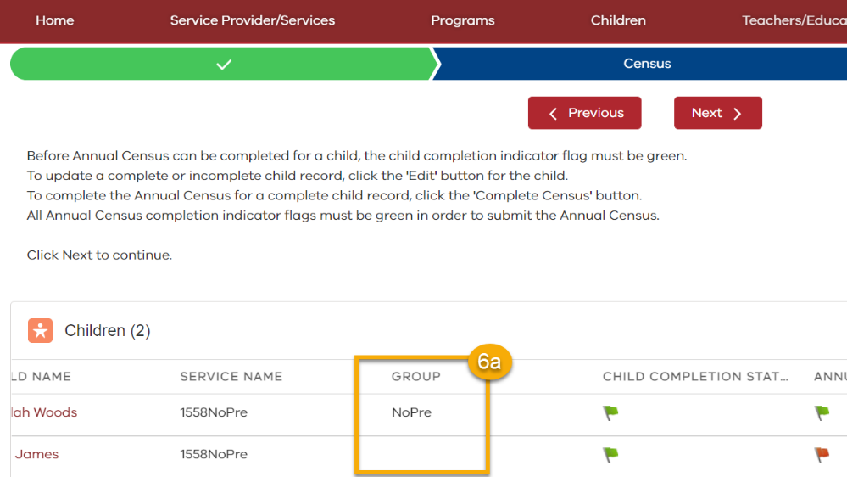
6b: SESSIONAL CHILDREN
Click Complete Census
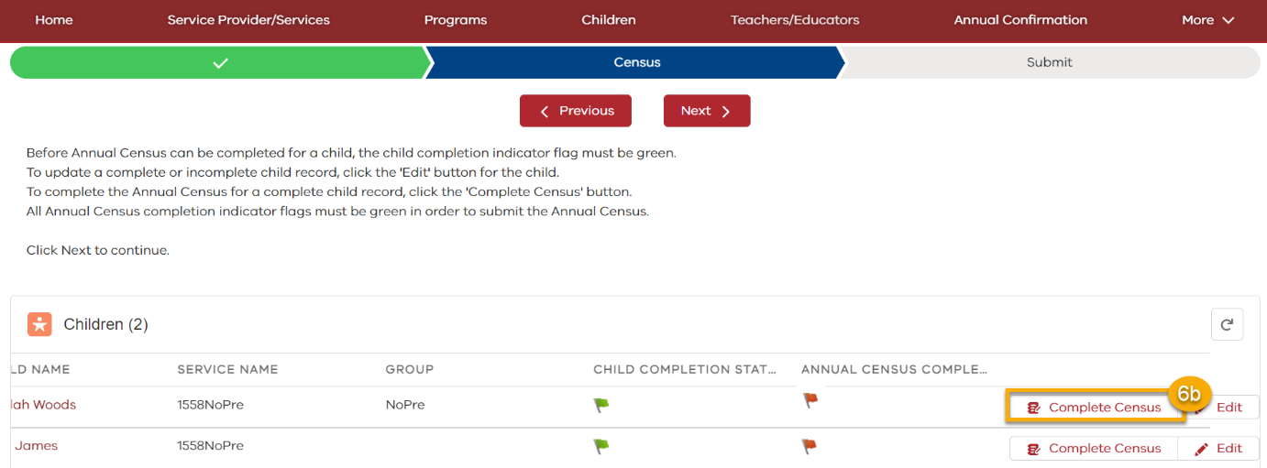
6b.1. Tick the checkboxes next to the days the child attended kindergarten in the census week. Or untick the checkboxes next to the days the child did not attend kindergarten in the census week.
Note: If a child did not attend kindergarten at all in the given week (all checkboxes are unticked) a message will appear asking if the child has attended at all in the last four weeks.
If the child has attended at all in the last four weeks there will be no further questions.
If no and the child is returning to kindergarten you will be required to input why the child was absent from kindergarten for the last 4 weeks and whether or not they will be returning to kindergarten.
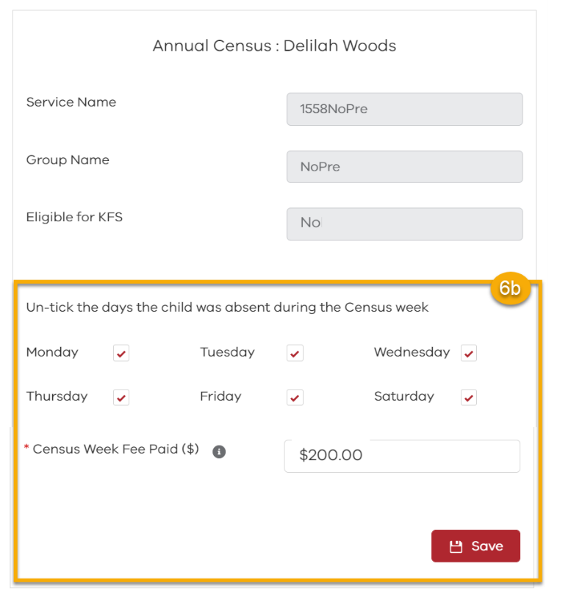 6b.2. Confirm the Census Weekly Fee Paid is correct (it will have prepopulated based on your $ value entry from the Groups tab.
Note: If a child is eligible for KFS (Kindergarten Fee Subsidy) then this number will be $0 and can remain $0 (it can be changed if required).
6b.3. Click Save
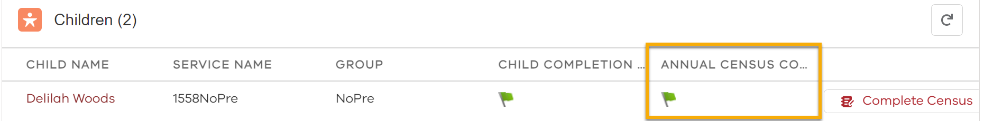The Annual Census Completion Indicator flag will now be green.
6c. INTEGRATED LONG DAY CARE CHILDREN
Click Complete Census
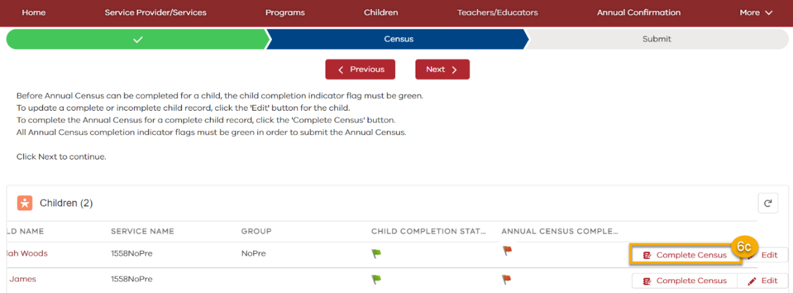
6c.1. Confirm or update the hours the child is normally enrolled in the kindergarten program per week. These are the hours where the child is receiving a kindergarten program delivered by a qualified teacher or other educator. 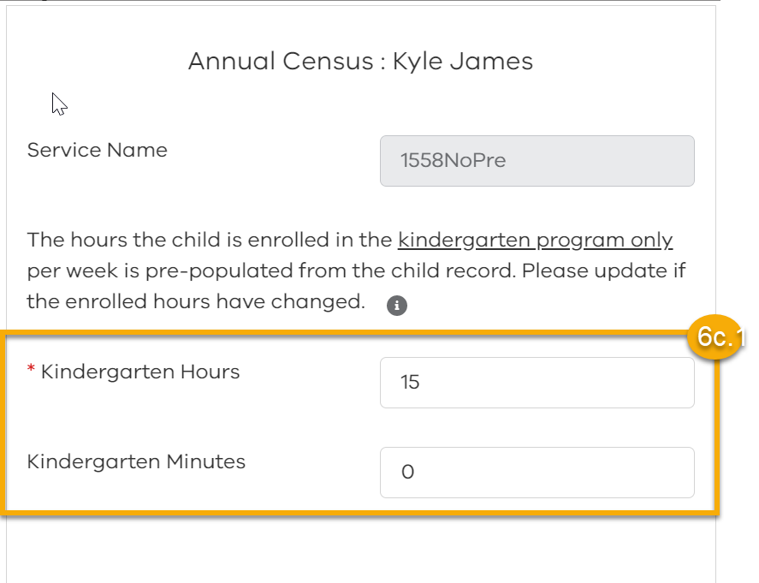
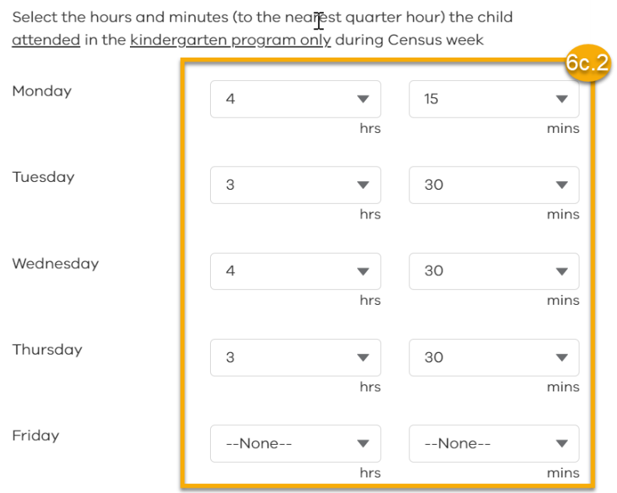6c.2. Enter the hours and minutes the child attended the kindergarten program during the Census week
Note: This time does not include any other services/programs the child accesses at the kindergarten, it is only the hours the child attends the kindergarten program.

6c.3. Enter the total hours and minutes the child is enrolled at the service (kindergarten program + any other hours the child receives in the long day care program), and enter the Census Weekly Fee Paid (the fee paid by the family for the child to attend the overall long day care in the period covering the census week – after any subsidies or discounts).
Note: The total hours enrolled at the service per week must be equal to or greater than the total hours enrolled in the kindergarten program per week.
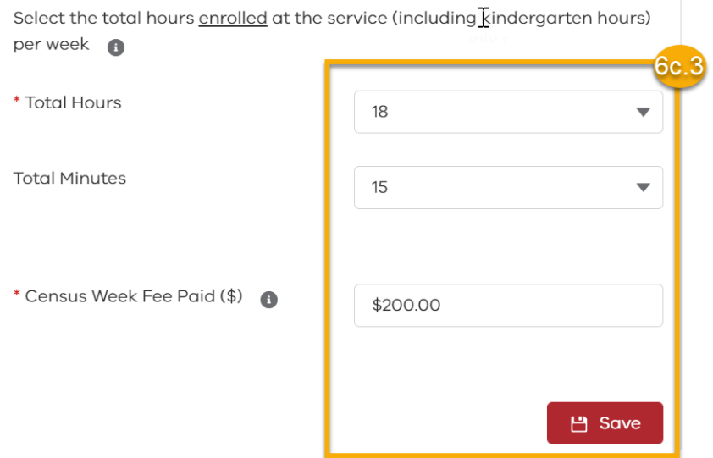Click Save
The Annual Census Completion flag will now be green
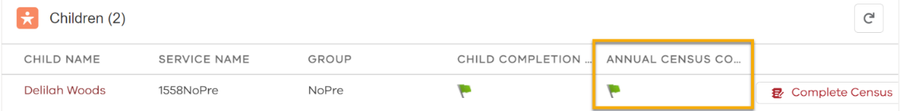
7. Once the Child Completion Indicator and Annual Census Completion Indicators are green and you are satisfied all the information entered for each child is accurate click Next
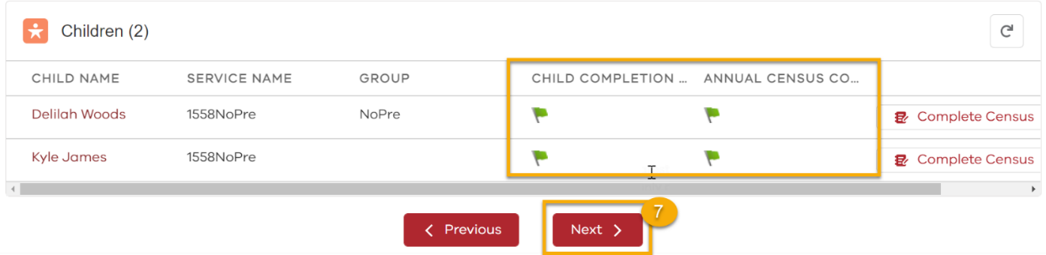
8. Enter your information – Name, Position and Date - as the submitter of the Annual Census.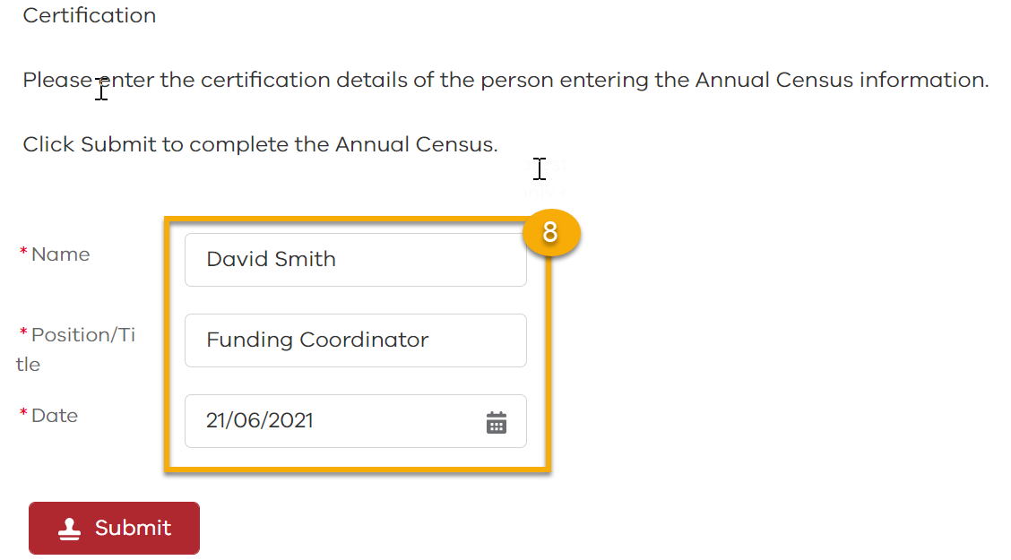
9. Click Submit
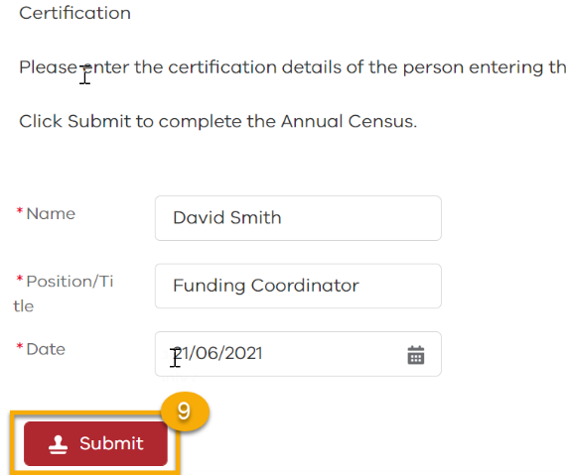
10. The Annual Census success message will indicate it has been successfully submitted. 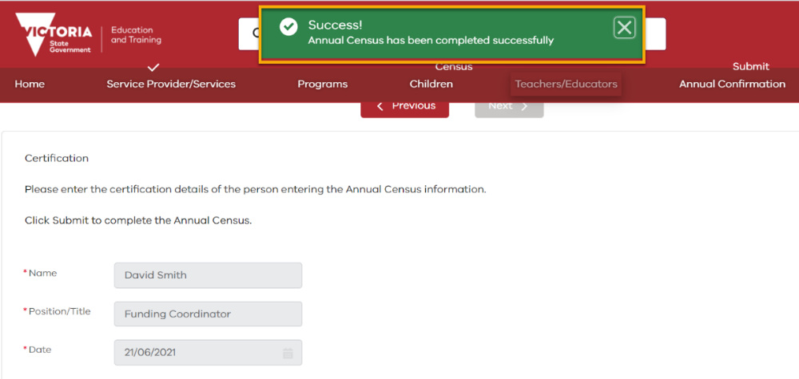
11. To confirm the Annual Census has been submitted click More and select Annual Census.
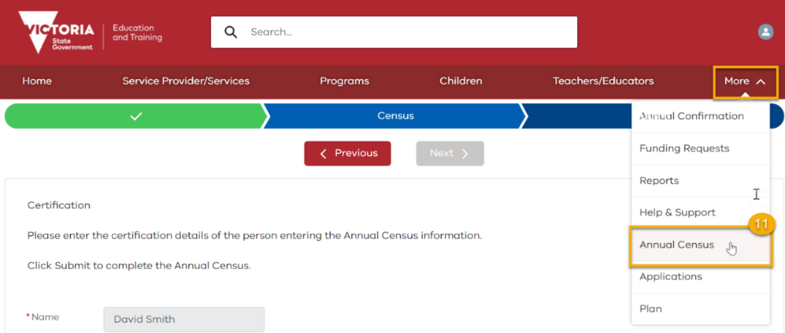
12. The status of the Annual Census will have changed from In Progress to Completed
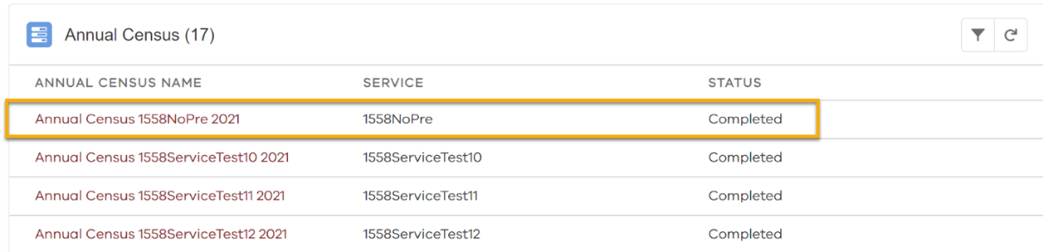

© State of Victoria (Department of Education and Training) 2021. Except where otherwise noted, material in this document is provided under a
Creative Commons Attribution 4.0 International Please check the full copyright notice

