QUICK REFERENCE GUIDE

HOW TO ADD A NEW CHILD IN THE KINDERGARTEN INFORMATION MANAGEMENT SYSTEM (KIMS)
This guide provides step-by-step instructions for adding a child in the Kindergarten Information Management System (KIMS).
All children who are enrolled in the funded three and four-year-old kindergarten programs should be added in KIMS. Children can be enrolled in KIMS for the current year (Current Year Enrolments) or for next year (Next Year Enrolments).
Children who are not enrolled in a funded kindergarten program or do not meet the eligibility for kindergarten funding, must not be entered in KIMS.
Child records can be edited at any time to ensure their details are up to date.
Once you have added a child in KIMS, their record will be retained in the system for subsequent enrolment years. At the end of each year, current year child records will be automatically moved to the Past Enrolments tab. If required, they can then be enrolled into the current year.
This guide covers the single child entry process, but you are also able to enter children using the Multiple Child Upload process.
Note. This guide shows all questions on the Child record, while the Multiple Child Upload process does not allow for all fields to be auto-popuated.
Please ensure you have updated the Progams tab, and Groups (sessional) before adding children. This will allow the system to present the correct fields on the child record.

Overview process for entering a child for the current year enrolments in KIMS
- Navigate to the Home Page and click New Child
- Select the Enrolment Year
- Complete all the mandatory fields (marked by a red asterisk *) to complete the record and obtain the green completion flag.
- Click Save to save all the details.
Notes.
Always ensure you save any updates to the child record. The Save button is located at the bottom of the second page of the child record.

System Steps for adding a child into Kindergarten Information Management System
ADDING A CHILD
- Navigate to the Home page and click New Child

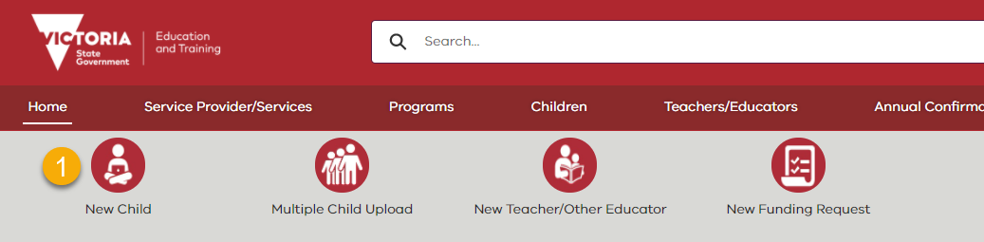
Alternatively, you can go to the Children tab and add a new Child from this tab.
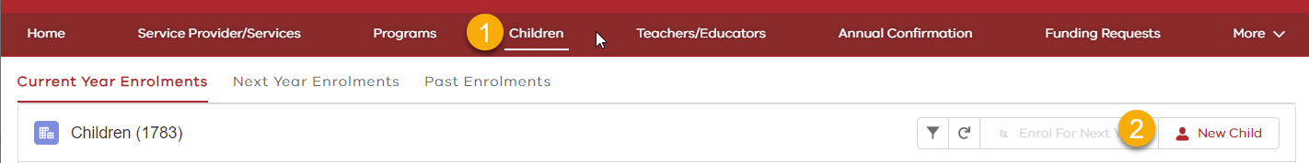
- Select the Enrolment Year and click Next

Note.
If you have access to more than one service, you will need to select the service the child is enrolled in.
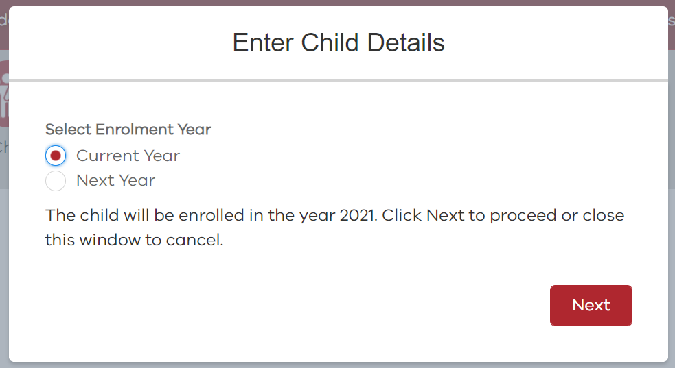
- Enter the child’s name, gender and date of birth and click Next

Note:
If you have already added this child to this service, a duplication message will display and you will not be able to enter the child twice.
Only enter children who are enrolled in the funded three-year-old or four-year-old kindergarten program. Children who are less than three-years-old or older than 6 year’s old cannot be entered.

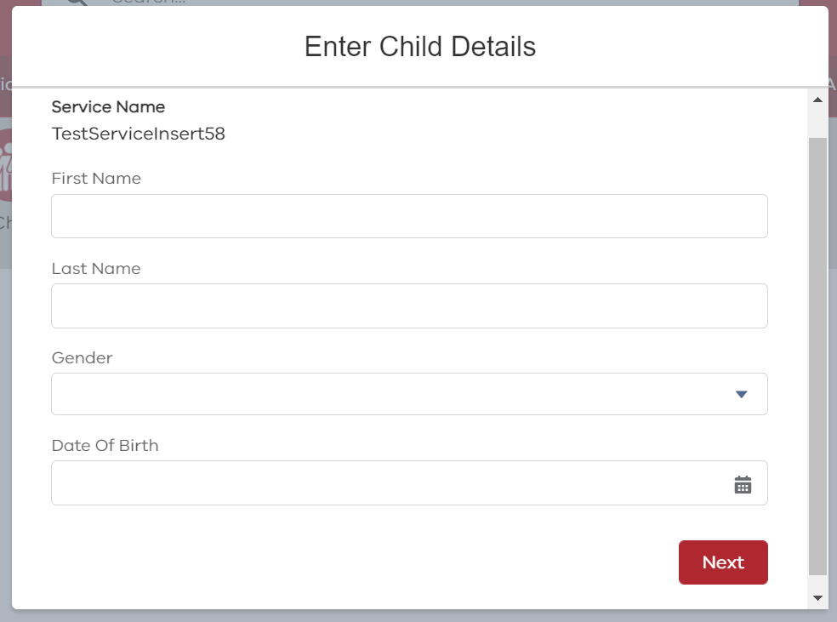
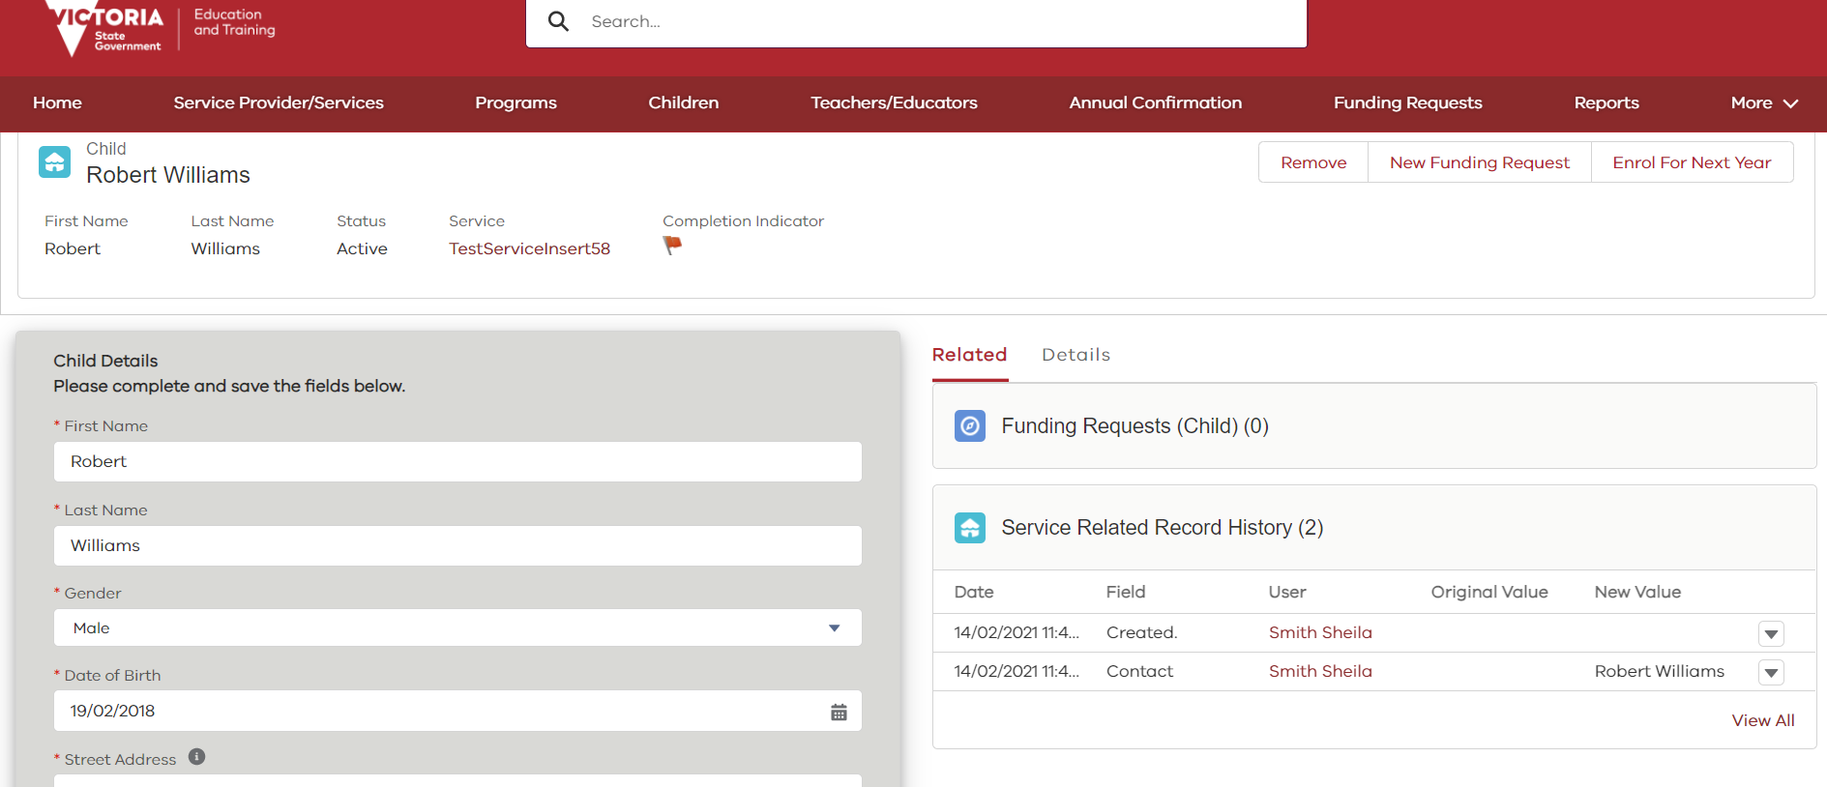
- Complete the Child Details form.

Notes:
- A complete child record is indicated by a green Completion Indicator flag
- When completing the Child Details form hover your mouse over the ‘i’ icon for help text related to the question
- To review your answers on the Child Details form click the Details tab for a summary of responses

- The following table lists all the questions in the Child Details form and options for answers. Note that some questions will only display if the child is enrolled in a sessional group.

Mandatory to complete | Field Name | Full Question | What options can I add in this field? | Example Entry | Notes
Yes | First Name | N/A | This is a free text field | Sally | Enter the child's first name as it appears on their enrolment paperwork/birth certificate if sighted. DO NOT include the child's middle name.
Yes | Last Name | N/A | This is a free text field | Jones | Enter the child's surname as it appears on their enrolment paperwork/birth certificate if sighted
Yes | Gender | N/A | Female |  | Select from list
 |  |  | Male
 |  |  | Other
Yes | Date of Birth | N/A | DD/MM/YYYY | 16/02/2016 | When entering the birthdate ensure you add the "/"
Yes | Street | N/A | This is a free text field | 1/28 Bush Street | The child's address should identify the place of usual/majority residence of the child’s parent or guardian. Please include the exact street address. If the address is located on a corner indicate the actual street name and number.
Yes | Suburb | N/A | This is a free text field | Essendon | The suburb information can include towns/cities e.g. Bendigo, Glen Waverley
Yes | State | N/A | This is a free text field | VIC | State information should be entered in the abbreviated format e.g. VIC, NSW
Yes | Postcode | N/A | This is a free text field | 3000 | Please enter a 4 digit postcode
Yes | Child Start Date | Date child commenced/is commencing in a funded kindergarten program with a VIT registered teacher | DD/MM/YYYY | 12/01/2020 | This will default to 1 January of selected enrolment year but can be changed.
Yes | 3YO OR 4YO | Is the child a three-year-old kindergarten enrolment or a four-year-old kindergarten enrolment? | Three-Year-Old Kindergarten Enrolment | Three-Year-Old Kindergarten Enrolment | Select from list  To be eligible for three-year-old kindergarten funding, a child must be three years old by 30 April in the year of enrolment.  To be eligible for four-year-old kindergarten funding, a child must be four years old by 30 April in the year of enrolment.
 |  |  | Four-Year-Old Kindergarten Enrolment
Yes | ATSI Indicator | Has this child been identified by a parent, carer or legal guardian as being of Aboriginal and/or Torres Strait Islander origin? (no supporting documentation should be requested from family) | No | Yes - Torres Strait Islander | Select from list.  If you answer Yes to this question - there will be additional questions to answer on the child record within KIMS: Is the child being supported by the Access to Early Learning program. Which Access to Early Learning Lead Agency is supporting the child.
 |  |  | Yes - Aboriginal
 |  |  | Yes - Torres Strait Islander
 |  |  | Yes - Aboriginal and Torres Strait Islander
Yes | Child Protection Indicator | This child has been identified as being known to Child Protection (record the source of identification in the child's enrolment record i.e. parent, carer, legal guardian, Child Protection/Child FIRST/Family services practitioner) | Yes | No | Select from list.  If you answer Yes to this question - there will be additional questions to answer on the child record within KIMS: Is the child being supported by the Access to Early Learning program. Which Access to Early Learning Lead Agency is supporting the child.
 |  |  | No
Yes | Additional Needs | Does this child need a high level of assistance with core activities (compare to peers) as a result of ongoing disability or health condition? | Yes | Yes | Select from list  Answer ‘Yes’ if the Child regularly requires a high level of assistance in one or more of the following areas:  -communication  -interpersonal interaction  -behaviour (safety risk to self/others)  -mobility  -self-care  -everyday tasks/routines  -cognition
 |  |  | No
Yes if main language is not English | Main Language At Home | Main Language spoken at home (if not English) | Leave blank for English or not known  Or  Select from list | Chinese | If a child's main language at home is English, leave this field blank
No | First Language | Child's first language (if not English) | Select from list | Chinese | If a child's first language is English, leave this field blank
No |  | Country of birth | Select from list | Chinese | If you know the Country of Birth, please provide it here
Yes | Child Lives With | Does this child live with: | Parent(s) | Parent(s) | Select Parent(s) if the child lives with one or both parents.  Select Formal Kinship Care if the child is living with extended family and is subject to a court order  If you select the "Other" option you are then required to fill in the "Child Lives With - Other" category
 |  |  | Informal Kinship Care
 |  |  | Formal Kinship Care
 |  |  | Foster Care
 |  |  | Permanent Care
 |  |  | Residential Care
 |  |  | Other
Yes if 'Other' selected for Child Lives With | Child Lives With - Other | N/A | This is a free text field |  | If you have not selected "Child Lives With - Other" in the previous question then you can leave this field blank
Yes | Immunisation Status | Please indicate the immunisation status for this child | The child has an up to date immunisation status certificate recorded | The child is on a recognised catch-up schedule | Select from list  Visit the No Jab, No Play website for information about the vaccination legislation that requires all children to be fully vaccinated to be enrolled in kindergarten in Victoria, unless they have a medical exemption.
 |  |  | The child's Immunisation History Statement indicates they have a medical condition preventing them from being fully vaccinated
 |  |  | The child is enrolled under the grace period and is on a recognised catch-up schedule
 |  |  | The child is enrolled under the grace period (not on a recognised catch-up schedule)
 |  |  | The child is on a recognised catch-up schedule
Yes - only if child in Sessional group | Group Name | Please select the group the child is enrolled in | Select from list | e.g. Wallabies | This is only applicable for sessional kindergarten programs (not applicable for kindergarten integrated in long day care).  Select the Group from the list if you have already created the Groups. Otherwise you can assign the child to a Group from Programs in the main menu.
Yes – Only if child is in a Long Day Care setting | Hours | Please enter the number of hours this child is enrolled in the funded kindergarten program per week | Enter hours | 15 | This is only applicable to Long Day Care centres. Please enter the time per week that the child is in the Funded Kindergarten Program
No | Country Birth Parent/Guardian 1 | N/A | Select from list | Australia | If unknown, enter Unknown  Not a mandatory question
No | Country Birth Parent/Guardian 2 | N/A | Select from list | Unknown | If unknown, enter Unknown  Not a mandatory question
Yes | Adult A Education | What is the highest year of primary or secondary school the Parent/Guardian A (Primary Carer) has completed? | Year 9 or equivalent or below | Year 10 or equivalent | Select from list  If the person has never attended school, select 'Year 9 or below'
 |  |  | Year 10 or equivalent
 |  |  | Year 11 or equivalent
 |  |  | Year 12 or equivalent
Yes | Adult A Qualification | What is the level of the highest qualification the Parent/Guardian A (Primary Carer) has completed? | No non-school qualification | Certificate I to IV (incl  uding trade certificate) | Select from list  If the person has not completed a qualification post-school, select 'No non-school qualification'. All qualifications from overseas should be ranked at the equivalent level. So, an overseas Bachelor would be ranked at 'Bachelor’s degree or above level'
 |  |  | Certificate I to IV (including trade certificate)
 |  |  | Advanced diploma / Diploma
 |  |  | Bachelor degree or above
Yes | Adult A Occupation | What is the occupation group of Parent/Guardian A (Primary Carer)? | A | A | Select from list. Go to the Department’s website for more info on this field.  If the person is not currently in paid work but had a job or retired in the last 12 months, select their last occupation group from the list. If they have not been in paid work in the last 12 months, select 'N', or select 'H' if they care for their own children full time.
 |  |  | B
 |  |  | C
 |  |  | D
 |  |  | N
 |  |  | H
 |  |  | U
Yes - only if 2 parents/guardians | Adult B Education | What is the highest year of primary or secondary school the Parent/Guardian B has completed? | See "Adult A Education" | Year 10 or equivalent | Select from list
Yes - only if 2 parents/guardians | Adult B Qualification | What is the level of the highest qualification the Parent/Guardian B has completed? | See "Adult A Qualification" | Bachelor degree or above | Select from list
Yes - only if 2 parents/guardians | Adult B Occupation | What is the occupation group of Parent/Guardian B? | See "Adult A Occupation" | N | Select from list
Yes - only if child in Sessional group | Health Care Card | Family have a Commonwealth Health Care Card | Yes | No | Select from list
 |  |  | No
Yes - only if child in Sessional group | Pensioner Concession Card | Family have a Commonwealth Pensioner Concession Card | Yes | No | Select from list
 |  |  | No
Yes - only if child in Sessional group | Veteran Healthcare Card | Family have a Department of Veteran's Affairs Gold or White Card | Yes | No | Select from list
 |  |  | No
Yes | Refugee Visa | Does this child or their family currently have a humanitarian or refugee visa? | Yes | Yes | Select from list
 |  |  | No
 |  |  | Unknown
Yes if family has humanitarian or refugee visa | Refugee Visa Type | Please select the visa type | Refugee visa (subclass 200) | Protection visa (subclass 866) | Select from list
 |  |  | In-country Special Humanitarian visa (subclass 201)
 |  |  | Global Special Humanitarian visa (subclass 202)
 |  |  | Temporary Humanitarian Concern visa (subclass 786)
 |  |  | Protection visa (subclass 866)
 |  |  | Emergency Rescue visa (subclass 203)
 |  |  | Woman at risk visa (subclass 204)
 |  |  | Bridging visa A-E for humanitarian or refugee visa
 |  |  | Humanitarian Stay visa (subclass 449)
 |  |  | Temporary Protection visa (subclass 785)
 |  |  | Safe Haven Enterprise visa (subclass 790)
 |  |  | Other
Yes - only if child in Sessional group | Multiple Birth | The child is identified on their birth certificate as being a multiple birth child (triplets or more) | Yes | No | Select from list  Child must be identified on their birth certificate as being a triplet or quadruplet and the other children on the birth certificate are attending a funded kindergarten program.
 |  |  | No
 |  |  | Unknown
No | Special Subsidy | Family is eligible for a Special Subsidy | Drought |  | Select from list  Special Subsidy is only applicable if advised by the Department
 |  |  | Bushfire

ADDING A CHILD (Continued)
- Click Save at the end of the form (on the 2nd page) to save changes
- The Completion Indicator will become green once all the child record fields are completed.
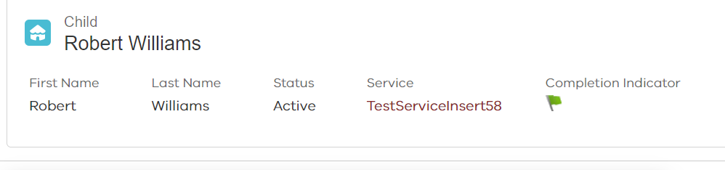
Note.
You are able to save as you go and come back later to complete the record.

