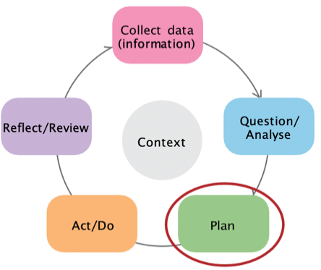

Stage 3: Plan to implement

This data literacy tip sheet outlines practical information and suggestions to help services write their SRF plan. It describes the process for developing S.M.A.R.T goals and indicators and measures of success. It aligns with the Plan stage of the Early Years Planning Cycle.
Early Years Planning Cycle

Developing S.M.A.R.T goals
The S.M.A.R.T goals method can help you develop achievable goals by making them:
- Specific: Clearly defined
- Measurable: Able to be measured
- Achievable: Able to be reached with existing resources and staffing
- Relevant: Focused on your priority area and directly related to the findings from the data
- Time-bound: Specified as needing to be achieved within 12 months
EXAMPLE: Making a goal a S.M.A.R.T goal
The goal “Educators are able to refer children” is made S.M.A.R.T through the following adaptations:
Specific: Is your goal clearly defined? What do you want to accomplish? Who needs to be included? | Educators refer children who demonstrate language delay
Measurable: Is your goal able to be measured? How will you measure it? How will you know if there has been a change? | Educators identify and refer 90% of children who demonstrate language delay
Achievable: Is your goal able to be reached with existing resources and staffing? | Educators identify and refer 90% of children who demonstrate language delay
Relevant: Is your goal focused on your priority area and directly related to the findings from the data? | Educators identify and refer 90% of children who we have identified at risk of language delay
Time-bound: Is your goal able to be achieved within the SRF cycle (12 months)? | Educators identify and refer 90% of children who we have identified at risk of language delay by the end of Term 4

Examples of SMART goals
Communication | Wellbeing | Access and Inclusion
Educators intentionally facilitate language and emergent literacy development skills in all children through reading, singing and role play over the next two months. | Educators incorporate two new strategies into practice to support children’s executive function (with a focus on self-regulation) over the next 6 months. | Increased enrolment of families from culturally diverse backgrounds by 25 percent in the service within 12 months.

Developing indicators and measures of success
Measures and indicators refer to things you can measure to help you understand whether you are making progress with your work.
- Indicators are measurable information used to determine if you are implementing your SRF activities as expected.
- Measures of success indicate whether you are making progress towards or have achieved your goal.
Table 1 outlines guiding questions to help you develop indicators and measures, example measures and common data sources for your measures.

Table 1: Overview of indicators and measures of success
Measure | Indicator | Measures of success
Purpose | Indicates whether you are implementing your SRF menu items as you planned | Indicate whether you are making progress towards or have achieved your goal
Guiding questions to develop measures | - What tasks/activities will we need to complete to implement this menu item?  - Who will do what and when? | - What will it look like when I have achieved my goal?  - How will I know when I have achieved my goal?  - What source of data will tell me if I have achieved my goal  - How will you measure success?
Example measures | - Educators complete training/coaching  - Educators use strategies from their training/coaching in their programming | - Increased knowledge/ skills/ confidence of educators, families, or children  - increased enrolment/attendance from vulnerable cohorts  - evidence of strategies being implemented through practice or curriculum development  - increase in identification and referrals for developmental delays
Data sources for your measures | - Calendars/schedules  - Program planning documents  - Staff reflections/journal entries  - Family and/or staff surveys  - Conversations with families and/or other early childhood professionals  - Self-assessment or observation of practice. | - Both formal and informal child assessment (e.g. standardised and/or validated assessment tools, child observations, pedagogical documentation, learning samples, teacher judgements, teacher checklists)  - Attendance records  - Family and/or staff surveys  - Conversations with families and/or other early childhood professionals  - Self-assessment or observation of practice  - Staff appraisals  - NQS assessment and rating results

S.M.A.R.T Goal Template

Use the template below to ensure you have included the relevant information in your goal.
- Start by writing your draft goal. You should create one goal for each of the SRF Priority Areas you select, or more where relevant to your service and data findings.
- Use the questions under each area to think about information you could add to your draft goal to make it clearer. Jot down your thoughts.
- Review your answers and write your S.M.A.R.T goal at the bottom of the template.

DRAFT GOAL:
Write the goal you have in mind.
Specific:
Is your goal clearly defined?
What do you want to accomplish?
Who needs to be included?
Measurable:
Is your goal able to be measured? How will you measure it?
How will you know if there has been a change?
Achievable:
Is your goal able to be reached with existing resources and staffing?
Relevant:
Is your goal focused on your priority area and directly related to the findings from the data?
Time-bound:
Is your goal able to be achieved within the SRF cycle (12 months)?
S.M.A.R.T GOAL:
Review your answers above and write a new goal statement.

