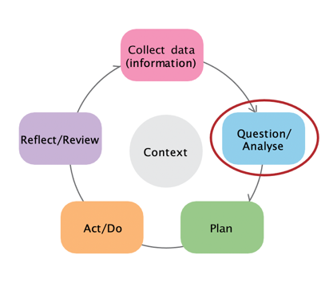

Stage 2: Question/analyse data

This data literacy tip sheet outlines practical information and suggestions to help services question and analyse data and use the
data findings to develop their School Readiness Funding plan. It aligns with the Question/Analyse stage of the Early Years Planning Cycle.
Early Years Planning Cycle

Making sense of your data
Working out what your data is telling you is a
two-part process: first, work out what each individual piece of data is telling you; then work out what the data tells you when you bring it all together.

Making sense of individual pieces of data
How you make sense of an individual piece of data depends on whether it is quantitative or qualitative.
Quantitative data is usually in table or chart format. To identify patterns in each table or chart, try asking:
- What stands out from this data? Is there a pattern?
- Is there a trend over time?
- Is there a relationship between different parts?
- Is the data consistent with other areas/state/national figures? Are there substantial variations (higher/lower rates)?
Qualitative data usually consists of written information, such as responses to survey questions or educators’ notes. Finding patterns in this data is about noticing the main topics or themes, try asking:
- What ideas are mentioned multiple times?
- What is the main message here?
- What are we still unsure about from this data?
- Does it represent all families that attend our service?
Making sense of combined data
To work out what the combined data under each priority area is telling you, try asking:
- Do these findings agree with each other?
- Do some of these findings disagree with or contradict each other? Is the finding from one piece of data more important than another?
- How would you sum up what this collection of findings is saying?

Developing key messages
Developing key messages that summarise what the data tells you is a simple and effective strategy for clearly communicating your findings. When developing key messages, consider the following:
- What data are you basing this key message on? (Include details e.g. “data from the AEDC and parents”)
- Are you concluding that this area needs attention or not?
- What contradictory data do you need to acknowledge in your key message?

Selecting SRF priority areas
If you’ve developed clear, simple key messages from the data under each of the SRF priority areas, this task will be reasonably straightforward.

When deciding which of the priority areas to select, try asking:
- What does the key message say about the needs of our families and/or the needs of our community in this priority area?
- Does the key message suggest that we have room for improvement in this priority area?

