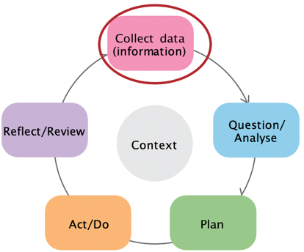

Stage 1: Collecting data

This data literacy tip sheet outlines practical information
and suggestions to help services collect data for their
School Readiness Funding plan. It aligns with the Collect Data

(information) stage of the Early Years Planning Cycle.

Early Years Planning Cycle

Types of data and data sources
- Quantitative data can be counted or measured with numbers.
- Qualitative data is descriptive and captures thoughts, opinions and/or experiences of people.
- Secondary data refers to existing data.
- Primary data is new information that you decide to collect for a specific purpose.
There is a range of existing data that can help answer the questions you have under the SRF priority areas. This includes community/child level, educator level and service level data. The table below describes each level of data and lists common data sources.
Table 1: Common data sources for SRF planning
Data level | Data sources
Community/child level data provides a picture of the recurrent learning, development, health, and wellbeing needs of children and families that typically attend your service. | - Australian Early Development Census (AEDC)  - Socio-Economic Indexes for Areas (SEIFA)  - Australian Bureau of Statistics (ABS)  - Local Government Data including kindergarten participation, Municipal Early Years Plan/ Council Plans  - SEHQ LGA Summaries (School Entrant Health Questionnaire)  - Trends in transition statements | - Trends in English Online Data (or other relevant school data)  - Discussions with teachers at schools, MCH nurses  - Formative and Summative assessment information both norm-referenced and teacher designed  - Anecdotal observations of children’s learning behaviour  - Cohort data trends i.e. numbers of children with NDIS/ECIS Plan/KIS funding  PSFO referrals, referrals to child health services
Service level data will provide valuable data to inform what areas of practice and pedagogy to focus on at a service level. | - Reflection of previous SRF plan/implementation  - Quality Improvement Plans  - Service Improvement Plans  - Assessment and Rating  - Parent Surveys  - Service Occupancy  - Reconciliation Action Plans | - ISS Applications  - Enrolment form data  - Number of children with Kinder Fee Subsidy  - Number of children enrolled in Early Start Kindergarten  - Discussions with families/parent-teacher meeting
Educator level data will help you to think about staff professional development needs | - Educator experience,qualifications  - Professional learning plans/Appraisals  - Staff surveys  - Trends/issues from staff meetings  - Behaviour Plan trends | - Trends in issues arising from educator/team reflections  - Trends in children’s learning goals  - Trends/issues from staff meetings  - Educational plan/classroom reflections

