KINDERGARTEN PARENT SURVEY 2018
SERVICE RESULTS
[Service Name]

CONTENTS

ABOUT THE SURVEY 2
ABOUT THIS REPORT 2
SURVEY RESULTS 2
APPENDIX A: Taking Action – How to use the report 2
APPENDIX B: Survey questions 2

ABOUT THE SURVEY
The Department of Education and Training (the Department) has been reporting on statewide levels of parent satisfaction with kindergarten in the year before school since 2016.
Each year, the Department invites all parents whose children attended a funded kindergarten program in that year to participate in a voluntary online Parent Opinion Survey to seek feedback about their child’s kindergarten service. The survey includes questions regarding parent satisfaction together with questions that reflect the Victorian Early Years Learning and Development Framework and the National Quality Framework. The survey questions are provided in Appendix B.
In October 2018, the Department requested service providers email a link to the online survey to parents of children accessing a funded kindergarten program at their service in 2018. Postcards promoting the survey and providing access details were also provided to all funded kindergarten services for distribution to parents. In 2018, the survey was also available in 10 languages other than English: Mandarin, Cantonese, Vietnamese, Arabic, Dari, Tamil, Sinhalese, Hindi, Punjabi and Urdu.
The survey was anonymous and at no stage were any personal details requested from respondents. When answering, parents were requested to select their kindergarten service from a series of drop down lists.
Survey results were analysed at a number of levels: statewide, local government authority (LGA), service provider (where applicable) and kindergarten service. The results are also compared (where possible) with the 2016 and 2017 survey results. The results will be used for planning and service improvement initiatives across the state and to report in the Victorian Budget papers.
A service report is only provided where 5 or more responses were received.
This report has been developed by the Social Research Centre on behalf of the Department.

ABOUT THIS REPORT
The report focuses on numeric survey results. Here is a description of the components, which appear in most charts.

Green cell indicates the proportion (%) of respondents who chose the two most positive rating points in the five point scale presented.

Yellow cell indicates the proportion (%) of respondents who chose the mid-point of the rating of the five point scale presented.

Red cell indicates the proportion (%) of respondents who chose the two most negative rating points of the five point scale presented.

Label to the left of a bar indicates the entity being reported. The n count indicates the number of respondents in that entity who answered with a rating point.

Respondents who provided no answer or who answered with don’t know / prefer not to say have been excluded from the analysis, which is one reason why n counts vary between charts.

SURVEY RESULTS
This section of the report presents summary results for a kindergarten service and compares its results with the service location’s local government authority (LGA) and statewide results. If no LGA results are displayed in the charts of this section, it means that there were:
- less than 50 survey responses for an LGA overall, or
- only one service had survey respondents in the LGA.

The service level results are based on the unweighted parent responses to each question. The results presented for the LGA and Victoria are weighted to represent the characteristics of parents in those regions.

Parent satisfaction
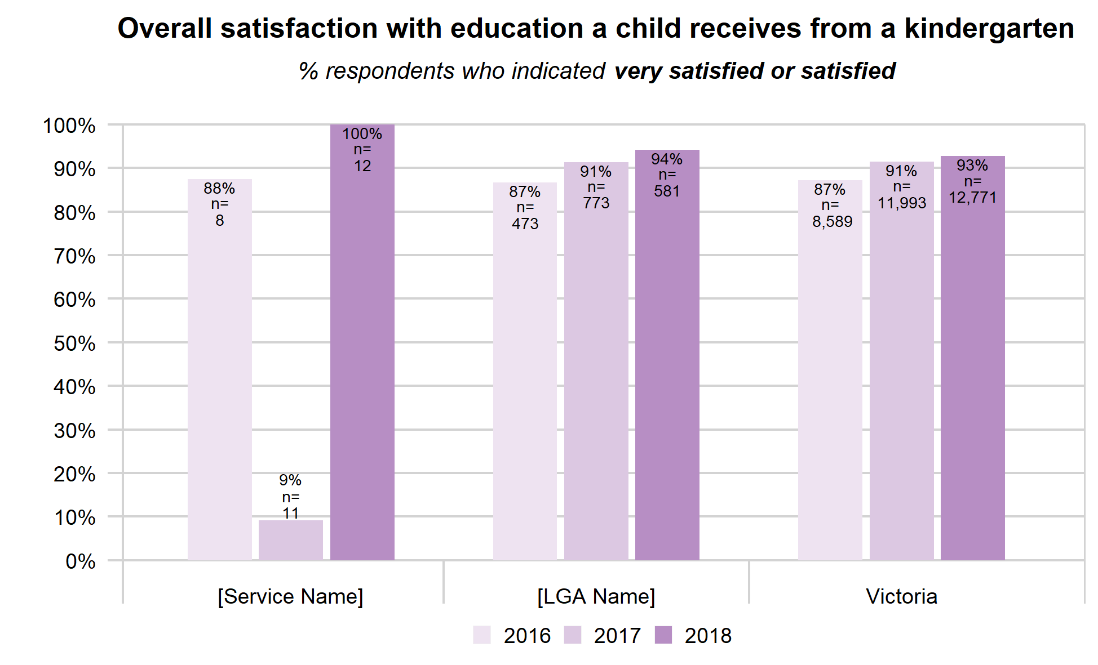

Quality of education offered
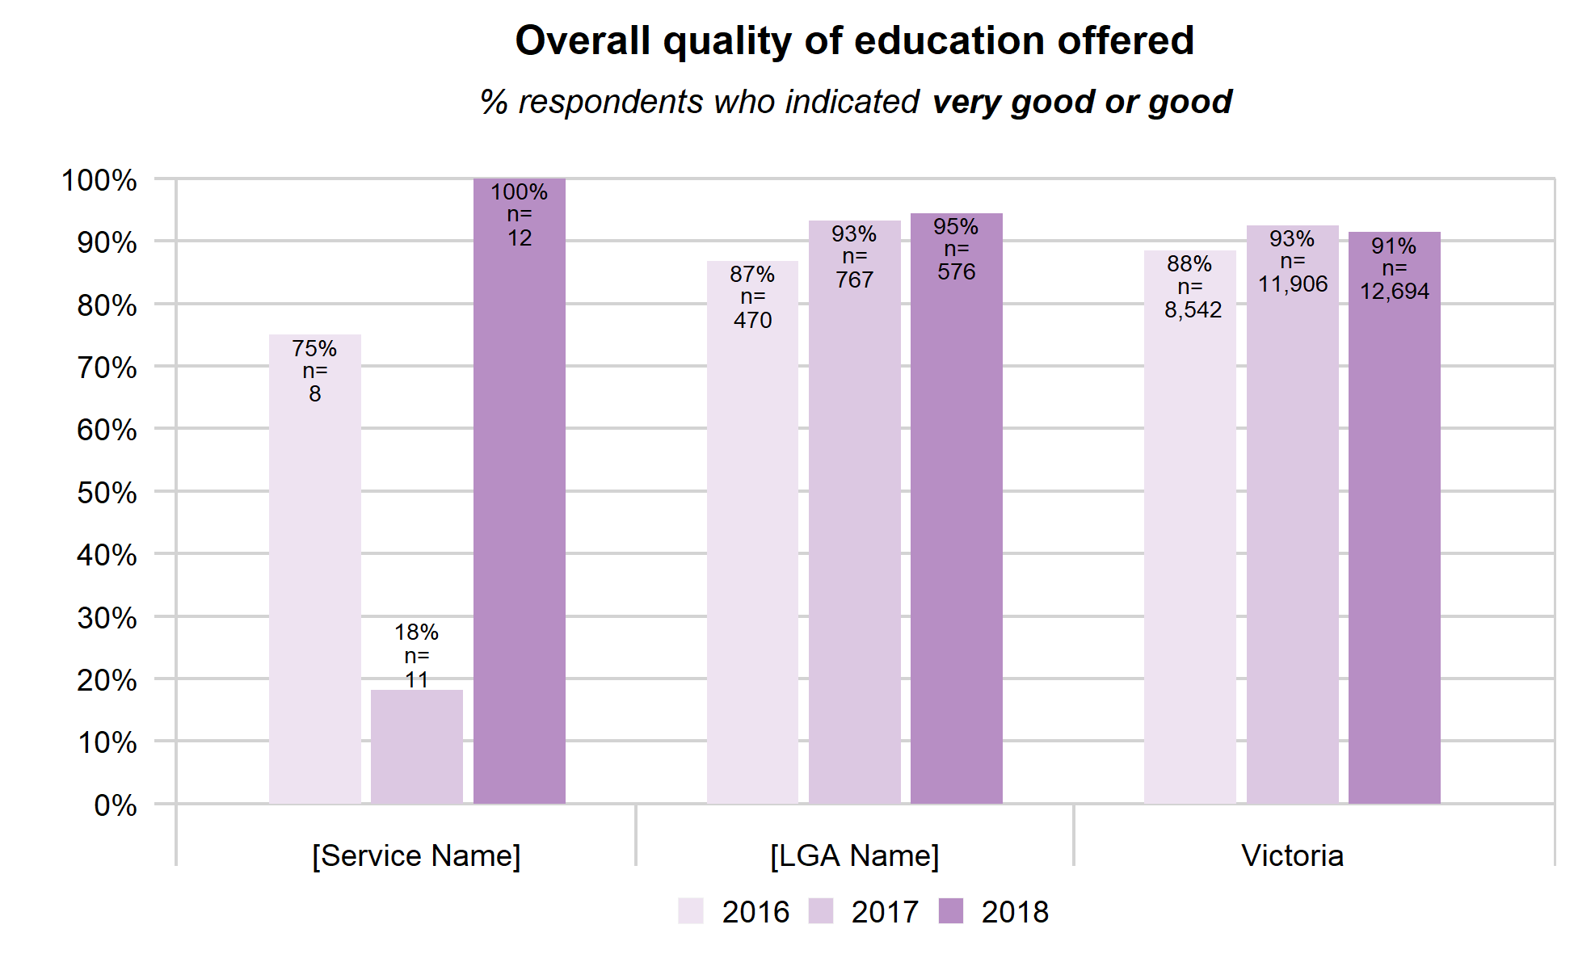

Importance of attending kindergarten
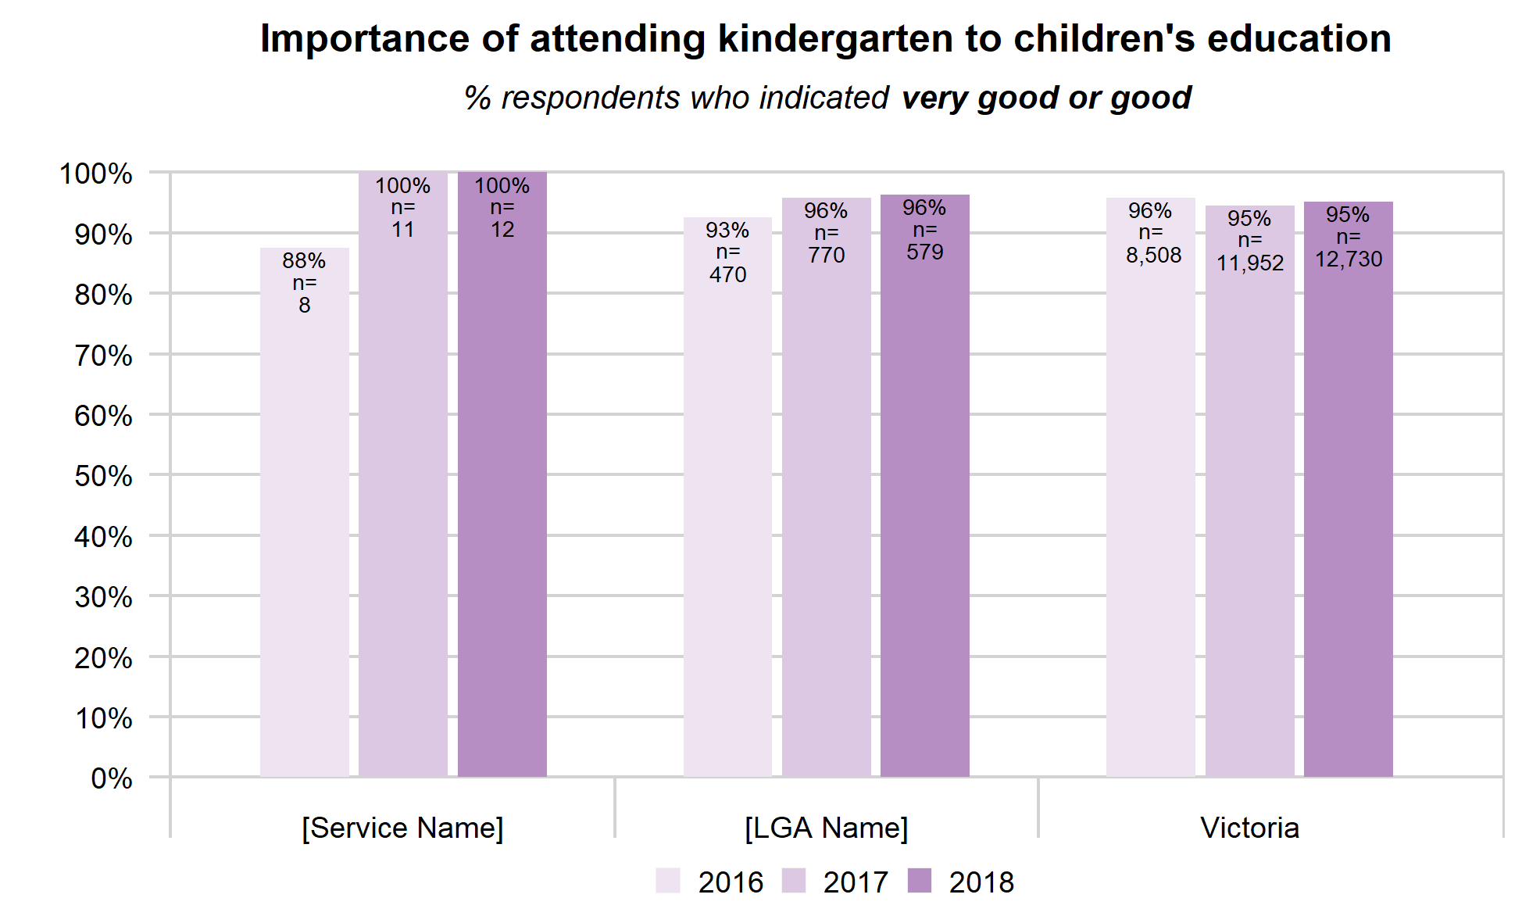

Choosing a kindergarten
Respondents could choose up to three importance factors. The table below shows the proportion (%) of respondents who chose a factor. Because it was a multi-choice question, column totals will be greater than 100%. The three highest ranked factors for each column (entity being reported on) are highlighted in pink. In some cases, factors may have equal ranks so there may be more than three highlights.
Most important factors in choosing a kindergarten
% of respondents choosing a factor
Multi-choice and selection of up to 3 factors allowed so total >100%
 | [Service Name] | [LGA Name] | Victoria
Factor ↓ | n=12 | n=566 | n=12,493
Location | 75 | 60 | 62
Service reputation | 67 | 65 | 58
Session days/time | 33 | 45 | 45
Children may go to same school | 33 | 31 | 30
NQS rating | 33 | 21 | 23
Long Day Care offered | 0 | 20 | 22
Other child attending | 25 | 19 | 17
Cost | 8 | 7 | 12
Cultural links | 0 | 5 | 8
Other | 0 | 9 | 9

Only place available
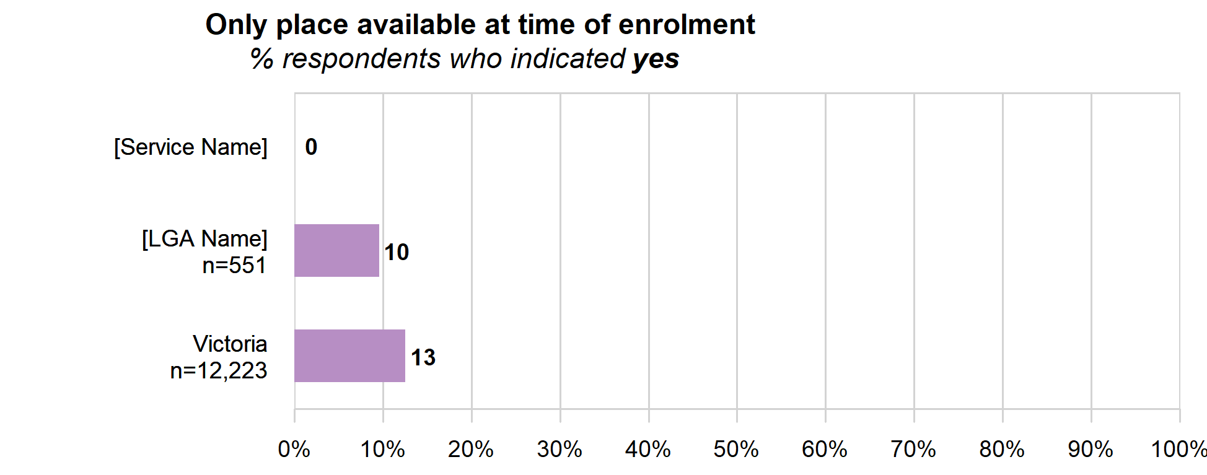
n=12

Involving parents AND CHILDREN
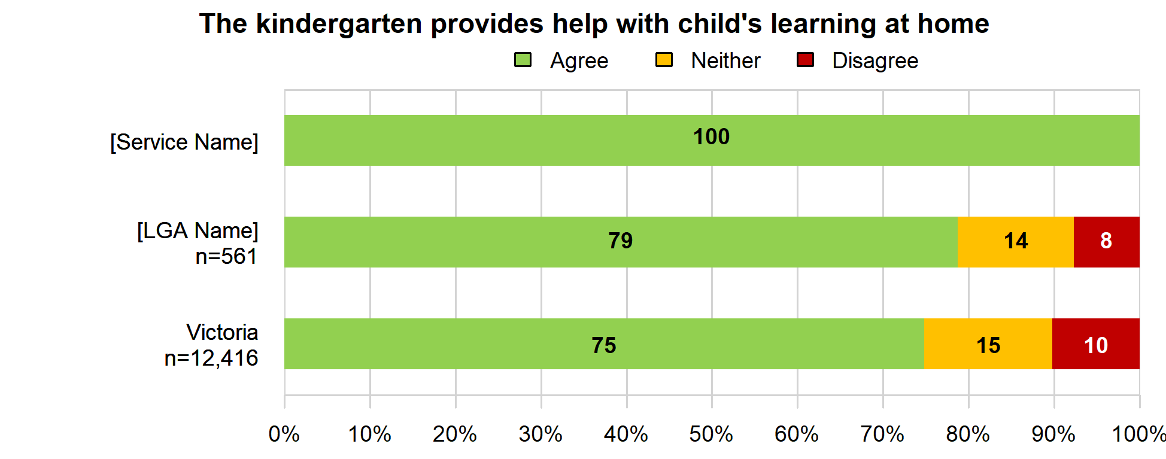
n=12

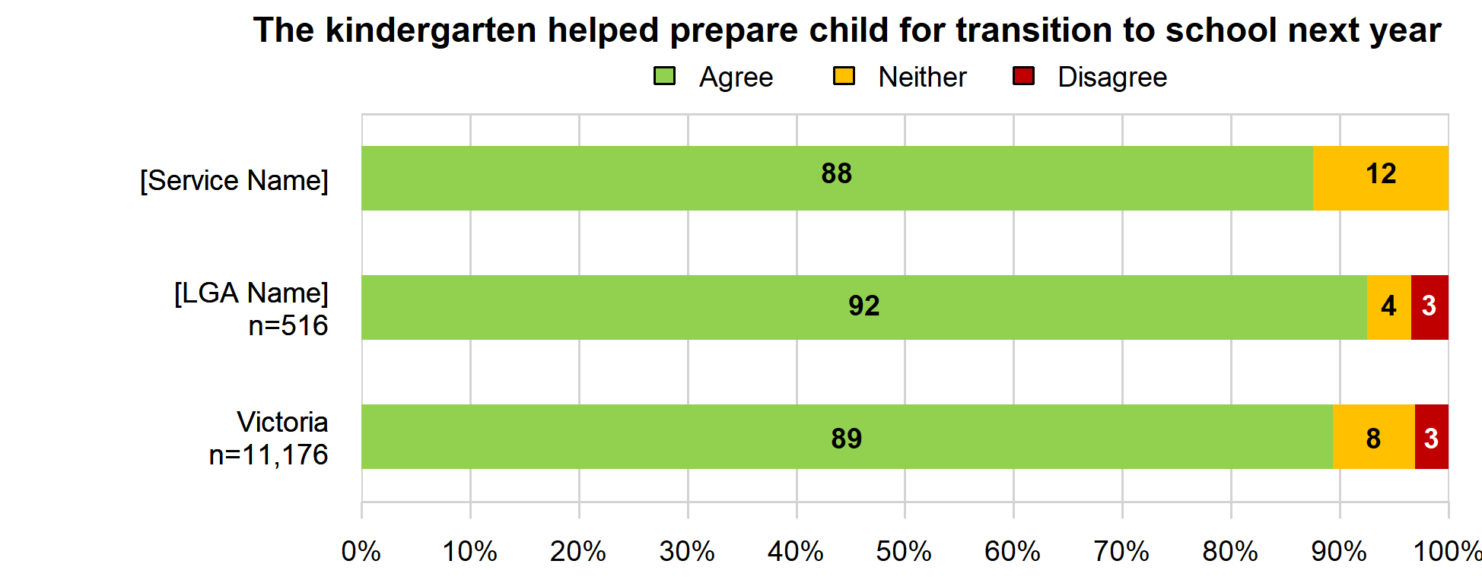
n=12

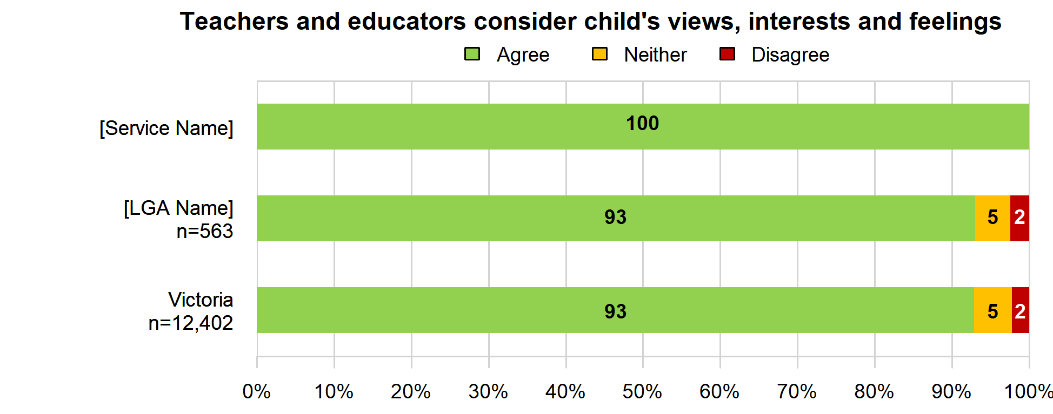
n=12

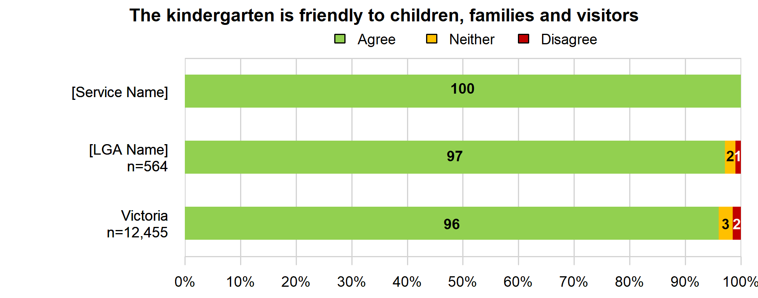
n=12

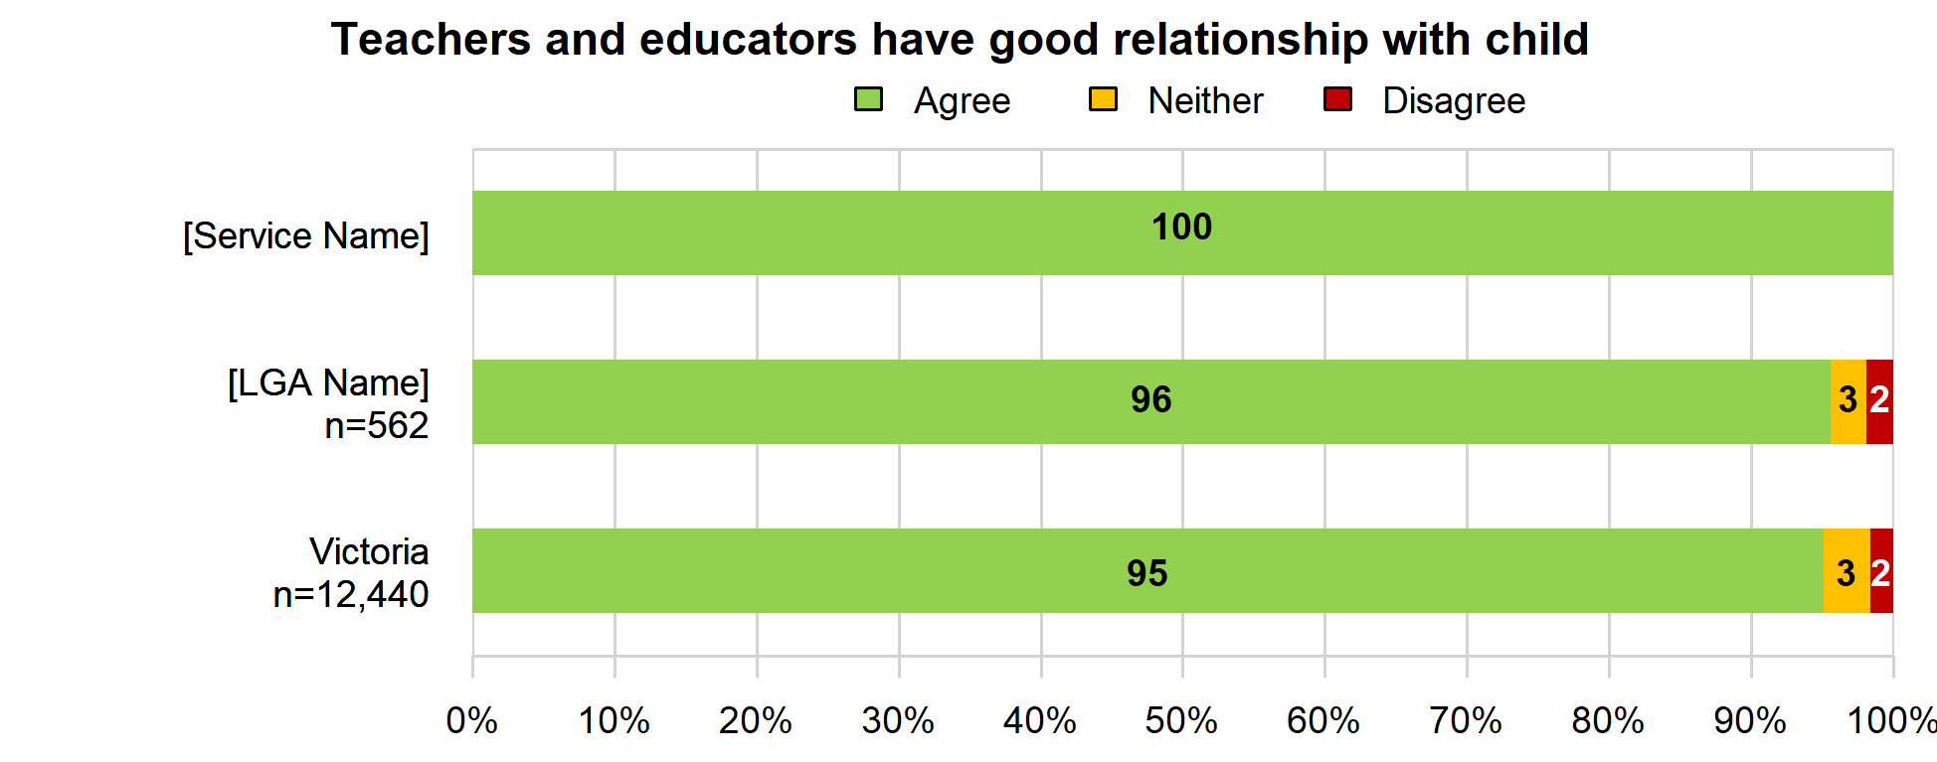
n=12

Discussion of child’s progress
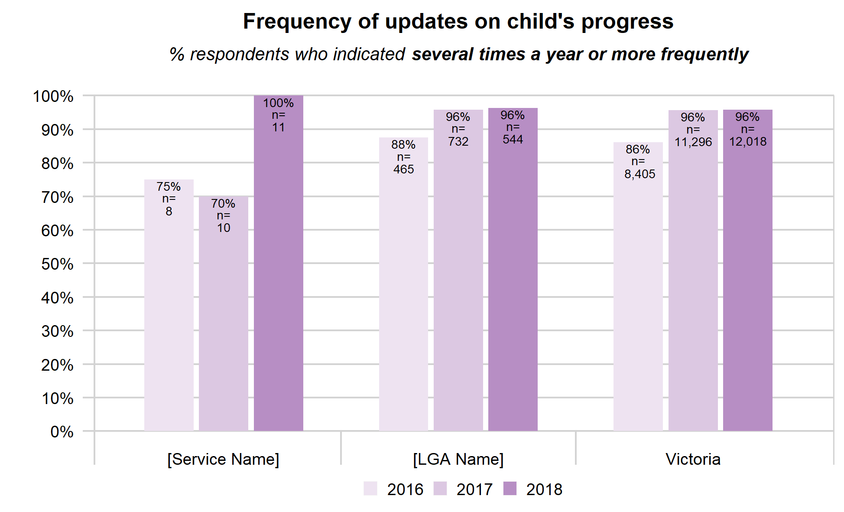

Recommend this service
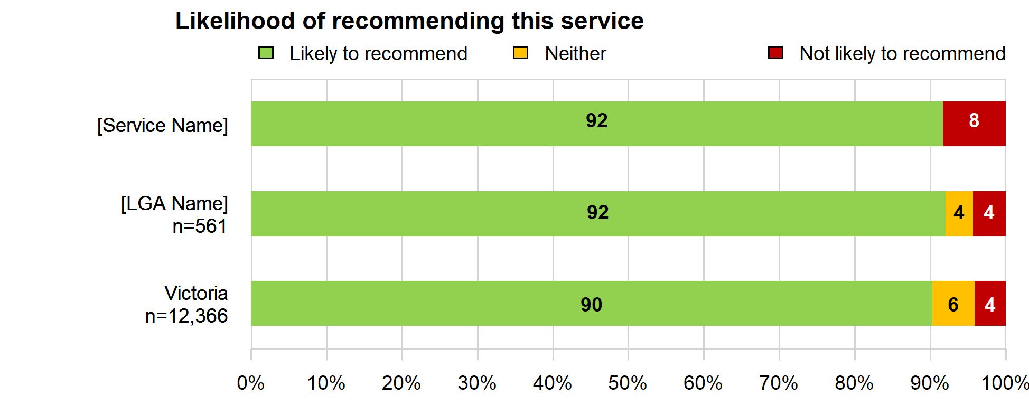
n=11

APPENDIX A: Taking Action – How to use the report
The National Quality Standard (NQS) is a key aspect of the National Quality Framework (NQF) and sets a high, national benchmark for early childhood education and care services in Australia. It gives services and families a better understanding of a quality service, helping families to make informed decisions about the services providing education and care to their child.
The survey questions relate to different components of the NQS and the results outlined in this report can be used to identify areas of strength and areas for improvement at your service(s). It is important to interpret the results in this report in the context of your service and remember there are various factors to consider when determining the best strategies and approaches for improvement at your service. The report provides a good starting point for conversations between service providers and teachers/educators about what actions might be taken to build on service strengths and to address areas for improvement.
The table below provides a breakdown of how the questions in the parent opinion survey relate to the different quality areas and elements that form the NQS. Linking the results from your report to the NQS table below can help determine which component(s) of the NQS to focus on improving or strengthening at your service. Then use the links after the table to access resources and information to support your service to strengthen the selected quality areas.
QUALITY AREA 1: Educational program and practice
Question: Teachers and educators at the kindergarten service consider your child’s views, interests and feelings.
NQS Element 1.1.2 Each child’s current knowledge, ideas, culture and abilities and interests are the foundation of the program on
Why is it important? Effective practice is strengthened when educators use the views, interests, knowledge and strengths of each child to inform curriculum decision making.
Assessing what children know, do and understand is critical to planning how next to advance children’s learning and development.
QUALITY AREA 5: Relationships with children
Question: The teachers and educators at the kindergarten service have a good relationship with my child.
NQS Element 5.1.1 Interactions with each child are warm, responsive and build trusting relationships
Why is it important? When educators are attuned to children’s thoughts and feelings, children are supported to develop a sense of wellbeing and belonging.
QUALITY AREA 6: Collaborative partnerships with families and communities
Question: The kindergarten service is friendly towards children, families and visitors.
NQS Element 6.1 Respectful, supportive relationships with families are developed and maintained.
Why is it important? Collaborative relationships with families are fundamental to achieve quality outcomes for children. Community partnerships that focus on active communication, consultation and collaboration also contribute to children’s learning and wellbeing.
Question: The kindergarten service gives you ideas / activities to help you with your child’s learning at home.
NQS Element 6.2 Families are supported in their parenting role and their values and beliefs about childrearing are respected.
Why is it important? When services work in partnership with families to support them in their parenting role, planned experiences for children are more meaningful and the family’s ability to support and nurture their child is enhanced.
The home learning environment plays a significant role in supporting children’s learning and development, health and wellbeing.
Question: Teachers and educators at the kindergarten service provide updates on your child’s progress.
NQS Element 6.3.2 Continuity of learning and transitions for each child are supported by sharing relevant information and clarifying responsibilities.
Why is it important? Families are the primary influence on their child’s learning and development and have valuable information about their child’s strengths, abilities, challenges and interests.
Children learn about themselves and construct their identity within the context of their families and communities. (VEYLDF p.5) Services that actively engage and build connections in the community in which they are located are better able to meet the needs of local families and their children.
Educators work with children, families, other professionals and the broader community to ensure successful transitions between settings and that children feel secure and confident.

More information
The links provided below can be used for further information and resources in relation to the National Quality Standard and the Victorian Early Years Learning and Development Framework, to support services with strengthening and improving practice.
- The Victorian Early Years Learning and Development Framework (VEYLDF)
- Resources on the VEYLDF Practice Principles and Outcomes
- National Quality Standard – Resource Links
- Parenting today – Raising Children Network

APPENDIX B: Survey questions
Q1. Overall, how satisfied are you with the education your child receives from this kindergarten service?

- Very satisfied
- Satisfied
- Neither satisfied nor dissatisfied
- Dissatisfied
- Very dissatisfied

Q2. How important do you think attending kindergarten is to your child's education?
- Very important
- Somewhat important
- Not important
- Don’t know / Prefer not to say

Q3. How would you rate the overall quality of education offered to your child at this kindergarten service?
- Very good
- Good
- Fair
- Poor
- Very poor
- Don’t know / Prefer not to say

Q4. Which of the following do you consider the three most important factors in choosing a kindergarten service for your child?
- Service location / distance from home or work
- Days and times the kindergarten program is available
- The service also offers long day care
- Reputation of the service
- The service's rating against the National Quality Standards
- Links to a particular culture or community group
- Cost
- My other child / children are attending or attended this service
- Children at this service are likely to go to the same school together
- Other (please specify)_________________
- Don’t know / Prefer not to say

Q5. At the time of enrolling your child in a kindergarten service, was [SERVICE NAME] the only service available in your local area?
- Yes
- No
- Don’t know / Prefer not to say

Q6. To what extent do you agree or disagree with the following statements?
- The kindergarten service gives you ideas / activities to help you with your child’s learning at home
- The kindergarten service has helped your child’s transition/move to school next year
- Teachers and educators at the kindergarten service consider your child's views, interests and feelings
- The kindergarten service is friendly to children, families and visitors
- The teachers and educators at the kindergarten service have a good relationship with my child

- Strongly agree
- Agree
- Neither agree nor disagree
- Disagree
- Strongly disagree
- Don’t know / Prefer not to say

Q7. How often do teachers and educators at the kindergarten service provide updates on your child’s progress?
This can include staff providing updates in person, via email or in a book at the kindergarten service etc.
- Daily, or on each day my child attends
- Weekly
- Monthly
- Several times a year
- Never
- Don’t know / Prefer not to say

Q8. How likely would you be to recommend this kindergarten service to other families?
- Very likely
- Likely
- Neither likely nor unlikely
- Unlikely
- Very unlikely
- Don’t know / Prefer not to say

Q9. If you have any comments about how the survey or questions could be improved, please share them with us in the box below.

