Kindergarten Infrastructure and Services Plan
Moorabool Shire

CONTENTS
1. Introduction 3
1.1. Reform context 3
1.2. Purpose of Kindergarten Infrastructure and Services Plans (KISPs) 3
1.3. Structure of the KISP 4
1.4. Disclaimer 4
2. Map of Early Childhood Education services in Moorabool 5
3. Local context 6
3.1 Purpose 6
3.2 Key considerations 6
4. Unmet demand estimates between 2025 - 2036 for Moorabool Shire Council 12
4.1 Purpose 12
4.2 Methodology 12
4.3 Summary of current kindergarten provision 14
4.4 Agreed estimates of demand for kindergarten places 14
5. Authorisation 17

Introduction

Reform context
The Victorian Government’s $14 billion Best Start, Best Life (BSBL) reforms are the most significant change to Victoria’s early childhood sector in a generation.
The BSBL reforms include:
- Free Kinder: Free Kinder is now available for Victorian 3- and 4-year-old children at participating services in standalone (sessional) kindergartens and long day care centres – a saving of up to $2,500 per child, every year.
- Pre-Prep: Four-Year-Old Kindergarten will gradually transition to ‘Pre-Prep’ – increasing to a universal 30-hour-a-week program of play-based learning for 4-year-old children in Victoria by 2036.
- Three-Year-Old Kindergarten: the continued roll-out of Three-Year-Old Kindergarten, with programs increasing to 15 hours a week across the state by 2029.
- Early learning and childcare centres: the establishment of 50 Victorian government-owned and operated early learning and childcare centres. These centres will be built in areas with the greatest need and will make it easier for families to access early childhood education and childcare. The first of the centres will open in 2025.
These initiatives demonstrate a clear commitment to improving early learning outcomes for Victorian children, workforce participation and access for families, and present the most significant change to Victoria’s early childhood sector in a generation.

Pre-Prep will roll-out in Moorabool in 2027. Statewide, Aboriginal and Torres Strait Islander children, children from a refugee or asylum seeker background, and children who have had contact with Child Protection services, will be able to access up to 25 hours of Pre-Prep in 2026, increasing to up to 30 hours from 2028. Children who have (or have a parent or guardian who has) a Commonwealth concession card and children who are a multiple birth child (triplets or more) across the state will be able to access up to 25 hours of Pre-Prep in 2028, increasing to up to 30 hours from 2030.

Purpose of Kindergarten Infrastructure and Services Plans (KISPs)
New and expanded infrastructure is key to delivering the BSBL reforms and will require a large expansion of kindergarten facilities across the State. KISPs, which are jointly developed with Local Governments, indicate where and when new infrastructure will be required to support both reform implementation and population growth in each of Victoria’s 79 local government areas (LGAs). KISPs help all kindergarten providers meet demand and collectively provide a clear picture of infrastructure need across the State.
KISPs support planning for services and future capital works and include detailed information about:
- Current capacity and demand for funded kindergarten
- Capacity to be delivered for planned infrastructure projects and future demand for kindergarten
- Forecast ‘unmet demand’ for kindergarten – that is, the kindergarten places needed that cannot be met by current or planned capacity
- Information specific to each local government area and its early childhood education and care landscape.
KISPs were initially developed to support the roll-out of Three-Year-Old Kindergarten and have now been updated to incorporate Pre-Prep.
KISPs are intended to support planning. They are not funding documents and do not commit any party to addressing the unmet demand identified.
However, it is expected that future investment requests through Building Blocks and funding decisions about Local Government, not-for-profit projects (including non-government schools) would align with the relevant KISP (including Section 3: Local Context).

Structure of the KISP
Each KISP consists of the following sections:
- Section 1: A short introduction to the Best Start, Best Life reform and the KISP.
- Section 2: A map of existing and planned Early Childhood Education and Care services.
- Section 3: Local context and knowledge of key information in Moorabool Shire relevant to early childhood education.
- Section 4: Unmet demand estimates in Moorabool Shire over the life of the reform.

Disclaimer
All data presented in this document is published for information purposes only. Operational and business decisions should not be based solely on this document. Neither the Department nor Moorabool Shire Council warrants, guarantees, makes any representation or assumes any duty of care in relation to the data, including as to its suitability, completeness, accuracy or adequacy.

Map of Early Childhood Education services in Moorabool
The map below shows the distribution of currently operating and new State-supported services that are planned to open in the future in Moorabool. Planned services by the private sector are not included.
This map has been prepared using departmental data, from both the National Quality Agenda IT System (NQAITS) and the Victorian School Building Authority (VSBA).
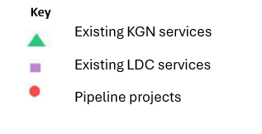
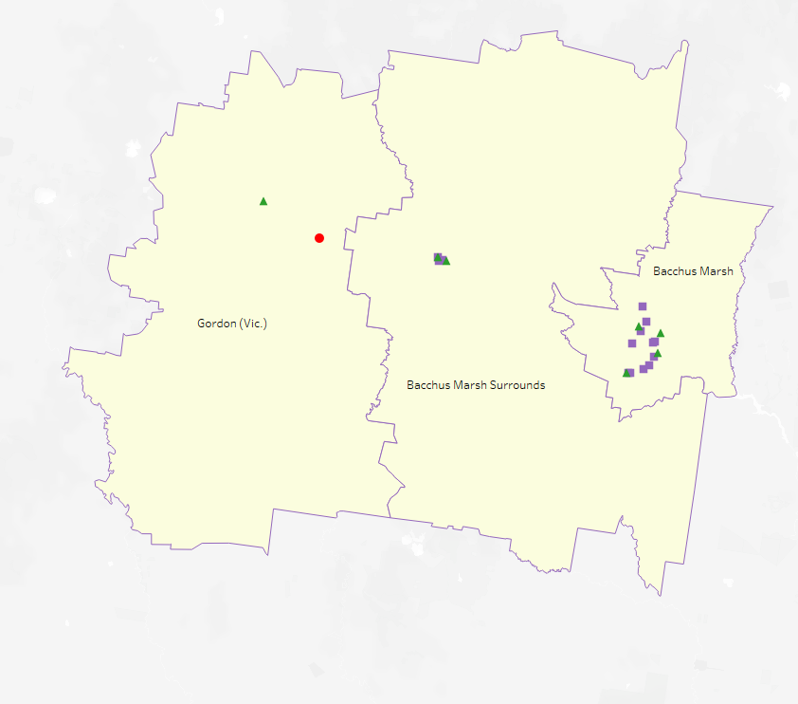

Local context
d

3.1 Purpose
Local, place-based knowledge and context play an important role in supporting the implementation of the BSBL reforms across Victoria. This section of the KISP documents this knowledge and context and should be considered alongside the kindergarten demand estimates in Section 4.
Information provided as local context may support applications through the Building Blocks Capacity Building and Planning Grants streams.

3.2 Key considerations
Aboriginal Self Determination in Early Childhood Education and Care
According to the 2021 Population and Housing Census, 1.4% of Moorabool’s population identified as Aboriginal or Torres Strait Islanders (approximately 526 individuals) compared to 1.0% across Victoria.
The number of kindergarten enrolments by children identifying as Aboriginal or Torres Strait Islander has increased from a total of 13 children in 2021 to 27 children in 2023, more than doubling in two years (mainly for four-year-olds). A similar rate of growth is not anticipated for future years. It is understood the growth between 2021 and 2023 is due to sector wide contributions including Department of Education programmes, Councils’ engagement with Best Start and Central Registration, Koori Kids Shine and sector wide participation in Networks and Forums. These positive practices and the delivery of kindergarten programmes have been underpinned by the ‘practice principles’ of the Victorian Early Years Learning and Development Framework are promoted at the service delivery level. The Indigenous Preschool Advancement Strategy (IPAS) is delivered across Moorabool Shire, and it is expected that that the Ballarat and District Aboriginal Co-operative service in Ballan will continue to support and promote the engagement with Indigenous families with early education.
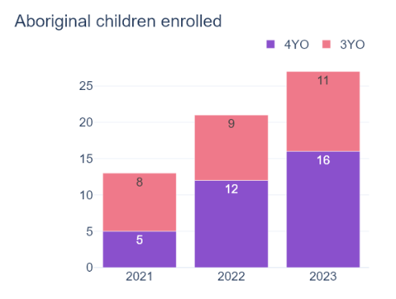
Key demographic trends that influence the demand for kindergarten
Between 2025 and the end of the KISP modelling period in 2036, the population of Moorabool Shire is forecast to grow by approximately 13,500 people, which equates to a one third increase in total population. For the same period (2025-2036) the KISP is modelling an increase of 309 three and four-year-old children, equivalent to +30% growth.

Uneven growth within the Bacchus Marsh SA2

Of the forecast 309 additional kindergarten-age children in Moorabool Shire by 2036, 75% of those (+231 children) will be in the Bacchus Marsh SA2. The Bacchus Marsh SA2 covers not only the existing suburbs of Darley, Bacchus Marsh and Maddingley but also the growth areas of Merrimu and Hopetoun Park. This large and complex SA2 is therefore not ideal for modelling local demand for kindergarten; important local factors that need to be considered within the Bacchus Marsh SA2 include:
- Over the 5 years between 2025 and 2030, all the forecast increase in kindergarten-aged children in the Bacchus Marsh SA2 will be within the existing urban areas of Bacchus Marsh, Darley and Maddingley. But between 2030 and 2036, almost all the growth in kindergarten demand will be in the new growth areas of Merrimu and Hopetoun Park where there is currently no kindergarten supply.
- In the suburb of Darley, the population of three and four-year-olds is expected to increase until the year 2030 (total growth of 31 children) but afterwards decline steadily to 2036 and beyond. By 2036, there will be a similar number of kindergarten-age children in Darley as at present.
- Similarly, for the suburbs of Bacchus Marsh and Maddingley, growth in kindergarten demand is expected to slow considerably after 2030. From 2030, increases in demand will shift towards Merrimu and Hopetoun Park.

While the unmet demand estimates in section 4 for Bacchus Marsh SA2 show no unmet demand, the local factors described above may result in the following localised supply shortfalls within the SA2:
- Kindergarten services in Darley may experience increased demand up to 2030, then a decrease thereafter. From 2032 onwards, demand will start to increase in the Merrimu-Hopetoun Park growth area. In the early years of this growth, supply in neighbouring Darley may be sufficient to satisfy demand for kindergarten from development in Merrimu-Hopetoun Park until there is sufficient population in the growth area to support local services.

Uneven growth within the Bacchus Marsh Surrounds SA2

The Bacchus Marsh Surrounds SA2 includes the township of Ballan, the growth area of Parwan Station (immediately southeast of Bacchus Marsh) and the rural areas surrounding the Bacchus Marsh SA2. Again, modelling supply and demand across this large SA2 does not highlight local issues for Ballan and the Parwan Station growth area. Over the 5 years between 2025 and 2030, roughly half the growth in kindergarten-age children in the Bacchus Marsh Surrounds SA2 will be within Ballan and the other half spread across rural areas of Moorabool’s east. But after 2030 growth in Ballan will increase three-fold compared to previous years and growth will commence in the Parwan Station growth area.
While the unmet demand estimates in section 4 for Bacchus Marsh Surrounds SA2 show no unmet demand, the local factors described above may result in the following localised supply shortfalls within the SA2:
- Supply and demand in Ballan and its immediate surrounds is a completely different market to the rural areas closer to the Bacchus Marsh urban area and Parwan Station. The new kindergarten at Ballan Primary School is expected to satisfy local demand up to and beyond 2036.
- In the early years of growth in Parwan Station, supply in neighbouring Maddingley and Bacchus Marsh may need to accommodate kindergarten demand from new developments until there is sufficient population in the growth area to support local services.

Significant population growth after 2036, with some decline in established areas

This KISP only considers demand up to the year 2036. However, it should be noted that population growth in Moorabool’s growth areas - Merrimu, Hopetoun Park and Parwan Station – is forecast to be much more significant after 2036 than before. Conversely, the number of kindergarten-aged children in the established urban areas of Darley, Bacchus Marsh and Maddingley are forecast to decline after 2036. Growth in Ballan is forecast to remain comparatively steady.
Council’s adopted Forecast ID projections estimate:

Three and four-year-olds | Population change  2025 to 2036 | Population change  2036 to 2046
Established urban area  (Darley, Bacchus Marsh, Maddingley) | +146 | -77
Merrimu-Hopetoun Park growth area3 | +109 | +411
Parwan Station growth area4 | +33 | +96
Ballan | +55 | +76
If these population forecasts continue, future updates to the KISP will need to consider how best to balance decreasing demand in some areas with large increases in others.

Family preference and market share
The KISP modelling does not distinguish between places in a sessional or integrated setting. Enrolment data provided by the Department of Education shows that in 2023 a little over one third (36%) of all kindergarten supply in Moorabool Shire was within sessional kindergartens but that 60% of kindergarten enrolments (number of children) were in sessional kindergarten. This indicates a strong preference by families for sessional kindergarten. This is further supported by a Council survey of young families undertaken in 2021 that identified a clear preference - by two-thirds of respondents - for sessional kindergarten compared to integrated.
By 2036, the KISP assumes the proportion of kindergarten supply in sessional services for Moorabool Shire overall will increase to 58%, up from 36% in 2023. This proportion will vary between SA2s:

 | % supply in sessional KGN | % supply in integrated kinder in LDCs
Bacchus Marsh SA2 | 51% | 49%
Bacchus Marsh Surrounds SA2 | 66% | 34%
Gordon SA2 | 100% | 0%

This assumed majority of sessional kindergarten supply is considered beneficial due to increased affordability. Currently, there may be out-of-pocket fees for funded kindergarten delivered in a long day care setting even after considering the Child Care Subsidy and Free Kindergarten offset. Free kindergarten has removed cost as a barrier for sessional kindergarten and in turn made sessional places even more sought-after. For families, a shortfall in sessional kindergarten places could place them into a long day care option with additional costs.
It is important to recognise the vital role that private services play in creating kindergarten supply and choice of program type. The survey of families conducted by Council in 2021 highlighted a preference among some families for longer days (i.e. in a long day care setting) due to the convenience for their family needs and other commitments. However, Council’s oversight of integrated kindergarten—both in volume and quality—is more limited than for sessional services. Council will be able to maintain strategic control over the supply of sessional kindergarten whereas it cannot guarantee the continuity of private services.
It is noted that 100% of kindergarten supply in the Gordon SA2 is within the two sessional services. While this benefits families living in the southern half of the SA2 (where the areas of greatest social disadvantage are located), it means that families in the SA2 need to access childcare in Ballan or in neighbouring City of Ballarat. Data for 2023 provided by the Department of Education indicated 77 children from Moorabool attended kindergarten programs in the City of Ballarat. This relatively large outflow may be due – at least in part – to a lack of childcare services in the west of Moorabool Shire. It is also likely a factor of parents travelling to Ballarat for work and using childcare services near their places of employment. For comparison, only 22 Moorabool children attended kindergarten in Melton in 2023.

Social disadvantage
Pockets of social disadvantage exist within Moorabool (as identified through Census 2021 data and reported through the SEIFA Index of Relative Socio-economic Disadvantage). Broadly speaking, the southern rural half of the Shire (Elaine, Mount Wallace, Balliang) is more disadvantaged than the north, and the west (Korweinguboora, Dunnstown, Wallace, Gordon, Lal Lal) is more disadvantaged than the east. Areas of disadvantage exist in:
- Central Bacchus Marsh and Darley
- Southern Maddingley
- Ballan
- Korweinguboora area
- Lal Lal and surrounds

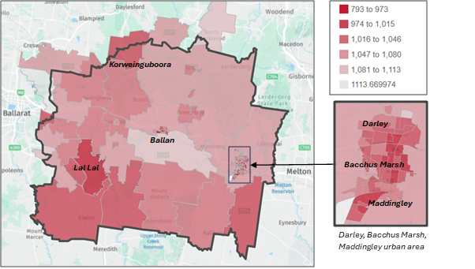
SEIFA (Index of Relative Socio-economic Disadvantage, Census 2021)
darker red = more disadvantaged

Similarly, concentrations of low-income households exist in Ballan, central Bacchus Marsh and Maddingley. And unemployment is highest in the rural west and in the rural areas surrounding Darley and Bacchus Marsh.
To ensure affordability for families, it will be important to maintain the current supply of sessional kindergarten in each of the SA2s. In addition, as travel distances in rural parts of the Shire are already significant, it will also be necessary to maintain the current distribution of sessional services as a minimum so as not to increase travel times. While it would be of great benefit to families in the rural southwest to create an additional service in this area, demand is too small to support a new local kindergarten.
- An analysis by Council conducted in 2021 suggests that families with incomes of less than $125,000 per annum may find it difficult to afford the 80 days of long day care per annum required to complete the 600 hours of kindergarten (assuming 7.5-hour days).
- The 2021 Census shows 29% of Moorabool households fall into the highest income bracket (> $125K/year). 29% of households fall into the lowest bracket (< $59K/year). This symmetry suggests a notably polarized income distribution in Moorabool Shire’s 2021 Census data. Subdued wage growth and the potential economic impacts of COVID-19 make this information relevant to the planning for the next decade, should these trends continue.

Key local geographic considerations or information relevant to Three-Year-Old Kindergarten and Pre-Prep
Public transport services are limited to buses within the major townships. Even in Bacchus Marsh public transport options are limited, with very little direct connection between the three main suburbs (Bacchus Marsh, Darley and Maddingley). People must access two or more bus routes to travel from one suburb to another, which highlights the difficulty families have accessing kindergarten outside of their local area by any other means than car.
The State Government’s Plan Melbourne puts a significant focus on the concept of 20-minute neighbourhoods, the underlying principle being that people should be able to access their daily needs within a 20-minute (round trip) walk or ride of their home. Moorabool Shire Council has adopted a similar concept named ‘Sustainable Neighbourhoods’ in the Housing Bacchus Marsh to 2041 strategy. The reality for most of Moorabool is that families outside of the core urban area must drive to reach children’s services. Families in the many rural parts of the Shire – particularly the far southwest and north – must drive for at least 20 minutes each way. It is therefore important that the current distribution of services is not reduced.
Some services in neighbouring Melton, Ballarat and Golden Plains Shire are currently accessible to Shire residents who live near the Shire boundaries. However, as all councils prioritise kindergarten places for their own residents, and with the expected increase in demand as Three-Year-Old Kindergarten is rolled out and scaled up, Council cannot be certain that its residents will always be able to access kindergarten facilities in other municipalities. Therefore, services outside of Moorabool cannot be relied upon to service Shire families indefinitely.
Projects or trends that may influence supply of early childhood education and care
In 2024 Council conducted audits of the physical condition of its 5 kindergarten assets in addition to ‘fitness of purpose’ assessments conducted in 2019 for the Moorabool Community Infrastructure Framework. These assessments show that Council-owned facilities are generally physically suitable. However, the following issues were identified with Young Street Kindergarten and Ballan Kindergarten:

Young Street Kindergarten
- Office layout does not have sufficient office space (6 or more staff work at once but the office is only fitted for 2 people)
- Indoor play areas limited to 33 and 27 children, requiring presenting child/teacher ratio issues and insufficient space to effectively cater for all the children playing inside.

Ballan Kindergarten
- Poor access ramps
- Unsuitable floor layout, which hinders service delivery
- Windows difficult to open due to poor structural integrity
- Lack of storage space
- Ageing plumbing infrastructure

Whether through improvement plans, renovations, expansions and upgrades or the building of new facilities, it is important that Council takes a proactive approach and ensures that infrastructure spending is staged over time, to offset the continual pressure on resources and budgets. The opportunities for grants will continue to be investigated as another way that Council can help offset costs while providing needed infrastructure improvements and new infrastructure in line with the priorities identified for kindergartens.
The KISP assumes that the availability of kindergarten places in Council’s current facilities will remain unchanged in the future. This approach does not consider the potential loss of kindergarten places due to services closing, ageing infrastructure, or sites that may no longer meet future service delivery requirements. These requirements could alter due to changes in regulations, legislation, or reform decisions. With the roll-out of Pre-prep from 2027, if the number of current places is reduced because of longer hours, this may result in more families being forced into higher cost programs.

Other information about the expansion of early childhood services

Challenges for the rollout of funded three-year-old kindergarten and four-year-old Pre Prep
Pre-Prep rolls out universally in Moorabool in 2027, with services offering 30 hours per week from 2031. When Pre-Prep has fully rolled out, four-year-olds will access twice as many hours of funded kindergarten they do in 2025. If a service does not have the capacity to increase the number or size of groups, the only way to accommodate the longer hours is to enrol fewer children.

Service providers’ ability to accommodate these increased hours will vary between services. The options available to each service will depend on factors such as the number, size and licensed capacity of children’s rooms, the extent of spare capacity that currently exists, and the availability and qualifications of teaching staff. Service preferences (how the service is delivered) and family preferences (how services are accessed) will also influence the maximum size of groups in each room and the length of sessions. For example, some services may prefer to limit numbers below the full licensed capacity of a 33-place room to create a quieter environment for children and reduce the number of children per kindergarten teacher. As a single-room service in a rural area, Wallace and District Kindergarten has the least flexibility to extend hours and implement solutions such as mixed age groups.

Unmet demand estimates between 2025 - 2036 for Moorabool Shire Council

4.1 Purpose
As the BSBL reforms are rolled out and Victoria’s population grows, demand for kindergarten and Pre-Prep places will increase significantly. While additional capacity will be needed to meet this demand, this will vary across the State and over time, due to differences in the capacity of existing services, growth trends and sector composition.
To identify where, when and how many additional kindergarten places are expected to be required over the roll-out in Moorabool, Moorabool Council and the department have developed:
- a summary of the current provision of kindergarten within Moorabool (Section 4.3).
- an estimate of kindergarten places that cannot be met through existing services for the 2025 - 2036 period, considering the additional demand that can be accommodated by optimising utilisation of existing services and infrastructure (Section 4.4).
Local governments and providers can use these published estimates to inform reform implementation activities such as service planning, kindergarten program expansion, infrastructure investments and Building Blocks funding applications in alignment with future demand over the roll-out.

4.2 Methodology
The estimated kindergarten places used in the following sections have been agreed between Moorabool Council and the department, and were informed by:
- demand projections developed by the department which draw on a range of inputs, including population forecasts and current enrolments
- the estimated capacity of existing and planned services in the LGA (Section 2)
- where applicable, modelling undertaken by Moorabool and service level information; and
- local knowledge and context provided by the local government (Section 3) that explains particular issues and trends in their area.
Kindergarten places explainer
The KISP measures a service’s capacity to deliver funded kindergarten in terms of the number of 15-hour places (referred to as “kindergarten places”) available for Three-Year-Old kindergarten and Pre-Prep (noting that, by 2036, two kindergarten places will be required for one Pre-Prep enrolment). The number of kindergarten places is different from a service’s licensed or approved places, which count the number of children permitted to attend the service at any one time under the license. Many services can enrol more children in their funded kindergarten program(s) than they have licensed places for because they can run more than one kindergarten program per week. Kindergarten places are therefore a more accurate measure of service kindergarten capacity than licensed places.
Kindergarten places have been presented as 15-hour places so that new Three-Year-Old Kindergarten places and the additional 15-hour places required for Pre-Prep can be easily compared to existing 15-hour Four-Year-Old Kindergarten places. This is because, when Three-Year-Old Kindergarten is fully rolled out in 2029, three-year-old children will have access to 15-hours of kindergarten. When Pre-Prep is fully rolled out in 2036, four-year-old children will have access to up to 30-hours of kindergarten, an increase of the current offering of 15-hours per week.
It is important to note that enrolments are not equivalent to 15-hour places. One 15-hour place can support a total of 15 hours of delivery per week split between one or more children, including but not limited to the following examples:
 |  | One 15-hour place (15 hours of delivery)
Example 1 | 1 child | 1 x 3YO attending 15 hours per week
Example 2 | 1 child | 1 x 4YO attending 15 hours per week
Example 3 | 2 children | 2 x 3YOs attending 7.5 hours per week
Example 4 | 3 children | 3 x 3YOs attending 5 hours per week
Two 15-hour places can support a total of 30 hours of delivery per week split between one or more children, including but not limited to the following examples:
 |  | Two 15-hour places (30 hours of delivery)
Example 1 | 1 child | 1 x 4YO attending 30 hours per week
Example 2 | 2 children | 2 x 3YOs attending 15 hours per week
Example 3 | 2 children | 1 x 3YO, and  1 x 4YO both attending 15 hours per week
Example 4 | 3 children | 2 x 3YOs attending 7.5 hours per week, and  1 x 4YO attending 15 hours per week
Geographic boundaries used in the KISP
These estimates have been developed at an LGA and community level to show the overall forecast and variation within an area. The KISP defines community at the Statistical Area Level 2 (SA2), which is a medium-sized area which represents a community that interacts socially and economically, with an approximate population range of 3,000 to 25,000 people, and an average population of about 10,000 people. The KISP uses 2021 SA2 boundaries. More information is available at the Australian Bureau of Statistics website.
Supply contributed by pipeline projects
Moorabool Council and the department have added any new places that will be made available through planned expansions of existing services or new services into estimates of existing supply, where this information is available. This may include projects being delivered by not-for-profit providers (including non-government schools) with support from the Victorian Government, planned Kindergartens on School Sites, and government-owned and operated early learning and childcare centres.
The KISP does not estimate how and when the broader sector will expand to meet the additional demand for kindergarten places that are estimated over the roll-out period.

4.3 Summary of current kindergarten provision
The figures below provide a summary of current kindergarten provision within the LGA and provide relevant context for the estimates of demand for funded kindergarten places included in Section 4.5. The data included in this section are largely drawn from:
- the department’s Kindergarten Information Management System (KIMS), as at 2023.
- the National Quality Agenda IT System (NQAITS), as at April 2025.
Number of services by service type (NQAITS)
Stand-alone kindergartens | 7
Long day care centres (including services not currently delivering funded kindergarten) | 14

Percentage of services by management type, LGA level (NQAITS)
Type | Percentage
Local Government | 0%
Private not for profit | 38%
Private for profit | 62%
Other | 0%

Current kindergarten offering in Moorabool Shire
Three-Year-Old Kindergarten participation rate (KIMS): | 102%
Four-Year-Old Kindergarten participation rate (KIMS): | 85%
Number of services that offer a funded kindergarten program (KIMS): | 14

4.4 Agreed estimates of demand for kindergarten places
The below estimates (Table 1 onwards) have been developed by Moorabool Council and the department to illustrate the estimated:
- Demand – the total number of kindergarten places expected to be required over the roll-out period to support the current provision of Four-Year-Old Kindergarten, the BSBL reforms, and population growth
- Supply – the total number of kindergarten places that can be accommodated by existing services and infrastructure, and planned, State-supported services which are yet to open.
- Unmet demand – kindergarten places that cannot be accommodated by optimising existing services and infrastructure (i.e. the shortfall between demand and supply).
Interpreting the estimates
Infrastructure need in the LGA and its local communities is indicated by the bottom rows of the tables in this section (Table 1 onwards): Unmet demand. If the number of kindergarten places in this row is above zero, it means that the area is estimated to need additional infrastructure capacity. Any type of provider – local government, not-for-profit (including non-government schools) or for-profit – can build this additional infrastructure.
Sub-SA2 factors may need to be considered to give a holistic picture of unmet demand. For example, in rural communities, one SA2 may contain several small towns, some with excess supply and some with unmet demand. At the SA2-level, demand may appear to be met because all supply and demand is considered in aggregate; however, it is not feasible to for families to drive long distances to access kindergarten capacity in another town. Sub-SA2 factors are covered in Section 3: Local context.

Table 1: Estimated kindergarten places required between 2025 - 2036 in Moorabool Shire

Moorabool Shire estimates | 2025 | 2026 | 2027 | 2028 | 2029 | 2030 | 2031 | 2032 | 2033 | 2034 | 2035 | 2036
Demand for kindergarten places | 878 | 971 | 1176 | 1267 | 1419 | 1481 | 1722 | 1744 | 1773 | 1819 | 1869 | 1907
Unmet demand | 13 | 0 | 0 | 0 | 0 | 0 | 0 | 0 | 0 | 0 | 0 | 0

Community estimates
Table 2-A: Estimated kindergarten places required between 2025 - 2036 in Bacchus Marsh
SA2 estimates | 2025 | 2026 | 2027 | 2028 | 2029 | 2030 | 2031 | 2032 | 2033 | 2034 | 2035 | 2036
Demand for kindergarten | 681 | 750 | 904 | 969 | 1084 | 1133 | 1310 | 1327 | 1350 | 1376 | 1404 | 1431
Kindergarten supply | 1527 | 1527 | 1527 | 1527 | 1527 | 1527 | 1527 | 1527 | 1527 | 1527 | 1527 | 1527
Unmet demand | 0 | 0 | 0 | 0 | 0 | 0 | 0 | 0 | 0 | 0 | 0 | 0

Table 2-B: Estimated kindergarten places required between 2025 - 2036 in Bacchus Marsh Surrounds
SA2 estimates | 2025 | 2026 | 2027 | 2028 | 2029 | 2030 | 2031 | 2032 | 2033 | 2034 | 2035 | 2036
Demand for kindergarten | 127 | 136 | 161 | 177 | 197 | 206 | 243 | 248 | 254 | 274 | 294 | 305
Kindergarten supply | 450 | 450 | 450 | 450 | 450 | 450 | 450 | 450 | 450 | 450 | 450 | 450
Unmet demand | 0 | 0 | 0 | 0 | 0 | 0 | 0 | 0 | 0 | 0 | 0 | 0

Table 2-C: Estimated kindergarten places required between 2025 - 2036 in Gordon (Vic.)
SA2 estimates | 2025 | 2026 | 2027 | 2028 | 2029 | 2030 | 2031 | 2032 | 2033 | 2034 | 2035 | 2036
Demand for kindergarten | 70 | 85 | 112 | 121 | 138 | 142 | 169 | 169 | 169 | 169 | 171 | 172
Kindergarten supply | 58 | 176 | 176 | 176 | 176 | 176 | 176 | 176 | 176 | 176 | 176 | 176
Unmet demand | 13 | 0 | 0 | 0 | 0 | 0 | 0 | 0 | 0 | 0 | 0 | 0

Authorisation
The Central Highlands Area Executive Director, Jen Winter of the Department of Education and the General Manager Community Strengthening, Leigh McCallum of Moorabool Shire Council endorse this Kindergarten Infrastructure and Services Plan (KISP) for Moorabool Council by signing on ………. / ………. / ……….
This KISP is not intended to create legal relations or constitute a legally binding contractual agreement between the parties. The parties may review this KISP in 2028 to publish a new version that will replace the previous version.
Signed for and on behalf and with the authority of Moorabool Shire Council.

……………………………………
Signature

Name: …………………………......................................
Title: ………………………………………………………

Signed for and on behalf and with the authority of the Department of Education

……………………………………
Signature

Name: …………………………......................................
Title: ………………………………………………………

