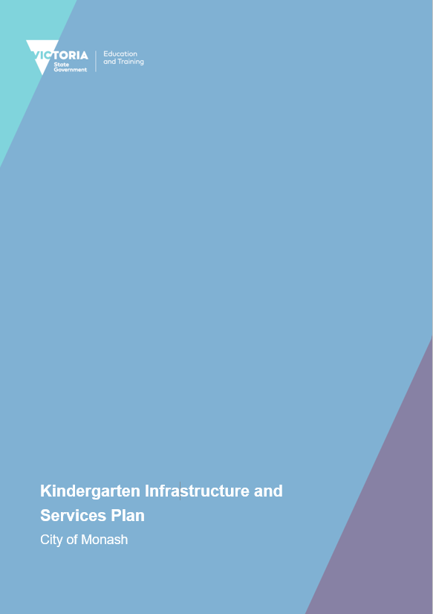

CONTENTS
- Introduction 3
  - Reform context 3
  - Purpose of KISPs 3
  - How to use the KISP 3
  - Structure of the KISP 3
  - Disclaimer 4
- Map of Early Childhood Education services in City of Monash 5
- Local context 6
  - Purpose 6
  - Key considerations 6
- Funded kindergarten enrolment estimates between 2021-29 for City of Monash 7
  - Purpose 7
  - Methodology 7
  - Summary of current kindergarten provision 8
  - Approach to optimising the use of existing services and infrastructure 9
  - Agreed estimates of demand for funded kindergarten places that cannot be met through existing services and infrastructure 11
- Authorisation 15

© State of Victoria (Department of Education and Training) 2020

Attachment 1 – Kindergarten Infrastructure Services Plan is provided under a Creative Commons Attribution 4.0 International licence. You are free to re-use the work under that licence, on the condition that you credit the State of Victoria (Department of Education and Training), indicate if changes were made and comply with the other licence terms, see: Creative Commons Attribution 4.0 International
The licence does not apply to:
- any images, photographs, trademarks or branding, including the Victorian Government logo and the DET logo; and
- content supplied by third parties.
Copyright queries may be directed to copyright@edumail.vic.gov.au

INTRODUCTION

REFORM CONTEXT

In an Australian first, the Victorian Government has committed to implement Three-Year-Old Kindergarten for all children over a 10-year roll-out with a total investment of almost $5 billion, including $1.68 billion to support the infrastructure expansion required for the reform. This reform will add another year of universal funded kindergarten so that, by 2029, all children in Victoria will have access to two years of play-based learning through a funded kindergarten program.

PURPOSE OF KISPS

Three-Year-Old Kindergarten will require a large expansion of kindergarten across the State. The Government has invited all 79 Victorian Local Governments to discuss and agree upon a Kindergarten Infrastructure and Services Plan (KISP) for their Local Government Area (LGA).

Each KISP has been jointly developed with Local Government and published to estimate the growth in demand for kindergarten within the LGA. The KISPs will help all kindergarten providers meet demand and provide a clear picture of infrastructure need across the State.

While a KISP is not a funding document and does not define required infrastructure projects or commit any party to funding specific projects, it is expected that future investment requests through Building Blocks and funding decisions about Local Government and not-for-profit projects would align with the relevant KISP.

HOW TO USE THE KISP
Each KISP contains estimates of future kindergarten supply of, and demand for, Three and Four- Year-Old Kindergarten places against existing enrolment capacity. Not-for-profit and for-profit providers can use these estimates to inform their plans to expand kindergarten programs, establish new services or invest in new or extended facilities.

For example, KISPs provide demand estimates in terms of where, when and how much demand for kindergarten places will grow in an LGA. KISPs also estimate where and how many kindergarten places providers can accommodate in existing facilities before an area needs new infrastructure to meet demand. The estimates can be used to inform decisions about where and when expansions of kindergarten program capacity and the construction of new or extended facilities are needed to meet demand growth.

Where there is an agreed KISP for the LGA, the Local Government and not-for-profit kindergarten providers seeking co-investments through the Building Blocks Capacity Building stream must refer to, and align their proposed project with, the infrastructure need identified in the KISP.

STRUCTURE OF THE KISP
Each KISP consists of the following sections:
- Section 1: A short introduction to the Three-Year-Old Kindergarten reform and the KISP.

3

- Section 2: A map of existing and planned Early Childhood Education and Care service locations.
- Section 3: Local knowledge and context relevant to the expansion of kindergarten services.
- Section 4: Funded kindergarten demand estimates.

DISCLAIMER
All data presented in this document are estimates only and are based on the best information available to the Department and Local Government at the time. They are published on an as-is basis and are for informational purposes only. They are subject to adjustment in response to market forces and as new data and other relevant information becomes available. The data may under- or over- estimate both total demand in a given location or year and the capacity for new demand to be met by providers. As a result, operational and business decisions should not be made solely based on this document. Any use of this data is solely at the risk of the user. The Department and Local Government accept no responsibility for any loss or damage, either direct or incidental, that may result from the use of the data.

MAP OF EARLY CHILDHOOD EDUCATION SERVICES IN CITY OF MONASH
The map below shows the distribution of currently operating and new services that are planned to open in the future in the LGA and across its communities.

This map has been prepared using Departmental data, from both the National Quality Agenda IT System (NQAITS) and the Victorian School Building Authority (VSBA). Where applicable, this map has been refined by the Monash City Council and the Department to capture other services that are planned to open in the future.

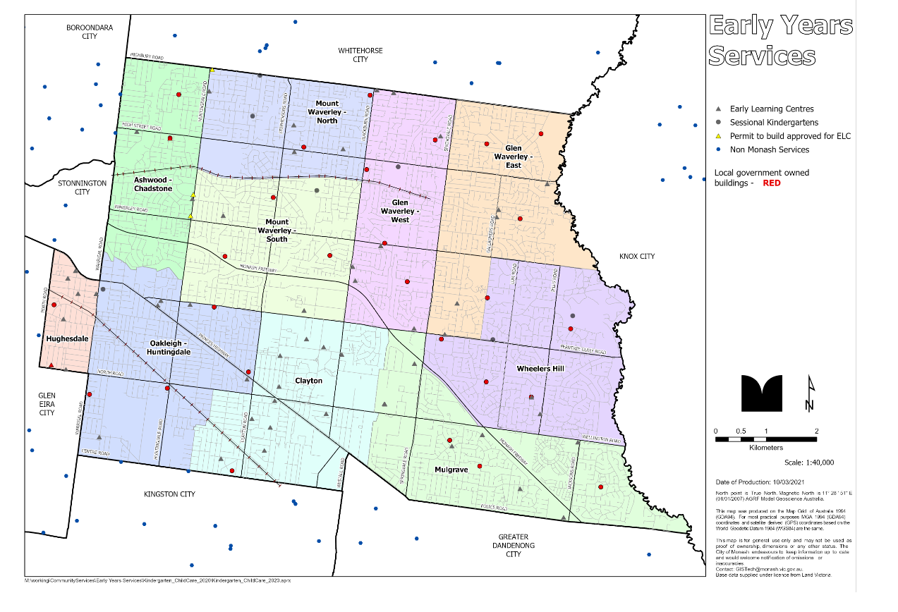

LOCAL CONTEXT

PURPOSE
Local, place-based knowledge and context play an important role in supporting the implementation of Three-Year-Old Kindergarten across Victoria. This section of the KISP documents this knowledge and context and has informed the funded kindergarten enrolment estimates in Section 4.

KEYCONSIDERATIONS

Key demographic trends that influence demand for kindergarten
The City of Monash is a culturally diverse community in Melbourne's southeast suburbs. It is home to an estimated population of 203,501 residents & forecasted to grow to 227,168 by 2031 making us one of the most populous municipalities in Victoria.

Between 2016 and 2031, the population for Monash is forecast to increase by 15%, at an average annual change of 1% - refer Table 1.

Source: https://forecast.id.com.au/monash

Table 1. Overall Population Forecast – Monash and suburbs

City of Monash | Change between 2016 and 2031
Area | 2016 | 2021 | 2026 | 2031 | Total change | Avg. annual % change
City of Monash | 192,850 | 203,501 | 216,864 | 227,168 | +34,318 | +1
Ashwood - Burwood | 10,198 | 10,431 | 10,710 | 11,382 | +1,184 | +0.7
Chadstone | 9,112 | 10,208 | 10,513 | 10,868 | +1,756 | +1.13
Clayton | 20,611 | 22,689 | 26,341 | 27,731 | +7,120 | +1.7
Glen Waverley | 42,272 | 44,530 | 47,330 | 49,932 | +7,660 | +1.06
Hughesdale | 8,002 | 8,509 | 8,825 | 9,146 | +1,144 | +0.8
Mount Waverley | 35,431 | 36,298 | 37,038 | 38,127 | +2,696 | +0.5
Mulgrave | 20,526 | 20,425 | 21,106 | 21,601 | +1,075 | +0.3
Notting Hill | 3,244 | 3,339 | 3,455 | 3,563 | +319 | +0.6
Oakleigh | 8,352 | 9,921 | 11,790 | 13,140 | +4,788 | +2.4
Oakleigh East - Huntingdale | 8,804 | 8,930 | 9,506 | 9,943 | +1,139 | +0.8
Oakleigh South | 5,381 | 5,870 | 6,588 | 7,487 | +2,106 | +1.9
Wheelers Hill | 20,917 | 22,351 | 23,661 | 24,249 | +3,332 | +0.9

Source: https://forecast.id.com.au/monash/population-summary

In Table 2, we note that half of the SA2’s will experience a shortfall in places by 2029.

Table 2. Three & Four Year old Demand for places (DET KISP Data)

 | 2021 | 2029
SA2 | 3 & 4 year olds | 3 & 4 year olds | Gap – places required by 2029
Ashwood - Chadstone | 125 | 378 | 117
Clayton | 197 | 599 | 36
Glen Waverley - East | 151 | 401 | 106*
Glen Waverley - West | 306 | 590 | 34
Mount Waverley - North | 153 | 377 | 102*
Mount Waverley - South | 200 | 468 | 203*
Mulgrave | 249 | 548 | 0
Oakleigh - Huntingdale | 396 | 786 | 167
Wheelers Hill | 298 | 507 | 13
Hughesdale | 191 | 368 | 0
DET Monash Overall Total | 2266 | 5022 | 778

*Mount Waverley and Glen Waverley are scheduled to have new Early Learning Centres constructed. Refer to Map 1.0 for an indication of placement.

Table 3. Children enrolled in Monash kindergartens by suburb.
Source: Central enrolments data February 2021.
Suburb | 2021 3yo | % of Total | 2021 4yo | % of Total
Ashwood | 19 | 2.9 | 31 | 2.7
Burwood | 6 | 0.9 | 18 | 1.6
Chadstone | 16 | 2.6 | 43 | 3.7
Clayton | 45 | 6.9 | 63 | 5.5
Glen Waverley | 148 | 22.8 | 244 | 21.2
Hughesdale | 28 | 4.4 | 33 | 2.8
Huntingdale | 9 | 1.4 | 11 | 1
Mount Waverley | 93 | 14.3 | 190 | 16.6
Mulgrave | 76 | 11.7 | 135 | 11.7
Notting Hill | 6 | 0.9 | 17 | 1.5
Oakleigh East | 31 | 4.9 | 51 | 4.4
Oakleigh South | 25 | 3.8 | 34 | 3
Oakleigh | 28 | 4.3 | 64 | 5.7
Wheelers Hill | 61 | 9.4 | 99 | 8.6
Non-residents | 57 | 8.8 | 119 | 10
Total | 648 | 100 | 1152 | 100

In Map 1.0 the early year’s capacity is illustrated across the municipality (number of centres including both Early Learning Centres & Kindergartens). When this map is considered alongside the population forecast, it is clear that:

- SA2 Oakleigh – Huntingdale requires some increase in Early Years Services;
- Clayton capacity reduces closer to the Kingston/ Monash Border;
- Glen Waverley and Mount Waverley, will have a lack of places available for 4 year olds; and
- Although there is an abundance of Early Learning Centres in Clayton, there is only one stand-alone Kindergarten service available. As discussion will show further in the document, Early Learning Centres alone do not cater for all of the community’s early learning needs.
Further to the overall view of Monash, six of the ten SA2s in Monash will experience growth in the three and four year old cohort - particularly in One Parent Families and Couple Families with dependants from 2020 to 2029 - most likely to utilise Kindergartens and Early Learning Centres over the next 9+ years.

Table 4. Household Type Population Forecast

City of Monash | 2020 | 2029
Type | Number | Number | Increase
Couple families with dependents | 25,746 | 28,201 | +2455
Couples without dependents | 17,083 | 19,113 | +2030
Group households | 4,491 | 5,152 | +661
Lone person households | 14,227 | 16,690 | +2463
One parent family | 6,519 | 7,180 | +661
Other families | 2,739 | 2,982 | +243

Source: https://profile.id.com.au/monash/households-with-children

Increasing rates of infill (housing developments) in the Oakleigh-Huntingdale SA2 will drive an increase in population mainly due to demand, proximity to Monash University and aged dwelling stock that would suit young families. This change in dwelling profile is one of the contributing factors behind the anticipated growth in families with young children expected in that area.

Ethnicity
Monash Kindergartens boast a diverse range of ethnicities with 48.9% of residents born overseas and nearly 50% speaking a language other than English at home. Given this level of diversity, it is vital to understand the potential impact of some cultural practices and their Early Years needs when planning. It has also been noted that some cultural groups send their children to family back at their home country from three years of age, which may affect enrolments for three-year-old kindergarten over time.

The predominance of people from culturally diverse backgrounds utilising early year’s services in Monash indicates a need for continuing support of the current model of both Early Learning Centre and Kindergarten availability, as it supports the communities expressed needs. Many intergenerational families in the community, that may be isolated and with limited English, benefit from the social connections made at Kindergarten services and Early Learning Centres. Social inclusion is one of the vital outcomes of early childhood services, which in today’s world is a vital consideration.

Workforce
In addition to a culturally diverse community, Monash has the highest rate of people coming into the municipality for work, outside of the CBD. This can influence the uptake of early years programs in that, many Monash based Early Learning Centre places are taken up by workers coming into the Municipality, as well as local residents. Anecdotally, workers coming into the area tend to prefer ELC places close to their workplace, suggesting that kindergarten enrolments favour families living closest to their local centre.

Projects or trends that may influence supply of early childhood education and care

In October 2020, Council’s building surveyor team measured the indoor and outdoor play space of all 28 LG owned Kindergarten buildings in Monash, allowing for 3.3 square metres per child, indoors, as required under the Regulations.

The table below displays the Department of Education and Training (DET) recorded Capacity (DET Licensed Places) alongside the recently determined Monash Capacity per centre – current as of OCT 2020.

Monash Early Learning Centres | Commonwealth Licensed Places | Funded Kindergarten Places
ELC Total | 4308 | 795
Standalone Kindergarten Funded Places 2020/21 |  | 1,283
Total Funded Places in Monash 2020/21 |  | 2,078

Conclusion
Based on Monash certified measurements, a further 41 places are available in existing Council owned buildings offering a Kindergarten service. In addition to this, none of the measurements captured for the indoor place space of each facility included the veranda measurement.
According to National Guidelines, veranda measurements may be applied to the indoor or outdoor play space with Monash electing to apply the veranda measurement to the outdoor total. However if additional places are required, the veranda space (if covered and enclosed) could be added to the internal total instead. All Monash outdoor spaces currently accommodate children numbers above the minimum requirement hence allocating the veranda to the indoor total would not compromise the outdoor space requirement per child.
However, a new Victorian Early Childhood Teachers and educators Agreement (VECTEA) Award may challenge the number of children able to be included per group.

Trends

Trend 1: According to feedback captured from Educators, Parents and Carers who have children enrolled at Monash Kindergartens and Monash Central Enrolment staff, there is a trend for parents to send their children to an Early Learning Centre to cater for the family work needs. Based on a phone survey of parents conducted by Council’s Central Enrolment staff, 70 - 80% of kindergarten-enrolled children also attend an Early Learning Centre.
Source: Survey of Kindergarten and Early Learning Centre services in Monash November 2020.

Trend 2: Every kindergarten service in Monash currently offers a three - year old program in some form. Some offer five hours per week over either one or two days, but others offer more hours as their parental surveys have requested. Some kindergartens have a small number of three and four year olds enrolled, so they provide a combined program for three and four year old children. Anecdotally, there appears to be a preference for three year-old kindergarten to be more than five hours per week, as this does not cater for families working needs. It is therefore assumed that the take up will potentially increase when more than 5 hours funded kindergarten are offered.
Source: Survey of Kindergarten and Early Learning Centre services in Monash November 2020.

Note: Parental Choice drives behaviour regardless of spaces available and assumptions. Parents may choose to take their children out of an Early Learning Centre and place them into a standalone Kindergarten at their discretion – and vice versa. Alternatively, as noted, parents may choose to have their child / children enrolled in a Kindergarten and an Early Learning Centre at the same time – thus potentially taking up 2 places for the one child, though only the Kindergarten receives the subsidy funding in these instances.

Trend 3: Parents tend to favour Kindergarten services that feed into their preferred primary school. This preference needs to be taken into consideration when considering the number and location of places actually required in the municipality to support a funded three-year-old program. High numbers of families from a migrant background (48.9% of residents are born overseas) also tend to favour grandparent support allowing parents to work whilst the grandparents drop off or pick up their grandchildren from Kindergarten and Primary Schools. Source: Birthplace | City of Monash | Community profile (id.com.au).

Culturally diverse families express a preference for Grandparents to care for pre-schoolers whilst parents work. This group may therefore be less likely to utilise both Early Learning Centres and KGN at the same time. Given that approx. 49% of Monash residents are culturally diverse, there may be a strong preference for this choice.
Source: Survey of Kindergarten and Early Learning Centre services in Monash November 2020.

Trend 4: It has previously been noted that a number of families prefer to send their pre-schoolers to sessional kindergarten as well as an Early Learning Centre. This is a variable finding, dependant on location e.g. based on anecdotal feedback captured in Nov 2020 - Appletree Hill Kindergarten (Glen Waverley) suggested that 50% of their enrolees attend both, whereas Ward Avenue Kindergarten (Oakleigh) reported it being as high as 70%.
Source: Survey of Kindergarten and Early Learning Centre services in Monash November 2020.

Trend 5. Parental choice again has a huge bearing on where families enrol their children for either a kindergarten or an Early Learning Centre. There are instances noted where educators are favoured at one service with parents tending to follow those educators if they change settings. Similarly, a kindergarten may be close to a grandparent’s home or it just might be the days that a program is offered that suits work commitments/ family logistics. This is obvious for kindergartens close to or on school sites example Pinewood Kindergarten and Oakleigh Primary School Kindergarten.
On Council’s central enrolment system, parents are offered the opportunity to submit a number of preferences that might appear random, though in reality the options entered correlate with logistical scenarios including, work, school proximity, grandparents and home location.
Source: central enrolments feedback NOV 2020.

Assumption: Working families will continue to utilise both settings for four year olds. It is likely that for three year olds, they will continue to attend an Early Learning Centre (if they have been attending one from an earlier age) that offers a three year old Kindergarten program, rather than attending a separate Kindergarten as well as an Early Learning Centre for their three year old. This may be because the standalone kindergarten may only offer five hours of three-year-old kindergarten per week.
However, families may consider sending their child to four-year-old kindergarten, for 15 hours per week, at a stand-alone kindergarten, as well as attending an Early Learning Centre for the remainder of the working week. This is primarily based on the anecdotal evidence that families send their children to a stand-alone Kindergarten in the year before school, because it helps to better prepare them for the school environment, rather than continuing with the kindergarten in the Early Learning Centre. Some change management to target this parent held view may be useful at this time.
Source: Parent Feedback and comments captured via Central Enrolment team.

Monash Kindergarten – Family Information.

Table 7. Enrolled Kindergarten Family Residence
The following table represents the location of residents for each of the families enrolled in a Monash Kindergarten Service, including non-residents.
Suburb | 2020 | % of enrolments | 2021 | % of enrolments
Ashwood | 50 | 3% | 47 | 2.7%
Burwood | 19 | 0.01% | 25 | 1.4%
Chadstone | 58 | 3.4% | 54 | 3.1%
Clayton | 93 | 5.5% | 100 | 5.6%
Glen Waverley | 358 | 21% | 360 | 21%
Hughesdale | 59 | 3.5% | 57 | 3.3%
Huntingdale | 27 | 1.6% | 19 | 1.1%
Mount Waverley | 282 | 16.8% | 276 | 16%
Mulgrave | 141 | 8.4% | 207 | 12%
Notting Hill | 22 | 1.3% | 23 | 1.3%
Oakleigh East | 80 | 4.7% | 79 | 4.6%
Oakleigh South | 60 | 3.5% | 52 | 3%
Oakleigh | 109 | 6.4% | 91 | 5.3%
Wheelers Hill | 173 | 10% | 158 | 9.1%
Other (non-residents) | 197 | 11% | 181 | 10.5%
Total | 1,678 | 100% | 1,729 | 100%

Key local geographic considerations or information relevant to Three-Year-Old Kindergarten

There are three proposed Early Learning Centre’s currently in the construction pipeline planned for completion over the next 12 months.

Please refer to map 1.0 for a view of Permit approved Early Learning Centres.

These proposed businesses have yet to apply to the Department of Education and Training for a formal license though they have already been approved by Local Government to build an Early Learning Centre with construction underway and anticipated to complete within 12 months.

Other information about the expansion of early childhood services

The timetabling used by early year’s services needs to consider the increasing trend of working families. Extended kindergarten sessions of 7.5 hours and wrap around programs are required so that parents can drop off and pick up their children on the way to and from work. The wrap around sessions are an additional cost to existing Kindergarten fees and families may therefore prefer to, in these instances, send their children to an Early Learning Centre which may work out to be more economical and logistically more viable.
Service providers need to be located (and are often selected due to their location) so as to enable families to drop off and pick up children on the way to work, including families with multi age children who may also prefer to drop off children at primary and secondary schools along the way. The Australian Early Development Census (AEDC) shows that families living in Monash actually attend 110 different primary schools – Monash has 39 primary schools within the borders. Therefore, selecting a service to support the needs of a family will tend to depend on the individual scenario. Service location and accessibility at a local level, is important in determining whether there is enough capacity across the system within a municipality to cater for demand.
Anecdotal feedback captured in November 2020, suggested that there will be a much higher demand for 3yr old sessional kinder once it is offered five+ hours.

Relative Cost of Services
Early Learning Centres offer a full day of education and care – covering up to 11 hours per day and for 50 weeks of the year in Monash, all but one or two services include a funded integrated four-year-old kindergarten program. If parents nominate the centre as their preschool, then the centre receives the kindergarten subsidy funding, which it puts towards its staffing requirement. No discount is applied to their childcare fees. To hold a place at an ELC, parents normally must enrol for a full year, including term holidays – this works out to be up to 50 weeks per year rather than 40 weeks for Kindergartens.
Sessional Kindergarten is usually a cheaper option for families, though it is noted that many families do send their children to Early Learning Centres also, if they work different days and hours than the sessional kindergartens are offering. Many parents also actively choose to send their children to both Kindergartens and Early Learning Centres thus increasing the cost and impacting the supply available in the area.

Kindergarten Assumptions

Item | Assumption
Four-year-old sessional kindergarten | The current participation rate for four-year-old sessional kindergarten – 93% of the annual projected age cohort.
Three-year-old sessional kindergarten | Subsidised three-year-old sessional kindergarten will commence with a minimum of five hours per week in 2022 and increase progressively to 15 hours per week in 2029, at which point the usage rate is expected to be lower than the 4 year old participation rate.
Service agreements (leases) for the provision of kindergarten services | While Council owns 28 of the buildings from which sessional kindergartens are provided, they are delivered by a mix of committees of management and not-for-profit early years managers. Service agreements (or equivalent arrangements) between Council and service providers will need to include clauses that ensure services provide programming models that maximise the capacity of both the building and timetabling opportunities. This is now included in Council leasing agreements from 2021.

At a high data only level, Monash appears to have enough Early Learning Centres & Kindergarten places to support 15 hours of both 3 and 4-year-old kindergarten based on the forecasts until approximately 2026. Having children attend both kindergarten and an early learning centre does take up two potential funded places, thus impacting on the system.
In reality the amount of places actually available are lower than the numbers suggest when you take into consideration the high number of places taken up by non-resident workers and the relatively low amount of funded places utilised in Early Learning Centres settings.
When delivering any change management activity in the City of Monash, it is recommended that the following is taken into account:

Opportunities for change in Monash – Department of Education and Training (DET).

Operational considerations:
  - Support Kindergartens in offering longer days for funded 3-year-old programs to ensure a higher take up by local residents/ families.
  - No one size fits all – Kindergartens with extended care hours are a great option for the future.

Stakeholder management:
  - Change management piece for families – to encourage families to attend a funded three and four-year-old program, as research shows this is in the best interests of the children. Families are also stakeholders that need to buy in to the changes proposed.
  - Intergenerational interaction – including grandparents becoming involved in Kindergartens and Early Learning Centres could support an uptake of these service types across the municipality.
  - Community Communication pieces – what are Early Learning Centres and how do they differ from Kindergarten. This should also address the widely held view in the community that proper Kindergarten can only be received at a stand-alone Kindergarten.
  - Information sessions for the community – available in top 3 languages.
  - Information sessions for the Educators which address their strongly held view of what constitutes a quality kindergarten program. Similar style to that provided for the change to 15 hours for kindergarten.
  - Match the expectations of numbers in groups to the requirements of the Victorian Early Childhood Teachers and Educators Agreement (VECTEA).

Note: The unmet kindergarten demand estimates in this document have been developed using data provided by the services in the City of Monash as part of the 2019 Kindergarten Capacity Assessment Program (KCAP) Survey. The estimates are based upon a sector-wide approach that identifies that sessional kindergarten has a greater capacity to deliver 15 hour places than the Long Day Care sector due to the greater capacity for programming flexibility. The agreed estimates in the KISP reflect an average programming model for sessional kindergarten which offers a 5 hour a day/5 days per week program.

FUNDED KINDERGARTEN ENROLMENT ESTIMATES BETWEEN 2021-29 FOR CITY OF MONASH

PURPOSE
As Three-Year-Old Kindergarten is rolled-out and Victoria’s population grows, demand for both
Three and Four-Year-Old Kindergarten places will increase significantly. While additional capacity will be needed to meet this demand, this will vary across the State and over time, due to differences in the capacity of existing services, growth trends and sector composition.

To identify where, when and how many additional kindergarten places are expected over the roll-out in the City of Monash, Monash City Council and the Department of Education and Training have developed:

    - A summary of the current provision of kindergarten within the LGA (Section 4.3).
    - An approach to optimising the utilisation of existing services and infrastructure through ‘change management’ strategies that Monash City Council and the Department will support to help meet additional demand in the LGA (Section 4.4).
    - An estimate of the Three and Four-Year-Old kindergarten places that cannot be met through existing services for the 2021-29 period, taking into account the additional demand that can be accommodated by optimising utilisation of existing services and infrastructure through point 2, above (Section 4.5).
Local Government and providers can use these published estimates to inform reform implementation activities such as service planning, kindergarten program expansion, infrastructure investments and Building Blocks funding applications in alignment with future demand over the 10-year roll-out.

METHODOLOGY

The estimated Three and Four-Year-Old Kindergarten places used in the following sections have been agreed between Monash City Council and the Department, and were informed by:
- Estimates developed by the Department which draw on a range of inputs, including population forecasts, current enrolments and results from the Kindergarten Capacity Assessment Program (KCAP), conducted in 2019.
- The estimated capacity of new services that are planned to open in the LGA (Section 2)
- Local knowledge and context provided by the Local Government (Section 3) that explains particular issues and trends in their area.
- The approach to optimising utilisation of existing services in the LGA (Section 4.4), and
- Other sources, such as modelling undertaken by Local Governments and local data.

7

The KISP measures a service’s capacity to deliver funded kindergarten in terms of the number of children it could enrol in Three and Four-Year-Old Kindergarten. The number of funded kindergarten places is different from a service’s licensed or approved places, which count the number of children permitted to attend the service at any one time under the license. Many services can enrol more children in their funded kindergarten program(s) than they have licensed places for because they can run more than one kindergarten program per week. Kindergarten places are therefore a more accurate measure of service kindergarten capacity than licensed places.

Three-Year-Old Kindergarten places have been presented as 15-hour places so they can be easily compared to Four-Year-Old Kindergarten places. Moreover, when Three-Year-Old Kindergarten is fully rolled-out in 2029, every three-year-old child will have access to 15-hours of kindergarten.

From 2023 all providers will have flexibility to determine how many hours of funded Three-Year-Old Kindergarten they deliver per week, with a minimum of five hours and a maximum of 15-hours funded pro-rata. It is expected that hours offered will vary. Given this variation, it is important to be aware that during the transition to all three-year-old children receiving 15-hours of funded kindergarten per week in 2029, the 15-hour places presented in this report may represent multiple three-year-old places that individually receive less than 15-hours of kindergarten per week.

These estimates have been developed at an LGA and community level to show the overall forecast and variation within an area. The KISP defines community at the Statistical Area Level 2, which is medium-sized areas which represent a community that interacts socially and economically, with a population range of 3,000 to 25,000 people, and an average population of about 10,000 people.

SUMMARY OF CURRENT KINDERGARTEN PROVISION
The figures below provide a summary of current kindergarten provision within the LGA and provide relevant context for the estimates of demand for funded kindergarten places included in Section 4.5. The data included in this section are largely drawn from:
- The Kindergarten Capacity Assessment Program (KCAP), collected between June and October 2019.
- The Department’s Kindergarten Information Management System (KIMS), as at 2019.
- The Department’s Quality and Regulatory Division (QARD) monitoring data, as at 2019.
- The National Quality Agenda IT System (NQAITS), as at April 2020.
- The Victorian Child and Adolescent Monitoring System (VCAMS), as at 2018.
Please note that, because these sources were collected at different points, this may result in slightly different totals appearing in the below data.

8

Number of services by service type (NQAITs, 2020)
Stand-alone kindergartens | 34
Long day care centres | 53

Percentage of services by management type, LGA level (NQAITs, 2020)
Type | Percentage
Local Government | 1%
Private not for profit | 47%
Private for profit | 47%
Other | 5%

Current kindergarten offering
Four-Year-Old Kindergarten participation rate (VCAMS, 2018): | 93%
Number of services that offer a funded kindergarten program (DET, 2019): | 80
Number of services that offer an unfunded Three-Year-Old Kindergarten program (DET, 2019): | 48
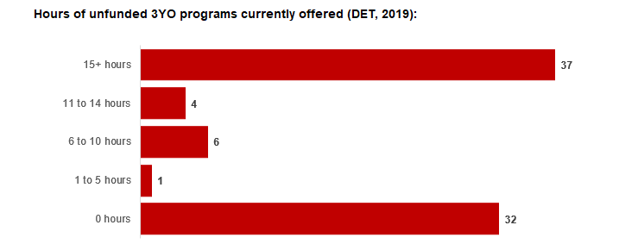

APPROACH TO OPTIMISING THE USE OF EXISTING SERVICES AND INFRASTRUCTURE

Change management strategies to optimise existing services and infrastructure

Children can often be accommodated through existing spare places and by services ‘unlocking’ unused capacity. As the experience of those Local Government Associations included in the 2020 Three-Year-Old Kindergarten roll-out shows, while the optimisation of existing services can be challenging, it is highly time- and cost-effective compared to building new capacity through infrastructure projects. It also helps target infrastructure investment to the places that need it most and avoids over-supplying the local market.

9

Monash City Council and the Department will support providers and services to maximise their kindergarten places through the following change management activities and practices:
- Increasing the capacity of any Local Government operated services by:
  - Running additional programs.
  - Using different timetables, including running 7.5-hour days.
  - Changing the delivery model, such as introducing rotational models or mixed-age groups.
  - Having degree-qualified kindergarten teachers leading integrated kindergarten programs in long day care settings.
- Encouraging and supporting other providers and services in the LGA to undertake change management.
Monash City Council and the Department have estimated how many Three and Four-Year-Old Kindergarten places can be accommodated through existing services in the LGA (Table 1). Both parties are committed to helping providers and services offer these kindergarten places before progressing to funded infrastructure solutions to meet demand. This commitment is reflected in the LGA and community level estimates below (Table 2 onwards), which assume that demand will be met first through existing services and second through additional infrastructure. Note that in some cases the number of kindergarten places that can be offered through existing services may exceed demand for kindergarten places.

Table 1: Total estimated funded kindergarten places that can be offered by optimising existing services and infrastructure across the LGA, between 2021-29 (presented in 15-hour equivalent places)

 | 2021 | 2022 | 2023 | 2024 | 2025 | 2026 | 2027 | 2028 | 2029
Estimated existing supply of kindergarten  places* | 4,439 | 4,601 | 4,601 | 4,601 | 4,601 | 4,601 | 4,601 | 4,601 | 4,601
*This may be higher than current three and four-year-old enrolments as it includ es any spare places that are currently available or could be gen erated by making some minor adjustments to programming approaches.

10

AGREED ESTIMATES OF DEMAND FOR FUNDED KINDERGARTEN PLACES THAT CANNOT BE MET THROUGH EXISTING SERVICES AND INFRASTRUCTURE
The below estimates (Table 2 onwards) have been developed by Monash City Council and the Department to illustrate the estimated:
    - Total number of Three and Four-Year-Old Kindergarten places expected over the roll-out period.
    - Three and Four-Year-Old Kindergarten places that cannot be accommodated by optimising existing services and infrastructure over the roll-out period.
These estimates have been developed to reflect that the increase in demand for Three-Year-Old Kindergarten places will be gradual.
In estimating how many Three and Four-Year-Old Kindergarten places cannot be accommodated by existing services and infrastructure, Monash City Council and the Department have taken into account any new places that will be made available through planned expansions of existing services or new services, into estimates of existing supply, where this information is available. This may include Local Government owned services being developed and planned Kindergartens on School sites.
These estimates do not, however, estimate how and when the broader sector will expand to meet the additional demand for kindergarten places that are estimated over the roll-out period.
Infrastructure need in the LGA and its local communities is indicated by the bottom rows of the tables in this section (Table 2 onwards): ‘Total kindergarten places that cannot be accommodated by existing services’. For example, if the number of kindergarten places for the LGA or a community is above zero in this row, it means that the area may to need additional infrastructure (noting that further optimisation which avoids the need for additional infrastructure may be possible). Any type of provider – Local Government, not-for-profit or for-profit – can build this additional infrastructure. If this row shows all zeros, it means that there is no estimated need for additional infrastructure in the area.
Local Government and not-for-profit kindergarten providers must refer to the estimates in this section when applying through the Building Blocks Capacity Building Grants stream for Government funding. Under this stream, projects must be in a community where there is infrastructure need as shown in the community’s table of estimated demand for kindergarten places (i.e. there are numbers in the bottom row above zero). Projects in LGAs or communities where demand can be met through existing services (i.e. the bottom row shows all zeros) are not eligible for funding under this stream.
The supply estimates included in the following tables are based upon the following assumptions:
- The Base utilisation rate used for the Monash City Council is 1.60 or an average programming model for sessional kindergarten which offers a 5 hour a day/5 days per week program.

11. LGA estimates

Table 2: Total estimated three and four-year-old kindergarten places between 2021-29 (presented in 15-hour equivalent places)

LGA level estimates | 2021 | 2022 | 2023 | 2024 | 2025 | 2026 | 2027 | 2028 | 2029
Total estimated  demand for kindergarten places (three and four-  year-old children) | 2,266 | 2,876 | 3,180 | 3,464 | 3,711 | 4,101 | 4,367 | 4,639 | 4,975
Total kindergarten places that cannot be accommodated by existing  services | 0 | 1 | 19 | 32 | 48 | 112 | 213 | 430 | 704

Community estimates

Table 3-12: Total estimated three and four-year-old kindergarten places between 2021- 29 (presented in 15-hour equivalent places)

Ashwood - Chadstone  estimates | 2021 | 2022 | 2023 | 2024 | 2025 | 2026 | 2027 | 2028 | 2029
Total estimated demand for kindergarten places (three  and four-year-old children) | 125 | 190 | 217 | 244 | 265 | 281 | 291 | 338 | 378
Total kindergarten places that cannot be accommodated by existing  services | 0 | 0 | 0 | 0 | 4 | 20 | 30 | 77 | 117

Clayton estimates | 2021 | 2022 | 2023 | 2024 | 2025 | 2026 | 2027 | 2028 | 2029
Total estimated demand for kindergarten places (three and four-year-old  children) | 197 | 259 | 301 | 343 | 383 | 448 | 507 | 545 | 599
Total kindergarten places  that cannot be accommodated by existing services | 0 | 0 | 0 | 0 | 0 | 0 | 0 | 0 | 0

Glen Waverley - East  estimates | 2021 | 2022 | 2023 | 2024 | 2025 | 2026 | 2027 | 2028 | 2029
Total estimated demand for kindergarten places (three and four-year-old  children) | 151 | 210 | 238 | 264 | 287 | 323 | 330 | 358 | 401
Total kindergarten places  that cannot be accommodated by existing services | 0 | 0 | 0 | 0 | 0 | 0 | 0 | 28 | 70

12

Glen Waverley - West estimates | 2021 | 2022 | 2023 | 2024 | 2025 | 2026 | 2027 | 2028 | 2029
Total estimated demand for kindergarten places (three and four-year-old  children) | 306 | 368 | 403 | 435 | 462 | 505 | 533 | 557 | 590
Total kindergarten places  that cannot be accommodated by existing services | 0 | 0 | 0 | 0 | 0 | 17 | 45 | 69 | 102

Hughesdale estimates | 2021 | 2022 | 2023 | 2024 | 2025 | 2026 | 2027 | 2028 | 2029
Total estimated demand for kindergarten places (three and four-year-old  children) | 191 | 221 | 240 | 258 | 274 | 312 | 342 | 334 | 321
Total kindergarten places  that cannot be accommodated by existing services | 0 | 0 | 0 | 0 | 0 | 0 | 0 | 0 | 0

Mount Waverley - North  estimates | 2021 | 2022 | 2023 | 2024 | 2025 | 2026 | 2027 | 2028 | 2029
Total estimated demand for kindergarten places (three and four-year-old  children) | 153 | 205 | 231 | 256 | 278 | 314 | 334 | 351 | 377
Total kindergarten places  that cannot be accommodated by existing services | 0 | 0 | 0 | 0 | 0 | 0 | 0 | 0 | 22

Mount Waverley - South  estimates | 2021 | 2022 | 2023 | 2024 | 2025 | 2026 | 2027 | 2028 | 2029
Total estimated demand for kindergarten places (three and four-year-old  children) | 200 | 264 | 281 | 295 | 307 | 324 | 368 | 424 | 468
Total kindergarten places  that cannot be accommodated by existing services | 0 | 1 | 19 | 32 | 44 | 61 | 105 | 161 | 205

Mulgrave estimates | 2021 | 2022 | 2023 | 2024 | 2025 | 2026 | 2027 | 2028 | 2029
Total estimated demand  for kindergarten places (three and four-year-old children) | 249 | 325 | 360 | 395 | 424 | 482 | 522 | 532 | 548
Total kindergarten places  that cannot be accommodated by existing  services | 0 | 0 | 0 | 0 | 0 | 0 | 0 | 0 | 0

13

Oakleigh – Huntingdale estimates | 2021 | 2022 | 2023 | 2024 | 2025 | 2026 | 2027 | 2028 | 2029
Total estimated demand for kindergarten places (three and four-year-old  children) | 396 | 484 | 532 | 576 | 614 | 666 | 686 | 735 | 786
Total kindergarten places  that cannot be accommodated by existing services | 0 | 0 | 0 | 0 | 0 | 14 | 33 | 82 | 133

Wheelers Hill estimates | 2021 | 2022 | 2023 | 2024 | 2025 | 2026 | 2027 | 2028 | 2029
Total estimated demand for kindergarten places (three and four-year-old  children) | 298 | 350 | 376 | 399 | 417 | 446 | 454 | 476 | 507
Total kindergarten places that cannot be accommodated by existing  services | 0 | 0 | 0 | 0 | 0 | 0 | 0 | 23 | 54

14

5. AUTHORISATION
The Area Executive Director (Inner East) of the Department of Education and Training and the Director, Community Services of Monash City Council endorse this Kindergarten Services and Infrastructure Plan (KISP) for City of Monash by signing on 04/05/2021.
This KISP is not intended to create legal relations or constitute a legally binding contractual agreement between the parties. The parties may review this KISP in 2024 to publish a new version that will replace the previous version.
An out-of-cycle review may be triggered if both parties agree that there has been a change in relevant data, information or the local early childhood sector that significantly affects the reliability of a KISP’s estimates for planning purposes.

Signed for and on behalf and with the authority of Monash City Council

Name: Russell Hopkins

Title: Director, Community Services

Address: 293 Springvale Road, Glen Waverley 3150

Signed by Area Executive Director (Inner East), Department of Education and Training

Signature 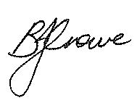 Witness Signature 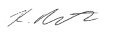

Name: Barbara Crowe

Title: Area Executive Director (Inner East)

Address: Level 3, 295 Springvale Road, Glen Waverley 3150

15

