Kindergarten Infrastructure and
Services Plan
Rural City of Mildura
CONTENTS
1. Introduction 3
1.1. Reform context 3
1.2. Purpose of KISPs 3
1.3. How to use the KISP 3
1.4. Structure of the KISP 3
1.5. Disclaimer 4
2. Map of Early Childhood Education services in Rural City of Mildura 5
3. Local context 6
3.1 Purpose 6
3.2 Key considerations 6
4. Funded kindergarten enrolment estimates between 2021-29 for the Rural City of Mildura 10
4.1 Purpose 10
4.2 Methodology 10
4.3 Summary of current kindergarten provision 11
4.4 Approach to optimising the use of existing services and infrastructure 12
4.5 Agreed estimates of demand for funded kindergarten places that cannot be met through existing services and infrastructure 13
5. Authorisation 17

Introduction

Reform context
In an Australian first, the Victorian Government has committed to implement Three-Year-Old Kindergarten for all children over a 10-year roll-out with a total investment of almost $5 billion, including $1.68 billion to support the infrastructure expansion required for the reform. This reform will add another year of universal funded kindergarten so that, by 2029, all children in Victoria will have access to two years of play-based learning through a funded kindergarten program.

Purpose of KISPs
Three-Year-Old Kindergarten will require a large expansion of kindergarten across the State. The Government has invited all 79 Victorian Local Governments to discuss and agree upon a Kindergarten Infrastructure and Services Plan (KISP) for their Local Government Area (LGA).
Each KISP has been jointly developed with Local Government and published to estimate the growth in demand for kindergarten within the LGA. The KISPs will help all kindergarten providers meet demand and provide a clear picture of infrastructure need across the State.
While a KISP is not a funding document and does not define required infrastructure projects or commit any party to funding specific projects, it is expected that future investment requests through Building Blocks and funding decisions about Local Government and not-for-profit projects would align with the relevant KISP.

How to use the KISP
Each KISP contains estimates of future kindergarten supply of, and demand for, Three and Four-Year-Old Kindergarten places against existing enrolment capacity. Not-for-profit and for-profit providers can use these estimates to inform their plans to expand kindergarten programs, establish new services or invest in new or extended facilities.
For example, KISPs provide demand estimates in terms of where, when and how much demand for kindergarten places will grow in an LGA. KISPs also estimate where and how many kindergarten places providers can accommodate in existing facilities before an area needs new infrastructure to meet demand. The estimates can be used to inform decisions about where and when expansions of kindergarten program capacity and the construction of new or extended facilities are needed to meet demand growth.
Where there is an agreed KISP for the LGA, the Local Government and not-for-profit kindergarten providers seeking co-investments through the Building Blocks Capacity Building stream must refer to, and align their proposed project with, the infrastructure need identified in the KISP.

Structure of the KISP
Each KISP consists of the following sections:
- Section 1: A short introduction to the Three-Year-Old Kindergarten reform and the KISP.
- Section 2: A map of existing and planned Early Childhood Education and Care service locations.
- Section 3: Local knowledge and context relevant to the expansion of kindergarten services.
- Section 4: Funded kindergarten demand estimates.

Disclaimer
All data presented in this document are estimates only and are based on the best information available to the Department and Local Government at the time. They are published on an as-is basis and are for informational purposes only. They are subject to adjustment in response to market forces and as new data and other relevant information becomes available. The data may under- or over-estimate both total demand in a given location or year and the capacity for new demand to be met by providers. As a result, operational and business decisions should not be made solely based on this document. Any use of this data is solely at the risk of the user. The Department and Local Government accept no responsibility for any loss or damage, either direct or incidental, that may result from the use of the data.

Map of Early Childhood Education services in Rural City of Mildura
The map below shows the distribution of currently operating and new services that are planned to open in the future in the LGA and across its communities. This map has been prepared using Departmental data, from both the National Quality Agenda IT System (NQAITS) and the Victorian School Building Authority (VSBA). Where applicable, this map has been refined by Mildura Rural City Council and the Department to capture other services that are planned to open in the future.
LGA Level
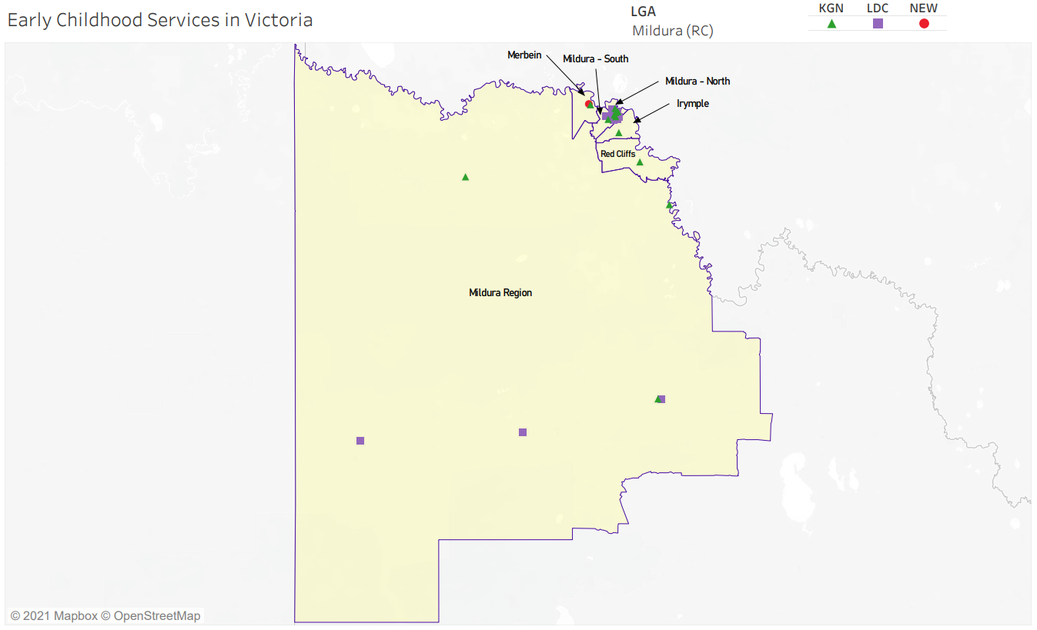
SA2 Level
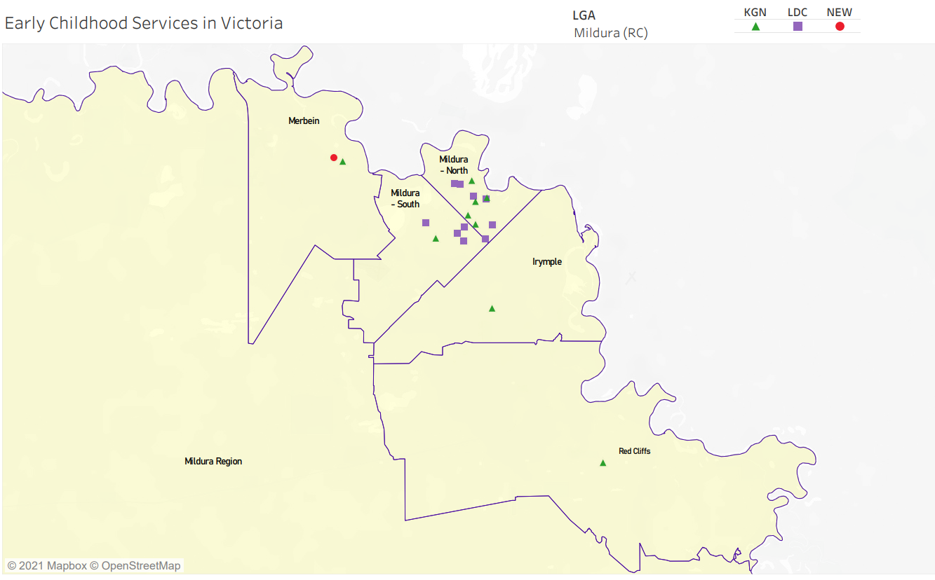

Local context
d

3.1 Purpose
Local, place-based knowledge and context play an important role in supporting the implementation of Three-Year-Old Kindergarten across Victoria. This section of the KISP documents this knowledge and context and has informed the funded kindergarten enrolment estimates in Section 4.

3.2 Key considerations
Key demographic trends that influence demand for kindergarten
Mildura Rural City Council is a regional Council located on tristate borders, with key industries including dryland farming, irrigated horticulture, tourism, food and beverage manufacturing, transport and logistics, retail, health and community services, attracting workers and their families to the area.

Victoria in Future (2016) (LGA) indicates expected growth in the 0-4 year age cohort population for the Mildura LGA (2011 – 2031), as per table below:

 | Persons 0-4
30 June 2011 | 3,423
30 June 2016 | 3,423
30 June 2021 | 3,420
30 June 2026 | 3,504
30 June 2031 | 3,521

- As noted in the State of Mildura Rural City Report 2018, certain cohorts within Mildura LGA are experiencing significant levels of socio-economic disadvantage in terms of income, education, occupation, wealth and living conditions. Based on the 2016 Australian Bureau of Statistics (ABS) Census of Population and Housing, the Mildura LGA was allocated an Index of Relative Socio-Economic Disadvantage (IRSD) score of 935 compared to the Victorian average of 1,000 (where a lower score represents greater levels of disadvantage). This ‘score’ sees the Mildura LGA ranked as the 5th most disadvantaged LGA of 79 LGAs in Victoria. These figures have remained constant between the 2011 and 2016 Census periods;
- According to the 2016 ABS Census of Population and Housing, Aboriginal and Torres Strait Islander Peoples Profile (Mildura LGA), 8.3% of the Mildura LGA population aged 0-4 years identify as Aboriginal and/or Torres Strait Islander (ATSI) and 7.5% are recorded as Indigenous status not stated, compared to 1.5% and 5.4% respectively across Victoria;
- An overview of Family Structures and Family Composition from the 2016 ABS Census of Population and Housing data (2017) (LGA and SA1), indicates the lowest proportion of ‘one parent families’ continued to be the Mallee Track (6.5% in 2011 and 4.5% in 2016), the highest proportion of ‘one parent families’ continued to be Mildura (21.2% in 2011), however the separation of the Mildura SA2 into two SA2s (Mildura North and Mildura South) revealed that the highest proportion of ‘one parent families’ was in Mildura North (23.7%), well above the Regional Victorian (16.2%), Melbourne (15.0%) and Victorian (15.3%) proportions;
- The Australian Early Development Census (AEDC), Community Profile 2018 (Mildura, Vic), which measures the development of children in their first year of full-time school, identified that children in Red Cliffs are developmentally at risk (29.7%) by more than double the state average (13.2%), for communication skills and general knowledge. Red Cliffs children are also significantly higher than state average to be developmentally at risk for physical health, social competence, emotional maturity and language and cognitive skills. Children will be supported in these domain measures, with access to two years of pre-school education provided by the roll-out of funded Three-Year-Old kindergarten.
- With a high level of vulnerable families in Mildura LGA, factors including proximity and ability to access facilities, influence a family’s choice of Early Years’ service provider. Often these families do not have reliable private transport and are limited by public transport or walking.
- There is an expectation the roll out of Three-Year-Old funded kindergarten will lead to an increase in participation by families by removing the financial barrier, however the full extent of this increase is difficult to predict.
- During Council consultation, service providers anecdotally reported that many parents prefer the stand-alone kindergarten curriculum as opposed to childcare kindergarten, as they believe it prepares children for the school environment. However, working parents often prefer a longer day session (7.5 hours), whether that be at a stand-alone kindergarten or a long day care centre. The convenience of session times offered therefore has an impact on whether a stand-alone kindergarten or long day care centre are preferred by families.
- Some kindergartens advocate for shorter session times (5 hours), especially in the lower socio-economic areas, as it is suggested by service providers that Three-Year-Old children struggle with attending for longer hours, which makes it challenging to schedule to capacity.
- Mallee Track families do not have choice of services, given low population and limited services available – integrated services are provided in Murrayville and Underbool, with both kindergarten and childcare places provided from each of the services. These services are shown as long day care services (purple squares) on the maps in Section 2, as they are not stand-alone kindergarten services.
Projects or trends that may influence supply of early childhood education and care
- Residential development in Mildura South, Irymple and Red Cliffs SA2’s will drive population growth in these localities and put additional pressure on existing kindergarten services.
- A new childcare centre was recently built in Merbein, which opened in January 2021. This has increased the supply of places in the Merbein SA2, which has been included in the estimated places in Section 4.
- There is a Planning Permit application for a new Child Care Centre in the Mildura South SA2, which has not been included in the numbers in Section 4 as timeframes around this development are unknown. Consultation during December 2020 indicated no other LDC’s are currently planning to expand in the immediate future.
- A Neighbourhood Activity Centre has been identified in the Mildura South (Sixteenth and Deakin West) Development Plan, which could potentially be an opportunity for either a public or private childcare provider, however timeframes around this development are unknown.
- Ageing kindergarten infrastructure across the Municipality, limited size and capacity of existing kindergartens and staffing, will all be challenging issues in order to meet the expected increase in demand from the roll out of funded 3yo kindergarten. Limited capital works budgets and available funding will impact the capability of both Council and kindergartens to address these matters.
- An increase in the Three-Year-Old cohort may require additional modified spaces, such as change tables for children who are not yet toileting and provision for sleeping or rest.
- A shortage of Bachelor and Diploma qualified teachers will be a challenge for the municipality, in addition to retaining existing staff and increasing working hours of these staff.
Key local geographic considerations or information relevant to Three-Year-Old Kindergarten
- Mildura South Development Plan covers an area of 180 hectares to be developed, with an additional 4,400 residents expected in this area.
- Nichols Point does not currently have any kindergarten or childcare services. Children from this location travel to Mildura or Irymple. Previous community consultation suggested a kindergarten service in the Nichols Point area.
- Irymple has been identified as a potential pressure point within the LGA, as there is an undersupply of Three-Year-Old kindergarten places within the LGA from 2022, according to the data in Section 4. Irymple Kindergarten is already utilising the existing space efficiently and is currently operating at capacity, with a waiting list for 2021. Council is exploring options with the Department to address this pressure.
- Irymple Kindergarten has many children attending that do not reside in Irymple. This is due to a number of factors, including:
  - popular choice and good reputation of service;
  - Irymple is an outer lying suburb and is the closest point for access for many of the more rural locations such as Koorlong and Cardross;
  - care providers such as grandparents live in Irymple or close to this service; and
  - parents who travel into Mildura for work or for parents who work in Irymple.
- Red Cliffs has also been identified as a pressure point for Three-Year-Old places and is expected to exceed capacity in 2022, however there is some potential to increase capacity at this service with some change management. Council is currently undertaking building assessments to evaluate the state of the infrastructure at all kindergartens, including Red Cliffs Kindergarten, to determine if replacement or upgrade is required in order to meet future demands.
- Residential development is expected to continue in both Irymple and Red Cliffs, which will potentially add further pressure on capacity at both Irymple and Red Cliffs Kindergartens.
- There are currently no Long Day Care Centres in Irymple or Red Cliffs.
- Council’s Family Day Care service has advised that demand for childcare in Red Cliffs and Irymple areas is high, however there are limited Educators located within these townships.
- While Mallee Track kindergartens (Ouyen, Underbool and Murrayville) have not been identified as exceeding capacity for the roll out of funded Three-Year-Old kindergarten, other issues are faced in these locations, such as ageing infrastructure (specifically in Ouyen and Murrayville) and integrated services not having suitable spaces for the different age cohorts.
Other information about the expansion of early childhood services
- Council leases buildings to most of the kindergarten services in Mildura Rural City Council. While there is no involvement in the daily operations of the kindergartens, Council assists with renewal and upgrades of Kindergarten buildings to meet service levels, subject to annual capital works budgets. Council is working with services to assess and prepare facilities to accommodate the proposed increase in demand for Three-Year-Old kindergarten with the rollout of the funded program, whilst maintaining service levels for Four-Year-Old Kindergarten. This will require a collaborative approach between Council, kindergartens and DET, as significant grant funding and capital contributions will be required.
- Mildura Rural City Council has identified the need for an Early Years Infrastructure Strategy, which will help set priorities and guide development and infrastructure requirements in this sector. It will be aimed at looking at potential service alternatives, such as integrated services (with other Early Years services) and kindergartens located on school grounds, in addition to potential expansion and upgrade opportunities and priorities.
- A Municipal Early Years Plan (MEYP) was endorsed by Council in January 2021. The MEYP will also provide input for the proposed Early Years Infrastructure Strategy.
- All local kindergarten services are prepared for offering 5 hour Three-Year-Old places by 2022. While some kindergartens are in a good position to be able to adopt change management in order to meet the required 15 hour places by 2029, there will be many services that will be restricted with options in order to meet this increased demand, due to lack of space and potentially staffing issues. For these reasons, we have ensured the numbers included in Section 4 are conservative (by selecting Scenario 1). Change management, potential building extensions, facility upgrades, etc, will help to reduce the unmet demand and help to ensure there are available spaces for all Three-Year-Olds to have the opportunity to attend a 15 hour educational program within Mildura Rural City Council by 2029.
All data, trends and local context will be reviewed as part of the formal review of the KISP in 2023 to ensure current information is included in the KISP. This will allow a review of the impact of commencement of Three-Year-Old funded kindergarten on the participation rate at services for 2022, in addition to assessing the impact on enrolments due to increasing population in the identified new residential development areas. It will also allow a review of the data for unmet demand by considering any new proposed private childcare centres or expansions. Please note that information referred to in this section of the KISP report has been drawn from various sources, which are listed below

Name of Document | Year Published
Victoria in Futures (VIF) Report | 2016
Australian Bureau of Statistics (ABS) Census of Population and Housing – General Community Profile | 2016
Mildura Housing and Settlement Strategy | 2013
Mildura Housing Supply and Demand Analysis | 2017
Mildura South (Sixteenth Street and Deakin West) Development Plan | 2014
Irymple Structure Plan | 2012
Red Cliffs Residential Development Plan | 2009
State of Mildura Rural City Report | 2018
Australian Early Development Census (AEDC), Community Profile | 2018

Funded kindergarten enrolment estimates between 2021-29 for the Rural City of Mildura

4.1 Purpose
As Three-Year-Old Kindergarten is rolled-out and Victoria’s population grows, demand for both Three and Four-Year-Old Kindergarten places will increase significantly. While additional capacity will be needed to meet this demand, this will vary across the State and over time, due to differences in the capacity of existing services, growth trends and sector composition.
To identify where, when and how many additional kindergarten places are expected over the roll-out in the Rural City of Mildura, Mildura Rural City Council and the Department have developed:
- A summary of the current provision of kindergarten within the LGA (Section 4.3).
- An approach to optimising the utilisation of existing services and infrastructure through ‘change management’ strategies that Mildura Rural City Council and the Department will support to help meet additional demand in the LGA (Section 4.4).
- An estimate of the Three and Four-Year-Old kindergarten places that cannot be met through existing services for the 2021-29 period, taking into account the additional demand that can be accommodated by optimising utilisation of existing services and infrastructure through point 2, above (Section 4.5).
Local Government and providers can use these published estimates to inform reform implementation activities such as service planning, kindergarten program expansion, infrastructure investments and Building Blocks funding applications in alignment with future demand over the 10-year roll-out.

4.2 Methodology
The estimated Three and Four-Year-Old Kindergarten places used in the following sections have been agreed between Mildura Rural City Council and the Department, and were informed by:
- Estimates developed by the Department which draw on a range of inputs, including population forecasts, current enrolments and results from the Kindergarten Capacity Assessment Program (KCAP), conducted in 2019.
- The estimated capacity of new services that are planned to open in the LGA (Section 2)
- Local knowledge and context provided by the Local Government (Section 3) that explains particular issues and trends in their area.
- The approach to optimising utilisation of existing services in the LGA (Section 4.4), and
- Other sources, such as modelling undertaken by Local Governments and local data.
The KISP measures a service’s capacity to deliver funded kindergarten in terms of the number of children it could enrol in Three and Four-Year-Old Kindergarten. The number of funded kindergarten places is different from a service’s licensed or approved places, which count the number of children permitted to attend the service at any one time under the license. Many services can enrol more children in their funded kindergarten program(s) than they have licensed places for because they can run more than one kindergarten program per week. Kindergarten places are therefore a more accurate measure of service kindergarten capacity than licensed places.
Three-Year-Old Kindergarten places have been presented as 15-hour places so they can be easily compared to Four-Year-Old Kindergarten places. Moreover, when Three-Year-Old Kindergarten is fully rolled-out in 2029, every three-year-old child will have access to 15-hours of kindergarten.
From 2023 all providers will have flexibility to determine how many hours of funded Three-Year-Old Kindergarten they deliver per week, with a minimum of five hours and a maximum of 15-hours funded pro-rata. It is expected that hours offered will vary. Given this variation, it is important to be aware that during the transition to all three-year-old children receiving 15-hours of funded kindergarten per week in 2029, the 15-hour places presented in this report may represent multiple three-year-old places that individually receive less than 15-hours of kindergarten per week.
These estimates have been developed at an LGA and community level to show the overall forecast and variation within an area. The KISP defines community at the Statistical Area Level 2, which is medium-sized areas which represent a community that interacts socially and economically, with a population range of 3,000 to 25,000 people, and an average population of about 10,000 people.

4.3 Summary of current kindergarten provision
The figures below provide a summary of current kindergarten provision within the LGA and provide relevant context for the estimates of demand for funded kindergarten places included in Section 4.5. The data included in this section are largely drawn from:
- The Kindergarten Capacity Assessment Program (KCAP), collected between June and October 2019.
- The Department’s Kindergarten Information Management System (KIMS), as at 2019.
- The Department’s Quality and Regulatory Division (QARD) monitoring data, as at 2019.
- The National Quality Agenda IT System (NQAITS), as at April 2020.
- The Victorian Child and Adolescent Monitoring System (VCAMS), as at 2018.
Please note that, because these sources were collected at different points, this may result in slightly different totals appearing in the below data.
Number of services by service type (NQAITs, 2020)

Stand-alone kindergartens | 12
Long day care centres | 14

Percentage of services by management type, LGA level (NQAITs, 2020)
Type | Percentage
Local Government | 4%
Private not for profit | 67%
Private for profit | 25%
Other | 4%

Current kindergarten offering
Four-Year-Old Kindergarten participation rate (VCAMS, 2018): | 95%
Number of services that offer a funded kindergarten program (DET, 2019): | 18
Number of services that offer an unfunded Three-Year-Old Kindergarten program (DET, 2019): | 11

4.4 Approach to optimising the use of existing services and infrastructure
Change management strategies to optimise existing services and infrastructure
Children can often be accommodated through existing spare places and by services ‘unlocking’ unused capacity. As the experience of providers in the 2020 Three-Year-Old Kindergarten roll-out LGAs shows, while the optimisation of existing services can be challenging, it is highly time- and cost-effective compared to building new capacity through infrastructure projects. It also helps target infrastructure investment to the places that need it most and avoids over-supplying the local market.
Mildura Rural City Council and the Department will support providers and services to maximise their kindergarten places through the following change management activities and practices:
- Increasing the capacity of any Local Government operated services by:
  - Running additional programs.
  - Using different timetables, including running 7.5-hour days.
  - Changing the delivery model, such as introducing rotational models or mixed-age groups.
  - Having degree-qualified kindergarten teachers leading integrated kindergarten programs in long day care settings.
- Encouraging and supporting other providers and services in the LGA to undertake change management.
Mildura Rural City Council and the Department have estimated how many Three and Four-Year-Old Kindergarten places can be accommodated through existing services in the LGA (Table 1). Both parties are committed to helping providers and services offer these kindergarten places before progressing to funded infrastructure solutions to meet demand. This commitment is reflected in the LGA and community level estimates below (Table 2 onwards), which assume that demand will be met first through existing services and second through additional infrastructure. Note that in some cases the number of kindergarten places that can be offered through existing services may exceed demand for kindergarten places.
Table 1: Total estimated funded kindergarten places that can be offered by optimising existing services and infrastructure across the LGA, between 2021-29 (presented in 15-hour equivalent places)
 | 2021 | 2022 | 2023 | 2024 | 2025 | 2026 | 2027 | 2028 | 2029
Estimated existing supply of kindergarten places* | 1,355 | 1,355 | 1,355 | 1,355 | 1,355 | 1,355 | 1,355 | 1,355 | 1,355
*This may be higher than current three and four-year-old enrolments as it includes any spare places that are currently available or could be generated by making some minor adjustments to programming approaches. The likely expansion of services and kindergarten places in response to population growth (i.e. growth in demand not generated by the Three-Year-Old Kindergarten Reform that would likely occur) is not accounted for in these estimates.

4.5 Agreed estimates of demand for funded kindergarten places that cannot be met through existing services and infrastructure
The below estimates (Table 2 onwards) have been developed by Mildura Rural City Council and the Department to illustrate the estimated:
- Total number of Three and Four-Year-Old Kindergarten places expected over the roll-out period.
- Three and Four-Year-Old Kindergarten places that cannot be accommodated by optimising existing services and infrastructure over the roll-out period.
These estimates have been developed to reflect that the increase in demand for Three-Year-Old Kindergarten places will be gradual.
In estimating how many Three and Four-Year-Old Kindergarten places cannot be accommodated by existing services and infrastructure, Mildura Rural City Council and the Department have taken into account any new places that will be made available through planned expansions of existing services or new services, into estimates of existing supply, where this information is available. This may include Local Government owned services being developed and planned Kindergartens on School Sites.
These estimates do not, however, estimate how and when the broader sector will expand to meet the additional demand for kindergarten places that are estimated over the roll-out period.
Infrastructure need in the LGA and its local communities is indicated by the bottom rows of the tables in this section (Table 2 onwards): ‘Total kindergarten places that cannot be accommodated by existing services’. For example, if the number of kindergarten places for the LGA or a community is above zero in this row, it means that the area is estimated to need additional infrastructure (noting that further optimisation which avoids the need for additional infrastructure may be possible). Any type of provider – Local Government, not-for-profit or for-profit – can build this additional infrastructure. If this row shows all zeros, it means that there is no estimated need for additional infrastructure in the area.
Local Government and not-for-profit kindergarten providers must refer to the estimates in this section when applying through the Building Blocks Capacity Building Grants stream for Government funding. Under this stream, projects must be in a community where there is infrastructure need as shown in the community’s table of estimated demand for kindergarten places (i.e. there are numbers in the bottom row above zero). Projects in LGAs or communities where demand can be met through existing services (i.e. the bottom row shows all zeros) are not eligible for funding under this stream.

LGA estimates
Table 2: Estimated three and four-year-old kindergarten places between 2021-29 (presented in 15-hour equivalent places)
LGA level estimates | 2021 | 2022 | 2023 | 2024 | 2025 | 2026 | 2027 | 2028 | 2029
Total estimated demand for kindergarten places (three and four-year-old children) | 702 | 902 | 970 | 1,056 | 1,119 | 1,226 | 1,280 | 1,336 | 1,410
Total kindergarten places that cannot be accommodated by existing services | - | 5 | 19 | 36 | 48 | 68 | 84 | 100 | 126

Community estimates
Table 3-8: Estimated three and four-year-old kindergarten places between 2021-29 (presented in 15-hour equivalent places)
Irymple estimates | 2021 | 2022 | 2023 | 2024 | 2025 | 2026 | 2027 | 2028 | 2029
Total estimated demand for kindergarten places (three and four-year-old children) | 109 | 132 | 140 | 150 | 157 | 168 | 175 | 182 | 191
Total kindergarten places that cannot be accommodated by existing services | 0 | 3 | 10 | 20 | 27 | 39 | 45 | 52 | 61

Merbein estimates | 2021 | 2022 | 2023 | 2024 | 2025 | 2026 | 2027 | 2028 | 2029
Total estimated demand for kindergarten places (three and four-year-old children) | 64 | 82 | 88 | 96 | 102 | 112 | 117 | 122 | 129
Total kindergarten places that cannot be accommodated by existing services | 0 | 0 | 0 | 0 | 0 | 0 | 5 | 10 | 17

Mildura – North estimates | 2021 | 2022 | 2023 | 2024 | 2025 | 2026 | 2027 | 2028 | 2029
Total estimated demand for kindergarten places (three and four-year-old children) | 344 | 425 | 452 | 488 | 514 | 558 | 578 | 600 | 628
Total kindergarten places that cannot be accommodated by existing services | 0 | 0 | 0 | 0 | 0 | 0 | 0 | 0 | 0

Mildura – South estimates | 2021 | 2022 | 2023 | 2024 | 2025 | 2026 | 2027 | 2028 | 2029
Total estimated demand for kindergarten places (three and four-year-old children) | 92 | 142 | 160 | 181 | 197 | 225 | 239 | 254 | 274
Total kindergarten places that cannot be accommodated by existing services | 0 | 0 | 0 | 0 | 0 | 0 | 0 | 0 | 4

Mildura Region estimates | 2021 | 2022 | 2023 | 2024 | 2025 | 2026 | 2027 | 2028 | 2029
Total estimated demand for kindergarten places (three and four-year-old children) | 35 | 45 | 49 | 52 | 55 | 60 | 63 | 66 | 70
Total kindergarten places that cannot be accommodated by existing services | 0 | 0 | 0 | 0 | 0 | 0 | 0 | 0 | 0

Red Cliffs estimates | 2021 | 2022 | 2023 | 2024 | 2025 | 2026 | 2027 | 2028 | 2029
Total estimated demand for kindergarten places (three and four-year-old children) | 58 | 76 | 82 | 89 | 94 | 103 | 107 | 112 | 118
Total kindergarten places that cannot be accommodated by existing services | 0 | 3 | 9 | 16 | 21 | 29 | 34 | 38 | 45

Authorisation
The Area Executive Director (Mallee) of the Department of Education and Training and the Chief Executive of Mildura Rural City Council endorse this Kindergarten Services and Infrastructure Plan (KISP) for the Rural City of Mildura by signing on 07/04/2021.
This KISP is not intended to create legal relations or constitute a legally binding contractual agreement between the parties. The parties may review this KISP in 2023 to publish a new version that will replace the previous version.
An out-of-cycle review may be triggered if both parties agree that there has been a change in relevant data, information or the local early childhood sector that significantly affects the reliability of a KISP’s estimates for planning purposes.

Signed for and on behalf and with the authority of Mildura Rural City Council

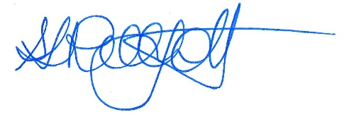 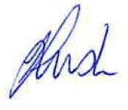…………………………………… …………………………………
Signature Witness Signature

Name: Sarah Philpott

Title: Chief Executive Officer
Address: PO Box 105, Mildura, Victoria, 3500

Signed by Area Executive Director (Mallee), Department of Education and Training

Name: Jane Maine
Title: Area Executive Director (Mallee)
Address: 91 Pine Avenue, Mildura, Victoria 3500

