Kindergarten Infrastructure and Services Plan
Mildura Rural City

CONTENTS
1. Introduction 3
1.1. Reform context 3
1.2. Purpose of Kindergarten Infrastructure and Services Plans (KISPs) 3
1.3. Structure of the KISP 4
1.4. Disclaimer 4
2. Map of Early Childhood Education services in Mildura Rural City 5
3. Local context 6
3.1 Purpose 6
3.2 Key considerations 6
4. Unmet demand estimates between 2025 - 2036 for Mildura Rural City 12
4.1 Purpose 12
4.2 Methodology 12
4.3 Summary of current kindergarten provision 14
4.4 Agreed estimates of demand for kindergarten places 14
5. Authorisation 18

Introduction

Reform context
The Victorian Government’s $14 billion Best Start, Best Life (BSBL) reforms are the most significant change to Victoria’s early childhood sector in a generation.
The BSBL reforms include:
- Free Kinder: Free Kinder is now available for Victorian 3- and 4-year-old children at participating services in standalone (sessional) kindergartens and long day care centres – a saving of up to $2,500 per child, every year.
- Pre-Prep: Four-Year-Old Kindergarten will gradually transition to ‘Pre-Prep’ – increasing to a universal 30-hour-a-week program of play-based learning for 4-year-old children in Victoria by 2036.
- Three-Year-Old Kindergarten: the continued roll-out of Three-Year-Old Kindergarten, with programs increasing to 15 hours a week across the state by 2029.
- Early learning and childcare centres: the establishment of 50 Victorian government-owned and operated early learning and childcare centres. These centres will be built in areas with the greatest need and will make it easier for families to access early childhood education and childcare. The first of the centres will open in 2025.
These initiatives demonstrate a clear commitment to improving early learning outcomes for Victorian children, workforce participation and access for families, and present the most significant change to Victoria’s early childhood sector in a generation.

Pre-Prep will roll-out in Mildura Rural City in 2028. Statewide, Aboriginal and Torres Strait Islander children, children from a refugee or asylum seeker background, and children who have had contact with Child Protection services, will be able to access up to 25 hours of Pre-Prep in 2026, increasing to up to 30 hours from 2028. Children who have (or have a parent or guardian who has) a Commonwealth concession card and children who are a multiple birth child (triplets or more) across the state will be able to access up to 25 hours of Pre-Prep in 2028, increasing to up to 30 hours from 2030.

Purpose of Kindergarten Infrastructure and Services Plans (KISPs)
New and expanded infrastructure is key to delivering the BSBL reforms and will require a large expansion of kindergarten facilities across the State. KISPs, which are jointly developed with Local Governments, indicate where and when new infrastructure will be required to support both reform implementation and population growth in each of Victoria’s 79 local government areas (LGAs). KISPs help all kindergarten providers meet demand and collectively provide a clear picture of infrastructure need across the State.
KISPs support planning for services and future capital works and include detailed information about:
- Current capacity and demand for funded kindergarten
- Capacity to be delivered for planned infrastructure projects and future demand for kindergarten
- Forecast ‘unmet demand’ for kindergarten – that is, the kindergarten places needed that cannot be met by current or planned capacity
- Information specific to each local government area and its early childhood education and care landscape.
KISPs were initially developed to support the roll-out of Three-Year-Old Kindergarten and have now been updated to incorporate Pre-Prep.
KISPs are intended to support planning. They are not funding documents and do not commit any party to addressing the unmet demand identified.
However, it is expected that future investment requests through Building Blocks and funding decisions about Local Government, not-for-profit projects (including non-government schools) would align with the relevant KISP (including Section 3: Local Context).

Structure of the KISP
Each KISP consists of the following sections:
- Section 1: A short introduction to the Best Start, Best Life reform and the KISP.
- Section 2: A map of existing and planned Early Childhood Education and Care services.
- Section 3: Local context and knowledge of key information in Mildura Rural City relevant to early childhood education.
- Section 4: Unmet demand estimates in Mildura Rural City over the life of the reform.

Disclaimer
All data presented in this document is published for information purposes only. Operational and business decisions should not be based solely on this document. Neither the Department nor Mildura Rural City Council warrants, guarantees, makes any representation or assumes any duty of care in relation to the data, including as to its suitability, completeness, accuracy or adequacy.

Map of Early Childhood Education services in Mildura Rural City
The map below shows the distribution of currently operating and new State-supported services that are planned to open in the future in Mildura Rural City. Planned services by the private sector are not included.
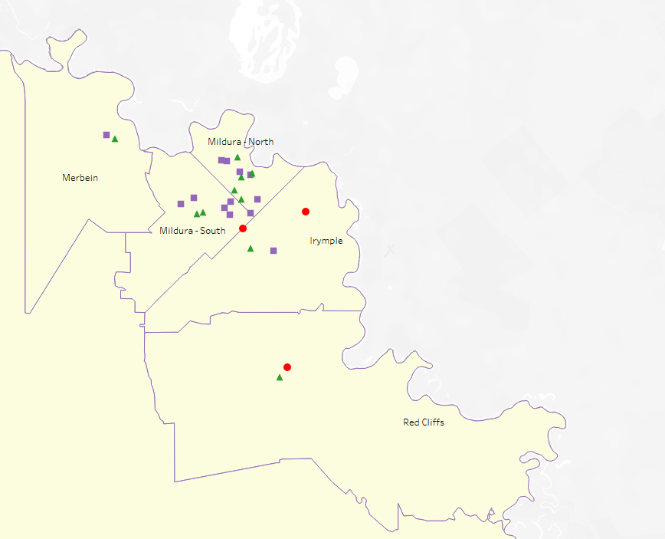
This map has been prepared using departmental data, from both the National Quality Agenda IT System (NQAITS) and the Victorian School Building Authority (VSBA).
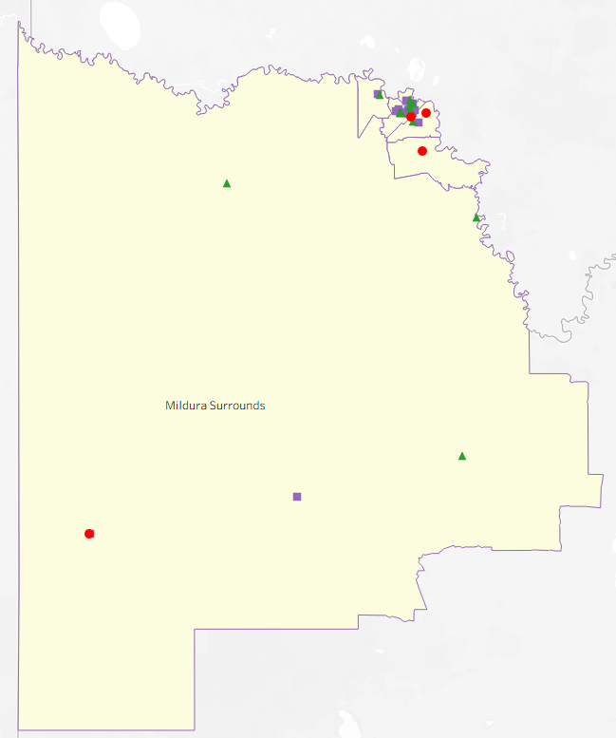
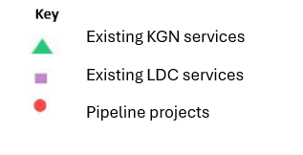

Local context
d

3.1 Purpose
Local, place-based knowledge and context play an important role in supporting the implementation of the BSBL reforms across Victoria. This section of the KISP documents this knowledge and context and should be considered alongside the kindergarten demand estimates in Section 4.
Information provided as local context may support applications through the Building Blocks Capacity Building and Planning Grants streams.

3.2 Key considerations
Mildura Rural City Council (MRCC) is a regional Council located on tristate borders, with key industries including dryland farming, irrigation horticulture, tourism, food and beverage manufacturing, transport and logistics, retail, health and community services, attracting workers and their families to the area.
Victoria in Future (2023) (LGA) indicates expected growth in the 0–4-year age population for the Mildura LGA (2021-2036), as per table below

Year | Persons 0-4
2021 | 3,323
2026 | 3,471
2031 | 3,553
2036 | 3,482

Aboriginal Self Determination in Early Childhood Education and Care
According to the 2021 ABS Census of Population and Housing, 9.72% of the Mildura Local Government Area (LGA) population aged 0-4 years identify as Aboriginal and/or Torres Strait Islander (ATSI) and 6.2% are recorded as Indigenous status not stated, compared to 1.87% and 3.99% respectively across Victoria. This data demonstrates an increase in ATSI children of 1.42%.
MRCC manages a Central Registration Enrolment Scheme (CRES) that provides a single point of contact for family’s data and has identified an increase of ATSI children registrations of 45% from 2021 to 2024.
There are several programs operating in the Mildura LGA. These programs are funded by various sources, including Department of Education (DE), local government, or independent organisations and support the increase in ATSI children registration. These programs include but are not exclusive to:
- Best Start – a DE program that focuses on all ATSI children as well as those experiencing vulnerability. The collaboration of the local partnership uses the data and community knowledge to increase access and participation in early years services. The local Best Start partnership escalates the importance of Early Start Kindergarten (ESK), access and transition for families with a local lens to drive change in our community.
- Connected Beginnings - an Australian Government grant funded program that supports ATSI children to get the best start to life. The program works closely with the Best Start partnership and closely collaborates with MRCC to provide the Victorian early years award winning event, First Steps to Learning. The annual event seeks to support families to register for kindergarten in the first instance, followed by a secondary event, Next Steps to Learning, which supports kindergarten enrolment, transition and kindergarten readiness. The addition of ATSI volunteer parent groups at these events have extended opportunities to volunteer and build networks with other organisations, to improve the school transition experience for children.
- Balert Gerrbik – Koorie Families as First Educators (KFFE) supports Koorie families to provide a strong foundation for their children's early learning and development through high-quality, culturally safe, evidence-based parenting support.
  - KFFE aligns with the HIPPY (Home Interaction Program for Parents and Youngsters) program, which is also based at Mallee District Aboriginal Services (MDAS) and is a two-year home-based early-learning and parenting program for families of pre-school children. The HIPPY programs support families to navigate kindergarten registration, enrolment and transition.
- Bupup balak wayipungang initiative, previously known as the Koorie Preschool Assistant Program, supports Early Years services to create welcoming kindergarten programs and is an auspice of MDAS.
This program helps:
- Aboriginal children and their families to be active participants in kindergarten
- Build the capacity of kindergartens to provide culturally relevant programs
- Families to locate a suitable kindergarten and assist with the enrolment process
- Liaise with the Koori Engagement Support Officers (KESO) in engaging with families of Aboriginal children

MRCC CRES Officers to support the registration and enrolment to kindergarten.

Key demographic trends that influence demand for kindergarten

A family’s choice of Early Years service provider for their child/ren can be influenced by several factors, including proximity and cost of service. Given the high level of families experiencing vulnerability , Mildura LGA is the equal 5th most disadvantaged in Victoria, (2021 ABS Census, SEIFA), proximity and cost become even more important. There is a high proportion of families who do not have reliable private transport and are limited to public transport or walking. Walking is not always an option for families where there are multiple children and/or extreme temperatures, which is often the case in Mildura LGA.
An overview of Family Structures and Family Composition from the 2021 ABS Census of Population and Housing data (2021) (LGA and SA1), indicates the lowest proportion of ‘one parent families’ is now Meringur (SA1-21502139809) at 0% closely followed by Nichols Point (SA1-21502139522) at 2.86% with the Mallee Track (SA1-21502139812, excluding Underbool and Murrayville) now sitting at 3.17%. The highest proportion of ‘one parent families’ from an SA1 perspective were Mildura North– Ambleside Cres (24.46%) and Mildura South– Cavallo Drive, Olympic Way (25.37%). The SA2 of Mildura North at 13.1% of one parent families is well above the Regional Victorian (9.62%), Melbourne (9.97%) and Victorian (9.89%) proportions.
During Council’s consultation and engagement with local providers, service providers anecdotally reported that many parents prefer the stand-alone kindergarten curriculum as opposed to childcare kindergarten programs, as they believe it better prepares children for the school environment. Working parents prefer a longer day session (7.5 hours) and prefer standalone kindergarten, as the out-of-pocket expense is less.
Shorter sessions, of five-hour days, are a preference for three kindergarten services in order to meet family needs and teacher availability. If services operate with fewer hours per day, they will be unable to offer as much kindergarten as forecast in section 4.
As Mildura LGA has cross border communities into both South Australia and New South Wales, there are many families who reside in another State, however work and seek education opportunities for their children in Victoria, impacting Merbein, Mildura – North, Mildura – South SA2’s and Murrayville.
The 2021 ABS Census data of Mildura indicates that 13.8% of the population was born overseas.
MRCC employ a Culturally and Linguistically Diverse (CALD) Outreach worker, this position supports CALD families to reduce the barriers to kindergarten. Since 2023 the CALD Outreach worker has supported over 100 children to enrol and transition to kindergarten, doubling the number of CALD children registering for kindergarten prior to the establishment of the role.

Projects or trends that may influence supply of early childhood education and care
Residential development in Mildura South, Irymple, Red Cliffs and Merbein SA2’s is expected to continue to drive population growth in these locations and put additional demand on existing services.
Planning applications have been approved for eight new Child Care Centres in various SA2’s - one in Mildura North, four in Irymple and three in Mildura South. These facilities have not been included in the section 4 data, as timeframes around the developments are unknown. The anecdotal evidence indicating parent preference for standalone kindergarten services to avoid out of pocket expense, along with the state-wide issue of limited early childhood teachers, particularly in our regional-remote LGA, may impact the utilisation of childcare facilities for children over 3 years of age.
A Neighbourhood Activity Centre has been identified in the Mildura South (Sixteenth and Deakin West) Development Plan, which could potentially provide an opportunity for either a public or private childcare provider, however timeframes for this development are unknown.
Ageing kindergarten infrastructure across the municipality, limited size and capacity of existing kindergartens and staffing, are all ongoing challenges faced locally. These challenges will continue to increase with the roll-out of the 30 hours of Pre-Prep across the LGA, with limited capital works budgets and funding available to increase capacity to meet maintenance/upgrade requirements for existing kindergartens.
Best Start, Best Life reforms will impact the number of 4-year-olds that can be enrolled in each service. As a result of increasing hours being available per child, the number of enrolment places available may decrease, particularly if change management is not adopted by the service.
The successful Building Blocks grants for early years hubs at both Red Cliffs (opened 2025) and Nichols Point (due to commence construction in mid-2025) will provide additional kindergarten spaces and alleviate pressure on the Irymple SA2 by offering additional options for families. The recent announcement by the State Government of a new Early Learning and Childcare Centre to open in Red Cliffs in 2027, will further help to ensure families from Red Cliffs and surrounds will have childcare and another kindergarten option closer to their residence. Red Cliffs is currently identified as a childcare desert with no centre-based care available within a 20km radius.
Henderson College, located in Irymple, will soon open an Early Learning Centre with long day care options and an integrated kindergarten program commencing in 2026.
Attraction and retention of qualified staff continues to be a challenge for the rural municipality. This could impact the ability for services to offer the levels of kindergarten supply modelled in section 4.

Key local geographic considerations or information relevant to Three-Year-Old Kindergarten and Pre-Prep
Merbein
- Merbein Kindergarten are managing delivery models to cater for the expected demand for Pre-Prep and 3-year-old places in 2026. Merbein Kindergarten had a waitlist for 3-year-old places for the 2025 kindergarten year. The privately operated integrated childcare centre Generations Early Learning has a waitlist for the under 3 age group for childcare. It is anticipated the demand will continue to increase, with the growth of the township due to affordable housing options that attract young families.
- The closest kindergarten outside of Merbein is in the Mildura South SA2, which is a significant 24 kilometre drive away and there are limited reliable public transport options available. Families residing in Merbein generally prefer their children to attend their local kindergartens service, for continuity through to the neighbourhood schools.
Mildura-North
- More than half of the kindergarten supply comes from long day care services rather than the stand-alone sessional kindergartens. The long day care option can be prohibitive for families who will have out of pocket expenses, as opposed to the free kindergarten option available for children attending a stand-alone kindergarten model.
- Pasadena and De Garis Preschools are both located in low-socio economic areas of Mildura and are often accessed by nearby residents walking their children to attend. These kindergartens also offer a bus service to help with access. Both services are land-locked and have no capacity to extend within their existing premises. With the roll-out of the Best Start Best Life reforms and the requirement to provide 30 hours of Pre-Prep by 2031, it has been identified that both services will need to lower enrolment numbers to accommodate the increased hours. Review of the infrastructure of these services and provision of additional funding for capital works will be critical to meet the demands of these kindergartens who service a high number of families experiencing vulnerability within the community. While the data indicates sufficient places in this SA2, the numbers include long day care services, which may not be an option for many families due to the out-of-pocket expense.
- The 2024 closure of St Margarets Preschool has impacted access to standalone kindergarten programs within walking distance from Mildura Central Primary School and the central business district, especially for families with limited transport options.
Mildura – South
- Mildura South Development Plan covers an area of 180 hectares to be developed, with an additional 4,400 residents expected in this area.
- The addition of the kindergarten on school site at Mildura South Primary School, Shine Bright Wetlands Drive Kindergarten, offers additional places for Mildura South residents and supports transition to the school.
- The area around Ranfurly Primary School is predominantly lower socio-economic housing and rental properties. While this area has a neighbourhood school within walking distance, the closest early years services are a 30–45-minute walk. As previously mentioned, this area has 25.37% one parent families.
- The increased number of long day care facilities will provide more choice, however, current trends indicate this model of kindergarten program is not preferred by families, as it is anecdotally perceived to not adequately provide school readiness and can be prohibitive for families who will have out of pocket expenses.

Irymple
- Irymple continues to be identified as a pressure point within the LGA. The development of the new Early Years service to be built in Nichols Point will help to alleviate this pressure, however Irymple Kindergarten traditionally has a high level of demand, including families who do not reside in Irymple. This is due to several factors including:
  - popular choice and good reputation of service.
  - Irymple is an outer-lying suburb and is the closest accessible service for many of the more rural locations, such as Cardross and Koorlong.
  - Carers outside of the immediate family, such as grandparents, live in Irymple or close to this service; and
  - It is conveniently located ‘on the way’ for parents who travel into Mildura for work from outer-lying suburbs, or conversely for parents who travel to work in Irymple.
- Residential development is expected to continue in Irymple, which will place further pressure on Irymple Kindergarten.
- Irymple has one long day care service and one currently nearing construction completion by Montessori Beginnings which is not listed in the pipeline projects. The intention to provide kindergarten programs at these services is unknown.
- Mildura Family Day Care have waiting lists for care in this area, including families putting names on the waiting list during pregnancy.
Red Cliffs
- The completion of the Red Cliffs Early Years Hub, including a 132 place kindergarten, and the recent announcement for construction of a new early learning centre, will provide additional 3- and 4-year-old kindergarten places. These developments will provide much needed options for the community, however the challenge of attracting early childhood teachers and educators will remain.
- Residential development is expected to continue at Red Cliffs, however the additional kindergarten places available from the new infrastructure should support this growth for many years.
Mildura Surrounds
- Ouyen’s population of 0–4-year-olds has increased since 2016 and is continuing to increase with families moving to Ouyen for affordable housing and the attraction of living in a smaller, rural community.
- Mallee Track Health and Community Services manage the staff across four sites in this SA2.
- Mallee Track Health and Community Services prefer Ouyen Kindergarten run a mixed age group session model. Currently it is running separate 3-year-old and 4-year-old groups to manage demand and manage workforce constraints. They are at capacity as a one-room service.
- Data indicates that Underbool and Murrayville have places available. However, the distance from Ouyen is significant at 110 kilometres and over an hour drive for families and not an option.
- Ouyen Mallee Minors is a 2 room, 37 place service, currently running childcare in both rooms with a waitlist for under 3-year-old children. It is anticipated that this waitlist will be up to 30 children by 2026. As of June 2025, the service knows there is an additional 19 babies being born to local families.
- Children located along the Mallee Track (Ouyen, Underbool, Murrayville, etc) do not have the option to attend the Millewa Kindergarten, which is also located in the Mildura Surrounds SA2 and included in this data. The travelling time between the two services is 2 hours and 30 minutes, or 250 kilometres.
- Residents living in outlying areas such Patchewollock, Speed, Tempy, Mittyack and Kulwin utilise the Ouyen Kindergarten and Mallee Minors Child Care Centre, as Ouyen is their closest town, school, place of work and shopping centre.

Other information about the expansion of early childhood services
MRCC leases buildings to most stand-alone kindergarten providers in the municipality. While there is no involvement of early years management or daily operations, Council assists with renewal and upgrades of kindergarten buildings to meet service levels, subject to annual capital works budgets. Council is working with services to assess and prepare for the Best Start, Best Life reforms with the introduction of Pre-Prep for priority children 2026 and 30 hours commencing 2031. This will require a collaborative approach between Council, early years managers and DE, as significant capital contributions are required.
MRCC endorsed a ten-year Early Years Infrastructure Strategy in 2022. The plan was endorsed prior to the Best Start Best Life announcement of 30 hours of Pre-Prep and will now be reviewed in 2025 to ensure alignment with the reforms. Priorities and timelines may be amended and service alternatives, such as advocation of kindergarten on school sites, potential expansions or upgrade opportunities may be explored.
The Municipal Early Years Plan (MEYP) was endorsed by MRCC in January 2021 and is due to be reviewed and a new plan prepared in 2025. The MEYP will provide input for the review of the Early Years Infrastructure Strategy.
All local kindergarten services will offer 15 hours for both three-year-old and four-year-old children from 2025 and they are currently considering options for delivery of the required 16-25 hours for high priority groups in 2026. While some kindergartens are in a good position to adopt change management to meet the requirements of a minimum 16 hours to the priority cohort, there will be some services who are unable to offer up to 25 hours, due to lack of space and potential staffing issues. The greatest challenge is increasing the hours for the priority cohort and meeting the demand for four-year-old places in the region.

Unmet demand estimates between 2025 - 2036 for Mildura Rural City

4.1 Purpose
As the BSBL reforms are rolled out and Victoria’s population grows, demand for kindergarten and Pre-Prep places will increase significantly. While additional capacity will be needed to meet this demand, this will vary across the State and over time, due to differences in the capacity of existing services, growth trends and sector composition.
To identify where, when and how many additional kindergarten places are expected to be required over the roll-out in Mildura Rural City, Mildura Rural City Council and the department have developed:
- a summary of the current provision of kindergarten within Mildura Rural City (Section 4.3).
- an estimate of kindergarten places that cannot be met through existing services for the 2025 - 2036 period, taking into account the additional demand that can be accommodated by optimising utilisation of existing services and infrastructure (Section 4.4).
Local governments and providers can use these published estimates to inform reform implementation activities such as service planning, kindergarten program expansion, infrastructure investments and Building Blocks funding applications in alignment with future demand over the roll-out.

4.2 Methodology
The estimated kindergarten places used in the following sections have been agreed between Mildura Rural City Council and the department, and were informed by:
- demand projections developed by the department which draw on a range of inputs, including population forecasts and current enrolments
- the estimated capacity of existing and planned services in the LGA (Section 2)
- where applicable, modelling undertaken by Mildura Rural City and service level information; and
- local knowledge and context provided by the local government (Section 3) that explains particular issues and trends in their area.
Kindergarten places explainer
The KISP measures a service’s capacity to deliver funded kindergarten in terms of the number of 15-hour places (referred to as “kindergarten places”) available for Three-Year-Old kindergarten and Pre-Prep (noting that, by 2036, two kindergarten places will be required for one Pre-Prep enrolment). The number of kindergarten places is different from a service’s licensed or approved places, which count the number of children permitted to attend the service at any one time under the license. Many services can enrol more children in their funded kindergarten program(s) than they have licensed places for because they can run more than one kindergarten program per week. Kindergarten places are therefore a more accurate measure of service kindergarten capacity than licensed places.
Kindergarten places have been presented as 15-hour places so that new Three-Year-Old Kindergarten places and the additional 15-hour places required for Pre-Prep can be easily compared to existing 15-hour Four-Year-Old Kindergarten places. This is because, when Three-Year-Old Kindergarten is fully rolled out in 2029, three-year-old children will have access to 15-hours of kindergarten. When Pre-Prep is fully rolled out in 2036, four-year-old children will have access to up to 30-hours of kindergarten, an increase of the current offering of 15-hours per week.
It is important to note that enrolments are not equivalent to 15-hour places. One 15-hour place can support a total of 15 hours of delivery per week split between one or more children, including but not limited to the following examples:
 |  | One 15-hour place (15 hours of delivery)
Example 1 | 1 child | 1 x 3YO attending 15 hours per week
Example 2 | 1 child | 1 x 4YO attending 15 hours per week
Example 3 | 2 children | 2 x 3YOs attending 7.5 hours per week
Example 4 | 3 children | 3 x 3YOs attending 5 hours per week
Two 15-hour places can support a total of 30 hours of delivery per week split between one or more children, including but not limited to the following examples:
 |  | Two 15-hour places (30 hours of delivery)
Example 1 | 1 child | 1 x 4YO attending 30 hours per week
Example 2 | 2 children | 2 x 3YOs attending 15 hours per week
Example 3 | 2 children | 1 x 3YO, and  1 x 4YO both attending 15 hours per week
Example 4 | 3 children | 2 x 3YOs attending 7.5 hours per week, and  1 x 4YO attending 15 hours per week
Geographic boundaries used in the KISP
These estimates have been developed at an LGA and community level to show the overall forecast and variation within an area. The KISP defines community at the Statistical Area Level 2 (SA2), which is a medium-sized area which represents a community that interacts socially and economically, with an approximate population range of 3,000 to 25,000 people, and an average population of about 10,000 people. The KISP uses 2021 SA2 boundaries. More information is available at the Australian Bureau of Statistics website.
Supply contributed by pipeline projects
Mildura Rural City Council and the department have added any new places that will be made available through planned expansions of existing services or new services into estimates of existing supply, where this information is available. This may include projects being delivered by not-for-profit providers (including non-government schools) with support from the Victorian Government, planned Kindergartens on School Sites, and government-owned and operated early learning and childcare centres.
The KISP does not estimate how and when the broader sector will expand to meet the additional demand for kindergarten places that are estimated over the roll-out period.

4.3 Summary of current kindergarten provision
The figures below provide a summary of current kindergarten provision within the LGA and provide relevant context for the estimates of demand for funded kindergarten places included in Section 4.5. The data included in this section are largely drawn from:
- the department’s Kindergarten Information Management System (KIMS), as at 2023.
- the National Quality Agenda IT System (NQAITS), as at April 2025.
Number of services by service type (NQAITS)
Stand-alone kindergartens | 12
Long day care centres (including services not currently delivering funded kindergarten) | 15

Percentage of services by management type, LGA level (NQAITS)
Type | Percentage
Local Government | 4%
Private not for profit | 62%
Private for profit | 31%
Other | 4%

Current kindergarten offering in Mildura Rural City
Three-Year-Old Kindergarten participation rate (KIMS): | 93%
Four-Year-Old Kindergarten participation rate (KIMS): | 95%
Number of services that offer a funded kindergarten program (KIMS): | 26

4.4 Agreed estimates of demand for kindergarten places
The below estimates (Table 1 onwards) have been developed by Mildura Rural City Council and the department to illustrate the estimated:
- Demand – the total number of kindergarten places expected to be required over the roll-out period to support the current provision of Four-Year-Old Kindergarten, the BSBL reforms, and population growth
- Supply – the total number of kindergarten places that can be accommodated by existing services and infrastructure, and planned, State-supported services which are yet to open.
- Unmet demand – kindergarten places that cannot be accommodated by optimising existing services and infrastructure (i.e. the shortfall between demand and supply).
Interpreting the estimates
Infrastructure need in the LGA and its local communities is indicated by the bottom rows of the tables in this section (Table 1 onwards): Unmet demand. If the number of kindergarten places in this row is above zero, it means that the area is estimated to need additional infrastructure capacity. Any type of provider – local government, not-for-profit (including non-government schools) or for-profit – can build this additional infrastructure.
Sub-SA2 factors may need to be considered to give a holistic picture of unmet demand. For example, in rural communities, one SA2 may contain several small towns, some with excess supply and some with unmet demand. At the SA2-level, demand may appear to be met because all supply and demand is considered in aggregate; however, it is not feasible to for families to drive long distances to access kindergarten capacity in another town. Sub-SA2 factors are covered in Section 3: Local context.

Table 1: Estimated kindergarten places required between 2025 - 2036 in Mildura Rural City

Mildura Rural City estimates | 2025 | 2026 | 2027 | 2028 | 2029 | 2030 | 2031 | 2032 | 2033 | 2034 | 2035 | 2036
Demand for kindergarten places | 963 | 1185 | 1278 | 1587 | 1764 | 1813 | 1978 | 1967 | 1955 | 1948 | 1944 | 1934
Unmet demand | 0 | 0 | 0 | 0 | 48 | 46 | 160 | 145 | 130 | 120 | 113 | 105

Community estimates
Table 2-A: Estimated kindergarten places required between 2025 - 2036 in Irymple
SA2 estimates | 2025 | 2026 | 2027 | 2028 | 2029 | 2030 | 2031 | 2032 | 2033 | 2034 | 2035 | 2036
Demand for kindergarten | 158 | 193 | 208 | 258 | 288 | 300 | 332 | 335 | 337 | 340 | 342 | 343
Kindergarten supply | 269 | 307 | 545 | 545 | 545 | 545 | 545 | 545 | 545 | 545 | 545 | 545
Unmet demand | 0 | 0 | 0 | 0 | 0 | 0 | 0 | 0 | 0 | 0 | 0 | 0

Table 2-B: Estimated kindergarten places required between 2025 - 2036 in Merbein
SA2 estimates | 2025 | 2026 | 2027 | 2028 | 2029 | 2030 | 2031 | 2032 | 2033 | 2034 | 2035 | 2036
Demand for kindergarten | 85 | 102 | 108 | 133 | 147 | 151 | 164 | 163 | 162 | 162 | 162 | 162
Kindergarten supply | 156 | 156 | 156 | 156 | 156 | 156 | 156 | 156 | 156 | 156 | 156 | 156
Unmet demand | 0 | 0 | 0 | 0 | 0 | 0 | 8 | 7 | 6 | 5 | 5 | 6

Table 2-C: Estimated kindergarten places required between 2025 - 2036 in Mildura - North
SA2 estimates | 2025 | 2026 | 2027 | 2028 | 2029 | 2030 | 2031 | 2032 | 2033 | 2034 | 2035 | 2036
Demand for kindergarten | 430 | 503 | 533 | 633 | 686 | 695 | 739 | 726 | 715 | 705 | 697 | 692
Kindergarten supply | 589 | 645 | 645 | 661 | 661 | 676 | 676 | 676 | 676 | 676 | 676 | 676
Unmet demand | 0 | 0 | 0 | 0 | 26 | 19 | 63 | 50 | 38 | 29 | 21 | 16

Table 2-D: Estimated kindergarten places required between 2025 - 2036 in Mildura - South
SA2 estimates | 2025 | 2026 | 2027 | 2028 | 2029 | 2030 | 2031 | 2032 | 2033 | 2034 | 2035 | 2036
Demand for kindergarten | 252 | 334 | 369 | 482 | 547 | 566 | 629 | 627 | 625 | 625 | 626 | 622
Kindergarten supply | 449 | 509 | 509 | 524 | 524 | 539 | 539 | 539 | 539 | 539 | 539 | 539
Unmet demand | 0 | 0 | 0 | 0 | 22 | 27 | 89 | 88 | 86 | 86 | 87 | 83

Table 2-E: Estimated kindergarten places required between 2025 - 2036 in Mildura Surrounds
SA2 estimates | 2025 | 2026 | 2027 | 2028 | 2029 | 2030 | 2031 | 2032 | 2033 | 2034 | 2035 | 2036
Demand for kindergarten | 42 | 54 | 57 | 73 | 80 | 81 | 89 | 87 | 86 | 85 | 84 | 83
Kindergarten supply | 156 | 156 | 179 | 179 | 179 | 179 | 179 | 179 | 179 | 179 | 179 | 179
Unmet demand | 0 | 0 | 0 | 0 | 0 | 0 | 0 | 0 | 0 | 0 | 0 | 0

Table 2-F: Estimated kindergarten places required between 2025 - 2036 in Red Cliffs
SA2 estimates | 2025 | 2026 | 2027 | 2028 | 2029 | 2030 | 2031 | 2032 | 2033 | 2034 | 2035 | 2036
Demand for kindergarten | 81 | 101 | 110 | 142 | 162 | 170 | 190 | 192 | 192 | 193 | 195 | 193
Kindergarten supply | 207 | 207 | 240 | 240 | 240 | 240 | 240 | 240 | 240 | 240 | 240 | 240
Unmet demand | 0 | 0 | 0 | 0 | 0 | 0 | 0 | 0 | 0 | 0 | 0 | 0

Authorisation
The Mallee Area Acting Executive Director of the Department of Education and Martin Hawson, Chief Executive Officer of Mildura Rural City Council endorse this Kindergarten Infrastructure and Services Plan (KISP) for Mildura Rural City Council by signing on
This KISP is not intended to create legal relations or constitute a legally binding contractual agreement between the parties. The parties may review this KISP in 2028 to publish a new version that will replace the previous version.
Signed for and on behalf and with the authority of Mildura Rural City Council.

……………………………………
Signature

Name: Martin Hawson
Title: Chief Executive Officer - Mildura Rural City Council

Signed for and on behalf and with the authority of the Department of Education

Signature

Name: Robert Pyers
Title: Acting Executive Director

