Kindergarten Infrastructure and
Services Plan
Mansfield Shire
CONTENTS
1. Introduction 3
1.1. Reform context 3
1.2. Purpose of KISPs 3
1.3. How to use the KISP 3
1.4. Structure of the KISP 3
1.5. Disclaimer 4
2. Map of Early Childhood Education services in Mansfield Shire 5
3. Local context 6
3.1 Purpose 6
3.2 Key considerations 6
4. Funded kindergarten enrolment estimates between 2021-29 for Mansfield Shire 11
4.1 Purpose 11
4.2 Methodology 11
4.3 Summary of current kindergarten provision 12
4.4 Approach to optimising the use of existing services and infrastructure 13
4.5 Agreed estimates of demand for funded kindergarten places that cannot be met through existing services and infrastructure 14
5. Authorisation 16

Introduction

Reform context
In an Australian first, the Victorian Government has committed to implement Three-Year-Old Kindergarten for all children over a 10-year roll-out with a total investment of almost $5 billion, including $1.68 billion to support the infrastructure expansion required for the reform. This reform will add another year of universal funded kindergarten so that, by 2029, all children in Victoria will have access to two years of play-based learning through a funded kindergarten program.

Purpose of KISPs
Three-Year-Old Kindergarten will require a large expansion of kindergarten across the State. The Government has invited all 79 Victorian Local Governments to discuss and agree upon a Kindergarten Infrastructure and Services Plan (KISP) for their Local Government Area (LGA).
Each KISP has been jointly developed with Local Government and published to estimate the growth in demand for kindergarten within the LGA. The KISPs will help all kindergarten providers meet demand and provide a clear picture of infrastructure need across the State.
While a KISP is not a funding document and does not define required infrastructure projects or commit any party to funding specific projects, it is expected that future investment requests through Building Blocks and funding decisions about Local Government and not-for-profit projects would align with the relevant KISP.

How to use the KISP
Each KISP contains estimates of future kindergarten supply of, and demand for, Three and Four-Year-Old Kindergarten places against existing enrolment capacity. Not-for-profit and for-profit providers can use these estimates to inform their plans to expand kindergarten programs, establish new services or invest in new or extended facilities.
For example, KISPs provide demand estimates in terms of where, when and how much demand for kindergarten places will grow in an LGA. KISPs also estimate where and how many kindergarten places providers can accommodate in existing facilities before an area needs new infrastructure to meet demand. The estimates can be used to inform decisions about where and when expansions of kindergarten program capacity and the construction of new or extended facilities are needed to meet demand growth.
Where there is an agreed KISP for the LGA, the Local Government and not-for-profit kindergarten providers seeking co-investments through the Building Blocks Capacity Building stream must refer to, and align their proposed project with, the infrastructure need identified in the KISP.

Structure of the KISP
Each KISP consists of the following sections:
- Section 1: A short introduction to the Three-Year-Old Kindergarten reform and the KISP.
- Section 2: A map of existing and planned Early Childhood Education and Care service locations.
- Section 3: Local knowledge and context relevant to the expansion of kindergarten services.
- Section 4: Funded kindergarten demand estimates.

Disclaimer
All data presented in this document are estimates only and are based on the best information available to the Department and Local Government at the time. They are published on an as-is basis and are for informational purposes only. They are subject to adjustment in response to market forces and as new data and other relevant information becomes available. The data may under- or over-estimate both total demand in a given location or year and the capacity for new demand to be met by providers. As a result, operational and business decisions should not be made solely based on this document. Any use of this data is solely at the risk of the user. The Department and Local Government accept no responsibility for any loss or damage, either direct or incidental, that may result from the use of the data.

Map of Early Childhood Education services in Mansfield Shire
The map below shows the distribution of currently operating and new services that are planned to open in the future in the LGA and across its communities.
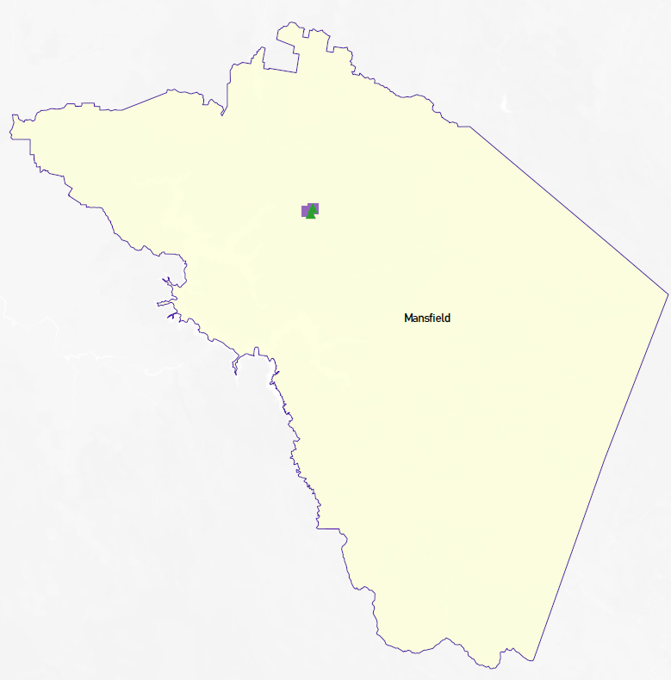
This map has been prepared using Departmental data, from both the National Quality Agenda IT System (NQAITS) and the Victorian School Building Authority (VSBA). Existing Kindergarten and Long Day Care services are all within the township of Mansfield. There are no new services planned to open in the next 12 months.
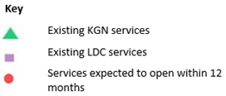

Local context
d

3.1 Purpose
Local, place-based knowledge and context play an important role in supporting the implementation of Three-Year-Old Kindergarten across Victoria. This section of the KISP documents this knowledge and context and has informed the funded kindergarten enrolment estimates in Section 4.

3.2 Key considerations
Key demographic trends that influence demand for kindergarten
Mansfield Shire Councils population is predicted to rise to 13,393 by 2036 based on a 2.08% increase, with the population age structure evolving over this period. However, it is important to note that this growth will not be evenly distributed across the Shire and our towns will evolve and change over time. In order to utilise the resources of Council effectively, these changes need to be understood so that new facilities are developed where needed, or existing facilities are updated or adapted to suit the needs of the community.
Mansfield Shire’s Non-Resident Ratepayers at March 2021 were 48.11%. Though this number represents rateable assessments, not population, during COVID-19 Mansfield has experienced increased numbers of people opting for a rural lifestyle and making Mansfield home.

Population Growth
- Population growth currently being experienced is greater than anticipated.
- Australian Bureau of Statistics (ABS). ABS states the population of Mansfield Shire in 2018 was 9,253. 2019 has a growth of 193 which represents a 2.08% increase. Using 2.08% as the increase rate, 2036 population would be 13,393. https://itt.abs.gov.au/itt/r.jsp?RegionSummary&region=204011057&dataset=ABS_REGIONAL_ASGS2016&geoconcept=ASGS_2016&measure=MEASURE&datasetASGS=ABS_REGIONAL_ASGS2016&datasetLGA=ABS_REGIONAL_LGA2018&regionLGA=LGA_2018&regionASGS=ASGS_2016
- The median age of people in Mansfield (State Electoral Divisions) is 36 years. Children aged 0 - 14 years made up 18.4% of the population.
- Birth rates have been relatively consistent within the Mansfield Shire over the last four years with an average birth rate of 73 – Table A.
- New Enrolments and new families to the Maternal and Child Health service has seen the most activity especially over the last 12 months with new families moving into the area and registering with Maternal and Child Health. - Table B.
- It can be assumed that the demand for kindergarten places will increase due to the increase in new families relocating to Mansfield Shire Council.
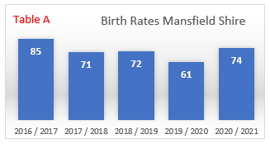
Transfers for Mansfield Shire – MCH service
Table B
 | Client transfers into the shire | Client transfers out of the shire | Number of additional clients in the shire
2020-21 | 116 | 24 | ↑ 92
2019-20 | 75 | 56 | ↑ 19
2018-19 | 55 | 34 | ↑ 21
2017-18 | 58 | 37 | ↑ 21
2016-17 | 55 | 38 | ↑ 17

Population Growth
The age structure of Mansfield Shire will continue to evolve over the period 2020–2036. In particular the high growth experienced in 2018 to 2019 has potential implications for planning for Three-Year-Old Kindergarten implementation should this level of growth continue

Real Estate Demand
Current demand for real estate is high within Mansfield Shire for rentals and sales. Mansfield Shire Council Planning department has received 377 submissions in 2020 which could see 377 new developments approved.
Agents have highlighted the following key real estate trends in Mansfield Shire:
- McGrath Real Estate: 40% of all sales went to families with children. 2020 was the best year for sales on record.
- Mansfield Real Estate: Last 12 months has been the best year of sales for over 20 years. Older generations purchased houses and the younger generations purchased land.
- A big demand for permanent rental properties with rental market being “tight”.
- Demand for housing is high.
Economic profile
In 2016 Mansfield had a SEIFA index disadvantage rating of 992.This figure is relative to the surrounding areas of Greater Shepparton 942, Benalla 945, Strathbogie 974, Murrindindi 996 and Wellington Shire 974. Regional Victoria is 977 and Victoria is 1010. Mansfield is placed 25 amongst the 79 Victorian LGA SEIFA index which indicates higher than average “advantage” across the state.

Projects or trends that may influence supply of early childhood education and care
- Mansfield Kindergarten was the successful recipient of a Victorian Government Building Blocks Grants program in December 2020 for the upgrade and extension to facilities. In 2023 the new extension will come on line to meet medium term population growth. Long term population growth will not be met.
- Mansfield Autistic State-wide Service (MASS): Planning approval granted for a major expansion.
- Mansfield Primary School (MPS): Enrolments have increased 72.79% over the past eight years. From year start 2020 to 2021, MPS received 44 new enrolments, almost all new arrivals to the area.
- Steiner School: Secured grant funding to increase capacity to meet future demand. Steiner has a wait list for 4 year old kinder in 2021.
- The Farmhouse: Increased its capacity in 2020 due to demand.
- The Cubby House: Moved the OSHC program to facilitate the extra uptake of enrolments and is at capacity and will not be able to accommodate any population growth in the short, medium or long term.
- Facilitated Playgroup has outgrown its current premises
- Maternal Child Health services are under pressure in the short term / medium and long term.

Key local geographic considerations or information relevant to Three-Year-Old Kindergarten
The town of Mansfield is the urban centre of the shire providing a “hub and spoke” community with the satellite communities regularly accessing the town to provide retail, employment, medical and sporting needs. This requires families to transport children to Mansfield to access preschool education. For some families this is a significant impost to undertake for two consecutive years and potentially sequentially for subsequent children.
- All Kindergartens and Child Care Centres are located within 5km of the centre of Mansfield.
- Families living in all outlying towns are required to travel to access 3-year-old kindergarten.
- Travel to kindergarten in another location is not an option for some families due to the distance creating a situation where some children are attending school without attending kindergarten.
- Jamieson has 5 families enrolled in Facilitated playgroup in 2020 within their community, Jamieson is located 39.6km (35 minutes) away from Mansfield.
- Merrijig is located 20.8Km (20 minutes) away from Mansfield.
- Woods Point is Mansfield Shire’s most southerly and distant settlement, it is 92 km, mostly on a windy dirt road requiring 1 hour 30 minutes travel time.
- Public transport is not available in our smaller communities and is limited in Mansfield.

Other information about the expansion of early childhood services
Mansfield Shire Council is currently undertaking an Early Years Infrastructure Plan which includes:
- Capacity and functionality review of existing Early Years Services (Council and non-Council owned) and commentary on current capacity to deliver programs for existing and future demands.
- Establishment of the level of support from Council and other funding bodies with regard to operations and maintenance of Early Years Services to meet current and future needs considering building lifecycles.
- Analysis of the existing and required infrastructure to meet estimated demand for a funded three year old kindergarten program proposed to commence in 2022.
- Identification of options and opportunities to optimise facility usage to address current and any increased demand.
- Recommendations to address service and infrastructure demand, prioritised, and costed in accordance with demand trend.
Infrastructure services within the Municipality of Mansfield should be able meet the demand for three year old kinder in the medium term with the addition to the following facilities;
- Mansfield Kindergarten - Successful recipient of a Victorian Government Building Blocks Grant in December 2020. This grant will see an extension and renovations to the existing Kindergarten, increasing places. Works are set to be completed by late 2022.
- Steiner School and Kindergarten - Approval for 42 children for Kindergarten and is planning to offer 15 hours of 3 year old subsidised kinder in 2023.
- The Farmhouse - Set up in such a way that it can change service delivery from year to year depending on the need. In 2020 the approval for places rose from 107 to 152.
Mansfield Cubbyhouse has no capacity to meet demand at this stage however integrated Kindergarten within the Child Care program has been undertaken from 2021 for ESK Children.
While the municipality will have sufficient capacity in Kindergartens for three year old children the addition of these extra funded places (short - medium term), small area provision strategies are recommenced in order to address oversupply / undersupply discrepancies between different locations and services.
Council and service providers will need to carefully balance supply of places with quality of the service, provision of choice and responsiveness to the local community.
Workforce implications for Mansfield Shire:
Currently our early year’s educational settings have adequate Batchelor trained educators to meet demand. There are a couple of staff in these settings who are undertaking additional study to increase their qualifications. This number will not be sufficient to meet future demands.
Local Certificated and Diploma Childcare educators have expressed reluctance to increase their qualifications because of the requirement for meeting the extra responsibility. Coupled with the difficulty in gaining housing, both rental and retail, we foresee a future work force shortage to meet the demand of two years funded kindergarten.

Funded kindergarten enrolment estimates between 2021-29 for Mansfield Shire

4.1 Purpose
As Three-Year-Old Kindergarten is rolled-out and Victoria’s population grows, demand for both Three and Four-Year-Old Kindergarten places will increase significantly. While additional capacity will be needed to meet this demand, this will vary across the State and over time, due to differences in the capacity of existing services, growth trends and sector composition.
To identify where, when and how many additional kindergarten places are expected over the roll-out in Mansfield Shire, Mansfield Shire Council and the Department have developed:
- A summary of the current provision of kindergarten within the LGA (Section 4.3).
- An approach to optimising the utilisation of existing services and infrastructure through ‘change management’ strategies that Mansfield Shire Council and the Department will support to help meet additional demand in the LGA (Section 4.4).
- An estimate of the Three and Four-Year-Old kindergarten places that cannot be met through existing services for the 2021-29 period, taking into account the additional demand that can be accommodated by optimising utilisation of existing services and infrastructure through point 2, above (Section 4.5).
Local Government and providers can use these published estimates to inform reform implementation activities such as service planning, kindergarten program expansion, infrastructure investments and Building Blocks funding applications in alignment with future demand over the 10-year roll-out.

4.2 Methodology
The estimated Three and Four-Year-Old Kindergarten places used in the following sections have been agreed between Mansfield Shire Council and the Department, and were informed by:
- Estimates developed by the Department which draw on a range of inputs, including population forecasts, current enrolments and results from the Kindergarten Capacity Assessment Program (KCAP), conducted in 2019.
- The estimated capacity of new services that are planned to open in the LGA (Section 2)
- Local knowledge and context provided by the Local Government (Section 3) that explains particular issues and trends in their area.
- The approach to optimising utilisation of existing services in the LGA (Section 4.4), and
- Other sources, such as modelling undertaken by Local Governments and local data.
The KISP measures a service’s capacity to deliver funded kindergarten in terms of the number of children it could enrol in Three and Four-Year-Old Kindergarten. The number of funded kindergarten places is different from a service’s licensed or approved places, which count the number of children permitted to attend the service at any one time under the license. Many services can enrol more children in their funded kindergarten program(s) than they have licensed places for because they can run more than one kindergarten program per week. Kindergarten places are therefore a more accurate measure of service kindergarten capacity than licensed places.
Three-Year-Old Kindergarten places have been presented as 15-hour places so they can be easily compared to Four-Year-Old Kindergarten places. Moreover, when Three-Year-Old Kindergarten is fully rolled-out in 2029, every three-year-old child will have access to 15-hours of kindergarten.
From 2023 all providers will have flexibility to determine how many hours of funded Three-Year-Old Kindergarten they deliver per week, with a minimum of five hours and a maximum of 15-hours funded pro-rata. It is expected that hours offered will vary. Given this variation, it is important to be aware that during the transition to all three-year-old children receiving 15-hours of funded kindergarten per week in 2029, the 15-hour places presented in this report may represent multiple three-year-old places that individually receive less than 15-hours of kindergarten per week.
These estimates have been developed at an LGA and community level to show the overall forecast and variation within an area. The KISP defines community at the Statistical Area Level 2, which is medium-sized areas which represent a community that interacts socially and economically, with a population range of 3,000 to 25,000 people, and an average population of about 10,000 people.

4.3 Summary of current kindergarten provision
The figures below provide a summary of current kindergarten provision within the LGA and provide relevant context for the estimates of demand for funded kindergarten places included in Section 4.5. The data included in this section are largely drawn from:
- The Kindergarten Capacity Assessment Program (KCAP), collected between June and October 2019.
- The Department’s Kindergarten Information Management System (KIMS), as at 2019.
- The Department’s Quality and Regulatory Division (QARD) monitoring data, as at 2019.
- The National Quality Agenda IT System (NQAITS), as at March 2021.
- The Victorian Child and Adolescent Monitoring System (VCAMS), as at 2018.
Please note that, because these sources were collected at different points, this may result in slightly different totals appearing in the below data.
Number of services by service type (NQAITs, 2021)

Stand-alone kindergartens | 2
Long day care centres | 2
Percentage of services by management type, LGA level (NQAITs, 2021)
Type | Percentage
Local Government | 0%
Private not for profit | 75%
Private for profit | 25%
Other | 0%

Current kindergarten offering
Four-Year-Old Kindergarten participation rate (VCAMS, 2018): | 107%
Number of services that offer a funded kindergarten program (DET, 2019): | 3
Number of services that offer an unfunded Three-Year-Old Kindergarten program (DET, 2019): | 2
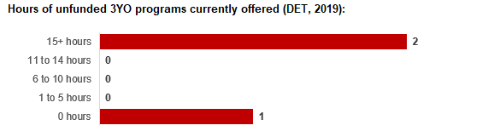

4.4 Approach to optimising the use of existing services and infrastructure
Change management strategies to optimise existing services and infrastructure
Children can often be accommodated through existing spare places and by services ‘unlocking’ unused capacity. As the experience of providers in the 2020 Three-Year-Old Kindergarten roll-out LGAs shows, while the optimisation of existing services can be challenging, it is highly time- and cost-effective compared to building new capacity through infrastructure projects. It also helps target infrastructure investment to the places that need it most and avoids over-supplying the local market.
Mansfield Shire Council and the Department will support providers and services to maximise their kindergarten places through the following change management activities and practices:
- Increasing the capacity of any Local Government operated services by:
  - Running additional programs.
  - Using different timetables, including running 7.5-hour days.
  - Changing the delivery model, such as introducing rotational models or mixed-age groups.
  - Having degree-qualified kindergarten teachers leading integrated kindergarten programs in long day care settings.
- Encouraging and supporting other providers and services in the LGA to undertake change management.
Mansfield Shire Council and the Department have estimated how many Three and Four-Year-Old Kindergarten places can be accommodated through existing services in the LGA (Table 1). Both parties are committed to helping providers and services offer these kindergarten places before progressing to funded infrastructure solutions to meet demand. This commitment is reflected in the LGA and community level estimates below (Table 2 onwards), which assume that demand will be met first through existing services and second through additional infrastructure. Note that in some cases the number of kindergarten places that can be offered through existing services may exceed demand for kindergarten places.
Table 1: Total estimated funded kindergarten places that can be offered by optimising existing services and infrastructure across the LGA, between 2021-29 (presented in 15-hour equivalent places)
 | 2021 | 2022 | 2023 | 2024 | 2025 | 2026 | 2027 | 2028 | 2029
Estimated existing supply of kindergarten places* | 402 | 448 | 448 | 448 | 448 | 448 | 448 | 448 | 448
*This may be higher than current three and four-year-old enrolments as it includes any spare places that are currently available or could be generated by making some minor adjustments to programming approaches.

4.5 Agreed estimates of demand for funded kindergarten places that cannot be met through existing services and infrastructure
The below estimates (Table 2 onwards) have been developed by Mansfield Shire Council and the Department to illustrate the estimated:
- Total number of Three and Four-Year-Old Kindergarten places expected over the roll-out period.
- Three and Four-Year-Old Kindergarten places that cannot be accommodated by optimising existing services and infrastructure over the roll-out period.
These estimates have been developed to reflect that the increase in demand for Three-Year-Old Kindergarten places will be gradual.
In estimating how many Three and Four-Year-Old Kindergarten places cannot be accommodated by existing services and infrastructure, Mansfield Shire Council and the Department have taken into account any new places that will be made available through planned expansions of existing services or new services, into estimates of existing supply, where this information is available. This may include Local Government owned services being developed and planned Kindergartens on School Sites.
These estimates do not, however, estimate how and when the broader sector will expand to meet the additional demand for kindergarten places that are estimated over the roll-out period.
Infrastructure need in the LGA and its local communities is indicated by the bottom rows of the tables in this section (Table 2 onwards): ‘Total kindergarten places that cannot be accommodated by existing services’. For example, if the number of kindergarten places for the LGA or a community is above zero in this row, it means that the area is estimated to need additional infrastructure (noting that further optimisation which avoids the need for additional infrastructure may be possible). Any type of provider – Local Government, not-for-profit or for-profit – can build this additional infrastructure. If this row shows all zeros, it means that there is no estimated need for additional infrastructure in the area.
Local Government and not-for-profit kindergarten providers must refer to the estimates in this section when applying through the Building Blocks Capacity Building Grants stream for Government funding. Under this stream, projects must be in a community where there is infrastructure need as shown in the community’s table of estimated demand for kindergarten places (i.e. there are numbers in the bottom row above zero). Projects in LGAs or communities where demand can be met through existing services (i.e. the bottom row shows all zeros) are not eligible for funding under this stream.

LGA estimates
Table 2: Total estimated three and four-year-old kindergarten places between 2021-29 (presented in 15-hour equivalent places)
LGA level estimates | 2021 | 2022 | 2023 | 2024 | 2025 | 2026 | 2027 | 2028 | 2029
Total estimated demand for kindergarten places (three and four-year-old children) | 112 | 135 | 153 | 165 | 174 | 189 | 200 | 210 | 224
Total kindergarten places that cannot be accommodated by existing services | 0 | 0 | 0 | 0 | 0 | 0 | 0 | 0 | 0

Community estimates
Table 3: Total estimated three and four-year-old kindergarten places between 2021-29 (presented in 15-hour equivalent places)
Mansfield estimates | 2021 | 2022 | 2023 | 2024 | 2025 | 2026 | 2027 | 2028 | 2029
Total estimated demand for kindergarten places (three and four-year-old children) | 112 | 135 | 153 | 165 | 174 | 189 | 200 | 210 | 224
Total kindergarten places that cannot be accommodated by existing services | 0 | 0 | 0 | 0 | 0 | 0 | 0 | 0 | 0

Authorisation
The Area Executive Director (Ovens Murray) of the Department of Education and Training and the Chief Executive of Mansfield Shire Council endorse this Kindergarten Services and Infrastructure Plan (KISP) for Mansfield Shire by signing on 16 / 08 / 2021.
This KISP is not intended to create legal relations or constitute a legally binding contractual agreement between the parties. The parties may review this KISP in 2024 to publish a new version that will replace the previous version.
An out-of-cycle review may be triggered if both parties agree that there has been a change in relevant data, information or the local early childhood sector that significantly affects the reliability of a KISP’s estimates for planning purposes.

Signed for and on behalf and with the authority of Mansfield Shire Council

…………………………………… …………………………………
Signature Witness Signature

Name: Kaylene Conrick
Title: Chief Executive Officer
Address: 33 Highett St, Mansfield, Vic, 3722

Signed by Area Executive Director (Ovens Murray), Department of Education and Training

…………………………………… …………………………………
Signature Witness Signature

Name: Bernie Boulton

Title: Area Executive Director (Ovens Murray),
Address: 150 Bridge Street East, Benalla, Vic, 3672

