Kindergarten Infrastructure and
Services Plan
City of Manningham
CONTENTS
1. Introduction 3
1.1. Reform context 3
1.2. Purpose of KISPs 3
1.3. How to use the KISP 3
1.4. Structure of the KISP 3
1.5. Disclaimer 4
2. Map of Early Childhood Education services in the City of Manningham 5
3. Local context 7
3.1 Purpose 7
3.2 Key considerations 7
4. Funded kindergarten enrolment estimates between 2021-29 for the City of Manningham 7
4.1 Purpose 17
4.2 Methodology 17
4.3 Summary of current kindergarten provision 18
4.4 Approach to optimising the use of existing services and infrastructure 19
4.5 Agreed estimates of demand for funded kindergarten places that cannot be met through existing services and infrastructure 20
5. Authorisation 24

Introduction

Reform context
In an Australian first, the Victorian Government has committed to implement Three-Year-Old Kindergarten for all children over a 10-year roll-out with a total investment of almost $5 billion, including $1.68 billion to support the infrastructure expansion required for the reform. This reform will add another year of universal funded kindergarten so that, by 2029, all children in Victoria will have access to two years of play-based learning through a funded kindergarten program.

Purpose of KISPs
Three-Year-Old Kindergarten will require a large expansion of kindergarten across the State. The Government has invited all 79 Victorian Local Governments to discuss and agree upon a Kindergarten Infrastructure and Services Plan (KISP) for their Local Government Area (LGA).
Each KISP has been jointly developed with Local Government and published to estimate the growth in demand for kindergarten within the LGA. The KISPs will help all kindergarten providers meet demand and provide a clear picture of infrastructure need across the State.
While a KISP is not a funding document and does not define required infrastructure projects or commit any party to funding specific projects, it is expected that future investment requests through Building Blocks and funding decisions about Local Government and not-for-profit projects would align with the relevant KISP.

How to use the KISP
Each KISP contains estimates of future kindergarten supply of, and demand for, Three and Four-Year-Old Kindergarten places against existing enrolment capacity. Not-for-profit and for-profit providers can use these estimates to inform their plans to expand kindergarten programs, establish new services or invest in new or extended facilities.
For example, KISPs provide demand estimates in terms of where, when and how much demand for kindergarten places will grow in an LGA. KISPs also estimate where and how many kindergarten places providers can accommodate in existing facilities before an area needs new infrastructure to meet demand. The estimates can be used to inform decisions about where and when expansions of kindergarten program capacity and the construction of new or extended facilities are needed to meet demand growth.
Where there is an agreed KISP for the LGA, the Local Government and not-for-profit kindergarten providers seeking co-investments through the Building Blocks Capacity Building stream must refer to, and align their proposed project with, the infrastructure need identified in the KISP.

Structure of the KISP
Each KISP consists of the following sections:
- Section 1: A short introduction to the Three-Year-Old Kindergarten reform and the KISP.
- Section 2: A map of existing and planned Early Childhood Education and Care service locations.
- Section 3: Local knowledge and context relevant to the expansion of kindergarten services.
- Section 4: Funded kindergarten demand estimates.

Disclaimer
All data presented in this document are estimates only and are based on the best information available to the Department and Local Government at the time. They are published on an as-is basis and are for informational purposes only. They are subject to adjustment in response to market forces and as new data and other relevant information becomes available. The data may under- or over-estimate both total demand in a given location or year and the capacity for new demand to be met by providers. As a result, operational and business decisions should not be made solely based on this document. Any use of this data is solely at the risk of the user. The Department and Local Government accept no responsibility for any loss or damage, either direct or incidental, that may result from the use of the data.

Map of Early Childhood Education services in the City of Manningham
The map below shows the distribution of currently operating and new services that are planned to open in the future in the LGA and across its communities.
This map has been prepared using Departmental data, from both the National Quality Agenda IT System (NQAITS) and the Victorian School Building Authority (VSBA). Where applicable, this map has been refined by Manningham City Council and the Department to capture other services that are planned to open in the future.
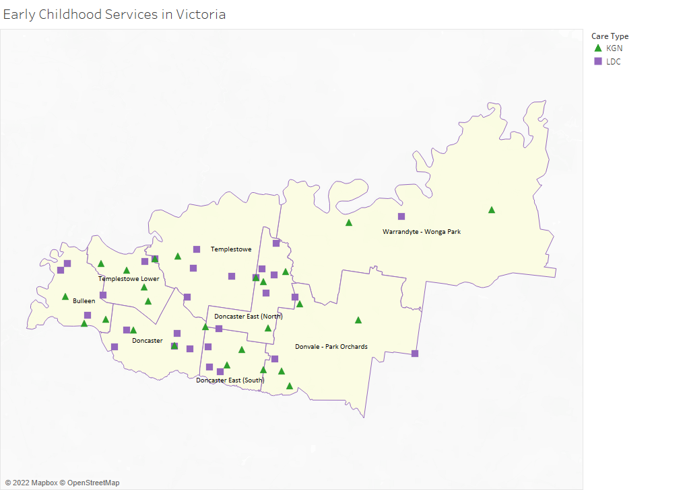

Local context
d

3.1 Purpose
Local, place-based knowledge and context play an important role in supporting the implementation of Three-Year-Old Kindergarten across Victoria. This section of the KISP documents this knowledge and context and has informed the funded kindergarten enrolment estimates in Section 4.

3.2 Key considerations
Key demographic trends that influence demand for kindergarten
The Manningham Council area is located in Melbourne's north-eastern suburbs, commencing with its western boundary in Bulleen, 10 kilometres from the Melbourne CBD and extending to Wonga Park at its eastern extremity, 32 kilometres from the CBD.
Curving along the Yarra River, Manningham includes the suburbs of Bulleen, Doncaster, Doncaster East, Donvale, Park Orchards, Templestowe, Templestowe Lower, Warrandyte, Warrandyte South and parts of Wonga Park, Nunawading and Ringwood North.
The population of Manningham is 128,929 according to the Australian Bureau of Statistics (ABS) – Census 2016 The population is forecast to grow to 149,274 by 2036.
Manningham’s population forecast for the next 15 years is illustrated below in Table 2.
Year | Population | % change (from 2020)
2020 | 131,757 | 0.0%
2025 | 138,440 | 5.1%
2030 | 144,016 | 9.3%
2035 | 148,432 | 12.7%
Source: Forecast i.d.
Table 2. Estimated Resident Population, 2020 to 2035
Like many Victorian municipalities, Manningham’s population is ageing. With a median age of forty-three years, the resident population of Manningham is significantly older than that of the greater Melbourne region.
The proportion of residents aged under twenty-five years has fallen from 32 percent in 2001, to 29 percent in 2016 and, at present, the ABS estimates that there are 33,600 residents aged under twenty-five years living in Manningham.
The change in the age profile of Manningham’s population since the 2001 Australian census is illustrated in Figure 1.
Figure 1 - Change in Service Age Groups as a Proportion of Manningham's Population – 2001 to 2016

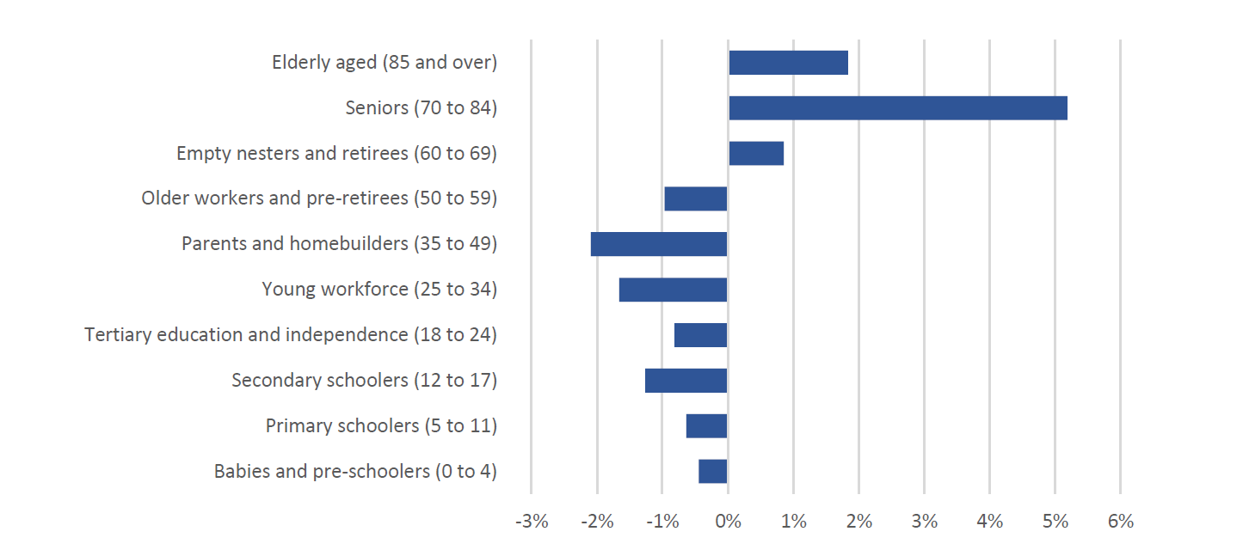
A total of 7.6 percent of Manningham residents are not fluent in English – in Doncaster this figure rises to 11 percent and in Doncaster Hill, 12.2 percent.
Over the next eighteen years to 2036, the population of Manningham is forecast to grow by almost 17 percent, to 149 274 residents. Population growth is expected to be greatest along the Doncaster Road alignment, where the population of Bulleen is predicted to grow by 16 percent; Doncaster East by more than 12 percent; Doncaster by 27 percent; and Doncaster Hill by 166 percent. Growth in total resident numbers is expected to occur most rapidly over the next ten years, during which time an additional 14,000 people will call Manningham home. By contrast, population growth in the years 2028 to 2036 is tipped to slow, with fewer than 7,400 new residents arriving in Manningham.
While the greatest growth in resident numbers is expected to relate to over 40-year-olds, the number of children living in Manningham is also forecast to increase. It is expected that an additional 1,100 children aged under five years will be living in Manningham by 2028, of whom 730 will be living in Doncaster Hill and Doncaster. By comparison, the under five-year-old populations of Warrandyte / Warrandyte South, Park Orchards / Ringwood North, Wonga Park, Templestowe and Templestowe Lower are forecast to remain relatively stable or undergo a small decline.

Socio Economic profile
The City of Manningham scores relatively highly in the ABS Socio-Economic Indexes for Areas (SEIFA). Australian census data from 2016 places the City of Manningham on the 91st percentile for relative socio-economic advantage and disadvantage with only 9 percent of Australian municipalities having a higher SEIFA score than Manningham.
As often occurs, SEIFA scores vary from one part of the municipality to the next; Park Orchards / Ringwood North is on the 99th percentile with a score of 1141.9, while Doncaster Hill scores 1025.4 at the 70th percentile.For context, Victoria sits at the 61st percentile with a state-wide SEIFA of 1009, and Australia’s national SEIFA score is 1003.1.
Manningham has a higher proportion of households in the medium to high income category compared to Victoria. The people who live in an area are one of the most important resources that an economy draws upon, both as a market that consumes goods and services and as a source of labour.
This table provides an overview of Manningham Council's population demographics, and how our characteristics compare to those of the broader region.
Key statistics of local residents
Manningham City Council | 2016 |  |  | 2011 |  |  | Change
Name | Number | % | Victoria % | Number | % | Victoria % | 2011 to 2016
Population summary
Total residents | 116,255 | 100.0 | 100.0 | 111,296 | 100.0 | 100.0 | +4,959
Males | 56,306 | 48.4 | 49.1 | 54,036 | 48.6 | 49.2 | +2,270
Females | 59,953 | 51.6 | 50.9 | 57,260 | 51.4 | 50.8 | +2,693
Age structure
0 - 14 years | 18,727 | 16.1 | 18.2 | 18,275 | 16.4 | 18.7 | +452
15 - 24 years | 14,764 | 12.7 | 13.0 | 14,672 | 13.2 | 13.5 | +92
25 - 54 years | 43,612 | 37.5 | 41.8 | 42,747 | 38.4 | 42.3 | +865
55 - 64 Years | 14,448 | 12.4 | 11.4 | 14,133 | 12.7 | 11.4 | +315
65 years and over | 24,704 | 21.2 | 15.6 | 21,469 | 19.3 | 14.2 | +3,235
Education institute attending
Primary school | 8,737 | 7.5 | 7.9 | 8,251 | 7.4 | 7.7 | +486
Secondary school | 8,162 | 7.0 | 6.1 | 7,960 | 7.2 | 6.5 | +202
TAFE | 1,631 | 1.4 | 1.7 | 1,925 | 1.7 | 2.2 | -294
University | 7,214 | 6.2 | 5.5 | 6,235 | 5.6 | 4.6 | +979
Diversity
Total overseas born | 46,290 | 39.8 | 28.3 | 40,629 | 36.5 | 26.2 | +5,661
Speaks language other than English at home | 49,342 | 42.4 | 25.9 | 43,140 | 38.8 | 23.0 | +6,202
Speaks another language, and English not well or not at all | 8,779 | 7.6 | 4.5 | 6,724 | 6.0 | 4.0 | +2,055
Qualifications
Bachelor or higher degree | 31,500 | 32.3 | 24.3 | 26,305 | 28.3 | 20.8 | +5,195
Advanced Diploma or Diploma | 9,498 | 9.7 | 9.2 | 9,225 | 9.9 | 8.4 | +273
Certificate level | 11,834 | 12.1 | 16.9 | 11,654 | 12.5 | 16.4 | +180
No qualification | 37,112 | 38.1 | 39.6 | 37,935 | 40.8 | 43.9 | -823
Household income
Nill to $649 | 6,455 | 16.0 | 18.3
$650 to $1,499 | 10,333 | 25.6 | 29.0
$1,500 to $2,449 | 8,314 | 20.6 | 22.2
$2,500 or more | 10,908 | 27.0 | 20.2
Housing tenure
Owned | 18,398 | 44.3 | 30.7 | 18,801 | 47.6 | 33.0 | -403
Purchasing | 12,914 | 31.1 | 33.5 | 12,637 | 32.0 | 34.5 | +277
Renting | 7,558 | 18.2 | 27.5 | 6,167 | 15.6 | 25.9 | +1,391
Dwelling structure
Separate house | 34,242 | 75.5 | 72.1 | 34,762 | 81.7 | 75.8 | -520
Medium house | 8,739 | 19.3 | 19.4 | 7,006 | 16.5 | 18.1 | +1,733
High density | 2,132 | 4.7 | 7.4 | 723 | 1.7 | 5.3 | +1,409

Source: Australian Bureau of Statistics, Census of Population and Housing 2011 and 2016. Compiled and presented by .id (informed decisions).

There were 7,363 couples with young children in Manningham in 2016, comprising 17.7% of households.
Overall, the proportion of single parent households with young children was 2.4%, compared to 3.2% in Greater Melbourne while the proportion of single parent households with older children was 6.2% compared to 5.8% in Greater Melbourne.
Households with children by life stage
City of Manningham - Households (Enumerated) | 2016 |  |  | 2011 |  |  | Change
Households with children | Number | % | Greater Melbourne % | Number | % | Greater Melbourne % | 2011 to 2016
Couples with children | 16,463 | 39.6 | 33.5 | 16,210 | 41.0 | 33.6 | +253
Couples with young children | 7,363 | 17.7 | 18.2 | 6,996 | 17.7 | 17.7 | +367
Couples with mixed-age children | 1,998 | 4.8 | 4.3 | 2,165 | 5.5 | 4.6 | -167
Couples with older children | 7,102 | 17.1 | 11.0 | 7,049 | 17.8 | 11.3 | +53
Single parents with children | 3,929 | 9.5 | 10.1 | 3,704 | 9.4 | 10.4 | +225
Single parents with young children | 996 | 2.4 | 3.2 | 887 | 2.2 | 3.5 | +109
Single parents with mixed-age children | 351 | 0.8 | 1.1 | 404 | 1.0 | 1.2 | -53
Single parents with older children | 2,582 | 6.2 | 5.8 | 2,413 | 6.1 | 5.7 | +169
Total households with children | 20,392 | 49.1 | 43.5 | 19,914 | 50.4 | 44.0 | +478
Total households | 41,541 | 100.0 | 100.0 | 39,517 | 100.0 | 100.0 | +2,024

Source: Australian Bureau of Statistics, Census of Population and Housing 2011 and 2016. Compiled and presented by .id (informed decisions).

Professional Workforce
In 2016, 52,819 people living in Manningham were employed, of which 59% worked full-time and 39% part-time. Manningham's employment statistics are an important indicator of socio-economic status. The levels of full or part-time employment, unemployment and labour force participation indicate the strength of the local economy and social characteristics of the population.

Employment status
City of Manningham - Persons (Usual residence) | 2016 |  |  | 2011 |  |  | Change
Employment status | Number | % | Greater Melbourne % | Number | % | Greater Melbourne % | 2011 to 2016
Employed | 52,819 | 93.9 | 93.2 | 53,193 | 95.3 | 94.5 | -374
Employed full-time | 31,343 | 55.7 | 58.0 | 32,501 | 58.2 | 60.1 | -1,158
Employed part-time | 20,520 | 36.5 | 33.5 | 19,583 | 35.1 | 32.3 | +937
Hours worked not stated | 956 | 1.7 | 1.8 | 1,109 | 2.0 | 2.1 | -153
Unemployed (Unemployment rate) | 3,457 | 6.1 | 6.8 | 2,631 | 4.7 | 5.5 | +826
Looking for full-time work | 1,615 | 2.9 | 3.5 | 1,389 | 2.5 | 3.1 | +226
Looking for part-time work | 1,842 | 3.3 | 3.3 | 1,242 | 2.2 | 2.4 | +600
Total labour force | 56,276 | 100.0 | 100.0 | 55,824 | 100.0 | 100.0 | +452

Source: Australian Bureau of Statistics, Census of Population and Housing 2011 and 2016. Compiled and presented by .id (informed decisions).

There were more professionals in Manningham in 2016 than any other occupation. Manningham's occupation statistics quantify the occupations in which the residents work (which may be within the residing area or elsewhere). This will be influenced by the economic base and employment opportunities available in the area, education levels, and the working and social aspirations of the population. When viewed with other indicators, such as Educational Qualifications and Individual Income, occupation is a key measure for evaluating Manningham's socio-economic status and skill base.
An analysis of the jobs held by the resident population in City of Manningham in 2016 shows the three most popular occupations were:
- Professionals (15,029 people or 28.5%)
- Managers (8,859 people or 16.8%)
- Clerical and Administrative Workers (7,579 people or 14.3%)
In combination these three occupations accounted for 31,467 people in total or 59.6% of the employed resident population.

Residents place of work
38,493 or 73.0% of Manningham’s resident workers travel outside of the area to work. Journey to Work data shows where resident workers go to work and whether they need to travel significant distances to work, or can live near work.
Employment location of resident workers
Manningham City Council | 2016
Location | Number | %
Live and work in the area | 12,105 | 22.9
Live in the area, but work outside | 38,493 | 73.0
No fixed place of work | 2,163 | 4.1
Total employed residents in the area | 52,761 | 100.0
Source: Australian Bureau of Statistics, Census of Population and Housing 2016. Compiled and presented in economy.id by .id (informed decisions)

Non English speaking population
In 2016, 27.0% of the non-English speaking population in Manningham were born in
Australia. People speaking a language other than English at home may have been born in a variety of different countries. Second and third generation migrants may be born in Australia. The figure below looks at the distribution of birthplaces for non-English language speakers only. It is likely to vary depending on which communities exist in the local area.

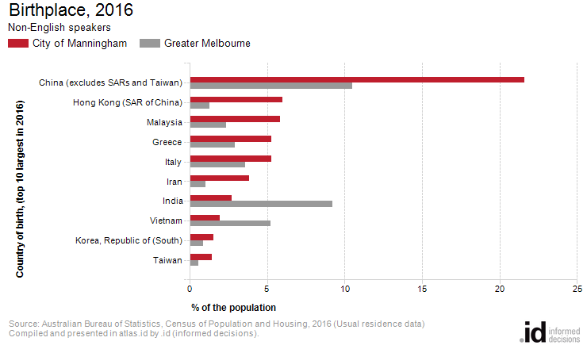
Analysis of the country of birth of the non-English speaking population in Manningham in 2016 compared to Greater Melbourne shows that there was a smaller proportion of people born overseas.
Overall, 71.6% of the non-English population was born overseas, compared with 72.2% for Greater Melbourne.
The major differences between the countries of birth of the non-English speaking population in Manningham and Greater Melbourne were:
- A larger percentage of people born in China (excludes SARs and Taiwan) (21.6% compared to 10.5%)
- A larger percentage of people born in Hong Kong (SAR of China) (6.0% compared to 1.3%)
- A larger percentage of people born in Malaysia (5.8% compared to 2.3%)
- A smaller percentage of people born in India (2.7% compared to 9.2%)
Between 2011 and 2016, the number of non-English speakers born overseas increased by 5,870 or 19.9%,
The largest changes in birthplace countries of the non-English speaking population in this area between 2011 and 2016 were for those born in:
- China (excludes SARs and Taiwan) (+4,226 persons)
- Iran (+893 persons)
- Malaysia (+512 persons)
- Italy (-413 persons)

Key local geographic considerations or information relevant to Three-Year-Old Kindergarten
Early Years Profile
In 2018, more than 95% of children starting school in Manningham had attended pre-school programs, consistent with the Victorian average (Source: Australian Early Development Census).
Analysis of the service age categories from 2020 shows that the most dominant groups across the municipality were ‘young workforce’ and ‘parents and home-builders’. This indicates high rates of young families in Manningham. Doncaster has a high proportion of younger workers whereas Park Orchards, Warrandyte and Wonga Park have lower rates of younger workers.

Table 4 - Existing Early Years Profile 2020 table

Age Profile | Births |  | 3-Year-Olds |  | 4-Year-Olds |  | 0-6-Year-Olds
Suburb | Number | % | Number | % | Number | % | Number | %
Bulleen | 118 | 8.9 | 122 | 9.5 | 115 | 8.9 | 868 | 9.5
Doncaster | 328 | 24.9 | 259 | 20.1 | 246 | 19.1 | 1862 | 20.4
Doncaster East | 345 | 26.2 | 328 | 25.5 | 309 | 24.1 | 2335 | 25.6
Donvale | 130 | 9.9 | 139 | 10.8 | 151 | 11.7 | 1006 | 11.0
Park Orchards - Ringwood North | 32 | 2.4 | 36 | 2.8 | 38 | 3.0 | 270 | 3.0
Templestowe | 158 | 12 | 162 | 12.6 | 172 | 13.4 | 1098 | 12.0
Templestowe Lower | 139 | 10.6 | 154 | 11.9 | 172 | 13.4 | 1106 | 12.1
Warrandyte - Warrandyte South | 43 | 3.3 | 58 | 4.5 | 49 | 3.8 | 381 | 4.2
Wonga Park | 24 | 1.8 | 29 | 2.3 | 33 | 2.6 | 207 | 2.3
Manningham (Total) | 1316 | 100 | 1288 | 100 | 1285 | 100 | 9133 | 100

Kindergarten models and offering
Manningham families are able to participate in kindergarten education via sessional and long day care/integrated programs with 25 sessional kindergartens and 30 long day care centres providing 2821 licenced places.
There is also extended care kindergarten which refers to kindergarten education in a kindergarten centre or room, which is longer than 15 hours and includes some child care (wrap around model).
It is acknowledged that the Victorian State Government is the primary funder of kindergarten, however Councils have traditionally and continue to provide infrastructure to support its provision.
Manningham plays this role by providing land for 19 (of 25) standalone kindergartens and 7 (of 30 long day care centres. As of 2019, 52 of these offered a funded kindergarten program and 32 indicated that they offer an unfunded program for three-year-old children. The majority (53 per cent) of the services in Manningham are non-government not-for-profit services apart from one long day care centre run by Council. The licenced place estimate for 2021 across these services provided by the Department of Education indicates the council has 886 places for sessional kindergarten and 1935 places for long day care.
Manningham Council does not manage central enrolments, nor can it influence enrolment or direct children to vacancies. Therefore, Council relies upon individual service providers to advise on capacity and vacancies.
Victoria in Future (VIF) 2019 estimates that the three and four-year-old population in Manningham will increase from 2,460 to 2,812 children over the reform roll-out period (2021-2029).
The KISP estimates that this growth, in combination with the roll-out of Three-Year-Old Kindergarten, will cause demand for kindergarten places to increase over this period. As a result, Manningham will experience growth in demand for kindergarten that cannot be met through existing capacity over the reform roll-out period and new solutions will be needed to accommodate this. The analysis suggests that there is modest unmet demand in the early years of the roll-out period (2022-2026) and the majority of the unmet demand is expected from 2027 onwards.
Increased demand for kindergarten places is expected across all 8 SA2s in Manningham. Bulleen, Donvale - Park Orchards and Templestowe appear to have sufficient existing capacity to deliver 15 hours of funded Three-Year-Old Kindergarten to meet demand throughout the reform. Doncaster East (North), Templestowe Lower and Warrandyte – Wonga Park may be able to meet some unmet demand by implementing some level of change management.
Change management activities will likely be insufficient to accommodate unmet demand in Doncaster and Doncaster East (South). Change management activities may be difficult to implement in Doncaster East (South) as the majority of kindergarten providers are long-day-care centres which have less flexibility, as they need to accommodate a variety of age groups.
Demand for four-year-old places is estimated using current enrolment patterns and projected population growth. Estimates of demand for three-year-old places are based on VIF population projections, assuming the majority of these children will attend at local services in the SA2 they live in. This approach balances current patterns of service delivery and the preferences of many families to use services close to their residence. In general, VIF projections for three- and four-year-olds are very closely aligned, so when the estimates for demand are different across these age-groups, this indicates families may currently be accessing kindergarten services outside of where they reside.
In Manningham, estimated demand for Three-Year-Old Kindergarten exceeds Four- Year-Old Kindergarten in Doncaster, Templestowe and Warrandyte – Wonga Park. It is possible that here, families are residing in these SA2s but are accessing Four-Year-Old Kindergarten elsewhere. Conversely, estimated demand for Four-Year-Old Kindergarten exceeds Three-Year-Old Kindergarten in Bulleen, Doncaster East (North), Doncaster East (South), Donvale Park – Orchards and Templestowe Lower. It is possible that here, families are accessing Four-Year-Old Kindergarten in these SA2s while residing elsewhere. The Department of Education and Training and Council will monitor the uptake and enrolment patterns for Three-Year-Old Kindergarten as the reform rolls out.
Manningham Council has reviewed and endorses this document in so far as it is an indicator of future unmet demand as predicted by currently available forecast data and a planning tool for potential future investment by various parties. Council’s endorsement is not, and should not be interpreted as an indication that Council accepts responsibility for meeting that unmet demand; or that Council is capable of, or committed to meeting that demand, through either service provision or infrastructure expansion.

Projects or trends that may influence supply of early childhood education and care
Manningham is currently finalising a Community Infrastructure Plan which will include recommendations for future infrastructure improvements and 20 year Implementation Plan.
The Community Infrastructure Plan (CIP) considers the needs of each kindergarten facility and the priorities within the CIP are based on the Early Years Needs Assessment which is reflected in this KISP. Where applicable, applications for Building Blocks Funding to support kindergarten expansion to accommodate 15 hours of 3 year old kindergarten will be developed by Manningham Council.
From the assessment, the following strategic directions have been developed and will guide our approach to planning and delivery of early year’s spaces and services:
- Continue to encourage kindergarten providers to review programming to maximise service delivery before looking for building expansion.
- Leverage available State funding opportunities to deliver new and upgraded facilities and services.
- Encourage the provision of early years services on primary school sites.
- Continue to advocate for the delivery of early years services by others (private, not-for-profit sector).
- Monitor demand and capacity for early year’s services over time.
- Continue to review the role of Council in different early year’s services over time, including our preferred model for future delivery for kindergarten and long-day care.
- Provide early years services as part of new intergenerational community hubs.
The CIP is currently being finalised and it is expected that it will be available to the community near the end of 2022.
There are currently 3 planning applications for a Long Day Care centres in Doncaster as detailed in the table below:

Current Planning Applications for Long Day Care
Application # | Address | Details | Current Status
PLN20/0303 | 674-680 Doncaster Road DONCASTER VIC 3108 | Multi story commercial and residential development, 120 licenced place centre. | Application endorsed at February 2022 Council meeting.
PLN20/0549 | 394 Manningham Road DONCASTER VIC 3108 | Three-storey childcare centre, 56 licenced places. | Currently awaiting submission of further information by applicant, information due 24 March 2022.
PLN21/0615 | 42 & 44 Victoria Street DONCASTER | 104 licenced place centre. | Currently awaiting submission of further information by applicant, information due by 23 March 2022.

Funded kindergarten enrolment estimates between 2021-29 for the City of Manningham

4.1 Purpose
As Three-Year-Old Kindergarten is rolled-out and Victoria’s population grows, demand for both Three and Four-Year-Old Kindergarten places will increase significantly. While additional capacity will be needed to meet this demand, this will vary across the State and over time, due to differences in the capacity of existing services, growth trends and sector composition.
To identify where, when and how many additional kindergarten places are expected over the roll-out in the City of Manningham, Manningham City Council and the Department have developed:
- A summary of the current provision of kindergarten within the LGA (Section 4.3).
- An approach to optimising the utilisation of existing services and infrastructure through ‘change management’ strategies that Manningham City Council and the Department will support to help meet additional demand in the LGA (Section 4.4).
- An estimate of the Three and Four-Year-Old kindergarten places that cannot be met through existing services for the 2021-29 period, taking into account the additional demand that can be accommodated by optimising utilisation of existing services and infrastructure through point 2, above (Section 4.5).
Local Government and providers can use these published estimates to inform reform implementation activities such as service planning, kindergarten program expansion, infrastructure investments and Building Blocks funding applications in alignment with future demand over the 10-year roll-out.

4.2 Methodology
The estimated Three and Four-Year-Old Kindergarten places used in the following sections have been agreed between Manningham City Council and the Department, and were informed by:
- Estimates developed by the Department which draw on a range of inputs, including population forecasts, current enrolments and results from the Kindergarten Capacity Assessment Program (KCAP), conducted in 2019.
- The estimated capacity of new services that are planned to open in the LGA (Section 2)
- Local knowledge and context provided by the Local Government (Section 3) that explains particular issues and trends in their area.
- The approach to optimising utilisation of existing services in the LGA (Section 4.4), and
- Other sources, such as modelling undertaken by Local Governments and local data.
The KISP measures a service’s capacity to deliver funded kindergarten in terms of the number of children it could enrol in Three and Four-Year-Old Kindergarten. The number of funded kindergarten places is different from a service’s licensed or approved places, which count the number of children permitted to attend the service at any one time under the license. Many services can enrol more children in their funded kindergarten program(s) than they have licensed places for because they can run more than one kindergarten program per week. Kindergarten places are therefore a more accurate measure of service kindergarten capacity than licensed places.
Three-Year-Old Kindergarten places have been presented as 15-hour places so they can be easily compared to Four-Year-Old Kindergarten places. Moreover, when Three-Year-Old Kindergarten is fully rolled-out in 2029, every three-year-old child will have access to 15-hours of kindergarten.
From 2023 all providers will have flexibility to determine how many hours of funded Three-Year-Old Kindergarten they deliver per week, with a minimum of five hours and a maximum of 15-hours funded pro-rata. It is expected that hours offered will vary. Given this variation, it is important to be aware that during the transition to all three-year-old children receiving 15-hours of funded kindergarten per week in 2029, the 15-hour places presented in this report may represent multiple three-year-old places that individually receive less than 15-hours of kindergarten per week.
These estimates have been developed at an LGA and community level to show the overall forecast and variation within an area. The KISP defines community at the Statistical Area Level 2, which is medium-sized areas which represent a community that interacts socially and economically, with a population range of 3,000 to 25,000 people, and an average population of about 10,000 people.

4.3 Summary of current kindergarten provision
The figures below provide a summary of current kindergarten provision within the LGA and provide relevant context for the estimates of demand for funded kindergarten places included in Section 4.5. The data included in this section are largely drawn from:
- The Kindergarten Capacity Assessment Program (KCAP), collected between June and October 2019.
- The Department’s Kindergarten Information Management System (KIMS), as at 2019.
- The Department’s Quality and Regulatory Division (QARD) monitoring data, as at 2019.
- The National Quality Agenda IT System (NQAITS), as at March 2021.
- The Victorian Child and Adolescent Monitoring System (VCAMS), as at 2018.
Please note that, because these sources were collected at different points, this may result in slightly different totals appearing in the below data.
Number of services by service type (NQAITs, 2021)

Stand-alone kindergartens | 25
Long day care centres | 30
Percentage of services by management type, LGA level (NQAITs, 2021)
Type | Percentage
Local Government | 2%
Private not for profit | 53%
Private for profit | 44%
Other | 2%

Current kindergarten offering
Four-Year-Old Kindergarten participation rate (VCAMS, 2018): | 97%
Number of services that offer a funded kindergarten program (DET, 2019): | 52
Number of services that offer an unfunded Three-Year-Old Kindergarten program (DET, 2019): | 32
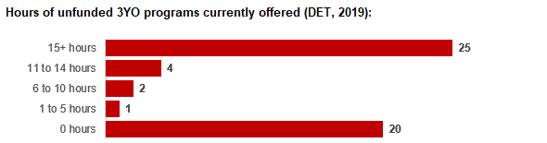

4.4 Approach to optimising the use of existing services and infrastructure
Change management strategies to optimise existing services and infrastructure
Children can often be accommodated through existing spare places and by services ‘unlocking’ unused capacity. As the experience of providers in the 2020 Three-Year-Old Kindergarten roll-out LGAs shows, while the optimisation of existing services can be challenging, it is highly time- and cost-effective compared to building new capacity through infrastructure projects. It also helps target infrastructure investment to the places that need it most and avoids over-supplying the local market.
Manningham City Council and the Department will support providers and services to maximise their kindergarten places through the following change management activities and practices:
- Increasing the capacity of any Local Government operated services by:
  - Running additional programs.
  - Using different timetables, including running 7.5-hour days.
  - Changing the delivery model, such as introducing rotational models or mixed-age groups.
  - Having degree-qualified kindergarten teachers leading integrated kindergarten programs in long day care settings.
- Encouraging and supporting other providers and services in the LGA to undertake change management.
Manningham City Council and the Department have estimated how many Three and Four-Year-Old Kindergarten places can be accommodated through existing services in the LGA (Table 1). Both parties are committed to helping providers and services offer these kindergarten places before progressing to funded infrastructure solutions to meet demand. This commitment is reflected in the LGA and community level estimates below (Table 2 onwards), which assume that demand will be met first through existing services and second through additional infrastructure. Note that in some cases the number of kindergarten places that can be offered through existing services may exceed demand for kindergarten places.
Table 1: [Range of] total estimated funded kindergarten places that can be offered by optimising existing services and infrastructure across the LGA, between 2021-29 (presented in 15-hour equivalent places)
 | 2021 | 2022 | 2023 | 2024 | 2025 | 2026 | 2027 | 2028 | 2029
Estimated existing supply of kindergarten places* | 2824 | 2824 | 2841 | 2841 | 2841 | 2841 | 2841 | 2841 | 2841
*This may be higher than current three and four-year-old enrolments as it includes any spare places that are currently available or could be generated by making some minor adjustments to programming approaches.

4.5 Agreed estimates of demand for funded kindergarten places that cannot be met through existing services and infrastructure
The below estimates (Table 2 onwards) have been developed by Manningham City Council and the Department to illustrate the estimated:
- Total number of Three and Four-Year-Old Kindergarten places expected over the roll-out period.
- Three and Four-Year-Old Kindergarten places that cannot be accommodated by optimising existing services and infrastructure over the roll-out period.
These estimates have been developed to reflect that the increase in demand for Three-Year-Old Kindergarten places will be gradual.
In estimating how many Three and Four-Year-Old Kindergarten places cannot be accommodated by existing services and infrastructure, Manningham City Council and the Department have taken into account any new places that will be made available through planned expansions of existing services or new services, into estimates of existing supply, where this information is available. This may include Local Government owned services being developed and planned Kindergartens on School Sites.
These estimates do not, however, estimate how and when the broader sector will expand to meet the additional demand for kindergarten places that are estimated over the roll-out period.
Infrastructure need in the LGA and its local communities is indicated by the bottom rows of the tables in this section (Table 2 onwards): ‘Total kindergarten places that cannot be accommodated by existing services’. For example, if the number of kindergarten places for the LGA or a community is above zero in this row, it means that the area is estimated to need additional infrastructure (noting that further optimisation which avoids the need for additional infrastructure may be possible). Any type of provider – Local Government, not-for-profit or for-profit – can build this additional infrastructure. If this row shows all zeros, it means that there is no estimated need for additional infrastructure in the area.
Local Government and not-for-profit kindergarten providers must refer to the estimates in this section when applying through the Building Blocks Capacity Building Grants stream for Government funding. Under this stream, projects must be in a community where there is infrastructure need as shown in the community’s table of estimated demand for kindergarten places (i.e. there are numbers in the bottom row above zero). Projects in LGAs or communities where demand can be met through existing services (i.e. the bottom row shows all zeros) are not eligible for funding under this stream.

LGA estimates
Table 2: Estimated three and four-year-old kindergarten places between 2021-29 (presented in 15-hour equivalent places)
LGA level estimates | 2021 | 2022 | 2023 | 2024 | 2025 | 2026 | 2027 | 2028 | 2029
Total estimated demand for kindergarten places (three and four-year-old children) | 1329 | 1637 | 1875 | 2041 | 2184 | 2416 | 2564 | 2715 | 2904
Total kindergarten places that cannot be accommodated by existing services | 0 | 0 | 0 | 0 | 15 | 70 | 114 | 186 | 383

Community estimates
Table 3-10: Estimated three and four-year-old kindergarten places between 2021-29 (presented in 15-hour equivalent places)
Bulleen estimates | 2021 | 2022 | 2023 | 2024 | 2025 | 2026 | 2027 | 2028 | 2029
Total estimated demand for kindergarten places (three and four-year-old children) | 178 | 207 | 231 | 248 | 262 | 294 | 326 | 354 | 347
Total kindergarten places that cannot be accommodated by existing services | 0 | 0 | 0 | 0 | 0 | 0 | 0 | 0 | 0

Doncaster estimates | 2021 | 2022 | 2023 | 2024 | 2025 | 2026 | 2027 | 2028 | 2029
Total estimated demand for kindergarten places (three and four-year-old children) | 165 | 237 | 292 | 335 | 374 | 429 | 448 | 479 | 545
Total kindergarten places that cannot be accommodated by existing services | 0 | 0 | 0 | 0 | 15 | 70 | 88 | 119 | 186

Doncaster East (North) estimates | 2021 | 2022 | 2023 | 2024 | 2025 | 2026 | 2027 | 2028 | 2029
Total estimated demand for kindergarten places (three and four-year-old children) | 236 | 277 | 310 | 332 | 352 | 383 | 405 | 421 | 446
Total kindergarten places that cannot be accommodated by existing services | 0 | 0 | 0 | 0 | 0 | 0 | 18 | 34 | 59

Doncaster East (South) estimates | 2021 | 2022 | 2023 | 2024 | 2025 | 2026 | 2027 | 2028 | 2029
Total estimated demand for kindergarten places (three and four-year-old children) | 207 | 248 | 279 | 299 | 316 | 325 | 333 | 351 | 394
Total kindergarten places that cannot be accommodated by existing services | 0 | 0 | 0 | 0 | 0 | 0 | 8 | 25 | 69

Donvale - Park Orchards estimates | 2021 | 2022 | 2023 | 2024 | 2025 | 2026 | 2027 | 2028 | 2029
Total estimated demand for kindergarten places (three and four-year-old children) | 207 | 243 | 272 | 290 | 306 | 343 | 379 | 411 | 406
Total kindergarten places that cannot be accommodated by existing services | 0 | 0 | 0 | 0 | 0 | 0 | 0 | 0 | 0

Templestowe estimates | 2021 | 2022 | 2023 | 2024 | 2025 | 2026 | 2027 | 2028 | 2029
Total estimated demand for kindergarten places (three and four-year-old children) | 70 | 106 | 130 | 148 | 163 | 194 | 218 | 239 | 243
Total kindergarten places that cannot be accommodated by existing services | 0 | 0 | 0 | 0 | 0 | 0 | 0 | 0 | 0

Templestowe Lower estimates | 2021 | 2022 | 2023 | 2024 | 2025 | 2026 | 2027 | 2028 | 2029
Total estimated demand for kindergarten places (three and four-year-old children) | 193 | 227 | 252 | 268 | 281 | 300 | 300 | 308 | 349
Total kindergarten places that cannot be accommodated by existing services | 0 | 0 | 0 | 0 | 0 | 0 | 0 | 7 | 49

Warrandyte - Wonga Park estimates | 2021 | 2022 | 2023 | 2024 | 2025 | 2026 | 2027 | 2028 | 2029
Total estimated demand for kindergarten places (three and four-year-old children) | 72 | 93 | 109 | 120 | 130 | 147 | 154 | 154 | 175
Total kindergarten places that cannot be accommodated by existing services | 0 | 0 | 0 | 0 | 0 | 0 | 0 | 0 | 21

Authorisation
The Area Executive Director, Inner Eastern Melbourne of the Department of Education and Training and the Chief Executive of Manningham City Council endorse this Kindergarten Services and Infrastructure Plan (KISP) for the City of Manningham by signing on 1/04/2022.
This KISP is not intended to create legal relations or constitute a legally binding contractual agreement between the parties. The parties may review this KISP in 2024 to publish a new version that will replace the previous version.

Signed for and on behalf and with the authority of Manningham City Council

…………………………………… …………………………………
Signature Witness Signature

Name: Andrew Day
Title: Chief Executive Officer
Address: 699 Doncaster Road, Doncaster

Signed by Area Executive Director, Inner Eastern Melbourne, Department of Education and Training

…………………………………… …………………………………
Signature Witness Signature

Name: Barbara Crowe
Title: Area Executive Director, Inner Eastern Melbourne
Address: …………………………………………………………………………………………………….

