Kindergarten Infrastructure and

Services Plan

City of Knox

**CONTENTS**

1. Introduction 3

1.1. Reform context 3

1.2. Purpose of KISPs 3

1.3. How to use the KISP 3

1.4. Structure of the KISP 4

1.5. Disclaimer 4

2. Map of Early Childhood Education services in City of Knox 5

3. Local context 6

3.1 Purpose 6

3.2 Key considerations 6

4. Funded kindergarten enrolment estimates between 2021-29 for City of Knox 12

4.1 Purpose 12

4.2 Methodology 12

4.3 Summary of current kindergarten provision 13

4.4 Approach to optimising the use of existing services and infrastructure 14

4.5 Agreed estimates of demand for funded kindergarten places that cannot be met through existing services and infrastructure 16

5. Authorisation 20

# Introduction

## Reform context

In an Australian first, the Victorian Government has committed to implement Three-Year-Old Kindergarten for all children over a 10-year roll-out with a total investment of almost $5 billion, including $1.68 billion to support the infrastructure expansion required for the reform. This reform will add another year of universal funded kindergarten so that, by 2029, all children in Victoria will have access to two years of play-based learning through a funded kindergarten program.

## Purpose of KISPs

Three-Year-Old Kindergarten will require a large expansion of kindergarten across the State. The Government has invited all 79 Victorian Local Governments to discuss and agree upon a Kindergarten Infrastructure and Services Plan (KISP) for their Local Government Area (LGA).

Each KISP has been jointly developed with Local Government and published to estimate the growth in demand for kindergarten within the LGA. The KISPs will help all kindergarten providers meet demand and provide a clear picture of infrastructure need across the State.

While a KISP is not a funding document and does not define required infrastructure projects or commit any party to funding specific projects, it is expected that future investment requests through Building Blocks and funding decisions about Local Government and not-for-profit projects would align with the relevant KISP.

## How to use the KISP

Each KISP contains estimates of future kindergarten supply of, and demand for, Three and Four-Year-Old Kindergarten places against existing enrolment capacity. Not-for-profit and for-profit providers can use these estimates to inform their plans to expand kindergarten programs, establish new services or invest in new or extended facilities.

For example, KISPs provide demand estimates in terms of where, when and how much demand for kindergarten places will grow in an LGA. KISPs also estimate where and how many kindergarten places providers can accommodate in existing facilities before an area needs new infrastructure to meet demand. The estimates can be used to inform decisions about where and when expansions of kindergarten program capacity and the construction of new or extended facilities are needed to meet demand growth.

Where there is an agreed KISP for the LGA, the Local Government and not-for-profit kindergarten providers seeking co-investments through the Building Blocks Capacity Building stream must refer to, and align their proposed project with, the infrastructure need identified in the KISP.

## Structure of the KISP

Each KISP consists of the following sections:

* **Section 1**: A short introduction to the Three-Year-Old Kindergarten reform and the KISP.
* **Section 2**: A map of existing and planned Early Childhood Education and Care service locations.
* **Section 3**: Local knowledge and context relevant to the expansion of kindergarten services.
* **Section 4**: Funded kindergarten demand estimates.

## Disclaimer

All data presented in this document are estimates only and are based on the best information available to the Department and Local Government at the time. They are published on an as-is basis and are for informational purposes only. They are subject to adjustment in response to market forces and as new data and other relevant information becomes available. The data may under- or over-estimate both total demand in a given location or year and the capacity for new demand to be met by providers. As a result, operational and business decisions should not be made solely based on this document. Any use of this data is solely at the risk of the user. The Department and Local Government accept no responsibility for any loss or damage, either direct or incidental that may result from the use of the data.

# Map of Early Childhood Education services in City of Knox

The map below shows the distribution of currently operating and new services that are planned to open in the future in the LGA and across its communities.

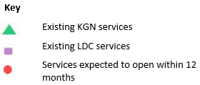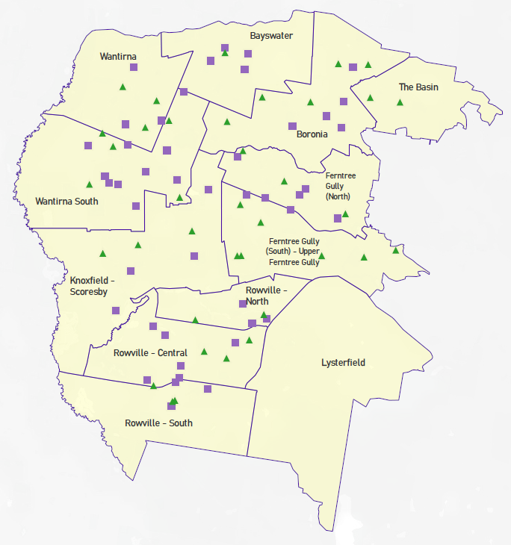This map has been prepared using Departmental data, from both the National Quality Agenda IT System (NQAITS) and the Victorian School Building Authority (VSBA). Where applicable, this map has been refined by the Knox City Council and the Department to capture other services that are planned to open in the next 12 months.

# Local context

d

## 3.1 Purpose

Local, place-based knowledge and context play an important role in supporting the implementation of Three-Year-Old Kindergarten across Victoria. This section of the KISP documents this knowledge and context and has informed the funded kindergarten enrolment estimates in Section 4.

## 3.2 Key considerations

**Key demographic trends that influence demand for kindergarten**

The City of Knox is located in Melbourne’s suburbs, between 20 and 25 kilometres south-east of the Melbourne CBD. The City of Knox is bounded by the City of Maroondah in the north, the Yarra Ranges Council area in the east, the City of Casey in the south, and the City of Monash, the City of Whitehorse and the City of Greater Dandenong in the west.

The area is made up of the suburbs of Bayswater, Boronia, The Basin, Ferntree Gully, Upper Ferntree Gully, Lysterfield, Rowville Central, North and South, Scoresby, Knoxfield, Wantirna and Wantirna South.

Knox City Council supports access to Kindergarten and other Early Years Services through its roles as an early years approved provider and Early Years Manager (EYM), owner of community infrastructure, municipal planner and advocate. Council also manages a Central Registration System for kindergartens operating under Council’s EYM.

Although the municipality is in a period of consolidation, Knox’ overall population is still expected to grow by 17% between 2019 and 2041. The increase for the early years population (0-6 year olds) is projected to be slightly lower at 14.2%, consistent with an ageing population. Birth rate data from this year and the next will be informative as to any effect Melbourne’s pandemic baby boom on Knox’s early years population as Knox does not have significant population growth from direct immigration. Systematic reviews of population change and its impact on population forecasts will be needed to inform service planning and infrastructure/development decisions into the future.

**Projects or trends that may influence supply of early childhood education and care**

Knox City Council is currently the primary provider of kindergarten in the municipality. Knox City Council operates 30 of 37 national licenced sessional settings operating in the municipality.

Kindergarten service provision in Knox is currently provided in a mixed economy which includes 45 private national licenced Long Day Care settings.

* Current 3YO provision does not cover the existing or projected 3-year-old population so a mixed market is required going forward.
* The Knox community continue to reiterate a preference for sessional kindergarten.

As an outer suburban municipality, Knox City Council’s existing early years infrastructure is on average 50-70 years old and includes a range of facilities that are entering into a lifecycle period of building replacement needed to maintain existing supply. Building replacement and radical transformation of some Council early years facilities will be needed within the KISP period. These may not be in areas of particularly high population growth or change as identified in the demand figures in section 4, but nevertheless are required to maintain access for eligible kindergarten children into the future. Without investment to replace these facilities, existing supply may drop to a point at which it can no longer meet demand for eligible kindergarten children. Any future supply disruption should be taken into account when assessing areas of demand for development and funding purposes.

**Key local geographic considerations or information relevant to Three-Year-Old Kindergarten**

Local geographic considerations to note are included by local area/suburb below.

**Bayswater**

Supply shortfalls are projected for Bayswater. Knox City Council’s comprehensive facilities review has identified no Council owned facilities or land parcels which could be used for new development/refurbishment or expansion which will meet this demand.

**Lysterfield**

There are currently no services located in Lysterfield, families from Lysterfield access services in surrounding suburbs i.e. FTG / Rowville.

**Ferntree Gully Upper Ferntree Gully**

While there is broad agreement one area of discrepancy remains in how Knox City Council data (population id.) and DET data (Victoria in Future) define the suburb boundaries in Ferntree Gully and Upper Ferntree Gully. Knox relies on population id. data which, in the case of FTG/UFTG, uses an east/west split (Map 1 and 2 below), The Victoria In Future (VIF) ABS data used by DET in the KISP follows a north/south split (Map 3 and 4 below). Despite the differences in how each party splits the suburbs and services therein, the overall implication regarding demand in the area is the same - neither indicates evidence of increased unmet demand in FTG/UFTG out to 2029.

For this local geographic area it is important to note that population id. data for current population projections takes into consideration local planning and contextual information.

Map 1: Knox City Council - Population id. Profile Area: Ferntree Gully

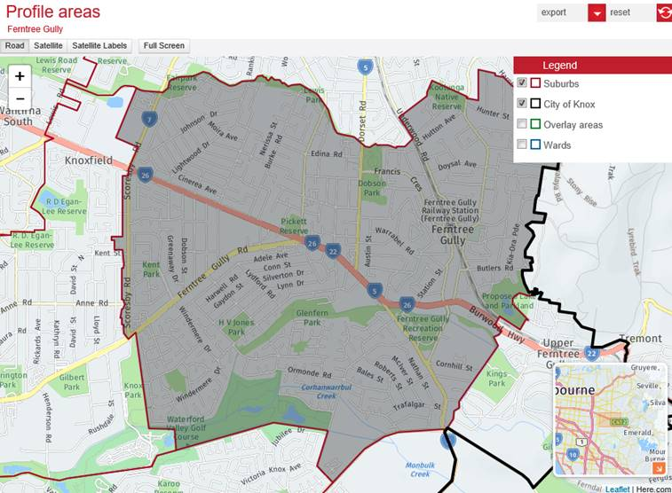

Map 2: Knox City Council - Population id. Profile Area: Upper Ferntree Gully

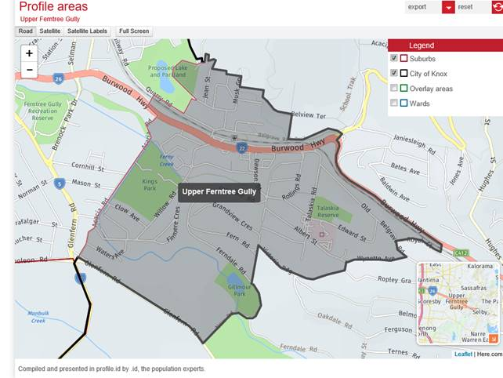

Map 3 DET - VIF SA 2: Ferntree Gully South (Upper Ferntree Gully)

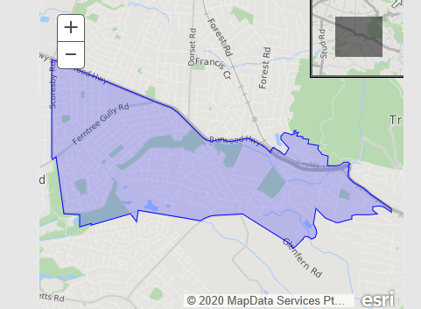

Map 4. DET - VIF SA2: Ferntree Gully North

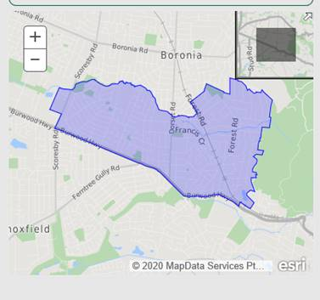

The addition of dwellings to the housing stock is a major driver of population growth in an area which then impacts demand data.

All of UFTG is in the Dandenong Foothills Policy Area, a key objective of which is ‘To ensure development is sympathetic to the significant landscape and environmental qualities of the Dandenong Ranges State and National Parks and National Parks Foothill areas.’  Only half of FTG is within this overlay, so greater residential development is anticipated and reflected in the forecasts. The VIF data used by DET distributes population growth evenly into areas without this application of background local policy or definition of suitable residential development sites. As a result, the VIF figures are basically split evenly between FTG and UFTG.

Forecast land developments and residential infill assumptions that underpin the population id. forecast used by Knox Council for Upper FTG and FTG will also impact the demand data. These are not evenly split between FTG, which has a moderate level of infill (19-23 dwellings per annum) and UFTG, which has a low level of infill (6 dwellings per annum).

Taking in all the above information into consideration, it is recommended that Knox id. data and the below population figures for FTG and Upper FTG are utilised in planning for this area of the municipality.

|  |  |  |  |  |  |  |  |  |
| --- | --- | --- | --- | --- | --- | --- | --- | --- |
| **FTG** | **2022** | **2023** | **2024** | **2025** | **2026** | **2027** | **2028** | **2029** |
| 3YO | 351 | 352 | 355 | 358 | 360 | 362 | 363 | 364 |
| 4YO | 349 | 350 | 354 | 355 | 359 | 360 | 361 | 363 |
|  |  |  |  |  |  |  |  |  |
| **Upper FTG** | **2022** | **2023** | **2024** | **2025** | **2026** | **2027** | **2028** | **2029** |
| 3YO | 37 | 37 | 37 | 36 | 36 | 36 | 36 | 36 |
| 4YO | 35 | 36 | 36 | 36 | 36 | 36 | 36 | 36 |

**Other information about the expansion of early childhood services**

The expansion of Knox City Council’s kindergarten services to include 5 hours of 3-year-old kindergarten for currently approximately 60% of the eligible 3-year-old cohort will be implemented within existing infrastructure from 2022.

The move to two years of 15 hours of universal kindergarten will increase demand on existing local government infrastructure beyond what was previously projected in the capital works program for Council facilities prior to the Governments kindergarten reform. While some expansion, redevelopment and consolidation of Council’s existing infrastructure may be possible, the limited availability and cost of additional land in suburban municipalities like Knox means entirely new developments on new parcels of land are not a viable option for further expansion.

Council has undertaken a review of its existing infrastructure and identified potential projects which could be used to increase capacity for kindergarten service delivery now and into the future, however the potential sites will not always align with the areas of the municipality where demand is highest as identified in the department data.

Council has long standing policy and integrated planning processes in the management of community facilities. Council has key principles to ensure all future community facilities in Knox are designed to support compatible multipurpose, flexible spaces, respond to the surrounding social, natural and built environment, contribute to sustainability outcomes and respect and celebrate the character and identity of local communities.

Should Council determine to enter into a Building Blocks Partnership Agreement with the State Government, the Agreement is designed to provide co-investment in infrastructure over the next 10 years. A review of the KISP should take place no later than 2024.

*\*Note: Knox City Council has reviewed and endorses this document in so far as it is an indicator of future unmet demand as predicted by currently available forecast data and a planning tool for potential future investment by various parties. Council’s endorsement is not, and should not be interpreted as an indication that Council accepts responsibility for meeting that unmet demand; or that Council is capable of, or committed to meeting that demand, through either service provision or infrastructure expansion.*

# Funded kindergarten enrolment estimates between 2021-29 for City of Knox

## 4.1 Purpose

As Three-Year-Old Kindergarten is rolled-out and Victoria’s population grows, demand for both Three and Four-Year-Old Kindergarten places will increase significantly. While additional capacity will be needed to meet this demand, this will vary across the State and over time, due to differences in the capacity of existing services, growth trends and sector composition.

To identify where, when and how many additional kindergarten places are expected over the roll-out in the City of Knox, the Knox City Council and the Department have developed:

1. A summary of the current provision of kindergarten within the LGA (**Section 4.3**).
2. An approach to optimising the utilisation of existing services and infrastructure through ‘change management’ strategies that the Knox City Council and the Department will support to help meet additional demand in the LGA (**Section 4.4**).
3. An estimate of the Three and Four-Year-Old kindergarten places that cannot be met through existing services for the 2021-29 period, taking into account the additional demand that can be accommodated by optimising utilisation of existing services and infrastructure through point 2, above (**Section 4.5**).

Local Government and providers can use these published estimates to inform reform implementation activities such as service planning, kindergarten program expansion, infrastructure investments and Building Blocks funding applications in alignment with future demand over the 10-year roll-out.

## 4.2 Methodology

The estimated Three and Four-Year-Old Kindergarten places used in the following sections have been agreed between the Knox City Council and the Department, and were informed by:

* Estimates developed by the Department which draw on a range of inputs, including population forecasts, current enrolments and results from the Kindergarten Capacity Assessment Program (KCAP), conducted in 2019.
* The estimated capacity of new services that are planned to open in the LGA (Section 2)
* Local knowledge and context provided by the Local Government (Section 3) that explains particular issues and trends in their area.
* The approach to optimising utilisation of existing services in the LGA (Section 4.4), and
* Other sources, such as modelling undertaken by Local Governments and local data.

The KISP measures a service’s capacity to deliver funded kindergarten in terms of the number of children it could enrol in Three and Four-Year-Old Kindergarten. The number of funded kindergarten places is different from a service’s licensed or approved places, which count the number of children permitted to attend the service at any one time under the license. Many services can enrol more children in their funded kindergarten program(s) than they have licensed places for because they can run more than one kindergarten program per week. Kindergarten places are therefore a more accurate measure of service kindergarten capacity than licensed places.

Three-Year-Old Kindergarten places have been presented as 15-hour places so they can be easily compared to Four-Year-Old Kindergarten places. Moreover, when Three-Year-Old Kindergarten is fully rolled-out in 2029, every three-year-old child will have access to 15-hours of kindergarten.

From 2023 all providers will have flexibility to determine how many hours of funded Three-Year-Old Kindergarten they deliver per week, with a minimum of five hours and a maximum of 15-hours funded pro-rata. It is expected that hours offered will vary. Given this variation, **it is important to be aware that during the transition to all three-year-old children receiving 15-hours of funded kindergarten per week in 2029,** **the 15‑hour places presented in this report may represent multiple three-year-old places that individually receive less than 15-hours of kindergarten per week.**

These estimates have been developed at an LGA and community level to show the overall forecast and variation within an area. The KISP defines community at the Statistical Area Level 2, which is medium-sized areas which represent a community that interacts socially and economically, with a population range of 3,000 to 25,000 people, and an average population of about 10,000 people.

## 4.3 Summary of current kindergarten provision

The figures below provide a summary of current kindergarten provision within the LGA and provide relevant context for the estimates of demand for funded kindergarten places included in Section 4.5. The data included in this section are largely drawn from:

* The Kindergarten Capacity Assessment Program (KCAP), collected between June and October 2019.
* The Department’s Kindergarten Information Management System (KIMS), as at 2019.
* The Department’s Quality and Regulatory Division (QARD) monitoring data, as at 2019.
* The National Quality Agenda IT System (NQAITS), as at March 2021.
* The Victorian Child and Adolescent Monitoring System (VCAMS), as at 2018.

Please note that, because these sources were collected at different points, this may result in slightly different totals appearing in the below data.

|  |  |
| --- | --- |
| Number of services by service type (NQAITs, 2021) | |
| Stand-alone kindergartens | 37 |
| Long day care centres | 45 |

|  |  |
| --- | --- |
| Percentage of services by management type, LGA level (NQAITs, 2021) | |
| ***Type*** | ***Percentage*** |
| Local Government | 37% |
| Private not for profit | 20% |
| Private for profit | 40% |
| Other | 4% |

|  |  |
| --- | --- |
| Current kindergarten offering | |
| Four-Year-Old Kindergarten participation rate (VCAMS, 2018): | 90% |
| Number of services that offer a funded kindergarten program (DET, 2019): | 69 |
| Number of services that offer an unfunded Three-Year-Old Kindergarten program (DET, 2019): | 8 |

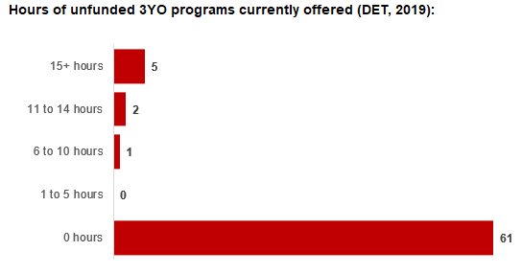

## 4.4 Approach to optimising the use of existing services and infrastructure

**Change management strategies to optimise existing** **services and infrastructure**

Children can often be accommodated through existing spare places and by services ‘unlocking’ unused capacity. As the experience of providers in the 2020 Three-Year-Old Kindergarten roll-out LGAs shows, while the optimisation of existing services can be challenging, it is highly time- and cost-effective compared to building new capacity through infrastructure projects. It also helps target infrastructure investment to the places that need it most and avoids over-supplying the local market.

Knox City Council and the Department will support approaches that maximise kindergarten places through the following change management activities and practices:

* Increasing the capacity of any Local Government operated services by:
  + Running additional programs.
  + Using different timetables, including running 7.5-hour days.
  + Changing the delivery model where it continues to respond to community preference and infrastructure capacity and amenity such as introducing rotational models or mixed-age groups.
  + Having degree-qualified kindergarten teachers leading integrated kindergarten programs in long day care settings.
* Encouraging and supporting other providers and services in the LGA to undertake change management.

The Knox City Council and the Department have estimated how many Three and Four-Year-Old Kindergarten places can be accommodated through existing services in the LGA (**Table 1**). Both parties are committed to helping providers and services offer these kindergarten places before progressing to funded infrastructure solutions to meet demand. This commitment is reflected in the LGA and community level estimates below (**Table 2** onwards), which assume that demand will be met first through existing services and second through additional infrastructure. Note that in some cases the number of kindergarten places that can be offered through existing services may exceed demand for kindergarten places.

**Table 1: Total estimated funded kindergarten places that can be offered by optimising existing services and infrastructure across the LGA, between 2021-29 (presented in 15-hour equivalent places)**

|  |  |  |  |  |  |  |  |  |  |
| --- | --- | --- | --- | --- | --- | --- | --- | --- | --- |
|  | **2021** | **2022** | **2023** | **2024** | **2025** | **2026** | **2027** | **2028** | **2029** |
| Estimated existing supply of kindergarten places* | 4,067 | 4,077 | 4,077 | 4,077 | 4,077 | 4,077 | 4,077 | 4,077 | 4,077 |

*\**This may be higher than current three and four-year-old enrolments as it includes any spare places that are currently available or could be generated by making some minor adjustments to programming approaches.

**The likely expansion of services and kindergarten places in response to population growth (i.e. growth in demand not generated by the Three-Year-Old Kindergarten Reform that would likely occur) is not accounted for in these estimates.

## 4.5 Agreed estimates of demand for funded kindergarten places that cannot be met through existing services and infrastructure

The below estimates (**Table 2** onwards) have been developed by the Knox City Council and the Department to illustrate the estimated:

1. Total number of Three and Four-Year-Old Kindergarten places expected over the roll-out period.
2. Three and Four-Year-Old Kindergarten places that cannot be accommodated by optimising existing services and infrastructure over the roll-out period.

These estimates have been developed to reflect that the increase in demand for Three-Year-Old Kindergarten places will be gradual. The level of estimated demand, and therefore also the level of estimated unmet demand, reflect assumed average participation and weekly hours in Three-Year-Old Kindergarten program. The figures for 2029 reflect estimated and unmet demand at full roll-out, with participation of all three-year-old children in 15 hours per week of Three-Year-Old Kindergarten.

In estimating how many Three and Four-Year-Old Kindergarten places cannot be accommodated by existing services and infrastructure, the Knox City Council and the Department have taken into account any new places that will be made available through planned expansions of existing services or new services, into estimates of existing supply, where this information is available. This may include Local Government owned services being developed and planned Kindergartens on School Sites.

These estimates do not, however, estimate how and when the broader sector will expand to meet the additional demand for kindergarten places that are estimated over the roll-out period.

Infrastructure need in the LGA and its local communities is indicated by the bottom rows of the tables in this section (**Table 2** onwards): ‘Total kindergarten places that cannot be accommodated by existing services’. For example, if the number of kindergarten places for the LGA or a community is above zero in this row, it means that the area is estimated to need additional infrastructure (noting that further optimisation which avoids the need for additional infrastructure may be possible). Any type of provider – Local Government, not-for-profit or for-profit – can build this additional infrastructure. If this row shows all zeros, it means that there is no estimated need for additional infrastructure in the area.

Local Government and not-for-profit kindergarten providers must refer to the estimates in this section when applying through the Building Blocks Capacity Building Grants stream for Government funding. Under this stream, projects must be in a community where there is infrastructure need as shown in the community’s table of estimated demand for kindergarten places (i.e. there are numbers in the bottom row above zero). Projects in LGAs or communities where demand can be met through existing services (i.e. the bottom row shows all zeros) are not eligible for funding under this stream.

**Please note that**

**LGA estimates**

**Table 2: Total estimated three and four-year-old kindergarten places between 2021-29 (presented in 15-hour equivalent places)**

|  |  |  |  |  |  |  |  |  |  |
| --- | --- | --- | --- | --- | --- | --- | --- | --- | --- |
| **LGA level estimates** | **2021** | **2022** | **2023** | **2024** | **2025** | **2026** | **2027** | **2028** | **2029** |
| Total estimated demand for kindergarten places (three and four-year-old children) | 1,892 | 2,456 | 2,689 | 2,924 | 3,124 | 3,460 | 3,652 | 3,843 | 4,090 |
| Total kindergarten places that cannot be accommodated by existing services | 0 | 7 | 10 | 12 | 15 | 19 | 30 | 125 | 359 |

**Community estimates**

**Table 3-14: Total estimated three and four-year-old kindergarten places between 2021-29 (presented in 15-hour equivalent places)**

|  |  |  |  |  |  |  |  |  |  |
| --- | --- | --- | --- | --- | --- | --- | --- | --- | --- |
| **Bayswater estimates** | **2021** | **2022** | **2023** | **2024** | **2025** | **2026** | **2027** | **2028** | **2029** |
| Total estimated demand for kindergarten places (three and four-year-old children) | 96 | 149 | 171 | 194 | 212 | 230 | 230 | 259 | 311 |
| Total kindergarten places that cannot be accommodated by existing services | 0 | 0 | 0 | 0 | 0 | 0 | 0 | 28 | 80 |

|  |  |  |  |  |  |  |  |  |  |
| --- | --- | --- | --- | --- | --- | --- | --- | --- | --- |
| **Boronia estimates** | **2021** | **2022** | **2023** | **2024** | **2025** | **2026** | **2027** | **2028** | **2029** |
| Total estimated demand for kindergarten places (three and four-year-old children) | 278 | 372 | 410 | 449 | 480 | 535 | 562 | 579 | 621 |
| Total kindergarten places that cannot be accommodated by existing services | 0 | 0 | 0 | 0 | 0 | 0 | 0 | 0 | 42 |

|  |  |  |  |  |  |  |  |  |  |
| --- | --- | --- | --- | --- | --- | --- | --- | --- | --- |
| **Ferntree Gully (North) estimates**  **(Please also see Section 3.2 Local Context)\*** | **2021** | **2022** | **2023** | **2024** | **2025** | **2026** | **2027** | **2028** | **2029** |
| Total estimated demand for kindergarten places (three and four-year-old children) | 133 | 189 | 210 | 232 | 250 | 285 | 303 | 316 | 330 |
| Total kindergarten places that cannot be accommodated by existing services | 0 | 0 | 0 | 0 | 0 | 0 | 0 | 0 | 0 |

*The suburb of Ferntree Gully encompasses all of the Ferntree Gully (North) SA2 and most of Fern Tree Gully (South) – Upper Fern Tree Gully SA2. See the Local Context section for further information.

|  |  |  |  |  |  |  |  |  |  |
| --- | --- | --- | --- | --- | --- | --- | --- | --- | --- |
| **Ferntree Gully (South) – Upper Ferntree Gully estimates**  **(Please also see Section 3.2 Local Context)\*** | **2021** | **2022** | **2023** | **2024** | **2025** | **2026** | **2027** | **2028** | **2029** |
| Total estimated demand for kindergarten places (three and four-year-old children) | 149 | 205 | 227 | 251 | 270 | 310 | 335 | 350 | 358 |
| Total kindergarten places that cannot be accommodated by existing services | 0 | 0 | 0 | 0 | 0 | 0 | 0 | 0 | 0 |

*The suburb of Upper Ferntree Gully encompasses only a portion of Ferntree Gully (South) – Upper Fern Tree Gully SA2. See the Local Context section for further information.

|  |  |  |  |  |  |  |  |  |  |
| --- | --- | --- | --- | --- | --- | --- | --- | --- | --- |
| **Knoxfield - Scoresby estimates** | **2021** | **2022** | **2023** | **2024** | **2025** | **2026** | **2027** | **2028** | **2029** |
| Total estimated demand for kindergarten places (three and four-year-old children) | 146 | 210 | 235 | 263 | 286 | 327 | 353 | 374 | 410 |
| Total kindergarten places that cannot be accommodated by existing services | 0 | 0 | 0 | 0 | 0 | 0 | 9 | 30 | 66 |

|  |  |  |  |  |  |  |  |  |  |
| --- | --- | --- | --- | --- | --- | --- | --- | --- | --- |
| **Lysterfield estimates** | **2021** | **2022** | **2023** | **2024** | **2025** | **2026** | **2027** | **2028** | **2029** |
| Total estimated demand for kindergarten places (three and four-year-old children) | 0 | 7 | 10 | 12 | 15 | 19 | 21 | 34 | 66 |
| Total kindergarten places that cannot be accommodated by existing services | 0 | 7 | 10 | 12 | 15 | 19 | 21 | 34 | 66 |

|  |  |  |  |  |  |  |  |  |  |
| --- | --- | --- | --- | --- | --- | --- | --- | --- | --- |
| **Rowville - Central estimates** | **2021** | **2022** | **2023** | **2024** | **2025** | **2026** | **2027** | **2028** | **2029** |
| Total estimated demand for kindergarten places (three and four-year-old children) | 228 | 286 | 310 | 334 | 355 | 400 | 427 | 442 | 436 |
| Total kindergarten places that cannot be accommodated by existing services | 0 | 0 | 0 | 0 | 0 | 0 | 0 | 0 | 0 |

|  |  |  |  |  |  |  |  |  |  |
| --- | --- | --- | --- | --- | --- | --- | --- | --- | --- |
| **Rowville - North estimates** | **2021** | **2022** | **2023** | **2024** | **2025** | **2026** | **2027** | **2028** | **2029** |
| Total estimated demand for kindergarten places (three and four-year-old children) | 119 | 144 | 155 | 165 | 174 | 190 | 199 | 206 | 214 |
| Total kindergarten places that cannot be accommodated by existing services | 0 | 0 | 0 | 0 | 0 | 0 | 0 | 0 | 0 |

|  |  |  |  |  |  |  |  |  |  |
| --- | --- | --- | --- | --- | --- | --- | --- | --- | --- |
| **Rowville - South estimates** | **2021** | **2022** | **2023** | **2024** | **2025** | **2026** | **2027** | **2028** | **2029** |
| Total estimated demand for kindergarten places (three and four-year-old children) | 94 | 123 | 136 | 148 | 160 | 181 | 194 | 203 | 209 |
| Total kindergarten places that cannot be accommodated by existing services | 0 | 0 | 0 | 0 | 0 | 0 | 0 | 0 | 0 |

|  |  |  |  |  |  |  |  |  |  |
| --- | --- | --- | --- | --- | --- | --- | --- | --- | --- |
| **The Basin estimates** | **2021** | **2022** | **2023** | **2024** | **2025** | **2026** | **2027** | **2028** | **2029** |
| Total estimated demand for kindergarten places (three and four-year-old children) | 80 | 97 | 102 | 102 | 102 | 102 | 102 | 107 | 138 |
| Total kindergarten places that cannot be accommodated by existing services | 0 | 0 | 0 | 0 | 0 | 0 | 0 | 5 | 36 |

|  |  |  |  |  |  |  |  |  |  |
| --- | --- | --- | --- | --- | --- | --- | --- | --- | --- |
| **Wantirna estimates** | **2021** | **2022** | **2023** | **2024** | **2025** | **2026** | **2027** | **2028** | **2029** |
| Total estimated demand for kindergarten places (three and four-year-old children) | 219 | 266 | 288 | 311 | 327 | 327 | 327 | 355 | 397 |
| Total kindergarten places that cannot be accommodated by existing services | 0 | 0 | 0 | 0 | 0 | 0 | 0 | 28 | 69 |

|  |  |  |  |  |  |  |  |  |  |
| --- | --- | --- | --- | --- | --- | --- | --- | --- | --- |
| **Wantirna South estimates** | **2021** | **2022** | **2023** | **2024** | **2025** | **2026** | **2027** | **2028** | **2029** |
| Total estimated demand for kindergarten places (three and four-year-old children) | 349 | 406 | 437 | 463 | 493 | 555 | 597 | 618 | 601 |
| Total kindergarten places that cannot be accommodated by existing services | 0 | 0 | 0 | 0 | 0 | 0 | 0 | 0 | 0 |

# Authorisation

The Executive Director of Early Childhood Implementation of the Department of Education and Training and the Chief Executive of Knox City Council endorse this Kindergarten Services and Infrastructure Plan (KISP) for the City of Knox by signing on 27 September 2021.

This KISP is not intended to create legal relations or constitute a legally binding contractual agreement between the parties. The parties may review this KISP in 2024 to publish a new version that will replace the previous version.

Signed for and on behalf and with the authority of Knox City Council

…………………………………… …………………………………

Signature Witness Signature

Name: Bruce Dobson

Title: Chief Executive Officer

Address: 511 Burwood Highway, Wantirna South 3152

Signed by Clayton Sturzaker Area Executive Directorm Outer East Area, NEVR, Department of Education and Training

…………………………………… …………………………………

Signature Witness Signature

Name: Clayton Sturzaker

Title: Area Executive Director, Outer East Area, NEVR

Address: 60-62 Maroondah Highway, Ringwood, Vic, 3134