

Kindergarten Infrastructure and Services Plan

Stonnington City

**CONTENTS**

1. Introduction 3
   1. Reform context 3
   2. Purpose of Kindergarten Infrastructure and Services Plans (KISPs) 3
   3. Structure of the KISP 4
   4. Disclaimer 4
2. Map of Early Childhood Education services in Stonnington City 5
3. Local context 6
   1. Purpose 6
   2. Key considerations 6
4. Unmet demand estimates between 2025 - 2036 for Stonnington City 10
   1. Purpose 10
   2. Methodology 10
   3. Summary of current kindergarten provision 12
   4. Agreed estimates of demand for kindergarten places 12
5. Authorisation 16

© State of Victoria (Department of Education) 2024

Kindergarten Infrastructure and Services Plan Stonnington City is provided under a Creative Commons Attribution 4.0 International licence. You are free to re-use the work under that licence, on the condition that you credit the State of Victoria (Department of Education), indicate if changes were made and comply with the other licence terms, see: [Creative Commons Attribution 4.0 International](https://creativecommons.org/licenses/by/4.0/)

The licence does not apply to:

* any images, photographs, trademarks or branding, including the Victorian Government logo and the DE logo; and
* content supplied by third parties.

# Introduction

## Reform context

The Victorian Government’s $14 billion Best Start, Best Life (BSBL) reforms are the most significant change to Victoria’s early childhood sector in a generation.

The BSBL reforms include:

* + - **Free Kinder:** Free Kinder is now available for Victorian 3- and 4-year-old children at participating services in standalone (sessional) kindergartens and long day care centres – a saving of up to $2,500 per child, every year.
    - **Pre-Prep**: Four-Year-Old Kindergarten will gradually transition to ‘Pre-Prep’ – increasing to a universal 30-hour-a-week program of play-based learning for 4-year-old children in Victoria by 2036.
    - **Three-Year-Old Kindergarten**: the continued roll-out of Three-Year-Old Kindergarten, with programs increasing to 15 hours a week across the state by 2029.
    - **Early learning and childcare centres:** the establishment of 50 Victorian government-owned and operated early learning and childcare centres. These centres will be built in areas with the greatest need and will make it easier for families to access early childhood education and childcare. The first of the centres will open in 2025.

These initiatives demonstrate a clear commitment to improving early learning outcomes for Victorian children, workforce participation and access for families, and present the most significant change to Victoria’s early childhood sector in a generation.

Pre-Prep will roll-out in Stonnington City in 2034. Statewide, Aboriginal and Torres Strait Islander children, children from a refugee or asylum seeker background, and children who have had contact with Child Protection services, will be able to access up to 25 hours of Pre-Prep in 2026, increasing to up to 30 hours from 2028. Children who have (or have a parent or guardian who has) a Commonwealth concession card and children who are a multiple birth child (triplets or more) across the state will be able to access up to 25 hours of Pre-Prep in 2028, increasing to up to 30 hours from 2030.

## Purpose of Kindergarten Infrastructure and Services Plans (KISPs)

New and expanded infrastructure is key to delivering the BSBL reforms and will require a large expansion of kindergarten facilities across the State. KISPs, which are jointly developed with Local Governments, indicate where and when new infrastructure will be required to support both reform implementation and population growth in each of Victoria’s 79 local government areas (LGAs). KISPs help all kindergarten providers meet demand and collectively provide a clear picture of infrastructure need across the State.

KISPs support planning for services and future capital works and include detailed information about:

* + - Current capacity and demand for funded kindergarten
    - Capacity to be delivered for planned infrastructure projects and future demand for kindergarten
    - Forecast ‘unmet demand’ for kindergarten – that is, the kindergarten places needed that cannot be met by current or planned capacity
    - Information specific to each local government area and its early childhood education and care landscape.

KISPs were initially developed to support the roll-out of Three-Year-Old Kindergarten and have now been updated to incorporate Pre-Prep.

KISPs are intended to support planning. They are not funding documents and do not commit any party to addressing the unmet demand identified.

### However, it is expected that future investment requests through Building Blocks and funding decisions about Local Government, not-for-profit projects (including non-government schools) would align with the relevant KISP (including Section 3: Local Context).

## Structure of the KISP

Each KISP consists of the following sections:

* + - **Section 1**: A short introduction to the Best Start, Best Life reform and the KISP.
    - **Section 2**: A map of existing and planned Early Childhood Education and Care services.
    - **Section 3**: Local context and knowledge of key information in Stonnington City relevant to early childhood education.
    - **Section 4**: Unmet demand estimates in Stonnington City over the life of the reform.

## Disclaimer

All data presented in this document is published for information purposes only. Operational and business decisions should not be based solely on this document. Neither the Department nor Stonnington City warrants, guarantees, makes any representation or assumes any duty of care in relation to the data, including as to its suitability, completeness, accuracy or adequacy.

# Map of Early Childhood Education services in Stonnington City

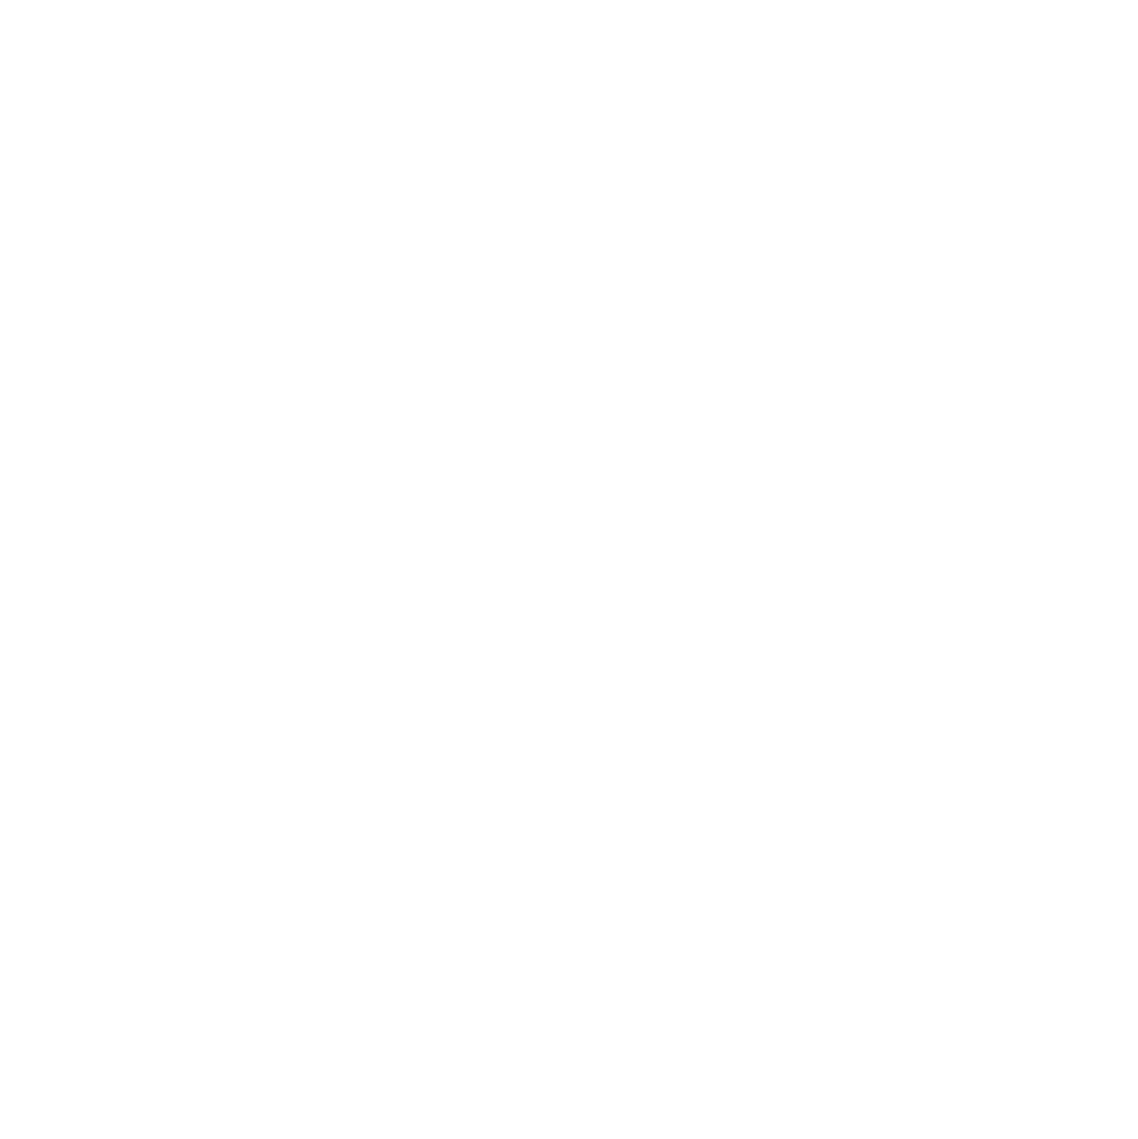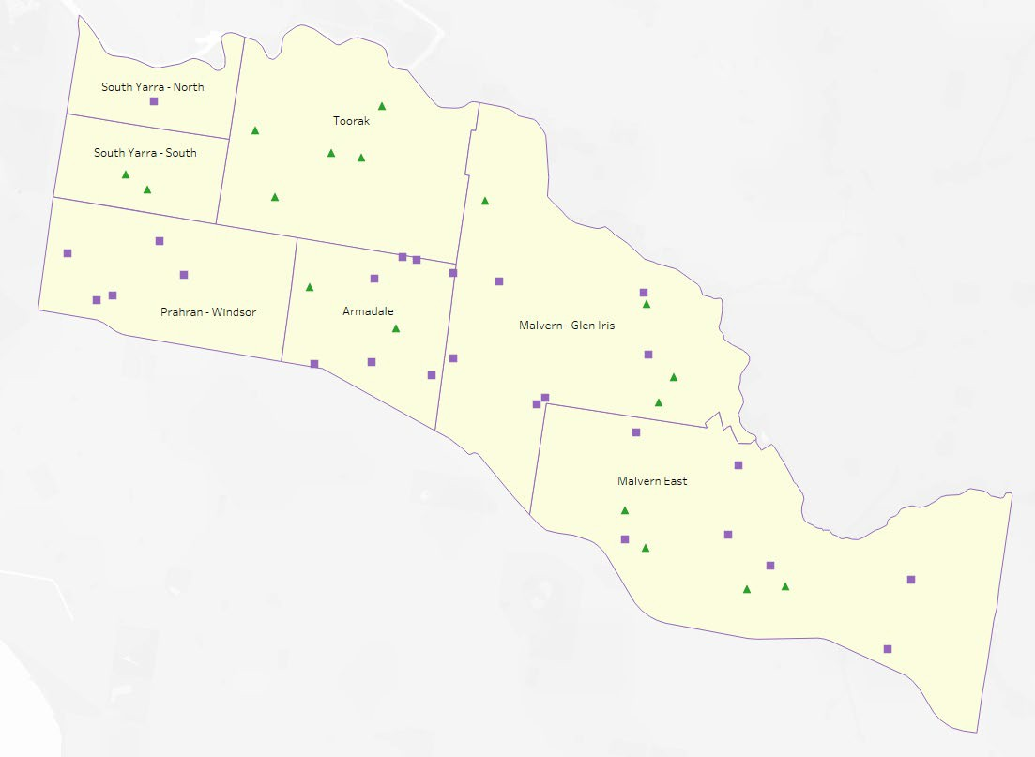

The map below shows the distribution of currently operating and new State-supported services that are planned to open in the future in Stonnington City. Planned services by the private sector are not included.

This map has been prepared using departmental data, from both the National Quality Agenda IT System (NQAITS) and the Victorian School Building Authority (VSBA).

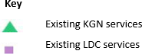

5

# Local context

## Purpose

Local, place-based knowledge and context play an important role in supporting the implementation of the BSBL reforms across Victoria. This section of the KISP documents this knowledge and context and should be considered alongside the kindergarten demand estimates in Section 4.

Information provided as local context may support applications through the Building Blocks Capacity Building and Planning Grants streams.

## Key considerations

### Key demographic trends that influence demand for kindergarten

*Population growth*

The City of Stonnington (CoS) is forecast to continue growing steadily from its current population of 112,000. However, Council’s latest population estimates now forecast a slower rate of growth than before: 7% (an increase of 7,770 people) over the five years to 2030 and 14% (an increase of 15,300 people) over the 11 years to 2036. With continued growth in medium to high density developments expected, ***South Yarra*** will continue to experience the highest population growth, followed by ***Armadale, Malvern East, Prahran*** and ***Toorak****.*

Council’s population forecasts estimate that 3- and 4-year-olds in the City of Stonnington will increase by 17% (+283 children) over the five years to 2030 and by 23% (+388 children) over the 11 years to 2036. The largest five-year increases will occur in ***Prahran*** (+53 children), ***South Yarra*** (+52 children) and ***Toorak*** (+51 children). Between 2025 and 2036 the population of kindergarten age children in the western suburbs of ***South Yarra, Prahran and Windsor*** will grow 32% (from 530 to 700 children).

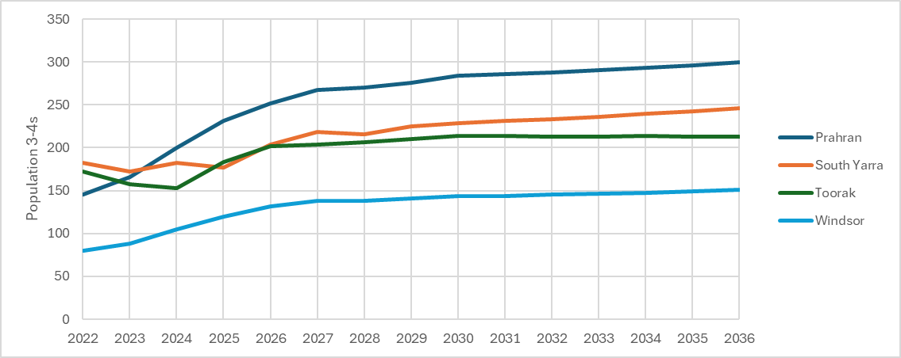

*Relative disadvantage*

Overall, the Stonnington community experiences low levels of disadvantage with a SEIFA (Index of Relative Socio-Economic Disadvantage) score of 1,087. This suggest that most families will have the ability to pay to access early years services. However, this masks the several locations of exceptionally high localised disadvantage, centred around the social housing estates in South Yarra, Prahran and Windsor. Consistent with this, a high proportion of children attending kindergarten on Department of Housing land in South Yarra, received Kindergarten Funding

Support in 2024. These areas will continue to generate more complex family issues, higher order service needs and reduced ability for people to pay. It is also worth noting that although Toorak is regarded as a wealthy suburb, it is also the area with the highest rate of households experiencing mortgage stress.

Financial stresses in these areas mean families are more likely to access stand-alone kindergarten services rather than kindergarten integrated with long daycare.

In addition, COVID-19 led to the closure of some local businesses (particularly in the retail and hospitality sector), increased incidence of family violence and harm from alcohol.

*Higher density living*

Medium and high-density housing is currently most prevalent in ***South Yarra, Prahran*** and ***Windsor***, in particular around the South Yarra and Prahran train stations. This is forecast to continue to be the case, with the majority of new housing in these areas due to be in the form of apartments and townhouses. Given the current forecasts for significant increases in the number of children living in the western suburbs, it will be important to secure sites for new kindergarten services where land values are at a premium.

It is commonly understood that higher density living drives up demand for childcare and influences families' preferences towards both free and paid care options, balancing financial considerations with the need for quality and convenience. As families living in higher density areas often have less outdoor space, kindergarten and childcare services can be particularly attractive as they offer opportunities for play in high-quality outdoor spaces, compensating for the lack of private gardens.

### Projects or trends that may influence supply of early childhood education and care

*Market share and family preferences for sessional kindergarten*

Enrolments for the year 2023 show that almost twice as many children attend sessional kindergarten compared to integrated programs in childcare services. Currently, 63% of three and four-year-old enrolment hours are within sessional services, with the remaining 37% attending integrated programs in childcare or independent schools. The Department of Education LGA Profile 2022 also indicated slight decrease in demand for LDC places. It is possible the changes to longer kindergarten hours being available has impacted the need for families to access long day care places.

The Victorian Department of Education takes a ‘service agnostic' approach to kindergarten, neither favouring nor prioritising whether kindergarten capacity is provided through sessional or integrated programs. This approach is intended to provide families with flexibility in terms of a range of options, accommodating kindergarten programs that suit different family needs and preferences.

The supply-side modelling conducted for this KISP (applying capacity multipliers to total licensed places) calculates that by 2036, of the total enrolment capacity available in existing services and planned pipeline projects, 53% will be in sessional services and 47% integrated through childcare. If future enrolments are actually distributed in this way, it would represent a 10% shift in market share away from funded sessional programs towards paid kindergarten in childcare services. It is not yet possible to determine if this shift is realistic to expect of families. However, such a shift does contrast with Council’s expectations that demand for sessional kindergarten will increase over the coming years as families access more hours of funded education.

*Kindergarten capacity within independent schools*

Currently, 388 licensed places of kindergarten are provided in independent schools, representing 13% of the total supply in Stonnington. Children enrolled at these services typically attend for 5 days per week, which means the schools are unable to offer traditional sessional programs. Accordingly, the supply-side modelling conducted for the KISP has used lower capacity multipliers based on average historical enrolments between 2021 and 2023.

#### Councils Strategic Role

As part of reviewing Council’s role in the early years, it has become clear the retention and growth of the licensed places for long daycare and kindergarten is critical in the western part of Stonnington and this will be a priority for Council, however future demand growth will continue across the municipality with council needed to consider the future of services as the role out of pre-prep continues.

#### Provider

As a provider, Council currently delivers one integrated Kindergarten Program within its facilities.

* Princes Close Early Years - 24 Place Integrated Kindergarten Program
* Winter St Early Years – LDC and Occasional Care

#### Partner

Council maintains a strong relationship with DE’s Early Childhood Improvement Branch - Bayside Peninsula area South-Eastern Victorian Region. Meeting each term to discuss any ongoing issues or challenges across the municipality and how to work together to develop services capacity to meet the reform changes and increases in demand. It is important to note, Council’s capacity to influence change management is primarily limited to the services operating from Council owned buildings.

#### Infrastructure

Council provides and supports a range of Early Years programs 8 of these programs are delivered in Council assets, operated by parent run committees, with a further 2 sites operated by Council. 8 of the council facilities operate a funded kindergarten program. Council is considering how the reforms impact on its assets and service delivery to inform future investment decisions.

A significant issue for Council is aging infrastructure, lack of land and cost of redevelopment on inner city sites. Some if the current council facilities are impacted by heritage overlays, parking/street frontage limitations and land capacity, resulting in many options only allowing for multiple story facilities again increasing the cost with the challenges and requirements of these sites.

When reviewing Councils current infrastructure assessments of some services showed cost and development challenges to likely be prohibitive for some sites, rather the need to look at service models as preferred opportunities to increase supply and only infrastructure on sites with maximum capacity opportunities.

Council will need to determine its ongoing in role in early years and continue to assess the priority areas in relation to retention and growth of licensed places within the municipality.

***Service Closures***

The impact of service closures across the municipality has resulted in an increase to the demand

across the municipality post 2025. Gardiner Preschool, Windsor Community Co-op and South Yarra Preschool have sighted the requirement to close and no longer offer Kindergarten programs due to circumstances beyond their control with landowners. Three other sessional Kindergarten’s lease their premises and maybe at future risk of closure.

The closure of South Yarra Preschool located on the Horace Petty Housing Estate, will impact the roll out of the 2026 priority cohort with children who would fall in this category needing to find future kindergarten services at another site and currently no communication as to if a future Kindergarten will be included in the future redevelopment scheduled for completion in 2034.

#### Central Registration Scheme

The City of Stonnington established a Central registration Scheme in August 2022. The Scheme currently has 5 Services, 2 sessional program’s and 3 integrated kindergarten programs. Council has been working with services across the municipality to adjust timetabling and local area criteria to support the differing requirements of different services, Council will continue to grow the scheme over the coming years. As there are large number of privately operated long daycare services in Stonnington and Independent schools this will impact upon the number of services who are likely to participate in the scheme

### Key local geographic considerations or information relevant to Three-Year-Old Kindergarten and Pre-Prep

A high proportion of children who are not Stonnington residents access kindergarten in the City of Stonnington. This is common in inner and middle ring local government areas where families regularly cross municipal boundaries to access early years services, but it is particularly high in Stonnington with 622 nonresidents attending kindergarten services and only 380 Stonnington residents accessing services outside the municipality *(as per 2023 State Government LGA Profile).* Glen Eira and Boroondara being the highest number of LGA residences outside of Stonnington.

### Other information about the expansion of early childhood services

*Planning Permits*

Council does not currently have any planning application for early years services across the municipality. This reflects the impact of the availability of inner-city land sites.

1. **Unmet demand estimates between 2025**

**- 2036 for Stonnington City**

## Purpose

As the BSBL reforms are rolled out and Victoria’s population grows, demand for kindergarten and Pre-Prep places will increase significantly. While additional capacity will be needed to meet this demand, this will vary across the State and over time, due to differences in the capacity of existing services, growth trends and sector composition.

To identify where, when and how many additional kindergarten places are expected to be required over the roll-out in Stonnington City, Stonnington City and the department have developed:

* + 1. a summary of the current provision of kindergarten within Stonnington City (**Section 4.3**).
    2. an estimate of kindergarten places that cannot be met through existing services for the 2025 - 2036 period, taking into account the additional demand that can be accommodated by optimising utilisation of existing services and infrastructure (**Section 4.4**).

Local governments and providers can use these published estimates to inform reform implementation activities such as service planning, kindergarten program expansion, infrastructure investments and Building Blocks funding applications in alignment with future demand over the roll- out.

## Methodology

The estimated kindergarten places used in the following sections have been agreed between Stonnington City and the department, and were informed by:

* demand projections developed by the department which draw on a range of inputs, including population forecasts and current enrolments
* the estimated capacity of existing and planned services in the LGA (Section 2)
* where applicable, modelling undertaken by Stonnington City and service level information; and
* local knowledge and context provided by the local government (Section 3) that explains particular issues and trends in their area.

### Kindergarten places explainer

The KISP measures a service’s capacity to deliver funded kindergarten in terms of the number of **15-hour places** (referred to as “kindergarten places”) available for Three-Year-Old kindergarten and Pre-Prep (noting that, by 2036, two kindergarten places will be required for one Pre-Prep enrolment). The number of kindergarten places is different from a service’s licensed or approved places, which count the number of children permitted to attend the service at any one time under the license. Many services can enrol more children in their funded kindergarten program(s) than they have licensed places for because they can run more than one kindergarten program per week. Kindergarten places are therefore a more accurate measure of service kindergarten capacity than licensed places.

Kindergarten places have been presented as 15-hour places so that new Three-Year-Old Kindergarten places and the additional 15-hour places required for Pre-Prep can be easily compared to existing 15-hour Four-Year-Old Kindergarten places. This is because, when Three-Year-Old Kindergarten is fully rolled out in 2029, three-year-old children will have access to 15-hours of kindergarten. When Pre-Prep is fully rolled out in 2036, four-year-old children will have access to up to 30-hours of kindergarten, an increase of the current offering of 15-hours per week.

It is important to note that enrolments are not equivalent to 15-hour places. One 15-hour place can support a total of 15 hours of delivery per week split between one or more children, including but not limited to the following examples:

|  |  |  |
| --- | --- | --- |
| One 15-hour place (15 hours of delivery) | | |
| Example 1 | 1 child | 1 x 3YO attending 15 hours per week |
| Example 2 | 1 child | 1 x 4YO attending 15 hours per week |
| Example 3 | 2  children | 2 x 3YOs attending 7.5 hours per week |
| Example 4 | 3  children | 3 x 3YOs attending 5 hours per week |

Two 15-hour places can support a total of 30 hours of delivery per week split between one or more children, including but not limited to the following examples:

|  |  |  |
| --- | --- | --- |
| Two 15-hour places (30 hours of delivery) | | |
| Example 1 | 1 child | 1 x 4YO attending 30 hours per week |
| Example 2 | 2  children | 2 x 3YOs attending 15 hours per week |
| Example 3 | 2  children | 1 x 3YO, and  1 x 4YO both attending 15 hours per week |
| Example 4 | 3  children | 2 x 3YOs attending 7.5 hours per week, and 1 x 4YO attending 15 hours per week |

### Geographic boundaries used in the KISP

These estimates have been developed at an LGA and community level to show the overall forecast and variation within an area. The KISP defines community at the Statistical Area Level 2 (SA2), which is a medium-sized area which represents a community that interacts socially and economically, with an approximate population range of 3,000 to 25,000 people, and an average population of about 10,000 people. The KISP uses 2021 SA2 boundaries. More information is available at the [Australian Bureau of Statistics website](https://www.abs.gov.au/statistics/standards/australian-statistical-geography-standard-asgs-edition-3/jul2021-jun2026/main-structure-and-greater-capital-city-statistical-areas/statistical-area-level-2).

### Supply contributed by pipeline projects

Stonnington City and the department have added any new places that will be made available through planned expansions of existing services or new services into estimates of existing supply, where this

information is available. This may include projects being delivered by not-for-profit providers (including non-government schools) with support from the Victorian Government, planned Kindergartens on School Sites, and government-owned and operated early learning and childcare centres.

The KISP does not estimate how and when the broader sector will expand to meet the additional demand for kindergarten places that are estimated over the roll-out period.

## Summary of current kindergarten provision

The figures below provide a summary of current kindergarten provision within the LGA and provide relevant context for the estimates of demand for funded kindergarten places included in Section 4.5. The data included in this section are largely drawn from:

* the department’s Kindergarten Information Management System (KIMS), as at 2023.
* the National Quality Agenda IT System (NQAITS), as at February 2025.

|  |  |
| --- | --- |
| Number of services by service type (NQAITS) | |
| Stand-alone kindergartens | 39% |
| Long day care centres (including services not currently delivering funded kindergarten) | 61% |

|  |  |
| --- | --- |
| Percentage of services by management type, LGA level (NQAITS) | |
| ***Type*** | ***Percentage*** |
| Local Government | 5% |
| Private not for profit | 45% |
| Private for profit | 34% |
| Other | 16% |

|  |  |
| --- | --- |
| Current kindergarten offering in Stonnington City | |
| Three-Year-Old Kindergarten participation rate (KIMS): | 93% |
| Four-Year-Old Kindergarten participation rate (KIMS): | 98% |
| Number of services that offer a funded kindergarten program (KIMS): | 38 |

## Agreed estimates of demand for kindergarten places

The below estimates (**Table 1** onwards) have been developed by Stonnington City and the department to illustrate the estimated:

* + 1. Demand – the total number of kindergarten places expected to be required over the roll-out period to support the current provision of Four-Year-Old Kindergarten, the BSBL reforms, and population growth
    2. Supply – the total number of kindergarten places that can be accommodated by existing services and infrastructure, and planned, State-supported services which are yet to open.
    3. Unmet demand – kindergarten places that cannot be accommodated by optimising existing services and infrastructure (i.e. the shortfall between demand and supply).

### Interpreting the estimates

Infrastructure need in the LGA and its local communities is indicated by the bottom rows of the tables in this section (**Table 1** onwards): *Unmet demand*. If the number of kindergarten places in this row is above zero, it means that the area is estimated to need additional infrastructure capacity. Any type of provider – local government, not-for-profit (including non-government schools) or for-profit – can build this additional infrastructure.

Sub-SA2 factors may need to be considered to give a holistic picture of unmet demand. For example, in rural communities, one SA2 may contain several small towns, some with excess supply and some with unmet demand. At the SA2-level, demand may appear to be met because all supply and demand is considered in aggregate; however, it is not feasible to for families to drive long distances to access kindergarten capacity in another town. Sub-SA2 factors are covered in **Section 3: Local context**.

### Table 1: Estimated kindergarten places required between 2025 - 2036 in Stonnington City

|  |  |  |  |  |  |  |  |  |  |  |  |  |
| --- | --- | --- | --- | --- | --- | --- | --- | --- | --- | --- | --- | --- |
| **Stonnington City estimates** | **2025** | **2026** | **2027** | **2028** | **2029** | **2030** | **2031** | **2032** | **2033** | **2034** | **2035** | **2036** |
| Demand for kindergarten places | 1,622 | 1,753 | 1,847 | 1,918 | 1,964 | 2,002 | 2,029 | 2,059 | 2,094 | 2,372 | 2,657 | 3,115 |
| Unmet demand | 74 | 101 | 122 | 134 | 147 | 159 | 170 | 192 | 218 | 377 | 543 | 826 |

### Community estimates

### Table 2-A: Estimated kindergarten places required between 2025 - 2036 in Armadale

|  |  |  |  |  |  |  |  |  |  |  |  |  |
| --- | --- | --- | --- | --- | --- | --- | --- | --- | --- | --- | --- | --- |
| **Armadale estimates** | **2025** | **2026** | **2027** | **2028** | **2029** | **2030** | **2031** | **2032** | **2033** | **2034** | **2035** | **2036** |
| Demand for  kindergarten | 320 | 322 | 329 | 340 | 344 | 349 | 353 | 357 | 360 | 387 | 416 | 461 |
| Kindergarten supply | 499 | 504 | 504 | 506 | 506 | 507 | 507 | 507 | 507 | 507 | 507 | 507 |
| Unmet demand | 0 | 0 | 0 | 0 | 0 | 0 | 0 | 0 | 0 | 0 | 0 | 0 |

### Table 2-B: Estimated kindergarten places required between 2025 - 2036 in Malvern – Glen Iris

|  |  |  |  |  |  |  |  |  |  |  |  |  |
| --- | --- | --- | --- | --- | --- | --- | --- | --- | --- | --- | --- | --- |
| **Malvern - Glen Iris estimates** | **2025** | **2026** | **2027** | **2028** | **2029** | **2030** | **2031** | **2032** | **2033** | **2034** | **2035** | **2036** |
| Demand for kindergarten | 294 | 322 | 347 | 366 | 378 | 388 | 396 | 403 | 412 | 479 | 546 | 658 |
| Kindergarten supply | 389 | 392 | 392 | 393 | 393 | 394 | 394 | 394 | 394 | 394 | 394 | 394 |
| Unmet demand | 0 | 0 | 0 | 0 | 0 | 0 | 2 | 9 | 18 | 85 | 152 | 264 |

### Table 2-C: Estimated kindergarten places required between 2025 - 2036 in Malvern East

|  |  |  |  |  |  |  |  |  |  |  |  |  |
| --- | --- | --- | --- | --- | --- | --- | --- | --- | --- | --- | --- | --- |
| **Malvern**  **East estimates** | **2025** | **2026** | **2027** | **2028** | **2029** | **2030** | **2031** | **2032** | **2033** | **2034** | **2035** | **2036** |
| Demand for kindergarten | 401 | 429 | 450 | 470 | 481 | 490 | 496 | 500 | 507 | 576 | 644 | 763 |
| Kindergarten supply | 726 | 732 | 732 | 734 | 734 | 735 | 735 | 735 | 735 | 735 | 735 | 735 |
| Unmet demand | 0 | 0 | 0 | 0 | 0 | 0 | 0 | 0 | 0 | 0 | 0 | 28 |

### Table 2-D: Estimated kindergarten places required between 2025 - 2036 in Prahran – Windsor

|  |  |  |  |  |  |  |  |  |  |  |  |  |
| --- | --- | --- | --- | --- | --- | --- | --- | --- | --- | --- | --- | --- |
| **Prahran - Windsor estimates** | **2025** | **2026** | **2027** | **2028** | **2029** | **2030** | **2031** | **2032** | **2033** | **2034** | **2035** | **2036** |
| Demand for kindergarten | 200 | 228 | 249 | 259 | 270 | 279 | 285 | 294 | 303 | 356 | 411 | 495 |
| Kindergarten supply | 125 | 127 | 127 | 128 | 128 | 128 | 128 | 128 | 128 | 128 | 128 | 128 |
| Unmet demand | 74 | 101 | 121 | 131 | 142 | 151 | 157 | 166 | 175 | 228 | 283 | 367 |

### Table 2-E: Estimated kindergarten places required between 2025 - 2036 in South Yarra - North

|  |  |  |  |  |  |  |  |  |  |  |  |  |
| --- | --- | --- | --- | --- | --- | --- | --- | --- | --- | --- | --- | --- |
| **South Yarra**  **- North estimates** | **2025** | **2026** | **2027** | **2028** | **2029** | **2030** | **2031** | **2032** | **2033** | **2034** | **2035** | **2036** |
| Demand for kindergarten | 71 | 84 | 91 | 93 | 95 | 97 | 100 | 104 | 110 | 130 | 152 | 180 |
| Kindergarten supply | 89 | 90 | 90 | 90 | 90 | 90 | 90 | 90 | 90 | 90 | 90 | 90 |
| Unmet demand | 0 | 0 | 1 | 3 | 5 | 7 | 9 | 14 | 20 | 40 | 62 | 90 |

### Table 2-F: Estimated kindergarten places required between 2025 - 2036 in South Yarra - South

|  |  |  |  |  |  |  |  |  |  |  |  |  |
| --- | --- | --- | --- | --- | --- | --- | --- | --- | --- | --- | --- | --- |
| **South Yarra**  **- South estimates** | **2025** | **2026** | **2027** | **2028** | **2029** | **2030** | **2031** | **2032** | **2033** | **2034** | **2035** | **2036** |
| Demand for kindergarten | 94 | 107 | 117 | 121 | 125 | 127 | 128 | 129 | 131 | 151 | 172 | 203 |
| Kindergarten supply | 126 | 126 | 126 | 126 | 126 | 126 | 126 | 126 | 126 | 126 | 126 | 126 |
| Unmet demand | 0 | 0 | 0 | 0 | 0 | 1 | 2 | 3 | 5 | 25 | 46 | 77 |

### Table 2-G: Estimated kindergarten places required between 2025 - 2036 in Toorak

|  |  |  |  |  |  |  |  |  |  |  |  |  |
| --- | --- | --- | --- | --- | --- | --- | --- | --- | --- | --- | --- | --- |
| **Toorak estimates** | **2025** | **2026** | **2027** | **2028** | **2029** | **2030** | **2031** | **2032** | **2033** | **2034** | **2035** | **2036** |
| Demand for kindergarten | 243 | 260 | 265 | 269 | 270 | 272 | 271 | 271 | 271 | 293 | 316 | 355 |
| Kindergarten supply | 387 | 387 | 387 | 387 | 387 | 387 | 387 | 387 | 387 | 387 | 387 | 387 |
| Unmet demand | 0 | 0 | 0 | 0 | 0 | 0 | 0 | 0 | 0 | 0 | 0 | 0 |

# Authorisation

The Michael Devine A/Area Executive Director, Bayside Peninsula of the Department of Education and Dale Dickson Chief Executive Officer of Stonnington City endorse this Kindergarten Infrastructure and Services Plan (KISP) for Stonnington City Council by signing on

This KISP is not intended to create legal relations or constitute a legally binding contractual agreement between the parties. The parties may review this KISP in 2028 to publish a new version that will replace the previous version.

Signed for and on behalf and with the authority of Stonnington City Council.

……………………………………

Signature

Name: … ……………......................................

Title:…………................

Signed for and on behalf and with the authority of the Department of Education

…………………………………… Signature

Name: …