Kindergarten Infrastructure and Services Plan

Knox City

**CONTENTS**

1. Introduction 3

1.1. Reform context 3

1.2. Purpose of Kindergarten Infrastructure and Services Plans (KISPs) 3

1.3. Structure of the KISP 4

1.4. Disclaimer 4

2. Map of Early Childhood Education services in Knox City 5

3. Local context 6

3.1 Purpose 6

3.2 Key considerations 6

4. Unmet demand estimates between 2025 - 2036 for Knox City 13

4.1 Purpose 13

4.2 Methodology 13

4.3 Summary of current kindergarten provision 15

4.4 Agreed estimates of demand for kindergarten places 15

5. Authorisation 20

# Introduction

## Reform context

The Victorian Government’s $14 billion Best Start, Best Life (BSBL) reforms are the most significant change to Victoria’s early childhood sector in a generation.

The BSBL reforms include:

* **Free Kinder:** Free Kinder is now available for Victorian 3- and 4-year-old children at participating services in standalone (sessional) kindergartens and long day care centres – a saving of up to $2,500 per child, every year.
* **Pre-Prep**: Four-Year-Old Kindergarten will gradually transition to ‘Pre-Prep’ – increasing to a universal 30-hour-a-week program of play-based learning for 4-year-old children in Victoria by 2036.
* **Three-Year-Old Kindergarten**: the continued roll-out of Three-Year-Old Kindergarten, with programs increasing to 15 hours a week across the state by 2029.
* **Early learning and childcare centres:** the establishment of 50 Victorian government-owned and operated early learning and childcare centres. These centres will be built in areas with the greatest need and will make it easier for families to access early childhood education and childcare. The first of the centres will open in 2025.

These initiatives demonstrate a clear commitment to improving early learning outcomes for Victorian children, workforce participation and access for families, and present the most significant change to Victoria’s early childhood sector in a generation.

Pre-Prep will roll-out in Knox City in 2034. Statewide, Aboriginal and Torres Strait Islander children, children from a refugee or asylum seeker background, and children who have had contact with Child Protection services, will be able to access up to 25 hours of Pre-Prep in 2026, increasing to up to 30 hours from 2028. Children who have (or have a parent or guardian who has) a Commonwealth concession card and children who are a multiple birth child (triplets or more) across the state will be able to access up to 25 hours of Pre-Prep in 2028, increasing to up to 30 hours from 2030.

## Purpose of Kindergarten Infrastructure and Services Plans (KISPs)

New and expanded infrastructure is key to delivering the BSBL reforms and will require a large expansion of kindergarten facilities across the State. KISPs, which are jointly developed with Local Governments, indicate where and when new infrastructure will be required to support both reform implementation and population growth in each of Victoria’s 79 local government areas (LGAs). KISPs help all kindergarten providers meet demand and collectively provide a clear picture of infrastructure need across the State.

KISPs support planning for services and future capital works and include detailed information about:

* Current capacity and demand for funded kindergarten
* Capacity to be delivered for planned infrastructure projects and future demand for kindergarten
* Forecast ‘unmet demand’ for kindergarten – that is, the kindergarten places needed that cannot be met by current or planned capacity
* Information specific to each local government area and its early childhood education and care landscape.

KISPs were initially developed to support the roll-out of Three-Year-Old Kindergarten and have now been updated to incorporate Pre-Prep.

KISPs are intended to support planning. They are not funding documents and do not commit any party to addressing the unmet demand identified.

**However, it is expected that future investment requests through Building Blocks and funding decisions about Local Government, not-for-profit projects (including non-government schools) would align with the relevant KISP (including Section 3: Local Context).**

## Structure of the KISP

Each KISP consists of the following sections:

* **Section 1**: A short introduction to the Best Start, Best Life reform and the KISP.
* **Section 2**: A map of existing and planned Early Childhood Education and Care services.
* **Section 3**: Local context and knowledge of key information in Knox City relevant to early childhood education.
* **Section 4**: Unmet demand estimates in Knox City over the life of the reform.

## Disclaimer

All data presented in this document is published for information purposes only. Operational and business decisions should not be based solely on this document. Neither the Department nor Knox City Council warrants, guarantees, makes any representation or assumes any duty of care in relation to the data, including as to its suitability, completeness, accuracy or adequacy.

# Map of Early Childhood Education services in Knox City

The map below shows the distribution of currently operating and new State-supported services that are planned to open in the future in Knox City. Planned services by the private sector are not included.

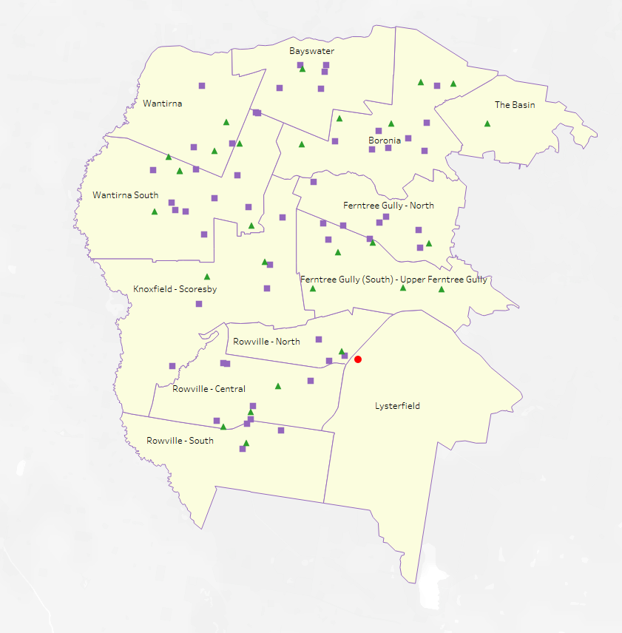This map has been prepared using departmental data, from both the National Quality Agenda IT System (NQAITS) and the Victorian School Building Authority (VSBA).

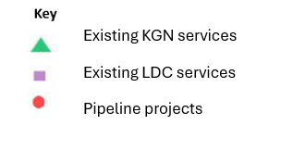

# Local context

d

## 3.1 Purpose

Local, place-based knowledge and context play an important role in supporting the implementation of the BSBL reforms across Victoria. This section of the KISP documents this knowledge and context and should be considered alongside the kindergarten demand estimates in Section 4.

Information provided as local context may support applications through the Building Blocks Capacity Building and Planning Grants streams.

## 3.2 Key considerations

The City of Knox is a suburban municipality located in Melbourne’s outer east, approximately 20 to 25 kilometres from the Central Business District. It is bordered by the City of Maroondah to the north, Yarra Ranges Council to the east, the City of Casey to the south, and the Cities of Monash, Whitehorse, and Greater Dandenong to the west. The municipality encompasses the suburbs of Bayswater, The Basin, Ferntree Gully, Upper Ferntree Gully, Lysterfield, Rowville (Central, North, and South), Scoresby, Knoxfield, Wantirna, and Wantirna South.

As part of Melbourne’s established eastern metropolitan region, Knox is characterised by a diverse urban landscape that includes residential areas, commercial centres, industrial precincts, and extensive green spaces. This mix of land uses contributes to the municipality’s distinctive identity and its role within the broader metropolitan area. The community’s strong attachment to the area’s leafy, green character also shapes local expectations around liveability, amenity, and urban development.

Knox City Council is committed to ensuring that every child has the opportunity to thrive by supporting access to high-quality kindergarten and early years services. This commitment is reflected in the various roles Council plays across the early years system:

* Direct service provision through its Children and Family Centres in Wantirna and Bayswater.
* Infrastructure ownership, the provision of current facilities for community-managed and not-for-profit early years providers.
* Strategic municipal planning and advocacy, embedding early years needs in local policy and development processes.
* Administration of the Central Registration Scheme (CRS), coordinating registrations across participating kindergarten services in the municipality.

**Kindergarten Service Landscape: A Mixed Model with Strategic Council Support**

There are currently 81 early years education and care services operating in the City of Knox, including 24 standalone kindergartens, 4 kindergarten programs delivered within schools, and 53 long day care (LDC) services with integrated kindergarten programs.

The standalone kindergarten sector is predominantly managed by not-for-profit providers, comprising 7 community-managed services, 17 services operated by other not-for-profit organisations under Early Years Management (EYM) arrangements. Funded sessional kindergarten is also delivered through 2 independent schools, 2 government schools, and two Council-managed long day care centres.

The long day care (LDC) sector in Knox is primarily composed of 40 privately operated for-profit centres, along with 10 privately operated not-for-profit centres managed by other organisations. In addition, there is 1 community-managed not-for-profit centre and 2 Council-managed centres, reflecting a mix of governance models within the integrated kindergarten service landscape.

The Council-managed services refers to Knox City Council’s Early Years Hubs, where they provide both sessional and integrated kindergarten alongside the long day care programs, offering a comprehensive model of early years education and care. Other early years integrated support services for children and families, including, Maternal Child Health, facilitated Playgroups and Allied Health services such as physiotherapy, occupational therapy, and counselling.

The kindergarten landscape in Knox reflects a strong presence of not-for-profit provision in standalone sessional kindergartens, while the LDC sector plays an increasingly important role in delivering funded kindergarten as part of a mixed delivery model. Knox City Council has shifted its focus from direct service delivery to enabling early years services through infrastructure, planning, and partnerships, retaining only two Council-managed services within its Early Years Hubs.

**Key local geographic considerations or information relevant to Three-Year-Old Kindergarten and Pre-Prep**

*Understanding the Difference Between Suburbs and SA2s*

Suburb boundaries and SA2 boundaries do not always align, and this can sometimes lead to confusion when interpreting spatial data. Suburbs are defined by local government for addressing and community identity purposes, whereas SA2s (Statistical Areas Level 2) are geographic units defined by the Australian Bureau of Statistics (ABS).

SA2s often include multiple suburbs or parts of suburbs within a single boundary. For example, the Ferntree Gully (South) – Upper Ferntree Gully SA2 includes the entire suburb of Upper Ferntree Gully as well as the southern part of Ferntree Gully. Similarly, Knoxfield and Scoresby are grouped into a single SA2, while Rowville is divided across three different SA2s: Rowville - North, Rowville - Central, and Rowville - South.

This kind of misalignment means that data reported at the SA2 level may not correspond neatly with residents’ understanding of their local suburb, which is important to keep in mind when analysing or presenting geographically based information.

Figure 1. Comparison of Suburb Boundaries and Statistical Area Level 2 (SA2) Boundaries in the City of Knox

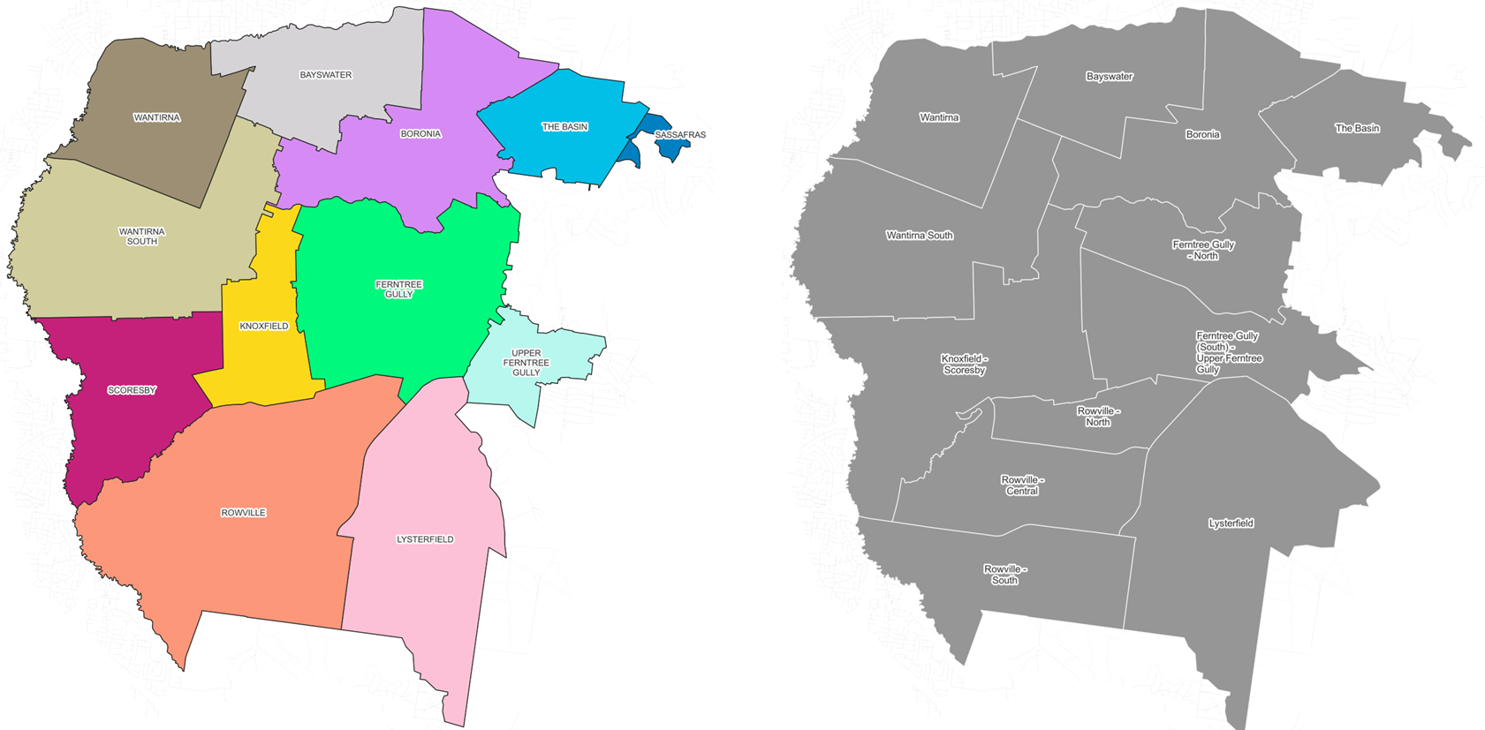

*Understanding Demand Through a Local Lens*

Children in Knox do not necessarily attend kindergarten in the same suburb where they live. According to central enrolment 2025 data[1], only 60% of children enrolled in kindergartens across the municipality reside in the same suburb as the service they attend. The tendency for children to attend kindergarten outside their suburb of residence has remained relatively stable over the last four years. In some suburbs, this proportion is significantly lower—for example, only 42% of children attending kindergartens in Wantirna South and 43% in Scoresby live locally. Conversely, areas like Ferntree Gully and Rowville show higher rates of local attendance (75% and 67% respectively). These figures highlight the variation in service catchments across Knox and reinforce the need to consider cross-suburb enrolment patterns in early years planning. Families often choose services based on availability, proximity to work, or perceived quality, rather than strictly on suburb of residence.

Figure 2. Kindergarten enrolments form within and outside each suburb (2025).

To better reflect how families access services in their local area, Council adopted Local Community Areas (LCAs) as part of its kindergarten priority allocation criteria since 2018. This place-based approach recognises that families often prefer to use early years services embedded in familiar community networks.

LCAs are informed by Maternal and Child Health (MCH) catchment boundaries and are reviewed regularly to reflect changes in birth patterns, local transport access, and walkability. From the moment a child is born, families are connected to local services through the MCH system—starting with birth notifications, followed by nurse key age and stage visits, regular health and development checks, and access to parent groups. These early connections often form the foundation of a family’s support network and influence how they engage with community playgroups and services, and eventually transition to kindergarten and primary school.

Because families within the same LCA are more likely to have shared experiences and established social ties, this approach supports continuity of care and helps strengthen social cohesion across the early years system.

Unlike statistical geographies such as SA2s—which are suburb-scale areas used by the ABS for population data—LCAs are shaped by real-life patterns of service use and social interaction. LCA’s can cross SA2 boundaries or span multiple suburbs, offering a more flexible and context-sensitive tool for planning and resource allocation.

Figure 3. Local Community Areas and SA2 Boundaries in the City of Knox

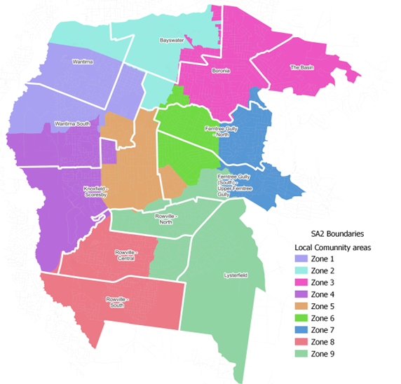

For example, while the SA2 of The Basin may appear to have unmet kindergarten demand in section 4.4, this does not necessarily reflect a shortage of kindergarten access as children who reside in The Basin travel out of the SA2 to receive their kindergarten. The only kindergarten in The Basin currently operates at approximately 90% utilisation, meaning that 90% of its available funded places are filled by enrolled children. Around 5% of these enrolments are from families residing in neighbouring local government areas. Additionally, kindergartens in Boronia, which is part of the same LCA Zone 3 as The Basin, however outside of the SA2 of The Basin, are often more accessible for local families, particularly given the location of The Basin Kindergarten on the suburb’s outer edge.

It is important to note that KISP data identifies areas of unmet demand but does not capture surplus capacity in nearby locations.

**Trends that may influence supply of early childhood education and care**

*Kindergarten Enrolment Trends in Knox*

Historically, the Knox community has demonstrated a strong preference for sessional kindergarten programs, particularly for 4-year-old children. Sessional services—typically provided by standalone kindergartens—have long been valued by local families for their educational quality, community orientation, and strong connections to neighbourhood identity. Consultations and ongoing feedback continue to affirm the high regard in which these services are held.

However, over the past decade, the proportion of kindergarten enrolments in sessional settings has steadily declined, as more families opt for integrated kindergarten programs delivered within Long Day Care (LDC) services. These shifts reflect changes both in demand and in the structure of service provision. While sessional kindergartens continue to play a vital role, LDC settings offer extended hours and greater flexibility—features that increasingly appeal to working families navigating complex routines and care arrangements.

In 2016, 79% of children enrolled in a funded kindergarten program in Knox were attending sessional services. By 2021, this figure had dropped to 62%, and by 2023 it had fallen further to 51%. Disaggregated by age group, 60% of 4-year-olds were still enrolled in sessional kindergarten in 2023, compared to just 42% of 3-year-olds.

This age-based difference reflects the staged rollout of funded kindergarten for 3-year-olds, which reached the full 15-hour entitlement in 2023 In line with this, enrolment in sessional kindergarten for 3-year-olds has steadily increased—from 35% in 2021 to 40% in 2022, and 42% in 2023—indicating growing awareness and uptake among families as the reforms continue to embed and expand. As awareness increases and access stabilises, it is reasonable to expect that enrolments for 3-year-olds in sessional settings could approach levels similar to those of 4-year-olds, particularly if sessional services remain responsive to family needs.

Despite the decline in proportional enrolment, sessional services have consistently operated at around 60% utilisation, indicating that the shift is driven more by changing preferences and expanded LDC options than by capacity constraints. Since 2023, efforts to improve viability and efficiency have included reducing the number of sessional groups, capping enrolment numbers, and, in some cases, closing under-utilised programs to consolidate service delivery and ensure the viability of services.

*Aging Facilities and Future Supply Challenges*

Much of Knox City Council’s early years infrastructure is aging, with the majority of facilities built 50 to 70 years ago. Most are single-room buildings originally designed for 4-year-old kindergarten programs. As these facilities approach the end of their functional life, some of them might require replacement or upgrades in the medium to long term. This is necessary not only to maintain existing supply, but to ensure facilities are fit-for-purpose under the expanded requirements of the Best Start, Best Life reforms—particularly the inclusion of 3-year-old kindergarten.

While many of these facilities are not located in areas identified as experiencing high population growth or demand, their renewal might be required to maintaining equitable access across the municipality. Without targeted investment, supply could fall below the level required to accommodate all eligible children. These buildings also require reconfiguration to meet contemporary service standards, including adequate staff rooms, accessible toilets, change facilities, and indoor/outdoor learning spaces.

Future disruptions to supply caused by deteriorating infrastructure should be considered in all planning, funding, and prioritisation decisions. Maintaining consistent, quality access across Knox will require both ongoing maintenance and, in some cases, transformation of existing sites.

**Key demographic trends that influence demand for kindergarten**

The number of children born in Knox each year helps us understand how many families may need early years services in the future. When tracing birth notifications over the last 10 years, a clear trend becomes evident. After peaking in 2016, birth numbers remained relatively stable between 2017 and 2019, hovering around 1,690 births per year. From 2020 onwards, however, a steady decline has taken place, with 2024 recording just over 1,370 births—the lowest figure of the decade. While the reasons behind this decline are likely varied, the trend points to a shrinking birth cohort, highlighting the importance of ongoing monitoring to ensure early years services remain responsive to the changing needs of local families.

This decline also has implications for population forecasts, as estimates of 3- and 4-year-old populations based on recent birth data— whether through linear projection or by holding 2024 levels constant beyond 2025—begin to diverge from the population forecast. This divergence suggests that the population forecasts anticipate a level of growth that would require either a rebound in birth numbers or increased internal migration, neither of which has been observed in recent trends. As a result, 3- and 4-year-old projections may overstate the number of children in early childhood cohorts if current birth and migration patterns persist. This mismatch underscores the importance of grounding local planning in up-to-date birth trends to ensure early years infrastructure and services remain appropriately scaled and targeted.

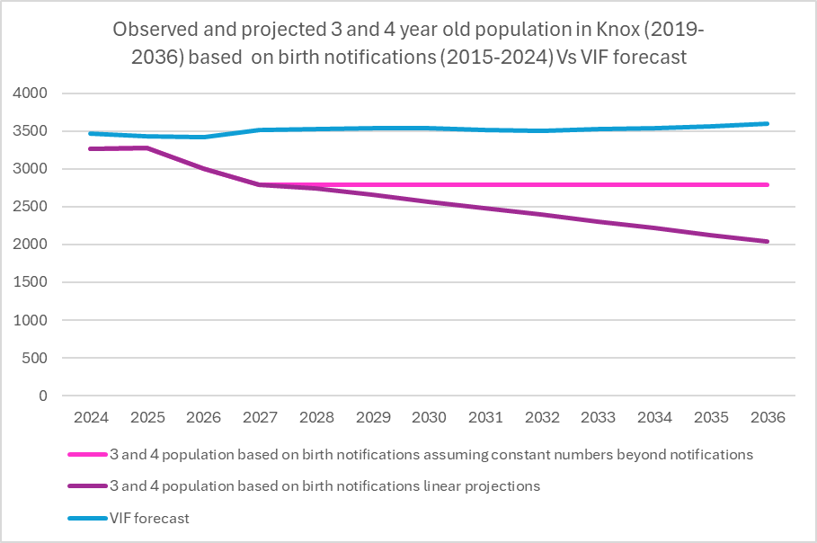

*Patterns internal migration post COVID in Knox*

Following the COVID-19 pandemic, the City of Knox has experienced notable shifts in internal migration. Between July 2021 and June 2023, Knox recorded a net gain of 867 residents from the City of Monash, suggesting increased movement from inner and middle-ring suburbs. At the same time, Knox experienced a net loss of 1,204 residents to the City of Casey, reflecting broader regional trends of outward movement to more affordable, outer suburban areas (.id community profile – Knox).

*Targeted Social Housing*

Looking further ahead, however, significant population growth is anticipated as part of Victoria’s broader housing strategy. The City of Knox has been allocated a target of approximately 43,000 new social and affordable housing dwellings by 2051. This represents a substantial increase in housing stock—far beyond what is projected under current growth scenarios—and would reshape the municipality’s demographic and spatial profile. The scale and timing of this housing rollout extends beyond the 2036 implementation horizon of the Best Start, Best Life reform, raising important questions about how and when new early childhood infrastructure will be needed.

While the specific locations and rollout stages of this housing growth are still being defined, it is clear that planning for early years services must remain responsive to both short-term birth trends and longer-term shifts in housing density, affordability, and community need. Ensuring alignment between residential growth and early years infrastructure will be critical to maintaining equitable access for all families across Knox.

**Aboriginal Self Determination in Early Childhood Education and Care**

The City of Knox is committed to supporting Aboriginal self-determination in early childhood education and care by working in partnership with Aboriginal Community Controlled Organisations (ACCOs), local agencies, and families to ensure culturally safe, inclusive, and accessible services.

Kindergarten participation among Aboriginal children in Knox has shown a modest but positive increase in recent years, with 18 children enrolled in 2021, rising to 23 in 2022, and 32 in 2023. While these numbers remain relatively small, the upward trend reflects growing engagement and ongoing efforts to support access and participation.

Council continues to strengthen its partnerships with key agencies, including the Victorian Aboriginal Child Care Agency (VACCA), which delivers a weekly playgroup at one of the Council managed Early Years hubs. This playgroup remains well-attended and provides a culturally supportive environment that fosters connection and confidence for children and families.

In collaboration with service providers and community organisations, Council is working to improve transition pathways from playgroup to kindergarten, recognising that early engagement and culturally safe relationships are central to building trust and supporting sustained participation.

*Disclaimer: Knox City Council has reviewed and endorses this document in so far as it is an indicator of future unmet demand as predicted by currently available forecast data and a planning tool for potential future investment by various parties at their own discretion. Council’s endorsement is not, and should not be interpreted as an indication that Council accepts responsibility for meeting that unmet demand, or that Council is capable of, or committed to meeting that demand, through either service provision or infrastructure expansion. Neither should Council’s endorsement be interpreted as a commitment to impose change management activities and practices upon independent service providers, as a means to resolve unmet demand.*

# Unmet demand estimates between 2025 - 2036 for Knox City

## 4.1 Purpose

As the BSBL reforms are rolled out and Victoria’s population grows, demand for kindergarten and Pre-Prep places will increase significantly. While additional capacity will be needed to meet this demand, this will vary across the State and over time, due to differences in the capacity of existing services, growth trends and sector composition.

To identify where, when and how many additional kindergarten places are expected to be required over the roll-out in Knox City, Knox City Council and the department have developed:

1. a summary of the current provision of kindergarten within Knox City (**Section 4.3**).
2. an estimate of kindergarten places that cannot be met through existing services for the 2025 - 2036 period, taking into account the additional demand that can be accommodated by optimising utilisation of existing services and infrastructure (**Section 4.4**).

Local governments and providers can use these published estimates to inform reform implementation activities such as service planning, kindergarten program expansion, infrastructure investments and Building Blocks funding applications in alignment with future demand over the roll-out.

## 4.2 Methodology

The estimated kindergarten places used in the following sections have been agreed between Knox City Council and the department, and were informed by:

* demand projections developed by the department which draw on a range of inputs, including population forecasts and current enrolments
* the estimated capacity of existing and planned services in the LGA (Section 2)
* where applicable, modelling undertaken by Knox City and service level information; and
* local knowledge and context provided by the local government (Section 3) that explains particular issues and trends in their area.

**Kindergarten places explainer**

The KISP measures a service’s capacity to deliver funded kindergarten in terms of the number of **15-hour places** (referred to as “kindergarten places”) available for Three-Year-Old kindergarten and Pre-Prep (noting that, by 2036, two kindergarten places will be required for one Pre-Prep enrolment). The number of kindergarten places is different from a service’s licensed or approved places, which count the number of children permitted to attend the service at any one time under the license. Many services can enrol more children in their funded kindergarten program(s) than they have licensed places for because they can run more than one kindergarten program per week. Kindergarten places are therefore a more accurate measure of service kindergarten capacity than licensed places.

Kindergarten places have been presented as 15-hour places so that new Three-Year-Old Kindergarten places and the additional 15-hour places required for Pre-Prep can be easily compared to existing 15-hour Four-Year-Old Kindergarten places. This is because, when Three-Year-Old Kindergarten is fully rolled out in 2029, three-year-old children will have access to 15-hours of kindergarten. When Pre-Prep is fully rolled out in 2036, four-year-old children will have access to up to 30-hours of kindergarten, an increase of the current offering of 15-hours per week.

It is important to note that enrolments are not equivalent to 15-hour places. One 15-hour place can support a total of 15 hours of delivery per week split between one or more children, including but not limited to the following examples:

|  |  |  |
| --- | --- | --- |
|  |  | **One 15-hour place (15 hours of delivery)** |
| **Example 1** | 1 child | 1 x 3YO attending 15 hours per week |
| **Example 2** | 1 child | 1 x 4YO attending 15 hours per week |
| **Example 3** | 2 children | 2 x 3YOs attending 7.5 hours per week |
| **Example 4** | 3 children | 3 x 3YOs attending 5 hours per week |

Two 15-hour places can support a total of 30 hours of delivery per week split between one or more children, including but not limited to the following examples:

|  |  |  |
| --- | --- | --- |
|  |  | **Two 15-hour places (30 hours of delivery)** |
| **Example 1** | 1 child | 1 x 4YO attending 30 hours per week |
| **Example 2** | 2 children | 2 x 3YOs attending 15 hours per week |
| **Example 3** | 2 children | 1 x 3YO, and  1 x 4YO both attending 15 hours per week |
| **Example 4** | 3 children | 2 x 3YOs attending 7.5 hours per week, and  1 x 4YO attending 15 hours per week |

**Geographic boundaries used in the KISP**

These estimates have been developed at an LGA and community level to show the overall forecast and variation within an area. The KISP defines community at the Statistical Area Level 2 (SA2), which is a medium-sized area which represents a community that interacts socially and economically, with an approximate population range of 3,000 to 25,000 people, and an average population of about 10,000 people. The KISP uses 2021 SA2 boundaries. More information is available at the [Australian Bureau of Statistics website](https://www.abs.gov.au/statistics/standards/australian-statistical-geography-standard-asgs-edition-3/jul2021-jun2026/main-structure-and-greater-capital-city-statistical-areas/statistical-area-level-2).

**Supply contributed by pipeline projects**

Knox City Council and the department have added any new places that will be made available through planned expansions of existing services or new services into estimates of existing supply, where this information is available. This may include projects being delivered by not-for-profit providers (including non-government schools) with support from the Victorian Government, planned Kindergartens on School Sites, and government-owned and operated early learning and childcare centres.

The KISP does not estimate how and when the broader sector will expand to meet the additional demand for kindergarten places that are estimated over the roll-out period.

## 4.3 Summary of current kindergarten provision

The figures below provide a summary of current kindergarten provision within the LGA and provide relevant context for the estimates of demand for funded kindergarten places included in Section 4.5. The data included in this section are largely drawn from:

* the department’s Kindergarten Information Management System (KIMS), as at 2023
* the National Quality Agenda IT System (NQAITS), as at April 2025.

|  |  |
| --- | --- |
| Number of services by service type (NQAITS) |  |
| Stand-alone kindergartens | 28 |
| Long day care centres (including services not currently delivering funded kindergarten) | 53 |

|  |  |
| --- | --- |
| Percentage of services by management type, LGA level (NQAITS) |  |
| ***Type*** | ***Percentage*** |
| Local Government | 2% |
| Private not for profit | 44% |
| Private for profit | 49% |
| Other | 4% |

|  |  |
| --- | --- |
| Current kindergarten offering in Knox City |  |
| Three-Year-Old Kindergarten participation rate (KIMS): | 86% |
| Four-Year-Old Kindergarten participation rate (KIMS): | 91% |
| Number of services that offer a funded kindergarten program (KIMS): | 78 |

## 4.4 Agreed estimates of demand for kindergarten places

The below estimates (**Table 1** onwards) have been developed by Knox City Council and the department to illustrate the estimated:

1. Demand – the total number of kindergarten places expected to be required over the roll-out period to support the current provision of Four-Year-Old Kindergarten, the BSBL reforms, and population growth
2. Supply – the total number of kindergarten places that can be accommodated by existing services and infrastructure, and planned, State-supported services which are yet to open.
3. Unmet demand – kindergarten places that cannot be accommodated by optimising existing services and infrastructure (i.e. the shortfall between demand and supply).

**Interpreting the estimates**

Infrastructure need in the LGA and its local communities is indicated by the bottom rows of the tables in this section (**Table 1** onwards): *Unmet demand*. If the number of kindergarten places in this row is above zero, it means that the area is estimated to need additional infrastructure capacity. Any type of provider – local government, not-for-profit (including non-government schools) or for-profit – can build this additional infrastructure.

Sub-SA2 factors may need to be considered to give a holistic picture of unmet demand. For example, in rural communities, one SA2 may contain several small towns, some with excess supply and some with unmet demand. At the SA2-level, demand may appear to be met because all supply and demand is considered in aggregate; however, it is not feasible to for families to drive long distances to access kindergarten capacity in another town. Sub-SA2 factors are covered in **Section 3: Local context**.

**Table 1: Estimated kindergarten places required between 2025 - 2036 in Knox City**

|  |  |  |  |  |  |  |  |  |  |  |  |  |
| --- | --- | --- | --- | --- | --- | --- | --- | --- | --- | --- | --- | --- |
| **Knox City estimates** | **2025** | **2026** | **2027** | **2028** | **2029** | **2030** | **2031** | **2032** | **2033** | **2034** | **2035** | **2036** |
| Demand for kindergarten places | 2,970 | 3,104 | 3,178 | 3,433 | 3,469 | 3,573 | 3,575 | 3,571 | 3,564 | 3,911 | 4,253 | 4,870 |
| Unmet demand | 68 | 13 | 14 | 20 | 20 | 23 | 23 | 24 | 24 | 77 | 217 | 612 |

**Community estimates**

**Table 2-A: Estimated kindergarten places required between 2025 - 2036 in Bayswater**

|  |  |  |  |  |  |  |  |  |  |  |  |  |
| --- | --- | --- | --- | --- | --- | --- | --- | --- | --- | --- | --- | --- |
| **SA2 estimates** | **2025** | **2026** | **2027** | **2028** | **2029** | **2030** | **2031** | **2032** | **2033** | **2034** | **2035** | **2036** |
| Demand for kindergarten | 201 | 217 | 226 | 249 | 254 | 264 | 266 | 267 | 268 | 300 | 333 | 389 |
| Kindergarten supply | 317 | 317 | 317 | 317 | 317 | 317 | 317 | 317 | 317 | 317 | 317 | 317 |
| Unmet demand | 0 | 0 | 0 | 0 | 0 | 0 | 0 | 0 | 0 | 0 | 16 | 72 |

**Table 2-B: Estimated kindergarten places required between 2025 - 2036 in Boronia**

|  |  |  |  |  |  |  |  |  |  |  |  |  |
| --- | --- | --- | --- | --- | --- | --- | --- | --- | --- | --- | --- | --- |
| **SA2 estimates** | **2025** | **2026** | **2027** | **2028** | **2029** | **2030** | **2031** | **2032** | **2033** | **2034** | **2035** | **2036** |
| Demand for kindergarten | 494 | 516 | 531 | 576 | 587 | 609 | 614 | 619 | 623 | 685 | 748 | 855 |
| Kindergarten supply | 865 | 865 | 865 | 865 | 865 | 865 | 865 | 865 | 865 | 865 | 865 | 865 |
| Unmet demand | 0 | 0 | 0 | 0 | 0 | 0 | 0 | 0 | 0 | 0 | 0 | 0 |

**Table 2-C: Estimated kindergarten places required between 2025 - 2036 in Ferntree Gully (South) – Upper Ferntree Gully**

|  |  |  |  |  |  |  |  |  |  |  |  |  |
| --- | --- | --- | --- | --- | --- | --- | --- | --- | --- | --- | --- | --- |
| **SA2 estimates** | **2025** | **2026** | **2027** | **2028** | **2029** | **2030** | **2031** | **2032** | **2033** | **2034** | **2035** | **2036** |
| Demand for kindergarten | 280 | 294 | 302 | 328 | 331 | 342 | 342 | 341 | 339 | 375 | 410 | 473 |
| Kindergarten supply | 342 | 342 | 342 | 342 | 342 | 342 | 342 | 342 | 342 | 342 | 342 | 342 |
| Unmet demand | 0 | 0 | 0 | 0 | 0 | 0 | 0 | 0 | 0 | 33 | 68 | 132 |

**Table 2-D: Estimated kindergarten places required between 2025 - 2036 in Ferntree Gully - North**

|  |  |  |  |  |  |  |  |  |  |  |  |  |
| --- | --- | --- | --- | --- | --- | --- | --- | --- | --- | --- | --- | --- |
| **SA2 estimates** | **2025** | **2026** | **2027** | **2028** | **2029** | **2030** | **2031** | **2032** | **2033** | **2034** | **2035** | **2036** |
| Demand for kindergarten | 240 | 251 | 255 | 275 | 276 | 283 | 281 | 278 | 276 | 306 | 337 | 392 |
| Kindergarten supply | 325 | 325 | 325 | 325 | 325 | 325 | 325 | 325 | 325 | 325 | 325 | 325 |
| Unmet demand | 0 | 0 | 0 | 0 | 0 | 0 | 0 | 0 | 0 | 0 | 12 | 67 |

**Table 2-E: Estimated kindergarten places required between 2025 - 2036 in Knoxfield - Scoresby**

|  |  |  |  |  |  |  |  |  |  |  |  |  |
| --- | --- | --- | --- | --- | --- | --- | --- | --- | --- | --- | --- | --- |
| **SA2 estimates** | **2025** | **2026** | **2027** | **2028** | **2029** | **2030** | **2031** | **2032** | **2033** | **2034** | **2035** | **2036** |
| Demand for kindergarten | 246 | 258 | 265 | 291 | 295 | 305 | 306 | 306 | 305 | 343 | 381 | 446 |
| Kindergarten supply | 392 | 392 | 392 | 392 | 392 | 392 | 392 | 392 | 392 | 392 | 392 | 392 |
| Unmet demand | 0 | 0 | 0 | 0 | 0 | 0 | 0 | 0 | 0 | 0 | 0 | 54 |

**Table 2-F: Estimated kindergarten places required between 2025 - 2036 in Lysterfield**

|  |  |  |  |  |  |  |  |  |  |  |  |  |
| --- | --- | --- | --- | --- | --- | --- | --- | --- | --- | --- | --- | --- |
| **SA2 estimates** | **2025** | **2026** | **2027** | **2028** | **2029** | **2030** | **2031** | **2032** | **2033** | **2034** | **2035** | **2036** |
| Demand for kindergarten | 57 | 68 | 77 | 92 | 96 | 102 | 104 | 106 | 106 | 123 | 139 | 168 |
| Kindergarten supply | 0 | 119 | 119 | 119 | 119 | 119 | 119 | 119 | 119 | 119 | 119 | 119 |
| Unmet demand | 57 | 0 | 0 | 0 | 0 | 0 | 0 | 0 | 0 | 4 | 20 | 49 |

**Table 2-G: Estimated kindergarten places required between 2025 - 2036 in Rowville - Central**

|  |  |  |  |  |  |  |  |  |  |  |  |  |
| --- | --- | --- | --- | --- | --- | --- | --- | --- | --- | --- | --- | --- |
| **SA2 estimates** | **2025** | **2026** | **2027** | **2028** | **2029** | **2030** | **2031** | **2032** | **2033** | **2034** | **2035** | **2036** |
| Demand for kindergarten | 282 | 292 | 296 | 316 | 317 | 324 | 321 | 317 | 312 | 335 | 356 | 402 |
| Kindergarten supply | 462 | 462 | 462 | 462 | 462 | 462 | 462 | 462 | 462 | 462 | 462 | 462 |
| Unmet demand | 0 | 0 | 0 | 0 | 0 | 0 | 0 | 0 | 0 | 0 | 0 | 0 |

**Table 2-H: Estimated kindergarten places required between 2025 - 2036 in Rowville - North**

|  |  |  |  |  |  |  |  |  |  |  |  |  |
| --- | --- | --- | --- | --- | --- | --- | --- | --- | --- | --- | --- | --- |
| **SA2 estimates** | **2025** | **2026** | **2027** | **2028** | **2029** | **2030** | **2031** | **2032** | **2033** | **2034** | **2035** | **2036** |
| Demand for kindergarten | 152 | 159 | 163 | 176 | 178 | 184 | 184 | 185 | 185 | 202 | 218 | 248 |
| Kindergarten supply | 209 | 209 | 209 | 209 | 209 | 209 | 209 | 209 | 209 | 209 | 209 | 209 |
| Unmet demand | 0 | 0 | 0 | 0 | 0 | 0 | 0 | 0 | 0 | 0 | 9 | 39 |

**Table 2-I: Estimated kindergarten places required between 2025 - 2036 in Rowville - South**

|  |  |  |  |  |  |  |  |  |  |  |  |  |
| --- | --- | --- | --- | --- | --- | --- | --- | --- | --- | --- | --- | --- |
| **SA2 estimates** | **2025** | **2026** | **2027** | **2028** | **2029** | **2030** | **2031** | **2032** | **2033** | **2034** | **2035** | **2036** |
| Demand for kindergarten | 192 | 198 | 201 | 216 | 218 | 225 | 227 | 229 | 231 | 254 | 276 | 315 |
| Kindergarten supply | 262 | 262 | 262 | 262 | 262 | 262 | 262 | 262 | 262 | 262 | 262 | 262 |
| Unmet demand | 0 | 0 | 0 | 0 | 0 | 0 | 0 | 0 | 0 | 0 | 14 | 53 |

**Table 2-J: Estimated kindergarten places required between 2025 - 2036 in The Basin**

|  |  |  |  |  |  |  |  |  |  |  |  |  |
| --- | --- | --- | --- | --- | --- | --- | --- | --- | --- | --- | --- | --- |
| **SA2 estimates** | **2025** | **2026** | **2027** | **2028** | **2029** | **2030** | **2031** | **2032** | **2033** | **2034** | **2035** | **2036** |
| Demand for kindergarten | 65 | 67 | 68 | 74 | 74 | 77 | 77 | 78 | 78 | 87 | 97 | 113 |
| Kindergarten supply | 54 | 54 | 54 | 54 | 54 | 54 | 54 | 54 | 54 | 54 | 54 | 54 |
| Unmet demand | 11 | 13 | 14 | 20 | 20 | 23 | 23 | 24 | 24 | 33 | 43 | 59 |

**Table 2-K: Estimated kindergarten places required between 2025 - 2036 in Wantirna**

|  |  |  |  |  |  |  |  |  |  |  |  |  |
| --- | --- | --- | --- | --- | --- | --- | --- | --- | --- | --- | --- | --- |
| **SA2 estimates** | **2025** | **2026** | **2027** | **2028** | **2029** | **2030** | **2031** | **2032** | **2033** | **2034** | **2035** | **2036** |
| Demand for kindergarten | 255 | 261 | 262 | 280 | 280 | 286 | 284 | 281 | 279 | 308 | 336 | 388 |
| Kindergarten supply | 301 | 301 | 301 | 301 | 301 | 301 | 301 | 301 | 301 | 301 | 301 | 301 |
| Unmet demand | 0 | 0 | 0 | 0 | 0 | 0 | 0 | 0 | 0 | 7 | 35 | 87 |

**Table 2-L: Estimated kindergarten places required between 2025 - 2036 in Wantirna South**

|  |  |  |  |  |  |  |  |  |  |  |  |  |
| --- | --- | --- | --- | --- | --- | --- | --- | --- | --- | --- | --- | --- |
| **SA2 estimates** | **2025** | **2026** | **2027** | **2028** | **2029** | **2030** | **2031** | **2032** | **2033** | **2034** | **2035** | **2036** |
| Demand for kindergarten | 505 | 523 | 533 | 560 | 563 | 571 | 568 | 565 | 562 | 593 | 624 | 681 |
| Kindergarten supply | 980 | 980 | 980 | 980 | 980 | 980 | 980 | 980 | 980 | 980 | 980 | 980 |
| Unmet demand | 0 | 0 | 0 | 0 | 0 | 0 | 0 | 0 | 0 | 0 | 0 | 0 |

# Authorisation

Clayton Sturzaker, the Outer Eastern Melbourne Area Executive Director of the Department of Education, and Bruce Dobson, Chief Executive of Knox City endorse this Kindergarten Infrastructure and Services Plan (KISP) for Knox City Council by signing on ………. / ………. / ……….

This KISP is not intended to create legal relations or constitute a legally binding contractual agreement between the parties. The parties may review this KISP in 2028 to publish a new version that will replace the previous version.

Signed for and on behalf and with the authority of Knox City Council.

……………………………………

Signature

Name: …………………………......................................

Title: ………………………………………………………

Signed for and on behalf and with the authority of the Department of Education

……………………………………

Signature

Name: …………………………......................................

Title: ………………………………………………………

1. The central registration system (CRS) represents approximately 38% of total kindergarten enrolments across Knox. While it does not capture the full cohort, it provides a valuable and consistent sample to observe trends in enrolment patterns