Kindergarten Infrastructure and Services Plan

Hindmarsh Shire Council

**CONTENTS**

1. Introduction 3

1.1. Reform context 3

1.2. Purpose of Kindergarten Infrastructure and Services Plans (KISPs) 3

1.3. Structure of the KISP 4

1.4. Disclaimer 4

2. Map of Early Childhood Education services in Hindmarsh Shire Council 5

3. Local context 6

3.1 Purpose 6

3.2 Key considerations 6

4. Unmet demand estimates between 2025 - 2036 for Hindmarsh Shire Council 9

4.1 Purpose 9

4.2 Methodology 9

4.3 Summary of current kindergarten provision 11

4.4 Agreed estimates of demand for kindergarten places 11

5. Authorisation 13

# Introduction

## Reform context

The Victorian Government’s $14 billion Best Start, Best Life (BSBL) reforms are the most significant change to Victoria’s early childhood sector in a generation.

The BSBL reforms include:

* **Free Kinder:** Free Kinder is now available for Victorian 3- and 4-year-old children at participating services in standalone (sessional) kindergartens and long day care centres – a saving of up to $2,500 per child, every year.
* **Pre-Prep**: Four-Year-Old Kindergarten will gradually transition to ‘Pre-Prep’ – increasing to a universal 30-hour-a-week program of play-based learning for 4-year-old children in Victoria by 2036.
* **Three-Year-Old Kindergarten**: the continued roll-out of Three-Year-Old Kindergarten, with programs increasing to 15 hours a week across the state by 2029.
* **Early learning and childcare centres:** the establishment of 50 Victorian government-owned and operated early learning and childcare centres. These centres will be built in areas with the greatest need and will make it easier for families to access early childhood education and childcare. The first of the centres will open in 2025.

These initiatives demonstrate a clear commitment to improving early learning outcomes for Victorian children, workforce participation and access for families, and present the most significant change to Victoria’s early childhood sector in a generation.

Pre-Prep will roll-out in Hindmarsh Shire in 2025. Statewide, Aboriginal and Torres Strait Islander children, children from a refugee or asylum seeker background, and children who have had contact with Child Protection services, will be able to access up to 25 hours of Pre-Prep in 2026, increasing to up to 30 hours from 2028. Children who have (or have a parent or guardian who has) a Commonwealth concession card and children who are a multiple birth child (triplets or more) across the state will be able to access up to 25 hours of Pre-Prep in 2028, increasing to up to 30 hours from 2030.

## Purpose of Kindergarten Infrastructure and Services Plans (KISPs)

New and expanded infrastructure is key to delivering the BSBL reforms and will require a large expansion of kindergarten facilities across the State. KISPs, which are jointly developed with Local Governments, indicate where and when new infrastructure will be required to support both reform implementation and population growth in each of Victoria’s 79 local government areas (LGAs). KISPs help all kindergarten providers meet demand and collectively provide a clear picture of infrastructure need across the State.

KISPs support planning for services and future capital works and include detailed information about:

* Current capacity and demand for funded kindergarten
* Capacity to be delivered for planned infrastructure projects and future demand for kindergarten
* Forecast ‘unmet demand’ for kindergarten – that is, the kindergarten places needed that cannot be met by current or planned capacity
* Information specific to each local government area and its early childhood education and care landscape.

KISPs were initially developed to support the roll-out of Three-Year-Old Kindergarten and have now been updated to incorporate Pre-Prep.

KISPs are intended to support planning. They are not funding documents and do not commit any party to addressing the unmet demand identified.

**However, it is expected that future investment requests through Building Blocks and funding decisions about Local Government, not-for-profit projects (including non-government schools) would align with the relevant KISP (including Section 3: Local Context).**

## Structure of the KISP

Each KISP consists of the following sections:

* **Section 1**: A short introduction to the Best Start, Best Life reform and the KISP.
* **Section 2**: A map of existing and planned Early Childhood Education and Care services.
* **Section 3**: Local context and knowledge of key information in Hindmarsh Shire Council relevant to early childhood education.
* **Section 4**: Unmet demand estimates in Hindmarsh Shire Council over the life of the reform.

## Disclaimer

All data presented in this document is published for information purposes only. Operational and business decisions should not be based solely on this document. Neither the Department nor Hindmarsh Shire Council warrants, guarantees, makes any representation or assumes any duty of care in relation to the data, including as to its suitability, completeness, accuracy or adequacy.

# Map of Early Childhood Education services in Hindmarsh Shire Council

The map below shows the distribution of currently operating and new State-supported services that are planned to open in the future in Hindmarsh Shire Council. Planned services by the private sector are not included.

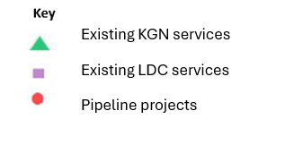This map has been prepared using departmental data, from both the National Quality Agenda IT System (NQAITS) and the Victorian School Building Authority (VSBA).

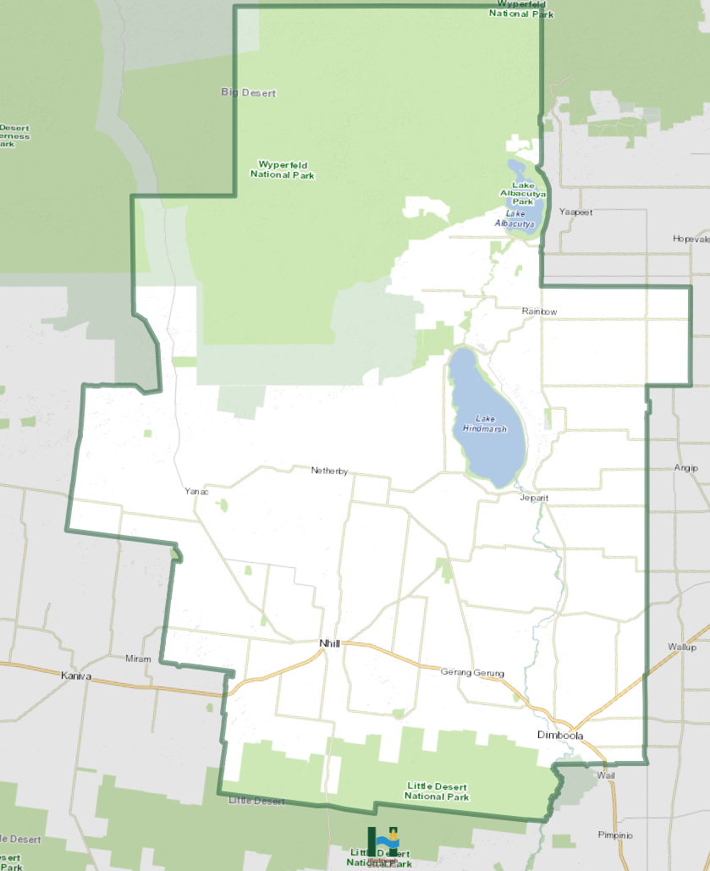

# Local context

d

## 3.1 Purpose

Local, place-based knowledge and context play an important role in supporting the implementation of the BSBL reforms across Victoria. This section of the KISP documents this knowledge and context and should be considered alongside the kindergarten demand estimates in Section 4.

Information provided as local context may support applications through the Building Blocks Capacity Building and Planning Grants streams.

## 3.2 Key considerations

Hindmarsh Shire Council is located halfway between Melbourne and Adelaide, comprises 7,500sq kilometres and has a population of approximately 5,588.

The Western Highway, the main thoroughfare between Melbourne and Adelaide, runs through the Shire.

Hindmarsh Shire has four main townships (Dimboola, Jeparit, Nhill and Rainbow) and is largely dependent on agriculture, health services, manufacturing and retail. Our towns have excellent sporting facilities, schools and hospitals, and our natural and heritage attractions draw thousands of visitors each year.

Hindmarsh Shire is responsible for the governance and delivery of services that support the residents and community of the municipality. Services include, but are not limited to, kindergarten and early children services, waste management, maintenance of roads, footpaths, and drainage, planning and building services, local laws and emergency management and recreation and community services etc.

It is widely recognised across Hindmarsh Shire and beyond that the lack of quality and accessible childcare is a serious barrier to local businesses and service providers, (including those in the education and health sectors), in the recruitment of new and retention of existing staff. This is particularly the case for women in instances when they wish to return to work after having a baby but are unable to due to lack of long day care childcare services.

Nhill and Dimboola have benefited from the delivery of new kindergartens through the Kindergartens on School Sites program in 2025, which has increased opportunities for both kindergarten and long day care, but as Jeparit and Rainbow only have kindergarten services, parents continue to struggle with balancing childcare and employment obligations.

**Aboriginal Self Determination in Early Childhood Education and Care**

Hindmarsh Shire is steeped in indigenous and culturally significant heritage and acknowledges the Wotjobaluk, Jaadwa, Jadawadjali, Wergaia and Jupagalk Nations as Traditional Owners of Country.

According to the 2021 Census Data Hindmarsh Shire had 92 people who identified as Indigenous or Torres Strait Islanders with 14 (approximately 15%) under the age of ten years.

In 2025, there are three children enrolled in kindergarten whose family identify as Aboriginal.

**Key demographic trends that influence demand for kindergarten**

According to the 2021 Census data, there are 285 children below the age of five years within Hindmarsh Shire which is 5% of the shire’s population and slightly below the Victorian and Australian average which is 5.8%.

These figures are slightly higher than the 2016 Census which stated there were 260 children or 4.5% of the population below the age of five years.

The 2021 Census data stated, that of the 285 children below the age of five years, 104 or approximately 36% of the cohort were attending pre-school.

In broader terms, Hindmarsh Shire’s demographics can be identified as approximately 14.9% in the 0 – 14 years age group, 56.9% in the 15 – 64 years age group and 28.2% over 65 years.

Projected birth rates for the shire are difficult to establish, but anecdotal evidence suggests that there may be a slight decline in birth rates. However, this could be mitigated due to the increased numbers of families relocating to the municipality from other areas and the arrival of refugee families. An example of this is that there are at least six (6) children from Karen refugee families attending kindergarten in Nhill in 2025 and many more attending the Multi-cultural Storytime -Mother Tongue program. These children will no doubt transition into traditional kindergarten services in the future as they reach the appropriate age.

As Hindmarsh Shire is a rural municipality it is necessary for school-aged children to be transported from remote areas such as family farms or neighboring towns by school buses to their local schools. This service is not available for children until they turn 4 years old, and subject to sufficient seating capacity on the bus route. In instances where kindergarten aged children can’t access a school bus, it is expected that parents or guardians will provide private transportation which then reduces their opportunities for employment.

As previously stated, the limited availability of long day care services also impacts on parents, particularly women, who are attempting to return to the workforce.

**Projects or trends that may influence supply of early childhood education and care**

Staffing shortages through the early years education system could be the biggest issue that faces the local sector into the future. Due to required child / teacher ratios to meet compliance protocols, a shortage of teachers will reduce the number of enrolments available which then decreases the sustainability of the services being provided. The reforms also may impact the number of available enrolments as, when taking into consideration fewer teachers alongside increased hours for Pre-Prep, there are limited opportunities for services to run additional sessions.

Dimboola currently has a relatively large housing estate development in the planning process and if it comes to fruition the estate could see the establishment of more than 100 new homes. Given the proximity of the proposed housing development to the Wimmera River it is feasible that blocks of land could be sold and built on relatively quickly.

Dimboola is also an easy commute for people who work in neighboring shires, such as Horsham Rural City Council and Warracknabeal in Yarriambiack Shire Council.

Given property values in Horsham and the impending construction of the Warracknabeal Energy Park it is feasible to consider that housing demand will increase in Dimboola which will then have a flow on effect for increased demand of early years education and childcare services.

Conversely, if there is a decrease in the number of enrolments, service providers may struggle to be financially viable without funding from the Department of Education.

**Key local geographic considerations or information relevant to Three-Year-Old Kindergarten and Pre-Prep**

Hindmarsh Shire Council is situated in the west of the state and located halfway between Melbourne and Adelaide and is approximately 370 kms (four hours’ drive) from both cities.

Ballarat and Bendigo are the closest large regional cities, both being approximately three hours (depending on your location) from the Shire with Horsham being the largest local city.

There are many residents of Hindmarsh Shire who commute to Horsham and district for employment and conversely there are many Horsham based residents who commute to employment within the Hindmarsh municipality.

Kindergartens are located in each of the main towns of Dimboola, Jeparit, Nhill and Rainbow, with Dimboola and Nhill also offering long day care services. Dimboola and Nhill have also been recipients of the Victorian Government’s KOSS with facilities at Dimboola Primary School and Nhill College.

As already stated, attracting staff to rural kindergartens is particularly difficult because of a range of factors including, but not limited to, travelling, housing and isolation of the community.

Population decline and low enrolment numbers in towns such as Jeparit, put the provision of services to children at risk and transportation to other centres is problematic because of previously stated reasons.

**Other information about the expansion of early childhood services**

Ongoing maintenance and operational costs associated with ECE facilities are a cost pressure for Hindmarsh Shire Council and the Early Years Service providers.

# Unmet demand estimates between 2025 - 2036 for Hindmarsh Shire Council

## 4.1 Purpose

As the BSBL reforms are rolled out and Victoria’s population grows, demand for kindergarten and Pre-Prep places will increase significantly. While additional capacity will be needed to meet this demand, this will vary across the State and over time, due to differences in the capacity of existing services, growth trends and sector composition.

To identify where, when and how many additional kindergarten places are expected to be required over the roll-out in Hindmarsh Shire Council and the department have developed:

1. a summary of the current provision of kindergarten within Hindmarsh Shire (**Section 4.3**).
2. an estimate of kindergarten places that cannot be met through existing services for the 2025 - 2036 period, taking into account the additional demand that can be accommodated by optimising utilisation of existing services and infrastructure (**Section 4.4**).

Local governments and providers can use these published estimates to inform reform implementation activities such as service planning, kindergarten program expansion, infrastructure investments and Building Blocks funding applications in alignment with future demand over the roll-out.

## 4.2 Methodology

The estimated kindergarten places used in the following sections have been agreed between Hindmarsh Shire Council and the department, and were informed by:

* demand projections developed by the department which draw on a range of inputs, including population forecasts and current enrolments
* the estimated capacity of existing and planned services in the LGA (Section 2)
* where applicable, modelling undertaken by Hindmarsh Shire Council and service level information; and
* local knowledge and context provided by the local government (Section 3) that explains particular issues and trends in their area.

**Kindergarten places explainer**

The KISP measures a service’s capacity to deliver funded kindergarten in terms of the number of **15-hour places** (referred to as “kindergarten places”) available for Three-Year-Old kindergarten and Pre-Prep (noting that, by 2036, two kindergarten places will be required for one Pre-Prep enrolment). The number of kindergarten places is different from a service’s licensed or approved places, which count the number of children permitted to attend the service at any one time under the license. Many services can enrol more children in their funded kindergarten program(s) than they have licensed places for because they can run more than one kindergarten program per week. Kindergarten places are therefore a more accurate measure of service kindergarten capacity than licensed places.

Kindergarten places have been presented as 15-hour places so that new Three-Year-Old Kindergarten places and the additional 15-hour places required for Pre-Prep can be easily compared to existing 15-hour Four-Year-Old Kindergarten places. This is because, when Three-Year-Old Kindergarten is fully rolled out in 2029, three-year-old children will have access to 15-hours of kindergarten. When Pre-Prep is fully rolled out in 2036, four-year-old children will have access to up to 30-hours of kindergarten, an increase of the current offering of 15-hours per week.

It is important to note that enrolments are not equivalent to 15-hour places. One 15-hour place can support a total of 15 hours of delivery per week split between one or more children, including but not limited to the following examples:

|  |  |  |
| --- | --- | --- |
|  |  | **One 15-hour place (15 hours of delivery)** |
| **Example 1** | 1 child | 1 x 3YO attending 15 hours per week |
| **Example 2** | 1 child | 1 x 4YO attending 15 hours per week |
| **Example 3** | 2 children | 2 x 3YOs attending 7.5 hours per week |
| **Example 4** | 3 children | 3 x 3YOs attending 5 hours per week |

Two 15-hour places can support a total of 30 hours of delivery per week split between one or more children, including but not limited to the following examples:

|  |  |  |
| --- | --- | --- |
|  |  | **Two 15-hour places (30 hours of delivery)** |
| **Example 1** | 1 child | 1 x 4YO attending 30 hours per week |
| **Example 2** | 2 children | 2 x 3YOs attending 15 hours per week |
| **Example 3** | 2 children | 1 x 3YO, and  1 x 4YO both attending 15 hours per week |
| **Example 4** | 3 children | 2 x 3YOs attending 7.5 hours per week, and  1 x 4YO attending 15 hours per week |

**Geographic boundaries used in the KISP**

These estimates have been developed at an LGA and community level to show the overall forecast and variation within an area. The KISP defines community at the Statistical Area Level 2 (SA2), which is a medium-sized area which represents a community that interacts socially and economically, with an approximate population range of 3,000 to 25,000 people, and an average population of about 10,000 people. The KISP uses 2021 SA2 boundaries. More information is available at the [Australian Bureau of Statistics website](https://www.abs.gov.au/statistics/standards/australian-statistical-geography-standard-asgs-edition-3/jul2021-jun2026/main-structure-and-greater-capital-city-statistical-areas/statistical-area-level-2).

**Supply contributed by pipeline projects**

Hindmarsh Shire Council and the department have added any new places that will be made available through planned expansions of existing services or new services into estimates of existing supply, where this information is available. This may include projects being delivered by not-for-profit providers (including non-government schools) with support from the Victorian Government, planned Kindergartens on School Sites, and government-owned and operated early learning and childcare centres.

The KISP does not estimate how and when the broader sector will expand to meet the additional demand for kindergarten places that are estimated over the roll-out period.

## 4.3 Summary of current kindergarten provision

The figures below provide a summary of current kindergarten provision within the LGA and provide relevant context for the estimates of demand for funded kindergarten places included in Section 4.5. The data included in this section are largely drawn from:

* the department’s Kindergarten Information Management System (KIMS), as at 2023.
* the National Quality Agenda IT System (NQAITS), as at April 2025.

|  |  |
| --- | --- |
| Number of services by service type (NQAITS) |  |
| Stand-alone kindergartens | 4 |
| Long day care centres (including services not currently delivering funded kindergarten) | 2 |

|  |  |
| --- | --- |
| Percentage of services by management type, LGA level (NQAITS) |  |
| ***Type*** | ***Percentage*** |
| Local Government | 0% |
| Private not for profit | 100% |
| Private for profit | 0% |
| Other | 0% |

|  |  |
| --- | --- |
| Current kindergarten offering in Hindmarsh Shire Council |  |
| Three-Year-Old Kindergarten participation rate (KIMS): | 89% |
| Four-Year-Old Kindergarten participation rate (KIMS): | 78% |
| Number of services that offer a funded kindergarten program (KIMS): | 4 |

## 4.4 Agreed estimates of demand for kindergarten places

The below estimates (**Table 1** onwards) have been developed by Hindmarsh Shire Council and the department to illustrate the estimated:

1. Demand – the total number of kindergarten places expected to be required over the roll-out period to support the current provision of Four-Year-Old Kindergarten, the BSBL reforms, and population growth
2. Supply – the total number of kindergarten places that can be accommodated by existing services and infrastructure, and planned, State-supported services which are yet to open.
3. Unmet demand – kindergarten places that cannot be accommodated by optimising existing services and infrastructure (i.e. the shortfall between demand and supply).

**Interpreting the estimates**

Infrastructure need in the LGA and its local communities is indicated by the bottom rows of the tables in this section (**Table 1** onwards): *Unmet demand*. If the number of kindergarten places in this row is above zero, it means that the area is estimated to need additional infrastructure capacity. Any type of provider – local government, not-for-profit (including non-government schools) or for-profit – can build this additional infrastructure.

Sub-SA2 factors may need to be considered to give a holistic picture of unmet demand. For example, in rural communities, one SA2 may contain several small towns, some with excess supply and some with unmet demand. At the SA2-level, demand may appear to be met because all supply and demand is considered in aggregate; however, it is not feasible to for families to drive long distances to access kindergarten capacity in another town. Sub-SA2 factors are covered in **Section 3: Local context**.

**Table 1: Estimated kindergarten places required between 2025 - 2036 in Hindmarsh Shire**

|  |  |  |  |  |  |  |  |  |  |  |  |  |
| --- | --- | --- | --- | --- | --- | --- | --- | --- | --- | --- | --- | --- |
| **Hindmarsh Shire estimates** | **2025** | **2026** | **2027** | **2028** | **2029** | **2030** | **2031** | **2032** | **2033** | **2034** | **2035** | **2036** |
| Demand for kindergarten places | 151 | 151 | 150 | 150 | 151 | 151 | 150 | 148 | 147 | 145 | 144 | 143 |
| Unmet demand | 0 | 0 | 0 | 0 | 0 | 0 | 0 | 0 | 0 | 0 | 0 | 0 |

**Community estimates**

**Table 2-A: Estimated kindergarten places required between 2025 - 2036 in – Nhill Region**

|  |  |  |  |  |  |  |  |  |  |  |  |  |
| --- | --- | --- | --- | --- | --- | --- | --- | --- | --- | --- | --- | --- |
| **SA2 estimates** | **2025** | **2026** | **2027** | **2028** | **2029** | **2030** | **2031** | **2032** | **2033** | **2034** | **2035** | **2036** |
| Demand for kindergarten | 151 | 151 | 150 | 150 | 151 | 151 | 150 | 148 | 147 | 145 | 144 | 143 |
| Kindergarten supply | 303 | 303 | 303 | 303 | 303 | 303 | 303 | 303 | 303 | 303 | 303 | 303 |
| Unmet demand | 0 | 0 | 0 | 0 | 0 | 0 | 0 | 0 | 0 | 0 | 0 | 0 |

# Authorisation

The Wimmera South West Area Executive Director of the Department of Education and Monica Revell, Chief Executive Officer of Hindmarsh Shire Council endorse this Kindergarten Infrastructure and Services Plan (KISP) for Hindmarsh Shire Council by signing on 23/07/2025.

This KISP is not intended to create legal relations or constitute a legally binding contractual agreement between the parties. The parties may review this KISP in 2028 to publish a new version that will replace the previous version.

Signed for and on behalf and with the authority of Hindmarsh Shire Council.

……………………………………

Signature

Name: …Monica Revell......................................

Title: …Chief Executive Officer…………………

Signed for and on behalf and with the authority of the Department of Education

Signature

Name: Emma Miller

Title: A/Executive Director, Wimmera South West