

Kindergarten Infrastructure and Services Plan
Colac-Otway Shire

CONTENTS

1. Introduction 3
1.1. Reform context 3
1.2. Purpose of Kindergarten Infrastructure and Services Plans (KISPs) 3
1.3. Structure of the KISP 4
1.4. Disclaimer 4
2. Map of Early Childhood Education services in Colac-Otway Shire 5
3. Local context 6
3.1 Purpose 6
3.2 Key considerations 6
4. Unmet demand estimates between 2025 - 2036 for Colac-Otway Shire 13
4.1 Purpose 13
4.2 Methodology 13
4.3 Summary of current kindergarten provision 15
4.4 Agreed estimates of demand for kindergarten places 15
5. Authorisation 18


© State of Victoria (Department of Education) 2024
Kindergarten Infrastructure and Services Plan Colac-Otway Shire is provided under a Creative Commons Attribution
4.0 International licence. You are free to re-use the work under that licence, on the condition that you credit the State of Victoria (Department of Education), indicate if changes were made and comply with the other licence terms, see: Creative Commons Attribution 4.0 International

The licence does not apply to:
- any images, photographs, trademarks or branding, including the Victorian Government logo and the DE logo; and
- content supplied by third parties.
Copyright queries may be directed to copyright@education.vic.gov.au

Introduction

Reform context
The Victorian Government’s $14 billion Best Start, Best Life (BSBL) reforms are the most significant change to Victoria’s early childhood sector in a generation.
The BSBL reforms include:

    - Free Kinder: Free Kinder is now available for Victorian 3- and 4-year-old children at participating services in standalone (sessional) kindergartens and long day care centres – a saving of up to $2,500 per child, every year.
    - Pre-Prep: Four-Year-Old Kindergarten will gradually transition to ‘Pre-Prep’ – increasing to a universal 30-hour-a-week program of play-based learning for 4-year-old children in Victoria by 2036.
    - Three-Year-Old Kindergarten: the continued roll-out of Three-Year-Old Kindergarten, with programs increasing to 15 hours a week across the state by 2029.
    - Early learning and childcare centres: the establishment of 50 Victorian government-owned and operated early learning and childcare centres. These centres will be built in areas with the greatest need and will make it easier for families to access early childhood education and childcare. The first of the centres will open in 2025.
These initiatives demonstrate a clear commitment to improving early learning outcomes for Victorian children, workforce participation and access for families, and present the most significant change to Victoria’s early childhood sector in a generation.

Pre-Prep will roll-out in Colac-Otway Shire in 2027. Statewide, Aboriginal and Torres Strait Islander children, children from a refugee or asylum seeker background, and children who have had contact with Child Protection services, will be able to access up to 25 hours of Pre-Prep in 2026, increasing to up to 30 hours from 2028. Children who have (or have a parent or guardian who has) a Commonwealth concession card and children who are a multiple birth child (triplets or more) across the state will be able to access up to 25 hours of Pre-Prep in 2028, increasing to up to 30 hours from 2030.

Purpose of Kindergarten Infrastructure and Services Plans (KISPs)
New and expanded infrastructure is key to delivering the BSBL reforms and will require a large expansion of kindergarten facilities across the State. KISPs, which are jointly developed with Local Governments, indicate where and when new infrastructure will be required to support both reform implementation and population growth in each of Victoria’s 79 local government areas (LGAs). KISPs help all kindergarten providers meet demand and collectively provide a clear picture of infrastructure need across the State.
KISPs support planning for services and future capital works and include detailed information about:

    - Current capacity and demand for funded kindergarten

    - Capacity to be delivered for planned infrastructure projects and future demand for kindergarten
    - Forecast ‘unmet demand’ for kindergarten – that is, the kindergarten places needed that cannot be met by current or planned capacity
    - Information specific to each local government area and its early childhood education and care landscape.
KISPs were initially developed to support the roll-out of Three-Year-Old Kindergarten and have now been updated to incorporate Pre-Prep.
KISPs are intended to support planning. They are not funding documents and do not commit any party to addressing the unmet demand identified.

However, it is expected that future investment requests through Building Blocks and funding decisions about Local Government, not-for-profit projects (including non-government schools) would align with the relevant KISP (including Section 3: Local Context).

Structure of the KISP
Each KISP consists of the following sections:
    - Section 1: A short introduction to the Best Start, Best Life reform and the KISP.
    - Section 2: A map of existing and planned Early Childhood Education and Care services.
    - Section 3: Local context and knowledge of key information in Colac-Otway Shire relevant to early childhood education.
    - Section 4: Unmet demand estimates in Colac-Otway Shire over the life of the reform.

Disclaimer
All data presented in this document is published for information purposes only. Operational and business decisions should not be based solely on this document. Neither the Department nor Colac-Otway Shire Council warrants, guarantees, makes any representation or assumes any duty of care in relation to the data, including as to its suitability, completeness, accuracy or adequacy.

Map of Early Childhood Education services in Colac-Otway Shire
The map below shows the distribution of currently operating and new State-supported services that are planned to open in the future in Colac-Otway Shire. Planned services by the private sector are not included.
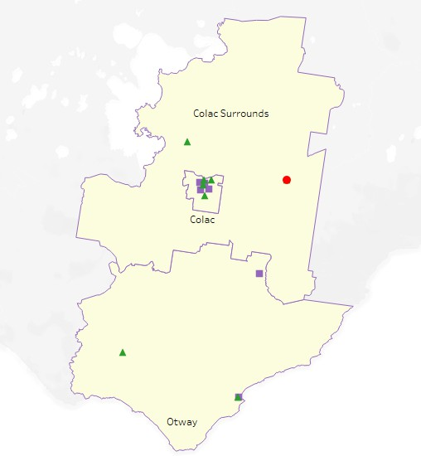
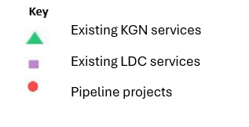
This map has been prepared using departmental data, from both the National Quality Agenda IT System (NQAITS) and the Victorian School Building Authority (VSBA).

Local context

Purpose
Local, place-based knowledge and context play an important role in supporting the implementation of the BSBL reforms across Victoria. This section of the KISP documents this knowledge and context and should be considered alongside the kindergarten demand estimates in Section 4.
Information provided as local context may support applications through the Building Blocks Capacity Building and Planning Grants streams.

Acknowledgement of Country
The Colac Otway Shire Council respectfully acknowledges the Gulidjan and Gadubanud peoples as the traditional custodians of the Colac Otway region, the land and waterways upon which the activities of the Colac Otway Shire Council are conducted, and pays respect to elders, past, present and emerging. Council recognises and respects their unique cultural heritage, beliefs and uphold their continuing relationship to this land.

Key considerations

Aboriginal Self Determination in Early Childhood Education and Care
Colac Otway Shire’s First Nations community makes up 1.4% of the overall population as outlined in the 2021 census. The 2023 Colac-Otway (S) Early Childhood Education Profile outlines that 3.84% of children enrolled in a kindergarten program which includes both 3-year-old and 4-year-old cohorts identified as First Nations.
Caracaramigen House – The Colac Aboriginal Gathering Place is based in Colac and is a place where the First Nations community can come to enquire about services they may require, or help navigating a service system, a range of community, arts and education-based events or simply to pop in for a cuppa and a yarn.
Caracaramigen House is a subsidiary of Wathaurong Aboriginal Co-operative. Wathaurong provides culturally appropriate programs, support and services for all Aboriginal and Torres Strait Islander peoples living in Wathaurong, Gulidjan and Gadubanud country, within the wider Geelong, Bellarine and Colac regions.
Caracaramigen and Council are working in partnership to support Aboriginal families access early years services. The establishment of this partnership has meant that Council has been able to and will continue to identify and support First Nations families and children to link into early years services such as Three-Year-Old kindergarten.

Key demographic trends that influence demand for kindergarten
Colac Otway Shire is situated in Southwest Victoria 160kms from Melbourne with an estimated population of 22,423 people living within the community and about 5,774 families as outlined in the 2021 Census. Colac Otway Shire has an expected growth of 14.3% by 2036, of which 8.8 % are projected to be children aged 0-6 years. Council notes that Colac Otway Shire’s population may have an undercount by around 2,000, based on overall dwelling numbers, average family size, and the numbers of new homes built between 2016 and 2021. Hence, there may be a larger cohort of families to cater kindergarten services to than currently projected.

Colac Otway Shire population is growing and becoming more diverse with 10% of residents being born overseas and current population growth being largely supported by overseas migration.

Overall, Colac Otway Shire has a SEIFA score of 973 which indicates higher levels of disadvantage in comparison to the G21 region (1,016) and somewhat higher levels compared to the state average (1010.1). There are pockets in the shire that have higher levels of vulnerability and disadvantage, highlighting the need for low-cost, high-quality services and facilities that are close to where people live to improve access.

Colac Otway Shire’s Australian Early Development Census (AEDC) results highlight that among the cohort of children, 20.2% are vulnerable in one or more domains and 10.3% who are vulnerable in two or more domains, who need support in the areas of Social Competence and Language and Cognitive Skills. There has been no significant change to these results since 2009.

In 2026 the Pre-prep rollout for children in the priority cohort will begin, this will be children who identify as Aboriginal, children from refugee or asylum seeker background as well as children who are known to Child Protection. Department of Education also provides Access to Early Learning (AEL) programs, which can be available to Colac Otway Shire families in future. AEL is a targeted program for three-year-old children from families with complex needs and will help young children to take part in early childhood education and care programs. It will also be a key in connecting with those families into a funded kindergarten program when the priority cohort rollout takes place in 2026.

Council’s Maternal & Child Health staff continue to support children and families who are under Out of Home Care for Colac Otway Shire. This allows Council to identify and support vulnerable children early and allow these children to access Early Start Kinder. An increase in Council’s Enhanced Funding, is helping identify children and their families who would be better supported in an early childhood setting and therefore allow parents the opportunity to attend a funded Three-Year-Old kindergarten program.

Projects or trends that may influence supply of early childhood education and care

Growth of Colac Otway Shire

Colac Otway Shire through its Colac 2050 Growth Plan, which was formally adopted in August 2019, has an ambition for Colac’s population to grow from around 13,000 to 20,000 by 2050. The Colac 2050 Growth Plan highlights areas within Colac/Elliminyt that are likely to expand due to residential construction or development. These areas are mostly around the South Colac/Elliminyt area, where substantial allotments of land have been recently rezoned for residential development.

Further development has been identified in the Colac West area, known as the Deans Creek Growth Area. This area covers 570 hectares and once completed could accommodate 4,500-6,000 dwellings. Council is currently preparing a Precinct Structure Plan for this area to plan for and coordinate the housing development that will occur.

Colac’s residential growth areas are outlined in the image below:
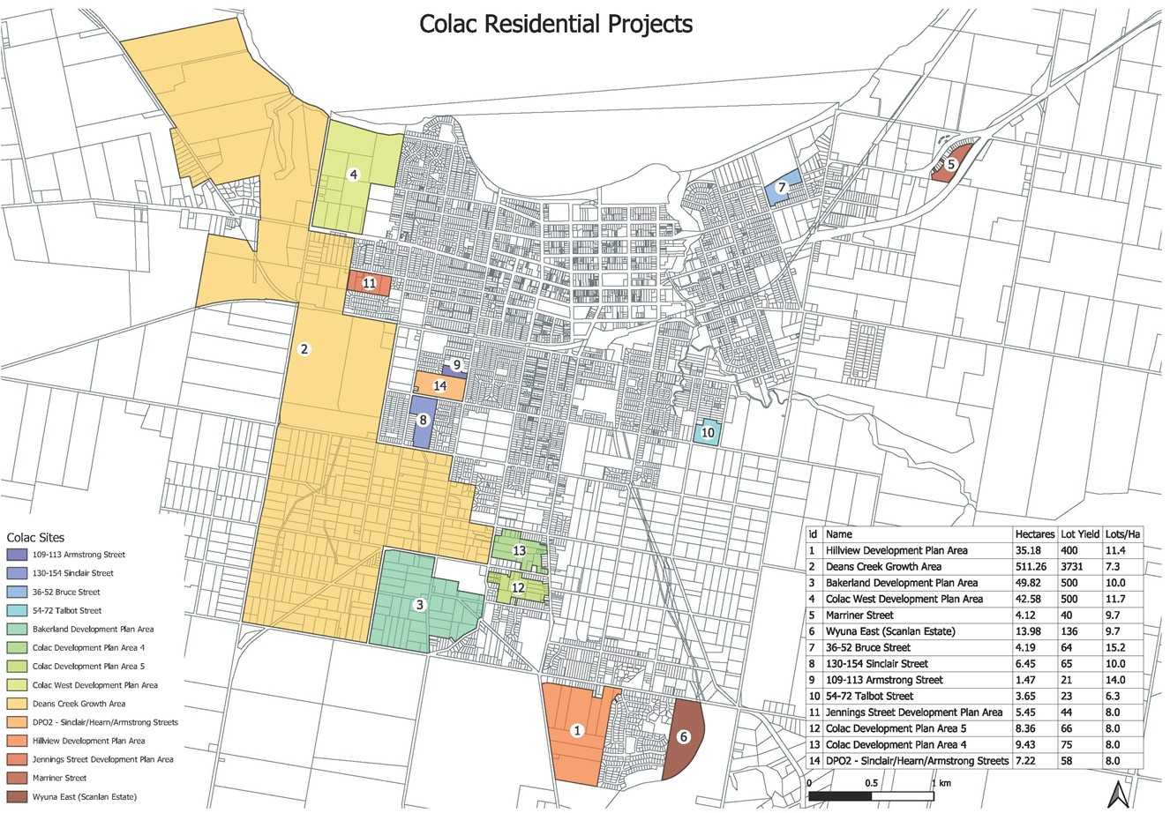

Condition data and fit for purpose facilities
Colac Otway Shire will be in the 2027 rollout for 20 hours of funded kindergarten as part of the staged approach to implementing the Best Start Best Life reforms. Council has actively sought to apply for Building Blocks State funding to support early years infrastructure improvements across Colac Otway Shire in the past. This funding has assisted Council to make improvements to facilities and accommodate early childhood reforms in relation to child/educator ratio changes and the roll out of 3-year-old funded kindergarten.
Colac Otway Shire has recently undertaken a condition assessment of all buildings that it owns to understand the long-term investment requirements for facilities. With regards to early years buildings, the report identified that a number of buildings are reaching end of life and long-term planning is necessary to consider the future needs of early years services.
The three Council-owned buildings in the Colac area that services are currently being delivered from are outlined below:
- Wydinia Kindergarten
- Winifred Nance Kindergarten
- Colac East Kindergarten

Kindergartens on School Sites (KOSS)
Council is committed to seeking further opportunities of having kindergartens on school sites (KOSS) following the success of the Apollo Bay kindergarten. The kindergarten was built on the Apollo Bay P-12 College site and has seen a range of benefits, including but not limited to:
- Inclusion of a Maternal and Child Health (M&CH) space.
- Continuum of care model – birth through to adulthood.
- Familiarity for children between early years and school.
- Integration between early years programs and workforce development.
- Holistic approach to children and families.
- Ease of access for families.

The inclusion of a minimum two rooms and options for consultation rooms to accommodate M&CH and allied health rooms for kinder on school sites will be Council’s preferred model moving forward.

In SA2 Colac and Surrounds, it has been identified that the two kindergarten services being Coragulac and District Kindergarten and Birregurra Kindergarten would not meet future capacity past 2027.

Further analysis identified that Coragulac and District Kindergarten was the likely service that would be unable to meet the shortfall in its current capacity given the growth in the area. This building is reaching end of life and is unable to expand in its current location. For future delivery of kindergarten services through this service, alternative modes or locations may need to be considered.

These two communities are vastly different in their demographics and are located in different parts of the shire, one on the east side and one on the west side. The likelihood that these services would share clients is extremely low and therefore each township needs to be considered in relation to their own demand.

Increased Long Day Care places
Colac has seen a considerable investment in long day care in recent years with several private operators moving into the area.

In 2020, a 44 place Long Day Care Service opened in Colac (Little Tikes Early Learning Centre). They have recently expanded the service to 52 places and provide a 3-year-old and 4-year-old kindergarten program within their service.

In late 2023, Creative Minds Pty Ltd opened a 33-place centre towards the west side of Colac to meet the increasing needs of childcare places. They are offering funded kindergarten places at the service.

Council has recently approved a planning application for a proposed 98 place Child Care Centre for the Elliminyt area. The applicant has not indicated as to whether or not the service will offer a funded kindergarten program.

In Apollo Bay, there is a long day care centre which is situated onsite at the Great Ocean Road Health precinct, and they currently have a lease agreement with the health service to use the space to provide childcare. It is licenced for 48 places and operates 5 days a week. Currently they are only offering 24 places due to availability of staff to meet required ratios.

The increased hours of funded kindergarten available through the Best Start, Best Life reforms risks reducing available places for 0-3 year olds in long day care services, which were already facing current demand pressure. Families within Colac Otway Shire are having to return to work a lot sooner than historically after giving birth due to financial pressures. This has added pressure on services to provide places for 0-3 year olds. Long day care services within COS struggle to find available staff to meet the high demand for that 0-3 age group.

Key local geographic considerations or information relevant to Three-Year-Old Kindergarten and Pre-Prep

Kindergarten Delivery in Colac Otway Shire
A combination of standalone kindergarten programs and long day care integrated kindergarten programs are situated within Colac Otway Shire. There also exists a mixture of EYM run services, parent committee services and school run services.

In consulting with families around a range of kindergarten program models for 3-year-old and 4-year- old kinder, kindergarten services have noted that parents are leaning towards the two days at 7.5 hours per day option and the 6hrs +6hrs+3 hours over 3 days option as their preferred choice for a model of kindergarten as it allows them more work-related opportunities. Some services are currently still offering the 3 days at 5 hours per day model as well.

SA2 Locations Colac
Council owns three buildings in Colac which operate as standalone Kindergartens – Wydinia Kindergarten, Colac East Kindergarten and Winifred Nance Kindergarten. These three Kindergartens are operated by an Early Years Management Service (EYM) called Meli Kindergartens. These standalone Kindergartens are all one room units. Meli Kindergartens are providing different models of kindergarten programs at each of these facilities so that they can provide choice for families. Due to only being one room centres the intake of children could be affected in their ability to provide 30 hours of kindergarten.
Apex Pre-school is located in the Elliminyt area and is situated on Crown land with Council as the appointed Committee of Management since 2019. The kindergarten service started operations at the venue through an agreement between the incorporated entity and State Government (then DELWP – currently DEECA). The Elliminyt area has been identified as a growth area, and although the data indicates that this kinder will meet capacity, it could be foreseen that this service could have a potential waitlist for children looking for a sessional kindergarten program.
There are currently four private childcare centres located in Colac – Nido Early School, Little Tikes Early Learning, Creative Minds Early Years and Millville Child Care – that provide a kindergarten program which is integrated within their childcare setting. These services are well prepared to meet the increased intake of children due to the foreseeable population increase to meet 3-year-old and 4-year-old cohort.

Colac Surrounds
There are two standalone Kindergartens situated in Colac and Surrounds SA2 area, Birregurra Preschool and Coragulac and District Kindergarten.
Birregurra Preschool is owned by the Country Women’s Association and managed through a trust by a Parent Committee.
The population of Birregurra has been on a steady increase with the 2016 population of 810 increasing to 942 by the 2021 Census, showing a population growth of 15% in the area. Birregurra remains a popular treechange community close to Geelong and Colac. The kindergarten is well placed to meet any increases in intake of children seeking a kindergarten program.
Coragulac and District Kindergarten is also operated by a Parent Committee and is situated on land owned by the Diocese of Ballarat. There are several smaller communities surrounding Coragulac which this kinder service’s such as Cororooke (310), Alvie (132) and Warrion (198). The kindergarten was previously called Alvie and District Kindergarten and changed its name in 2017 to Coragulac and District Kindergarten. The facility is located adjacent to St Brendan’s Primary School on the local school site. This site is limited in the number of children it will be able

to provide a kindergarten program to and will have an unmet demand from 2027 onwards if it continues to provide the current model of kinder.

Otway
There is a Primary School at Forrest, and a P-12 school site at Lavers Hill that provide a Kindergarten program as well as a combination of other childcare programs on the school site.

The Forrest Primary School includes an early year’s space that provides Long Day Care with 18 places and within that offer funded 3- and 4-year-old kindergarten programs. Depending on numbers and demand, the school does have the capacity to provide OSHC programs. Forrest likely has enough licensed places to meet the demand generated by the Pre-Prep roll out.

Council owned a 1 room 24 place kindergarten in Apollo Bay which was operated by a Parent Committee. This was closed in 2021 due to the facility no longer being fit for purpose. The new building, built in partnership with the VSBA under the KOSS model, is situated at the P-12 College in Apollo Bay, and is a two room 66 place service. The service is run by EYM One Tree Community Service. The kindergarten program at Apollo Bay will support the rollout of the increased kindergarten hours for both the 3-year-old and 4-year-old cohort.

Other information about the expansion of early childhood services

National Children’s Education and Care Work Force Strategy outcomes

Colac Otway Shire has been identified as having a workforce shortage in the early years sector and as such, appropriate strategies will be required to ensure that the expansion of early childhood services can be achieved.

Current Early Years Management services have workforce strategic plans in place that outline clear goals and initiatives in addressing workforce shortages within the services they run and the communities they serve.

The three main themes that are consistently coming through from both EYM’s are:

- Difficulties around attraction, availability and retention of qualified early childhood staff.
- Lack of affordable housing and availability of rental accommodation.
- Level of pay to attract staff to regional areas.

Urban migration to regional areas
Several communities within Colac Otway Shire had an increase in populations over the COVID period such as Birregurra and Apollo Bay. These communities have seen an increase in kindergarten enrolments based on families with young children relocating from metropolitan areas. A range of influences behind this movement include work opportunities, lifestyle choice and the ability to be able to work from home while still maintaining the opportunity and flexibility to commute to the city if need be.

Early childhood services demand
Colac Otway Shire has quite a substantial industry-based workforce with a majority working in Ice Cream manufacturing, Meat Processing, Timber manufacturing and health services, which all rely on early childhood services to meet their childcare needs. This can be challenging for some services as these families bring complexities around rotating shifts and the requirement of longer days. Parents are seeking supplementary care options around their kindergarten programs and their choice in early years services have reflected this. Numbers have been consistent across long day care services, which indicates that parents prefer longer sessions of care that contain a kindergarten program to support their work commitments.

Strategic Reference Documents

Colac Otway Shire’s Council Plan 2021 – 2025 Click link Here
Theme 3: Healthy and Inclusive Community page 33

Colac 2050 Growth Plan Clink link here

Municipal Public Health and Wellbeing Plan (under review) Click link here
Young people and their families - Support families to provide the best start for their children page 30

Social Housing Plan – Colac Otway Shire 2021-2024 Click link here

4. Unmet demand estimates between 2025

- 2036 for Colac-Otway Shire

Purpose
As the BSBL reforms are rolled out and Victoria’s population grows, demand for kindergarten and Pre-Prep places will increase significantly. While additional capacity will be needed to meet this demand, this will vary across the State and over time, due to differences in the capacity of existing services, growth trends and sector composition.
To identify where, when and how many additional kindergarten places are expected to be required over the roll-out in Colac-Otway Shire, Council and the department have developed:
    - a summary of the current provision of kindergarten within Colac-Otway Shire (Section 4.3).
    - an estimate of kindergarten places that cannot be met through existing services for the 2025 - 2036 period, taking into account the additional demand that can be accommodated by optimising utilisation of existing services and infrastructure (Section 4.4).
Local governments and providers can use these published estimates to inform reform implementation activities such as service planning, kindergarten program expansion, infrastructure investments and Building Blocks funding applications in alignment with future demand over the roll- out.

Methodology
The estimated kindergarten places used in the following sections have been agreed between Colac- Otway Shire Council and the department, and were informed by:
- demand projections developed by the department which draw on a range of inputs, including population forecasts and current enrolments
- the estimated capacity of existing and planned services in the LGA (Section 2)
- where applicable, modelling undertaken by Colac-Otway Shire and service level information; and
- local knowledge and context provided by the local government (Section 3) that explains particular issues and trends in their area.

Kindergarten places explainer

The KISP measures a service’s capacity to deliver funded kindergarten in terms of the number of 15-hour places (referred to as “kindergarten places”) available for Three-Year-Old kindergarten and Pre-Prep (noting that, by 2036, two kindergarten places will be required for one Pre-Prep enrolment). The number of kindergarten places is different from a service’s licensed or approved places, which count the number of children permitted to attend the service at any one time under the license. Many services can enrol more children in their funded kindergarten program(s) than they have licensed places for because they can run more than one kindergarten program per week. Kindergarten places are therefore a more accurate measure of service kindergarten capacity than licensed places.

Kindergarten places have been presented as 15-hour places so that new Three-Year-Old Kindergarten places and the additional 15-hour places required for Pre-Prep can be easily compared to existing 15-hour Four-Year-Old Kindergarten places. This is because, when Three-Year-Old Kindergarten is fully rolled out in 2029, three-year-old children will have access to 15-hours of kindergarten. When Pre-Prep is fully rolled out in 2036, four-year-old children will have access to up to 30-hours of kindergarten, an increase of the current offering of 15-hours per week.
It is important to note that enrolments are not equivalent to 15-hour places. One 15-hour place can support a total of 15 hours of delivery per week split between one or more children, including but not limited to the following examples:

One 15-hour place (15 hours of delivery)
Example 1 | 1 child | 1 x 3YO attending 15 hours per week
Example 2 | 1 child | 1 x 4YO attending 15 hours per week
Example 3 | 2  children | 2 x 3YOs attending 7.5 hours per week
Example 4 | 3  children | 3 x 3YOs attending 5 hours per week
Two 15-hour places can support a total of 30 hours of delivery per week split between one or more children, including but not limited to the following examples:

Two 15-hour places (30 hours of delivery)
Example 1 | 1 child | 1 x 4YO attending 30 hours per week
Example 2 | 2  children | 2 x 3YOs attending 15 hours per week
Example 3 | 2  children | 1 x 3YO, and  1 x 4YO both attending 15 hours per week
Example 4 | 3  children | 2 x 3YOs attending 7.5 hours per week, and 1 x 4YO attending 15 hours per week

Geographic boundaries used in the KISP

These estimates have been developed at an LGA and community level to show the overall forecast and variation within an area. The KISP defines community at the Statistical Area Level 2 (SA2), which is a medium-sized area which represents a community that interacts socially and economically, with an approximate population range of 3,000 to 25,000 people, and an average population of about 10,000 people. The KISP uses 2021 SA2 boundaries. More information is available at the Australian Bureau of Statistics website.

Supply contributed by pipeline projects
Colac-Otway Shire and the department have added any new places that will be made available through planned expansions of existing services or new services into estimates of existing supply, where this information is available. This may include projects being delivered by not-for-profit

providers (including non-government schools) with support from the Victorian Government, planned Kindergartens on School Sites, and government-owned and operated early learning and childcare centres.
The KISP does not estimate how and when the broader sector will expand to meet the additional demand for kindergarten places that are estimated over the roll-out period.

Summary of current kindergarten provision
The figures below provide a summary of current kindergarten provision within the LGA and provide relevant context for the estimates of demand for funded kindergarten places included in Section 4.5. The data included in this section are largely drawn from:
- the department’s Kindergarten Information Management System (KIMS), as of 2023.
- the National Quality Agenda IT System (NQAITS), as of October 2024.

Number of services by service type (NQAITS)
Stand-alone kindergartens | 8
Long day care centres (including services not currently delivering funded kindergarten) | 6

Percentage of services by management type, LGA level (NQAITS)
Type | Percentage
Local/State Government | 12%
Private not for profit | 50%
Private for profit | 38%
Other | 0%

Current kindergarten offering in Colac-Otway Shire
Three-Year-Old Kindergarten participation rate (KIMS): | 80%
Four-Year-Old Kindergarten participation rate (KIMS): | 99%
Number of services that offer a funded kindergarten program (KIMS): | 16

Agreed estimates of demand for kindergarten places
The below estimates (Table 1 onwards) have been developed by Colac-Otway Shire Council and the department to illustrate the estimated:
    - Demand – the total number of kindergarten places expected to be required over the roll-out period to support the current provision of Four-Year-Old Kindergarten, the BSBL reforms, and population growth

    - Supply – the total number of kindergarten places that can be accommodated by existing services and infrastructure, and planned, State-supported services which are yet to open.
    - Unmet demand – kindergarten places that cannot be accommodated by optimising existing services and infrastructure (i.e. the shortfall between demand and supply).

Interpreting the estimates
Infrastructure need in the LGA and its local communities is indicated by the bottom rows of the tables in this section (Table 1 onwards): Unmet demand. If the number of kindergarten places in this row is above zero, it means that the area is estimated to need additional infrastructure capacity. Any type of provider – local government, not-for-profit (including non-government schools) or for-profit – can build this additional infrastructure.
Sub-SA2 factors may need to be considered to give a holistic picture of unmet demand. For example, in rural communities, one SA2 may contain several small towns, some with excess supply and some with unmet demand. At the SA2-level, demand may appear to be met because all supply and demand is considered in aggregate; however, it is not feasible to for families to drive long distances to access kindergarten capacity in another town. Sub-SA2 factors are covered in Section 3: Local context.

Table 1: Estimated kindergarten places required between 2025 - 2036 in Colac-Otway Shire

Colac Otway Shire estimates | 2025 | 2026 | 2027 | 2028 | 2029 | 2030 | 2031 | 2032 | 2033 | 2034 | 2035 | 2036
Demand for kindergarten places | 465 | 537 | 587 | 626 | 676 | 687 | 765 | 769 | 767 | 765 | 763 | 761
Unmet demand | 0 | 0 | 0 | 0 | 0 | 0 | 45 | 51 | 49 | 47 | 46 | 46

Community estimates

Table 2-A: Estimated kindergarten places required between 2025 - 2036 in Colac

Colac estimates | 2025 | 2026 | 2027 | 2028 | 2029 | 2030 | 2031 | 2032 | 2033 | 2034 | 2035 | 2036
Demand for kindergarten | 326 | 373 | 407 | 434 | 468 | 477 | 532 | 538 | 537 | 536 | 534 | 534
Kindergarten supply | 566 | 572 | 485 | 487 | 487 | 488 | 488 | 488 | 488 | 488 | 488 | 488
Unmet demand | 0 | 0 | 0 | 0 | 0 | 0 | 43 | 50 | 49 | 47 | 46 | 46

Table 2-B: Estimated kindergarten places required between 2025 - 2036 in Colac Surrounds

Colac Surrounds estimates | 2025 | 2026 | 2027 | 2028 | 2029 | 2030 | 2031 | 2032 | 2033 | 2034 | 2035 | 2036
Demand for kindergarten | 86 | 101 | 109 | 117 | 127 | 127 | 142 | 142 | 141 | 140 | 140 | 139
Kindergarten supply | 140 | 140 | 140 | 140 | 140 | 140 | 140 | 140 | 140 | 140 | 140 | 140
Unmet demand | 0 | 0 | 0 | 0 | 0 | 0 | 2 | 1 | 1 | 0 | 0 | 0

Table 2-C: Estimated kindergarten places required between 2025 - 2036 in Otway

Otway estimates | 2025 | 2026 | 2027 | 2028 | 2029 | 2030 | 2031 | 2032 | 2033 | 2034 | 2035 | 2036
Demand for kindergarten | 53 | 63 | 71 | 76 | 82 | 82 | 91 | 89 | 89 | 88 | 88 | 88
Kindergarten supply | 155 | 155 | 155 | 155 | 155 | 155 | 155 | 155 | 155 | 155 | 155 | 155
Unmet demand | 0 | 0 | 0 | 0 | 0 | 0 | 0 | 0 | 0 | 0 | 0 | 0

5. Authorisation
Catriona Salt, the Barwon Area Executive Director of the Department of Education and Andrew Tenni, Acting Chief Executive Officer of Colac Otway Shire Council endorse this Kindergarten Infrastructure and Services Plan (KISP) for Colac-Otway Shire Council by signing on ………. / ………. / ……….
This KISP is not intended to create legal relations or constitute a legally binding contractual agreement between the parties. The parties may review this KISP in 2028 to publish a new version that will replace the previous version.
Signed for and on behalf and with the authority of Colac-Otway Shire Council.

……………………………………
Signature

Name: …………………………......................................

Title: ………………………………………………………

Signed for and on behalf and with the authority of the Department of Education

……………………………………
Signature

Name: …………………………......................................

Title: ………………………………………………………

