QUICK REFERENCE GUIDE

HOW TO COMPLETE A SECOND YEAR DECLARATION FOR A CHILD IN THE KINDERGARTEN INFORMATION MANAGEMENT SYSTEM (KIMS)
This guide provides step-by-step instructions on how to complete a Second Year Declaration for a child in KIMS.
This can be done in the year before or in the same year that the child is completing the second year.
If a child is receiving a second year, from a different service and the declaration had not been completed, a new declaration can be completed in KIMS in the current year.
Please ensure all Second Year Declarations are completed prior to Annual Confirmation submission, otherwise the child will display as ineligible for funding.
For more information about Second Year Declarations refer to this webpage.
Overview of how to add a Second Year Declaration to a Child record in KIMS:
- On the Child Details page, click on the Second Year Declaration button.
- Select at least two (2) of the listed areas (in which the child is displaying delay) and click the right pointing arrow to move into the Selected Options list.
Note. To remove the selected areas, click on the area and use the left pointing arrow.
- Select the Teacher who has assessed this child as eligible for a second year of kindergarten. The Teacher list shows those Teachers at your Service.
- Once the Second Year Declaration Form is complete click Save.

System Steps for completing a Second Year Declaration for a child in KIMS
COMPLETING A SECOND YEAR DECLARATION
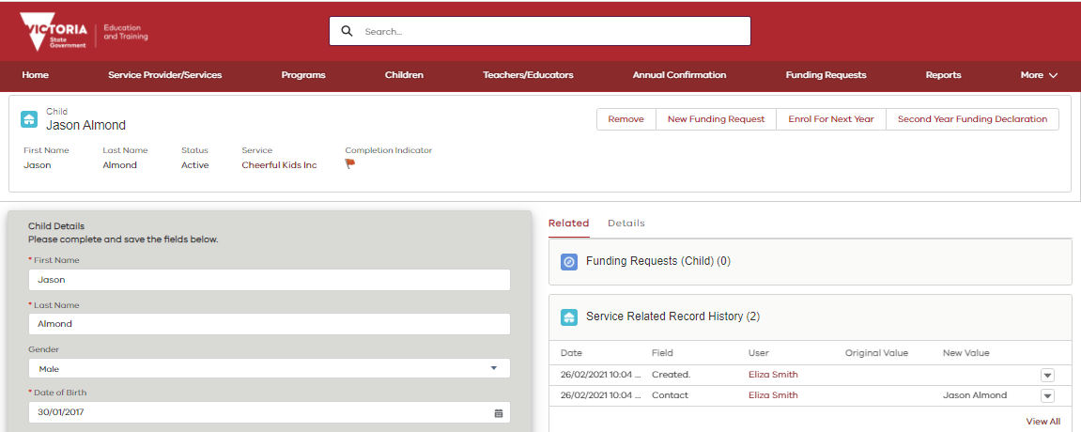

1
In the child details page of an eligible child

- Click on the Second Year Declaration button

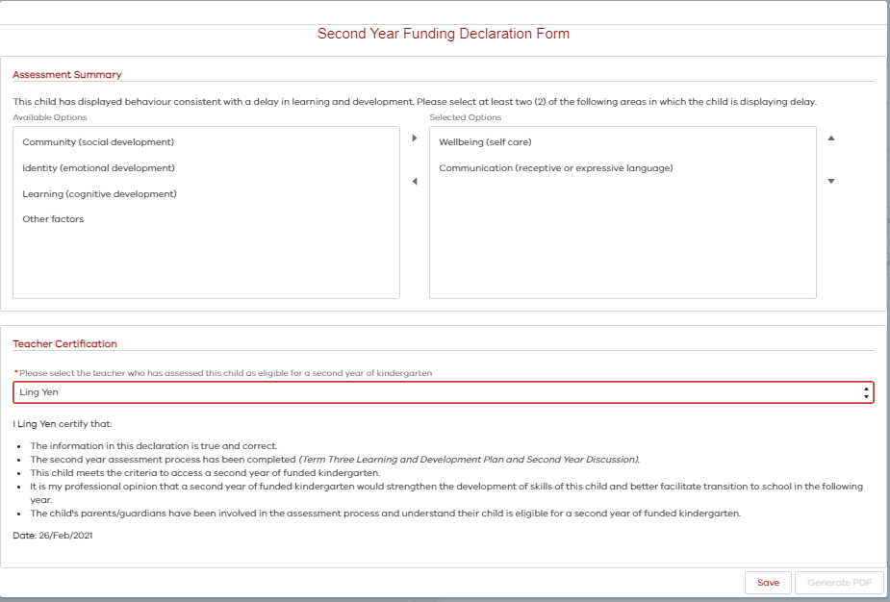
On the Second Year Declaration Form

1

2

3

4

- Select at least two (2) of the listed areas in which the child is displaying delay
- Click the right pointing arrow to move them into the Select options list
Note. To remove an area, click on the area and then click the left pointing arrow.
- Select the teacher who has assessed this child as eligible for a second year of kindergarten
Note. This teacher must already have a Teacher record against the Service.
- Click Save

Once the Second Year Declaration Form is completed and saved generate a pdf of the form by clicking Generate PDF, to give to the parent(s).
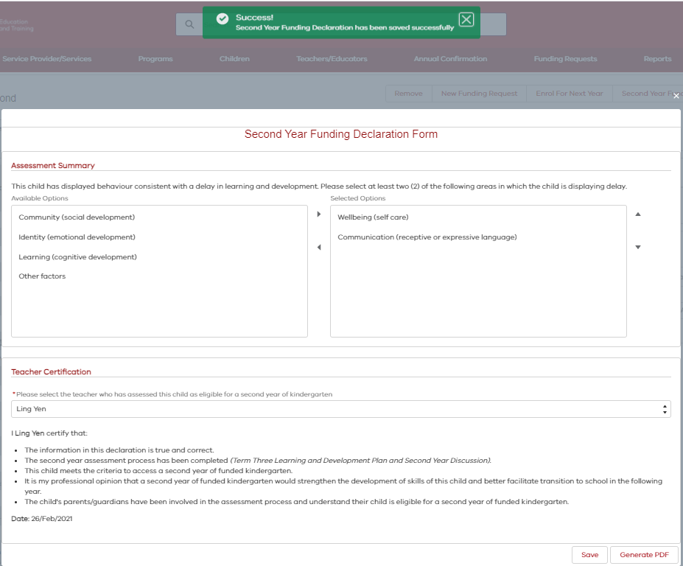
The PDF version of the Second Year Declaration will display.

- To download a verson of this form on your device, click on the download button, and then you can email this to the parent(s).
- Or, to print a version of this form click on the print icon and give the printed version to the parent(s).

1

2

