QUICK REFERENCE GUIDE

HOW TO UPDATE SERVICE PROVIDER DETAILS IN THE KINDERGARTEN INFORMATION MANAGEMENT SYSTEM (KIMS)
This guide provides step-by-step instructions on how to update a Service Provider’s details in KIMS.
Overview of how to update the Service Provider’s details:
- Go to the Service Provider /Service tab, on the Service Provider page, open the Service provider by clicking on the Service Provider Name
- In the Service Provider details page, provide the relevant updates to the Service Provider details in the fields provided
- Once the details are complete click Save to update

System Steps for updating Service Provide details
UPDATING SERVICE PROVIDERS DETAILS IN KIMS

1
In the Service Provider /Service tab, under the Service Provider page

- Click on the Service Provider Name that is being updated

In the Service Provider Details page  - Provide the Telephone and Email Address for the Service Provider. |  | 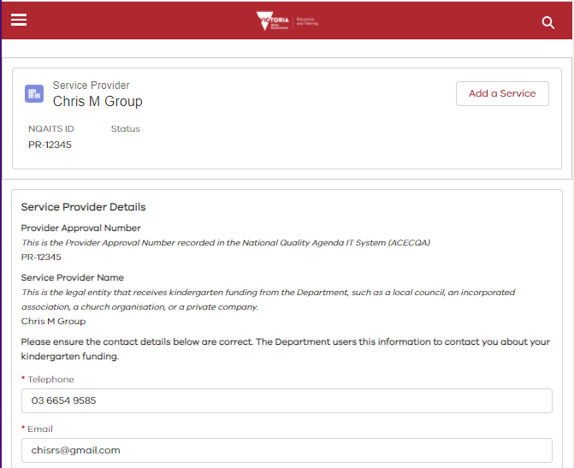
Update/Proivide the Emergency Contact Details for the service provider | 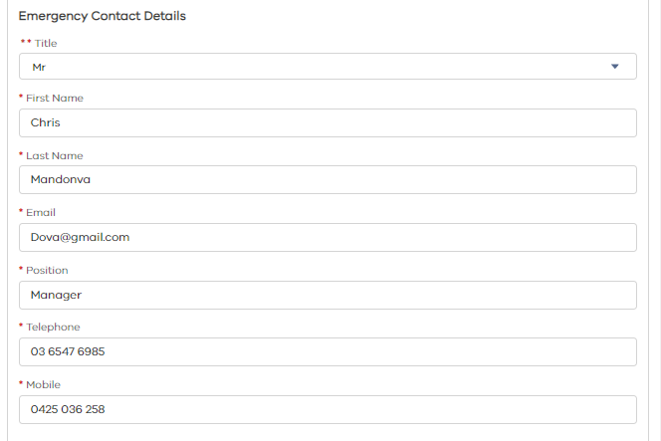
In the address section  - Update/Provide the postal address (if iddferent from the Princial Address)  - Indicate if the street address is the same as the postal address  - Update/Proivide the Prinicpal Address in Victoria  Once all the details have been updated  - Click Save |  |  | 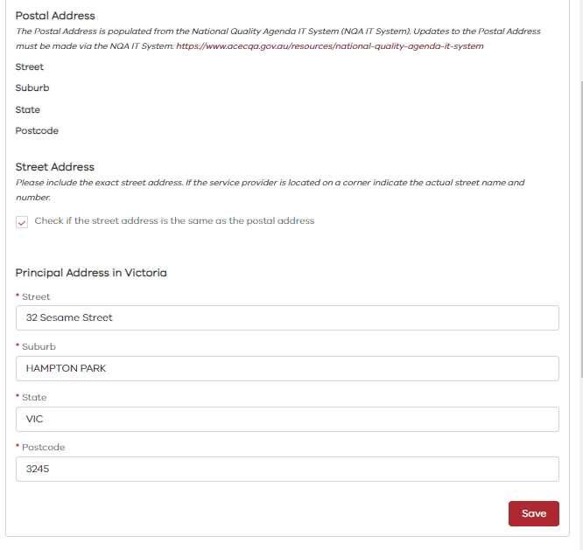  1  3  4  2

