QUICK REFERENCE GUIDE

HOW TO UPDATE SERVICE DETAILS IN THE KINDERGARTEN INFORMATION MANAGEMENT SYSTEM (KIMS)
This guide provides step-by-step instructions on how to update Service details in KIMS
Overview of how to update the Service details in KIMS:
- From the Service Provider /Service tab, go to the Services page, and then open the Service by clicking on the Service Name
- In the Service details page, provide/update the details in the fields provided
- Once the details are complete click Next
- Click Finish to finalise

System Steps for a updating Service details
UPDATING SERVICE DETAILS IN KIMS
In the Service Provider /Service tab

- Click on the Services page
- In the Services page, click on the Service Name of the service that is being updated

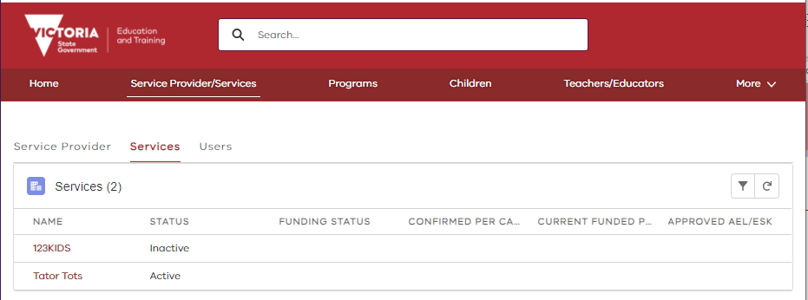

2

1

In the Service Details page  - Update/Provide the Emergency Contact Details for the service  - Answer the question: Does this service operate out of a Council owned facility?  - Answer the question: Is the only funded kindergarten the only program offered at this service?  Once the Service Details have been updated  - Click Next |  | 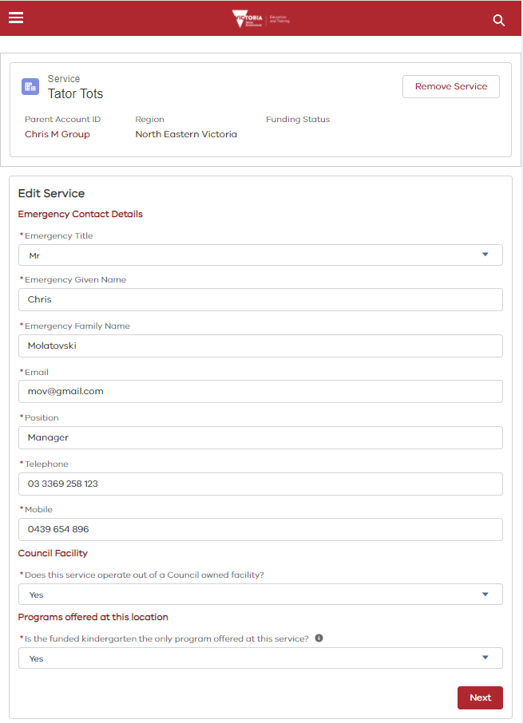  1  2  3  4
The Service has been updated  - Click Finish to finalise update | 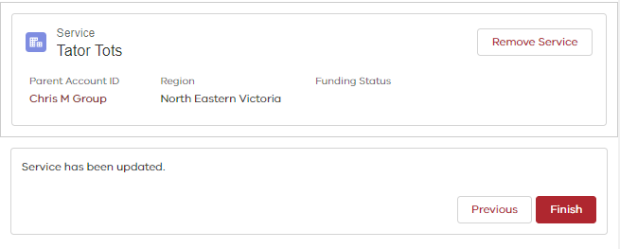  1

