QUICK REFERENCE GUIDE

HOW TO A SERVICE PROVIDER CAN ADD SERVICE IN THE KINDERGARTEN INFORMATION MANAGEMENT SYSTEM (KIMS)
This guide provides step-by-step instructions on how a Service Provider can add a new Service in KIMS.
Overview of how a Service Provider will add a Service to KIMS
- From the Service Provider / Service tab, on the Service Provider page, open the Service Provider record by clicking on the Service Provider Name
- Click the Add Service button
- Complete the New Service Form
- Once the details are complete click Save
- On the Service Details page click Submit
- Review the Service Details and click Save to finalise submission
The Request to create a new service has been submitted to the Department for review and approval by your local Early Childhood Improvement Branch.
Note:
You are able to save the Add Service application to complete and submit late. The saved application will display within the Applications tab on the main menu.

System Steps for adding a Service in the Kindergarten Information Management System
Adding a Service
In the Service Provider /Service tab, under the Service Provider tab:

- Click on the Service Provider Name that the Service is being added to

1

2
In the Service Provider record

- Click Add a service

Adding a Service
On the New Service Application  - Enter the Service Approval number (from the ACECQA National Register)  - Enter the Service Name  - Enter the date that the kindergarten program will/did commence at this location  - Enter the address of the Service  - Select the Local government area (LGA) that the service will/is operating in  - Enter the phone number and email address for the service  - Complete the emergency contact details for the service | 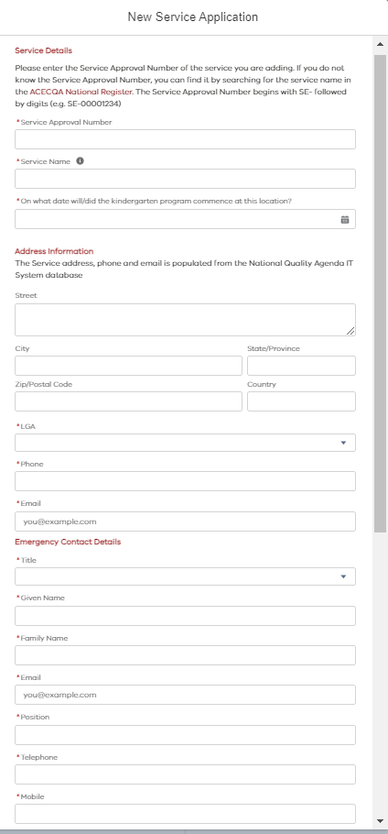  1  2  3  4  5  6  7

Adding a Service
On the Service Application (Continued)  - Is the service operated out of a council owned facility?  - Is the funded kindergarten the only porgam offered at this service?  Once all the details have been completed  - Click Save  Note. At this point you could leave the application and return to it later. | 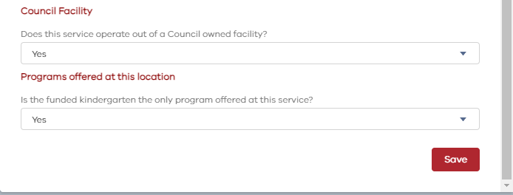  3  1  2

Adding a Service

1
The Details have been saved. To submit the application

- Click Submit

Review the details and  - Click Save  The submission has been completed, and the status of the application will update to Pending Approval. | 2

