QUICK REFERENCE GUIDE

HOW TO COMPLETE ANNUAL CONFIRMATION IN THE KINDERGARTEN INFORMATION MANAGEMENT SYSTEM (KIMS)
This guide provides step-by-step instructions on how to complete the Annual Confirmation process for a service in KIMS.
The Annual Confirmation process has been designed to flow in a systematic way to allow you to review the data that you have already entered, make any changes and then progress to the next step.
A chevron flow appears at the top and changes colour to green when that tab / set of data has been completed.
The Annual Confirmation Process:
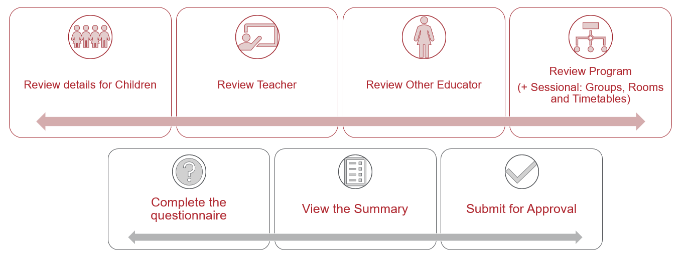
This diagram shows the seven key steps that are involved with completing the Annual Confirmation for your Service.

Overview of how to complete an Annual Confirmation in KIMS:
From the Annual Confirmation tab (main menu), open the Annual Confirmation by clicking on the Annual Confirmation Name for the current year. If the Annual Confirmation does not display under this tab, it means that the Annual Confirmation process is not open yet.
Step 1 – Children | - In the Children tab, review the children listed.  - Ensure all children have a green completion indicator flag.  - If you notice a red flag, use the Edit button to update any child’s details.  - Check the Ineligible Children tab for any children who are ineligible for funding. The reason for ineligibility will be displayed.  - If needed, update those child records to make sure they meet the criteria for eligibility eg add a Second Year Declaration.  - Once all the child records have been reviewed and are complete, click Next to proceed to the Teacher tab.
Step 2 – Teachers | - On the Teacher tab, review the teachers listed.  - Ensure all teachers have a green completion indicator flag, use the Edit button to update any details.  - Once all the teachers are complete, click Next to proceed to the Other Educators tab.
Step 3 – Other Educators | - On the Other Educator tab, review the other educators listed.  - Ensure all other educators have a green completion indicator flag, use the Edit button to update any details.  - If there is no educator assisting the teacher to deliver the funded kindergarten program for this service, click on the checkbox to indicate that there are no other educators aligned to this program.  - Once the other educator completion flags are green or the ‘no other educator’ checkbox has been ticked, click Next to proceed to the program details page.
Step 4 – Programs | - On the Program tab, review the program details.  - Ensure that the program has a green completion indicator, click the Edit button to update any details.  - Once the program has a green completion indicator flag, either click Next to progress to the Questionnaire, or for sessional kindergartens click on the Groups tab.
Step 4 a – SESSIONAL ONLY | - In the Groups tab, review the details.  - Ensure that all groups have a green completion indicator flag. To update a group, use the action buttons (edit, delete, assign child, and assign teacher.)  - Once all the group details are correct and have a green completion indicator flag, click on the Rooms tab.  - Check all of the room details and ensure they have a green completion indicator flag. To update rooms, click on the Edit button.  - Once all the room details are complete and have a green completion indicator flag, click on the Timetable tab.  - On the Timetable tab, check that all the timetable details are correct and have a green completion indicator flag. To update timetables, click on the Edit button.  - Once all the program details, group details, room details, and timetable details are correct, click Next to proceed to the questionnaire.
Step 5 – Questionnaire | - Complete all of the Questionnaire fields, then Click Save.  - Once all the Questionnaire details have been completed and saved, click Next to proceed to the Annual Confirmation Summary.
Step 6 – Review | - Check the Annual confirmation Summary details and click on the Check Eligibility button to review Eligibility details.  - Once all Annual Confirmation details have been reviewed, Tick the Eligibility checking acknowledgment box.
Step 7 – Certification | - Check that the certification details are correct and then tick the box to indicate that the Annual confirmation submission details are accurate. Once the form is complete, click Submit to submit the Annual Confirmation.
Note:
The Annual confirmation page chevron indicates the progression of the form.
Pages deemed complete by the system will appear green with a tick.
Pages deemed incomplete by the system will remain blue with the page name.
Use the Next and Previous button to toggle or move between pages.

Completing the Annual Confirmation in KIMS
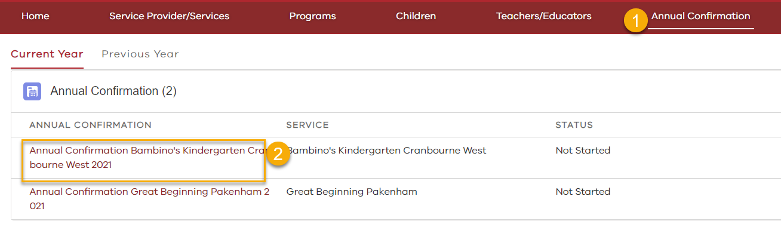
OPEN THE ANNUAL CONFIRMATION
On the Annual Confirmation page, click the Annual Confirmation Name in the current year to open it.

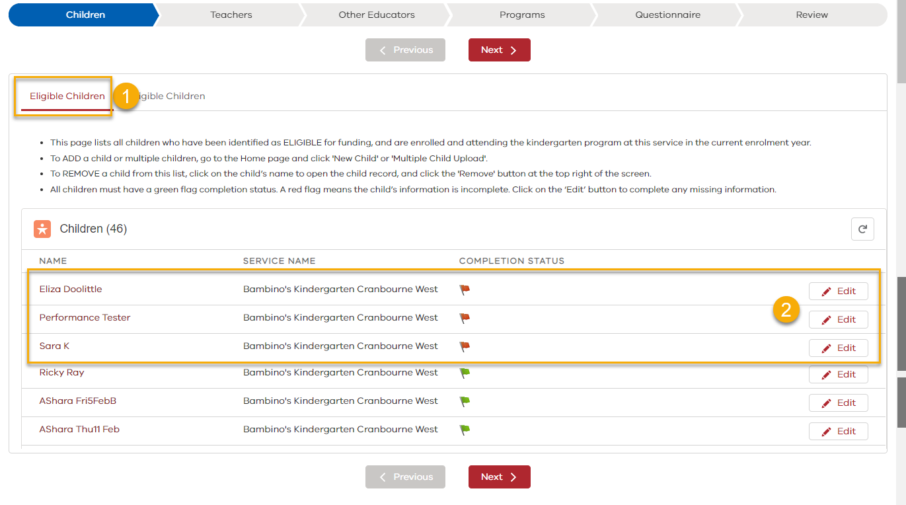
STEP 1 - CHILDREN

On the Children tab, review the Eligible Children tab ensure all children have a green completion indicator flag.
- To update any child details, click the Edit button to open the child record and address any fields that require completion.
- Child records which require completion display at the top, those that are completed (green flag) should display at the bottom of the page.

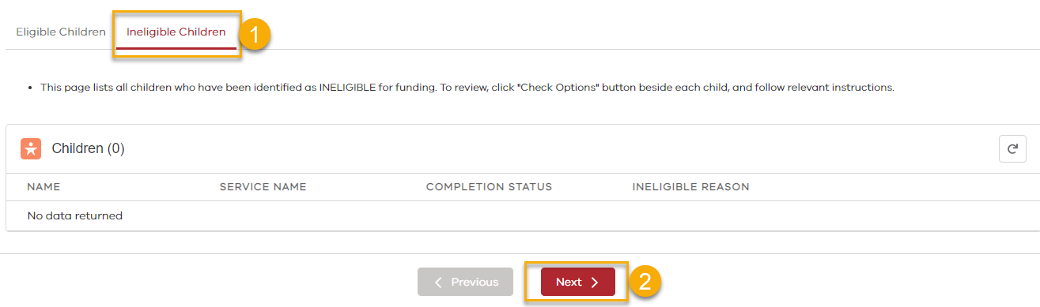
- Once all the Eligible children have a green completion indicator flag, click on the Ineligible Children tab.
- Review the list of ineligible children (if any) and follow any action required.
- Click Next to proceed to the Teacher page.

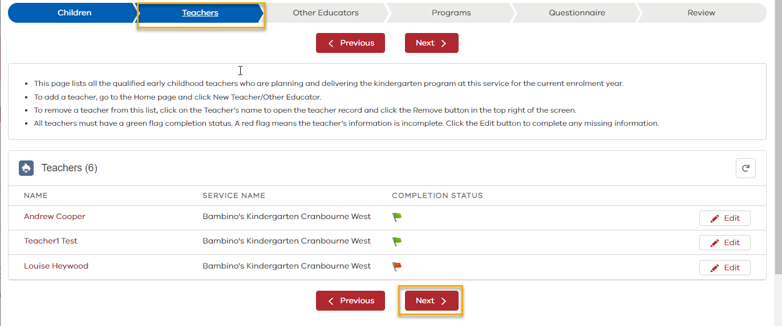
STEP 2 – TEACHERS
On the Teachers tab
- Review the teacher details.
- To update any Teacher details, click the Edit button.
- Once all the Teachers have a green completion indicator flag, click Next to proceed to Other Educators page.

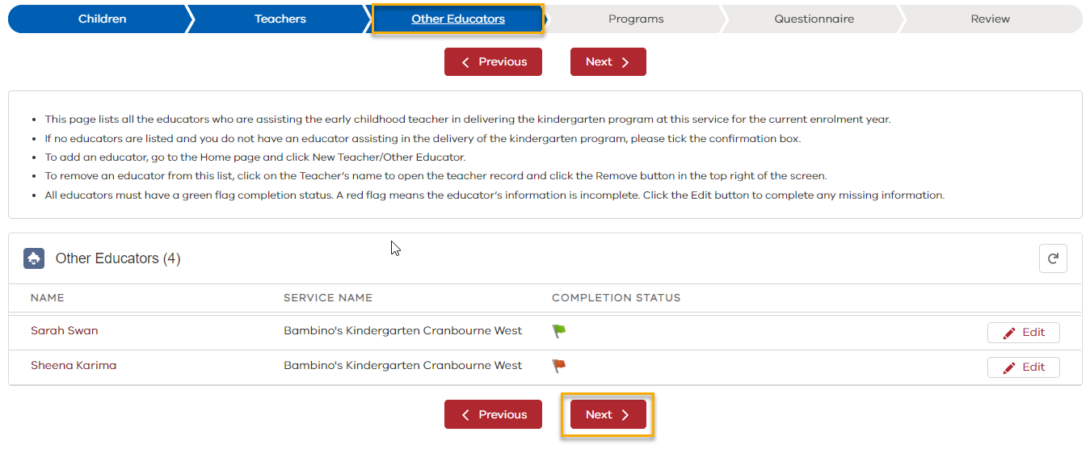
STEP 3 - OTHER EDUCATORS
On the Other Educators tab
- Review the Other Educators details
- Ensure all educators have a green completion indicator flag. To update educator details, click the Edit button.
- Or if there are no other educators assisting the teacher in delivering the funded kindergarten program, click on the checkbox to indicate that there are no educators aligned to this program.
- Once all educators are complete, or the ‘no other educator’ checkbox has been ticked, click Next to proceed to the program details page

Completing the Annual Confirmation in KIMS
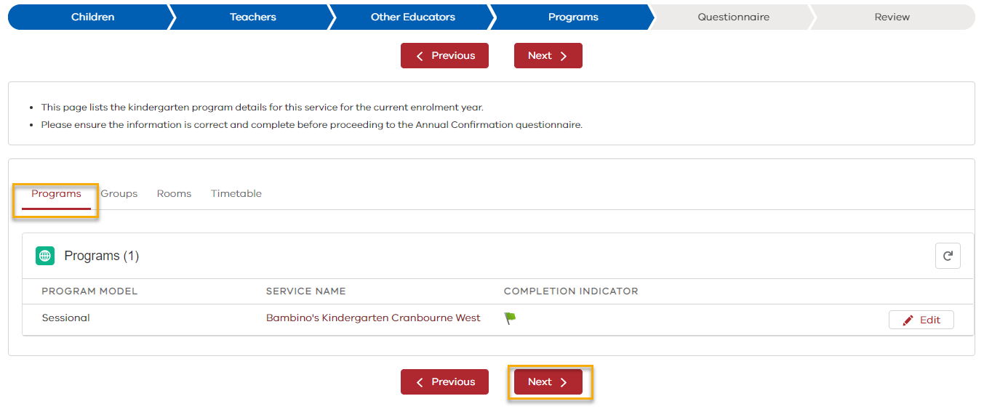
STEP 4 - PROGRAMS
On the Programs tab
- Review the program information to ensure all the programs have a green completion indicator.
- To update program details, click the Edit button.
- Once the program(s) have a green completion indicator flag, go to the next appropriate step:
  - For Sessional programs go to Groups
  - For Integrated in Long Day Care programs click Next, to go to the Questionnaire
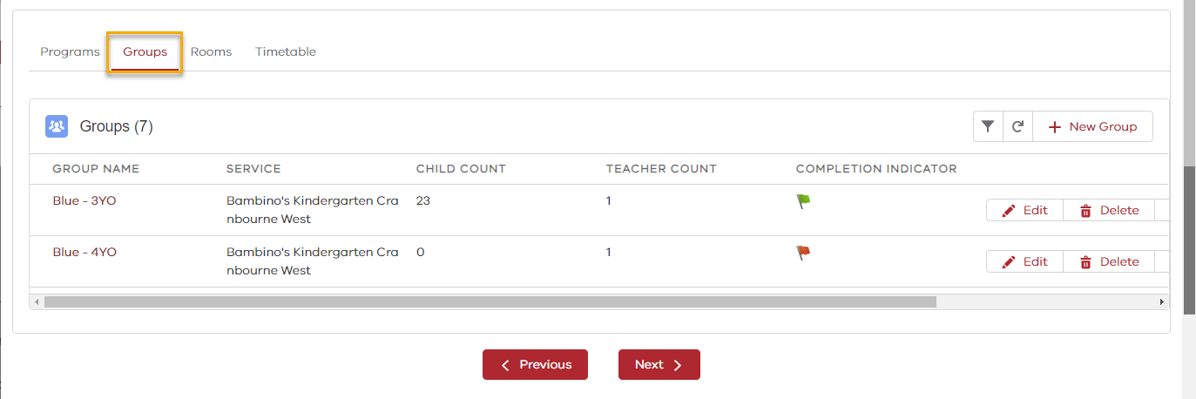
STEP 4a – SESSIONAL ONLY
In the Groups tab
- Review the Group details
- Ensure all the groups have a green completion indicator.
- To update group details, click the Action buttons (Edit, Remove, Assign Child, Assign Teacher).
- To create a new group, click + New Group
- Once the Group(s) are complete, click on the Rooms tab

Completing the Annual Confirmation in KIMS
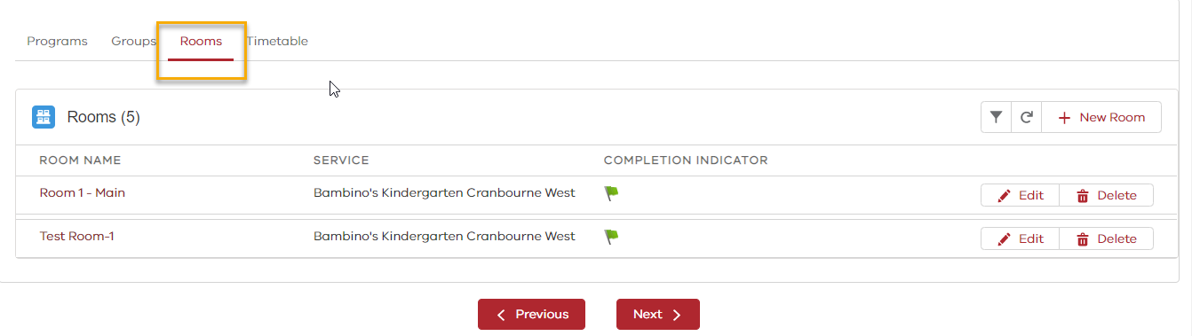
In the Rooms tab
- Review the Room details
- Ensure all the rooms have a green completion indicator
- To update room details, click the Edit button
- To add a new room, click + New Room
- Once the Room(s) are complete, click on the Timetables tab
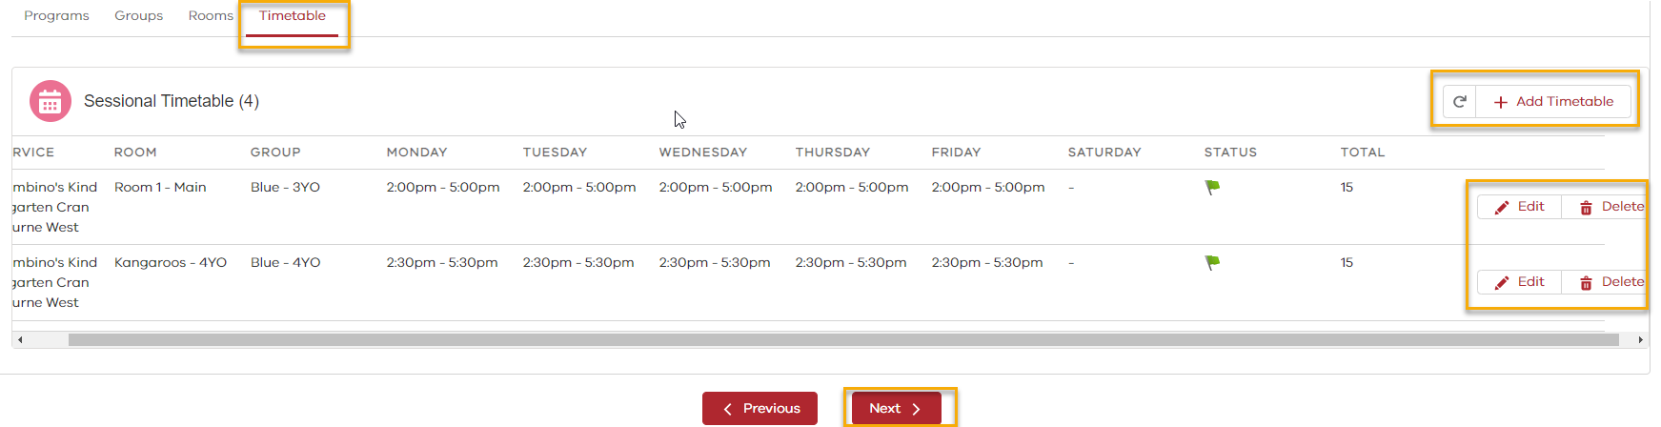
In the Timetable tab
- Review the Timetable information
- Ensure all the timetables have a green completion indicator
- To update timetables details, click the Edit button
- To add a new timetable, click + New Timetable
- To delete a timetable, click Delete
- Once all the service program details are correct and complete, click Next to continue to the Annual Confirmation Questionnaire page

Completing the Annual Confirmation in KIMS
STEP 5 - QUESTIONNAIRE
Ensure that the children, teacher, other educator, and program details for this service are correct prior to completing the Annual Confirmation questionnaire.
On the questionnaire provide answers for the following:
- Central Enrolment - Are children at your service enrolled via a Central Registration and Enrolment Scheme?
- Warp Around Care - Does this service offer before and/or after-program care?
- Fee Subsidy - Does this service have a fees policy that reflects the requirements of the kindergarten fee subsidy fees policy as outlined in the Kindergarten Funding Guide?
- Fee Subsidy - Last year, did payment of the kindergarten fee subsidy result in a surplus greater than $5000 for this service?
- Insurance cover at the service level – Is this service an incorporated association, co-operative or company limited by guarantee? (only asked for community-based service provider)
- Other qualified early childhood teachers - How many other staff with early childhood teaching qualifications are employed at this service? (If none, enter 0). If a number is entered, a new set of questions will display:
  - Please indicate the qualification level of these teachers
  - How many of these teachers are provisionally registered and intend to move to full teacher registration with the Victorian Institute of Teaching within the next 12 months?
  - Please enter the name and VIT number of the provisionally registered teachers
- Funding eligibility checklist:
  - Four-Year-Old Kindergarten Program – Each child is enrolled and attending a kindergarten program that is offered for a minimum of 15 hours of kindergarten per week for a minimum of 40 weeks per year (or 600 hours per year)
  - Three- Year-Old Kindergarten Program – Each child is enrolled and attending a kindergarten program that is offered for a minimum of 5 hours of kindergarten per week (only displayed if service is delivering a funded three-year-old kindergarten program
  - Written confirmation has been provided to parents that their child will receive a funded kindergarten program at this service
Click Save when the questionnaire has been completed or at any time to save the progress made on the questionnaire.
Once the questionnaire has been completed and Saved, click Next to view the Annual Confirmation Summary.
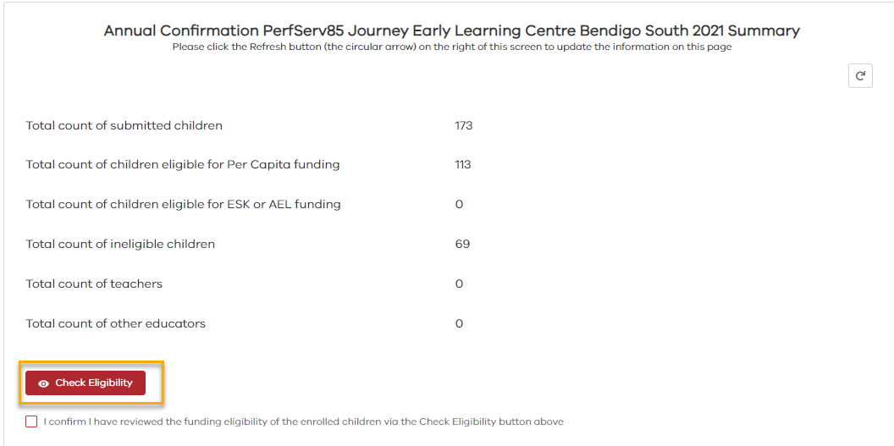
STEP 6 – REVIEW
On the Annual Confirmation Summary
- Check the Annual confirmation Summary details are correct
- Click on the Check Eligibility button to review Eligibility details.

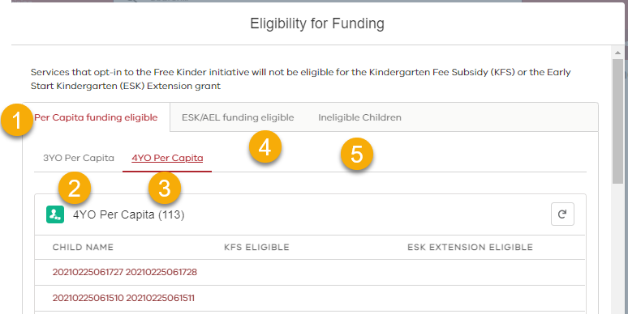
On the Eligibility for Funding page
Review Eligibility details
- Click on the Per Capita funding eligible tab
- Children eligible for 3YO per capita funding are listed under the 3YO Per Capita tab. If they are also eligible for KFS or ESK Extension, these columns will display ‘Yes’
- Children eligible for 4YO per capita funding are listed under the 4YO Per Capita tab. If they are also eligible for KFS or ESK Extension, these columns will display ‘Yes’
- AEL/ESK eligible children are listed under the ESK/AEL funding eligible tab
- Any children who are ineligible for funding are listed in the Ineligible Children tab

Completing the Annual Confirmation in KIMS
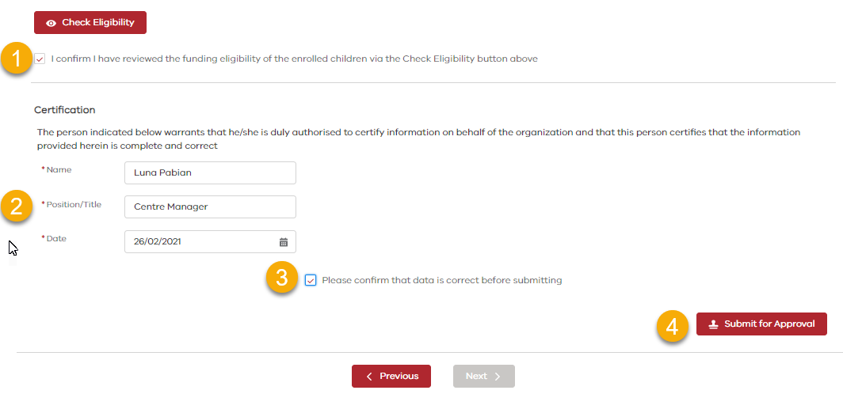
STEP 7 – CERTIFICATION

On the Annual Confirmation Summary Page (Continued)

- Once all Annual Confirmation details have been reviewed, tick the box acknowledging you have checked the eligibility of the children
- Check that the certification details are correct or amend if required
- Tick to confirm that the Annual confirmation submission details are accurate.
- Click Submit for Approval to submit the Annual Confirmation.

3
The Annual confirmaiton has been successfully submitted.

Note. The system will display a list of children it has identified as eligible for Early Start Kindergaten (ESK) or Access to Early Learning (AEL) funding. To apply for ESK or AEL funding for these children, click Apply for Funding.

