QUICK REFERENCE GUIDE

HOW TO ADD OR UPDATE A TEACHER IN THE KINDERGARTEN INFORMATION MANAGEMENT SYSTEM (KIMS)
This guide provides step-by-step instructions for adding a teacher in the Kindergarten Information Management System (KIMS).
A VIT registered teacher must be added in KIMS for each service delivering a funded kindergarten program(s). A teacher can be linked to multiple services and can also be transferred from one service to another service under the same service provider.
A teacher record can be edited at any time to ensure their details are up to date.
Once a teacher is added in KIMS, the record will remain in the system across enrolment years but can be removed (made Inactive) if the teacher leaves the service or no longer delivers the kindergarten program.
Overview process for adding or updating a Teacher in KIMS  - Navigate to the Home Page and click New Teacher/Other Educator  - Click New Teacher  - Click Next  - Select the service to assign the teacher to (if you have access to multiple services)  Note: If the service name does not prepopulate or appear in the drop-down list, begin typing the service name for it to appear  - Click Next  - Complete all the Teacher details (click Next or Previous to navigate between pages) | - Click Save once the form is complete  - The Completion Indicator flag will be green once all mandatory fields are completed.

System Steps for adding and updating a Teacher in Kindergarten Information Management System
ADDING A TEACHER
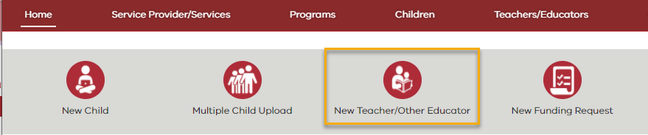

- Navigate to the Home Page and click New Teacher/Other Educator

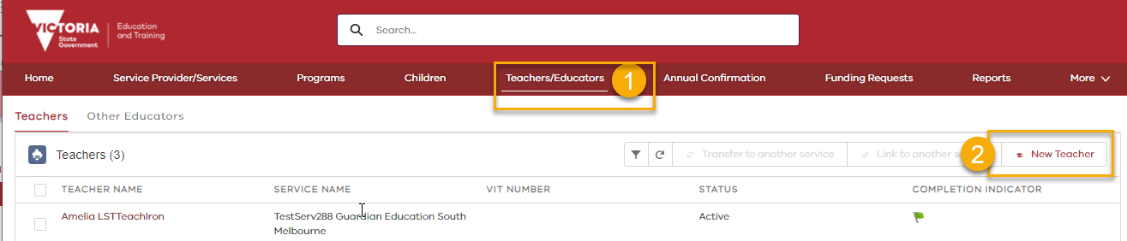
Note:
You can also add a Teacher via Teachers/Educators tab

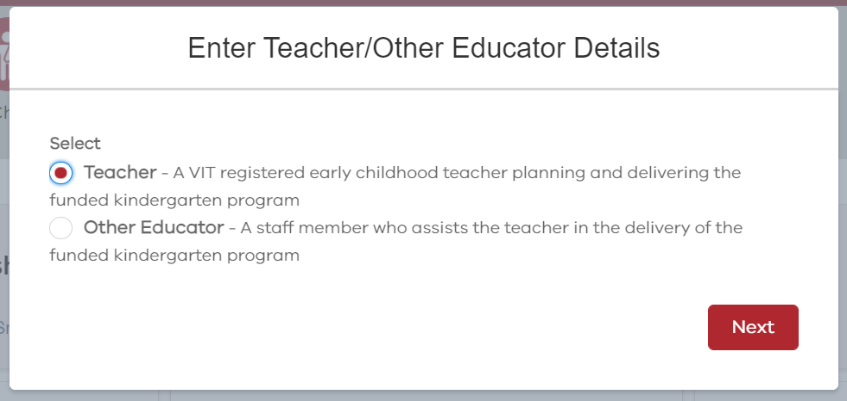
- Select Teacher

- Click Next

- If you have access to more than one service, select the service to assign the teacher to and then click Next

Note:

If the service name does not prepopulate or appear in the drop-down list begin typing the service name for it to appear.

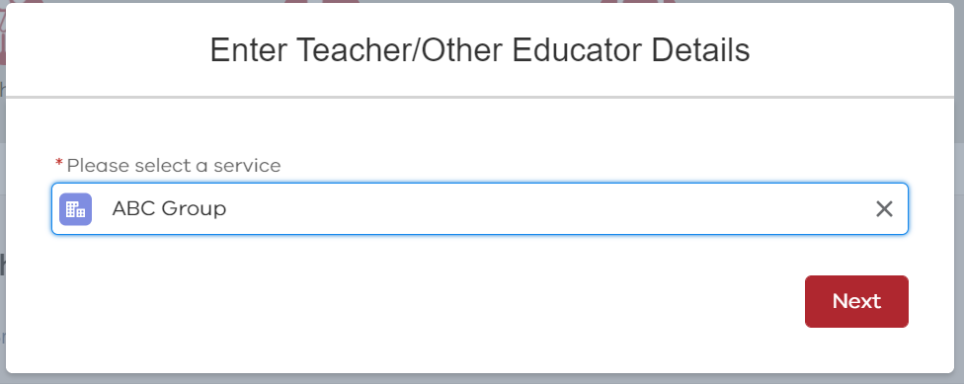
- Enter the following information for the Teacher:

- First Name
- Last Name
- Date of Birth
- Gender
- Registration status with VIT
- VIT Number (if VIT Registered)

Click Next
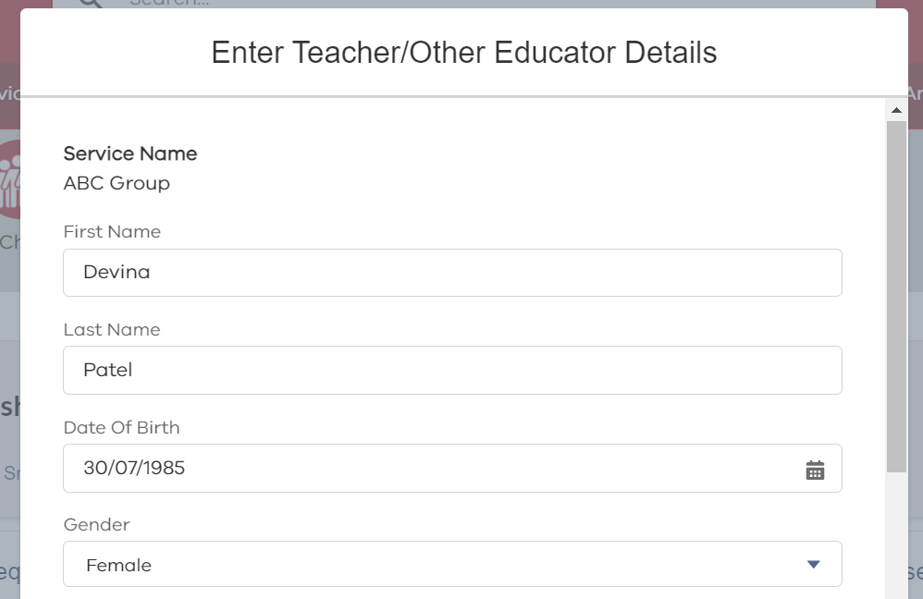
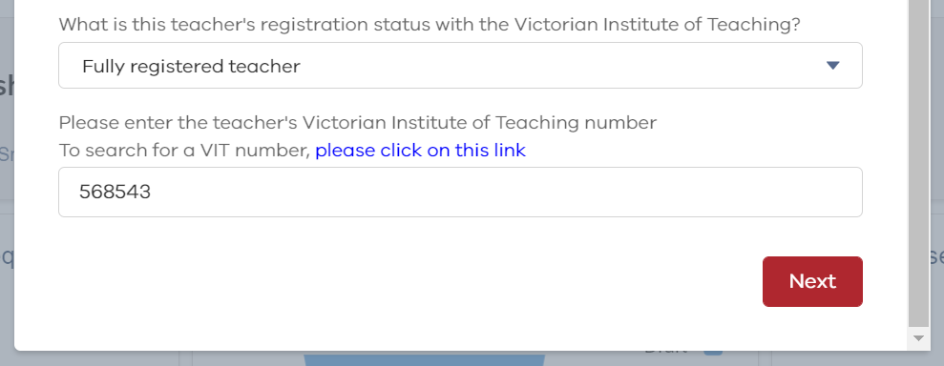

Fields on the Teacher Record
- The following table lists all the questions in the Teacher details form and options for answers.

Mandatory for completion | Field Name | Full Question | What options can I add in this field? | Notes
Yes | First Name | N/A | This is a free text field | Enter the Teacher’s first name
Yes | Last Name | N/A | This is a free text field | Enter the Teacher’s surname
Yes | Gender | N/A | Female | Select from list
 |  |  | Male
 |  |  | Other
Yes | Date of Birth | N/A | DD/MM/YYYY | When entering the birthdate ensure you add the "/"
Yes | VIT Status | What is this teacher's registration status with the Victorian Institute of Teaching? | Fully registered Teacher | Select from the list.
 |  |  | Provisionally registered Teacher
 |  |  | Provisionally registered Teacher and will apply for registration within the next 12 months
 |  |  | Not registered (and with temporary approval and service exemption)
Yes | VIT Number | Please enter the teacher's Victorian Institute of Teaching number | 6-digit number | A link to the VIT register is provided for you to check the VIT Number is correct.
Yes | Start date | When did this person commence employment as an early childhood teacher with this service provider? | DD/MM/YYYY | Enter a date using the format or select using the calendar icon
Yes | Qualification | Please indicate which of the following applies to this teacher's qualification | Early Childhood teaching qualification on the approved ACECQA list | Dependent on the answer selected, you will be asked questions about the teacher’s qualifications and/or be required to upload a letter of equivalency from ACECQA.
 |  |  | Early Childhood teaching qualification not on the approved ACECQA list or other qualification
Yes | In Australia | Did the teacher undertake their teaching qualification as an international student in Australia? | Yes
 |  |  | No
Yes | Hours of PD | Please indicate the total number of hours of professional development that was undertaken in the previous year by this early childhood teacher. If none, enter '0' | This is a free text field

Click Next, to go to the 2nd page of the form.

Required for Completion of Record | Field Name | Full Question | What options can I add in this field? | Notes
Yes | Total Hours | What is the total weekly hours worked by this teacher? | This is a free text field | Note:  The system checks that the total weekly hours worked by the teacher is within 5 hours of the total Contact and Non Contact hours.
Yes | Hours per week in the funded kindergarten program. | Contact hours: Hours | This is a free text field
Yes |  | Contact hours: Minutes | This is a free text field
Yes |  | Non contact hours: Hours | This is a free text field
Yes |  | Non contact hours: Minutes | This is a free text field

Required for Completion of Record | Field Name | Full Question | What options can I add in this field? | Notes
Yes | Hours per week in any other program. | Contact hours: Hours | This is a free text field
Yes |  | Contact hours: Minutes | This is a free text field
Yes |  | Non contact hours: Hours | This is a free text field
Yes |  | Non contact hours: Minutes | This is a free text field
Yes | Employment | What is the teacher’s employment status? | Permanent
 |  |  | Temporary
 |  |  | Casual
Yes | Award | Please select the award or industrial agreement used in the employment of this early childhood teacher in the kindergarten program | Victorian Early Childhood Teachers and Educators Agreement 2016 (VECTEA) | Select from list
 |  |  | Early Education Employees Agreement 2016 (EEEA)
 |  |  | Children’s Services Award (2010)
 |  |  | Educational Services (Teachers) Award 2010
 |  |  | Education Services (Schools) General Staff Award 2010
 |  |  | A local council agreement with EEEA appended
 |  |  | A local council agreement (no EEEA appended)
 |  |  | Other agreement equivalent to VECTEA or EEEA
 |  |  | Other
Yes – if a VECTEA or EEEA Award is selected | Classification | Please indicate the level at which the teacher is classified and paid |  | Select from list

ADDING A TEACHER
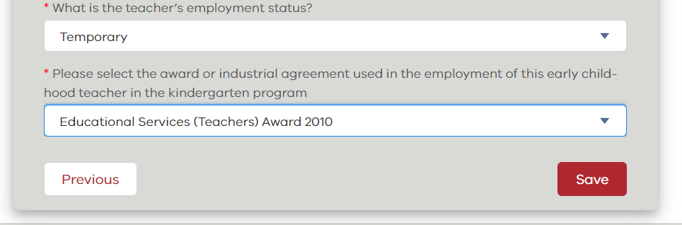
- Click Save once the form is complete

Notes:

Click Previous to return to the first page of the form to confirm or update any of the responses.

The Save button is at the bottom of the second page.

- Click Close

- The Teacher profile is complete if the Completion Indicator is green.

Note: The teacher details can be updated at any time. Remember when updating details to click Save on the second page of the form.
