QUICK REFERENCE GUIDE

HOW TO ADD OR UPDATE AN OTHER EDUCATOR IN THE KINDERGARTEN INFORMATION MANAGEMENT SYSTEM (KIMS)
This guide provides step-by-step instructions for adding an other educator in the Kindergarten Information Management System (KIMS).
An other educator record can be edited at any time to ensure their details are up to date.
Once an other educator is added in KIMS, the record will remain in the system across enrolment years but can be removed (made Inactive) if the other educator leaves the service or no longer delivers the kindergarten program.
Overview process for adding or updating an Other Educator in KIMS  - Navigate to the Home Page and click New Teacher/Other Educator  - Click Other Educator  - Click Next  - Select the service to assign the other Educator to (if you have access to multiple services)  Note: If the service name does not prepopulate or appear in the drop-down list, begin typing the service name for it to appear  - Click Next  - Complete all the Other Educator details (click Next or Previous to navigate between pages) | - Click Save once the form is complete  - The Completion Indicator flag will be green once all mandatory fields are completed.

System Steps for adding and updating an Other Educator in Kindergarten Information Management System
ADDING AN OTHER EDUCATOR
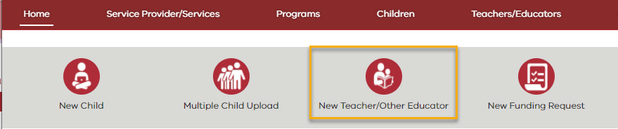

- Navigate to the Home Page and click New Teacher/Other Educator

- Select Other Educator

- Click Next
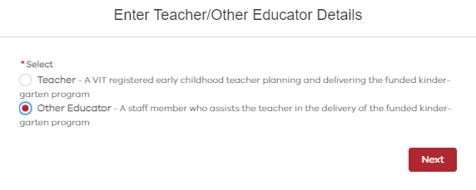

2

3
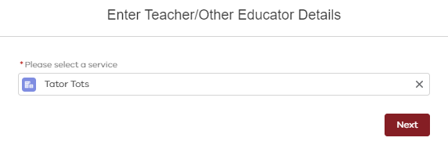
- If you have access to more than one service, select the service to assign the other educator to and then click Next

Note: If the service name does not prepopulate or appear in the drop-down list begin typing the service name for it to appear.

- Enter the following information for the Other Educator:  - First Name  - Last Name  - Date of Birth  - Gender  Click Next | 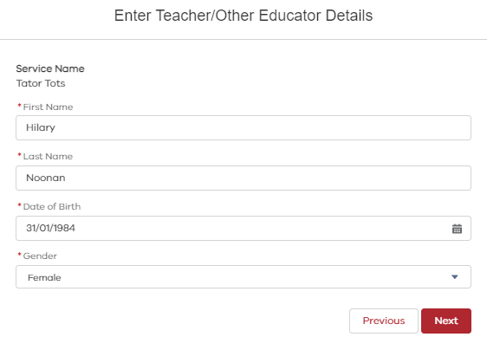

Fields on the Other Educator Record
- The following table lists all the questions in the Other Educator details form and options for answers.

Mandatory for completion | Field Name | Full Question | What options can I add in this field? | Notes
Yes | First Name | N/A | This is a free text field | Enter the Other Educator’s first name
Yes | Last Name | N/A | This is a free text field | Enter the Other Educator’s surname
Yes | Gender | N/A | Female | Select from list
 |  |  | Male
 |  |  | Other
Yes | Date of Birth | N/A | DD/MM/YYYY | When entering the birthdate ensure you add the "/"
Yes | Highest Teaching Qualification | What is the highest qualification or teaching qualification this educator holds? | Certificate 3 in Children's Services (or equivalent) | Select from the list.
 |  |  | Diploma in Children's Services (or equivalent)
 |  |  | Early Childhood Teaching Degree (3 or 4 years)
 |  |  | Kindercraft Assistant
 |  |  | Level III Community Services Nanny Certificate
 |  |  | Mothercraft/Mothercraft Nurse Certificate
 |  |  | Pre-school Teachers Aide Certificate
 |  |  | Primary Teaching Degree
 |  |  | Teacher Assistant Certificate
 |  |  | University Preparation Course (Education Assistant Program)
 |  |  | University Preparation Course (Education Assistant: Special Needs)
 |  |  | Professional development in lieu of minimum training (Grandfathering)
 |  |  | None
Yes | Please select which award or industrial agreement is used in the employment of this early childhood educator in the funded kindergarten program | N/A | Victorian Early Childhood Teachers and Educators Agreement 2016 (VECTEA) | Select from the list
 |  |  | Early Education Employees Agreement 2016 (EEEA)
 |  |  | Children's Services Award (2010)
 |  |  | Educational Services (Teachers) Award 2010
 |  |  | Education Services (Schools) General Staff Award 2010
 |  |  | A local council agreement with EEEA appended
 |  |  | A local council agreement (no EEEA appended)
 |  |  | Other agreement equivalent to VECTEA or EEEA
 |  |  | Other
Yes | Please indicate the total number of hours of professional development that was undertaken in the previous year by this educator. If none enter '0'. | Hours | Free text (Numeral) | If none enter '0'.
 |  | Minutes | Free text (Numeral)
Yes | Hours worked in any program other than the kindergarten program for children in the year before school at this service. If none enter '0'. | Hours | Free text (Numeral) | If none enter '0'.
 |  | Minutes | Free text (Numeral)
Yes | What type of contract is the educator employed on? | N/A | Permanent | Select from the list.
 |  |  | Temporary
 |  |  | Casual
Yes | Is the educator currently completing a teaching degree in early childhood? | N/A | Yes | Select from the list.
 |  |  | No

ADDING AN OTHER EDUCATOR
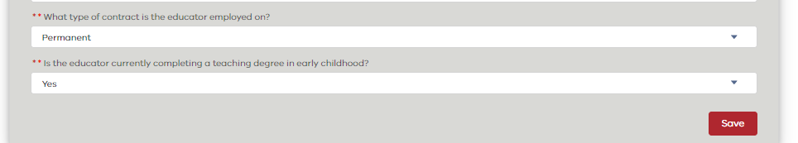
- Click Save once the form is complete

- Click Close

- The Other Educator profile is complete if the Completion Indicator flag is green.

Note: The other educator details can be updated at any time. Remember when updating details to click Save.

