Kindergarten Infrastructure and
Services Plan
City of Greater Geelong
CONTENTS
1. Introduction 3
1.1. Reform context 3
1.2. Purpose of KISPs 3
1.3. How to use the KISP 3
1.4. Structure of the KISP 3
1.5. Disclaimer 4
2. Map of Early Childhood Education services in City of Greater Geelong 5
3. Local context 7
3.1 Purpose 7
3.2 Key considerations 7
4. Funded kindergarten enrolment estimates between 2021-29 for City of Greater Geelong 8
4.1 Purpose 8
4.2 Methodology 8
4.3 Summary of current kindergarten provision 9
4.4 Approach to optimising the use of existing services and infrastructure 10
4.5 Agreed estimates of demand for funded kindergarten places that cannot be met through existing services and infrastructure 12
5. Authorisation 17

Introduction

Reform context
In an Australian first, the Victorian Government has committed to implement Three-Year-Old Kindergarten for all children over a 10-year roll-out with a total investment of almost $5 billion, including $1.68 billion to support the infrastructure expansion required for the reform. This reform will add another year of universal funded kindergarten so that, by 2029, all children in Victoria will have access to two years of play-based learning through a funded kindergarten program.

Purpose of KISPs
Three-Year-Old Kindergarten will require a large expansion of kindergarten across the State. The Government has invited all 79 Victorian Local Governments to discuss and agree upon a Kindergarten Infrastructure and Services Plan (KISP) for their Local Government Area (LGA).
Each KISP has been jointly developed with Local Government and published to estimate the growth in demand for kindergarten within the LGA. The KISPs will help all kindergarten providers meet demand and provide a clear picture of infrastructure need across the State.
While a KISP is not a funding document and does not define required infrastructure projects or commit any party to funding specific projects, it is expected that future investment requests through Building Blocks and funding decisions about Local Government and not-for-profit projects would align with the relevant KISP.

How to use the KISP
Each KISP contains estimates of future kindergarten supply of, and demand for, Three and Four-Year-Old Kindergarten places against existing enrolment capacity. Not-for-profit and for-profit providers can use these estimates to inform their plans to expand kindergarten programs, establish new services or invest in new or extended facilities.
For example, KISPs provide demand estimates in terms of where, when and how much demand for kindergarten places will grow in an LGA. KISPs also estimate where and how many kindergarten places providers can accommodate in existing facilities before an area needs new infrastructure to meet demand. The estimates can be used to inform decisions about where and when expansions of kindergarten program capacity and the construction of new or extended facilities are needed to meet demand growth.
Where there is an agreed KISP for the LGA, the Local Government and not-for-profit kindergarten providers seeking co-investments through the Building Blocks Capacity Building stream must refer to, and align their proposed project with, the infrastructure need identified in the KISP.

Structure of the KISP
Each KISP consists of the following sections:
- Section 1: A short introduction to the Three-Year-Old Kindergarten reform and the KISP.
- Section 2: A map of existing and planned Early Childhood Education and Care service locations.
- Section 3: Local knowledge and context relevant to the expansion of kindergarten services.
- Section 4: Funded kindergarten demand estimates.

Disclaimer
All data presented in this document are estimates only and are based on the best information available to the Department and Local Government at the time. They are published on an as-is basis and are for informational purposes only. They are subject to adjustment in response to market forces and as new data and other relevant information becomes available. The data may under- or over-estimate both total demand in a given location or year and the capacity for new demand to be met by providers. As a result, operational and business decisions should not be made solely based on this document. Any use of this data is solely at the risk of the user. The Department and Local Government accept no responsibility for any loss or damage, either direct or incidental, that may result from the use of the data.

Map of Early Childhood Education services in City of Greater Geelong
The map below shows the distribution of currently operating and new services that are planned to open in the future in the LGA and across its communities.
This map has been prepared using Departmental data, from both the National Quality Agenda IT System (NQAITS) and the Victorian School Building Authority (VSBA). Where applicable, this map has been refined by the Geelong City Council and the Department to capture other services that are planned to open in the future.
Note: In some instances, SA2s overlap multiple LGAs. Where this occurs, the SA2 and any services within it, are allocated to the LGA that it has the greater land area in. As a result, services that sit within these SA2s have been excluded from the diagram below as they are represented on the neighbouring LGA’s map.
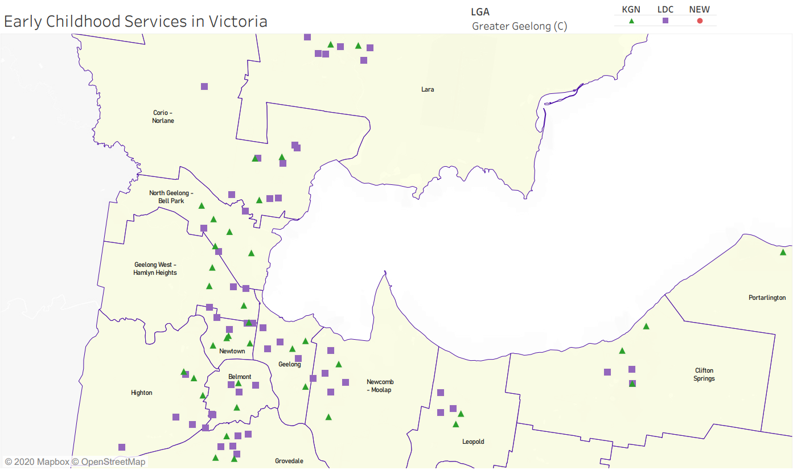
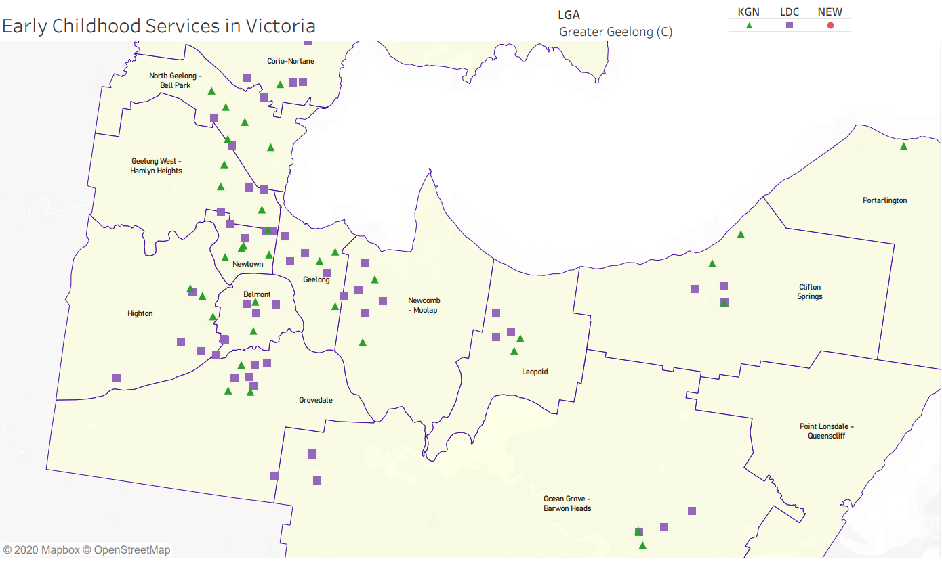

Local context
d

3.1 Purpose
Local, place-based knowledge and context play an important role in supporting the implementation of Three-Year-Old Kindergarten across Victoria. This section of the KISP documents this knowledge and context and has informed the funded kindergarten enrolment estimates in Section 4.

3.2 Key considerations
Key demographic trends that influence demand for kindergarten
Location and Demographic Trends
The City of Greater Geelong is a wonderful place to bring up children and we are committed to continually improving on our liveability and the support offered to all families across the municipality.

The City of Greater Geelong has a total population of 260,280 people and is Victoria’s second largest regional municipality. It covers an area of 1,247km2 comprising suburban, coastal and country areas and is bounded by Moorabool Shire, Wyndham City Council, Borough of Queenscliffe, Surfcoast Shire and Golden Plains Shire. The population is diverse and is expected to increase to 393,216 by 2041.

Geelong has a number of identified growth areas across Geelong with the North and Western Growth Area the largest greenfield planning project in regional Victoria. The North and Western Growth area is anticipated to accommodate a further 110,000 new Geelong residents.

Together with the forecast growth, Geelong has a reasonable proportion of households with children 15.3%, with a larger proportion of single parent households with young children. In some parts of greater Geelong there are high levels of cultural diversity, with some suburbs experiencing high levels of socio-economic disadvantage according to the 2016 Census with a score of 994.

According to the 2018 Australian Early Development Census, 21.4% of children in Greater Geelong are vulnerable on one or more domains and 11% vulnerable on two or more domains. The number of children who are vulnerable on one or more developmental domain(s) or two or more developmental domains is showing a continual increase up from 17.8% in 2015 vulnerable on one or more domains and 8.7% vulnerable on two or more domains.
Strategic Directions and Leadership
Our Clever & Creative Vision together with the Municipal Public Health Plan 2018-2021, Social Infrastructure Plan 2020, Municipal Early Years Plan 2018-2022 and Social Equity Principles, all support investment and delivery of early years infrastructure and services to ensure a thriving community. It is important that there is a mix of provision and choice when selecting early years services and continual reviews are undertaken to ensure the planning is responsive to changing needs while also being socially, financially, culturally and environmentally sustainable.
We recognise the leadership, advocacy and partnership role we play within the community and early childhood industry to promote the welfare and education of children and to provide high quality services that are accessible and equitable to all families; including people encountering economic and social disadvantage.
Factors influencing demand for kindergarten
Geelong has a strong participation rate of children attending kindergarten with 96% percent of children enrolled in a kindergarten program, higher than the Victorian average of 92%. The number of four-year old kindergarten enrolments in a long day care or integrated children’s service setting has been steadily increasing over the last ten plus years.
Provisions of Facilities and Services
While we provide a range of infrastructure that supports services for children and families across Greater Geelong, early childhood services are provided by a mix of public, private, and not-for-profit providers. Only 7% of the total early years’ service delivery (across all early years’ services) is delivered by the City of Greater Geelong. We provide 57% of the buildings that deliver kindergarten programs and 16% for long day care. Council owned kindergarten buildings are leased to Early Years Managers and community groups who deliver the kindergarten program. Kindergarten programs operating within council’s long day care facilities are delivered by accredited council staff.

In 2020, council adopted the Social Infrastructure Policy and Social Infrastructure Plan 2020.
Our statement of commitment as follows:
- Social infrastructure (including access to services such as kindergarten, long day care, maternal and child health) is essential for the health wellbeing and economic prosperity of the community
- Putting our community first – means using evidence and insights to delivery equity and access for all
- Exploring new opportunities and embracing new ways of working; to ensure the community gets the social infrastructure it needs
The Plan identifying the following strategic focus areas for early years infrastructure and services:
- Integrate family services
- Prepare for sector growth
- Strengthen partnership / service model
- Deploy services where and when they are needed.
Working Better Together
The recent legislation changes and the need to provide every three-year-old in Victoria with access to 15 hours of subsidised kindergarten by 2029, combined with the existing strategic challenges of growth, asset renewal, funding and service capacity means that it will be important for us to work better together with other levels of government, services providers and users to understand the implications and demands on services and infrastructure now and into the future. We will need to work better together to understand infrastructure capacity, service delivery, operation models and community needs, developing a joint response plan that is fair and equitable, adaptive and responsive.

Projects or trends that may influence supply of early childhood education and care
Changes in policy directions
Changes in policy directions, including funding models of three and four-year old kindergarten, the shift from stand-alone facilities to integrated and co-located facilities and services, such as kindergartens on school sites means existing models need to be re-viewed and re-assessed.
Participation in kindergarten programs
Geelong has a strong participation rate in funded four-year-old kindergarten of 96% which has been consistent over the last three years.
COVID-19 impacts
The impacts of COVID-19 are yet to be fully realised, including the flow on effects to the early childhood sector. Changes to funding, free four-year old kindergarten and more people working from home may change the way in which people prefer to access services in their local community. Early indicators are suggesting a reduction in planning applications in some locations from the private sector for the delivery of long day care. The migration of people to regional areas is also likely to have an increase on demand.
Models of delivery and partnership opportunities
As we work through the impacts to infrastructure and services as a result of the changes to three and four year old kindergarten funding and COVID-19, we will need to work with early years managers and service providers on models of delivery and change management options while continuing to provide support to private operators for funding applications that can support increases in service capacity that respond to areas of highest need.
Asset renewal and changes in service needs
The aging portfolio of our early years infrastructure in existing communities combined with changes in service needs is placing additional pressure on the need to increase investment in asset renewal, redevelopment and maintenance. The Social Infrastructure Plan 2020 and supporting policy outlines council’s investment in early years infrastructure over the next four years.
Growth and development
Geelong is experiencing significant development and population growth. To accommodate the needs of new communities, development contribution plans are established where necessary to partially fund new infrastructure provision, however council needs to budget for the balance placing continued pressure on the overall resources and budgets. Grant opportunities are continually explored to help offset the cost to council.
Funding limitations
Rate capping and reduced grant funding continues to be a challenge, like many other LGA’s and we are continually managing competing needs, demands and expectations.
Workforce Planning
The changes to three and four-year kindergarten funding will have a flow on effect to workforce planning, which will require a well-considered and strategic response in addition to infrastructure investment and service modelling changes.
Family needs
The need to access longer kindergarten sessions is becoming more and more evident with families needing to access longer days. Session flexibility and adaptability will need to be considered across all suburbs together with local area data and community demands.
Key local geographic considerations or information relevant to Three-Year-Old Kindergarten
Planning Areas
For planning purposes, the municipality has been divided into 15 planning areas that consider existing social infrastructure and services, current and forecast population and local area trends to determine future investment needs. From the recent Social Infrastructure Plan 2020, Growth Area Planning and the outcomes from Kindergarten Infrastructure and Services Plan we have identified some key areas where investment in infrastructure and services will be required in the next five years.
We recognise that some planning areas have better provision of facilities and services than others, and we will continue to ensure our social equity principles are applied when considering and prioritising investment.
Focus Areas through infrastructure investment and / or service change
This KISP identifies unmet demand in various areas across the municipality. This unmet demand is the key driver of infrastructure growth and is a key focus of investment to support the rollout of the three-year-old kindergarten program. This program rollout will be supported in those areas without unmet demand through service model changes and, where required, minor infrastructure improvement works.
It will be important for us to work together with the DET, service providers and the community to understand the best and most sustainable models of delivery to ensure our communities have the best possible access to the spaces and services they need.
Movement and shifts between and across suburbs
We recognise there is continual movement and shifts between services and suburbs which have a continual impact on the data, number of places available and demand for services. Regular reviews of the data are required to ensure planning and response models are reflective of any new information, policy changes and data shifts. Reviewing the data together with the local area birth rates will also assist to inform future needs.

Other information about the expansion of early childhood services
It will be important for us to continually review the Kindergarten Infrastructure and Services data and needs of the community. We will need to work in partnership with others to ensure child and family services are equitable, accessible, adaptable, integrated and sustainable to meeting our Social Infrastructure Policy objectives and Clever and Creative Vision. We will need to do this by
- Advocating and demonstrating leadership
- Working with others and developing partnerships
- Planning and co-ordinating early years infrastructure and services
- Working together on opportunities and change management strategies
- Sharing information
- Continually reviewing evidence, data and insights
- Working together to developing strategic response plans.

Funded kindergarten enrolment estimates between 2021-29 for City of Greater Geelong

4.1 Purpose
As Three-Year-Old Kindergarten is rolled-out and Victoria’s population grows, demand for both Three and Four-Year-Old Kindergarten places will increase significantly. While additional capacity will be needed to meet this demand, this will vary across the State and over time, due to differences in the capacity of existing services, growth trends and sector composition.
To identify where, when and how many additional kindergarten places are expected over the roll-out in City of Greater Geelong, Greater Geelong City Council and the Department have developed:
- A summary of the current provision of kindergarten within the LGA (Section 4.3).
- An approach to optimising the utilisation of existing services and infrastructure through ‘change management’ strategies that Greater Geelong City Council and the Department will support to help meet additional demand in the LGA (Section 4.4).
- An estimate of the Three and Four-Year-Old kindergarten places that cannot be met through existing services for the 2021-29 period, taking into account the additional demand that can be accommodated by optimising utilisation of existing services and infrastructure through point 2, above (Section 4.5).
Local Government and providers can use these published estimates to inform reform implementation activities such as service planning, kindergarten program expansion, infrastructure investments and Building Blocks funding applications in alignment with future demand over the 10-year roll-out.

4.2 Methodology
The estimated Three and Four-Year-Old Kindergarten places used in the following sections have been agreed between Greater Geelong City Council and the Department, and were informed by:
- Estimates developed by the Department which draw on a range of inputs, including population forecasts, current enrolments and results from the Kindergarten Capacity Assessment Program (KCAP), conducted in 2019.
- The estimated capacity of new services that are planned to open in the LGA (Section 2)
- Local knowledge and context provided by the Local Government (Section 3) that explains particular issues and trends in their area.
- The approach to optimising utilisation of existing services in the LGA (Section 4.4), and
- Other sources, such as modelling undertaken by Local Governments and local data.
The KISP measures a service’s capacity to deliver funded kindergarten in terms of the number of children it could enrol in Three and Four-Year-Old Kindergarten. The number of funded kindergarten places is different from a service’s licensed or approved places, which count the number of children permitted to attend the service at any one time under the license. Many services can enrol more children in their funded kindergarten program(s) than they have licensed places for because they can run more than one kindergarten program per week. Kindergarten places are therefore a more accurate measure of service kindergarten capacity than licensed places.
Three-Year-Old Kindergarten places have been presented as 15-hour places so they can be easily compared to Four-Year-Old Kindergarten places. Moreover, when Three-Year-Old Kindergarten is fully rolled-out in 2029, every three-year-old child will have access to 15-hours of kindergarten.
From 2023 all providers will have flexibility to determine how many hours of funded Three-Year-Old Kindergarten they deliver per week, with a minimum of five hours and a maximum of 15-hours funded pro-rata. It is expected that hours offered will vary. Given this variation, it is important to be aware that during the transition to all three-year-old children receiving 15-hours of funded kindergarten per week in 2029, the 15-hour places presented in this report may represent multiple three-year-old places that individually receive less than 15-hours of kindergarten per week.
These estimates have been developed at an LGA and community level to show the overall forecast and variation within an area. The KISP defines community at the Statistical Area Level 2, which is medium-sized areas which represent a community that interacts socially and economically, with a population range of 3,000 to 25,000 people, and an average population of about 10,000 people.

4.3 Summary of current kindergarten provision
The figures below provide a summary of current kindergarten provision within the LGA and provide relevant context for the estimates of demand for funded kindergarten places included in Section 4.5. The data included in this section are largely drawn from:
- The Kindergarten Capacity Assessment Program (KCAP), collected between June and October 2019.
- The Department’s Kindergarten Information Management System (KIMS), as at 2019.
- The Department’s Quality and Regulatory Division (QARD) monitoring data, as at 2019.
- The National Quality Agenda IT System (NQAITS), as at April 2020.
- The Victorian Child and Adolescent Monitoring System (VCAMS), as at 2018.
Please note that, because these sources were collected at different points, this may result in slightly different totals appearing in the below data.

Number of services by service type (NQAITs, 2020)

Stand-alone kindergartens | 40
Long day care centres | 63

Percentage of services by management type, LGA level (NQAITs, 2020)
Type | Percentage
Local Government | 11%
Private not for profit | 47%
Private for profit | 38%
Other | 5%
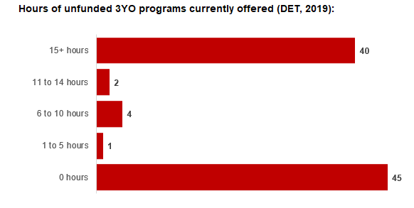
Current kindergarten offering
Four-Year-Old Kindergarten participation rate (VCAMS, 2018): | 97%
Number of services that offer a funded kindergarten program (DET, 2020): | 94
Number of services that offer an unfunded Three-Year-Old Kindergarten program (DET, 2019): | 47

4.4 Approach to optimising the use of existing services and infrastructure
Change management strategies to optimise existing services and infrastructure
Children can often be accommodated through existing spare places and by services ‘unlocking’ unused capacity. As the experience of providers in the 2020 Three-Year-Old Kindergarten roll-out LGAs shows, while the optimisation of existing services can be challenging, it is highly time- and cost-effective compared to building new capacity through infrastructure projects. It also helps target infrastructure investment to the places that need it most and avoids over-supplying the local market.
Greater Geelong City Council and the Department will support providers and services to maximise their kindergarten places through the following change management activities and practices:
- Increasing the capacity of any Local Government operated services by:
  - Running additional programs.
  - Using different timetables, including running 7.5-hour days.
  - Changing the delivery model, such as introducing rotational models or mixed-age groups.
  - Having degree-qualified kindergarten teachers leading integrated kindergarten programs in long day care settings.
- Encouraging and supporting other providers and services in the LGA to undertake change management.
Greater Geelong City Council and the Department have estimated how many Three and Four-Year-Old Kindergarten places can be accommodated through existing services in the LGA (Table 1). Both parties are committed to helping providers and services offer these kindergarten places before progressing to funded infrastructure solutions to meet demand. This commitment is reflected in the LGA and community level estimates below (Table 2 onwards), which assume that demand will be met first through existing services and second through additional infrastructure. Note that in some cases the number of kindergarten places that can be offered through existing services may exceed demand for kindergarten places.
Table 1: Total estimated funded kindergarten places that can be offered by optimising existing services and infrastructure across the LGA, between 2021-29 (presented in 15-hour equivalent places)
 | 2021 | 2022 | 2023 | 2024 | 2025 | 2026 | 2027 | 2028 | 2029
Estimated existing supply of kindergarten places* | 7,506 | 7,506 | 7,506 | 7,506 | 7,506 | 7,506 | 7,506 | 7,506 | 7,506
*This may be higher than current three and four-year-old enrolments as it includes any spare places that are currently available or could be generated by making some minor adjustments to programming approaches.

4.5 Agreed estimates of demand for funded kindergarten places that cannot be met through existing services and infrastructure
The below estimates (Table 2 onwards) have been developed by Greater Geelong City Council and the Department to illustrate the estimated:
- Total number of Three and Four-Year-Old Kindergarten places expected over the roll-out period.
- Three and Four-Year-Old Kindergarten places that cannot be accommodated by optimising existing services and infrastructure over the roll-out period.
These estimates have been developed to reflect that the increase in demand for Three-Year-Old Kindergarten places will be gradual.
In estimating how many Three and Four-Year-Old Kindergarten places cannot be accommodated by existing services and infrastructure, Greater Geelong City Council and the Department have taken into account any new places that will be made available through planned expansions of existing services or new services, into estimates of existing supply, where this information is available. This may include Local Government owned services being developed and planned Kindergartens on School Sites.
These estimates do not, however, estimate how and when the broader sector will expand to meet the additional demand for kindergarten places that are estimated over the roll-out period.
Infrastructure need in the LGA and its local communities is indicated by the bottom rows of the tables in this section (Table 2 onwards): ‘Total kindergarten places that cannot be accommodated by existing services’. For example, if the number of kindergarten places for the LGA or a community is above zero in this row, it means that the area is estimated to need additional infrastructure (noting that further optimisation which avoids the need for additional infrastructure may be possible). Any type of provider – Local Government, not-for-profit or for-profit – can build this additional infrastructure. If this row shows all zeros, it means that there is no estimated need for additional infrastructure in the area.
Local Government and not-for-profit kindergarten providers must refer to the estimates in this section when applying through the Building Blocks Capacity Building Grants stream for Government funding. Under this stream, projects must be in a community where there is infrastructure need as shown in the community’s table of estimated demand for kindergarten places (i.e. there are numbers in the bottom row above zero). Projects in LGAs or communities where demand can be met through existing services (i.e. the bottom row shows all zeros) are not eligible for funding under this stream.

LGA estimates
Table 2: Estimated three and four-year-old kindergarten places between 2021-29 (presented in 15-hour equivalent places)
LGA level estimates | 2021 | 2022 | 2023 | 2024 | 2025 | 2026 | 2027 | 2028 | 2029
Total estimated demand for kindergarten places (three and four-year-old children) | 3,456 | 4,418 | 4,812 | 5,308 | 5,737 | 6,407 | 6,819 | 7,241 | 7,767
Total kindergarten places that cannot be accommodated by existing services | 0 | 1 | 2 | 46 | 104 | 217 | 363 | 618 | 1,133

Community estimates
Table 3-17: Estimated three and four-year-old kindergarten places between 2021-29 (presented in 15-hour equivalent places)
Belmont estimates | 2021 | 2022 | 2023 | 2024 | 2025 | 2026 | 2027 | 2028 | 2029
Total estimated demand for kindergarten places (three and four-year-old children) | 196 | 242 | 258 | 280 | 305 | 351 | 383 | 399 | 387
Total kindergarten places that cannot be accommodated by existing services | 0 | 0 | 0 | 0 | 0 | 0 | 0 | 0 | 0

Clifton Springs estimates | 2021 | 2022 | 2023 | 2024 | 2025 | 2026 | 2027 | 2028 | 2029
Total estimated demand for kindergarten places (three and four-year-old children) | 191 | 245 | 265 | 291 | 315 | 351 | 369 | 384 | 402
Total kindergarten places that cannot be accommodated by existing services | 0 | 0 | 0 | 0 | 0 | 0 | 0 | 0 | 18

Corio - Norlane estimates | 2021 | 2022 | 2023 | 2024 | 2025 | 2026 | 2027 | 2028 | 2029
Total estimated demand for kindergarten places (three and four-year-old children) | 251 | 339 | 374 | 419 | 467 | 547 | 598 | 632 | 646
Total kindergarten places that cannot be accommodated by existing services | 0 | 0 | 0 | 0 | 0 | 0 | 0 | 0 | 0

Geelong estimates | 2021 | 2022 | 2023 | 2024 | 2025 | 2026 | 2027 | 2028 | 2029
Total estimated demand for kindergarten places (three and four-year-old children) | 218 | 265 | 284 | 309 | 333 | 369 | 392 | 410 | 430
Total kindergarten places that cannot be accommodated by existing services | 0 | 0 | 0 | 0 | 0 | 0 | 0 | 0 | 6

Geelong West - Hamlyn Heights estimates | 2021 | 2022 | 2023 | 2024 | 2025 | 2026 | 2027 | 2028 | 2029
Total estimated demand for kindergarten places (three and four-year-old children) | 296 | 370 | 397 | 433 | 464 | 509 | 512 | 516 | 604
Total kindergarten places that cannot be accommodated by existing services | 0 | 0 | 0 | 0 | 0 | 0 | 0 | 4 | 92

Grovedale estimates | 2021 | 2022 | 2023 | 2024 | 2025 | 2026 | 2027 | 2028 | 2029
Total estimated demand for kindergarten places (three and four-year-old children) | 321 | 470 | 540 | 625 | 683 | 747 | 799 | 912 | 1,056
Total kindergarten places that cannot be accommodated by existing services | 0 | 0 | 0 | 44 | 101 | 166 | 218 | 331 | 475

Highton estimates | 2021 | 2022 | 2023 | 2024 | 2025 | 2026 | 2027 | 2028 | 2029
Total estimated demand for kindergarten places (three and four-year-old children) | 306 | 401 | 441 | 473 | 473 | 506 | 550 | 635 | 743
Total kindergarten places that cannot be accommodated by existing services | 0 | 0 | 0 | 0 | 0 | 33 | 77 | 162 | 270

Lara estimates | 2021 | 2022 | 2023 | 2024 | 2025 | 2026 | 2027 | 2028 | 2029
Total estimated demand for kindergarten places (three and four-year-old children) | 269 | 354 | 390 | 438 | 485 | 558 | 602 | 635 | 666
Total kindergarten places that cannot be accommodated by existing services | 0 | 0 | 0 | 0 | 0 | 0 | 0 | 0 | 0

Leopold estimates | 2021 | 2022 | 2023 | 2024 | 2025 | 2026 | 2027 | 2028 | 2029
Total estimated demand for kindergarten places (three and four-year-old children) | 168 | 222 | 247 | 279 | 308 | 328 | 328 | 337 | 415
Total kindergarten places that cannot be accommodated by existing services | 0 | 0 | 0 | 0 | 0 | 0 | 0 | 9 | 87

Newcomb - Moolap estimates | 2021 | 2022 | 2023 | 2024 | 2025 | 2026 | 2027 | 2028 | 2029
Total estimated demand for kindergarten places (three and four-year-old children) | 123 | 166 | 182 | 203 | 226 | 267 | 294 | 308 | 300
Total kindergarten places that cannot be accommodated by existing services | 0 | 0 | 0 | 0 | 0 | 0 | 0 | 0 | 0

Newtown estimates | 2021 | 2022 | 2023 | 2024 | 2025 | 2026 | 2027 | 2028 | 2029
Total estimated demand for kindergarten places (three and four-year-old children) | 359 | 396 | 409 | 431 | 459 | 509 | 545 | 561 | 530
Total kindergarten places that cannot be accommodated by existing services | 0 | 0 | 0 | 0 | 0 | 0 | 0 | 0 | 0

North Geelong - Bell Park estimates | 2021 | 2022 | 2023 | 2024 | 2025 | 2026 | 2027 | 2028 | 2029
Total estimated demand for kindergarten places (three and four-year-old children) | 325 | 381 | 402 | 433 | 463 | 513 | 545 | 565 | 569
Total kindergarten places that cannot be accommodated by existing services | 0 | 0 | 0 | 0 | 0 | 0 | 0 | 0 | 0

Ocean Grove - Barwon Heads estimates | 2021 | 2022 | 2023 | 2024 | 2025 | 2026 | 2027 | 2028 | 2029
Total estimated demand for kindergarten places (three and four-year-old children) | 394 | 511 | 561 | 624 | 683 | 773 | 823 | 867 | 919
Total kindergarten places that cannot be accommodated by existing services | 0 | 0 | 0 | 0 | 0 | 15 | 65 | 109 | 161

Point Lonsdale - Queenscliff estimates | 2021 | 2022 | 2023 | 2024 | 2025 | 2026 | 2027 | 2028 | 2029
Total estimated demand for kindergarten places (three and four-year-old children) | 0 | 1 | 2 | 2 | 3 | 3 | 4 | 4 | 7
Total kindergarten places that cannot be accommodated by existing services | 0 | 1 | 2 | 2 | 3 | 3 | 4 | 4 | 7

Portarlington estimates | 2021 | 2022 | 2023 | 2024 | 2025 | 2026 | 2027 | 2028 | 2029
Total estimated demand for kindergarten places (three and four-year-old children) | 41 | 55 | 60 | 66 | 71 | 75 | 75 | 75 | 93
Total kindergarten places that cannot be accommodated by existing services | 0 | 0 | 0 | 0 | 0 | 0 | 0 | 0 | 18

Authorisation
The Area Executive Director (Barwon) of the Department of Education and Training and the Director Community Life of Greater Geelong City Council endorse this Kindergarten Services and Infrastructure Plan (KISP) for City of Greater Geelong by signing on 13/1/2021.
This KISP is not intended to create legal relations or constitute a legally binding contractual agreement between the parties. The parties may review this KISP in 2022 to publish a new version that will replace the previous version.
An out-of-cycle review may be triggered if both parties agree that there has been a change in relevant data, information or the local early childhood sector that significantly affects the reliability of a KISP’s estimates for planning purposes.

Signed for and on behalf and with the authority of Greater Geelong City Council

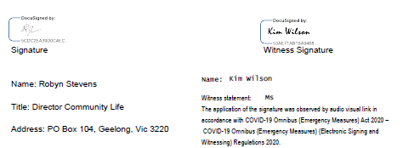

Signed by Area Executive Director (Barwon), Department of Education and Training

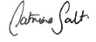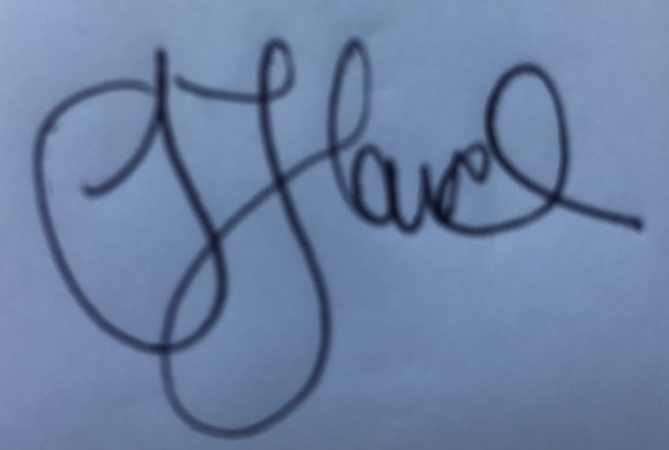

Signature Witness Signature

Name: Catriona Salt

Title: Area Executive Director (Barwon)

Address: 75 High St Belmont, Vic 3216

Australian Bureau of Statistics, Census of Population and Housing, 2016 (usual residence data). Compiled and presented in profile.id by .id, the population experts
Australian Bureau of Statistics, Census of Population and Housing 2016 (usual residence data). Compiled and presented in profile.id by .id, the population experts.
Commonwealth of Australia (2019) ‘Australian Early Development Census Community profile 2018 Geelong’.

