Kindergarten Infrastructure and Services Plan
Greater Bendigo City

CONTENTS
1. Introduction 3
1.1. Reform context 3
1.2. Purpose of Kindergarten Infrastructure and Services Plans (KISPs) 3
1.3. Structure of the KISP 4
1.4. Disclaimer 4
2. Map of Early Childhood Education services in Greater Bendigo City 5
3. Local context 6
3.1 Purpose 6
3.2 Key considerations 6
4. Unmet demand estimates between 2026 - 2036 for Greater Bendigo City 11
4.1 Purpose 11
4.2 Methodology 11
4.3 Summary of current kindergarten provision 13
4.4 Agreed estimates of demand for kindergarten places 13
5. Authorisation 17

Introduction

Reform context
The Victorian Government’s $14 billion Best Start, Best Life (BSBL) reforms are the most significant change to Victoria’s early childhood sector in a generation.
The BSBL reforms include:
- Free Kinder: Free Kinder is now available for Victorian 3- and 4-year-old children at participating services in standalone (sessional) kindergartens and long day care centres – a saving of up to $2,500 per child, every year.
- Pre-Prep: Four-Year-Old Kindergarten will gradually transition to ‘Pre-Prep’ – increasing to a universal 30-hour-a-week program of play-based learning for 4-year-old children in Victoria by 2036.
- Three-Year-Old Kindergarten: the continued roll-out of Three-Year-Old Kindergarten, with programs increasing to 15 hours a week across the state by 2029.
- Early learning and childcare centres: the establishment of 50 Victorian government-owned and operated early learning and childcare centres. These centres will be built in areas with the greatest need and will make it easier for families to access early childhood education and childcare. The first of the centres opened in 2025.
These initiatives demonstrate a clear commitment to improving early learning outcomes for Victorian children, workforce participation and access for families, and present the most significant change to Victoria’s early childhood sector in a generation.

Pre-Prep will roll-out in Greater Bendigo City in 2032. Statewide, Aboriginal and Torres Strait Islander children, children from a refugee or asylum seeker background, and children who have had contact with Child Protection services, will be able to access up to 25 hours of Pre-Prep in 2026, increasing to up to 30 hours from 2028. Children who have (or have a parent or guardian who has) a Commonwealth concession card and children who are a multiple birth child (triplets or more) across the state will be able to access up to 25 hours of Pre-Prep in 2028, increasing to up to 30 hours from 2030.

Purpose of Kindergarten Infrastructure and Services Plans (KISPs)
New and expanded infrastructure is key to delivering the BSBL reforms and will require a large expansion of kindergarten facilities across the State. KISPs, which are jointly developed with Local Governments, indicate where and when new infrastructure will be required to support both reform implementation and population growth in each of Victoria’s 79 local government areas (LGAs). KISPs help all kindergarten providers meet demand and collectively provide a clear picture of infrastructure need across the State.
KISPs support planning for services and future capital works and include detailed information about:
- Current capacity and demand for funded kindergarten
- Capacity to be delivered for planned infrastructure projects and future demand for kindergarten
- Forecast ‘unmet demand’ for kindergarten – that is, the kindergarten places needed that cannot be met by current or planned capacity
- Information specific to each local government area and its early childhood education and care landscape.
KISPs were initially developed to support the roll-out of Three-Year-Old Kindergarten and have now been updated to incorporate Pre-Prep.
KISPs are intended to support planning. They are not funding documents and do not commit any party to addressing the unmet demand identified.
However, it is expected that future investment requests through Building Blocks and funding decisions about Local Government, not-for-profit projects (including non-government schools) would align with the relevant KISP (including Section 3: Local Context).

Structure of the KISP
Each KISP consists of the following sections:
- Section 1: A short introduction to the Best Start, Best Life reform and the KISP.
- Section 2: A map of existing and planned Early Childhood Education and Care services.
- Section 3: Local context and knowledge of key information in Greater Bendigo City relevant to early childhood education.
- Section 4: Unmet demand estimates in Greater Bendigo City over the life of the reform.

Disclaimer
All data presented in this document is published for information purposes only. Operational and business decisions should not be based solely on this document. Neither the Department nor Greater Bendigo City Council warrants, guarantees, makes any representation or assumes any duty of care in relation to the data, including as to its suitability, completeness, accuracy or adequacy.

Map of Early Childhood Education services in Greater Bendigo City
The map below shows the distribution of currently operating and new State-supported services that are planned to open in the future in Greater Bendigo City. Planned services by the private sector are not included.
This map has been prepared using departmental data, from both the National Quality Agenda IT System (NQAITS) and the Victorian School Building Authority (VSBA).
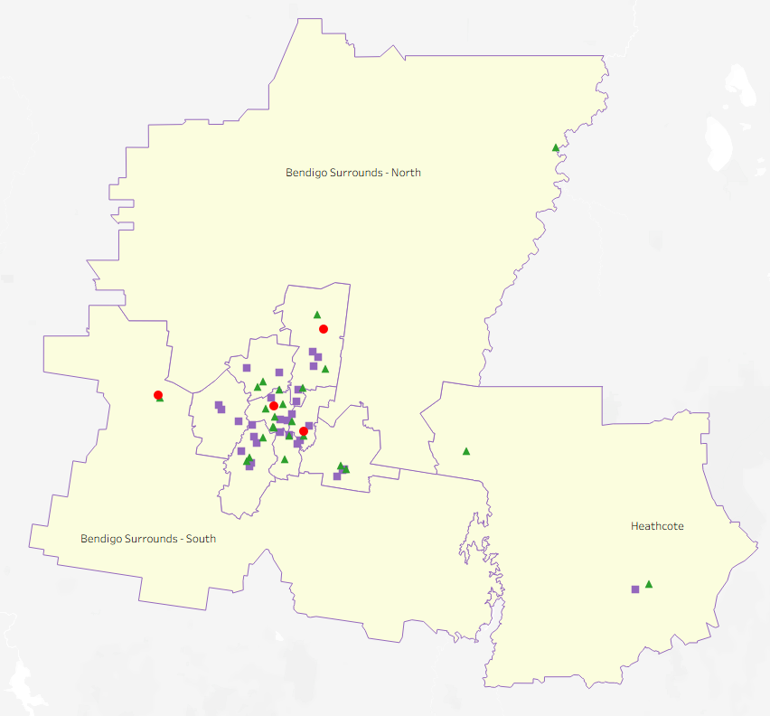
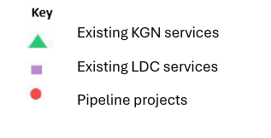
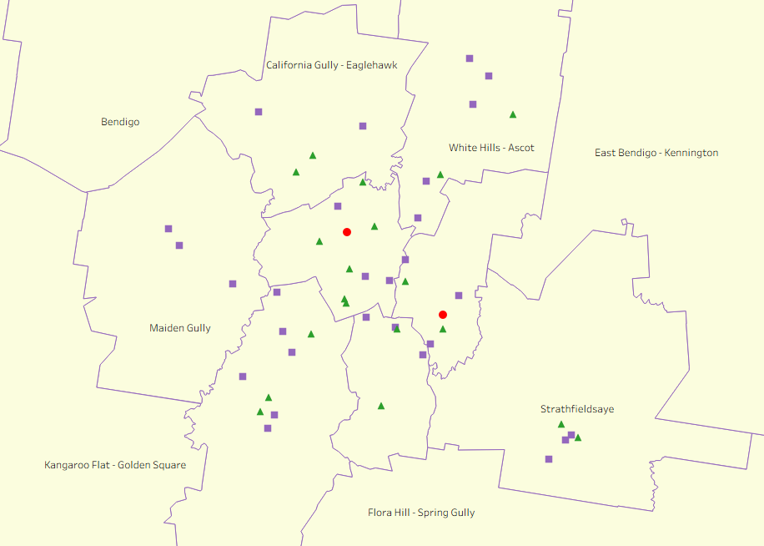

Local context
d

3.1 Purpose
Local, place-based knowledge and context play an important role in supporting the implementation of the BSBL reforms across Victoria. This section of the KISP documents this knowledge and context and should be considered alongside the kindergarten demand estimates in Section 4.
Information provided as local context may support applications through the Building Blocks Capacity Building and Planning Grants streams.

3.2 Key considerations
The City of Greater Bendigo is located in the geographic centre of Victoria, covering almost 3,000 square kilometres. We have a growing population of more than 125,000. Our 2046 population forecast is 172,000.
Our municipality includes the thriving smaller communities of Heathcote, Elmore, Goornong, Marong, Redesdale and Axedale.
The City of Greater Bendigo is a service and infrastructure centre for north central Victoria, and surrounded by 40,000 hectares of regional, state and national parkland. Our catchment area has a population of more than 250,000.
In 2025, Greater Bendigo had 29 Long Day Care services and 24 standalone kindergartens in operation.
Council’s role in the provision of funded kindergarten
Greater Bendigo City Council has the following roles in the provision of funded kindergarten:
Infrastructure owner
- Council owns or manages on behalf of Department of Energy, Environment and Climate Action 17 kindergarten buildings
  - 12 are licenced to Shine Bright EYM
  - 5 are licenced to Y Kinders EYM.
Service operator
- Council owns, manages and operates two long day care services that include kindergarten programs – Annie Galvin ELC and Helen Jessen ELC.
Advocate
- Council recognises the importance of access to high-quality, early years programs and infrastructure through
  - Advocacy to all levels of government to fund and deliver new facilities on new and existing sites
  - Advocacy to existing for-profit and not-for-profit providers to invest in site upgrades, expansion, and/or new development
  - Exploring and supporting funding opportunities through the Victoria School Building Authority Building Blocks funding.
Planner and Partner
Working in partnership across all levels of government, training organisations (Latrobe University and Bendigo Kangan TAFE) and with the sector to ensure local services support the developmental needs of children and families in our community.
In 2024 the City developed an Early Years Workforce Plan aiming to attract, retain and recognise the need for greater workforce support for the sector.
Coordination of the Kindergarten Central Registration Scheme
From 2026 the City will manage the Kindergarten Central Registration Scheme for the local government area.

Aboriginal Self Determination in Early Childhood Education and Care
The Aboriginal people of the area are the Dja Dja Wurrung and Taungurung language groups of the Central Kulin nation. The City is committed to self-determination in supporting Aboriginal and Torres Strait Islander children and to ensuring the facilities and services we provide are culturally safe and lead to quality experiences and outcomes.
According to the 2021 Population and Housing Census, 2.3 per cent of Greater Bendigo’s population identified as Aboriginal and/or Torres Strait Islanders (approximately 2738 individuals) compared to 1.0 per cent across Victoria.
The 2021 Population and Housing Census showed:
- Greater Bendigo’s Aboriginal and Torres Strait Islander peoples have a median age of 22 years (versus 24 years median in Victoria).
- 310 0–4-year-olds self-identified to be Aboriginal and Torres Strait Islanders.
Bendigo District Aboriginal Cooperation operates a 99-place kindergarten, Djimbaya Kindergarten.
Demographic trends that influence demand for kindergarten
The City of Greater Bendigo uses ID Community demographic resources to provide community profile data. The State Government use Victoria in Future (VIF) population projections. Where the data differs a population midpoint has been agreed which is reflected in the numbers outlined below.
In Greater Bendigo, the population of 0–5-year-olds in 2021 was 8,813, and this is expected to increase to 12,357 by 2036. There were 1,453 3-year-olds and 1,477 4-year-olds in 2021. This is projected to grow to 1,839 3-year-olds and 1,852 4-year-olds by 2036.
Current population growth in some suburbs is higher than forecast (e.g. Huntly).
Greater Bendigo has regions termed a ‘childcare desert’, meaning in some areas there are more than 3 children per (available) place. In 2022, Bendigo Surrounds– North had 0.07 places per child and Bendigo Surrounds– South had 0.13 places per child (anything below 0.333 is more than 3 children per place).
In 2021 in Greater Bendigo, 9.2% of 0–4-year-olds were from non-English speaking backgrounds, and 1.2% were born overseas. For those aged 5-9 years, 8.0% were from non-English speaking backgrounds and 2.6% were born overseas. In the City of Greater Bendigo, 1,597 people reported speaking Karen at home in 2021, making it one of the region’s most common non-English language.
The City has a Culturally and Linguistically Diverse (CALD) outreach officer who engages with CALD children and families, particularly Karen community members, to build trusted relationships, provide much needed support and connect them with early years services.
In 2024 the Australian Early Development Census (AEDC) results showed 24.7% of Greater Bendigo children were vulnerable on one or more domains of the AEDC, compared to 22.3% of Victoria children and 12.1% were vulnerable on two or more domains compared to a 11.8% state average.

Relative disadvantage
An equity lens needs to be applied to the provision of services. Greater Bendigo has some areas of significant advantage and some areas of significant disadvantage. Several areas across Greater Bendigo are in the lowest 15% in Australia.

Based on the ABS SEIFA Index of Relative Socioeconomic Disadvantage (IRSD, 2021), the City of Greater Bendigo records an overall score of 959, 34th percentile, a significantly higher level of disadvantage than Victorian (1011, 65th percentile). Areas experiencing significant disadvantage include Long Gully–West Bendigo–Ironbark (5th percentile), North Bendigo–California Gully (8th percentile), Eaglehawk – Eaglehawk North – Sailors Gully (12th percentile) and Kangaroo Flat – Big Hill (15th percentile).
By contrast, Rural East (83rd percentile), Strathfieldsaye (82nd percentile), and Maiden Gully (72nd percentile) score in the top percentiles, reflecting lower levels of disadvantage.
With rapidly evolving social and economic pressures, including the rising cost of living, plus free sessional kindergarten and the increase of kindergarten hours, it is anticipated that many families may choose to attend sessional kindergarten as opposed to long day care, potentially increasing demand for sessional services. Some of these children will be eligible for Pre-Prep earlier than the universal roll-out in 2032, in either 2026 or 2028. However, it is anticipated even greater demand for sessional kindergarten places from 2032.

Enrolment decisions
Families consider many factors when making the decision about where to enrol a child in a kindergarten program including cost, location, hours of operation and program scheduling. Families in Greater Bendigo are known to travel so their child can attend a service of choice.

The Department of Education 2024 ECE profile shows that in 2024 approximately 69% of four-year-olds attended a standalone kindergarten and 31% attended a kindergarten as part of a Long Day Care program. For three-year-olds there has been a steady increase in the number attending a standalone kindergarten over the past several years – in 2022 it was 53% and 2024 58%. These numbers will need be monitored over the next several years as it is anticipated the split for three-year-old kindergarten will start to replicate the split for four-year-old kindergarten.

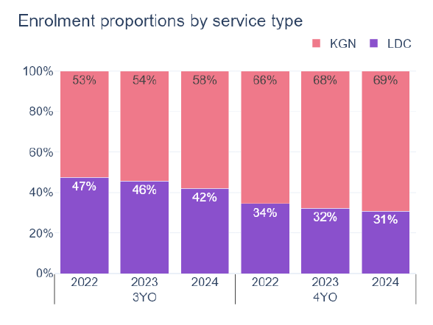

From 2022 to 2024 the overall number of children enrolled through Early Start Kindergarten or Access to Early Learning programs has risen from 137 to 154. In 2024, there was a 60% preference for attending kindergarten over long day care. These numbers will also need to be monitored as a reflection of community need and uptake of Pre-Prep from 2026.

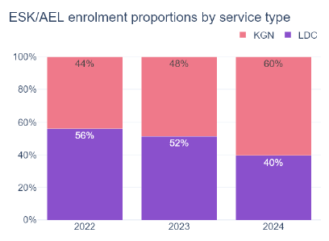

Projects or trends that may influence supply of early childhood education and care
- The City’s Managed Growth Strategy and housing density initiatives will drive greater population increases in well serviced locations and identified growth areas.
- Projects like the Bendigo Regional Employment Precinct in Marong, and the Bendigo Airport Business precinct in East Bendigo may influence population increases.
- Child safety needs to be factored into all decision making. The City has recently appointed a Child Safeguarding Officer.
- The City’s Early Years Workforce Plan highlights some of the workforce challenges the sector is facing.

Ageing Infrastructure
The majority of the City’s owned or managed early years facilities are more than 40 years old. This includes 13 single room only facilities, eight facilities that are DDA compliant to today’s standards and nine are compliant to the year they were built, and only four facilities are co-located with Maternal and Child Health Services or Allied Health Services. A significant stock of ageing infrastructure places a risk that, although there may be sufficient capacity of places available, the buildings are not fit for purpose.

Over the past several years the City has undertaken feasibility studies of most of the kindergarten sites it owns and manages, to understand the opportunities and constraints of each location. Many sites are landlocked with no room to expand; have contaminated soil risks that make building or expanding on the site prohibitive; or are in areas that are not experiencing unmet demand for kindergarten places.

The City’s Early Years Infrastructure Framework outlines priorities.

Key local geographic considerations or information relevant to Three-Year-Old Kindergarten
- Trend for residential development in outer suburbs – Marong/Maiden Gully, Strathfieldsaye, Huntly/Epsom, and the potential for development even further north with the regional rail station improvements at Huntly, Goornong and Raywood.
- Increased residential housing in City Centre and other activity centres such as Eaglehawk.
- Increased risk of bushfire and flooding impacting on areas suitable for development in many suburbs across Greater Bendigo.
- Greater Bendigo is a historic gold mining region and soil contamination is a common and expected occurrence.
- Primary travel patterns – north, south, east and west into central Bendigo with kindergartens along the way. However, people also willingly travel to a preferred kindergarten location.

Other information about the expansion of early childhood services
The City only manages two services in Greater Bendigo which limits its ability to manage significant change and influence broadly across all Greater Bendigo services.
While the City monitors planning permits, projecting the delivery of new services is challenging due to limited visibility beyond the permit process. Therefore, future private sector development is not included in the estimates at section 4.4.
The City recognises the need for a strong workforce strategy to ensure training and development opportunities are offered locally, and workforce is attracted to regional jobs.

Unmet demand estimates between 2026 - 2036 for Greater Bendigo City

4.1 Purpose
As the BSBL reforms are rolled out and Victoria’s population grows, demand for kindergarten and Pre-Prep places will increase significantly. While additional capacity will be needed to meet this demand, this will vary across the State and over time, due to differences in the capacity of existing services, growth trends and sector composition.
To identify where, when and how many additional kindergarten places are expected to be required over the roll-out in Greater Bendigo City, Greater Bendigo City Council and the department have developed:
- a summary of the current provision of kindergarten within Greater Bendigo City (Section 4.3).
- an estimate of kindergarten places that cannot be met through existing services for the 2026 - 2036 period, taking into account the additional demand that can be accommodated by optimising utilisation of existing services and infrastructure (Section 4.4).
Local governments and providers can use these published estimates to inform reform implementation activities such as service planning, kindergarten program expansion, infrastructure investments and Building Blocks funding applications in alignment with future demand over the roll-out.

4.2 Methodology
The estimated kindergarten places used in the following sections have been agreed between Greater Bendigo City Council and the department, and were informed by:
- demand projections developed by the department which draw on a range of inputs, including population forecasts and current enrolments
- the estimated capacity of existing and planned services in the LGA (Section 2)
- where applicable, modelling undertaken by Greater Bendigo City and service level information; and
- local knowledge and context provided by the local government (Section 3) that explains particular issues and trends in their area.
Kindergarten places explainer
The KISP measures a service’s capacity to deliver funded kindergarten in terms of the number of 15-hour places (referred to as “kindergarten places”) available for Three-Year-Old kindergarten and Pre-Prep (noting that, by 2036, two kindergarten places will be required for one Pre-Prep enrolment). The number of kindergarten places is different from a service’s licensed or approved places, which count the number of children permitted to attend the service at any one time under the license. Many services can enrol more children in their funded kindergarten program(s) than they have licensed places for because they can run more than one kindergarten program per week. Kindergarten places are therefore a more accurate measure of service kindergarten capacity than licensed places.
Kindergarten places have been presented as 15-hour places so that new Three-Year-Old Kindergarten places and the additional 15-hour places required for Pre-Prep can be easily compared to existing 15-hour Four-Year-Old Kindergarten places. This is because, when Three-Year-Old Kindergarten is fully rolled out in 2029, three-year-old children will have access to 15-hours of kindergarten. When Pre-Prep is fully rolled out in 2036, four-year-old children will have access to up to 30-hours of kindergarten, an increase of the current offering of 15-hours per week.
It is important to note that enrolments are not equivalent to 15-hour places. One 15-hour place can support a total of 15 hours of delivery per week split between one or more children, including but not limited to the following examples:
One 15-hour place (15 hours of delivery)
Example 1 | 1 child | 1 x 3YO attending 15 hours per week
Example 2 | 1 child | 1 x 4YO attending 15 hours per week
Example 3 | 2 children | 2 x 3YOs attending 7.5 hours per week
Example 4 | 3 children | 3 x 3YOs attending 5 hours per week
Two 15-hour places can support a total of 30 hours of delivery per week split between one or more children, including but not limited to the following examples:
Two 15-hour places (30 hours of delivery)
Example 1 | 1 child | 1 x 4YO attending 30 hours per week
Example 2 | 2 children | 2 x 3YOs attending 15 hours per week
Example 3 | 2 children | 1 x 3YO, and  1 x 4YO both attending 15 hours per week
Example 4 | 3 children | 2 x 3YOs attending 7.5 hours per week, and  1 x 4YO attending 15 hours per week
Geographic boundaries used in the KISP
These estimates have been developed at an LGA and community level to show the overall forecast and variation within an area. The KISP defines community at the Statistical Area Level 2 (SA2), which is a medium-sized area which represents a community that interacts socially and economically, with an approximate population range of 3,000 to 25,000 people, and an average population of about 10,000 people. The KISP uses 2021 SA2 boundaries. More information is available at the Australian Bureau of Statistics website.
Supply contributed by pipeline projects
Greater Bendigo City Council and the department have added any new places that will be made available through planned expansions of existing services or new services into estimates of existing supply, where this information is available. This may include projects being delivered by not-for-profit providers (including non-government schools) with support from the Victorian Government, planned Kindergartens on School Sites, and government-owned and operated early learning and childcare centres.
The KISP does not estimate how and when the broader sector will expand to meet the additional demand for kindergarten places that are estimated over the roll-out period.

4.3 Summary of current kindergarten provision
The figures below provide a summary of current kindergarten provision within the LGA and provide relevant context for the estimates of demand for funded kindergarten places included in Section 4.4. The data included in this section are largely drawn from:
- the department’s Kindergarten Information Management System (KIMS), as at 2024.
- the National Quality Agenda IT System (NQAITS), as at August 2025.
Number of services by service type (NQAITS)
Stand-alone kindergartens | 24
Long day care centres (including services not currently delivering funded kindergarten) | 29

Percentage of services by management type, LGA level (NQAITS)
Type | Percentage
Local Government | 4%
Private not for profit | 57%
Private for profit | 36%
Other | 4%

Current kindergarten offering in Greater Bendigo City
Three-Year-Old Kindergarten participation rate (KIMS): | 89%
Four-Year-Old Kindergarten participation rate (KIMS): | 96%
Number of services that offer a funded kindergarten program (KIMS): | 50

4.4 Agreed estimates of demand for kindergarten places
The below estimates (Table 1 onwards) have been developed by Greater Bendigo City Council and the department to illustrate the estimated:
- Demand – the total number of kindergarten places expected to be required over the roll-out period to support the current provision of Four-Year-Old Kindergarten, the BSBL reforms, and population growth
- Supply – the total number of kindergarten places that can be accommodated by existing services and infrastructure, and planned, State-supported services which are yet to open.
- Unmet demand – kindergarten places that cannot be accommodated by optimising existing services and infrastructure (i.e. the shortfall between demand and supply).
Interpreting the estimates
Infrastructure need in the LGA and its local communities is indicated by the bottom rows of the tables in this section (Table 1 onwards): Unmet demand. If the number of kindergarten places in this row is above zero, it means that the area is estimated to need additional infrastructure capacity. Any type of provider – local government, not-for-profit (including non-government schools) or for-profit – can build this additional infrastructure.
Sub-SA2 factors may need to be considered to give a holistic picture of unmet demand. For example, in rural communities, one SA2 may contain several small towns, some with excess supply and some with unmet demand. At the SA2-level, demand may appear to be met because all supply and demand is considered in aggregate; however, it is not feasible to for families to drive long distances to access kindergarten capacity in another town. Sub-SA2 factors are covered in Section 3: Local context.

Table 1: Estimated kindergarten places required between 2026 - 2036 in Greater Bendigo City

Greater Bendigo City estimates | 2026 | 2027 | 2028 | 2029 | 2030 | 2031 | 2032 | 2033 | 2034 | 2035 | 2036
Demand for kindergarten places | 3195 | 3307 | 3723 | 3800 | 3978 | 4017 | 4649 | 5218 | 5269 | 5325 | 5372
Unmet demand | 115 | 135 | 241 | 271 | 324 | 361 | 822 | 1313 | 1215 | 1271 | 1320

Community estimates

Table 2-A: Estimated kindergarten places required between 2026 - 2036 in Bendigo
SA2 estimates | 2026 | 2027 | 2028 | 2029 | 2030 | 2031 | 2032 | 2033 | 2034 | 2035 | 2036
Demand for kindergarten | 476 | 490 | 534 | 542 | 557 | 557 | 618 | 670 | 670 | 670 | 668
Kindergarten supply | 682 | 801 | 814 | 814 | 814 | 814 | 814 | 814 | 839 | 839 | 839
Unmet demand | 0 | 0 | 0 | 0 | 0 | 0 | 0 | 0 | 0 | 0 | 0

Table 2-B: Estimated kindergarten places required between 2026 - 2036 in Bendigo Surrounds - North
SA2 estimates | 2026 | 2027 | 2028 | 2029 | 2030 | 2031 | 2032 | 2033 | 2034 | 2035 | 2036
Demand for kindergarten | 75 | 81 | 98 | 105 | 114 | 119 | 146 | 171 | 175 | 179 | 181
Kindergarten supply | 54 | 54 | 54 | 54 | 54 | 54 | 54 | 54 | 54 | 54 | 54
Unmet demand | 21 | 27 | 44 | 51 | 60 | 65 | 92 | 117 | 121 | 125 | 127

Table 2-C: Estimated kindergarten places required between 2026 - 2036 in Bendigo Surrounds - South
SA2 estimates | 2026 | 2027 | 2028 | 2029 | 2030 | 2031 | 2032 | 2033 | 2034 | 2035 | 2036
Demand for kindergarten | 241 | 253 | 298 | 308 | 332 | 343 | 415 | 484 | 498 | 511 | 524
Kindergarten supply | 287 | 287 | 287 | 287 | 287 | 287 | 287 | 287 | 287 | 287 | 287
Unmet demand | 0 | 0 | 11 | 21 | 45 | 55 | 128 | 197 | 211 | 224 | 237

Table 2-D: Estimated kindergarten places required between 2026 - 2036 in California Gully - Eaglehawk
SA2 estimates | 2026 | 2027 | 2028 | 2029 | 2030 | 2031 | 2032 | 2033 | 2034 | 2035 | 2036
Demand for kindergarten | 307 | 318 | 363 | 370 | 389 | 392 | 461 | 522 | 524 | 526 | 528
Kindergarten supply | 218 | 218 | 224 | 224 | 224 | 224 | 224 | 224 | 236 | 236 | 236
Unmet demand | 89 | 100 | 139 | 146 | 165 | 168 | 238 | 298 | 288 | 290 | 292

Table 2-E: Estimated kindergarten places required between 2026 - 2036 in East Bendigo - Kennington
SA2 estimates | 2026 | 2027 | 2028 | 2029 | 2030 | 2031 | 2032 | 2033 | 2034 | 2035 | 2036
Demand for kindergarten | 294 | 302 | 340 | 342 | 353 | 350 | 400 | 443 | 438 | 436 | 434
Kindergarten supply | 425 | 425 | 425 | 425 | 425 | 425 | 425 | 425 | 433 | 433 | 433
Unmet demand | 0 | 0 | 0 | 0 | 0 | 0 | 0 | 17 | 5 | 3 | 1

Table 2-F: Estimated kindergarten places required between 2026 - 2036 in Flora Hill – Spring Gully
SA2 estimates | 2026 | 2027 | 2028 | 2029 | 2030 | 2031 | 2032 | 2033 | 2034 | 2035 | 2036
Demand for kindergarten | 231 | 235 | 259 | 259 | 265 | 263 | 294 | 322 | 321 | 320 | 317
Kindergarten supply | 228 | 228 | 234 | 234 | 234 | 234 | 234 | 234 | 247 | 247 | 247
Unmet demand | 4 | 8 | 25 | 25 | 31 | 29 | 60 | 88 | 74 | 73 | 70

Table 2-G: Estimated kindergarten places required between 2026 - 2036 in Heathcote
SA2 estimates | 2026 | 2027 | 2028 | 2029 | 2030 | 2031 | 2032 | 2033 | 2034 | 2035 | 2036
Demand for kindergarten | 93 | 96 | 105 | 106 | 109 | 109 | 124 | 136 | 136 | 137 | 137
Kindergarten supply | 118 | 118 | 121 | 121 | 121 | 121 | 121 | 121 | 125 | 125 | 125
Unmet demand | 0 | 0 | 0 | 0 | 0 | 0 | 3 | 16 | 12 | 12 | 12

Table 2-H: Estimated kindergarten places required between 2026 - 2036 in Kangaroo Flat- Golden Square
SA2 estimates | 2026 | 2027 | 2028 | 2029 | 2030 | 2031 | 2032 | 2033 | 2034 | 2035 | 2036
Demand for kindergarten | 492 | 504 | 560 | 564 | 583 | 580 | 660 | 729 | 729 | 730 | 731
Kindergarten supply | 523 | 523 | 538 | 538 | 603 | 603 | 603 | 603 | 642 | 642 | 642
Unmet demand | 0 | 0 | 22 | 26 | 0 | 0 | 57 | 126 | 87 | 88 | 89

Table 2-I: Estimated kindergarten places required between 2026 - 2036 in Maiden Gully
SA2 estimates | 2026 | 2027 | 2028 | 2029 | 2030 | 2031 | 2032 | 2033 | 2034 | 2035 | 2036
Demand for kindergarten | 141 | 152 | 177 | 187 | 204 | 214 | 259 | 302 | 313 | 327 | 340
Kindergarten supply | 176 | 176 | 184 | 184 | 184 | 184 | 184 | 184 | 205 | 205 | 205
Unmet demand | 0 | 0 | 0 | 3 | 20 | 30 | 75 | 118 | 108 | 122 | 136

Table 2-J: Estimated kindergarten places required between 2026 - 2036 in Strathfieldsaye
SA2 estimates | 2026 | 2027 | 2028 | 2029 | 2030 | 2031 | 2032 | 2033 | 2034 | 2035 | 2036
Demand for kindergarten | 330 | 344 | 388 | 402 | 421 | 427 | 496 | 560 | 572 | 584 | 594
Kindergarten supply | 444 | 444 | 454 | 454 | 454 | 454 | 454 | 454 | 473 | 473 | 473
Unmet demand | 0 | 0 | 0 | 0 | 0 | 0 | 42 | 106 | 99 | 111 | 121

Table 2-K: Estimated kindergarten places required between 2026 - 2036 in White Hills - Ascot
SA2 estimates | 2026 | 2027 | 2028 | 2029 | 2030 | 2031 | 2032 | 2033 | 2034 | 2035 | 2036
Demand for kindergarten | 514 | 533 | 600 | 616 | 651 | 663 | 775 | 877 | 892 | 905 | 916
Kindergarten supply | 512 | 631 | 648 | 648 | 648 | 648 | 648 | 648 | 682 | 682 | 682
Unmet demand | 1 | 0 | 0 | 0 | 3 | 15 | 127 | 229 | 210 | 223 | 235

Authorisation
The Loddon Campaspe Area Executive Director of the Department of Education and Jessica Howard, Director Healthy Communities and Environments of Greater Bendigo City endorse this Kindergarten Infrastructure and Services Plan (KISP) for Greater Bendigo City Council by signing on ………. / ………. / ……….
This KISP is not intended to create legal relations or constitute a legally binding contractual agreement between the parties. The parties may review this KISP in 2029 to publish a new version that will replace the previous version.
Signed for and on behalf and with the authority of Greater Bendigo City Council.

……………………………………
Signature

Name: …………………………......................................
Title: ………………………………………………………

Signed for and on behalf and with the authority of the Department of Education

……………………………………
Signature

Name: …………………………......................................
Title: ………………………………………………………

