Kindergarten Infrastructure and
Services Plan
East Gippsland Shire
CONTENTS
1. Introduction 3
1.1. Reform context 3
1.2. Purpose of KISPs 3
1.3. How to use the KISP 3
1.4. Structure of the KISP 3
1.5. Disclaimer 4
2. Map of Early Childhood Education services in East Gippsland Shire 5
3. Local context 7
3.1 Purpose 7
3.2 Key considerations 7
4. Funded kindergarten enrolment estimates between 2021-29 for East Gippsland Shire 10
4.1 Purpose 10
4.2 Methodology 10
4.3 Summary of current kindergarten provision 11
4.4 Approach to optimising the use of existing services and infrastructure 12
4.5 Agreed estimates of demand for funded kindergarten places that cannot be met through existing services and infrastructure 13
5. Authorisation 17

Introduction

Reform context
In an Australian first, the Victorian Government has committed to implement Three-Year-Old Kindergarten for all children over a 10-year roll-out with a total investment of almost $5 billion, including $1.68 billion to support the infrastructure expansion required for the reform. This reform will add another year of universal funded kindergarten so that, by 2029, all children in Victoria will have access to two years of play-based learning through a funded kindergarten program.

Purpose of KISPs
Three-Year-Old Kindergarten will require a large expansion of kindergarten across the State. The Government has invited all 79 Victorian Local Governments to discuss and agree upon a Kindergarten Infrastructure and Services Plan (KISP) for their Local Government Area (LGA).
Each KISP has been jointly developed with Local Government and published to estimate the growth in demand for kindergarten within the LGA. The KISPs will help all kindergarten providers meet demand and provide a clear picture of infrastructure need across the State.
While a KISP is not a funding document and does not define required infrastructure projects or commit any party to funding specific projects, it is expected that future investment requests through Building Blocks and funding decisions about Local Government and not-for-profit projects would align with the relevant KISP.

How to use the KISP
Each KISP contains estimates of future kindergarten supply of, and demand for, Three and Four-Year-Old Kindergarten places against existing enrolment capacity. Not-for-profit and for-profit providers can use these estimates to inform their plans to expand kindergarten programs, establish new services or invest in new or extended facilities.
For example, KISPs provide demand estimates in terms of where, when and how much demand for kindergarten places will grow in an LGA. KISPs also estimate where and how many kindergarten places providers can accommodate in existing facilities before an area needs new infrastructure to meet demand. The estimates can be used to inform decisions about where and when expansions of kindergarten program capacity and the construction of new or extended facilities are needed to meet demand growth.
Where there is an agreed KISP for the LGA, the Local Government and not-for-profit kindergarten providers seeking co-investments through the Building Blocks Capacity Building stream must refer to, and align their proposed project with, the infrastructure need identified in the KISP.

Structure of the KISP
Each KISP consists of the following sections:
- Section 1: A short introduction to the Three-Year-Old Kindergarten reform and the KISP.
- Section 2: A map of existing and planned Early Childhood Education and Care service locations.
- Section 3: Local knowledge and context relevant to the expansion of kindergarten services.
- Section 4: Funded kindergarten demand estimates.

Disclaimer
All data presented in this document are estimates only and are based on the best information available to the Department and Local Government at the time. They are published on an as-is basis and are for informational purposes only. They are subject to adjustment in response to market forces and as new data and other relevant information becomes available. The data may under- or over-estimate both total demand in a given location or year and the capacity for new demand to be met by providers. As a result, operational and business decisions should not be made solely based on this document. Any use of this data is solely at the risk of the user. The Department and Local Government accept no responsibility for any loss or damage, either direct or incidental, that may result from the use of the data.

Map of Early Childhood Education services in East Gippsland Shire
The map below shows the distribution of currently operating and new services that are planned to open in the future in the LGA and across its communities.
This map has been prepared using Departmental data, from both the National Quality Agenda IT System (NQAITS) and the Victorian School Building Authority (VSBA). Where applicable, this map has been refined by the East Gippsland Shire Council and the Department to capture other services that are planned to open in the future.
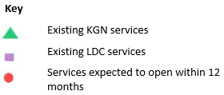
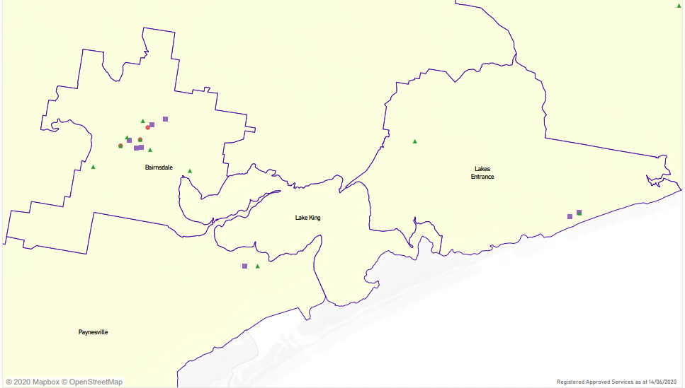

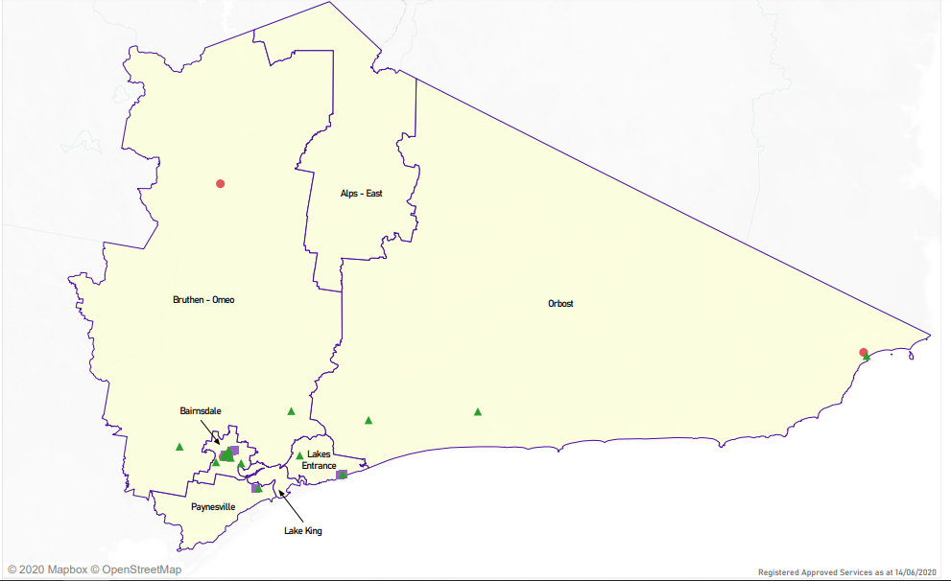

Local context
d

3.1 Purpose
Local, place-based knowledge and context play an important role in supporting the implementation of Three-Year-Old Kindergarten across Victoria. This section of the KISP documents this knowledge and context and has informed the funded kindergarten enrolment estimates in Section 4.

3.2 Key considerations
Key demographic trends that influence demand for kindergarten
The past 30 years have seen East Gippsland evolve from its traditional rural origins to a flourishing economic and tourism region in Eastern Victoria, drawing more than one million visitors each year. The region has kept its identity and sense of place as it has grown.
East Gippsland Shire is located in the eastern corner of Victoria, up to 550 kilometres from Melbourne. It covers 21,051 square kilometres and is the second largest municipality in Victoria.
The main towns of the Shire are Bairnsdale, Lakes Entrance, Orbost, Paynesville, Omeo and Mallacoota. Bairnsdale has the largest population and is also the regional retail and service centre. The geography of the area is complex, featuring large areas of national park and state forest, an extensive coastline and productive farmland. Mountains, rivers and lakes are barriers to easy travel.
In 2016 there were 45,040 people residing in East Gippsland. The population of East Gippsland has increased nearly seven percent between 2011 and 2016 – an increase of 2844 people. Children and young people under 25-years-old make up 25% of the total East Gippsland population in 2016, a two percent decrease. The older cohorts, those over 65, have increased by 4000 people to make-up 45% of the population.
Aboriginal and/or Torres Strait Islander people make up nearly three percent of the East Gippsland population. This can be compared with the Victoria wide average of nearly one percent. The total Aboriginal and/or Torres Strait Islander population is comprised of 54% of children and young people under 25. Those over 65-years-old make up just six percent of the total Aboriginal and/or Torres Strait Islander population.
The population in Bairnsdale, Lakes Entrance, Paynesville and Mallacoota increased between 2011-2016, while in Omeo, Orbost and Swifts Creek, populations have declined. (Source: ABS Census 2016, Quick Stats, State Suburbs Collection). Major Aboriginal and/or Torres Strait Islander population centres are Orbost, Bairnsdale, Lakes Entrance, Lake Tyers, Nowa Nowa and Cann River
The population projections indicate an increase in the number of newborns to nine-year-olds over the next 15 years, and a significant increase in the number of elderly people 65 and over. The total population of East Gippsland is projected to increase by 16% by 2031.
Feedback from the leading Early Years Management (EYM) organisations suggest Kindergarten enrolment numbers across the region has remained relatively stable with the exception of Orbost. The closure of sawmills and logging industries in the region has reduced employment opportunities for families. This has impacted on kindergarten enrolment numbers in Orbost over the years. However, in other regions the low number of families moving away because of lack of employment opportunities has been equivalent to new families arriving in communities.

Projects or trends that may influence supply of early childhood education and care
The anticipated increase in the early years population is not anticipated to impact significantly on the current infrastructure with many of the older facilities having recently undergone extensions and upgrades.
Significant recent investment in early learning infrastructure has resulted in additional kindergarten places, including:
- Westdale Kindergarten expansion, providing an additional room increased the capacity by 48 children. The new room was completed towards the end of 2020, ready for the 3-year-old roll out in 2021.
- Gippsland Lakes Children’s Centre expansion, providing an additional room, increasing the licensed capacity for 22 children. This opened in time to welcome the first round of 3-year old’s in 2021.
- High Country Early Learning Centre is a purpose built childcare and kindergarten located at the site of the Omeo primary school. This service was designed with the forethought to accommodate a potential increase in population caused by a proposed mine in the region.
- Lakes Entrance Pre-school restructure, to increase capacity and update infrastructure, completed in 2019.

Key local geographic considerations or information relevant to Three-Year-Old Kindergarten
Currently East Gippsland Shire Council does not fund or operate kindergarten facilities however, it has responsibilities with land and/or asset administration for 13 of the 23 kindergartens in the region. These kindergartens operate as either standalone kindergartens, or under an Early Years Manger. Six kindergartens are currently managed by Uniting and four are managed by YMCA. Three standalone kindergartens are managed by Committees of Management and a further nine are managed by other private and community based organisations. Over 800 children enrolled into a funded three and four-year-old kindergarten program for 2021.
The unique geography and overall size of East Gippsland makes transport an on-going issue for families and children to travel easily around the region. This in turn creates challenges in accessibility to critical services such as health care, education and employment. Whilst some improvement to transport access has occurred over the last few years, particularly with extra services per day from Orbost to Bairnsdale, those in remote areas still have limited or no access to public transport.
Several of the rural kindergartens such as Buchan, Omeo, Cann River and Swifts Creek offer mixed 3 and 4-year-old groups as well as some integrated hours that include younger children. Operating a dual integrated kindergarten in rural areas generally requires a higher ratio of educators to meet the child: educator ratio. This is a mandatory requirement when including children under 3 years of age into an early education program.
Anecdotal information suggests, there is limited training support available to trainees in rural areas such as Mallacoota due to the lack of Registered Training Organisations (RTOs). Online training is available, however there is no training supervisor able to travel to Mallacoota. Currently, Mallacoota trainee’s must travel to Orbost to complete their 180 placement hours at the early years’ service. This is a 3 and half hour return trip. The Early Years Managed services offer mentoring to support their staff.
Attracting qualified early years staff in East Gippsland has been challenging with the roll out of three-year-old kindergarten in 2021. Incentives from the Department of Education and Training (DET) such as scholarships, moving allowances and engaging recruitments agencies has attracted staff to the region and provided opportunities for existing early education staff to upskill.
However, challenges still exist when recruiting Kindergarten Inclusion Support (KIS) and relief staff. The pool of casual and KIS staff across the region is low, this is exacerbated in rural locations and is impacted by the relatively low hours, generally 3- 4 hours a day, offered. The cost of travel for educators who do not live in the kindergarten locale, can be prohibitive for the number of KIS hours offered at rural kindergartens. There is little incentive for staff to travel outside of their region.
An approach taken by one of the EYM is to employee their own KIS educators rather than through the agency that auspices the KIS program. This enables the EYM to be more flexible in recruiting and retaining KIS staff. Many of the KIS staff also work as relief and/or part time staff. This becomes problematic when KIS staff are required to work as relief staff to ensure the program can operate with sufficient staffing.

Other information about the expansion of early childhood services
To support the successful roll out of the Three-Year-Old Kindergarten Reform the East Gippsland Shire Council has been working closely with local DET, kindergartens and early years networks across the region. This has included supporting infrastructure grants to increase capacity at current kindergartens as well promoting the recruitment of Bachelor and other qualified staff to deliver programs in 2021.

Funded kindergarten enrolment estimates between 2021-29 for East Gippsland Shire

4.1 Purpose
As Three-Year-Old Kindergarten is rolled-out and Victoria’s population grows, demand for both Three and Four-Year-Old Kindergarten places will increase significantly. While additional capacity will be needed to meet this demand, this will vary across the State and over time, due to differences in the capacity of existing services, growth trends and sector composition.
To identify where, when and how many additional kindergarten places are expected over the roll-out in East Gippsland Shire, East Gippsland Shire Council and the Department have developed:
- A summary of the current provision of kindergarten within the LGA (Section 4.3).
- An approach to optimising the utilisation of existing services and infrastructure through ‘change management’ strategies that East Gippsland Shire Council and the Department will support to help meet additional demand in the LGA (Section 4.4).
- An estimate of the Three and Four-Year-Old kindergarten places that cannot be met through existing services for the 2021-29 period, taking into account the additional demand that can be accommodated by optimising utilisation of existing services and infrastructure through point 2, above (Section 4.5).
Local Government and providers can use these published estimates to inform reform implementation activities such as service planning, kindergarten program expansion, infrastructure investments and Building Blocks funding applications in alignment with future demand over the 10-year roll-out.

4.2 Methodology
The estimated Three and Four-Year-Old Kindergarten places used in the following sections have been agreed between East Gippsland Shire Council and the Department, and were informed by:
- Estimates developed by the Department which draw on a range of inputs, including population forecasts, current enrolments and results from the Kindergarten Capacity Assessment Program (KCAP), conducted in 2019.
- The estimated capacity of new services that are planned to open in the LGA (Section 2)
- Local knowledge and context provided by the Local Government (Section 3) that explains particular issues and trends in their area.
- The approach to optimising utilisation of existing services in the LGA (Section 4.4), and
- Other sources, such as modelling undertaken by Local Governments and local data.
The KISP measures a service’s capacity to deliver funded kindergarten in terms of the number of children it could enrol in Three and Four-Year-Old Kindergarten. The number of funded kindergarten places is different from a service’s licensed or approved places, which count the number of children permitted to attend the service at any one time under the license. Many services can enrol more children in their funded kindergarten program(s) than they have licensed places for because they can run more than one kindergarten program per week. Kindergarten places are therefore a more accurate measure of service kindergarten capacity than licensed places.
Three-Year-Old Kindergarten places have been presented as 15-hour places so they can be easily compared to Four-Year-Old Kindergarten places. Moreover, when Three-Year-Old Kindergarten is fully rolled-out in 2029, every three-year-old child will have access to 15-hours of kindergarten.
From 2023 all providers will have flexibility to determine how many hours of funded Three-Year-Old Kindergarten they deliver per week, with a minimum of five hours and a maximum of 15-hours funded pro-rata. It is expected that hours offered will vary. Given this variation, it is important to be aware that during the transition to all three-year-old children receiving 15-hours of funded kindergarten per week in 2029, the 15-hour places presented in this report may represent multiple three-year-old places that individually receive less than 15-hours of kindergarten per week.
These estimates have been developed at an LGA and community level to show the overall forecast and variation within an area. The KISP defines community at the Statistical Area Level 2, which is medium-sized areas which represent a community that interacts socially and economically, with a population range of 3,000 to 25,000 people, and an average population of about 10,000 people.

4.3 Summary of current kindergarten provision
The figures below provide a summary of current kindergarten provision within the LGA and provide relevant context for the estimates of demand for funded kindergarten places included in Section 4.5. The data included in this section are largely drawn from:
- The Kindergarten Capacity Assessment Program (KCAP), collected between June and October 2019.
- The Department’s Kindergarten Information Management System (KIMS), as at 2019.
- The Department’s Quality and Regulatory Division (QARD) monitoring data, as at 2019.
- The National Quality Agenda IT System (NQAITS), as at April 2020.
- The Victorian Child and Adolescent Monitoring System (VCAMS), as at 2018.
Please note that, because these sources were collected at different points, this may result in slightly different totals appearing in the below data.

Number of services by service type (NQAITs, 2020)

Stand-alone kindergartens | 19
Long day care centres | 9

Percentage of services by management type, LGA level (NQAITs, 2020)
Type | Percentage
Local Government | 0%
Private not for profit | 64%
Private for profit | 25%
Other | 11%

Current kindergarten offering
Four-Year-Old Kindergarten participation rate (VCAMS, 2018): | 85%
Number of services that offer a funded kindergarten program (DET, 2019): | 22
Number of services that offer an unfunded Three-Year-Old Kindergarten program (DET, 2019): | 15
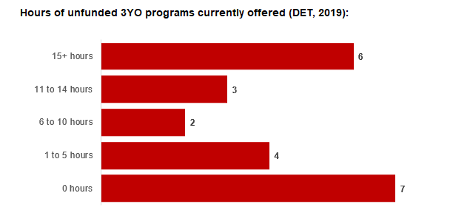

4.4 Approach to optimising the use of existing services and infrastructure
Change management strategies to optimise existing services and infrastructure
Children can often be accommodated through existing spare places and by services ‘unlocking’ unused capacity. As the experience of providers in the 2020 Three-Year-Old Kindergarten roll-out LGAs shows, while the optimisation of existing services can be challenging, it is highly time- and cost-effective compared to building new capacity through infrastructure projects. It also helps target infrastructure investment to the places that need it most and avoids over-supplying the local market.
East Gippsland Shire Council and the Department will support providers and services to maximise their kindergarten places through the following change management activities and practices:
- Increasing the capacity of any Local Government operated services by:
  - Running additional programs.
  - Using different timetables, including running 7.5-hour days.
  - Changing the delivery model, such as introducing rotational models or mixed-age groups.
  - Having degree-qualified kindergarten teachers leading integrated kindergarten programs in long day care settings.
- Encouraging and supporting other providers and services in the LGA to undertake change management.
East Gippsland Shire Council and the Department have estimated how many Three and Four-Year-Old Kindergarten places can be accommodated through existing services in the LGA (Table 1). Both parties are committed to helping providers and services offer these kindergarten places before progressing to funded infrastructure solutions to meet demand. This commitment is reflected in the LGA and community level estimates below (Table 2 onwards), which assume that demand will be met first through existing services and second through additional infrastructure. Note that in some cases the number of kindergarten places that can be offered through existing services may exceed demand for kindergarten places.
Table 1: Total estimated funded kindergarten places that can be offered by optimising existing services and infrastructure across the LGA, between 2021-29 (presented in 15-hour equivalent places)
 | 2021 | 2022 | 2023 | 2024 | 2025 | 2026 | 2027 | 2028 | 2029
Estimated existing supply of kindergarten places* | 1,450 | 1,545 | 1,545 | 1,545 | 1,545 | 1,545 | 1,545 | 1,545 | 1,545
*This may be higher than current three and four-year-old enrolments as it includes any spare places that are currently available or could be generated by making some minor adjustments to programming approaches.
**The likely expansion of services and kindergarten places in response to population growth (i.e. growth in demand not generated by the Three-Year-Old Kindergarten Reform that would likely occur) is not accounted for in these estimates.

4.5 Agreed estimates of demand for funded kindergarten places that cannot be met through existing services and infrastructure
The below estimates (Table 2 onwards) have been developed by East Gippsland Shire Council and the Department to illustrate the estimated:
- Total number of Three and Four-Year-Old Kindergarten places expected over the roll-out period.
- Three and Four-Year-Old Kindergarten places that cannot be accommodated by optimising existing services and infrastructure over the roll-out period.
These estimates have been developed to reflect that the increase in demand for Three-Year-Old Kindergarten places will be gradual.
In estimating how many Three and Four-Year-Old Kindergarten places cannot be accommodated by existing services and infrastructure, East Gippsland Shire Council and the Department have taken into account any new places that will be made available through planned expansions of existing services or new services, into estimates of existing supply, where this information is available. This may include Local Government owned services being developed and planned Kindergartens on School Sites.
These estimates do not, however, estimate how and when the broader sector will expand to meet the additional demand for kindergarten places that are estimated over the roll-out period.
Infrastructure need in the LGA and its local communities is indicated by the bottom rows of the tables in this section (Table 2 onwards): ‘Total kindergarten places that cannot be accommodated by existing services’. For example, if the number of kindergarten places for the LGA or a community is above zero in this row, it means that the area is estimated to need additional infrastructure (noting that further optimisation which avoids the need for additional infrastructure may be possible). Any type of provider – Local Government, not-for-profit or for-profit – can build this additional infrastructure. If this row shows all zeros, it means that there is no estimated need for additional infrastructure in the area.
Local Government and not-for-profit kindergarten providers must refer to the estimates in this section when applying through the Building Blocks Capacity Building Grants stream for Government funding. Under this stream, projects must be in a community where there is infrastructure need as shown in the community’s table of estimated demand for kindergarten places (i.e. there are numbers in the bottom row above zero). Projects in LGAs or communities where demand can be met through existing services (i.e. the bottom row shows all zeros) are not eligible for funding under this stream.

LGA estimates
Table 2: Total estimated three and four-year-old kindergarten places between 2021-29 (presented in 15-hour equivalent places)
LGA level estimates | 2021 | 2022 | 2023 | 2024 | 2025 | 2026 | 2027 | 2028 | 2029
Total estimated demand for kindergarten places (three and four-year-old children) | 863 | 884 | 893 | 902 | 907 | 959 | 962 | 965 | 968
Total kindergarten places that cannot be accommodated by existing services | 0 | 0 | 0 | 0 | 0 | 0 | 0 | 0 | 0

Community estimates
Table 3-9: Total estimated three and four-year-old kindergarten places between 2021-29 (presented in 15-hour equivalent places)
Alps - East estimates | 2021 | 2022 | 2023 | 2024 | 2025 | 2026 | 2027 | 2028 | 2029
Total estimated demand for kindergarten places (three and four-year-old children) | 0 | 0 | 0 | 0 | 0 | 0 | 0 | 0 | 0
Total kindergarten places that cannot be accommodated by existing services | 0 | 0 | 0 | 0 | 0 | 0 | 0 | 0 | 0

Bairnsdale estimates | 2021 | 2022 | 2023 | 2024 | 2025 | 2026 | 2027 | 2028 | 2029
Total estimated demand for kindergarten places (three and four-year-old children) | 389 | 400 | 405 | 413 | 418 | 444 | 445 | 446 | 446
Total kindergarten places that cannot be accommodated by existing services | 0 | 0 | 0 | 0 | 0 | 0 | 0 | 0 | 0

Bruthen - Omeo estimates | 2021 | 2022 | 2023 | 2024 | 2025 | 2026 | 2027 | 2028 | 2029
Total estimated demand for kindergarten places (three and four-year-old children) | 115 | 118 | 119 | 119 | 119 | 126 | 126 | 126 | 126
Total kindergarten places that cannot be accommodated by existing services | 0 | 0 | 0 | 0 | 0 | 0 | 0 | 0 | 0

Lake King estimates | 2021 | 2022 | 2023 | 2024 | 2025 | 2026 | 2027 | 2028 | 2029
Total estimated demand for kindergarten places (three and four-year-old children) | 0 | 0 | 0 | 0 | 0 | 0 | 0 | 0 | 0
Total kindergarten places that cannot be accommodated by existing services | 0 | 0 | 0 | 0 | 0 | 0 | 0 | 0 | 0

Lakes Entrance estimates | 2021 | 2022 | 2023 | 2024 | 2025 | 2026 | 2027 | 2028 | 2029
Total estimated demand for kindergarten places (three and four-year-old children) | 183 | 186 | 187 | 188 | 187 | 195 | 196 | 197 | 198
Total kindergarten places that cannot be accommodated by existing services | 0 | 0 | 0 | 0 | 0 | 0 | 0 | 0 | 0

Orbost estimates | 2021 | 2022 | 2023 | 2024 | 2025 | 2026 | 2027 | 2028 | 2029
Total estimated demand for kindergarten places (three and four-year-old children) | 95 | 96 | 96 | 95 | 95 | 98 | 99 | 99 | 100
Total kindergarten places that cannot be accommodated by existing services | 0 | 0 | 0 | 0 | 0 | 0 | 0 | 0 | 0

Paynesville estimates | 2021 | 2022 | 2023 | 2024 | 2025 | 2026 | 2027 | 2028 | 2029
Total estimated demand for kindergarten places (three and four-year-old children) | 81 | 84 | 86 | 87 | 88 | 95 | 96 | 97 | 98
Total kindergarten places that cannot be accommodated by existing services | 0 | 0 | 0 | 0 | 0 | 0 | 0 | 0 | 0

Authorisation
The Area Executive Director (Outer Gippsland) of the Department of Education and Training and the Chief Executive of East Gippsland Shire Council endorse this Kindergarten Services and Infrastructure Plan (KISP) for East Gippsland Shire by signing on 07/05/2021.
This KISP is not intended to create legal relations or constitute a legally binding contractual agreement between the parties. The parties may review this KISP in 2024 to publish a new version that will replace the previous version.
An out-of-cycle review may be triggered if both parties agree that there has been a change in relevant data, information or the local early childhood sector that significantly affects the reliability of a KISP’s estimates for planning purposes.

Signed for and on behalf and with the authority of East Gippsland Shire Council

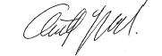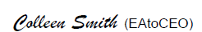
…………………………………… …………………………………
Signature Witness Signature

Name: Anthony Basford
Title: Chief Executive Officer

Address: PO Box 1618, Bairnsdale VIC 3850

Signed by Area Executive Director (Outer Gippsland), Department of Education and Training

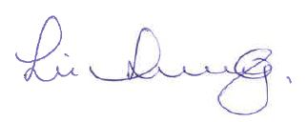
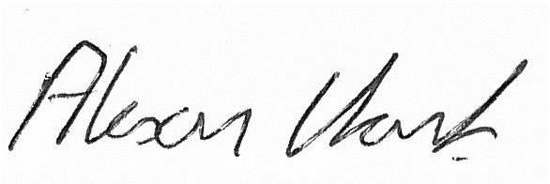

…………………………………… …………………………………
Signature Witness Signature

Name: Alison Clark
Title: Area Executive Director (Outer Gippsland)
Address: 64-66 Foster Street, Sale VIC 3850

