Kindergarten Infrastructure and
Services Plan
Benalla Rural City
CONTENTS
1. Introduction 3
1.1. Reform context 3
1.2. Purpose of KISPs 3
1.3. How to use the KISP 3
1.4. Structure of the KISP 3
1.5. Disclaimer 4
2. Map of Early Childhood Education services in Benalla Rural City 5
3. Local context 7
3.1. Purpose 7
3.2. Key considerations 7
4. Funded kindergarten enrolment estimates between 2021-29 for Benalla Rural City 12
4.1 Purpose 12
4.2 Methodology 12
4.3 Summary of current kindergarten provision 13
4.4 Approach to optimising the use of existing services and infrastructure 14
4.5 Agreed estimates of demand for funded kindergarten places that cannot be met through existing services and infrastructure 15
5. Authorisation 18

Introduction

Reform context
In an Australian first, the Victorian Government has committed to implement Three-Year-Old Kindergarten for all children over a 10-year roll-out with a total investment of almost $5 billion, including $1.68 billion to support the infrastructure expansion required for the reform. This reform will add another year of universal funded kindergarten so that, by 2029, all children in Victoria will have access to two years of play-based learning through a funded kindergarten program.

Purpose of KISPs
Three-Year-Old Kindergarten will require a large expansion of kindergarten across the State. The Government has invited all 79 Victorian Local Governments to discuss and agree upon a Kindergarten Infrastructure and Services Plan (KISP) for their Local Government Area (LGA).
Each KISP has been jointly developed with Local Government and published to estimate the growth in demand for kindergarten within the LGA. The KISPs will help all kindergarten providers meet demand and provide a clear picture of infrastructure need across the State.
While a KISP is not a funding document and does not define required infrastructure projects or commit any party to funding specific projects, it is expected that future investment requests through Building Blocks and funding decisions about Local Government and not-for-profit projects would align with the relevant KISP.

How to use the KISP
Each KISP contains estimates of future kindergarten supply of, and demand for, Three and Four-Year-Old Kindergarten places against existing enrolment capacity. Not-for-profit and for-profit providers can use these estimates to inform their plans to expand kindergarten programs, establish new services or invest in new or extended facilities.
For example, KISPs provide demand estimates in terms of where, when and how much demand for kindergarten places will grow in an LGA. KISPs also estimate where and how many kindergarten places providers can accommodate in existing facilities before an area needs new infrastructure to meet demand. The estimates can be used to inform decisions about where and when expansions of kindergarten program capacity and the construction of new or extended facilities are needed to meet demand growth.
Where there is an agreed KISP for the LGA, the Local Government and not-for-profit kindergarten providers seeking co-investments through the Building Blocks Capacity Building stream must refer to, and align their proposed project with, the infrastructure need identified in the KISP.

Structure of the KISP
Each KISP consists of the following sections:
- Section 1: A short introduction to the Three-Year-Old Kindergarten reform and the KISP.
- Section 2: A map of existing and planned Early Childhood Education and Care service locations.
- Section 3: Local knowledge and context relevant to the expansion of kindergarten services.
- Section 4: Funded kindergarten demand estimates.

Disclaimer
All data presented in this document are estimates only and are based on the best information available to the Department and Local Government at the time. They are published on an as-is basis and are for informational purposes only. They are subject to adjustment in response to market forces and as new data and other relevant information becomes available. The data may under- or over-estimate both total demand in a given location or year and the capacity for new demand to be met by providers. As a result, operational and business decisions should not be made solely based on this document. Any use of this data is solely at the risk of the user. The Department and Local Government accept no responsibility for any loss or damage, either direct or incidental, that may result from the use of the data.

Map of Early Childhood Education services in Benalla Rural City
The map below shows the distribution of currently operating and new services that are planned to open in the future in the LGA and across its communities.
This map has been prepared using Departmental data, from both the National Quality Agenda IT System (NQAITS) and the Victorian School Building Authority (VSBA). Where applicable, this map has been refined by the Benalla Rural City Council and the Department to capture other services that are planned to open in the future.
Service Name | Project type | Suburb | Total licensed capacity
Ride Avenue Preschool | Early Learning Facilities Upgrade | Benalla | 43
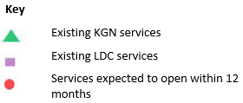
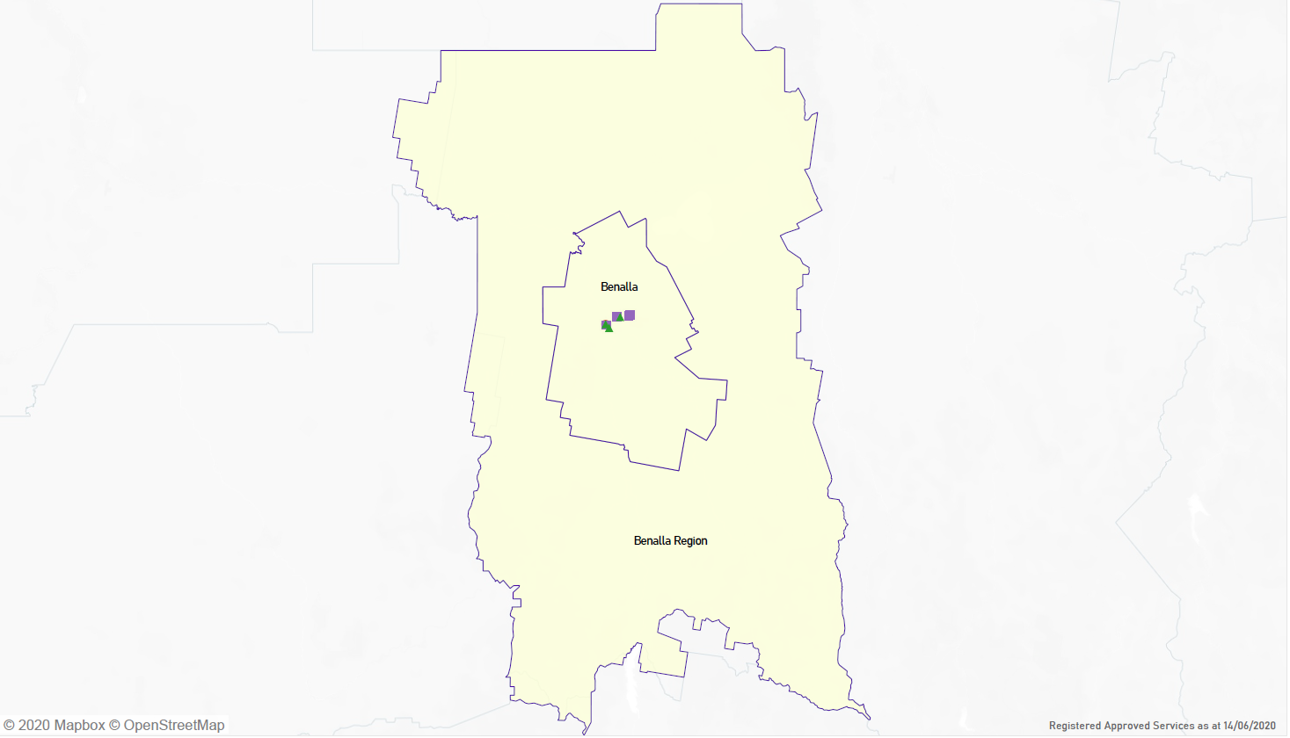

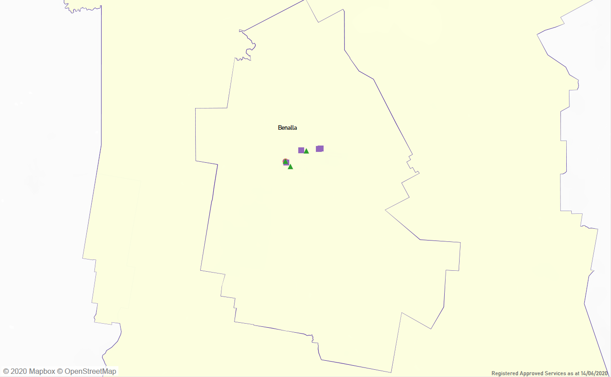

Local context
d

PURPOSE
Local, place-based knowledge and context play an important role in supporting the implementation of Three-Year-Old Kindergarten across Victoria. This section of the KISP documents this knowledge and context and has informed the funded kindergarten enrolment estimates in Section 4.

Key considerations
Key demographic trends that influence demand for kindergarten
Benalla Rural City Council has a significant pocket of socio-economic disadvantage as is evidenced by the succeeding data.

Indicator | Benalla  LGA | Victoria | Data Source
Single parent families with children aged less than 15 years (2016) | 30.5% | 18.3% | ABS Census of Population and Housing, 2016
Jobless families with children aged less than 15 years (2016) | 18.6% | 11% | ABS Census of Population and Housing, 2016
Children in families where the mother has low educational attainment (2016) | 19.8% | 12.7% | ABS Census of Population and Housing, 2016
Low income, welfare-dependant families -with children (2017) | 11.6% | 8.4% | Department of Social Services, June 2017; and the Estimated Resident Population 30 June 2017.
Social housing -rented dwellings (2016) | 4.7% | 2.9% | ABS Census of Population and Housing, 2016
Low income households (2016) | 50.3% | 40.9% | ABS Census of Population and Housing, 2016
Dwellings with no motor vehicle (2016) | 6%  *limited access to public transportation | 7.9% | ABS Census of Population and Housing, 2016
People receiving an unemployment benefit long-term (2017) | 6.4% | 3.9% | Department of Social Services, June 2017; and the Estimated Resident Population 30 June 2017.
Health care card holders (2017) | 10.5% | 7.9% | Department of Social Services, June 2017; and the Estimated Resident Population 30 June 2017.
SEIFA Index of Relative Socio-Economic Disadvantage (IRSED)- 2006-2016 | 2016: 951  2011: 957  2006: 967  *disadvantage continues to grow over time in the Benalla LGA |  | Australian Bureau of Statistics 2006, 2011 and 2016 Census of Population and Housing.

Preference for stand-alone preschool centres over LDC’s

Anecdotally, during recent consultation in 2020 two service providers have mentioned a hesitance for some families with lower incomes to access childcare services. This could potentially result in a greater preference for stand-alone, centre-based preschools from this cohort, rather than kindergarten programs in LDC settings.

Stakeholders shared that this is due to the negative experiences of some families who had enrolled a child in a childcare centre, stopped using the childcare place without notifying the provider and as a result these families faced extremely high bills despite not using the service.

“A number of families have had their childcare bills racked up because they only go a few days to childcare and then don’t show up and get big bills. This will create a hesitance for families to go in the future”.
-Benalla Service Provider-

“I have seen families enrol their children in childcare services and end up with big bills even though they are not using the service. The families ignore these debts and they grow. When their second and third children come along, they won’t use childcare at all”.
-Benalla Service Provider-

Real Estate Demand

Current demand for rental properties is very high in the Benalla LGA with one real estate agent reporting only one available rental on the books.

Benalla Real Estate Principal highlighted a few key Benalla LGA real estate trends:
- A big demand for rental properties
- Single men are primarily renting/looking for rentals
- Current demand for rental properties exceeds supply
- Very low numbers of homes on the market for sale

“What is currently unusual is the very low number of dwellings on the market, the lowest I have seen in 21 years”.

“Demand exceeds supply particularly for rentals. This demand I think is driven by property buyers who are investors, many of them from Melbourne and elsewhere and larger numbers of first home buyers because of low interest rates”.

Ray White Benalla’s local insight closely matches saying there are:
- A lack of rental properties
- Low number of properties for sale currently on the market
- A mix of property investors and new buyers

“Over the past twelve months we have had huge demand for rental properties”.

“In 2015 we had over a hundred active listings for sale, now we have fifteen”.

“Properties between $300,000-$350,000 just walk out the door”.

Projects or trends that may influence supply of early childhood education and care

Program Reclassification

In 2019 during DET commissioned local research it was identified that there were four stand- alone kindergartens and three long day care centres (DET Benalla KISP Draft Report 2020).

The Australian Christian College has changed their stand-alone kindergarten program to Smartplay and are now operating as a long day care centre. With this recent change there are now four long day care centres and three stand-alone kindergartens in Benalla.

Subdivision Applications in Benalla

The Benalla Rural City Council Planning Department has shared that at present there are approximately 800-1000 residential blocks at different stages of planning. This number of subdivision applications is unprecedented, well above any numbers seen within the LGA over the past two decades.

Benalla West Estate Revitalisation Project

The Victorian Government is investing $10 million to improve the Benalla West Estate, 2.5km west of central Benalla.
The project’s goals include improving housing, public areas and connections with the surrounding community. To guide the improvements, a masterplan will be prepared with input from residents, the broader community and other stakeholders.
The community engagement report suggests interest from community in increasing the amount of social housing in Benalla:

‘Overall, 78% (68 participants) agreed with this Key Direction (provide more social housing in new developments in Benalla). Participants were eager to see an increase in social housing provision in Benalla. Several members of the Consultative Committee considered how an increase in social housing will accommodate the housing needs of vulnerable people’.
(Capire, April 2020)

Employment Growth
Benalla’s largest employing industries are manufacturing, retail, health and agriculture. Total employment in the area is estimated at 5,212 jobs (REMPLAN, 2019).
The major contributors to employment are:
Benalla RC Industry Sector | Jobs | %
Health Care, Social Assistance | 766 | 14.7%
Agriculture, Forestry, Fishing | 576 | 11.1%
Manufacturing | 568 | 10.9%
Other | 3,302 | 63.4%
Source: REMPLAN, 2019
Benalla has seen significant growth in new jobs since 2018. The Royal Freemasons Aged Care Facility opened in Benalla in 2019 and is expected to offer 160 jobs when it is at full capacity.

The manufacturing industry includes larger employers such as Thales Australia, D & R Henderson Pty Ltd, Schneider Electric (Australia) Pty Ltd and the most recent addition of the LS Precast factory in 2018 which forecasted 400 new jobs in Benalla.

NIOA’s long-term tenancy alongside Thales from July 1, 2020 is expected to bring 100 new highly sophisticated, advanced manufacturing jobs to Benalla over the next three years. Additionally, a new hydroponic fruit and vegetable farm on the midland highway is expected to bring 200 new jobs to Benalla.

Also, of note are that there are a number of upcoming and current solar farm developments in the Benalla Rural City and nearby in the Rural City of Wangaratta: https://www.planning.vic.gov.au/permits-and-applications/specific-permit-topics/solar-energy-facilities/solar-energy-projects

Under construction:
- Winton
- Glenrowan West

Planning Permit Application Lodged and Process Underway:
- Kennedys Creek (5 km north east of Benalla)
- Laceby (5 km north east of Glenrowan)
- Mokoan 2 (9 km west of Glenrowan)
- Winton North (4km west of Glenrowan)

Key local geographic considerations or information relevant to Three-Year-Old Kindergarten

Users from other towns
Benalla offers employment for a range of other neighbouring localities that are based outside the Benalla LGA e.g. Dookie, Violet Town, Wangaratta, Mansfield, Glenrowan etc. In some instances, this may result in children from other shires being enrolled in childcare within the Benalla LGA.

All Preschool/LDC’s are based in the town of Benalla
Currently, all preschool and LDC’s are all based within the town centre of Benalla. This requires families living in all outlying towns to travel in to access 3-year-old kindergarten. This cost and time requirement could be a potential barrier for 3-year-old preschool engagement. This geographic experience should be taken into account when planning models of delivery.

Other information about the expansion of early childhood services

COVID fall-out, potential for greater geographic diversification

A recent whitepaper The Great Australian Population Shift captured the three underpinning reasons why the pandemic could influence people’s preferred lifestyle and living location into the future:

- We are now far more willing to work from home
- We favour larger properties, with room to form a home base, grow veggies and spend time with the kids; and
- We may be happy to live further from key CBD locations, because we are not commuting every day (Ripehouse Advisory 2020)

The whitepaper names Benalla (in the ‘golden circle’ of 2-3 hours from Melbourne), as an LGA that could see significant growth of 5.08 per cent making it the eighth largest population increase in Australia. What is not clear is the extent of this projected growth in terms of growing numbers of preschool aged children.

Funded kindergarten enrolment estimates between 2021-29 for Benalla Rural City

4.1 Purpose
As Three-Year-Old Kindergarten is rolled-out and Victoria’s population grows, demand for both Three and Four-Year-Old Kindergarten places will increase significantly. While additional capacity will be needed to meet this demand, this will vary across the State and over time, due to differences in the capacity of existing services, growth trends and sector composition.
To identify where, when and how many additional kindergarten places are expected over the roll-out in Benalla Rural City, Benalla Rural City Council and the Department have developed:
- A summary of the current provision of kindergarten within the LGA (Section 4.3).
- An approach to optimising the utilisation of existing services and infrastructure through ‘change management’ strategies that Benalla Rural City Council and the Department will support to help meet additional demand in the LGA (Section 4.4).
- An estimate of the Three and Four-Year-Old kindergarten places that cannot be met through existing services for the 2021-29 period, taking into account the additional demand that can be accommodated by optimising utilisation of existing services and infrastructure through point 2, above (Section 4.5).
Local Government and providers can use these published estimates to inform reform implementation activities such as service planning, kindergarten program expansion, infrastructure investments and Building Blocks funding applications in alignment with future demand over the 10-year roll-out.

4.2 Methodology
The estimated Three and Four-Year-Old Kindergarten places used in the following sections have been agreed between Benalla Rural City Council and the Department, and were informed by:
- Estimates developed by the Department which draw on a range of inputs, including population forecasts, current enrolments and results from the Kindergarten Capacity Assessment Program (KCAP), conducted in 2019.
- The estimated capacity of new services that are planned to open in the LGA (Section 2)
- Local knowledge and context provided by the Local Government (Section 3) that explains particular issues and trends in their area.
- The approach to optimising utilisation of existing services in the LGA (Section 4.4), and
- Other sources, such as modelling undertaken by Local Governments and local data.
The KISP measures a service’s capacity to deliver funded kindergarten in terms of the number of children it could enrol in Three and Four-Year-Old Kindergarten. The number of funded kindergarten places is different from a service’s licensed or approved places, which count the number of children permitted to attend the service at any one time under the license. Many services can enrol more children in their funded kindergarten program(s) than they have licensed places for because they can run more than one kindergarten program per week. Kindergarten places are therefore a more accurate measure of service kindergarten capacity than licensed places.
Three-Year-Old Kindergarten places have been presented as 15-hour places so they can be easily compared to Four-Year-Old Kindergarten places. Moreover, when Three-Year-Old Kindergarten is fully rolled-out in 2029, every three-year-old child will have access to 15-hours of kindergarten.
From 2023 all providers will have flexibility to determine how many hours of funded Three-Year-Old Kindergarten they deliver per week, with a minimum of five hours and a maximum of 15-hours funded pro-rata. It is expected that hours offered will vary. Given this variation, it is important to be aware that during the transition to all three-year-old children receiving 15-hours of funded kindergarten per week in 2029, the 15-hour places presented in this report may represent multiple three-year-old places that individually receive less than 15-hours of kindergarten per week.
These estimates have been developed at an LGA and community level to show the overall forecast and variation within an area. The KISP defines community at the Statistical Area Level 2, which is medium-sized areas which represent a community that interacts socially and economically, with a population range of 3,000 to 25,000 people, and an average population of about 10,000 people.

4.3 Summary of current kindergarten provision
The figures below provide a summary of current kindergarten provision within the LGA and provide relevant context for the estimates of demand for funded kindergarten places included in Section 4.5. The data included in this section are largely drawn from:
- The Kindergarten Capacity Assessment Program (KCAP), collected between June and October 2019.
- The Department’s Kindergarten Information Management System (KIMS), as at 2019.
- The Department’s Quality and Regulatory Division (QARD) monitoring data, as at 2019.
- The National Quality Agenda IT System (NQAITS), as at April 2020.
- The Victorian Child and Adolescent Monitoring System (VCAMS), as at 2018.
Please note that, because these sources were collected at different points, this may result in slightly different totals appearing in the below data.

Number of services by service type (NQAITs, 2020)

Stand-alone kindergartens | 4
Long day care centres | 3

Percentage of services by management type, LGA level (NQAITs, 2020)
Type | Percentage
Local Government | 0%
Private not for profit | 57%
Private for profit | 29%
Other | 14%

Current kindergarten offering
Four-Year-Old Kindergarten participation rate (VCAMS, 2018): | 83%
Number of services that offer a funded kindergarten program (DET, 2019): | 5
Number of services that offer an unfunded Three-Year-Old Kindergarten program (DET, 2019): | 0
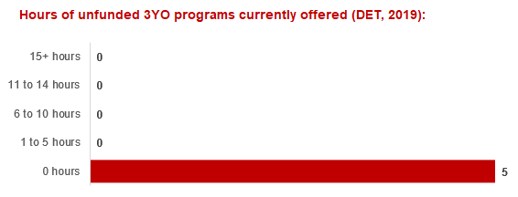

4.4 Approach to optimising the use of existing services and infrastructure
Change management strategies to optimise existing services and infrastructure
Children can often be accommodated through existing spare places and by services ‘unlocking’ unused capacity. As the experience of providers in the 2020 Three-Year-Old Kindergarten roll-out LGAs shows, while the optimisation of existing services can be challenging, it is highly time- and cost-effective compared to building new capacity through infrastructure projects. It also helps target infrastructure investment to the places that need it most and avoids over-supplying the local market.
Although the Benalla Rural City Council does not operate any early childhood services, in its planning capacity it commits to working with the Department to support providers and services to maximise their kindergarten places through the following change management activities and practices:
- Running additional programs.
- Using different timetables, including running 7.5-hour days.
- Changing the delivery model, such as introducing rotational models or mixed-age groups.
- Having degree-qualified kindergarten teachers leading integrated kindergarten programs in long day care settings.
Benalla Rural City Council and the Department have estimated how many Three and Four-Year-Old Kindergarten places can be accommodated through existing services in the LGA (Table 1). Both parties are committed to helping providers and services offer these kindergarten places before progressing to funded infrastructure solutions to meet demand. This commitment is reflected in the LGA and community level estimates below (Table 2 onwards), which assume that demand will be met first through existing services and second through additional infrastructure. Note that in some cases the number of kindergarten places that can be offered through existing services may exceed demand for kindergarten places.
Table 1: Total estimated funded kindergarten places that can be offered by optimising existing services and infrastructure across the LGA, between 2021-29 (presented in 15-hour equivalent places)
 | 2021 | 2022 | 2023 | 2024 | 2025 | 2026 | 2027 | 2028 | 2029
Total three and four-year-old places that can be accommodated by optimising existing services* | 490 | 490 | 490 | 490 | 490 | 490 | 490 | 490 | 490
*The likely expansion of services and kindergarten places in response to population growth (i.e. growth in demand not generated by the Three-Year-Old Kindergarten Reform that would likely occur) is not accounted for in these estimates.

4.5 Agreed estimates of demand for funded kindergarten places that cannot be met through existing services and infrastructure
The below estimates (Table 2 onwards) have been developed by Benalla Rural City Council and the Department to illustrate the estimated:
- Total number of Three and Four-Year-Old Kindergarten places expected over the roll-out period.
- Three and Four-Year-Old Kindergarten places that cannot be accommodated by optimising existing services and infrastructure over the roll-out period.
These estimates have been developed to reflect that the increase in demand for Three-Year-Old Kindergarten places will be gradual.
In estimating how many Three and Four-Year-Old Kindergarten places cannot be accommodated by existing services and infrastructure, Benalla Rural City Council and the Department have taken into account any new places that will be made available through planned expansions of existing services or new services, into estimates of existing supply, where this information is available. This may include Local Government owned services being developed and planned Kindergartens on School Sites.
These estimates do not, however, estimate how and when the broader sector will expand to meet the additional demand for kindergarten places that are estimated over the roll-out period.
Infrastructure need in the LGA and its local communities is indicated by the bottom rows of the tables in this section (Table 2 onwards): ‘Total kindergarten places that cannot be accommodated by existing services’. For example, if the number of kindergarten places for the LGA or a community is above zero in this row, it means that the area is estimated to need additional infrastructure (noting that further optimisation which avoids the need for additional infrastructure may be possible). Any type of provider – Local Government, not-for-profit or for-profit – can build this additional infrastructure. If this row shows all zeros, it means that there is no estimated need for additional infrastructure in the area.
Local Government and not-for-profit kindergarten providers must refer to the estimates in this section when applying through the Building Blocks Capacity Building Grants stream for Government funding. Under this stream, projects must be in a community where there is infrastructure need as shown in the community’s table of estimated demand for kindergarten places (i.e. there are numbers in the bottom row above zero). Projects in LGAs or communities where demand can be met through existing services (i.e. the bottom row shows all zeros) are not eligible for funding under this stream.

LGA estimates
Table 2: Estimated three and four-year-old kindergarten places between 2021-29 (presented in 15-hour equivalent places)
LGA level estimates | 2021 | 2022 | 2023 | 2024 | 2025 | 2026 | 2027 | 2028 | 2029
Total estimated demand for kindergarten places (three and four-year-old children) | 144 | 185 | 202 | 218 | 231 | 252 | 263 | 273 | 287
Total kindergarten places that cannot be accommodated by existing services | 0 | 0 | 0 | 0 | 0 | 0 | 0 | 0 | 0

Community estimates
Table 3-4: Estimated three and four-year-old kindergarten places between 2021-29 (presented in 15-hour equivalent places)
Benalla estimates | 2021 | 2022 | 2023 | 2024 | 2025 | 2026 | 2027 | 2028 | 2029
Total estimated demand for kindergarten places (three and four-year-old children) | 144 | 176 | 190 | 203 | 212 | 229 | 238 | 246 | 257
Total kindergarten places that cannot be accommodated by existing services | 0 | 0 | 0 | 0 | 0 | 0 | 0 | 0 | 0

Benalla Region estimates | 2021 | 2022 | 2023 | 2024 | 2025 | 2026 | 2027 | 2028 | 2029
Total estimated demand for kindergarten places (three and four-year-old children) | 0 | 9 | 12 | 15 | 18 | 23 | 25 | 27 | 30
Total kindergarten places that cannot be accommodated by existing services | 0 | 0 | 0 | 0 | 0 | 0 | 0 | 0 | 0

Authorisation
The Area Executive Director (Ovens Murray) of the Department of Education and Training and the Chief Executive of Benalla Rural City Council endorse this Kindergarten Services and Infrastructure Plan (KISP) for Benalla Rural City Council by signing on 16 September 2020.
This KISP is not intended to create legal relations or constitute a legally binding contractual agreement between the parties. The parties may review this KISP in 2023 to publish a new version that will replace the previous version.
An out-of-cycle review may be triggered if both parties agree that there has been a change in relevant data, information or the local early childhood sector that significantly affects the reliability of a KISP’s estimates for planning purposes.

Signed for and on behalf and with the authority of Benalla Rural City Council

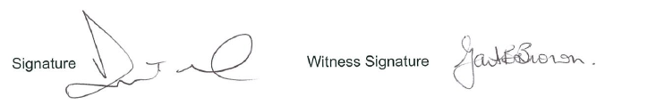

Name: Dominic Testoni
Title: Chief Executive Officer, Benalla Rural City Council
Address: 1 Bridge Street East, Benalla, 3672

Signed by Area Executive Director (Ovens Murray), Department of Education and Training

Signature 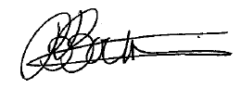 Witness Signature 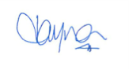

Name: Bernie Boulton

Title: Area Executive Director (Ovens Murray), Department of Education and Training
Address: 150 Bridge Street East, Benalla, 3672

