Kindergarten Infrastructure and Services Plan
Baw Baw Shire

CONTENTS
1. Introduction 3
1.1. Reform context 3
1.2. Purpose of Kindergarten Infrastructure and Services Plans (KISPs) 3
1.3. Structure of the KISP 4
1.4. Disclaimer 4
2. Map of Early Childhood Education services in Baw Baw Shire 5
3. Local context 6
3.1 Purpose 6
3.2 Key considerations 6
4. Unmet demand estimates between 2026 - 2036 for Baw Baw Shire 11
4.1 Purpose 11
4.2 Methodology 11
4.3 Summary of current kindergarten provision 13
4.4 Agreed estimates of demand for kindergarten places 13
5. Authorisation 16

Introduction

Reform context
The Victorian Government’s $14 billion Best Start, Best Life (BSBL) reforms are the most significant change to Victoria’s early childhood sector in a generation.
The BSBL reforms include:
- Free Kinder: Free Kinder is now available for Victorian 3- and 4-year-old children at participating services in standalone (sessional) kindergartens and long day care centres – a saving of up to $2,500 per child, every year.
- Pre-Prep: Four-Year-Old Kindergarten will gradually transition to ‘Pre-Prep’ – increasing to a universal 30-hour-a-week program of play-based learning for 4-year-old children in Victoria by 2036.
- Three-Year-Old Kindergarten: the continued roll-out of Three-Year-Old Kindergarten, with programs increasing to 15 hours a week across the state by 2029.
- Early learning and childcare centres: the establishment of 50 Victorian government-owned and operated early learning and childcare centres. These centres will be built in areas with the greatest need and will make it easier for families to access early childhood education and childcare. The first of the centres opened in 2025.
These initiatives demonstrate a clear commitment to improving early learning outcomes for Victorian children, workforce participation and access for families, and present the most significant change to Victoria’s early childhood sector in a generation.

Pre-Prep will roll-out in Baw Baw Shire in 2028. Statewide, Aboriginal and Torres Strait Islander children, children from a refugee or asylum seeker background, and children who have had contact with Child Protection services, will be able to access up to 25 hours of Pre-Prep in 2026, increasing to up to 30 hours from 2028. Children who have (or have a parent or guardian who has) a Commonwealth concession card and children who are a multiple birth child (triplets or more) across the state will be able to access up to 25 hours of Pre-Prep in 2028, increasing to up to 30 hours from 2030.

Purpose of Kindergarten Infrastructure and Services Plans (KISPs)
New and expanded infrastructure is key to delivering the BSBL reforms and will require a large expansion of kindergarten facilities across the State. KISPs, which are jointly developed with Local Governments, indicate where and when new infrastructure will be required to support both reform implementation and population growth in each of Victoria’s 79 local government areas (LGAs). KISPs help all kindergarten providers meet demand and collectively provide a clear picture of infrastructure need across the State.
KISPs support planning for services and future capital works and include detailed information about:
- Current capacity and demand for funded kindergarten
- Capacity to be delivered for planned infrastructure projects and future demand for kindergarten
- Forecast ‘unmet demand’ for kindergarten – that is, the kindergarten places needed that cannot be met by current or planned capacity
- Information specific to each local government area and its early childhood education and care landscape.
KISPs were initially developed to support the roll-out of Three-Year-Old Kindergarten and have now been updated to incorporate Pre-Prep.
KISPs are intended to support planning. They are not funding documents and do not commit any party to addressing the unmet demand identified.
However, it is expected that future investment requests through Building Blocks and funding decisions about Local Government, not-for-profit projects (including non-government schools) would align with the relevant KISP (including Section 3: Local Context).

Structure of the KISP
Each KISP consists of the following sections:
- Section 1: A short introduction to the Best Start, Best Life reform and the KISP.
- Section 2: A map of existing and planned Early Childhood Education and Care services.
- Section 3: Local context and knowledge of key information in Baw Baw Shire relevant to early childhood education.
- Section 4: Unmet demand estimates in Baw Baw Shire over the life of the reform.

Disclaimer
All data presented in this document is published for information purposes only. Operational and business decisions should not be based solely on this document. Neither the Department nor Baw Baw Shire Council warrants, guarantees, makes any representation or assumes any duty of care in relation to the data, including as to its suitability, completeness, accuracy or adequacy.

Map of Early Childhood Education services in Baw Baw Shire
The map below shows the distribution of currently operating and new State-supported services that are planned to open in the future in Baw Baw Shire. Planned services by the private sector are not included.
This map has been prepared using departmental data, from both the National Quality Agenda IT System (NQAITS) and the Victorian School Building Authority (VSBA).
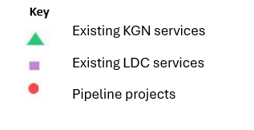
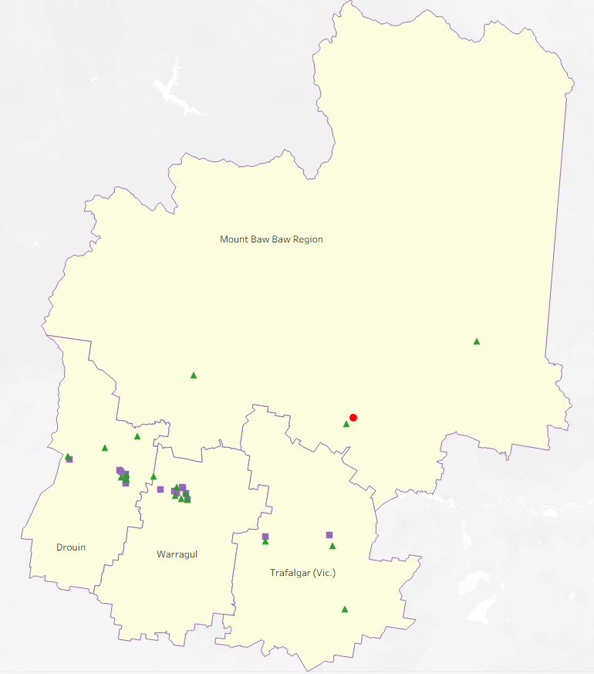

Local context
d

3.1 Purpose
Local, place-based knowledge and context play an important role in supporting the implementation of the BSBL reforms across Victoria. This section of the KISP documents this knowledge and context and should be considered alongside the kindergarten demand estimates in Section 4.
Information provided as local context may support applications through the Building Blocks Capacity Building and Planning Grants streams.

3.2 Key considerations
Aboriginal Self Determination in Early Childhood Education and Care
According to the 2021 Census, 728 Aboriginal and/or Torres Strait Islander (ATSI) people live within Baw Baw Shire, approximately 1.3% of the population, an increase from 1.0% in 2016. This indicates a higher percentage than the Victorian proportion of 1.0%.
The Drouin SA2 contains the largest population of ATSI residents, with 1.8% of the population.
Baw Baw’s Aboriginal community tend to favour specific kindergarten and early learning centres based on cultural/family connections to these sites. In particular, two kindergartens (one in Warragul and one in Drouin) have historically attracted a higher proportion of enrolments from Aboriginal families. Council’s involvement with the Aboriginal Best Start Program indicates that these are the preferred services for the local community due to high level of cultural safety provided. This is reflected in lower enrolments for other services.
Self-determination is essential for ensuring that Aboriginal children grow up strong in culture, connected to family, and with the opportunity to thrive on their own terms. When planning for early years infrastructure, consideration needs to be given to Aboriginal families’ preference for services, respecting their rights to choose services which they consider culturally safe.

Key demographic trends that influence demand for kindergarten
Baw Baw Shire is the sixth fastest growing LGA in Victoria, and the second fastest growing regional municipality. Located 100km east of Melbourne, the Shire offers a mix of rural and urban living with affordable housing, scenic views and relaxed lifestyle making it an attractive option for new residents, leading to unprecedented growth.
Baw Baw Shire covers approximately 4,027 square kilometres of high-quality farmland, national parks and residential areas. The northern half of the Shire is heavily forested and lies in the Great Dividing Range, while the south is bounded by the Strzelecki Ranges. The Shire’s largest towns are located along the rail and road corridor which provides direct access to Melbourne.
The large geographic area the Shire covers presents some challenges for service and infrastructure provision, particularly in communities more remote from major townships. There is a high need for services and infrastructure in the major townships of Warragul and Drouin, but also in smaller townships and communities such as Trafalgar, Yarragon, Longwarry, Neerim South Willow Grove, and Thorpdale. Key characteristics of the Baw Baw community are highlighted below:
Population
The current estimated residential population in Baw Baw of 63,723 (forecast.id) is expected to rise to just under 94,000 by 2046, which would be an increase of 62.80% since the 2021 census. In the years between the 2016 and 2021 censuses, the population of Baw Baw Shire has increased by 18.87% (an average of 3.8% per year).
Most residents are in the towns along the rail and road corridor of Warragul, Drouin, Trafalgar, Yarragon and Longwarry.
Victoria’s average annual growth rate between the 2016 and 2021 Census was 1.94%. In comparison, strong year-on-year growth occurred in these major Baw Baw Shire towns:
- Warragul (5.14% per annum)
- Drouin (4.44% per annum) and Longwarry (4.23% per annum). Both towns are within the Drouin SA2 area.
- Neerim South (3.52% per annum)
- Yarragon (3.04% per annum)
The Warragul and Drouin Precinct Structure Plans provide a framework for increasing Warragul’ s population by 30,000 people living in 12,500 new homes and Drouin’s population by 18,000 residents across 7,400 new homes over the next 30 years. Permit activity mapping in Warragul and Drouin currently shows approximately 11,000 lots in the pipeline.
Although the bulk of the growth is taking place in Warragul and Drouin, there is also some activity elsewhere, such as in Yarragon and Trafalgar. Trafalgar has two subdivisions totalling over 600 lots imminent in the south-west part of the township. Yarragon is expected to accommodate several hundred homes in the area on the eastern side of the town recently rezoned to Neighbourhood Residential Zone.
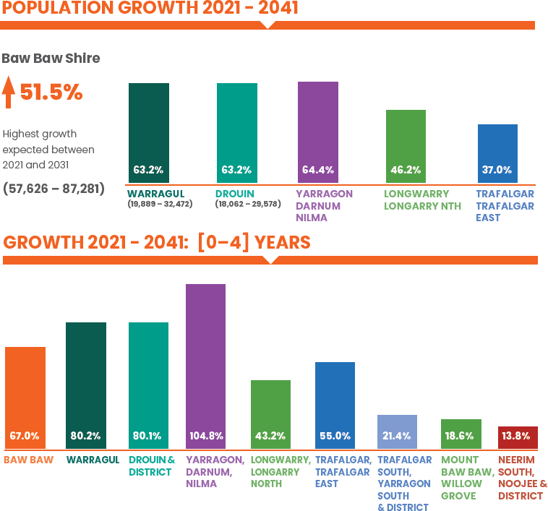
As part of Council’s Municipal Early Years Infrastructure Plan (2025-2041), detailed population projections were undertaken, specific to the 0-4 year age bracket. This analysis indicated that, whilst the overall population of Baw Baw Shire is anticipated to increase by 51.5% in the 20 years to 2041, the number of children in the 0-4 age bracket is expected to increase by 67%.
(Source: Baw Baw Shire Municipal Early Years Plan 2025-2041, p. 14)

Early childhood services and uptake patterns
Both sessional kindergartens and long day care providers currently operate within the Baw Baw Shire. All long day care providers are concentrated along the Princes Highway towns of Warragul, Drouin, Longwarry, Yarragon and Trafalgar, meaning sessional kindergartens are the primary option for rural families within the Shire, without having to travel significant distances. A network of family day carers, primarily located in Warragul and Drouin and in smaller localities, also support these services.
Baw Baw’s Early Childhood Education profile (2024) indicates exceptional uptake of 4-year-old kindergarten, with 100% enrolments (compared with Victorian average of 96%). Uptake of 3-year-old funded kindergarten is lower, with 82% of eligible children enrolled.
Families in Baw Baw Shire exhibit strong preferences for sessional kindergarten enrolment compared with long day care funded programs. In 2024, only 16% of all kindergarten enrolments were in long day care services.

Disadvantage data in Baw Baw Shire
SEIFA data shows that the areas within Baw Baw Shire experiencing the most level of disadvantage are within the Drouin SA2 area (decile 4). Looking more closely, the following areas are considered more disadvantaged than Regional Victoria (960)
- Drouin- North 957.6
- Trafalgar- Trafalgar East 957.4
- Mount Baw Baw- Willow Grove and District 955.6
- Drouin 951.6
- Drouin South 941.0
- Longwarry- Longwarry North 934.4

The Longwarry area of Baw Baw Shire scores lowest on SEIFA data, with only 25% of Australia’s suburbs registering as a higher level of disadvantage.
Socio-economic disadvantage can be a barrier to accessing kindergarten services as families prioritise food, housing, clothing, health, transport and other costs ahead of non-compulsory early childhood education.
Australian Early Development Census (AEDC) data shows that there are fewer children ‘on track’ in each of the five developmental domains than the average across Victoria and Australia. AEDC data also demonstrates a statistically significant downward trend in the percentage of children ‘on track’ in Baw Baw in social, emotional and language development, when compared with results from 2021.
The Index of Household Advantage and Disadvantage (IHAD) provides a summary measure of relative socio-economic advantage and disadvantage at the household level. This data shows more than a quarter of households in the Drouin and Trafalgar SA2’s experiencing greater disadvantage than the Victorian and Australian average. Detailed breakdown of this data is available at Index of Household Advantage and Disadvantage, 2021 | Australian Bureau of Statistics

Projects or trends that may influence supply of early childhood education and care
In 2024, Council endorsed the Baw Baw Shire Municipal Early Years Plan 2023-2041 (MEYIP). This strategic planning document was developed to guide future decisions by Council about its investment in, and advocacy for, early years infrastructure. Significant community consultation was undertaken in the development.
The following are excerpts from the from the MEYIP in relation to trends in early childhood education and care:
Demand: The demand for early years services, supports and infrastructure will increase significantly because of population growth and sector reforms for kindergarten and MCH. The communities where increased demand will be highest are Warragul and Drouin, but also Yarragon – Darnum – Nilma and Trafalgar – Trafalgar East. Communities where limited or no early years services are available also rely heavily upon the larger urban townships to access services (p. 66)
Kindergarten access: Baw Baw families prefer accessing kindergarten in their local town and prefer sessional kindergarten over kindergarten integrated with childcare (90% of children attended sessional kindergarten in 2022). If these preferences remain constant, up to 29 additional kindergarten program rooms will be needed to support sessional kindergarten in Baw Baw Shire by 2032. (p. 8)
Child Care Access: Access to childcare is difficult for families in many communities across Baw Baw Shire. It is a key area of concern for families and their concerns are supported by the supply and demand data. Childcare is not available in three planning areas- Trafalgar South- Yarragon South and District, Mt Baw Baw- Willow Grove and District; and Neerim South- Noojee and District. These communities are highly reliant upon being able to access childcare in neighbouring areas which are already experiencing high and unmet demand (p. 77)

Key local geographic considerations or information relevant to Three-Year-Old Kindergarten and Pre-Prep
Baw Baw Shire Council utilises 8 precincts when planning for early years services and infrastructure, not 4 SA2s as in this document. These precincts have been developed taking into account current service usage and travel patterns, and user feedback.
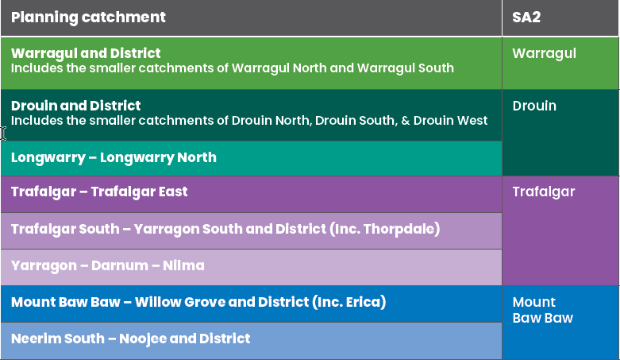
The MEYIP considers the current and future early years’ service and infrastructure needs across eight planning areas in Baw Baw Shire, aligning the planning areas with the four SA2 Census catchments typically used by the State Government to assess demand for kindergarten services and infrastructure. The table below identifies the 8 planning areas and their relationship to the SA2 catchments.

The use of SA2 catchments in Baw Baw becomes problematic in the more rural areas, especially the Mt Baw Baw SA2. This becomes evident when there is variation in supply and demand - for example, an oversupply in Erica will mask unmet demand in Neerim South. If there are insufficient places in the single room service at Neerim South, it is not viable for a child to be placed at Erica (which would require round trip travel of 1 hour 45 minutes, twice a day).
Single room services
Of the 17 sessional kindergartens in Baw Baw Shire, nine are single room facilities. With the exception of Thorpdale Kindergartens, the other sessional kindergartens will be unable to fully service need and demand for the current reforms of 15 hours kindergarten and 30 hours of Pre-Prep. In reality, the staged nature of the roll out will see Baw Baw Shire unable to meet the demands of the reform before the full 30 hour program is required without additional kindergarten infrastructure. With a typical pattern of around 25% of families having Health Care Card entitlements, this inclusion within the priority access cohort means that current infrastructure will be insufficient even in dual room facilities.
Aging infrastructure
In addition to addressing the need for increased capacity, Council is also faced with a number of facilities which are at, or approaching, end of life cycle. Council’s kindergarten facilities range in age from 2 years old to 69 years old. It is noted that the four facilities in the 1-10 year age bracket are all Kindergarten On School Site facilities (leased by Council on DE land). All Council owned facilities are over thirty years old and require different levels of investment in the facility.
An internal report undertaken in 2024, assessed Council owned and leased kindergarten infrastructure to determine the current state of facilities. The report determined that three services were less than optimal standard, including Mary Beck Kindergarten, which will cease operation as by 2028. This closure has been considered in the unmet demand estimates in section 4.
Concerns regarding the timing of and volume of capacity shortfall
Baw Baw Shire Council maintains strong concerns that children will miss out on kinder in the Drouin and Warragul SA2s before unmet demand is forecast to emerge. This will be actively monitored by Council and the department.
In addition, the data from the MEYIP predicts that the volume of the shortfall experienced in Drouin will be significantly higher than unmet demand in section 4.

Other information about the expansion of early childhood services
Current enrolment patterns
Indicative enrolment patterns for 2026 show significant pressure on 4-year-old placements. This is consistent with MEYIP data.

Unmet demand estimates between 2026 - 2036 for Baw Baw Shire

4.1 Purpose
As the BSBL reforms are rolled out and Victoria’s population grows, demand for kindergarten and Pre-Prep places will increase significantly. While additional capacity will be needed to meet this demand, this will vary across the State and over time, due to differences in the capacity of existing services, growth trends and sector composition.
To identify where, when and how many additional kindergarten places are expected to be required over the roll-out in Baw Baw Shire, Baw Baw Shire Council and the department have developed:
- a summary of the current provision of kindergarten within Baw Baw Shire (Section 4.3).
- an estimate of kindergarten places that cannot be met through existing services for the 2026 - 2036 period, taking into account the additional demand that can be accommodated by optimising utilisation of existing services and infrastructure (Section 4.4).
Local governments and providers can use these published estimates to inform reform implementation activities such as service planning, kindergarten program expansion, infrastructure investments and Building Blocks funding applications in alignment with future demand over the roll-out.

4.2 Methodology
The estimated kindergarten places used in the following sections have been agreed between Baw Baw Shire Council and the department, and were informed by:
- demand projections developed by the department which draw on a range of inputs, including population forecasts and current enrolments
- the estimated capacity of existing and planned services in the LGA (Section 2)
- where applicable, modelling undertaken by Baw Baw Shire and service level information; and
- local knowledge and context provided by the local government (Section 3) that explains particular issues and trends in their area.
Kindergarten places explainer
The KISP measures a service’s capacity to deliver funded kindergarten in terms of the number of 15-hour places (referred to as “kindergarten places”) available for Three-Year-Old kindergarten and Pre-Prep (noting that, by 2036, two kindergarten places will be required for one Pre-Prep enrolment). The number of kindergarten places is different from a service’s licensed or approved places, which count the number of children permitted to attend the service at any one time under the license. Many services can enrol more children in their funded kindergarten program(s) than they have licensed places for because they can run more than one kindergarten program per week. Kindergarten places are therefore a more accurate measure of service kindergarten capacity than licensed places.
Kindergarten places have been presented as 15-hour places so that new Three-Year-Old Kindergarten places and the additional 15-hour places required for Pre-Prep can be easily compared to existing 15-hour Four-Year-Old Kindergarten places. This is because, when Three-Year-Old Kindergarten is fully rolled out in 2029, three-year-old children will have access to 15-hours of kindergarten. When Pre-Prep is fully rolled out in 2036, four-year-old children will have access to up to 30-hours of kindergarten, an increase of the current offering of 15-hours per week.
It is important to note that enrolments are not equivalent to 15-hour places. One 15-hour place can support a total of 15 hours of delivery per week split between one or more children, including but not limited to the following examples:
 |  | One 15-hour place (15 hours of delivery)
Example 1 | 1 child | 1 x 3YO attending 15 hours per week
Example 2 | 1 child | 1 x 4YO attending 15 hours per week
Example 3 | 2 children | 2 x 3YOs attending 7.5 hours per week
Example 4 | 3 children | 3 x 3YOs attending 5 hours per week
Two 15-hour places can support a total of 30 hours of delivery per week split between one or more children, including but not limited to the following examples:
 |  | Two 15-hour places (30 hours of delivery)
Example 1 | 1 child | 1 x 4YO attending 30 hours per week
Example 2 | 2 children | 2 x 3YOs attending 15 hours per week
Example 3 | 2 children | 1 x 3YO, and  1 x 4YO both attending 15 hours per week
Example 4 | 3 children | 2 x 3YOs attending 7.5 hours per week, and  1 x 4YO attending 15 hours per week
Geographic boundaries used in the KISP
These estimates have been developed at an LGA and community level to show the overall forecast and variation within an area. The KISP defines community at the Statistical Area Level 2 (SA2), which is a medium-sized area which represents a community that interacts socially and economically, with an approximate population range of 3,000 to 25,000 people, and an average population of about 10,000 people. The KISP uses 2021 SA2 boundaries. More information is available at the Australian Bureau of Statistics website.
Supply contributed by pipeline projects
Baw Baw Shire Council and the department have added any new places that will be made available through planned expansions of existing services or new services into estimates of existing supply, where this information is available. This may include projects being delivered by not-for-profit providers (including non-government schools) with support from the Victorian Government, planned Kindergartens on School Sites, and government-owned and operated early learning and childcare centres.
The KISP does not estimate how and when the broader sector will expand to meet the additional demand for kindergarten places that are estimated over the roll-out period.

4.3 Summary of current kindergarten provision
The figures below provide a summary of current kindergarten provision within the LGA and provide relevant context for the estimates of demand for funded kindergarten places included in Section 4.4. The data included in this section are largely drawn from:
- the department’s Kindergarten Information Management System (KIMS), as at August 2025.
- the National Quality Agenda IT System (NQAITS), as at 2024.
Number of services by service type (NQAITS)
Stand-alone kindergartens | 18
Long day care centres (including services not currently delivering funded kindergarten) | 15

Percentage of services by management type, LGA level (NQAITS)
Type | Percentage
Local Government | 0%
Private not for profit | 52%
Private for profit | 36%
Other | 12%

Current kindergarten offering in Baw Baw Shire
Three-Year-Old Kindergarten participation rate (KIMS): | 82%
Four-Year-Old Kindergarten participation rate (KIMS): | 100%
Number of services that offer a funded kindergarten program (KIMS): | 28

4.4 Agreed estimates of demand for kindergarten places
The below estimates (Table 1 onwards) have been developed by Baw Baw Shire Council and the department to illustrate the estimated:
- Demand – the total number of kindergarten places expected to be required over the roll-out period to support the current provision of Four-Year-Old Kindergarten, the BSBL reforms, and population growth
- Supply – the total number of kindergarten places that can be accommodated by existing services and infrastructure, and planned, State-supported services which are yet to open.
- Unmet demand – kindergarten places that cannot be accommodated by optimising existing services and infrastructure (i.e. the shortfall between demand and supply).
Interpreting the estimates
Infrastructure need in the LGA and its local communities is indicated by the bottom rows of the tables in this section (Table 1 onwards): Unmet demand. If the number of kindergarten places in this row is above zero, it means that the area is estimated to need additional infrastructure capacity. Any type of provider – local government, not-for-profit (including non-government schools) or for-profit – can build this additional infrastructure.
Sub-SA2 factors may need to be considered to give a holistic picture of unmet demand. For example, in rural communities, one SA2 may contain several small towns, some with excess supply and some with unmet demand. At the SA2-level, demand may appear to be met because all supply and demand is considered in aggregate; however, it is not feasible to for families to drive long distances to access kindergarten capacity in another town. Sub-SA2 factors are covered in Section 3: Local context.
Table 1: Estimated kindergarten places required between 2026 - 2036 in Baw Baw Shire
Baw Baw Shire estimates | 2026 | 2027 | 2028 | 2029 | 2030 | 2031 | 2032 | 2033 | 2034 | 2035 | 2036
Demand for kindergarten places | 1625 | 1689 | 2076 | 2278 | 2403 | 2714 | 2751 | 2790 | 2823 | 2859 | 2893
Unmet demand | 0 | 0 | 196 | 315 | 403 | 714 | 751 | 790 | 823 | 859 | 893

Community estimates
Table 2-A: Estimated kindergarten places required between 2026 - 2036 in Drouin
Drouin estimates | 2026 | 2027 | 2028 | 2029 | 2030 | 2031 | 2032 | 2033 | 2034 | 2035 | 2036
Demand for kindergarten | 603 | 629 | 778 | 858 | 910 | 1035 | 1052 | 1070 | 1088 | 1106 | 1121
Kindergarten supply | 798 | 798 | 810 | 861 | 876 | 876 | 876 | 876 | 876 | 876 | 876
Unmet demand | 0 | 0 | 0 | 0 | 34 | 159 | 177 | 194 | 213 | 230 | 245

Table 2-B: Estimated kindergarten places required between 2026 - 2036 in Mount Baw Baw
Mount Baw Baw Region estimates | 2026 | 2027 | 2028 | 2029 | 2030 | 2031 | 2032 | 2033 | 2034 | 2035 | 2036
Demand for kindergarten | 96 | 98 | 122 | 132 | 137 | 155 | 154 | 156 | 155 | 155 | 154
Kindergarten supply | 119 | 99 | 59 | 59 | 59 | 59 | 59 | 59 | 59 | 59 | 59
Unmet demand | 0 | 0 | 62 | 73 | 78 | 95 | 95 | 96 | 96 | 95 | 94

Table 2-C: Estimated kindergarten places required between 2026 - 2036 in Trafalgar (Vic.)
Trafalgar (Vic.) estimates | 2026 | 2027 | 2028 | 2029 | 2030 | 2031 | 2032 | 2033 | 2034 | 2035 | 2036
Demand for kindergarten | 240 | 243 | 299 | 325 | 342 | 383 | 386 | 390 | 392 | 398 | 402
Kindergarten supply | 297 | 297 | 302 | 302 | 306 | 306 | 306 | 306 | 306 | 306 | 306
Unmet demand | 0 | 0 | 0 | 24 | 36 | 77 | 80 | 84 | 86 | 92 | 96

Table 2-D: Estimated kindergarten places required between 2026 - 2036 in Warragul
Warragul estimates | 2026 | 2027 | 2028 | 2029 | 2030 | 2031 | 2032 | 2033 | 2034 | 2035 | 2036
Demand for kindergarten | 687 | 718 | 878 | 963 | 1015 | 1142 | 1158 | 1175 | 1187 | 1201 | 1216
Kindergarten supply | 729 | 729 | 744 | 744 | 759 | 759 | 759 | 759 | 759 | 759 | 759
Unmet demand | 0 | 0 | 134 | 219 | 256 | 383 | 399 | 416 | 428 | 442 | 457

Authorisation
The Inner Gippsland Area Executive Director, Andrew Eastcott, of the Department of Education and the Director Strategy & Organisational Performance, Cohen Van der Velde of Baw Baw Shire endorse this Kindergarten Infrastructure and Services Plan (KISP) for Baw Baw Shire Council by signing on ………. / ………. / ……….
This KISP is not intended to create legal relations or constitute a legally binding contractual agreement between the parties. The parties may review this KISP in 2028 to publish a new version that will replace the previous version.
Signed for and on behalf and with the authority of Baw Baw Shire Council.

……………………………………
Signature

Name: …………………………......................................
Title: ………………………………………………………

Signed for and on behalf and with the authority of the Department of Education

……………………………………
Signature

Name: …………………………......................................
Title: ………………………………………………………

