Victorian Early Years Learning
and Development Framework
For all children from birth to 8 years

Acknowledgement of Country
The department proudly acknowledges Victoria’s First Nations communities as the Traditional Owners of the unceded lands, waters and skies, and pays respect to all Elders past and present. We recognise First Nations people as Victoria’s first educators, artists and scientists, and we value the ongoing contribution of First Nations people and communities to Victorian life and how this enriches us all. We also commit to work together to deliver the Victorian Government’s commitment to self-determination, Truth and Treaty.
Language statement
Throughout this document the term Koorie is used to refer to Aboriginal people living in Victoria. The terms Aboriginal, Aboriginal and Torres Strait Islander, Indigenous and Australian First Nations are used throughout and unless noted otherwise are inclusive of all Aboriginal and Torres Strait Islander peoples.
First Nations people are advised that this document contains images of Aboriginal and Torres Strait Islander people who have now passed.


© State of Victoria (Department of Education) 2026
The Victorian Early Years Learning and Development Framework 2026 is provided under a Creative Commons Attribution 4.0 International licence. You are free to re-use the work under that licence, on the condition that you credit the State of Victoria (Department of Education), indicate if changes were made and comply with the other licence terms, see: Creative Commons Attribution 4.0 International
The licence does not apply to:
- Government logo and the DE logo; and
- content supplied by third parties.
any images, photographs, trademarks or branding, including the Victorian Copyright queries may be directed to copyright@education.vic.gov.au

Contents
The Framework 5
Vision 7
Cultural Knowledge Story: the Fern 8
Cultural Knowledge Stories 9
Pedagogy 9
VEYLDF’s place within early childhood education 10
Key terms 12
How it fits together 14
The importance of Cultural Knowledge Stories 15
Cultural Knowledge Story: the Yam Daisy 17
Early Years Planning Cycle 18
Cultural Knowledge Story: Woven Strands 19
Integrated teaching and learning approaches 20
Cultural Knowledge Story: Ochre Mountain 22
Practice Principles 23
Principle 1. Reflective practice 24
Principle 2. Partnerships with families 26
Principle 3. High expectations for every child 28
Principle 4. Respectful relationships and responsive engagement 30
Principle 5. Equity, diversity and inclusion 32
Principle 6. Assessment for learning and development 34
Principle 7. Partnerships between professionals 36
Cultural Knowledge Story: Scar Trees and Message Stick 38
Learning and Development Outcomes 39
Outcome 1. Children have a strong sense of identity 41
Outcome 2. Children are connected with and contribute to their world 42
Outcome 3. Children have a strong sense of wellbeing 43
Outcome 4. Children are confident and involved learners 44
Outcome 5. Children are effective communicators 45
Cultural Knowledge Story: River Stepping Stones 46
Transitions 47
Continuity of learning 48
Supporting children and families through transitions 49

The Framework
Learning happens through play, exploration, conversation and shared experiences. Adults play an important role in children’s learning. They can notice children’s interests, ask thoughtful questions, introduce new ideas and create environments where children can explore and think deeply.
The Victorian Early Years Learning and Development Framework (VEYLDF) exists to support early childhood professionals and families to work together so that children in Victoria can develop as confident learners, becoming strong in their identity and connection to others.
The purpose of the VEYLDF is to drive a shared understanding and common language among early childhood professionals to:
- recognise each child’s strengths, identity and culture
- build strong partnerships with families
- create learning environments where every child belongs and can participate
- support children to develop confidence, wellbeing and curiosity
- extend children’s learning through play, intentional teaching and meaningful experiences.
The VEYLDF complements the range of discipline-specific resources that support early childhood professionals working with children and families.
The VEYLDF recognises the knowledge, cultures and histories of First Nations peoples, and the importance of children learning with Country, community and respect for the land and each other. Learning about and valuing the place of Koorie people enhances all Victorian children’s sense of place in community.
The VEYLDF recognises that children’s learning and development happen within relationships and communities over time. It is underpinned by the Ecological Model, which acknowledges the life of each child within the surrounding context. This ecological understanding is reflected in the Cultural Knowledge Stories and the Ochre Artworks, which illustrate how children’s learning is connected to family, community, culture, kin and Country.

The VEYLDF is organised around 3 interconnected elements that guide professionals’ decision-making to support children’s wellbeing, holistic learning and development.
Practice Principles explain how professionals work with children, families and each other to create the conditions for children’s development, supporting progress across the 5 Learning and Development Outcomes.
Learning and Development Outcomes describe what children learn, describe the knowledge, concepts, skills and approaches to learning that children develop over time and guide professionals’ documentation, assessment and planning.
Transitions explain how learning continues across settings and support continuity of learning as children move within and across settings such as family homes, early childhood services, health services and schools.
Together, these elements support professionals, families and communities to work collaboratively so that all children make progress across the 5 Learning and Development Outcomes.
Research about how children learn and develop – including their early brain development – informs the VEYLDF. It shapes the Practice Principles, Learning and Development Outcomes and Transitions, and supports professionals to teach intentionally and respond to each child.

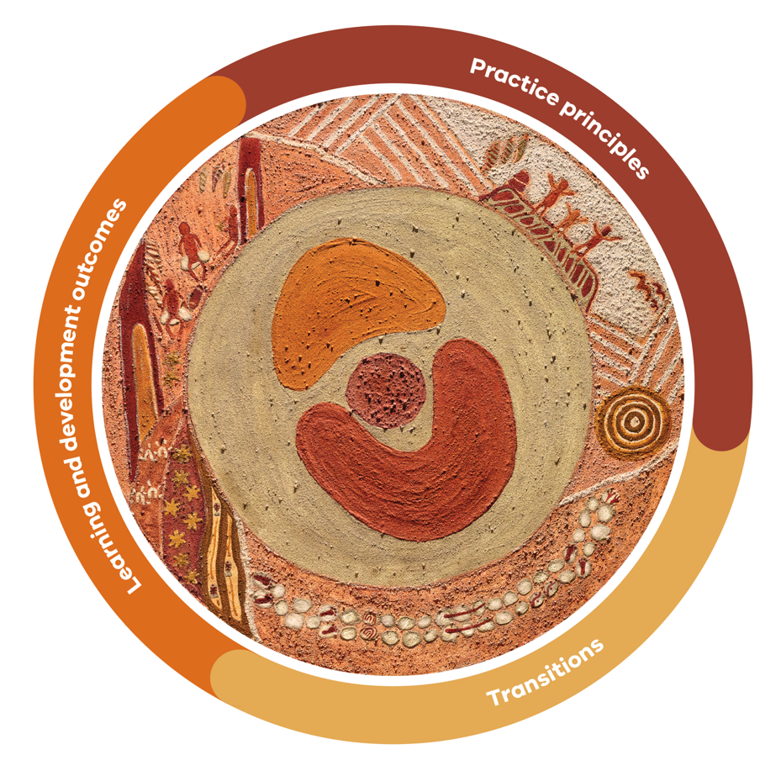

Vision
Promoting children’s learning and development: birth to 8 years
Every child is capable, curious and full of possibility.
Early childhood is a time of rapid brain development, when the foundations for learning, behaviour and wellbeing are formed. Research shows the neural connections that support thinking, communication and self-regulation are built in this period through everyday experiences, such as secure relationships, play, investigation and intentional teaching.
Children have the right to be heard, be safe, be treated fairly and have decisions made in their best interests. These rights, recognised in the United Nations Convention on the Rights of the Child, are reflected throughout the VEYLDF.
Children develop through strong relationships with families, educators and communities. All children influence and are affected by their environment.
Children learn best when they feel physically, emotionally and culturally safe, respected and connected to the people and places around them. The VEYLDF supports the creation of environments to protect children’s safety, wellbeing and dignity, and also recognises and values diversity, including neurodiversity.

Cultural Knowledge Story: the Fern
The unfolding Austral bracken fern, representing learning and pedagogical practices, shows us a spiral pattern that often connects humans to nature visually and emotionally. The unfolding fronds of a young bracken fern as a spiral represent the evolving growth of the child and their identity.
The fern reminds us of child-led nature play as the basis of First Nations pedagogy and its growing significance in Western pedagogy. The 3 adult fronds also serve as a reminder of the interconnection of all parts of learning, development and culture. The way in which the fern adapts to its environment reflects how pedagogical practices shift and change in response to children’s learning dispositions (habits of mind) and engagement.
This Indigenous fern is significant to First Nations Victorians in its use as medicine and bedding. Taungurung Elder, Aunty Glenys Merry, took Annette Sax (Taungurung) along the Rubicon River and shared how our people layered the fern, alternating the position of the fronds so the ferns were thick like a mattress and used for bedding.
Aunty Glenys also shared that the bracken fern was used as an insect repellent.
This intergenerational knowledge demonstrates our connection to nature.

Figure 1 The Fern. Image credit: Robert Barnett (of Yorta Yorta descent) with Dr Sue Atkinson AM (Yorta Yorta)

Cultural Knowledge Stories
The Cultural Knowledge Stories are the result of collaboration between Dr Sue Atkinson AM (Yorta Yorta), artist Annette Sax (Taungurung) and artist Robert Barnett (of Yorta Yorta descent). They carry First Nations knowledge, perspectives and connections to Country, community and identity. The stories are living knowledge systems, reflecting knowledge that has been understood and practised across generations. Contemporary evidence often reflects the same understanding. Throughout this document, Cultural Knowledge Stories appear alongside key components of the Framework, connecting practice to Country, culture and community. To read more about these stories and the Ochre Artworks, see page 12.

Pedagogy
Pedagogy is the approach professionals take to teaching, learning and care. It includes the decisions they make about how to support children’s learning through play, relationships, environments, interactions and intentional teaching. In the Cultural Knowledge Stories, pedagogy also refers to ways of teaching and learning that are grounded in Country, culture, community and the wisdom of Elders.

VEYLDF’s place within early childhood education
Research shows that the brain’s ability to change in response to experiences is highest at birth and then reduces significantly throughout childhood. The evidence indicates the period between birth and 8 years of age is critical for achieving cognitive milestones.
The highly adaptive and responsive nature of children’s brains means they are most conducive to learning new things and developing through play during these formative years. It is crucial that early childhood professionals have the knowledge and skills to make the most of this window of time for children’s cognitive development.
The VEYLDF supports professionals to plan and deliver learning and wellbeing programs for children from birth to 8 years of age. It guides how professionals work with families and one another to support each child’s learning, development and safety.
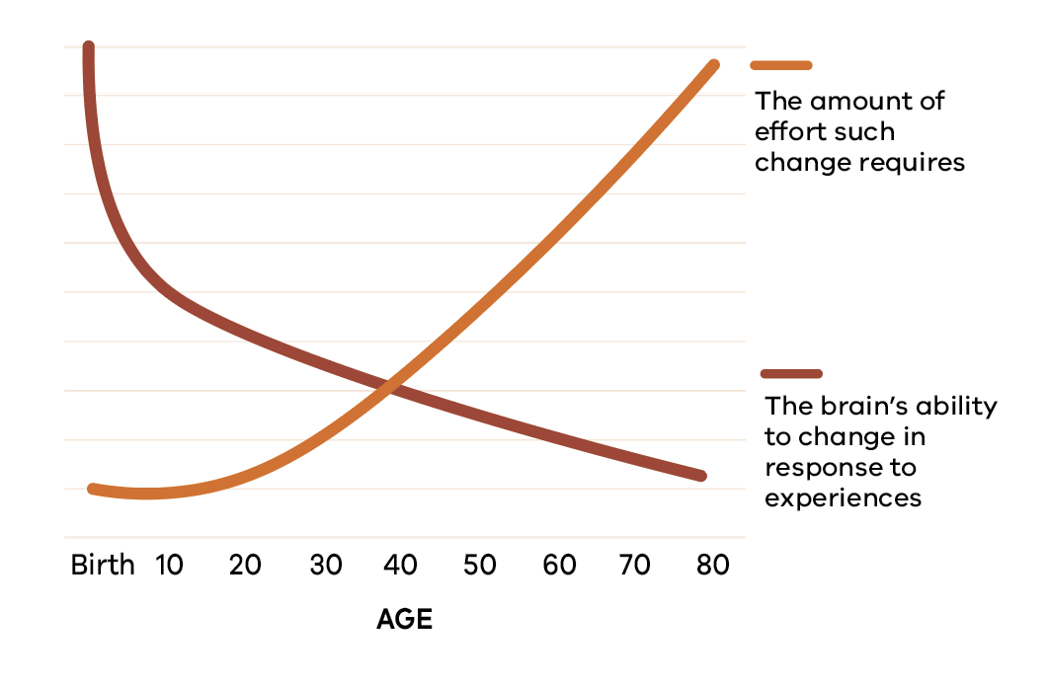
Figure 2 The brain is more influenced by experience in a child’s earliest years. The brain’s ability to adapt – known as brain plasticity – declines as we age. Adapted from a graph created by Pat Levitt in collaboration with the Center on the Developing Child at at Harvard University (Levitt, 2009).

The VEYLDF is one of 3 approved national frameworks, along with Belonging, Being and Becoming: The Early Years Learning Framework for Australia (EYLF) and My Time, Our Place: Framework for School Age Care in Australia. These approved learning frameworks form part of Australia’s National Quality Framework.
Operating alongside the National Quality Framework and the Child Safe Standards, the VEYLDF supports early childhood professionals to provide environments that ensure children’s physical, emotional and cultural safety.
The VEYLDF supports continuity of learning across early years services from Victoria’s Maternal and Child Health service to the school system. The VEYLDF recognises the importance of partnerships between services, families and communities, and embeds Australian First Nations’ perspectives.
Victorian Government-funded kindergarten services are required to use the VEYLDF. Other early childhood education and care settings may use the VEYLDF, the EYLF, or both.
The VEYLDF links to the Victorian Curriculum F–10 (Victorian Curriculum). It maps the Learning and Development Outcomes in early childhood to the curriculum areas in the first 3 years of school. The VEYLDF is designed to help professionals to support children’s continuity of learning by exchanging ideas and knowledge. Through this collaborative approach professionals develop a shared understanding of how children learn and develop, as well as how they can support children to transition between settings. The VEYLDF works with the Victorian Teaching and Learning Model 2.0, which guides teaching practices in Victorian Government primary schools.

Key terms

The following terms underpin the VEYLDF. Further terms are defined in short panels where the term first appears.

Child safety
Child safety means actively protecting every child’s physical, emotional and cultural wellbeing. Professionals create environments where children feel safe, risks of harm are identified and managed, and all children are treated with dignity. Child safety is everyone’s responsibility and is embedded in everyday practice, not treated as a separate process.

Cultural safety
Cultural safety means recognising, respecting and protecting a child’s identity, culture and ways of being. In a culturally safe environment, children and families experience no challenge to or denial of who they are. First Nations children and families, cultural safety includes connection to Country, community, kin and cultural practices, and requires professionals to reflect on their own assumptions and biases.

Families
In this Framework, ‘families’ is used to represent the significant people who care for and raise a child – including parents, carers (kinship, foster, permanent and informal), grandparents, siblings, extended kin and the wider networks who share responsibility for a child’s wellbeing.

Child voice
To recognise a child’s voice is to understand that children are active participants in their own learning and that their perspectives, ideas and feelings matter. This means that professionals listen to and observe what children communicate through words, gestures, play and behaviour, and children’s views are considered in decisions that affect them as appropriate to their age and evolving capacities.

Early childhood professionals
Early childhood professionals are the people who work with children and families across education, care, health, disability and community settings. This includes teachers, educators, Maternal and Child Health nurses, primary school nurses, primary welfare officers, allied health practitioners, preschool field officers, inclusion support facilitators, family support workers and playgroup facilitators.

Play
Play is a context for learning through which children explore, imagine, experiment and make sense of their world. Through play, children develop language, thinking, creativity, social skills and physical capabilities. In the VEYLDF, play works alongside intentional teaching. Professionals observe, participate in and extend children’s play to deepen their learning while following their interests and agency.

How it fits together

If you want to … | Go to …
Understand the VEYLDF’s foundations | The Framework  Page 4 | Cultural Knowledge Stories  Page 12 | Key terms  Page 10
Improve interactions and teaching practice | Practice Principles  Page 19 | The Woven Strands  Page 16  Integrated teaching and learning approaches  Page 17 | Do/See/Reflect tables  Pages 21, 23, 25, 27, 29, 31, 33
Strengthen assessment – understand what learning you’re seeing | Learning and Development Outcomes  Page 35 | Assessment for learning and development Practice Principle  Page 30 | The Yam Daisy  Page 14  Early Years Planning Cycle Page 15
Plan next steps | The Yam Daisy  Page 14 | Early Years Planning Cycle  Page 15 | Continuity of Learning  Page 44
Support learning continuity | Learning and Development Outcomes  Page 35 | Transitions  Page 43 | Ochre Artworks  Page 12  The Fern  Page 7

The importance of Cultural Knowledge Stories
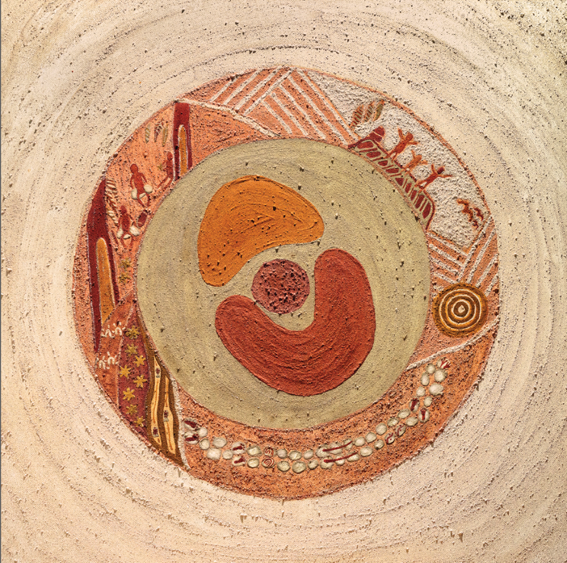
Ochre Artworks by Annette Sax (Taungurung), developed in collaboration with Dr Sue Atkinson AM (Yorta Yorta)
Ochre is a precious mineral collected by Aboriginal people who grind this soft rock to make paint. Ochre is painted on people’s faces and bodies for special ceremonies and also painted on leather of Possum Skin Cloaks.

Ochre Artworks and Cultural Knowledge Stories
The Ochre Artworks were created through a collaborative process between Dr Sue Atkinson AM (Yorta Yorta) and artist Annette Sax (Taungurung). The artwork represents the ecological nature of children’s learning and development. It illustrates how children’s learning is shaped through relationships with family, community, culture, kin and Country.
The Ochre Artworks visually connect the 3 elements of the VEYLDF:
- Practice Principles – how educators work with children and families
- Learning and Development Outcomes – what children learn over time
- Transitions – how learning continues across settings and stages.
While the original Ochre Artworks and Cultural Knowledge Stories have been important in the development of Victorian early childhood education, their significance and connection to the VEYLDF and everyday practice has not always been clear. The artwork and stories have been revisited and expanded to make these connections clearer.

New Cultural Knowledge Stories and artwork
Through collaboration between Dr Sue Atkinson AM (Yorta Yorta) and artist Robert Barnett (of Yorta Yorta descent), additional Cultural Knowledge Stories have been developed to deepen the connection between First Nations knowledge and early childhood practice. These stories build on the originals and further embed First Nations perspectives on learning, Country and community throughout the Framework.
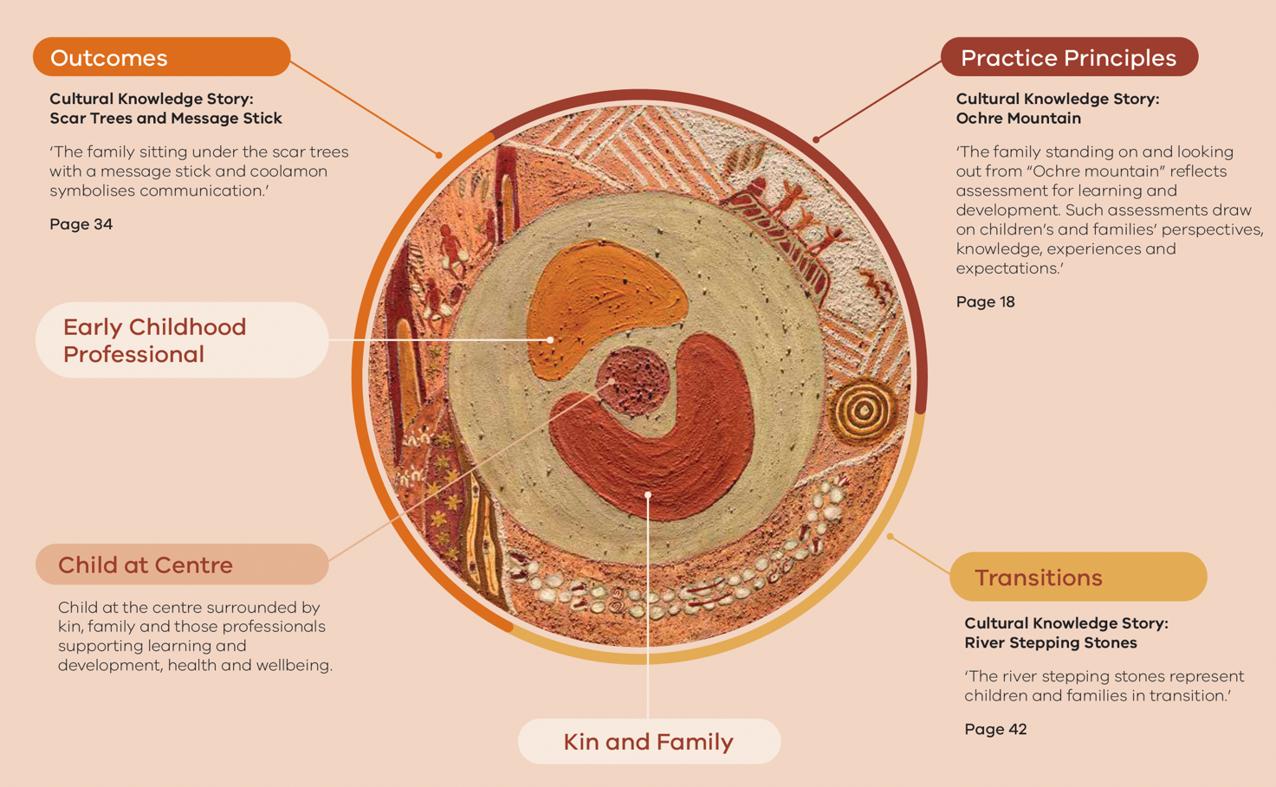

Cultural Knowledge Story: the Yam Daisy
The yam daisy, widely known as the Murnong from the Wurundjeri Woi Wurrung language, is used to represent planning, highlighting the complex and sophisticated process professionals engage in when delivering programs for children.
The petals outline the various components which are all connected. Meanwhile the yam which grows below Country symbolises the foundations and nourishment of the thinking that is needed when planning along the continuum.
Connection to Country, kin, culture and identity that First Nations people in Victoria have, must always be considered. These aspects should be at the forefront of professionals’ minds when they draw on their knowledge of child development research and learning theories.
The yam daisy was a significant staple food for First Nations Victorians for tens of thousands of years and is known by a variety of First Nations languages across the state. Women would dig up the yams with digging sticks and carry them away in dilly bags.
Through colonisation and the introduction of sheep, the yam daisy almost became extinct as the sheep would walk on the daisies and compact the land, making it difficult for them to grow back. More recently there has been a revival and recultivation of the plant, signifying the survival of a strong First Nations identity and culture.
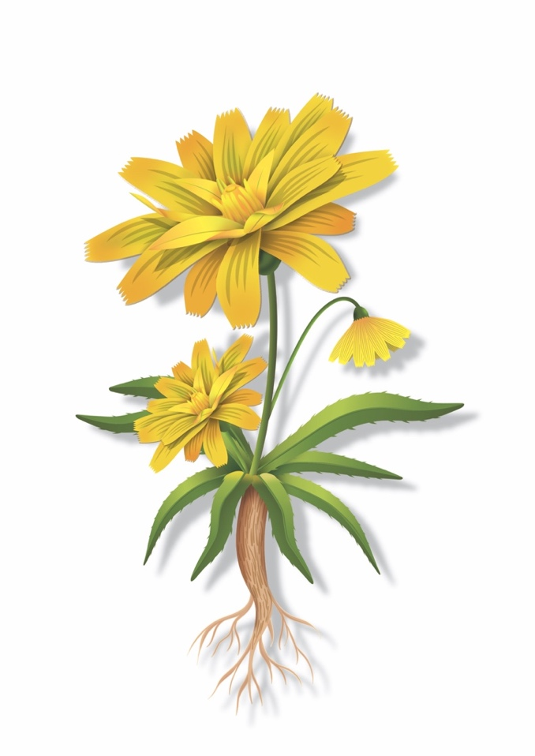
Figure 3 The Yam Daisy. Image credit: Robert Barnett (of Yorta Yorta descent) with Dr Sue Atkinson AM (Yorta Yorta)

Early Years Planning Cycle
The Early Years Planning Cycle guides how professionals observe, plan and respond to children’s learning over time, within the context of each child’s family.
There is no set order or timeframe to the cycle. The 5 parts may happen in a single moment, across a sequence of learning or over an entire project. Professionals move between them as needed, revisiting earlier thinking and responding to what they notice.
- Observe. Watch and listen to what children do, say and make. Include the voice of the child and their family.
- Assess. Make sense of what you’ve noticed. What does it tell you about this child’s learning, strengths and interests?
- Plan. Choose teaching strategies, environments, experiences and materials that progress children’s learning.
- Implement. Put plans into action. Be responsive and inclusive. Scaffold and adjust in the moment.
- Evaluate. Reflect on what changed for the child or the group. Did your actions achieve what was intended? What next?
Documentation can occur at any point in the cycle – it is not a separate step. It should be purposeful and useful for teaching and learning – it is about gathering the evidence professionals need to understand each child’s learning and plan the next steps.
What matters most is having clear intentions for each child’s learning and being flexible as learning emerges.
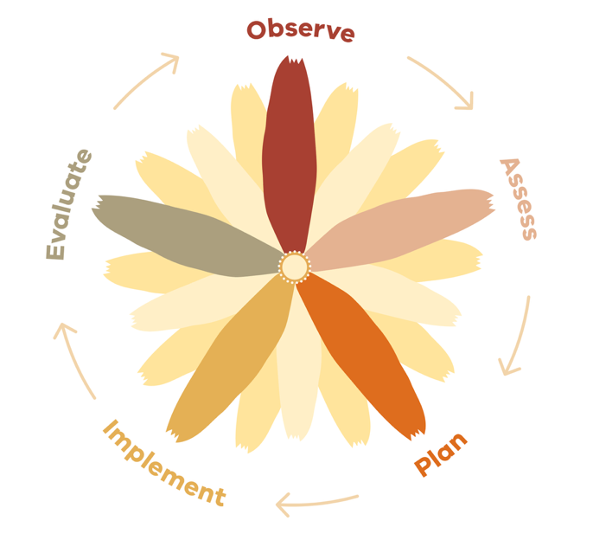
Figure 4 Early Years Planning Cycle adapted from the EYLF (2022) Image credit: Robert Barnett (of Yorta Yorta descent) with Dr Sue Atkinson AM (Yorta Yorta)

Cultural Knowledge Story: Woven Strands
This image (Figure 5) of intertwined strands represents the interconnected play and learning approaches that inform early years pedagogy from a Victorian First Nations perspective. Interconnected play and learning practices are evident and foundational in all early years settings for Victorian children. Local First Nations land-based pedagogies are important in the environmental and cultural education of all children with guidance from the local First Nations community.
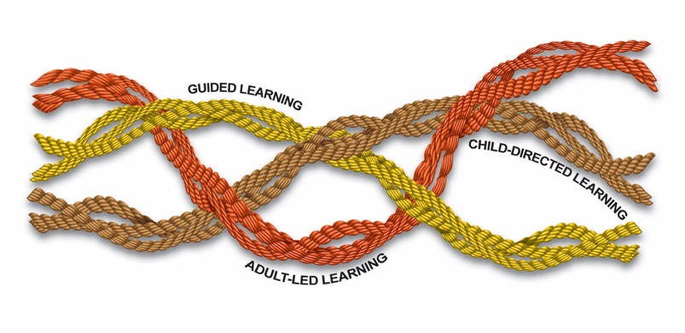
Figure 5 The Woven Strands of integrated teaching and learning approaches. Image credit: Robert Barnett (of Yorta Yorta descent) with Dr Sue Atkinson AM (Yorta Yorta)

In adult-led learning
- Women will weave in circles along with girls of all ages and young boys. In this setting children would learn not only the techniques of weaving, but also the cultural knowledge and connection to Country it entails.

In child-directed learning
- Children will learn informally as they explore Country. Weaving begins by gathering and preparing local resources, such as grasses and reeds. This requires a knowledge of local flora (that is, where it is to be found and when).

In guided learning
- Adults and older children will talk to young children about the flora around them, how it is gathered and prepared, and its uses, such as in weaving baskets, ropes and nets.

Integrated teaching and learning approaches

Play is essential to learning in the early years. Professionals intentionally combine 3 approaches to support children’s learning. They move between them, responding to what children need and what the learning requires. Integrated teaching and learning means combining child-directed learning, guided learning and adult-led learning – weaving these 3 approaches together so that professionals make intentional decisions about when to follow, when to guide and when to lead.
Professionals use evidence, observation and professional knowledge intentionally to enrich play and create meaningful learning opportunities.

Adult-led learning
Professionals introduce ideas, concepts or experiences and provide structure, questions and direct teaching. This includes intentional teaching of areas such as literacy, numeracy, executive function, physical and sensory development and science. Children still have input and make choices within adult-led experiences.

Child-directed learning
Children lead their own learning through play, exploration, imagination and experimentation. They choose what to investigate, how to engage and when to move on. Professionals observe closely, recognising what children know and can do, and make decisions about when to step in and shape the learning moments and when to step back and let the learning moment emerge.

Guided learning
Children and adults learn together. Professionals follow children’s interests and intentionally extend their learning through conversation, provocations and shared problem-solving. Learning is co-constructed.
These 3 approaches are not separate – they are interwoven. In any learning experience, professionals may move from observing a child play, to joining in and extending their thinking, to introducing a new idea. What matters is that the decision about which approach to use is intentional and responsive to each child and their learning.

Intentional teaching
Intentional teaching is when teachers and educators are deliberate and purposeful in their decisions about what children learn and how to support them. It includes understanding where a child’s learning is at, planning experiences, asking thoughtful questions, introducing new ideas and building on what children already know. Intentional teaching happens through play, conversation and everyday interactions. It requires professional knowledge of how children’s learning progresses in areas such as literacy, numeracy, executive function, physical and sensory development and science.

Cultural Knowledge Story: Ochre Mountain
Bunjil the Eagle and Waa the Crow represent Aboriginal culture and partnerships with families. The water hole symbolises reflective practice. The gum leaves with their different patterns and colours represent diversity. The stones underneath the leaves represent equity and inclusion.
They reflect the additional support put in place to help all children achieve. The child and adults standing on ‘Ochre mountain’ symbolise the high and equitable expectations we hold for children and adults.
The family standing on and looking out from ‘Ochre mountain’ reflects assessment for learning and development. Such assessments draw on children’s and families’ perspectives, knowledge, experiences and expectations.
The child and adult figures also represent partnerships between professionals. The land symbol as mother earth represents the basis for respectful and reciprocal relationships.
The symbols for land, water and people signify holistic pedagogical practices based on connections to Clan and Country.
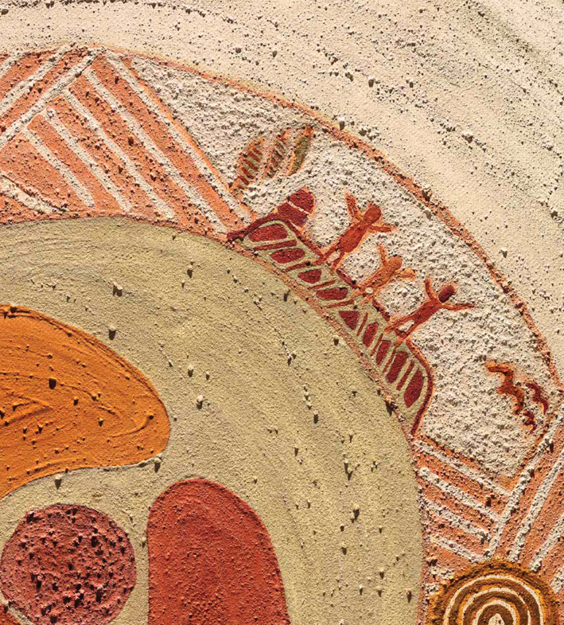

Practice Principles
The Practice Principles describe how professionals work with children, families and each other to support learning, development and wellbeing. They are interrelated – each one informs the others.
The 7 Practice Principles are:
- reflective practice
- partnerships with families
- high expectations for every child
- respectful relationships and responsive engagement
- equity, diversity and inclusion
- assessment for learning and development
- partnerships between professionals.
Professionals use the Practice Principles to guide their everyday decisions about how they work with children, families and each other. Together, the Practice Principles support children’s progress across the 5 Learning and Development Outcomes.

Principle 1. Reflective practice
Reflective practice is how professionals think about their work so they can make intentional decisions that support children’s learning, development and safety. It means noticing what is happening (observe), why it is happening (assess) and what needs to change (plan). It is when early childhood professionals question and analyse the evidence they have collected.
Most importantly, reflection leads to implementation.
Professionals use reflection to understand each child’s strengths, interests, identity and culture. It helps professionals understand the impact of their planned experiences and interactions on children’s learning and make adjustments to improve them. Reflection also helps professionals identify where they can improve their professional skills and practices.
Reflection also helps professionals recognise barriers, bias or assumptions that may affect a child’s safety, access or wellbeing. Reflection draws on evidence from observations, documentation and assessment, and informs planning and intentional teaching.
Reflection is shared work. Professionals talk with families, colleagues and children to understand different perspectives and plan next steps. When reflection is part of everyday practice, it strengthens relationships, supports cultural safety, and deepens and connects learning to children’s lives and communities.

In short
Reflective practice:
- supports intentional decisions about teaching, learning, wellbeing and safety
- helps professionals recognise strengths and identify barriers
- includes listening to children, families and colleagues
- leads to more responsive and inclusive practice.

In practice
Do | See | Reflect
- Take time to think about how everyday interactions affect children’s wellbeing, learning and safety  - Notice how personal values, experiences and assumptions shape decisions  - Reflect on how teaching is progressing children’s learning  - Seek feedback from children, families and colleagues  - Adjust teaching practices and learning plans or experiences when something is not working for a child or group  - Use evidence from observations, documentation and assessment to inform decisions about teaching, learning and extension | - Adults talk openly about what they are learning and changing  - Practice adapts in response to learning  - Children’s responses influence what happens next  - Practice changes after reflection, not just discussion  - Concerns about inclusion, wellbeing or safety are acted on promptly | - Who is benefiting most from current practice, and who might be missing out?  - How do decisions support children’s safety, wellbeing, dignity and sense of belonging?  - What assumptions might be shaping responses to children or families?  - Is reflection improving teaching quality?  - Are there areas I need to learn more about to improve my understanding of children’s learning progress, and what teaching supports this?

Principle 2. Partnerships with families
Families are children’s first and most important teachers. They know their child’s strengths, interests, culture, routines and ways of communicating. Partnerships with families are built on trust, mutual respect and shared decision-making. Professionals work alongside families as equal partners, recognising that each family is unique and brings valuable knowledge about their child.
Every partnership is unique, just as each family is unique with different values and priorities. Effective partnerships welcome all families and ways of caring, including kinship care, blended families, gender diverse parents and extended family networks. Some families benefit from additional or flexible engagement approaches, including for reasons related to language, culture, health or past experiences. Professionals use flexible and responsive ways to communicate conversations, notes, photos, digital updates or quiet chats at drop-off – and persist in building trust over time. Consensus is not always possible or necessary, but respectful, honest communication is.
Partnerships with families strengthen learning when professionals and families share information about what children are doing when in their care. Together, they plan for each child’s learning, wellbeing and safety. When families feel heard and valued, children develop a stronger sense of belonging and move with confidence between home and other learning environments.

In short
Partnerships with families:
- recognise families as children’s first and most important teachers
- build trust through respectful, flexible and honest communication
- support shared decision-making about children’s learning, wellbeing and safety
- strengthen children’s sense of belonging.

In practice
Do | See | Reflect
- Build respectful, trusting relationships with families  - Listen to families’ knowledge of their children  - Draw on family knowledge to inform teaching  - Share information about children’s learning in ways that are respectful, timely and culturally appropriate  - Work with families to support children’s safety, inclusion and wellbeing | - Families feel welcomed and listened to  - Communication is two-way and culturally respectful  - Family knowledge is reflected in everyday practice  - Learning reflects children’s lives and contexts  - Concerns about children’s development, safety or wellbeing are shared and followed up promptly | - Whose voices are being heard, and whose might need more support to participate?  - How do partnerships strengthen children’s wellbeing, safety and sense of belonging?  - Are there barriers that make it harder for some families to engage? What am I doing to address these?  - Is family input shaping teaching decisions?  - How are you sharing with families what children have learned; what they know, can do and understand?

Principle 3. High expectations for every child
Every child is capable of learning and developing. To have high expectations is to believe in each child’s potential and act on that belief every day. This includes providing experiences that are challenging and achievable, recognising effort and progress, and building children’s confidence to try new things. High expectations are a protective factor promoting resilience, motivation and a strong sense of self.
Having high expectations for every child does not mean having the same expectations for every child. Each child has a unique learning path shaped by their identity, strengths, culture and context. Some children will need different opportunities, additional support or adjusted approaches. Professionals take responsibility for noticing what each child is capable of and responding with intention, rather than waiting for children to fit a predetermined path.
Expectations are communicated through everyday interactions. When professionals focus on strengths, offer encouragement and set goals alongside children and families, this builds children’s confidence as they grow and develop. Critically, professionals also reflect on how biases, assumptions or low expectations may be affecting what they offer and to whom.

In short
Having high expectations for every child:
- starts with knowing each child – their strengths, interests and how they learn best
- recognises that every child will learn, with the right support and opportunities
- focuses on strengths, capabilities and progress rather than deficits
- requires professionals to reflect on bias and remove barriers to participation
- is shared with families to create a unified sense of purpose around each child.

In practice
Do | See | Reflect
- Believe that every child can learn and develop in their own way  - Set high expectations and adjust support so every child can access and participate in learning  - Intentionally teach to extend every child’s learning  - Focus on strengths, not just challenges  - Support children to feel confident, capable and safe to try  - Use observations and assessment, alongside professional knowledge, to maintain high expectations and support every child’s learning | - Children express their views and contribute to decisions that affect them  - Children are encouraged without pressure or comparison  - Adjustments are in place so every child can participate and progress  - Children take risks in learning because they feel safe and supported  - Differences are valued and respected  - Adults scaffold, challenge and encourage learning  - Children are given time to practise, consolidate and build on learning | - Do expectations support inclusion or unintentionally exclude some children?  - Are safety and emotional wellbeing prioritised alongside learning?  - How do expectations respond to each child’s strengths and context?  - Are expectations shaping teaching and learning?  - Are expectations diverse and responsive to children’s strengths and interests?

Principle 4. Respectful relationships and responsive engagement
Warm, respectful relationships are fundamental to children’s learning, development and safety. From birth, children build secure attachments through predictable, caring interactions with familiar adults. These relationships act as a protective factor – they help children feel safe, regulate their emotions and develop the confidence to explore, take risks and learn new things.
Responsive engagement means being attuned to what children communicate through words, gestures, behaviour and emotion. Professionals listen carefully, respond thoughtfully and adapt their interactions to each child. This responsiveness builds trust and supports sustained shared thinking.
Respectful relationships extend to families and colleagues. When professionals interact across cultures with openness and genuine interest, and when they take the time to understand each family’s values and perspectives, they create environments where everyone feels they belong. Children learn how to build relationships by observing and experiencing them.

In short
- Respectful relationships and responsive engagement:
- provide a secure base from which children can explore, learn and develop
- require professionals to be attuned to each child’s communication, emotions and needs
- support sustained shared thinking and deeper learning
- model for children how to build trusting, respectful connections with others.

In practice
Do | See | Reflect
- Build warm, respectful relationships with children  - Use relationships to support teaching and learning  - Respond to children’s cues, emotions and communication  - Support children to feel safe and heard, and intervene early when children feel distressed, excluded or unsafe  - Respect the knowledge and experience of other professionals | - Children’s feelings and views are listened to, heard and taken into account  - Children seek comfort, help or connection from trusted adults  - Interactions extend thinking, language and learning  - Adults listen, and respond calmly and respectfully  - Children’s emotions are acknowledged, not dismissed  - Unsafe or unfair behaviour is addressed consistently  - All behaviour is understood as communication and responded to with curiosity | - How do interactions support children’s emotional and physical safety?  - Are all children experiencing respect and connection?  - How is power shared between adults and children?  - Are interactions strengthening learning?  - What interactions are being modelled and observed?

Sustained shared thinking
Sustained shared thinking happens when 2 or more people – a child and an adult, or children with each other – work together in an intellectual way to solve a problem, clarify a concept, evaluate an activity or extend a narrative. Everyone contributes, and the thinking develops and extends the understanding of all involved.

Principle 5. Equity, diversity and inclusion
Every child has the right to participate, learn and thrive. Equity means providing each child with the support they need recognising that fair does not always mean the same. Some children will need extra time, visual tools, calm spaces, adapted materials or different approaches. Diversity is a strength. Children and families bring many cultures, languages, abilities and ways of being, and professionals plan learning that respects and reflects this.
Inclusion is the active response by early childhood professionals to understand the experiences and capabilities of each child and family. Inclusion means designing learning environments so that all children can belong, take part and learn, regardless of their ability, background, language, culture or family circumstances. This includes neuro-affirming approaches that recognise and value neurodiversity. Inclusive culturally safe practices remove barriers early so children do not miss out. Professionals work with families and kin to understand each child’s experiences, strengths and goals, and they challenge bias, stereotypes or low expectations that may limit a child’s opportunities.
Children feel included when they see their culture, language and identity reflected in their environment and in their learning. When practice is fair, welcoming and culturally safe, children show confidence, use their strengths and build strong relationships with adults and peers. Professionals actively promote respect for diversity and support children in understanding and valuing differences.

In short
Equity, diversity and inclusion:
- ensure each child is supported to participate
- recognise diversity, including neurodiversity, as a strength
- require professionals to identify and remove barriers to access and belonging
- are guided by families’ and children’s knowledge of culture, identity and experience.

In practice
Do | See | Reflect
- Respect, value and learn about children’s cultures, languages, abilities and identities  - Challenge bias, stereotypes and exclusion when they arise  - Design environments, routines and experiences so all children can access and participate in them  - Plan inclusive teaching that removes learning barriers  - Support culturally, emotionally and physically safe environments | - Diverse cultures and identities are visible and respected  - Adjustments are made without children having to ask  - Children feel proud of who they are  - Learning is accessible and responsive for all children  - Discrimination or exclusion is addressed promptly  - Children experience diversity | - Whose experiences are centred in practice, and whose are overlooked?  - Do teaching approaches support equitable learning?  - How does practice promote fairness, dignity and safety for every child?  - What changes could reduce barriers to participation?  - Are environments calm, predictable and safe enough to support children’s learning and self-regulation?

Principle 6. Assessment for learning and development
Assessment builds a picture of each child’s learning, identity and development. It shows what children know, understand and can do, and how they learn best over time. Assessment is ongoing – it happens through observing, listening to and talking with children and families in everyday interactions and experiences. It highlights each child’s strengths, interests, culture and the supports they need to participate confidently.
Professionals look for patterns, changes and progress in children’s learning and use them to plan their approach, adjust environments and set next steps. Sharing ideas with families and other professionals helps create a fuller and culturally safer picture of each child. Assessment guides planning and can be formative, summative or diagnostic. Where appropriate, it includes children’s own reflections on their learning, which builds their confidence and voice.
Assessment should be authentic and responsive to how children can best demonstrate their learning and development.
Assessment and documentation are intentional acts of professional practice. They draw on professionals’ deep knowledge of each child, of child development, and of the cultural and family context in which the child is learning. Skilled professional judgement – built over time and refined through reflection – is itself a form of expertise. Assessment must be fair, respectful and inclusive, honouring each child’s culture, language, identity and diverse ways of expressing learning.

In short
Assessment for learning and development:
- builds understanding of each child’s strengths, progress and next steps over time
- guides planning and intentional teaching
- includes families’ knowledge and children’s perspectives
- supports meaningful documentation
- draws on skilled professional judgement built through experience and reflection.

In practice
Do | See | Reflect
- Observe children respectfully and ethically  - Use assessment to support learning, not label or limit children  - Share information proactively and appropriately with families and colleagues  - Use assessment to guide intentional teaching  - Protect children’s privacy, dignity and wellbeing  - Collect children’s thoughts and ideas about their own learning | - Observations focus on strengths and learning progress  - Assessment information leads to meaningful support  - Children are not compared or ranked  - Teaching responds to assessment  - Confidential information is handled in line with privacy and record keeping requirements  - Professionals assess and moderate each other’s views about a child’s authentic learning | - How does assessment support inclusion and learning progression rather than judgement?  - How do assessment choices uphold children’s dignity by adapting how learning is noticed, interpreted and documented?  - Are children’s rights, safety and dignity being protected?  - Is assessment improving teaching practice?  - What might be missing from current understanding?
Figure 6 Early Years Planning Cycle adapted from the EYLF (2022). Image credit: Robert Barnett (of Yorta Yorta descent) with Dr Sue Atkinson AM (Yorta Yorta)

Principle 7. Partnerships between professionals
Early childhood professionals work across many roles and disciplines – as educators, teachers, nurses, allied health practitioners, inclusion support workers, family support workers and more. No single professional can support all aspects of a child’s learning, development and wellbeing alone. Partnerships between professionals are built on shared goals, mutual respect and an understanding of each other’s roles, knowledge, skills and expertise.
Partnerships are strengthened when professionals are willing to learn from one another. Learning communities, professional networks and collaborative reflection all create opportunities to deepen practice and improve outcomes. Leaders across the early years play a significant role in creating the conditions for these partnerships, including dedicated time, clear processes and a culture that values collaboration.
Effective partnerships involve sharing information, planning together and making referrals when a child or family needs further support. This is especially important for children with disability, developmental concerns or delays, who may benefit from coordinated support across settings and disciplines.
Professionals also work together to support transitions, sharing knowledge about each child’s strengths, prior learning and experiences so that children feel secure and their learning continues as they move between settings.

In short
Partnerships between professionals:
- bring together diverse expertise to support children’s learning, wellbeing and safety
- rely on shared goals, clear communication and understanding of each other’s roles
- support transitions by sharing knowledge about each child and their strengths across settings
- are strengthened by professional learning communities and collaborative leadership.

In practice
Do | See | Reflect
- Work respectfully with other professionals to support children’s learning, wellbeing and safety  - Share information clearly and ethically  - Collaborate to strengthen teaching and learning  - Value different skills, knowledge and cultural perspectives  - Coordinate so children and families experience continuity of support  - Act on child wellbeing and safety concerns in line with shared responsibilities | - Professionals communicate openly and respectfully  - Support for children is coordinated rather than fragmented  - Roles and responsibilities are clear  - Shared expertise informs learning support  - Information is shared proactively and appropriately with professionals supporting the child  - Safety, developmental and wellbeing concerns are responded to in a timely and collaborative way | - Do you have strong partnerships with other early childhood professionals? How could these be expanded or improved?  - How do partnerships strengthen outcomes, inclusion, wellbeing and safety for children?  - Are all relevant perspectives being heard and respected?  - Is collaboration improving learning outcomes?  - Where could collaboration be improved to better support children and families?

Cultural Knowledge Story: Scar Trees and Message Stick
Gum leaves as bush medicine symbolise connection to wellbeing.
The yam daisy represents the survival of a strong Aboriginal identity. The yam daisy was central to the diet of Aboriginal Victorians. It was almost wiped out by colonisation but has survived.
The family sitting under the scar trees with a message stick and coolamon symbolises communication.
The family seated on the land symbolises the child learning through their connection to and involvement with community.
A Scar Tree is also known as a Canoe Tree and is a significant artefact. Aboriginal people use the bark of the tree to make a canoe or boat.

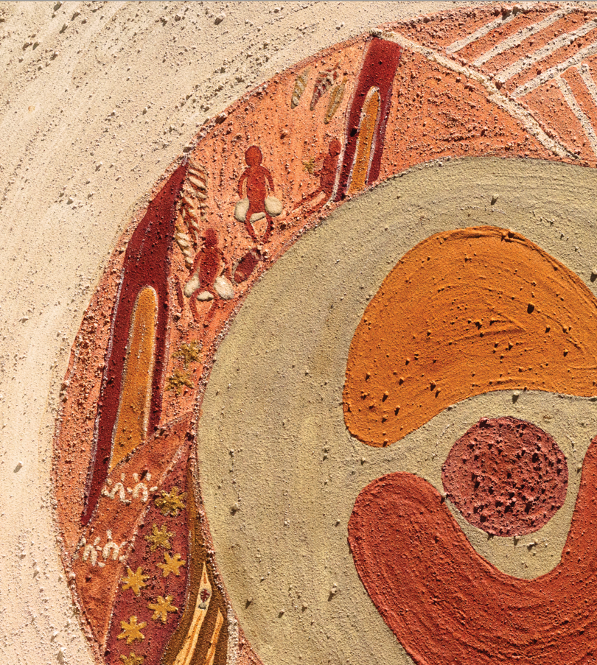

Learning and Development Outcomes
From birth, children are in a period of extraordinary brain development. A child’s brain architecture is shaped by the ‘serve and return’ interactions with adults, building the neural pathways that set the foundations for all later learning.2 In the early years, these interactions are most effective when supported by warm, responsive relationships and predictable routines.
Neuroscience has demonstrated, as shown in Figure 7, that children’s brains are most sensitive to developing the foundational domains of learning during the early years. This sensitivity shapes how teaching and learning happen in the early years.
Research shows that the more children develop their oral language, literacy, numeracy, and social and executive functioning skills in their early years, the more likely they are to be confident and engaged learners. When young children are overloaded with information or demands beyond their developmental capacity, stress can disrupt learning and limit the brain’s ability to consolidate these critical skills.
It is also important to acknowledge young children are not passive recipients of information; they construct knowledge by doing, exploring and engaging with their environment. Learning in the early years is most effective when it is hands-on and inquiry-based, and facilitated through play.
Neuroscience has shown that children’s brains best remember and understand learning that is connected to their existing experiences, linked to previous familiar concepts, and recalled and applied in varied ways.
The Learning and Development Outcomes support a shared understanding of children’s learning and development, from birth to 8 years. They are not a checklist or milestone: they guide what early childhood professionals notice, plan for and support.

The 5 Learning and Development Outcomes are:
- children have a strong sense of identity
- children are connected with and contribute to their world
- children have a strong sense of wellbeing
- children are confident and involved learners
- children are effective communicators.
These outcomes are interconnected and develop over time through play, relationships and intentional practice. Professionals use the Practice Principles (pages 19–33) and the Early Years Planning Cycle (page 15, Figure 4) to support each child’s progress across the outcomes.
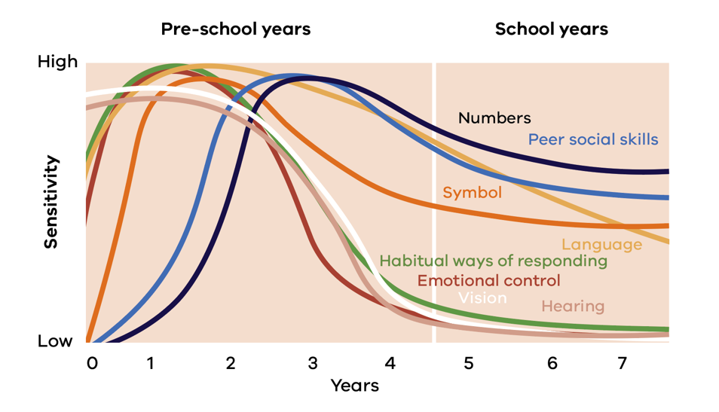
Figure 7 Sensitive periods in early brain development. Adapted from Council for Early Child Development (ref: Nash, 1997; Early Years Study, 1999; Shonkoff, 2000)

Identity

Outcome 1. Children have a strong sense of identity
Children’s sense of identity shapes how they see themselves, relate to others and engage in learning.
Identity can be understood in 3 ways:
- personal knowing and valuing who I am (self-awareness, self-esteem, self-efficacy)
- social (inward): how I think others see me (attachment, communication, trust)
- social (outward): how I know and value others (empathy, respect, belonging).
From birth, secure and caring relationships with family, kin and attentive adults build confidence and create a sense of belonging. When children feel valued and included, they take on challenges, express ideas, solve problems, take risks and form friendships. Over time, children develop the ability to identify and manage their emotions, focus their attention and plan their actions – skills that strengthen their growing sense of agency and autonomy.
Children feel safe and supported in their bodies and emotions, and culturally safe in their identities, knowing that who they are, where they come from and how they belong is recognised and valued.
Children with a strong sense of identity are comfortable in their cultures and communities, including using their home language. For Koorie children, learning on, with, from and about Country is central. Professionals respect each child’s temperament, strengths, personality and culture, and encourage collaboration, initiative, persistence and new challenges.

This is evident when children:
- feel safe, secure and supported
- develop their emerging autonomy, inter-dependence, resilience and agency
- develop knowledgeable, confident self-identities and a positive sense of self-worth
- learn to interact in relation to others with care, empathy and respect.

Connection

Outcome 2. Children are connected with and contribute to their world
From their earliest experiences, they begin to understand where they belong and how they relate to others. As children grow, they seek out relationships, shared experiences and new environments, building a sense of connection that shapes how they see themselves in the world. They help and show concern for others, learn to respect those who are different from them and practise peaceful and inclusive ways of resolving conflicts. They come to understand fair play, interact with each other and learn how to contribute to a community. Children become aware of the impact of the local environment, both physical and social, on their lives.
Through everyday interactions, children learn about fairness, consent, responsibilities and how their actions affect others. Positive experiences build empathy, respect, problem-solving skills and confidence. For children who experience disconnection from familiar people and places, consistent, safe and culturally responsive relationships are especially important.
Experiences in different settings help children learn to value diverse cultures, family structures and ways of being.
Connection to land and Country helps children understand sustainability, equity, fairness and how to care for the environment.

This is evident when children:
- develop a sense of connectedness to groups and communities and an understanding of their reciprocal rights and responsibilities as active and informed citizens
- respond to diversity with respect
- become aware of fairness
- become socially responsible and show respect for the environment.

Sustainability comprises 3 dimensions – environmental, social and economic:
- Environmental sustainability focuses on caring for our natural world.
- Social sustainability is about living peacefully, fairly and respectfully together in resilient local and global communities.
- Economic sustainability refers to practices that support economic development without negatively impacting the other dimensions. This includes a focus on fair and equitable access to resources, conserving resources, and reducing consumption and waste.

Wellbeing

Outcome 3. Children have a strong sense of wellbeing
Children’s wellbeing is a positive state in which they are safe, healthy and feel able to learn. It includes physical, emotional, social, spiritual and mental wellbeing.
Caring, consistent relationships and predictable routines help children manage stress, regulate emotions and develop confidence and resilience. Skills such as focusing, planning, remembering steps and managing emotions support wellbeing. Children develop these skills when their environments feel safe, calm and responsive to their needs.
Children learn to be comfortable in the range of settings that are part of their lives. They are becoming capable of seeking and receiving assistance and of being alone and with others. Children learn how to express and manage their feelings and develop self-reliance.
Children learn to manage emotions and impulses, cope with day-to-day stresses and persevere when faced with challenging learning situations.
Children also need protection from harm and from experiences that undermine their identity, culture or sense of belonging.
Physical wellbeing is promoted through active play, movement, rest, nutrition and understanding healthy choices. Children learn to manage and move their bodies in a range of environments and settings. They learn to maintain their own basic hygiene practices and they contribute to and maintain basic health and safety practices. These experiences build strong foundations for lifelong wellbeing.

This is evident when children:
- become strong in their emotional, social, spiritual and mental wellbeing
- become strong in their physical learning and wellbeing
- are aware of and develop strategies to support their own mental and physical health and personal safety.

Learning

Outcome 4. Children are confident and involved learners
Children’s learning begins from birth and continues as they actively explore their world through play, inquiry, interactions and guided experiences.
Children develop early mathematical and scientific thinking as they notice patterns, explore quantity, test ideas and make sense of cause and effect in their everyday worlds. These experiences build and strengthen neural pathways that support increasingly complex thinking over time. Building on these foundations, children develop skills in problem-solving, investigation and creative thinking across many areas of learning.
In responsive environments, children share ideas, negotiate, listen to others and build friendships. These interactions support language, social skills and a sense of belonging, all of which underpin learning. They begin to understand that listening to the responses of others can help them understand and make new meaning of experiences.
Children are active learners and thinkers who use their senses to investigate, experiment, count, compare and create theories about how things work. Dispositions such as curiosity, persistence and creativity enable children to manage challenges and learn from mistakes. When professionals value children’s ideas and provide time for deep exploration, children become confident and involved learners who can transfer learning to new situations.

This is evident when children:
- develop a growth mindset and learning dispositions such as curiosity, cooperation, confidence, creativity, commitment, enthusiasm, persistence, imagination and reflexivity
- develop a range of learning and thinking skills and processes such as problem-solving, inquiry, experimentation, hypothesising, researching and investigating
- transfer and adapt what they have learned from one context to another
- resource their own learning by connecting with people, place, technologies, and natural and processed materials.

Communication

Outcome 5. Children are effective communicators
Children’s communication enables them to express ideas, connect with others and make sense of their world.
From birth, children use gestures, sounds, movement, visual cues and early language to communicate meaning. These early forms of communication are strengthened through warm, responsive relationships with adults and peers.
Children acquire language through interaction, play and exposure to rich communication. They learn how languages work when they listen to others, share stories, sing, take turns and use vocabulary in meaningful contexts. Literacy develops as children build phonological awareness and learn about the relationships between sounds, letters, words and meaning. Early experiences in reading, writing, symbol use and oral language support strong communication throughout school and life.
For children learning English as an additional language, communication grows when they have time, modelling, explicit teaching and opportunities to use their first language. Multilingual children bring strengths that enrich communication and learning for everyone.
Children express themselves in many ways, including drawing, painting, movement, storytelling, pretend/imaginative play, music and early writing. These forms of expression support thinking and creativity. Diverse experiences, including family language, culture, creative arts and digital tools, help children build communication skills.

This is evident when children:
- interact verbally and non-verbally with others for a range of purposes
- engage with a range of texts and gain meaning from these texts
- express ideas and make meaning using a range of media
- begin to understand how symbols and pattern systems work
- use digital technologies and media to access information, investigate ideas and represent their thinking.

Cultural Knowledge Story: River Stepping Stones
The river stepping stones represent children and families in transition. The footprints and wheelchair tracks symbolise all abilities. Animal footprints show children and families walking proudly with culture in transition.
Educators must engage with such pride in culture, with respect and authentic understanding, thereby promoting positive transitions.
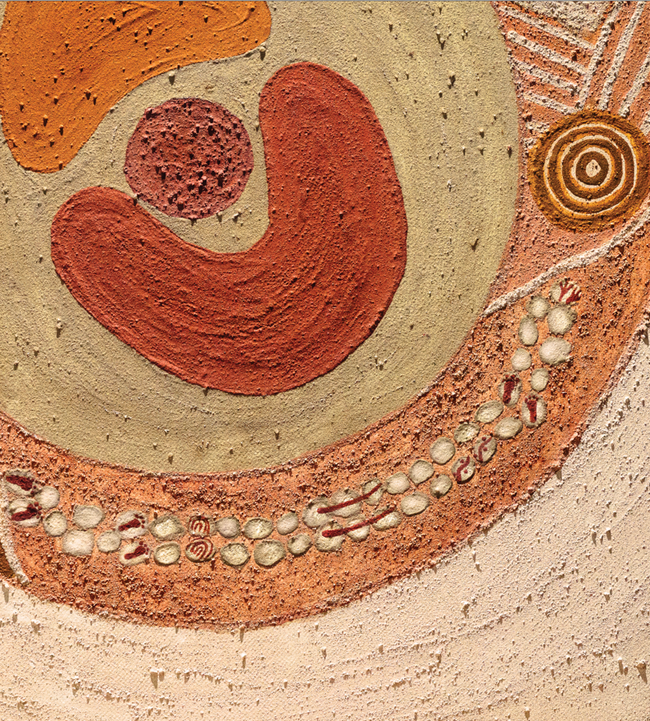

Transitions
Transitions occur when children and families move between settings and stages of learning.
These transitions happen every day between home and a learning setting, between rooms, between activities as well as at key points, such as starting early learning, moving from 3-year-old to 4-year-old kindergarten or starting school. Transitions are not just events: they are ongoing processes that require planning, communication and trust.
Children experience transitions most positively when they feel safe, routines are predictable, and the adults around them share information and work together. Professionals draw on the Practice Principles and the Learning and Development Outcomes to make transitions safe and supportive. Coordinated support, using tools such as the Transition Learning and Development Statement, helps ensure continuity of learning.

Transitions

Continuity of learning
Continuity of learning is strengthened when professionals understand how children’s learning and development builds over time. Knowing what a child has already experienced, practised and consolidated, and how their learning is likely to progress, supports cumulative learning. New learning builds on previous experiences, knowledge and understanding rather than repeating or ignoring them.
Shared understanding of learning progressions and outcomes help professionals plan learning that builds on children’s strengths across settings.
Continuity extends beyond educational settings to include the home environment and the broader community. When professionals share information with families and with each other, with respect for a child’s dignity and wellbeing, children experience greater consistency between the people and places in their lives. For First Nations children, continuity includes connection to Country, culture, kin and community across all settings.

Continuity of learning into school
Play-based intentional teaching in early childhood builds the foundation for the explicit teaching practices that follow in primary and secondary school.
This integration of play and intentionality is fundamental to the learning and development of children.
- The VEYLDF promotes integrated approaches that blend child-directed learning, guided learning and adult-led learning, with experiences shaped around each child’s strengths and interests.
- As children transition into the early years of school, explicit teaching approaches build on these foundations, extending children’s knowledge and skills as their executive functioning, language and prior learning mature

Supporting children and families through transitions
A transition to a new learning environment is a time of significant change. Children and families may experience a range of emotions: excitement, uncertainty, anxiety or pride.
Additional support may be required for some children during transitions, including children with disability, developmental concerns or delays, children in out-of-home care, and children from culturally and linguistically diverse backgrounds. Professionals across services work together to share information, coordinate support and ensure that each child’s learning, identity and wellbeing are recognised and carried forward.
The Transition Learning and Development Statement helps families and professionals share information about each child’s strengths, learning and development as they move from kindergarten to school. The Learning and Development Maps provide further guidance on how learning connects across the early years and the first years of school.

In short
- Transitions happen throughout a child’s daily routine as well as during major life changes.
- Children feel safest when adults explain what will happen and keep routines predictable.
- Partnerships with families, educators and other professionals improve transitions.
- Some children need more personalised support or extra time for transitions.
- Continuity of learning is strengthened when professionals share knowledge about each child across settings.

In practice
Do | See | Reflect
- Use photos, visual aids or simple language to explain upcoming changes  - Share strengths-based information across settings (e.g. from kindergarten to school)  - Offer visits or gradual entry to new environments  - Use familiar objects, songs or stories to support security  - Share information with families’ consent, respecting privacy and cultural safety | - Children enter new spaces with growing confidence  - Signs of stress are lower during transitions  - Families report clear communication and support  - Adjustments are in place from day one for children with disabilities, developmental concerns or delays  - Evidence of collaboration across settings | - What does this transition feel like from the child’s perspective, and how do we know?  - Whose voices are informing our transition planning (child, family, educators, other professionals)?  - How have family insights shaped the way we are supporting this child through change?  - In what ways are we supporting continuity of relationships, learning and identity across settings?  - What have we learned from this transition that can inform future practice?

Continuity of learning
Continuity of learning means recognising and building on a child’s progress, strengths and identity as they move between settings and stages of education. Professionals share information with families and between themselves so that transitions are smooth and disruption to children’s learning is minimised. Continuity of learning is supported when there is a shared understanding of each child across the people and places in their lives.

Adapted from Sylva, K., Melhuish, E., Sammons, P., Siraj-Blatchford, I., & Taggart, B. (2004), The Effective Provision of Pre-school Education (EPPE) Project: Final Report, Institute of Education, University of London.

