Tip sheet 5 – Secure Relationships: Creating strong connections and building relationships with all children and families
From birth, warm and respectful relationships with familiar adults build and strengthen secure attachments that are fundamental to children’s learning and development.
These relationships nurture, regulate and provide protective factors to support children’s wellbeing, resilience and learning. VEYLDF p11

Why it matters
Warm and respectful relationships with children and their families form the foundation for effective early childhood education and care programs.
Strong connections with and between educators help to generate a sense of belonging, and nurture learning and development for children.
With the implementation of two years of funded kindergarten, it is important to make decisions that promote the importance of establishing and maintaining strong relationships with children and their families. Strong connections with children start an inclusive and responsive approach to communication with families. This builds understanding and respect, and supports families to understand changes to their child’s participation in early childhood education.
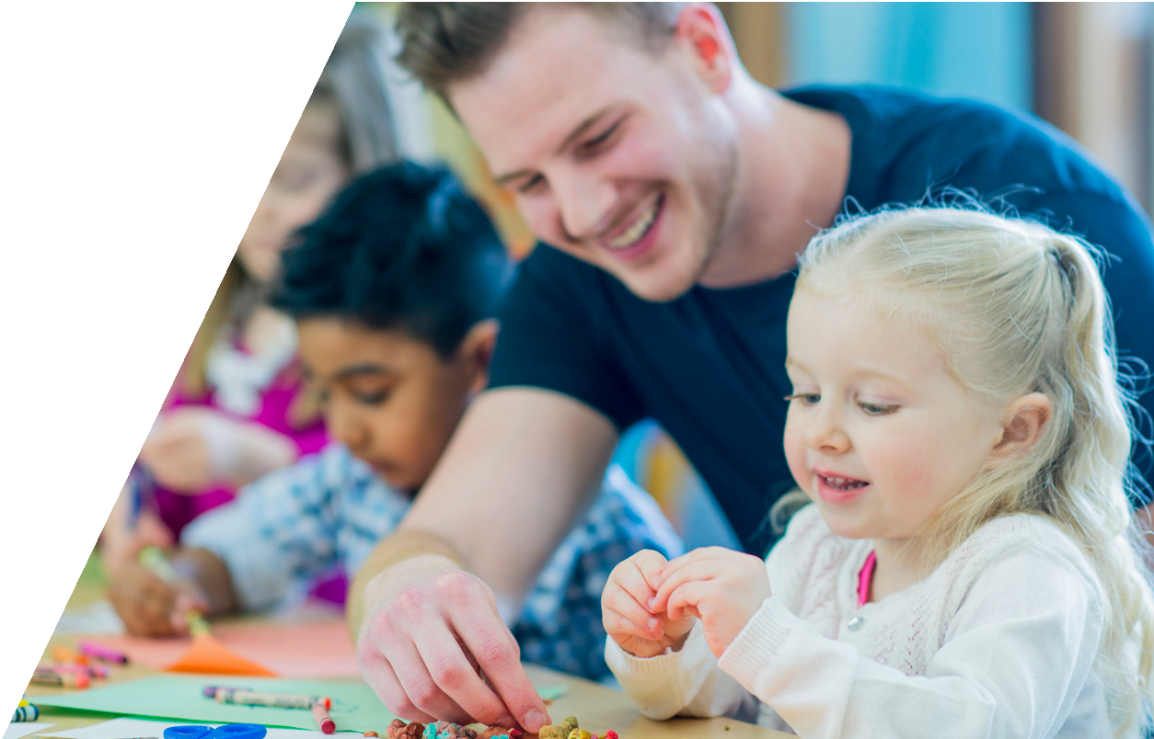
This is further enhanced when educators plan for, monitor and assess relationships as part of an ongoing cycle of planning and program development that offers children opportunities to learn about themselves and their relationships with others.

Practical tips to support the development of secure relationships:
- Building secure relationships starts with respectful enrolment processes. Developing strong, inclusive enrolment processes that respect families and create a sense of belonging is critical to outcomes for children. Educators might like to consider changes to this process that allow families to engage with the program and staff in stronger and more meaningful ways. Some examples might include:
  - Ensure that families meet with all the educators during the enrolment process, especially if there are multiple staff who will be educating and caring for their children. Take this opportunity to communicate the strategies you will use to build relationships with children.
  - Create a more relaxed opportunity for families to enrol and get to know the service through change to one-on-one conversations. Inviting families and children to attend the service to complete the necessary paperwork gives educators the opportunity to listen to families and talk through important aspects of the program.
  - Offer an opportunity for families to talk to educators once the program has begun; for example after a month or so. This will offer an opportunity for both families and educators to raise concerns or to clarify expectations.
  - Where possible, use educators who speak the same language as families to support the enrolment process.
- Establish a primary care giving model with the team. This means that the educators working in a team establish key ‘primary care’ responsibilities for individual children in the group. This does not mean that children are no longer the responsibility of all staff. Instead this model ensures that children’s wellbeing is closely monitored by particular educators, resulting in a level of confidence that children are not slipping ‘off the radar’. This model relies on a common understanding of teaching and learning by the staff and a willingness to share responsibilities and plan collaboratively for children’s learning. Comprehensive information about this model is available in references and further reading below.
- Plan for relationships. Prioritise relationships in curriculum decision making as part of the planning cycle. Consider using relationships as a lens or filter as you collect information about children, analyse, plan for and review children’s learning. This might mean that observation formats change, prompting educators to observe children’s relationships and how they are settling into the program. It could also mean that curriculum plans are developed that teach children how to make friends, self- regulate and share in a group, for example. In larger groups it is helpful to support children to learn ways of being with each other and resolving difficulties.
- Assess children’s relationship learning and development and share this with families. Families might express a concern about how their children will manage accessing two years of kindergarten. It would be helpful to let families know that the educators will develop particular strategies to support children to develop strong relationships. Children’s progress will be monitored and assessed as part of ongoing planning, particularly towards wellbeing outcomes. This area of learning and development could be reported to families through documentation and summative assessment work.

- Consider how individual children are participating in the program. You may invite other professionals to offer their feedback as well. Use this to develop individual learning plans to maximise learning and development outcomes.

Questions for reflective discussion:
The VEYLDF Practice Principle Reflective practice invites educators to think about and challenge the practices they take for granted.
Use the following questions to support discussion with your colleagues.
- What are your shared understandings of the role of relationships in children’s learning?
- How will relationships be developed and enhanced over two years?
- What does it mean to be responsive to all children? Discuss the difference between equity and equality in the development of relationship with children and their families.
- How are these commitments communicated to families?
- What strategies have you utilised to establish strong relationships with children and their families? Why do you think they have worked? What might you do differently?
Effective implementation of two years of funded kindergarten is enhanced when educators engage with the Practice Principles of the Victorian Early Years Learning and Development Framework:
- Reflective practice
- Partnerships with families
- High expectations for every child
- Respectful relationships and responsive engagement
- Equity and diversity
- Assessment for learning and development
- Integrated teaching and learning approaches
- Partnerships with professionals.

It is recommended that educators refer to the VEYLDF and the Practice Guides for further suggestions and ideas about continuous improvement.

References and further reading
Department of Education and Training and the Victorian Curriculum and Assessment Authority (2016). Victorian Early Years Learning and Development Framework. DET and VCAA, Melbourne. https://www.education.vic.gov.au/Documents/childhood/providers/edcare/veyldframework.pdf
Department of Education and Training (2019). Belonging, Being and Becoming: The Early Years Learning Framework for Australia. Australian Government, Canberra. https://docs.education.gov.au/node/2632
Resources on the Practice Principles
https://www.education.vic.gov.au/childhood/professionals/learning/Pages/veyldfproflearn.aspx
Reflective Practice Education Resource
https://www.education.vic.gov.au/childhood/professionals/profdev/Pages/reflectivepractice.aspx

NQS Professional Learning Program e-Newsletter, no.: 36, 40, 68, 73, 74
Search for archived issues via your web browser.
Attachment theory and primary caregiving by Kaye Colmer, Pam Murphy, Lynne Rutherford Through the Looking Glass Project Gowrie SA
https://www.researchgate.net/publication/290195892_Attachment_Theory_and_Primary_Caregiving
VCAA Assessment for Learning
https://www.vcaa.vic.edu.au/assessment/ey-assessment/Pages/index.aspx
DET webpage supporting educators to plan for and run Three-Year-Old Kindergarten Programs https://www.education.vic.gov.au/childhood/Pages/running-three-year-old-kinder.aspx

Developed by Catharine Hydon in consultation with the Department of Education and Training.

