The ideas and suggestions in this tip sheet connect with the practice principles of the Victorian Early Years Learning and Development Framework.
- Family centred practice
- Partnerships with professionals
- High expectations for every child
- Equity and diversity
- Respectful relationships and responsive engagement
- Integrated teaching and learning approaches
- Assessment for learning and development
- Reflective practice
It is recommended that educators refer to the VEYLDF and the practice guides for further suggestions and ideas about continuous improvement.
Multi-age groups that bring together children aged three to five years old offer unique opportunities for learning and development. In communities where children are more likely to grow up in smaller families the benefits of learning from younger or older peers is significant.
“Viewing children as active participants and decision makers opens up possibilities for educators to move beyond pre-conceived expectations about what children can do and learn. This requires educators to respect and work with each child’s unique qualities and abilities.”
– The Early Years Learning Framework for Australia p9
With the change to the educator to child ratio, programs may now include children of different ages – three year olds and four year olds for example. While this model may be familiar to some educators, for others it will be very new and require some reflection to develop responses to assist both children and staff.
Making multi-age groups work effectively requires educators to offer flexible spaces that allow children to learn effectively. In such environments children can be supported to access resources, materials and experiences that match their interests and skills as well as those that challenge them to extend their capabilities.

Children in multi-age groups will develop friendships and engage in learning just as they would in same age settings with the added bonus of being able to access peer support and lead learning for other children. These opportunities offer children the opportunity to develop more sophisticated social skills.
Suggested strategies to
support multi-age groups:
Take some time to discuss multi-age groups – particularly if this is new for educators. Use the reflective questions overleaf to talk about multi-age groups before the program starts. In particular, discuss the ways that the educator team can demonstrate high expectations for every child as well as being responsive to children’s individual strengths and interests. Record your responses and suggested strategies to review as the year proceeds. »

Communicate strategies with families. There may be questions about the learning that can take place when there are children of different ages in the same group and perhaps some anxiety about how less mature children might cope. The strategies developed to support multi-age groups can be shared with families as a way of helping them understand how their child will benefit from the program.
Use your regular staff meetings to discuss how you will respond to each child. Plan specific and responsive strategies to support all children to actively participate. This may include spending more time with some children to assist them with routines or planning longer group times for those children who will benefit from them.
Set up systems that enable children to support and lead each other’s learning. Many services working with older and younger children establish processes that support children to work positively together.
Set up a buddy system. Support children by offering them opportunities to learn from peers. This might mean that children support others during routines or particular learning experiences. Make sure that all children

get an opportunity to lead others by observing and documenting children’s new skills or abilities.
Questions for
reflective discussion
The VEYLDF practice principles invites educators to think about and challenge their current practices. Use the following questions to support discussion with your colleagues.
- What are your shared understandings of the benefits of multi-age groups in early childhood education?
- What does it mean to be responsive to all children? Discuss the difference between the competencies and skills of children of different ages in the group. What are the differences and similarities?
- What does it mean for children to lead others’ learning? What might this look like in the program and how can it be supported by educators?
- What strategies have you utilised to establish strong relationships with children and their families? Why do you think they have worked? What might you do differently?

Appoint ‘experts’. These are children who are nominated to lead others in particular areas such as puzzles or drawing or feeding the animals for example. Children can be given opportunities to share their skills in a more formal way and build confidence in sharing their knowledge with others.
Establish a culture of nurturing and care between the children. Use intentional teaching strategies to encourage children to look out for and support each other when they experience difficulty. While some children will do this naturally, others will need to be taught how to care for other’s wellbeing. This could start with establishing a place in the room where children can go to have some time to think and be quiet, followed by more deliberate strategies that teach children what to do when someone is hurt or in trouble.
Design flexible spaces that support younger and older children. This may include specific and intentional spaces to extend learning as well as areas that allow children to practise skills over time. It is important to note that effective programs are holistic in that they offer a wide range of different learning experiences for children that provide opportunities for them to participate successfully.
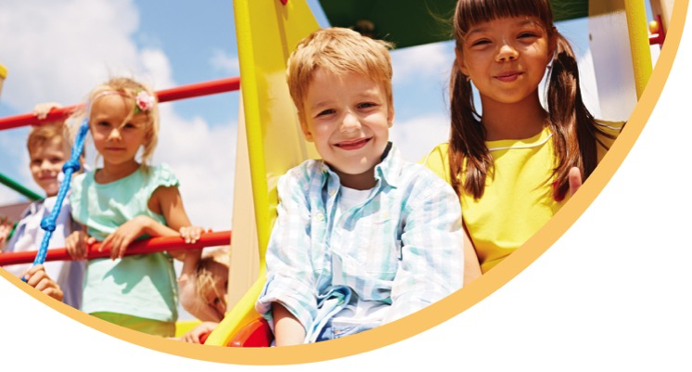
Educators might consider planning for experiences that cater for various levels of skill and provide easy ways for children to work together; playdough or water play may be good places to start.
References and further reading
http://www.education.vic.gov.au/childhood/providers/funding/Pages/improvedchildratioinkindergarten.aspx

