The ideas and suggestions in this tip sheet connect with the practice principles of the Victorian Early Years Learning and Development Framework.
- Partnerships with families
- Partnerships with professionals
- High expectations for every child
- Equity and diversity
- Respectful relationships and responsive engagement
- Integrated teaching and learning approaches
- Assessment for learning and development
- Reflective practice
It is recommended that educators refer to the VEYLDF and the practice guides for further suggestions and ideas about continuous improvement.
Warm and respectful relationships with children and their families form the foundation for effective early childhood education programs. Strong connections with and between educators helps to generate a sense of belonging and nurture learning and development of children.
“Interactions with children and families inform early childhood professional’s knowledge of children’s distinctive interests, skills, cultures and abilities. This is crucial to providing positive experiences and a safe and stimulating environment that will encourage children to expand their capacities and deepen their knowledge and understandings.”
– VEYLDF p11
With the change to the educator to child ratio, the presence of more educators and the possibility of larger groups, it is important to be mindful of the importance of establishing and maintaining strong connections with children and their families.
Supporting relationships starts with an inclusive and responsive approach to communication with families that builds understanding and respect.
This is further supported when educators plan for, monitor and assess relationships as part of an ongoing cycle of planning and program development that offers children opportunities to learn about themselves and their relationships with others.
Suggested strategies to
support the development of secure relationships:
Building secure relationships starts with enrolment. Developing strong, inclusive enrolment processes that respect families and create a sense of belonging is critical to positive outcomes for children. Educators might like to consider changes to this process that allows families to engage with the program and staff in more meaningful ways. Some examples might include:
- Ensure that families meet with all the educators during the enrolment process, especially if there are multiple staff who will be educating and caring for their children. Take this opportunity to communicate the strategies you will use to build relationships with children. »
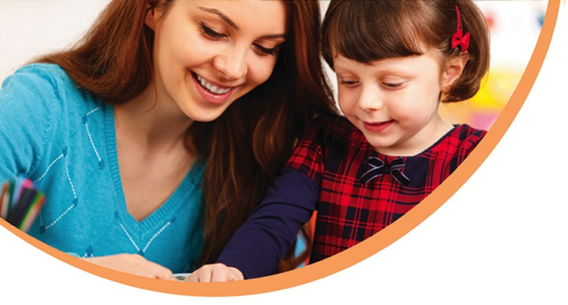
- Create a more relaxed opportunity for families to enrol and get to know the service through one-on-one interviews. Invite families and children to attend the service to complete the necessary paperwork gives educators the opportunity to listen to families and talk through important aspects of the program.
- Utilise a ‘primary care giving’ model where families know who has primary responsibility for their child and who they should talk to about their child’s learning and development.
- Offer an opportunity for families to talk to educators once the program has begun; for example, after a month or so. This will offer an opportunity for both families and educators to raise any concerns or to clarify expectations.
Establish a primary care giving model with the team. This means that the educators working in a team establish and plan for key ‘primary care’ responsibilities for individual children in the group. This does not mean that children are no longer the responsibility of all staff. Instead this model ensures that children’s wellbeing is closely monitored resulting in a level of confidence that children are not slipping ‘under the radar’.

This model relies on a common understanding of learning by staff and a willingness to share responsibilities and plan collaboratively for children’s learning. Comprehensive information about this model is available in references and further reading.
Questions for
reflective discussion
The VEYLDF practice principles invites educators to think about and challenge their current practices. Use the following questions to support discussion with your colleagues.
- What are your shared understandings of the role of relationships in children’s learning?
- What does it mean to be responsive to all children? Discuss the difference between equity and equality in the development of relationships with children and their families.
- How are these commitments communicated to families?
- What strategies have you utilised to establish strong relationships with children and their families? Why do you think they have worked? What might you do differently?

Plan for relationships. Prioritise relationships in the curriculum decision making and the planning cycle. Consider using relationships as a lens to collect information about children, plan for and review their learning. This might mean that observation formats change prompting educators to observe children’s relationships and how they are settling into the program. It could also mean that curriculum plans are developed that teach children how to make friends, self-regulate and speak up in a group for example. In large groups it is helpful to support children to learn ways of being with each other and resolving difficulties.
Assess children’s relationship learning and development and share this with families. Families might express a concern about how their child will manage in larger groups. It would be helpful to let families know that educators will plan particular strategies to support children in developing strong relationships.

Children’s progress will be monitored and assessed as part of ongoing planning, particularly towards wellbeing outcomes. This area of learning and development could be reported to families through documentation and summative assessment work.
References and further reading
http://www.education.vic.gov.au/childhood/providers/funding/Pages/improvedchildratioinkindergarten.aspx

